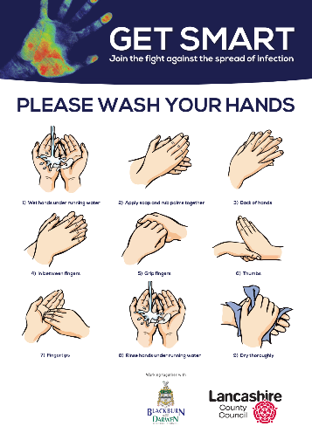
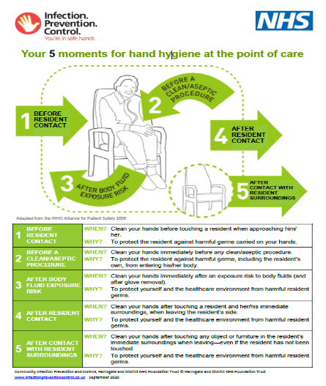
IPC BEST CHECKLIST
To be completed twice a week into the workplace
ACTIONS
- This tool is to be completed before every shift.
- All columns should be completed.
Month ………………………………….

Bare below the elbows sweep, do a visual check of all care staff when they come onto shift. |  | WK1 |  | WK2 |  | WK3 |  | WK4 |  | Comments

Environmental sweep, do a walk round of communal, personal care areas, bathrooms and toilets. |  | WK1 |  | WK2 |  | WK3 |  | WK4 |  | Comments
Stock. check stock of PPE available and liquid soap, paper towels at communal sinks. |  | WK1 |  | WK2 |  | WK3 |  | WK4 |  | Comments

Tell the senior/manager. Report onward to the care home manager. |  | WK1 |  | WK2 |  | WK3 |  | WK4 |  | Comments



