
Mattress and Pillow Audit tool – V3.0
Mattresses and covers in a poor condition are known to be a source of healthcare associated infections.

In the event of equipment or equipment cover failure, action plans must be drawn up locally, reviewed and monitored.

Key Points | - The purpose of the audit tool is to undertake monthly audits to monitor and record the condition of mattress/pressure relieving cushion/pillow covers, pressure relieving cushions and fall mats.  - All columns should be completed.  - In the event of non-compliance, action plans should be produced and reviewed regularly.  - Completed audit tools should be kept locally for good practice assurance and as evidence for CQC inspections.  - Add the total number of pass answers in each standard  - Divide by the total number of pass and fail answers,  - Multiply by 100 to get the percentage.  - Follow the formula below to work out your percentage:
  Total number of pass answers | X 100 = |  | %
  Total number of pass and fail answers | X 100 = |  | %
  Audit Scoring Key:
  Green Rating | 95 - 100%
  Amber Rating | 80 - 94%
  Red Rating | 79% and below*

Water penetration test (Only for sealed mattresses covers without a zip; DO NOT UNDERTAKE ON AIRFLOW MATTRESSES)
Water penetration testing should only be carried out on mattresses that have a sealed cover, i.e., no zip, which make it impossible to inspect the core mattress. This is intended as a quick positive check to determine whether or not the mattress cover is permeable to fluids.

- Using the fist, press the mattress cover to form a shallow well in the centre of the mattress where it would have high usage or on any areas of concern.
- Pour a small volume of tap water (approximately half teacup/75ml) in the well and agitate the area for about a minute.
- Visually inspect for loss of water/water penetration which includes failure of the test.
- Mop up the water.

PLEASE CONSIDER CONDUCTING TISSUE VIABILITY CHECKS AT THIS TIME!

Auditor: Unit/Location: Date:
Room Number/Location | Mattress/Pillow Covers Number/Identifier | Is there a breach in the integrity of the mattress/pillow cover e.g., Torn, or damaged? | Does the mattress/pillow cover have any staining outside or inside that cleaning cannot remove? | Removable mattress covers: is the mattress cover fastening compromised, e.g., is the zip or any other cover fastening device broken? | Non removable mattress covers e.g., no zip: did the cover fail the water penetration test? (See page 2). | If the answers to any of the mattress / pillow cover questions are yes, the item has failed and must be replaced.
 |  | ☐ Yes ☐ No | ☐ Yes ☐ No | ☐ Yes ☐ No | ☐ Yes ☐ No | ☐ Pass ☐ Fail
 |  | ☐ Yes ☐ No | ☐ Yes ☐ No | ☐ Yes ☐ No | ☐ Yes ☐ No | ☐ Pass ☐ Fail
 |  | ☐ Yes ☐ No | ☐ Yes ☐ No | ☐ Yes ☐ No | ☐ Yes ☐ No | ☐ Pass ☐ Fail
 |  | ☐ Yes ☐ No | ☐ Yes ☐ No | ☐ Yes ☐ No | ☐ Yes ☐ No | ☐ Pass ☐ Fail
 |  | ☐ Yes ☐ No | ☐ Yes ☐ No | ☐ Yes ☐ No | ☐ Yes ☐ No | ☐ Pass ☐ Fail
 |  | ☐ Yes ☐ No | ☐ Yes ☐ No | ☐ Yes ☐ No | ☐ Yes ☐ No | ☐ Pass ☐ Fail
 |  | ☐ Yes ☐ No | ☐ Yes ☐ No | ☐ Yes ☐ No | ☐ Yes ☐ No | ☐ Pass ☐ Fail
 |  | ☐ Yes ☐ No | ☐ Yes ☐ No | ☐ Yes ☐ No | ☐ Yes ☐ No | ☐ Pass ☐ Fail
 |  | ☐ Yes ☐ No | ☐ Yes ☐ No | ☐ Yes ☐ No | ☐ Yes ☐ No | ☐ Pass ☐ Fail
 |  | ☐ Yes ☐ No | ☐ Yes ☐ No | ☐ Yes ☐ No | ☐ Yes ☐ No | ☐ Pass ☐ Fail
 |  | ☐ Yes ☐ No | ☐ Yes ☐ No | ☐ Yes ☐ No | ☐ Yes ☐ No | ☐ Pass ☐ Fail
 |  | ☐ Yes ☐ No | ☐ Yes ☐ No | ☐ Yes ☐ No | ☐ Yes ☐ No | ☐ Pass ☐ Fail
 |  | ☐ Yes ☐ No | ☐ Yes ☐ No | ☐ Yes ☐ No | ☐ Yes ☐ No | ☐ Pass ☐ Fail
 |  | ☐ Yes ☐ No | ☐ Yes ☐ No | ☐ Yes ☐ No | ☐ Yes ☐ No | ☐ Pass ☐ Fail
 |  | ☐ Yes ☐ No | ☐ Yes ☐ No | ☐ Yes ☐ No | ☐ Yes ☐ No | ☐ Pass ☐ Fail
 |  | ☐ Yes ☐ No | ☐ Yes ☐ No | ☐ Yes ☐ No | ☐ Yes ☐ No | ☐ Pass ☐ Fail
 |  |  |  |  | Percentage total
- Criteria for Mattress/Pillow Covers

(2) Criteria for Mattresses
Room Number/Location | Mattress Number/Identifier | Undo the removable cover. Is the mattress wet, soiled or stained on either side?  (Not applicable to sealed mattress covers without a zip) | Does the mattress have an offensive odour? | If the answers to any of the questions are yes, the mattress has failed and must be replaced. | Comments/Actions
 |  | ☐ Yes ☐ No | ☐ Yes ☐ No | ☐ Pass ☐ Fail
 |  | ☐ Yes ☐ No | ☐ Yes ☐ No | ☐ Pass ☐ Fail
 |  | ☐ Yes ☐ No | ☐ Yes ☐ No | ☐ Pass ☐ Fail
 |  | ☐ Yes ☐ No | ☐ Yes ☐ No | ☐ Pass ☐ Fail
 |  | ☐ Yes ☐ No | ☐ Yes ☐ No | ☐ Pass ☐ Fail
 |  | ☐ Yes ☐ No | ☐ Yes ☐ No | ☐ Pass ☐ Fail
 |  | ☐ Yes ☐ No | ☐ Yes ☐ No | ☐ Pass ☐ Fail
 |  | ☐ Yes ☐ No | ☐ Yes ☐ No | ☐ Pass ☐ Fail
 |  | ☐ Yes ☐ No | ☐ Yes ☐ No | ☐ Pass ☐ Fail
 |  | ☐ Yes ☐ No | ☐ Yes ☐ No | ☐ Pass ☐ Fail
 |  | ☐ Yes ☐ No | ☐ Yes ☐ No | ☐ Pass ☐ Fail
 |  | ☐ Yes ☐ No | ☐ Yes ☐ No | ☐ Pass ☐ Fail
 |  | ☐ Yes ☐ No | ☐ Yes ☐ No | ☐ Pass ☐ Fail
 |  | ☐ Yes ☐ No | ☐ Yes ☐ No | ☐ Pass ☐ Fail
 |  | ☐ Yes ☐ No | ☐ Yes ☐ No | ☐ Pass ☐ Fail
 |  | ☐ Yes ☐ No | ☐ Yes ☐ No | ☐ Pass ☐ Fail
 |  | ☐ Yes ☐ No | ☐ Yes ☐ No | ☐ Pass ☐ Fail
 |  |  |  | Percentage total

(3) Criteria for Pressure Relieving Cushions
Room Number/Location | Pressure Relieving Cushion Number/Identifier | Undo the removable cover. Is the cushion wet, soiled or stained on either side? | Does the cushion have an offensive odour? | If the answers to any of the questions are yes, the cushion has failed and must be replaced. | Comments/Actions
 |  | ☐ Yes ☐ No | ☐ Yes ☐ No | ☐ Pass ☐ Fail
 |  | ☐ Yes ☐ No | ☐ Yes ☐ No | ☐ Pass ☐ Fail
 |  | ☐ Yes ☐ No | ☐ Yes ☐ No | ☐ Pass ☐ Fail
 |  | ☐ Yes ☐ No | ☐ Yes ☐ No | ☐ Pass ☐ Fail
 |  | ☐ Yes ☐ No | ☐ Yes ☐ No | ☐ Pass ☐ Fail
 |  | ☐ Yes ☐ No | ☐ Yes ☐ No | ☐ Pass ☐ Fail
 |  | ☐ Yes ☐ No | ☐ Yes ☐ No | ☐ Pass ☐ Fail
 |  | ☐ Yes ☐ No | ☐ Yes ☐ No | ☐ Pass ☐ Fail
 |  | ☐ Yes ☐ No | ☐ Yes ☐ No | ☐ Pass ☐ Fail
 |  | ☐ Yes ☐ No | ☐ Yes ☐ No | ☐ Pass ☐ Fail
 |  | ☐ Yes ☐ No | ☐ Yes ☐ No | ☐ Pass ☐ Fail
 |  | ☐ Yes ☐ No | ☐ Yes ☐ No | ☐ Pass ☐ Fail
 |  | ☐ Yes ☐ No | ☐ Yes ☐ No | ☐ Pass ☐ Fail
 |  | ☐ Yes ☐ No | ☐ Yes ☐ No | ☐ Pass ☐ Fail
 |  | ☐ Yes ☐ No | ☐ Yes ☐ No | ☐ Pass ☐ Fail
 |  | ☐ Yes ☐ No | ☐ Yes ☐ No | ☐ Pass ☐ Fail
 |  | ☐ Yes ☐ No | ☐ Yes ☐ No | ☐ Pass ☐ Fail
 |  |  |  | Percentage total

(4) Criteria for Fall Mats
Room Number/Location | Fall mat Number/Identifier | Undo the removable cover. Is the fall mat wet, soiled, stained, torn on either side? | Does the fall mat have an offensive odour? | If the answers to any of the questions are yes, the fall mat has failed and must be replaced. | Comments/Actions
 |  | ☐ Yes ☐ No | ☐ Yes ☐ No | ☐ Pass ☐ Fail
 |  | ☐ Yes ☐ No | ☐ Yes ☐ No | ☐ Pass ☐ Fail
 |  | ☐ Yes ☐ No | ☐ Yes ☐ No | ☐ Pass ☐ Fail
 |  | ☐ Yes ☐ No | ☐ Yes ☐ No | ☐ Pass ☐ Fail
 |  | ☐ Yes ☐ No | ☐ Yes ☐ No | ☐ Pass ☐ Fail
 |  | ☐ Yes ☐ No | ☐ Yes ☐ No | ☐ Pass ☐ Fail
 |  | ☐ Yes ☐ No | ☐ Yes ☐ No | ☐ Pass ☐ Fail
 |  | ☐ Yes ☐ No | ☐ Yes ☐ No | ☐ Pass ☐ Fail
 |  | ☐ Yes ☐ No | ☐ Yes ☐ No | ☐ Pass ☐ Fail
 |  | ☐ Yes ☐ No | ☐ Yes ☐ No | ☐ Pass ☐ Fail
 |  | ☐ Yes ☐ No | ☐ Yes ☐ No | ☐ Pass ☐ Fail
 |  | ☐ Yes ☐ No | ☐ Yes ☐ No | ☐ Pass ☐ Fail
 |  | ☐ Yes ☐ No | ☐ Yes ☐ No | ☐ Pass ☐ Fail
 |  | ☐ Yes ☐ No | ☐ Yes ☐ No | ☐ Pass ☐ Fail
 |  | ☐ Yes ☐ No | ☐ Yes ☐ No | ☐ Pass ☐ Fail
 |  | ☐ Yes ☐ No | ☐ Yes ☐ No | ☐ Pass ☐ Fail
 |  | ☐ Yes ☐ No | ☐ Yes ☐ No | ☐ Pass ☐ Fail
 |  |  |  | Percentage total

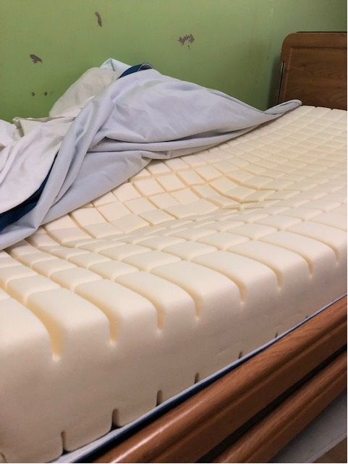
Appendix - Examples
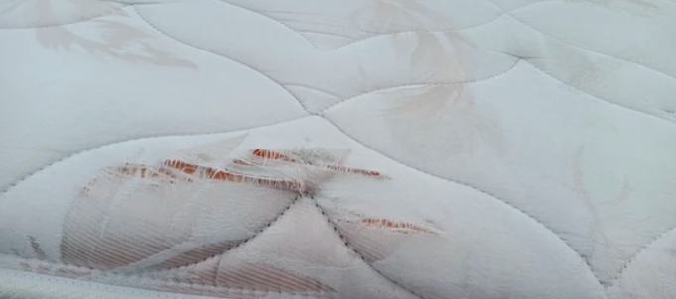
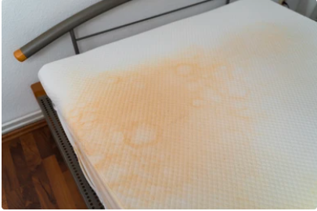
(5.b) Appendix – References
Regulation 15: Premises and equipment - Care Quality Commission (cqc.org.uk)
Health and Social Care Act 2008: code of practice on the prevention and control of infections and related guidance - GOV.UK (www.gov.uk)
All types of bed mattresses - contamination through damaged mattresses or covers - GOV.UK (www.gov.uk)
(5.c) Appendix – Version Control Information
Title
Version number | 3.0
Document author(s) name and role title | IPC Team
Document owner name and role title | Tanya Shaw (IPC Service Lead/Lead Nurse)
Document approver name and role title | Tanya Shaw (IPC Service Lead/Lead Nurse)
Date of creation |  | Review cycle
Last review | 10/10/2024 | Next review date | 10/10/2026

Version | Date | Section/Reference | Amendment
1.0 | 05/07/2023 | Whole Document | Document Created
2.0 | 10/10/2024 | Whole Document | Incorporated pressure relief mattress/fall mat sections and changed document language to reflect changes; Clarity on water penetration testing; Added references section; Version control information added.
3.0 | 19/03/2026 | Whole Document | Updated BwD logos; Added 'Percentage Total' cells; Formatting

