Key Points | - The purpose of the audit tool is to undertake weekly audits to assess the standard of cleanliness of the sluice room.  - All columns should be completed.  - In the event of non-compliance, action plans should be produced and reviewed regularly.  - Completed audit tools should be kept locally for good practice assurance and as evidence for CQC inspections.  Disposing of potentially hazardous human waste in an efficient and hygienic manner is key to preventing the spread of harmful bacteria and Healthcare-Associated Infections (HCAIs) such as C.difficile, norovirus, and E. coli.  - Add the total number of pass answers in each standard  - Divide by the total number of pass and fail answers,  - Multiply by 100 to get the percentage.  - Follow the formula below to work out your percentage:
  Total number of pass answers | X 100 = |  | %
  Total number of pass and fail answers | X 100 = |  | %
  Audit Scoring Key:
  Green Rating | 95 - 100%
  Amber Rating | 80 - 94%
  Red Rating | 79% and below*

Sluice Audit Tool – V2.0

Sluice room | The room is clean, free from clutter, malodours and inappropriate storage of items? | There is a safe cleaning method in place for disinfecting bedpans/urinals? | Bedpan rack and drip tray are available, clean and in a good state of repair? | Sanitary ware and fittings are in good condition, clean and free from lime scale and stains? | Comments | Pass or fail
Bottom floor | ☐ Yes ☒ No | ☒ Yes ☐ No | ☒ Yes ☐ No | ☒ Yes ☐ No | Vases being stored in the sluice, will remove. | Fail
Top floor | ☒ Yes ☐ No | ☒ Yes ☐ No | ☒ Yes ☐ No | ☒ Yes ☐ No |  | Pass
 | ☐ Yes ☐ No | ☐ Yes ☐ No | ☐ Yes ☐ No | ☐ Yes ☐ No
 | ☐ Yes ☐ No | ☐ Yes ☐ No | ☐ Yes ☐ No | ☐ Yes ☐ No
 | ☐ Yes ☐ No | ☐ Yes ☐ No | ☐ Yes ☐ No | ☐ Yes ☐ No
 | ☐ Yes ☐ No | ☐ Yes ☐ No | ☐ Yes ☐ No | ☐ Yes ☐ No
 | ☐ Yes ☐ No | ☐ Yes ☐ No | ☐ Yes ☐ No | ☐ Yes ☐ No
 | ☐ Yes ☐ No | ☐ Yes ☐ No | ☐ Yes ☐ No | ☐ Yes ☐ No
 | ☐ Yes ☐ No | ☐ Yes ☐ No | ☐ Yes ☐ No | ☐ Yes ☐ No
 | ☐ Yes ☐ No | ☐ Yes ☐ No | ☐ Yes ☐ No | ☐ Yes ☐ No
 |  |  |  |  | Percentage total
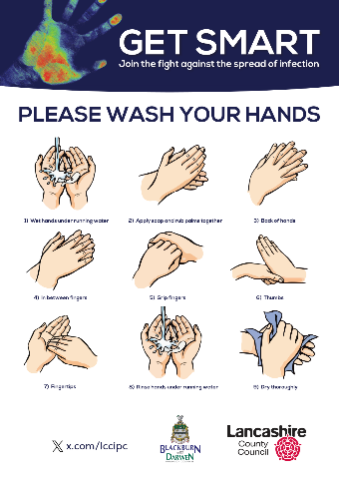
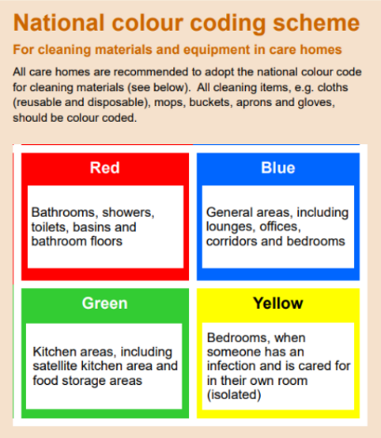
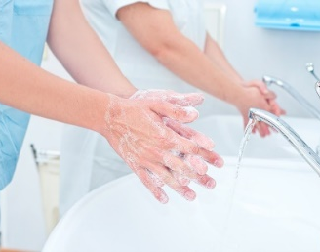


*If no sink available in the sluice room please hand gel your hands prior to exiting and then carry out hand washing at the nearest hand washing sink before carrying out any further tasks


SLUICE RULES

RISK ASSESS
CLEANING
HAND WASHING


- Accessible hand washing sink*
- Wall mounted soap and paper towels
- Laminated hand wash poster displayed above the sink
- Plug free sinks
- Foot operated pedal bin

- Good supply/access to appropriate PPE
- Cleaning schedule in place
- Clearly defined cleaning roles/responsibilities
- Washable flooring, impervious to moisture
- Always have a foot pedal bin

- Clean/tidy and clutter free
- No food or drink
- Fit for purpose and no damage
- No clean linen or inappropriate items (vases)

