Overview

Cleaning only removes microorganisms rather than killing them.

Cleaning with a general-purpose detergent is usually sufficient for routine cleaning.

There are areas/items of the setting that also require disinfection after use, in addition to cleaning to kill viruses and/or bacteria:

- Sanitary fittings, including commodes and bedpan holders/carriers.

- Food preparation areas

There are occasions that also require disinfection in addition to cleaning to kill viruses and/or bacteria:

- Enhanced clean (during symptomatic service user's isolation period)

- Terminal decontamination (end of isolation period/outbreaks). (Separate IPC document listed)

Introduction | - This document is part of the IPC cleaning schedules for domestic staff, day, or night staff.  - This document is to be used to check a service users bedroom following the checklist below on a routine/rotational basis.  - A resident of the day cleaning checklist is required in order to maintain acceptable levels of cleanliness and hygiene for service users.  - High standards of cleanliness are particularly important in health and social care settings where they are key factor in helping to ensure that people using the care services live with dignity and respect in pleasant surroundings.  - Effective cleaning will also help to achieve suitable standards of infection control, particular during outbreaks of illness or if there has been a spillage of body fluids.
Key | - Low surfaces include items such as skirting boards, floor edges, low-level pipe work and trunking, low cupboard exteriors.  - Middle surfaces include items such as grab rails, tables, trunking, desks, shelves, ledges, work surfaces, cupboard exteriors, windowsills.  - High surfaces include items such as filing cabinets, curtain rails, locker and cupboard tops, picture frames.
Cleaning | The manual removal of dirt, debris. Micro-organisms are removed rather than killed.  Effective cleaning leaves a surface or equipment visibly clean:  - Clean with a fresh solution of general-purpose neutral detergent in warm water  - This should be changed when dirty or when changing tasks.  REMEMBER! Cleaning is a pre-requisite to effective disinfection
Two Step Cleaning Process | The two-step cleaning process is cleaning that needs to be carried out in 2 stages; 1. cleaning, 2. disinfecting.  - First, clean using a detergent and water to remove visible dirt from surfaces and equipment, and then rinse. Secondly, disinfect the item/surface by using a disinfectant. Ensure that the correct dilution and contact time for the product is used.  - *Disinfectants will only work on clean surfaces. Always use a detergent to remove visible dirt and grease before disinfecting.
Disinfection | Disinfection: Process of reducing or eliminating harmful microorganisms from objects and surfaces.  Disinfectant products should contain chlorine at 1000ppm as per the national cleaning standards.  - Any surface disinfectant used in healthcare/social care settings must have been verified by testing according to the British & European standards (BS EN numbers) to support bactericidal and virucidal claims and other healthcare acquired infection (HCAI) pathogens:  - Please look for the BS EN number on the bottle. This is usually displayed on the label and can be located on the front or on the back of the product.  - Disinfectants compliant with BS EN 14476, confirms the product is effective against viruses such as. For enhanced cleaning due to a COVID-19 infection, BS EN 14476 should state that it is effective against enveloped viruses.  - Products compliant with BS EN 1276 or BS EN 13697 confirm the product is effective for preventing the growth and spread of harmful bacteria such as E- coli and Salmonella.  Disinfection products for kitchen and food preparation areas should meet the following BS EN criteria: BS EN 1276 or BS EN 13697.

Terminal decontamination (Deep clean) | The term in this document refers to cleaning and disinfection, either using separate cleaning and disinfecting products using a two-step process:  - a general-purpose neutral detergent in warm water followed by solution of 1,000 parts per million available chlorine (ppm available chlorine (av.cl.) or a ‘2 in 1’ product that cleans and disinfects in one step:  - a combined detergent/disinfectant solution at a dilution of 1,000 parts per million available chlorine (ppm available chlorine (av.cl).

Damp Dusting | The process of removing microorganisms from hard surface, furniture, fixtures and fittings with a damp cloth.  Apply general purpose detergent to a clean cloth and dust the areas. Using a damp cloth soaked in detergent will aid the dust to stick to the cloth rather than being dispersed into the when dry dusting.

Correct use of product

Products must be used at the recommended dilution rate and contact time to be effective, please follow manufacturer guidance.

We advise that you:

- MUST provide adequate training to staff using any chemical-based products.
- Pay attention to the contact time for the cleaner to be effective.
- Make sure you and your staff follow the instructions for the product chosen.
- Use the correct dilution level for products that need to be diluted before use.
- Supervise staff to ensure that all requirements of the cleaning process are completed.
- Remind staff to regularly clean down surfaces, touch points, etc properly, by using the right product, and following the instructions.

How to clean

To minimise recontamination of an area and transfer of virus and other microorganisms, clean from:

- top to bottom.
- clean to dirty areas
- the furthest point to nearest point
- low risk to high-risk pathways.

Staff need to be trained in manual cleaning processes to prevent recontamination of surfaces e.g., clean large and flat surfaces using an ‘S’ shape motion.

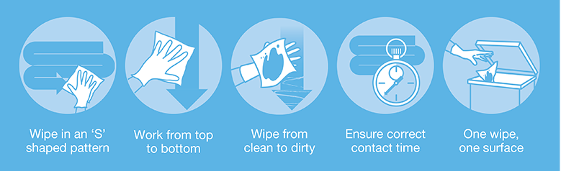
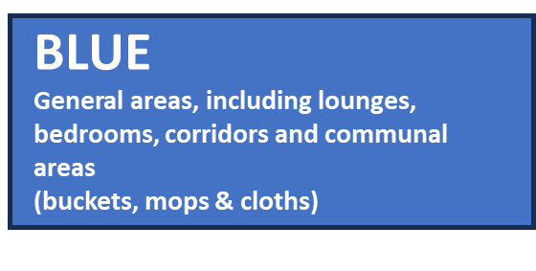
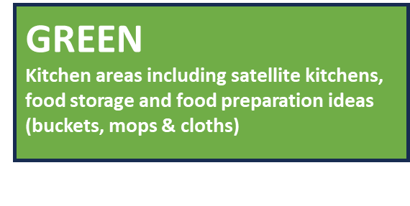
Colour Coded Cleaning
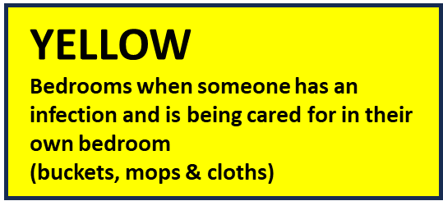

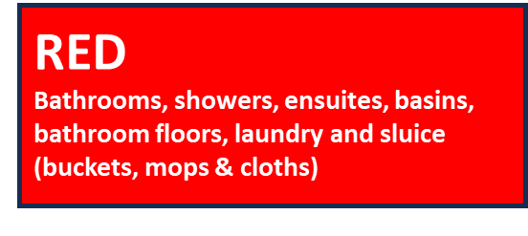

BEDROOM: | 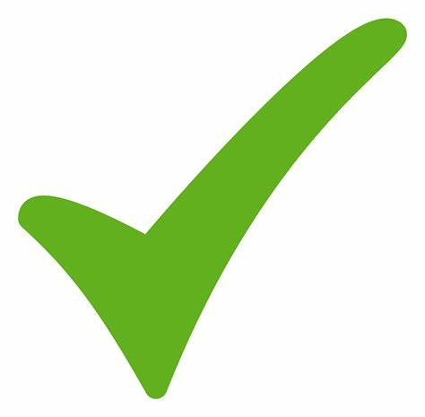  Check Mark Tick · Free vector graphic on Pixabay by Unknown Author | En- suite | Check Mark Tick · Free vector graphic on Pixabay by Unknown Author
- Remove used crockery and dirty laundry |  | - Empty bin, Remove waste and dirty linen
- Separate recycling waste and empty bin |  | - Remove/dust ceiling, air extraction vents and lighting.
- Damp wipe window and wipe curtain rail |  | - Wipe walls and window frames and ledges
- High dust ceilings, vents, and lighting. |  | - Steam clean tiles and grouting on walls and floors
- Spot wipe walls, skirting and sockets. |  | - Start sanitary toilet clean procedure (brush left in)
- Steam Clean/extract soft furnishings and fabrics. |  | - Clean bath & shower/ shower surround and wash basin.
- Check interior, damp wipe pressure cushions, and disinfect. |  | - Clean hard surfaces.
- Damp dust fixtures and fittings. |  | - Clean fixtures & fittings, handrails, mirrors, and dispensers
- Damp dust hard surfaces and furniture |  | - Detergent wipe pull cord
- Wipe and arrange personal effects. |  | - Detergent wipe and disinfect raised toilet seat
- Check integrity of mattress, detergent wipe and disinfect. |  | - Detergent wipe and disinfect shower chair
- Check integrity, damp wipe crashmats/pressure pad and disinfect. |  | - Detergent wipe and disinfect commode
- Detergent wipe bed frame/bedrails and disinfect. |  | - Replenish consumable items face cloth and towels
- Launder/change duvet. |  | - Wipe and arrange service users' toiletries
- Launder/change pillows. |  | - Vacuum/mop/steam clean flooring
- Detergent wipe and disinfect wheelchair. |  | - Wipe both door handles and light switch
- Detergent wipe and disinfect hoist. |  | - Odours neutralise where necessary
- Detergent wipe and disinfect stand rail. |  | Room Number/date
- Steam or launder curtains. |  | Completed by:
- Hoover and steam hard floor
- Shampoo carpet/steam clean flooring |  | Manager/supervisor checked:
- Check laundry.

Comments/Notes

Useful Links and reference guide.
- https://www.england.nhs.uk/national-infection-prevention-and-control-manual-nipcm-for-england/

- COSHH and cleaners - key messages - COSHH (hse.gov.uk)

- Infection prevention and control - Lancashire County Council

- Health and Social Care Act 2008: code of practice on the prevention and control of infections - GOV.UK (www.gov.uk)

- Infection prevention and control in adult social care: acute respiratory infection - GOV.UK (www.gov.uk)

- Care Quality Commission (cqc.org.uk)

- Cleaning effectively in your business | Food Standards Agency

- https://infectionpreventioncontrol.co.uk/wp-content/uploads/2019/07/03-Decontamination-cleaning-and-disinfection-March-2016-Version-2.00.pdf

- https://www.england.nhs.uk/wp-content/uploads/2021/04/B0271-national-standards-of-healthcare-cleanliness-2021.pdf

- https://www.england.nhs.uk/wp-content/uploads/2021/04/B0271-national-standards-of-healthcare-cleanliness-2021.pdf

Other documents available in our IPC cleaning schedules are.
(1) IPC Touchpoint Cleaning.
(2) IPC Cleaning Schedule.
(3) IPC Decontamination – deep cleans.

