Key Points | - The purpose of the audit tool is to undertake weekly audits to assess the standard of cleanliness of commodes and commode pans.  - All columns should be completed.  - In the event of non-compliance, action plans should be produced and reviewed regularly.  - Completed audit tools should be kept locally for good practice assurance and as evidence for CQC inspections.  Appropriate PPE must be worn.  Use 1,000 ppm of the chlorine-based disinfectant solution (made with cold water only) following the manufacturers guidance or sporicidal wipes. Adhere to COSHH standards.  Commodes should be replaced when scratched, stained or if any metal work is rusted.  - Add the total number of pass answers in each standard  - Divide by the total number of pass and fail answers,  - Multiply by 100 to get the percentage.  - Follow the formula below to work out your percentage:
  Total number of pass answers | X 100 = |  | %
  Total number of pass and fail answers | X 100 = |  | %
  Audit Scoring Key:
  Green Rating | 95 - 100%
  Amber Rating | 80 - 94%
  Red Rating | 79% and below*

Commode Audit Tool

Commode | Commode is rust free with no signs of damage | Commode and pans are visibly clean, including underneath surfaces | Appropriate PPE is available when decontaminating commodes and pans | Staff can explain the correct procedure for manually cleaning and disinfecting a commode pan | Comments |  | Pass or fail
(Room 5) | ☐ Yes ☒ No | ☐ Yes ☒ No | ☒ Yes ☐ No | ☐ Yes ☐ No | Commode rusted on legs and faeces observed on underneath of commode. |  | Fail
 | ☐ Yes ☐ No | ☐ Yes ☐ No | ☐ Yes ☐ No | ☐ Yes ☐ No
 | ☐ Yes ☐ No | ☐ Yes ☐ No | ☐ Yes ☐ No | ☐ Yes ☐ No
 | ☐ Yes ☐ No | ☐ Yes ☐ No | ☐ Yes ☐ No | ☐ Yes ☐ No
 | ☐ Yes ☐ No | ☐ Yes ☐ No | ☐ Yes ☐ No | ☐ Yes ☐ No
 | ☐ Yes ☐ No | ☐ Yes ☐ No | ☐ Yes ☐ No | ☐ Yes ☐ No
 | ☐ Yes ☐ No | ☐ Yes ☐ No | ☐ Yes ☐ No | ☐ Yes ☐ No
 | ☐ Yes ☐ No | ☐ Yes ☐ No | ☐ Yes ☐ No | ☐ Yes ☐ No
 | ☐ Yes ☐ No | ☐ Yes ☐ No | ☐ Yes ☐ No | ☐ Yes ☐ No
 | ☐ Yes ☐ No | ☐ Yes ☐ No | ☐ Yes ☐ No | ☐ Yes ☐ No
 |  |  |  |  |  | Percentage total
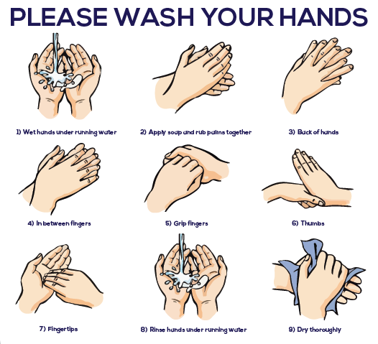
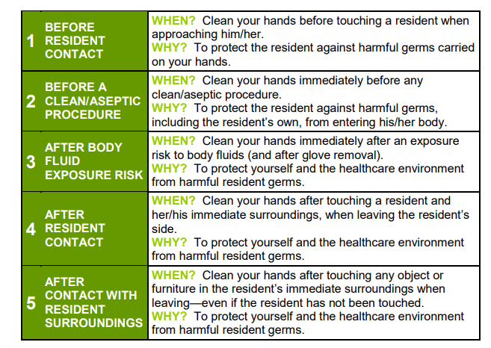
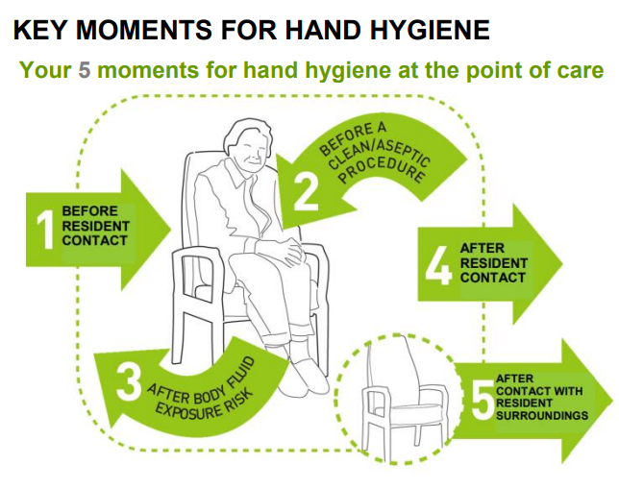

Manual decontamination
- Staff must perform hand hygiene before donning PPE.
- Wear eye protection if there is a risk of splashing to the eyes.
- Cover commodes pan with lid and carefully remove from the commode to avoid spillages. Empty contents into en-suite toilet in the resident's room or transfer the covered commode pan to the sluice room and discard the contents into the waste disposal.
- Rinse the pan with cold water, clean with detergent and then followed by chlorine- use disposable cloths. If using sporicidal wipes, then detergent clean first is not required.
- Wipe the outside of the pan first, then the inside, do not dry with paper towels but leave inverted to dry naturally.
- Dispose of the cloth into clinical waste bin.
- Doff PPE appropriately and perform hand hygiene.

