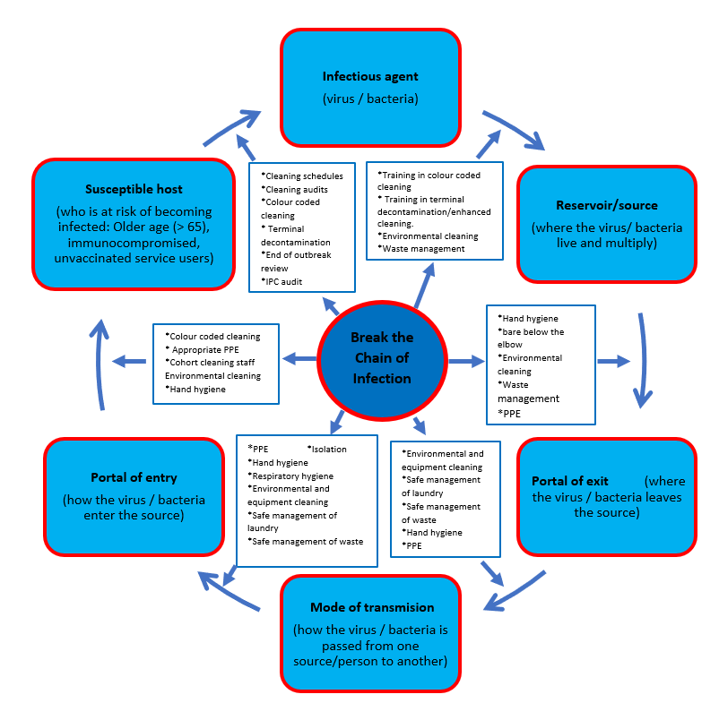

Chain of infection: general

No matter the germ, there are six points at which the chain can be broken, and a germ can be stopped from infecting another person.
The six links are shown on the diagram including the steps in IPC which will help to break the chain of infection.

The 10 Standard Infection Control Precautions (SICPS)
Standard infection control precautions should be used by all staff, in all care settings, at all times for all service users whether infection is known to be present or not, to ensure the safety of those being cared for, staff and visitors in the care environment.

- Resident placement/assessment for infection risk.
- Hand hygiene.
- Respiratory and cough hygiene.
- Personal protective equipment.
- Safe management of care equipment.
- Safe management of care environment.
- Safe management of linen.
- Safe management of blood and body fluid spillage.
- Safe disposal of waste.
- Occupational safety prevention and exposure management (including sharps).

When there is a suspected or confirmed outbreak, additional measures may be required.
Overview

Cleaning only removes microorganisms rather than killing them.
Cleaning with a general-purpose detergent is usually sufficient for routine cleaning.

There are areas/items of the setting that also require disinfection after use, in addition to cleaning to kill viruses and/or bacteria:

- Sanitary fittings, including commodes and bedpan holders/carriers.
- Food preparation areas

There are occasions that also require disinfection in addition to cleaning to kill viruses and/or bacteria:

- Enhanced clean (during symptomatic service user's isolation period)

- Terminal decontamination (end of isolation period/outbreaks)

Cleaning Schedule | This document is part of the IPC cleaning schedules for domestic staff, day, or night staff.  - A regular cleaning schedule is required in order to maintain the appearance of premises and achieve acceptable levels of cleanliness and hygiene.  - High standards of cleanliness are particularly important in health and social care settings where they are key factor in helping to ensure that people using the care services live with dignity and respect in pleasant surroundings.  - Effective cleaning will also help to achieve suitable standards of infection control, particular during outbreaks of illness or  If there has been a spillage of body fluids.  A cleaning schedule should show.  - What needs to be cleaned.  - What needs to be disinfected.  - How often it needs to be done.  - How the cleaning/disinfecting should be done.

Key | - Low surfaces include items such as skirting boards, floor edges, low-level pipe work and trunking, low cupboard exteriors.  - Middle surfaces include items such as grab rails, tables, trunking, desks, shelves, ledges, work surfaces, cupboard exteriors, windowsills.  - High surfaces include items such as filing cabinets, curtain rails, locker and cupboard tops, picture frames.    = Spot Clean high traffic areas twice daily.  Check Mark Tick · Free vector graphic on Pixabay by Unknown Author    = Cleaned between uses.  Check Mark Tick · Free vector graphic on Pixabay by Unknown Author

Cleaning | The manual removal of dirt, debris. Micro-organisms are removed rather than killed.  Effective cleaning leaves a surface or equipment visibly clean:  - Clean with a fresh solution of general-purpose neutral detergent in warm water  - This should be changed when dirty or when changing tasks.  REMEMBER! Cleaning is a pre-requisite to effective disinfection

Damp Dusting | The process of removing microorganisms from hard surface, furniture, fixtures and fittings with a damp cloth.  Apply general purpose detergent to a clean cloth and dust the areas. Using a damp cloth soaked in detergent will aid the dust to stick to the cloth rather than being dispersed into the when dry dusting.

Terminal decontamination (deep clean) | The term in this document refers to cleaning and disinfection, either using separate cleaning and disinfecting products using a two-step process:  - a general-purpose neutral detergent in warm water followed by solution of 1,000 parts per million available chlorine (ppm available chlorine (av.cl.) or a ‘2 in 1’ product that cleans and disinfects in one step:  - a combined detergent/disinfectant solution at a dilution of 1,000 parts per million available chlorine (ppm available chlorine (av.cl).

Two Step Cleaning Process | The two-step cleaning process is cleaning that needs to be carried out in 2 stages; 1. cleaning, 2. disinfecting.  - First, clean using a detergent and water to remove visible dirt from surfaces and equipment, and then rinse. Secondly, disinfect the item/surface by using a disinfectant. Ensure that the correct dilution and contact time for the product is used.  - *Disinfectants will only work on clean surfaces. Always use a detergent to remove visible dirt and grease before disinfecting.  Disinfection: Process of reducing or eliminating harmful microorganisms from objects and surfaces.  Disinfectant products should contain chlorine at 1000ppm as per the national cleaning standards.  - Any surface disinfectant used in healthcare/social care settings must have been verified by testing according to the British & European standards (BS EN numbers) to support bactericidal and virucidal claims and other healthcare acquired infection (HCAI) pathogens:  - Please look for the BS EN number on the bottle. This is usually displayed on the label and can be located on the front or on the back of the product.  - Disinfectants compliant with BS EN 14476, confirms the product is effective against viruses such as. For enhanced cleaning due to a COVID-19 infection, BS EN 14476 should state that it is effective against enveloped viruses.  - Products compliant with BS EN 1276 or BS EN 13697 confirm the product is effective for preventing the growth and spread of harmful bacteria such as E- coli and Salmonella.  Disinfection products for kitchen and food preparation areas should meet the following BS EN criteria: BS EN 1276 or BS EN 13697.

Spillages of bodily substances. | ‘Bodily substances’ refers to fluid or tissue issuing from a patient either directly or indirectly in the form of, for example, a specimen. Staff with cleaning responsibilities are most likely to encounter wound exudate, blood, vomit, sputum, urine, and faeces. Staff members performing this duty must have been trained in spillage cleaning and follow the method statement for this.  items contaminated with blood, or any body fluids stained with blood should be disinfected promptly and then the affected area cleaned to reduce the risk of infection to other people. Best practice is to use a chlorine-based solution Dilution of 1,000 parts per million (ppm) available chlorine and following the manufacturer’s instructions on the bottle where available.  If the dilution of the chlorine-based disinfectant is incorrect and a weak solution is used, any blood-borne virus, e.g. hepatitis B, hepatitis C and HIV, will not be killed. If the dilution is too strong, the care equipment or surfaces may be damaged.  To ensure that micro-organisms are killed, always leave chlorine-based disinfectant solutions for 5-10 minutes contact time, or as specified on the container. • If soft furnishings or other items are heavily contaminated with blood or body fluids that cannot be adequately decontaminated, they should be disposed of.

Colour Coded Cleaning | 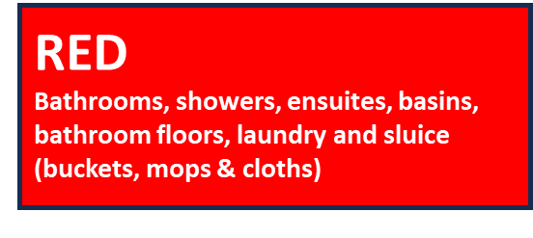  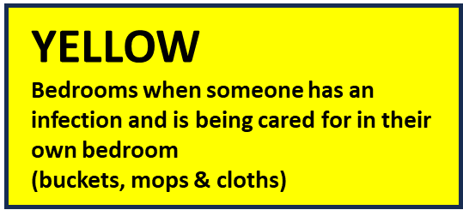  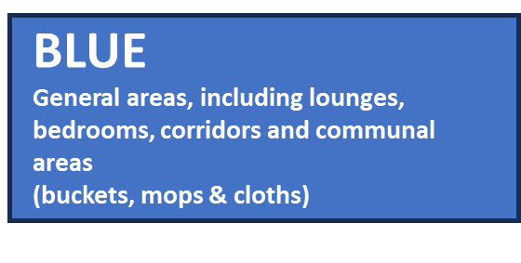  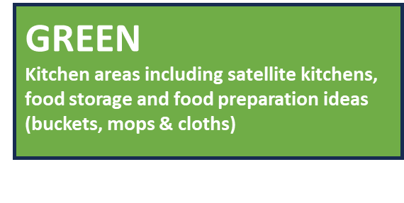

Five Principles of Cleaning

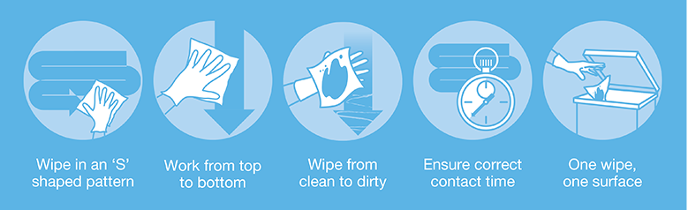

Correct use of product

Products must be used at the recommended dilution rate and contact time to be effective, please follow manufacturer guidance.

We advise that you:

- MUST provide adequate training to staff using any chemical-based products.
- Pay attention to the contact time for the cleaner to be effective.
- Make sure you and your staff follow the instructions for the product chosen.
- Use the correct dilution level for products that need to be diluted before use.
- Supervise staff to ensure that all requirements of the cleaning process are completed.
- Remind staff to regularly clean down surfaces, touch points, etc properly, by using the right product, and following the instructions.

How to clean

To minimise recontamination of an area and transfer of virus and other microorganisms, clean from:
- top to bottom.
- clean to dirty areas
- the furthest point to nearest point
- low risk to high-risk pathways.

Staff need to be trained in manual cleaning processes to prevent recontamination of surfaces e.g., clean large and flat surfaces using an ‘S’ shape motion.

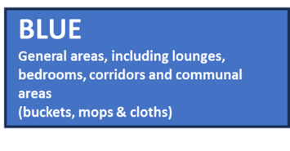
Functional Area: Lounges and Communal Seating Area
Staff Initials: Date:

Standard: The area is visibly clean with no dust, dirt, debris, or malodour. All parts of the chairs are visibly clean with no blood, body substances, dust, dirt, food debris, stains, or spillages. All parts of the furniture including underneath surfaces, wheels and castors are visibly clean. The complete floor including all the edges, corners and main space is visibly clean with no dirt, litter, spillages, or scuff marks. Seating and other furniture is positioned to accommodate Residents’ needs. Fresh drinks are replenished and accessible. This functional area is medium risk. If found dirty it must be cleaned within 3 hours.
Routine | Daily | Weekly | Quarterly or as required | Deep Clean | Comments
- Remove used crockery and discarded items | Check Mark Tick · Free vector graphic on Pixabay by Unknown Author |  |  | Check Mark Tick · Free vector graphic on Pixabay by Unknown Author
- Separate waste for recycling and empty waste bins | Check Mark Tick · Free vector graphic on Pixabay by Unknown Author |  |  | Check Mark Tick · Free vector graphic on Pixabay by Unknown Author
- Damp dust ceiling, vents, and lighting |  |  | Check Mark Tick · Free vector graphic on Pixabay by Unknown Author | Check Mark Tick · Free vector graphic on Pixabay by Unknown Author
- Wipe walls and skirting boards, ventilation grills |  |  | Check Mark Tick · Free vector graphic on Pixabay by Unknown Author | Check Mark Tick · Free vector graphic on Pixabay by Unknown Author
- Steam clean, soft furnishings and blinds |  |  | Check Mark Tick · Free vector graphic on Pixabay by Unknown Author | Check Mark Tick · Free vector graphic on Pixabay by Unknown Author
- Damp dust door and window frames and kick plates |  |  |  | Check Mark Tick · Free vector graphic on Pixabay by Unknown Author
- Damp dust fixtures and fittings |  |  |  | Check Mark Tick · Free vector graphic on Pixabay by Unknown Author
- Damp dust electrical equipment, sockets, and screens |  |  |  | Check Mark Tick · Free vector graphic on Pixabay by Unknown Author
- Spot wipe glass | Check Mark Tick · Free vector graphic on Pixabay by Unknown Author |  |  | Check Mark Tick · Free vector graphic on Pixabay by Unknown Author
- Damp dust hard surfaces and furniture | Check Mark Tick · Free vector graphic on Pixabay by Unknown Author |  |  | Check Mark Tick · Free vector graphic on Pixabay by Unknown Author
- Hoover and wipe clean, soft furnishings | Check Mark Tick · Free vector graphic on Pixabay by Unknown Author |  |  | Check Mark Tick · Free vector graphic on Pixabay by Unknown Author
- Wipe and arrange Residents’ personal effects | Check Mark Tick · Free vector graphic on Pixabay by Unknown Author |  |  | Check Mark Tick · Free vector graphic on Pixabay by Unknown Author
- Hoover/brush and mop floor. Reposition furniture. | Check Mark Tick · Free vector graphic on Pixabay by Unknown Author |  |  | Check Mark Tick · Free vector graphic on Pixabay by Unknown Author

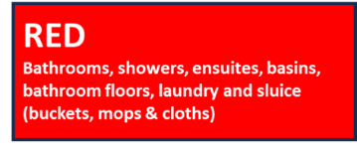
Functional Area: En suite Bathroom.
Staff Initials: Date:

Standard: The area and the bathroom fittings are visibly clean with no dust, dirt, debris, malodour, body substances, scum, limescale, stains, or smears. Resident’s personal effects are arranged as they like them.
This function area is high risk category. If found dirty it must be cleaned immediately.
Routine | Daily | Weekly | Quarterly or as required | Deep Clean | Comments
- Empty bin. Remove waste and dirty linen | Check Mark Tick · Free vector graphic on Pixabay by Unknown Author |  |  | Check Mark Tick · Free vector graphic on Pixabay by Unknown Author
- Damp dust ceiling, air extraction vents and lighting |  |  | Check Mark Tick · Free vector graphic on Pixabay by Unknown Author | Check Mark Tick · Free vector graphic on Pixabay by Unknown Author
- Wipe walls and window frames and ledges |  |  | Check Mark Tick · Free vector graphic on Pixabay by Unknown Author | Check Mark Tick · Free vector graphic on Pixabay by Unknown Author
- Steam clean tiles and grouting on walls and floors |  |  | Check Mark Tick · Free vector graphic on Pixabay by Unknown Author | Check Mark Tick · Free vector graphic on Pixabay by Unknown Author
- Start sanitary toilet clean procedure (brush left in) | Check Mark Tick · Free vector graphic on Pixabay by Unknown Author |  |  | Check Mark Tick · Free vector graphic on Pixabay by Unknown Author
- Clean bath and shower and shower surround and wash basin | Check Mark Tick · Free vector graphic on Pixabay by Unknown Author |  |  | Check Mark Tick · Free vector graphic on Pixabay by Unknown Author
- Clean hard surfaces | Check Mark Tick · Free vector graphic on Pixabay by Unknown Author |  |  | Check Mark Tick · Free vector graphic on Pixabay by Unknown Author
- Clean fixtures and fittings. Handrails and mirrors and dispensers | Check Mark Tick · Free vector graphic on Pixabay by Unknown Author |  |  | Check Mark Tick · Free vector graphic on Pixabay by Unknown Author
- Clean personal care equipment and pull cord | Check Mark Tick · Free vector graphic on Pixabay by Unknown Author |  |  | Check Mark Tick · Free vector graphic on Pixabay by Unknown Author
- Replenish consumable items, face cloths and towels | Check Mark Tick · Free vector graphic on Pixabay by Unknown Author |  |  | Check Mark Tick · Free vector graphic on Pixabay by Unknown Author
- Wipe and arrange Resident’s toiletries | Check Mark Tick · Free vector graphic on Pixabay by Unknown Author |  |  | Check Mark Tick · Free vector graphic on Pixabay by Unknown Author
- Complete sanitary toilet cleaning sequence | Check Mark Tick · Free vector graphic on Pixabay by Unknown Author |  |  | Check Mark Tick · Free vector graphic on Pixabay by Unknown Author
- Hoover/brush and mop floor | Check Mark Tick · Free vector graphic on Pixabay by Unknown Author |  |  | Check Mark Tick · Free vector graphic on Pixabay by Unknown Author
- Wipe both door handles and light switch | Check Mark Tick · Free vector graphic on Pixabay by Unknown Author |  |  | Check Mark Tick · Free vector graphic on Pixabay by Unknown Author

Raised toilets seats (framed or fixed with clips) and shower seats to be wiped clean between uses.

Routine: | Daily | Weekly | Quarterly or as required | Deep clean | Comments
- Empty waste bins. Separate waste and recycle | Check Mark Tick · Free vector graphic on Pixabay by Unknown Author |  |  | Check Mark Tick · Free vector graphic on Pixabay by Unknown Author
- Damp dust ceiling, air extraction vents and lighting |  | Check Mark Tick · Free vector graphic on Pixabay by Unknown Author |  | Check Mark Tick · Free vector graphic on Pixabay by Unknown Author
- Wipe walls and window frames and pipework and ledges |  | Check Mark Tick · Free vector graphic on Pixabay by Unknown Author |  | Check Mark Tick · Free vector graphic on Pixabay by Unknown Author
- Damp wipe fixtures and fittings and chemical dispensers |  | Check Mark Tick · Free vector graphic on Pixabay by Unknown Author |  | Check Mark Tick · Free vector graphic on Pixabay by Unknown Author
- Damp wipe loose equipment and rails and laundry trolley | Check Mark Tick · Free vector graphic on Pixabay by Unknown Author | Check Mark Tick · Free vector graphic on Pixabay by Unknown Author |  | Check Mark Tick · Free vector graphic on Pixabay by Unknown Author
- Clean sink and surrounding hard surfaces | Check Mark Tick · Free vector graphic on Pixabay by Unknown Author |  |  | Check Mark Tick · Free vector graphic on Pixabay by Unknown Author
- Damp wipe machines and dryers | Check Mark Tick · Free vector graphic on Pixabay by Unknown Author |  |  | Check Mark Tick · Free vector graphic on Pixabay by Unknown Author
- Clean and replenish consumable item dispenser | Check Mark Tick · Free vector graphic on Pixabay by Unknown Author |  |  | Check Mark Tick · Free vector graphic on Pixabay by Unknown Author
- Hoover and mop floor | Check Mark Tick · Free vector graphic on Pixabay by Unknown Author |  |  | Check Mark Tick · Free vector graphic on Pixabay by Unknown Author
- Wipe door handles and push plate | Check Mark Tick · Free vector graphic on Pixabay by Unknown Author |  |  | Check Mark Tick · Free vector graphic on Pixabay by Unknown Author
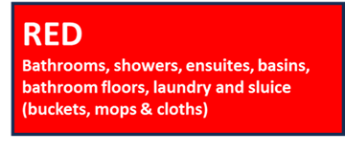
Functional Area: laundry.
Staff Initials: Date:

Standard: The area is visibly clean with no dust, dirt, debris, scale, stains or smears. Consumable items such as paper towels, gloves and soap are replenished. All parts of the laundry equipment are visibly clean. The washing machine and dryers are free from lint build up. The area is free from clutter and unused equipment. Information notices are to company standard and fixed to wall.
This function area, if found dirty it must be cleaned within 3 hours.

Functional Area: Sluice Rooms
Staff Initials: Date:

Standard: The area is visibly clean with no dust, dirt, debris, limescale, stains, and malodour. Consumable items such as paper towels, gloves and soap are replenished. Clean and dirty areas are segregated. The area is free from clutter and unused cleaning equipment. Information notices are to company standard and fixed to wall.
This function area is high. If found dirty is must be cleaned immediately.
Routine: | Daily | Weekly | Quarterly or as required | Deep clean | Comments
- Remove all clinical waste and clean bin frame. | Check Mark Tick · Free vector graphic on Pixabay by Unknown Author |  |  | Check Mark Tick · Free vector graphic on Pixabay by Unknown Author
- High dust ceiling, air extraction vents and lighting. |  |  | Check Mark Tick · Free vector graphic on Pixabay by Unknown Author | Check Mark Tick · Free vector graphic on Pixabay by Unknown Author
- Wipe walls, skirting boards, and ledges. |  |  | Check Mark Tick · Free vector graphic on Pixabay by Unknown Author | Check Mark Tick · Free vector graphic on Pixabay by Unknown Author
- Steam clean tiled hard surfaces and grout. |  |  | Check Mark Tick · Free vector graphic on Pixabay by Unknown Author | Check Mark Tick · Free vector graphic on Pixabay by Unknown Author
- Clean fixtures and fittings. Toilet sluice and macerator. | Check Mark Tick · Free vector graphic on Pixabay by Unknown Author |  |  | Check Mark Tick · Free vector graphic on Pixabay by Unknown Author
- Damp wipe loose equipment. | Check Mark Tick · Free vector graphic on Pixabay by Unknown Author |  |  | Check Mark Tick · Free vector graphic on Pixabay by Unknown Author
- Clean sink and surrounding hard surfaces. | Check Mark Tick · Free vector graphic on Pixabay by Unknown Author |  |  | Check Mark Tick · Free vector graphic on Pixabay by Unknown Author
- Clean and replenish consumable item dispensers. | Check Mark Tick · Free vector graphic on Pixabay by Unknown Author |  |  | Check Mark Tick · Free vector graphic on Pixabay by Unknown Author
- Dust control sweep and mop floor | Check Mark Tick · Free vector graphic on Pixabay by Unknown Author |  |  | Check Mark Tick · Free vector graphic on Pixabay by Unknown Author
- Wipe door handles and push plates | Check Mark Tick · Free vector graphic on Pixabay by Unknown Author |  |  | Check Mark Tick · Free vector graphic on Pixabay by Unknown Author
Clinical waste bin bags (YELLOW) to be removed when ¾ full and by someone who has had clinical waste training.
Never put chemicals into the macerator.
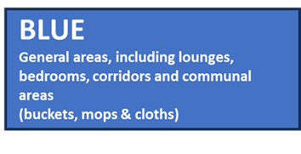
Functional Area: Office and meeting rooms.
Staff Initials: Date:

Standard: The area is visibly clean with no dust, dirt, debris, or malodour. Used crockery is removed and replaced. Wastepaper, cardboard packaging, and clutter are removed.
This functional area is low risk. If found dirty it must be cleaned within 48 hours.
Routine: | Daily | Weekly | Quarterly or as required | Deep clean | Comments
- Remove used crockery | Check Mark Tick · Free vector graphic on Pixabay by Unknown Author
- Separate waste for recycling and empty waste bin | Check Mark Tick · Free vector graphic on Pixabay by Unknown Author
- Spot wipe window. Wipe blinds or curtain rail |  |  | Check Mark Tick · Free vector graphic on Pixabay by Unknown Author
- Damp dust ceiling, lighting, and vents |  |  | Check Mark Tick · Free vector graphic on Pixabay by Unknown Author
- Wipe walls and skirting boards, cables, and socket |  |  | Check Mark Tick · Free vector graphic on Pixabay by Unknown Author
- Damp dust fixtures and fittings. Shelves and notices |  |  | Check Mark Tick · Free vector graphic on Pixabay by Unknown Author
- Damp dust office equipment and telephones |  | Check Mark Tick · Free vector graphic on Pixabay by Unknown Author
- Damp dust hard surfaces and furniture |  | Check Mark Tick · Free vector graphic on Pixabay by Unknown Author
- Hoover/brush and mop floor |  | Check Mark Tick · Free vector graphic on Pixabay by Unknown Author
- For carpeted areas, clean carpet with carpet cleaner |  |  | Check Mark Tick · Free vector graphic on Pixabay by Unknown Author | Check Mark Tick · Free vector graphic on Pixabay by Unknown Author

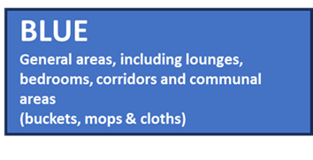
Functional Area: Bedrooms
Staff Initials: Date:

Standard: The bedroom is visibly clean with no dust, dirt, debris, or malodour. The service user's personal effects are clean and arranged as they prefer.
This function area is medium risk. If found dirty it must be cleaned within 3 hours.
Routine: | Daily | Weekly | Quarterly or as required | Deep clean | Comments
- Remove used crockery and dirty laundry | Check Mark Tick · Free vector graphic on Pixabay by Unknown Author |  |  | Check Mark Tick · Free vector graphic on Pixabay by Unknown Author
- Separate recycling waste and empty bin | Check Mark Tick · Free vector graphic on Pixabay by Unknown Author |  |  | Check Mark Tick · Free vector graphic on Pixabay by Unknown Author
- Spot wipe window and wipe curtain rail |  |  | Check Mark Tick · Free vector graphic on Pixabay by Unknown Author | Check Mark Tick · Free vector graphic on Pixabay by Unknown Author
- Damp dust ceilings, vents, and lighting |  |  | Check Mark Tick · Free vector graphic on Pixabay by Unknown Author | Check Mark Tick · Free vector graphic on Pixabay by Unknown Author
- Spot wipe walls and skirting and sockets |  |  | Check Mark Tick · Free vector graphic on Pixabay by Unknown Author | Check Mark Tick · Free vector graphic on Pixabay by Unknown Author
- Steam clean, soft furnishings and fabrics |  |  | Check Mark Tick · Free vector graphic on Pixabay by Unknown Author | Check Mark Tick · Free vector graphic on Pixabay by Unknown Author
- Damp dust fixtures and fittings |  |  |  | Check Mark Tick · Free vector graphic on Pixabay by Unknown Author
- Damp dust personal care equipment | Check Mark Tick · Free vector graphic on Pixabay by Unknown Author |  |  | Check Mark Tick · Free vector graphic on Pixabay by Unknown Author
- Damp dust hard surfaces and furniture |  |  |  | Check Mark Tick · Free vector graphic on Pixabay by Unknown Author
- Wipe and arrange personal effects |  |  |  | Check Mark Tick · Free vector graphic on Pixabay by Unknown Author
- Hoover and/or mop floor |  |  |  | Check Mark Tick · Free vector graphic on Pixabay by Unknown Author
- For carpeted areas, clean carpet with carpet cleaner |  |  | Check Mark Tick · Free vector graphic on Pixabay by Unknown Author | Check Mark Tick · Free vector graphic on Pixabay by Unknown Author
Wipe contact points between each use.
Check Mark Tick · Free vector graphic on Pixabay by Unknown Author

Functional Area: Communal Bathrooms and Visitor Toilets.
Staff Initials: Date:

Standard: The area is visibly clean with no dust, dirt, debris, or malodour. Bathroom fittings have uniform shine and are visibly clean with no bodily fluids, scum, dust, limescale, stains, deposits, or smears. Consumable items such as paper towels, gloves and soap are replenished. The area is free from clutter and unused equipment. Signage should be wipeable and fixed to the wall (laminated or in a covered notice board).
This function area is high risk - If found dirty it must be cleaned immediately.
Routine: | Daily | Weekly | Quarterly or as required | Deep clean | Comments
- Empty waste bin. Wipe lid and frame | Check Mark Tick · Free vector graphic on Pixabay by Unknown Author |  |  | Check Mark Tick · Free vector graphic on Pixabay by Unknown Author
- Damp dust ceiling, air extraction vents and lighting | Check Mark Tick · Free vector graphic on Pixabay by Unknown Author |  |  | Check Mark Tick · Free vector graphic on Pixabay by Unknown Author
- Wipe walls and window frames and ledges |  |  |  | Check Mark Tick · Free vector graphic on Pixabay by Unknown Author
- Steam clean tiles and tile grouting on walls and floors |  |  |  | Check Mark Tick · Free vector graphic on Pixabay by Unknown Author
- Start toilet clean procedure (brush left in) |  |  |  | Check Mark Tick · Free vector graphic on Pixabay by Unknown Author
- Clean bath and shower, shower surround and wash basin |  |  |  | Check Mark Tick · Free vector graphic on Pixabay by Unknown Author
- Clean hard surfaces |  | Check Mark Tick · Free vector graphic on Pixabay by Unknown Author |  | Check Mark Tick · Free vector graphic on Pixabay by Unknown Author
- Clean fixtures and fittings including handrails, mirrors, and dispensers. | Check Mark Tick · Free vector graphic on Pixabay by Unknown Author |  |  | Check Mark Tick · Free vector graphic on Pixabay by Unknown Author
- Clean personal care equipment | Check Mark Tick · Free vector graphic on Pixabay by Unknown Author |  |  | Check Mark Tick · Free vector graphic on Pixabay by Unknown Author
- Complete toilet cleaning sequence and wipe pull cord. | Check Mark Tick · Free vector graphic on Pixabay by Unknown Author |  |  | Check Mark Tick · Free vector graphic on Pixabay by Unknown Author
- Replenish consumable items. | Check Mark Tick · Free vector graphic on Pixabay by Unknown Author |  |  | Check Mark Tick · Free vector graphic on Pixabay by Unknown Author
- Hoover/brush and mop floor | Check Mark Tick · Free vector graphic on Pixabay by Unknown Author |  |  | Check Mark Tick · Free vector graphic on Pixabay by Unknown Author

High traffic areas twice daily.
Check Mark Tick · Free vector graphic on Pixabay by Unknown Author

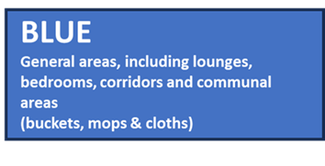
Functional Area: Entrance and Reception.
Staff Initials: Date:

Standard: The area is visibly clean with no dust, dirt, debris, or malodour. All parts of the door structure are visibly clean and free of finger marks and adhesive tape. External ventilation grills are free of dust and cobwebs. Hard surfaces are free from stains and spillages. All signage is to company standard and fixed to the wall. Visitor book and pens are neatly arranged. The floor is visibly clean with no dirt, litter, spillages, or scuff marks. The entrance mat is minimum 1square meter and rubber backed.
This functional area is medium risk. If found dirty it must be cleaned within 3 hours.

Routine: | Daily | Weekly | Quarterly or as required | Deep clean | Comments
- Damp dust exterior door frame, handles and kick plates. | Check Mark Tick · Free vector graphic on Pixabay by Unknown Author |  |  | Check Mark Tick · Free vector graphic on Pixabay by Unknown Author
- Spot wipe glass. | Check Mark Tick · Free vector graphic on Pixabay by Unknown Author |  |  | Check Mark Tick · Free vector graphic on Pixabay by Unknown Author
- Damp dust ceiling, vents, and lighting. |  | Check Mark Tick · Free vector graphic on Pixabay by Unknown Author |  | Check Mark Tick · Free vector graphic on Pixabay by Unknown Author
- Wipe walls, skirting boards, ventilation grills. |  |  | Check Mark Tick · Free vector graphic on Pixabay by Unknown Author | Check Mark Tick · Free vector graphic on Pixabay by Unknown Author
- Steam clean, soft furnishings and blinds. |  |  | Check Mark Tick · Free vector graphic on Pixabay by Unknown Author | Check Mark Tick · Free vector graphic on Pixabay by Unknown Author
- Damp dust fixtures and fittings. Shelves and notices. |  | Check Mark Tick · Free vector graphic on Pixabay by Unknown Author |  | Check Mark Tick · Free vector graphic on Pixabay by Unknown Author
- Damp dust electrical equipment and screens. |  | Check Mark Tick · Free vector graphic on Pixabay by Unknown Author |  | Check Mark Tick · Free vector graphic on Pixabay by Unknown Author
- Damp dust hard surfaces and furniture. | Check Mark Tick · Free vector graphic on Pixabay by Unknown Author |  |  | Check Mark Tick · Free vector graphic on Pixabay by Unknown Author
- Wipe and arrange stationary, sign in book. | Check Mark Tick · Free vector graphic on Pixabay by Unknown Author |  |  | Check Mark Tick · Free vector graphic on Pixabay by Unknown Author
- Hoover/brush and mop floor. | Check Mark Tick · Free vector graphic on Pixabay by Unknown Author |  |  | Check Mark Tick · Free vector graphic on Pixabay by Unknown Author
- For carpeted areas, clean with carpet cleaner. |  |  | Check Mark Tick · Free vector graphic on Pixabay by Unknown Author | Check Mark Tick · Free vector graphic on Pixabay by Unknown Author

Functional Area: Storage and Staff Rooms
Staff Initials: Date:

Standard: The area is visibly clean with no dust, dirt, debris, or malodour. Colleague’s personal items are stored neatly. The area is free from clutter and unused equipment. Information notices should be wipeable and fixed to the wall (laminated or in a covered notice board).
This functional area is low risk - If found dirty it must be cleaned within 48 hours.

Routine: | Daily | Weekly | Quarterly or as required | Deep clean | Comments
- Separate waste for recycling and empty waste bin. | Check Mark Tick · Free vector graphic on Pixabay by Unknown Author |  |  | Check Mark Tick · Free vector graphic on Pixabay by Unknown Author
- Damp dust ceiling, air extraction vents and lighting. |  |  | Check Mark Tick · Free vector graphic on Pixabay by Unknown Author | Check Mark Tick · Free vector graphic on Pixabay by Unknown Author
- Wipe walls and window frames and ledges. |  |  | Check Mark Tick · Free vector graphic on Pixabay by Unknown Author | Check Mark Tick · Free vector graphic on Pixabay by Unknown Author
- Damp wipe fixtures and fittings. |  | Check Mark Tick · Free vector graphic on Pixabay by Unknown Author |  | Check Mark Tick · Free vector graphic on Pixabay by Unknown Author
- Clean and replenish consumable item dispensers. |  | Check Mark Tick · Free vector graphic on Pixabay by Unknown Author |  | Check Mark Tick · Free vector graphic on Pixabay by Unknown Author
- Clean sink and surrounding hard surface area. | Check Mark Tick · Free vector graphic on Pixabay by Unknown Author |  |  | Check Mark Tick · Free vector graphic on Pixabay by Unknown Author
- Vacuum and/ or mop floor. | Check Mark Tick · Free vector graphic on Pixabay by Unknown Author |  |  | Check Mark Tick · Free vector graphic on Pixabay by Unknown Author
- Wipe door handles and push plates. | Check Mark Tick · Free vector graphic on Pixabay by Unknown Author |  |  | Check Mark Tick · Free vector graphic on Pixabay by Unknown Author

Standards are also important in staff only areas. These are high traffic areas for staff working in the setting. Cleanliness is important to minimise contamination and the spread of infection.
All paper, cardboard, empty cans, bottles, and mixed material waste must be separated into the mixed recycling sack and disposed of in the recycling bin.
Functional Area: Corridors, Lifts and Stairs.
Staff Initials: Date:

Standard: The area is visibly clean with no dust, dirt, debris, or malodour. All parts of the door structures and partitions are visibly clean and free of adhesive tape. External ventilation grills are free of dust and cobwebs. Hard surfaces are free from stains and spillages. Lift surfaces are free from dirt, stains, and finger marks. All signage is wipeable and fixed to the wall (laminated or in a covered notice board). The complete floor including the edges, corners and main spaces are visibly clean with no dirt, litter, spillages, or scuff marks. No equipment is stored in corridor or stair wells with the exception of evacuation equipment. Hand sanitising gel dispensers are clean and refilled. This function area is medium risk. If found dirty it must be cleaned within 3 hours.
This function area is medium risk - If found dirty it must be cleaned within 3 hours.

Routine: | Daily | Weekly | Quarterly or as required | Deep clean | Comments
- Damp dust ceiling, vents, and lighting. |  |  | Check Mark Tick · Free vector graphic on Pixabay by Unknown Author | Check Mark Tick · Free vector graphic on Pixabay by Unknown Author
- Wipe walls, skirting boards, ventilation, and radiators. |  |  | Check Mark Tick · Free vector graphic on Pixabay by Unknown Author | Check Mark Tick · Free vector graphic on Pixabay by Unknown Author
- Steam clean, soft furnishings and blinds. |  |  | Check Mark Tick · Free vector graphic on Pixabay by Unknown Author | Check Mark Tick · Free vector graphic on Pixabay by Unknown Author
- Damp dust doors, window frames and kick plates. |  | Check Mark Tick · Free vector graphic on Pixabay by Unknown Author |  | Check Mark Tick · Free vector graphic on Pixabay by Unknown Author
- Damp dust fixtures, fittings, and information notices. |  | Check Mark Tick · Free vector graphic on Pixabay by Unknown Author |  | Check Mark Tick · Free vector graphic on Pixabay by Unknown Author
- Damp dust electrical equipment, sockets, and screens. |  | Check Mark Tick · Free vector graphic on Pixabay by Unknown Author |  | Check Mark Tick · Free vector graphic on Pixabay by Unknown Author
- Clean personal care equipment. |  | Check Mark Tick · Free vector graphic on Pixabay by Unknown Author |  | Check Mark Tick · Free vector graphic on Pixabay by Unknown Author
- Spot wipe glass and stainless steel. | Check Mark Tick · Free vector graphic on Pixabay by Unknown Author |  |  | Check Mark Tick · Free vector graphic on Pixabay by Unknown Author
- Damp dust door handles, push plates and handrails. | Check Mark Tick · Free vector graphic on Pixabay by Unknown Author |  |  | Check Mark Tick · Free vector graphic on Pixabay by Unknown Author
- Damp dust hard surfaces and furniture. | Check Mark Tick · Free vector graphic on Pixabay by Unknown Author |  |  | Check Mark Tick · Free vector graphic on Pixabay by Unknown Author
- Vacuum and /or mop floor. | Check Mark Tick · Free vector graphic on Pixabay by Unknown Author |  |  | Check Mark Tick · Free vector graphic on Pixabay by Unknown Author
- For Carpeted areas, clean carpet with carpet cleaner |  |  | Check Mark Tick · Free vector graphic on Pixabay by Unknown Author

Spot clean high traffic areas twice daily.
Check Mark Tick · Free vector graphic on Pixabay by Unknown Author

Notes/Comment.

Routine: | Daily | Weekly | Quarterly or as required | Deep clean | Comments
1. Remove waste and clean bin | Check Mark Tick · Free vector graphic on Pixabay by Unknown Author |  |  | Check Mark Tick · Free vector graphic on Pixabay by Unknown Author
2. Wash dirty crockery and glass wear | Check Mark Tick · Free vector graphic on Pixabay by Unknown Author |  |  | Check Mark Tick · Free vector graphic on Pixabay by Unknown Author
3. Damp dust ceiling and lighting |  |  | Check Mark Tick · Free vector graphic on Pixabay by Unknown Author | Check Mark Tick · Free vector graphic on Pixabay by Unknown Author
4. Wipe walls, skirting boards, and ventilation grills |  |  | Check Mark Tick · Free vector graphic on Pixabay by Unknown Author | Check Mark Tick · Free vector graphic on Pixabay by Unknown Author
5. Damp dust fixtures and fittings. Cupboards and Shelving |  |  | Check Mark Tick · Free vector graphic on Pixabay by Unknown Author | Check Mark Tick · Free vector graphic on Pixabay by Unknown Author
6. Clean dishwasher, microwave, and fridges |  | Check Mark Tick · Free vector graphic on Pixabay by Unknown Author |  | Check Mark Tick · Free vector graphic on Pixabay by Unknown Author
7. Clean food and drink dispensers, kettles, toaster, and microwave. | Check Mark Tick · Free vector graphic on Pixabay by Unknown Author |  |  | Check Mark Tick · Free vector graphic on Pixabay by Unknown Author
8.Clean sink, drainer, and surrounding splashbacks | Check Mark Tick · Free vector graphic on Pixabay by Unknown Author |  |  | Check Mark Tick · Free vector graphic on Pixabay by Unknown Author
9.Clean food preparation surfaces. *2 stage cleaning process | Check Mark Tick · Free vector graphic on Pixabay by Unknown Author |  |  | Check Mark Tick · Free vector graphic on Pixabay by Unknown Author
10.Hoover and mop floor | Check Mark Tick · Free vector graphic on Pixabay by Unknown Author |  |  | Check Mark Tick · Free vector graphic on Pixabay by Unknown Author
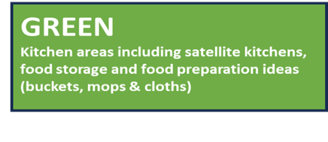
Functional Area: Food and Beverage Service Areas.
Staff Initials: Date:

Standard: All surfaces including undersides and rims are visibly clean with no dust, dirt, debris, spillages, or food debris. There is no build-up of greasy deposits or burnt food stuffs. Utensils, shelving, cupboards, and equipment is visibly clean with no food debris or stains.
This functional area is medium risk - If found dirty it must be cleaned within 3 hours.
Cleaned between uses.
Check Mark Tick · Free vector graphic on Pixabay by Unknown Author
Routine: | Daily | Weekly | Quarterly or as required | Deep clean | Comments
- Remove used crockery and clutter. | Check Mark Tick · Free vector graphic on Pixabay by Unknown Author |  |  | Check Mark Tick · Free vector graphic on Pixabay by Unknown Author
- Damp dust ceiling and lighting. |  |  | Check Mark Tick · Free vector graphic on Pixabay by Unknown Author | Check Mark Tick · Free vector graphic on Pixabay by Unknown Author
- Wipe walls and skirting boards and vents. |  |  | Check Mark Tick · Free vector graphic on Pixabay by Unknown Author | Check Mark Tick · Free vector graphic on Pixabay by Unknown Author
- Steam clean, soft furnishings and fabrics. |  |  | Check Mark Tick · Free vector graphic on Pixabay by Unknown Author | Check Mark Tick · Free vector graphic on Pixabay by Unknown Author
- Spot wipe windows and wipe curtain rails |  | Check Mark Tick · Free vector graphic on Pixabay by Unknown Author |  | Check Mark Tick · Free vector graphic on Pixabay by Unknown Author
- Damp dust fixtures and fittings. |  | Check Mark Tick · Free vector graphic on Pixabay by Unknown Author |  | Check Mark Tick · Free vector graphic on Pixabay by Unknown Author
- Wipe and arrange ornaments. |  | Check Mark Tick · Free vector graphic on Pixabay by Unknown Author |  | Check Mark Tick · Free vector graphic on Pixabay by Unknown Author
- Damp dust hard surfaces and furniture | Check Mark Tick · Free vector graphic on Pixabay by Unknown Author |  |  | Check Mark Tick · Free vector graphic on Pixabay by Unknown Author
- Vacuum and/or mop floor | Check Mark Tick · Free vector graphic on Pixabay by Unknown Author |  |  | Check Mark Tick · Free vector graphic on Pixabay by Unknown Author
- Reposition furniture and set tables | Check Mark Tick · Free vector graphic on Pixabay by Unknown Author |  |  | Check Mark Tick · Free vector graphic on Pixabay by Unknown Author
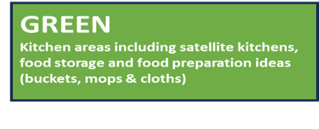
Functional Area: Dining Rooms and Café.
Staff Initials: Date:

Standard: The area is visibly clean with no dust, dirt, debris, or malodour. All parts of the furniture, including chair sliders, wheels and the underside are visibly clean with no dirt, bodily fluids, stains, or food debris. The complete floor including all edges, corners and main space is visibly clean with no stains or watermarks. The area is replenished and set for use by service users and visitors.
This function area is medium risk - If found dirty it must be cleaned within 3 hours.
Clean dining room and café in between busy mealtimes. Remove food debris from crevices of chairs. Wipe hand contact points between mealtimes.
Functional Area: Medicine/ Treatment Room.
Staff Initials: Date:

Standard: The area is visibly clean with no dust, dirt, debris, blood, body spillages, stains, or smears. All parts of the medicine trolley, including underneath and inside is visibly clean with no blood and bodily fluids, dust, dirt, debris, or spillages. Consumable items such as paper towels, gloves (size S, M & L should be available) and soap are replenished. The area is free from clutter and unused equipment. Information notices are wipeable and fixed to wall (laminated or in a covered notice board). - Medication and documentation are put away prior to cleaning.
This function area is medium risk - If found dirty it must be cleaned within 3 hours.

Routine: | Daily | Weekly | Quarterly or as required | Deep clean | Comments
- Empty waste bin and clean bin frame. | Check Mark Tick · Free vector graphic on Pixabay by Unknown Author |  |  | Check Mark Tick · Free vector graphic on Pixabay by Unknown Author
- Damp dust ceiling, air extraction vents and lighting. |  |  | Check Mark Tick · Free vector graphic on Pixabay by Unknown Author | Check Mark Tick · Free vector graphic on Pixabay by Unknown Author
- Wipe walls, skirting boards, and ledges. |  |  | Check Mark Tick · Free vector graphic on Pixabay by Unknown Author | Check Mark Tick · Free vector graphic on Pixabay by Unknown Author
- Damp wipe fixtures, fittings, cupboards, and medicine trolleys. |  | Check Mark Tick · Free vector graphic on Pixabay by Unknown Author |  | Check Mark Tick · Free vector graphic on Pixabay by Unknown Author
- Damp wipe loose equipment and cabinets and telephone |  | Check Mark Tick · Free vector graphic on Pixabay by Unknown Author |  | Check Mark Tick · Free vector graphic on Pixabay by Unknown Author
- Clean sink and surrounding hard surfaces. | Check Mark Tick · Free vector graphic on Pixabay by Unknown Author
- Clean and replenish dispensers. | Check Mark Tick · Free vector graphic on Pixabay by Unknown Author |  |  | Check Mark Tick · Free vector graphic on Pixabay by Unknown Author
- Hoover and mop floor. | Check Mark Tick · Free vector graphic on Pixabay by Unknown Author |  |  | Check Mark Tick · Free vector graphic on Pixabay by Unknown Author
- Wipe door handles and push plates. | Check Mark Tick · Free vector graphic on Pixabay by Unknown Author |  |  | Check Mark Tick · Free vector graphic on Pixabay by Unknown Author

Housekeepers must ensure that medication and documentation are put away before the cleaning routine begins. The treatment room must be locked after the cleaning routine. Housekeepers must be trained to remove bodily fluid spillages.
Clinical waste bags (yellow) must be removed when ¾ full by someone who has had clinical waste training.
Functional Area: Personal Care and Clinical Equipment.
Staff Initials: Date:

Standard: The item is visibly clean with no dust, dirt, rust, stains, or smears.
Personal care equipment has a high-risk. It must be wiped in-between uses. If found dirty it must be cleaned immediately.

Routine: | Daily | Weekly | Quarterly or as required | Deep clean | Comments
- Commodes (RED) | Check Mark Tick · Free vector graphic on Pixabay by Unknown Author | Check Mark Tick · Free vector graphic on Pixabay by Unknown Author
- Mobility hoists and stand aids | Check Mark Tick · Free vector graphic on Pixabay by Unknown Author | Check Mark Tick · Free vector graphic on Pixabay by Unknown Author
- Walking aids and wheelchairs |  | Check Mark Tick · Free vector graphic on Pixabay by Unknown Author
- Trolleys |  | Check Mark Tick · Free vector graphic on Pixabay by Unknown Author
- Drip stands |  | Check Mark Tick · Free vector graphic on Pixabay by Unknown Author
- Bath hoists and shower chairs | Check Mark Tick · Free vector graphic on Pixabay by Unknown Author | Check Mark Tick · Free vector graphic on Pixabay by Unknown Author
- Seated weighing scales | Check Mark Tick · Free vector graphic on Pixabay by Unknown Author | Check Mark Tick · Free vector graphic on Pixabay by Unknown Author
- Wash bowls | Check Mark Tick · Free vector graphic on Pixabay by Unknown Author
- Pressure mattresses and cushions | Check Mark Tick · Free vector graphic on Pixabay by Unknown Author
- Non disposable slings | Check Mark Tick · Free vector graphic on Pixabay by Unknown Author
- Cleaning record signed and dated | Check Mark Tick · Free vector graphic on Pixabay by Unknown Author
Wipe Contact surfaces with disinfectant wipes between uses.
Check Mark Tick · Free vector graphic on Pixabay by Unknown Author

- All crockery, cutlery and food service utensils must be washed in a sterilising dish washing machine.

- Glasses and tumblers can be washed by hand following the hand dish washing method. *Follow 2 Stage Terminal Disinfection Procedure.

- All paper, cardboard, empty cans, bottles, and mixed materials waste must be separated into the mixed recycling sack and disposed of in recycling bin.

- Clinical waste bags should be taken to the clinical waste external bin when ¾'s full.

Useful Links / Reference
- https://www.england.nhs.uk/national-infection-prevention-and-control-manual-nipcm-for-england/

- COSHH and cleaners - key messages - COSHH (hse.gov.uk)

- Infection prevention and control - Lancashire County Council

- Health and Social Care Act 2008: code of practice on the prevention and control of infections - GOV.UK (www.gov.uk)

- Infection prevention and control in adult social care: acute respiratory infection - GOV.UK (www.gov.uk)

- Care Quality Commission (cqc.org.uk)

- Cleaning effectively in your business | Food Standards Agency

- https://infectionpreventioncontrol.co.uk/wp-content/uploads/2019/07/03-Decontamination-cleaning-and-disinfection-March-2016-Version-2.00.pdf

- https://www.england.nhs.uk/wp-content/uploads/2021/04/B0271-national-standards-of-healthcare-cleanliness-2021.pdf

- https://www.england.nhs.uk/wp-content/uploads/2021/04/B0271-national-standards-of-healthcare-cleanliness-2021.pdf

Other documents available in our IPC cleaning schedules are –
(1) IPC Terminal Decontamination Procedure - deep clean
(2) IPC Touchpoint cleaning.
(3) IPC Resident room cleaning checklist).

