Job Description

Senior Commissioning Manager

Directorate: | Education and Children's Services
Service: | Children and Families Commissioning
Location: | Preston
Salary range: | £55,612 - £60,147 | Grade: | 12
Reports to: | Head of Service: Children and Families Commissioning | Staff responsible for: | Line management of staff supporting commissioning activity as appropriate

Job purpose and scope
This role will lead the development and delivery of commissioning plans for education, health and care, ensuring services are outcome focused, financially sustainable and responsive to local need.
A significant element of the role includes commissioning for children and young people with special educational needs and disabilities (SEND). In this context, the postholder will work with partners across the Lancashire SEND Partnership, contributing to relevant inclusion activity and the delivery of the Council’s wider service improvement priorities.

Performance Indicators
- Quality of advice/service against legal, safety and best practice standards
- Achievement of relevant service targets
- Adherence to internal/external quality standards
- Adherence to policies and procedures
- Accuracy and timeliness of information recording and processing
- Customer and stakeholder feedback
- Leading Lancashire Framework

Leading Lancashire – Our Leadership Framework
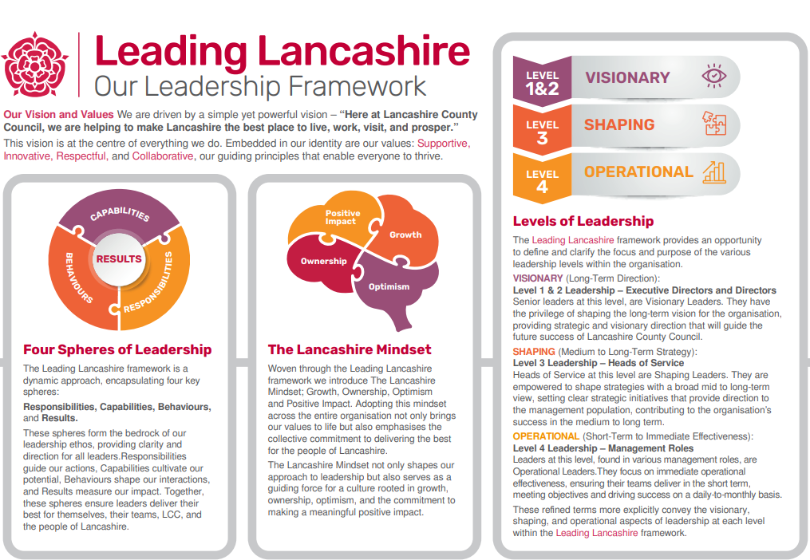

Accountabilities/Responsibilities
- Lead the development and delivery of commissioning strategies and plans across priority service portfolios, including complex statutory services for children and young people, ensuring alignment with relevant legislation, policy and best practice.
- Provide proactive, expert commissioning advice to shape service design and delivery, both internally and with partners, influencing decisions that improve outcomes and deliver value for money.
- Ensure commissioned services are informed by robust data, performance insight and feedback from children, young people and families, working with appropriate participation networks and representative forums.
- Assess the effectiveness of current services and develop evidence based recommendations for system wide improvement, influencing decision making within the Council and across partnership arrangements.
- Provide senior oversight of commissioned services, including SEND requirements such as the SEND Local Offer for Lancashire.
- Foster professional networks throughout Lancashire, South Cumbria, and the region, leveraging these connections to guide strategic planning and delivery, and to promote collaborative partnerships.
- Develop and endorse a culture of ongoing professional growth for staff at all levels, ensuring a commitment to excellence and development.

Other
- Equal Opportunities
We are committed to achieving equal opportunities in the way we deliver services to the community and in our employment arrangements. We expect all employees to understand and promote this policy in their work.

- Health and safety
All employees have a responsibility for their own health and safety and that of others when carrying out their duties and must help us to apply our general statement of health and safety policy.

- Customer Focused
We put our customers' needs and expectations at the heart of all that we do. We expect our employees to have a full understanding of those needs and expectations so that we can provide high quality, appropriate services at all times.

- Safeguarding Commitment
We are committed to protecting and promoting the welfare of children, young people and vulnerable adults.

- Skills Pledge
We are committed to developing the skills of our workforce. All employees will be supported to work towards a level 2 qualification in literacy and numeracy if they do not have one already.

Our Values
We expect all our employees to demonstrate and promote our values:

- Supportive
We are supportive of our customers and colleagues, recognising their contributions and making the best of their strengths to enable our communities to flourish.

- Innovative
We deliver the best services we possibly can, always looking for creative ways to do things better, putting the customer at the heart of our thinking, and being ambitious and focused on how we can deliver the best services now and in the future.

- Respectful
We treat colleagues, customers and partners with respect, listening to their views, empathising and valuing their diverse needs and perspectives, to be fair, open and honest in all that we do.

- Collaborative
We listen to, engage with, learn from and work with colleagues, partners and customers to help achieve the best outcomes for everyone.

Person Specification

All the following requirements are essential unless otherwise indicated by *

Your ability to meet the job requirements will initially be assessed by the information provided on your application but further assessment will be undertaken at interview and, in some cases, by using other types of assessment(s).

Qualifications
- Honours Degree level qualification or equivalent, or equivalent substantial vocational experience in a complex commissioning environment
- A commitment to continuing professional development.
Experience
- Extensive experience in commissioning at scale within local government or healthcare contexts, including services for children and young people.
- Broad experience in cross-departmental and partnership working, overseeing commissioning processes, service transformation, and delivery across organisational boundaries.
- Proven success in strategic and policy development in a local government or health context, leading to enhanced outcomes for people with additional needs.
- Experience of using innovative and creative approaches to improve outcomes, within a changing and challenging financial environment.
- A strong track record of market shaping, market oversight and contingency planning to support service sustainability.
- A strong track record of stakeholder engagement and fostering effective partnerships across public, community and independent sectors.

Essential knowledge, skills & abilities
- Excellent communication and interpersonal skills, capable of engaging with stakeholders, parents, and young people effectively.
- Strong understanding of the statutory and policy framework for children's services, including SEND.
- Understanding of current challenges and developments within the SEND landscape, and their relationship to county council objectives.
- Strong analytical and problem-solving abilities to assess complex needs and commission appropriate services
- Ability to use sound judgement to lead the design and delivery of plans to resolve service issues and improve performance, using creative thinking and robust risk assessment.
- Effective Leadership and Management at a senior level of a diverse workforce to support excellence in service delivery.
- Good understanding of the political context at regional and local level and working with Elected Members in a constructive and sensitive way.
- Successful financial management including prioritisation within decreasing resources.
- Proven leadership and management skills, with the ability to influence, motivate and support multidisciplinary teams and partners.
- Ability to quickly build credibility with senior managers and stakeholders.

Other essential requirements
- Commitment to equality and diversity.
- Commitment to health and safety.
- Display the LCC values and behaviours at all times and actively promote them in others.
- This is an essential car user post
You will be required to provide a car for use in connection with the duties of this post and must be insured for business use. In certain circumstances consideration may be given to applicants who, as a consequence of a disability, are unable to drive

