Job Description

Directorate: | Resources
Service: | Data and Analytics
Location: | County Hall, Preston
Salary range: |  | Grade: | 12
Reports to: | Head of Data and Analytics | Staff responsible for: | TBC

Job purpose and scope
Lancashire County Council is shaping a transformational approach to data and intelligence to ensure organisational decision-making is informed by strategic insight that drives better outcomes for residents.

The postholder will operate as a Strategic Data Partner, acting as the primary conduit between senior service leaders and the central Data & Analytics function. The role exists to provide high-quality insight, analysis and intelligence that supports strategic decision-making, service transformation and performance improvement.

The postholder will shape intelligence requirements, translate organisational and service priorities into actionable analytical work, present insights to senior leaders, and act as a trusted advisor on data, performance and evidence-based decision-making.

Performance Indicators
- Quality of advice/service against legal, safety and best practice standards
- Achievement of relevant service targets
- Adherence to internal/external quality standards if applicable
- Adherence to policies and procedures
- Accuracy and timeliness of information recording and processing
- Customer and stakeholder feedback
- Leading Lancashire Framework

Leading Lancashire – Our Leadership Framework
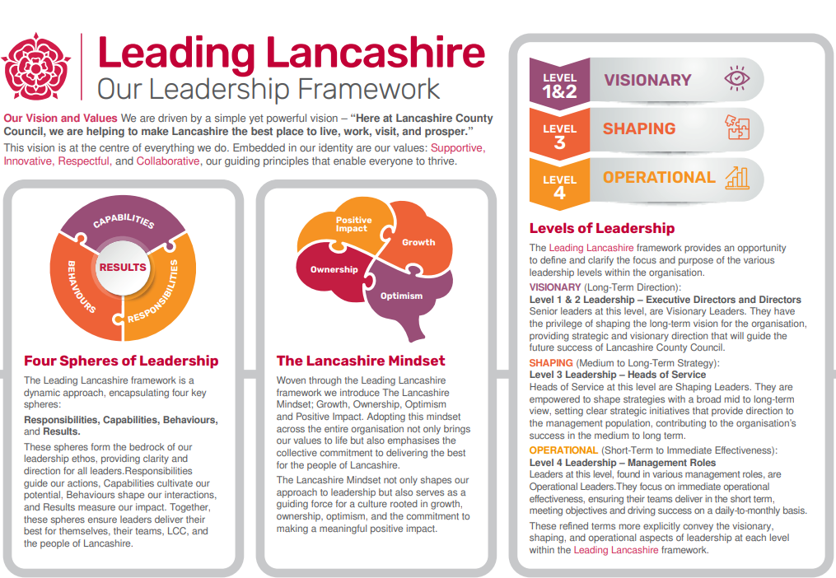

Accountabilities/Responsibilities
Strategic Insight & Partnering
- Build strong, trusted relationships with senior leaders, acting as a strategic advisor on data, insight and performance.
- Work collaboratively with services to clarify emerging or ambiguous requirements and convert them into well-defined analytical questions.
- Identify opportunities for innovation, efficiency and improved outcomes through data-led thinking.
- Present complex analysis and insight to non-technical audiences in a clear, accessible and actionable way.

Performance Management and Improvement
- Provide monitoring, analysis and insight on key performance indicators aligned to the Corporate Performance Management Framework.
- Deliver benchmarking and trend analysis using national, regional and local datasets.
- Operate as a critical friend, offering constructive challenge to drive continuous improvement and better decision-making.

Data Products, Reporting and Analytical Delivery
- Shape service-level reporting requirements and lead the development of high-quality dashboards, datasets and analytical products.
- Create reusable, high-value insight assets that support consistency and scalability across the organisation.
- Ensure insight is timely, robust and aligned with organisational priorities.
- Support the adoption of automation and improved analytical processes where appropriate.

Governance, Standards and Responsible Data Use
- Promote responsible, secure and compliant use of data within services.
- Apply organisational data standards, policies and quality assurance processes to all insight products.
- Support services to understand data quality issues and their impact on analysis and decision-making.
- Champion data literacy and evidence-based practice across the organisation.

Organisational Data Culture and Literacy
- Contribute actively to the intelligence and data community of practice, sharing learning and best practice.
- Identify synergies and opportunities to streamline reporting and insight across services.
- Support and lead change initiatives that embed insight into everyday decision-making.
- Work closely with the central Data & Analytics team to ensure service needs inform wider data product development.

Other
- Equal Opportunities
We are committed to achieving equal opportunities in the way we deliver services to the community and in our employment arrangements. We expect all employees to understand and promote this policy in their work.

- Health and safety
All employees have a responsibility for their own health and safety and that of others when carrying out their duties and must help us to apply our general statement of health and safety policy.

- Customer Focused
We put our customers' needs and expectations at the heart of all that we do. We expect our employees to have a full understanding of those needs and expectations so that we can provide high quality, appropriate services at all times.

- Safeguarding Commitment
We are committed to protecting and promoting the welfare of children, young people and vulnerable adults.

- Skills Pledge
We are committed to developing the skills of our workforce. All employees will be supported to work towards a level 2 qualification in literacy and numeracy if they do not have one already.

Our Values
We expect all our employees to demonstrate and promote our values:

- Supportive
We are supportive of our customers and colleagues, recognising their contributions and making the best of their strengths to enable our communities to flourish.

- Innovative
We deliver the best services we possibly can, always looking for creative ways to do things better, putting the customer at the heart of our thinking, and being ambitious and focused on how we can deliver the best services now and in the future.

- Respectful
We treat colleagues, customers and partners with respect, listening to their views, empathising and valuing their diverse needs and perspectives, to be fair, open and honest in all that we do.

- Collaborative
We listen to, engage with, learn from and work with colleagues, partners and customers to help achieve the best outcomes for everyone.

Person Specification

All the following requirements are essential unless otherwise indicated by *

Your ability to meet the job requirements will initially be assessed by the information provided on your application but further assessment will be undertaken at interview and, in some cases, by using other types of assessment(s).

Qualifications
- Degree-level qualification (or equivalent professional experience) in data, analytics, social research, statistics, information management or a related field.
Experience
- Significant experience providing strategic insight, intelligence or analytical support to senior leaders.
- Experience working in complex organisations, ideally within local government or the public sector.
- Proven experience of performance management, benchmarking and trend analysis.
- Demonstrable experience developing dashboards and analytical products using business intelligence tools (e.g. Power BI).
- Experience presenting complex analysis to non‑technical audiences.

Essential knowledge, skills & abilities
- Advanced analytical and business intelligence capability, including data manipulation, modelling, visualisation and interpretation.
- Strong understanding of performance frameworks and outcome‑based measurement.
- Ability to translate complex organisational priorities into clear, actionable analytical outputs.
- Excellent communication and influencing skills, with strong political awareness.
- Knowledge of data governance principles and the importance of data quality.
- Proactive, solution‑focused approach with the ability to identify new lines of enquiry.
- Ability to manage competing priorities and deliver at pace in a dynamic environment.
- Strong interpersonal skills and ability to build trusted partnerships.

Other essential requirements
- Commitment to equality and diversity.
- Commitment to health and safety.
- Display the LCC values and behaviours at all times and actively promote them in others.
- This is an essential car user post
You will be required to provide a car for use in connection with the duties of this post and must be insured for business use. In certain circumstances consideration may be given to applicants who, as a consequence of a disability, are unable to drive

