Job Description

Directorate: | Place
Service: | External Affairs
Location: | Preston/Hybrid
Salary range: | SCP 61-66 | Grade: | 14
Reports to: | Director of Communities and Engagement | Staff responsible for: | -

Job purpose and scope
- The Head of External Affairs is responsible for leading Lancashire County Council’s external positioning, influence and reputation with partners, stakeholders, media and opinion formers at local, regional, national and international level.

- The postholder will provide strategic leadership on how the Council engages externally to advance its priorities—shaping the Council’s external narrative and reputation management—and ensuring Lancashire has a clear, confident and credible voice in key policy, funding and place shaping conversations.

- Operating at senior leadership level, the role will advise elected members, the Chief Executive and Executive Leadership Team, ensuring that external engagement is co ordinated, purposeful and focused on impact, rather than reactive or fragmented.

Performance Indicators
- Quality of advice/service against legal, safety and best practice standards
- Achievement of relevant service targets
- Adherence to internal/external quality standards if applicable
- Adherence to policies and procedures
- Accuracy and timeliness of information recording and processing
- Customer and stakeholder feedback
- Leading Lancashire Framework

Leading Lancashire – Our Leadership Framework
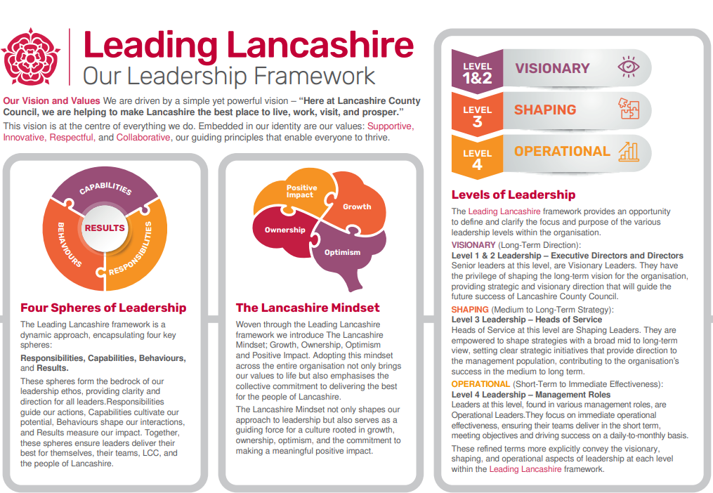

Accountabilities/Responsibilities
- Strategic leadership of external affairs

- Lead the development and delivery of an external affairs strategy aligned to the Council Plan, Place priorities and major reform agendas (e.g. devolution, system change, public service reform).
- Act as the Council’s senior professional lead on external influence, positioning and reputation management.
- Ensure the Council is clear about where it needs to show up, with whom, and to what end—prioritising activity that delivers tangible benefit for Lancashire.

- Reputation, profile and strategic narrative

- Own the Council’s external narrative, ensuring consistent, credible messaging about Lancashire’s priorities, achievements and ambitions.
- Work closely with communications colleagues to align stakeholder engagement, media, events and place activity behind a single strategic story.
- Lead on sensitive or high profile external issues, ensuring appropriate handling, escalation and reassurance where required.
- Protect and enhance the Council’s reputation through foresight, risk management and proactive engagement.

- Senior advice and political engagement

- Act as a trusted adviser to elected members, the Chief Executive and Executive Leadership Team on external affairs and stakeholder dynamics.
- Provide high quality briefings, insight and horizon scanning to inform decision making and risk management.
- Support leaders in high level external engagement, including meetings, events, visits and national forums.

- Leadership, governance and performance

- Lead and develop the External Affairs function, setting clear priorities, standards and ways of working.
- Ensure strong governance, ethical standards and transparency in external engagement and engagement activity.
- Oversee performance, evaluation and reporting to demonstrate the impact and value of external affairs activity.
- Manage budgets and resources effectively, ensuring value for money.

Other
- Equal Opportunities
We are committed to achieving equal opportunities in the way we deliver services to the community and in our employment arrangements. We expect all employees to understand and promote this policy in their work.

- Health and safety
All employees have a responsibility for their own health and safety and that of others when carrying out their duties and must help us to apply our general statement of health and safety policy.

- Customer Focused
We put our customers' needs and expectations at the heart of all that we do. We expect our employees to have a full understanding of those needs and expectations so that we can provide high quality, appropriate services at all times.

- Safeguarding Commitment
We are committed to protecting and promoting the welfare of children, young people and vulnerable adults.

- Skills Pledge
We are committed to developing the skills of our workforce. All employees will be supported to work towards a level 2 qualification in literacy and numeracy if they do not have one already.

Our Values
We expect all our employees to demonstrate and promote our values:

- Supportive
We are supportive of our customers and colleagues, recognising their contributions and making the best of their strengths to enable our communities to flourish.

- Innovative
We deliver the best services we possibly can, always looking for creative ways to do things better, putting the customer at the heart of our thinking, and being ambitious and focused on how we can deliver the best services now and in the future.

- Respectful
We treat colleagues, customers and partners with respect, listening to their views, empathising and valuing their diverse needs and perspectives, to be fair, open and honest in all that we do.

- Collaborative
We listen to, engage with, learn from and work with colleagues, partners and customers to help achieve the best outcomes for everyone.

Person Specification

All the following requirements are essential unless otherwise indicated by *

Your ability to meet the job requirements will initially be assessed by the information provided on your application but further assessment will be undertaken at interview and, in some cases, by using other types of assessment(s).

Qualifications
- Honours Degree level qualification or equivalent experience

- Relevant professional qualification or equivalent
Experience
- Significant senior leadership experience in external affairs, public affairs, communications, policy or place leadership, ideally within local government or a comparable complex organisation.
- Proven track record of influencing at national or regional level, including engagement with system leaders and demonstrable stakeholder management experience.
- Experience of advising senior executive leaders in high pressure, high profile contexts with evidence of influencing decisions, managing risk and protecting organisational reputation.
- Demonstrable experience of reputation management and handling complex external issues with evidence of sound judgement and risk mitigation.
- Experience of place based leadership, devolution or combined authority environments.*
- Experience working across media, public affairs and partnership landscapes.*

Essential knowledge, skills & abilities
- Deep understanding of the political, policy and public sector landscape, including how decisions are shaped and influenced.
- Strong strategic thinking and the ability to translate organisational priorities into effective external positioning.
- Excellent judgement, diplomacy and relationship building skills.
- Highly developed written and verbal communication skills.
- Strong leadership capability, with experience of leading senior teams and complex portfolios.
- Credible, authoritative and politically astute.
- Calm under pressure, with strong ethical judgement.
- Collaborative and system minded, able to work across organisational boundaries.
- Outcome focused, with a clear sense of public value.
- Understanding of local government reform and system change agendas.*

Other essential requirements
- Commitment to equality and diversity.
- Commitment to health and safety.
- Display the LCC values and behaviours at all times and actively promote them in others.
- This is an essential car user post
You will be required to provide a car for use in connection with the duties of this post and must be insured for business use. In certain circumstances consideration may be given to applicants who, as a consequence of a disability, are unable to drive

