Job Description

Directorate: | Highways & Transport
Service: | Accessible Transport
Location: | Bamber Bridge
Salary range: | £55,612 to £60,147 | Grade: | 12
Reports to: | Head of Accessible Transport | Staff responsible for: | 1000+  Up to 8 Direct Reports

Job purpose and scope
- To Lead the Accessible Transport team in the supply of commissioned Home to School Transport for children with Special Needs and Disabilities and Adults to Day Service provision, additionally fulfil Dial-a-Ride services in relevant districts.
- To ensure service users meet the appropriate eligibility criteria and that transport assistance solutions are provided in a safe, proportionate and efficient manner.
- Serving over 6000 passengers daily the Accessible Transport fulfils a statutory role in providing transport services. The post holder will ensure that all relevant rules and legislation associated with passenger transport services in a local government environment in an efficient and productive manner.
- The team consists of over 1000 employees in both managerial and frontline roles. It operated around 250 minibuses in its internal fleet and holds around 2000 contracts with external suppliers

Performance Indicators
- Quality of advice/service against legal, safety and best practice standards
- Achievement of relevant service targets
- Adherence to internal/external quality standards if applicable
- Adherence to policies and procedures
- Accuracy and timeliness of information recording and processing
- Customer and stakeholder feedback
- Leading Lancashire Framework

Leading Lancashire – Our Leadership Framework
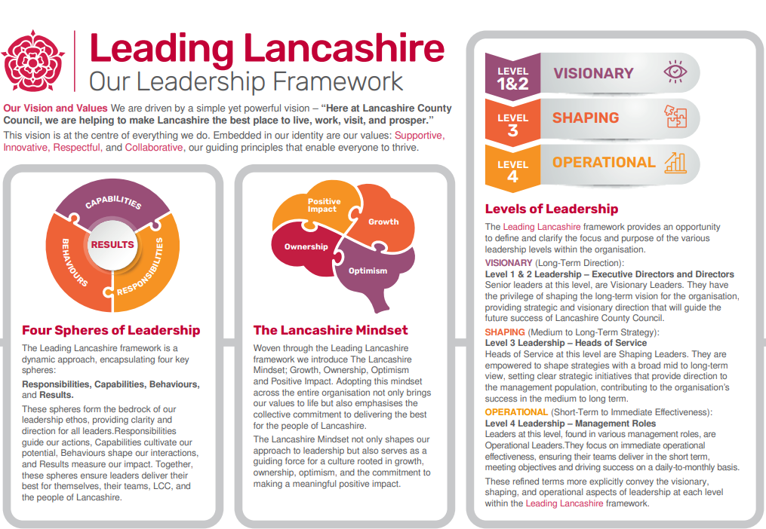

Accountabilities/Responsibilities
- Accountable for safe and legal operation of the In-House fleet of minibuses and front-line employees
- Accountable for the monitoring of external supplier performance, Quality and safeguarding in respect of taxi / private hire services
- Required to exercise financial control over a large budget (In excess of £50m)
- Accountable for compliance of Health and Safety matters and other regulations affecting the service, for example road traffic legislation, procurement rules and statutory guidance from central government.
- Accountable for adherence to county council policies and procedures relating to transport provision and passenger eligibility

- To ensure policies and processes are fulfilled to in order to meet absence, recruitment and productivity and employee engagement targets

Other
- Equal Opportunities
We are committed to achieving equal opportunities in the way we deliver services to the community and in our employment arrangements. We expect all employees to understand and promote this policy in their work.

- Health and safety
All employees have a responsibility for their own health and safety and that of others when carrying out their duties and must help us to apply our general statement of health and safety policy.

- Customer Focused
We put our customers' needs and expectations at the heart of all that we do. We expect our employees to have a full understanding of those needs and expectations so that we can provide high quality, appropriate services at all times.

- Safeguarding Commitment
We are committed to protecting and promoting the welfare of children, young people and vulnerable adults.

- Skills Pledge
We are committed to developing the skills of our workforce. All employees will be supported to work towards a level 2 qualification in literacy and numeracy if they do not have one already.

Our Values
We expect all our employees to demonstrate and promote our values:

- Supportive
We are supportive of our customers and colleagues, recognising their contributions and making the best of their strengths to enable our communities to flourish.

- Innovative
We deliver the best services we possibly can, always looking for creative ways to do things better, putting the customer at the heart of our thinking, and being ambitious and focused on how we can deliver the best services now and in the future.

- Respectful
We treat colleagues, customers and partners with respect, listening to their views, empathising and valuing their diverse needs and perspectives, to be fair, open and honest in all that we do.

- Collaborative
We listen to, engage with, learn from and work with colleagues, partners and customers to help achieve the best outcomes for everyone.

Person Specification

All the following requirements are essential unless otherwise indicated by *

Your ability to meet the job requirements will initially be assessed by the information provided on your application but further assessment will be undertaken at interview and, in some cases, by using other types of assessment(s).

Qualifications
- Honours Degree level qualification or equivalent experience

- Relevant professional qualification or equivalent
Experience
- Significant professional and/or management experience of a strategic operation/service

- A demonstrative record of delivering high quality services against challenging objectives and resources.

- A demonstrative record of operational management of a major service spanning across a major arm of the organisation.

- Engaging, guiding and influencing senior managers within the area of responsibility.

- Experience of leading, inspiring and motivating teams to drive services forward, achieving high quality delivery within reducing resources.

- Experience of working across services outside of the area of responsibility to ensure delivery of corporate objectives.

Essential knowledge, skills & abilities
- Highly developed knowledge (broad and/or deep) of the principles, theory and practice of the specialist area of responsibility.

- Comprehensive understanding of the activities and objectives of the Council, both current and future.

- Ability to successfully influence key decision makers at senior levels, both internal and external to the Council.

- Effective Leadership and Management at a senior level of a diverse workforce to support excellence in service delivery.

- Good understanding of the political context at regional and local level and working with Elected Members in a constructive and sensitive way.

- Successful financial management including prioritisation within decreasing resources.

- Ability to lead, develop, manage and motivate services/teams in a challenging and changing environment.

- Ability to quickly build credibility with senior managers and stakeholders.

- Ability to embed services which are compliant and fit with the wider organisational strategy.

- Ability to utilise significant judgement to lead the design and delivery of a service/collection of services operational business plans to resolve service issues or improve services; including creative and innovative thinking and risk assessment.

Other essential requirements
- Commitment to equality and diversity.
- Commitment to health and safety.
- Display the LCC values and behaviours at all times and actively promote them in others.
- This is an essential car user post
You will be required to provide a car for use in connection with the duties of this post and must be insured for business use. In certain circumstances consideration may be given to applicants who, as a consequence of a disability, are unable to drive

