Job Description

Directorate: | Adult Social Care
Service: | Adults Social Care
Location:
Salary range: | £40,777 - £46,142 | Grade: | 9
Reports to: | Line Manager | Staff responsible for: | Yes

Job purpose and scope
To contribute to the leadership and development of the team in addition to providing a strength based, outcome focussed assessment service to all adults across community and hospital settings.

Performance Indicators
- Quality of advice/service against legal, safety and best practice standards
- Achievement of relevant service targets
- Adherence to internal/external quality standards if applicable
- Adherence to policies and procedures
- Accuracy and timeliness of information recording and processing
- Customer and stakeholder feedback
- Leading Lancashire Framework

Leading Lancashire – Our Leadership Framework
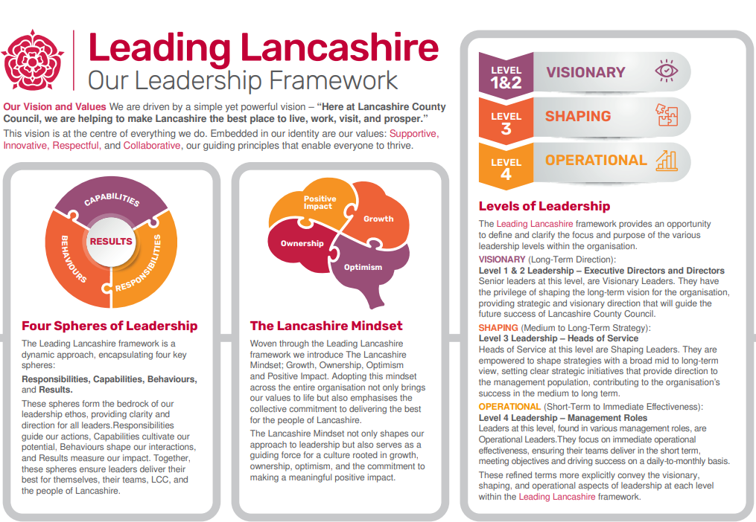

Accountabilities/Responsibilities
Promote and provide a strength based, outcome focussed assessment service to all adults within Lancashire, who are eligible for services.

Work collaboratively with other professionals and agencies to ensure the statutory social care responsibilities are met; identifying safeguarding issues, addressing complex needs, promoting independence and choice, supporting individuals to achieve their ideal outcomes.

Manage and prioritise a reduced case load, which is likely to include a higher proportion of complex and contentious cases, which will be negotiated and reviewed via supervision.

Supervise staff and undertake duties as delegated by the Team Manager;
- Act as a Practice Educator to student Social Workers, as either a qualified Practice Educator (Practice Educator Professional Standards (PEPS stage 2) or have a commitment to working towards this.
- Supporting the Team Manager with management of newly qualified staff through their Assessed and Supported Year in Employment (ASYF) and the probationary period for all new staff.
- Supervise team members Grade 6-8 as required by the service area.

Support the Team Manager in the successful running of the team; support with complaints process, promote continuous improvement via case management and case progression meetings as well as updating oracle as required.

Allocate and approve work of team members grade 6-8 (depending up service requirement)

Chair and co-ordinate a range of meetings specific to service area.

Support or undertake work in relation to legal processes (eg court work, legal challenges, etc) and produce high quality assessments and reports for a range of functions.

Act in a consultative role in relation to complex cases, providing professional advice, support and learning opportunities through the dissemination of information, resources and practice wisdom.

Contribute to the development of policy, procedural and service development, working with all levels of management as required, to improve practice and implement change.

Represent the Authority internally and externally at the request of the Team Manager, negotiating/liaising with Health and other statutory colleagues as required.

To keep accurate records in relation to the contract and work undertaken, using electronic record systems (Liquid Logic) and other relevant ICT systems.

Operate with a higher level of independence and decision making.

To undertake continuous professional development including the completion of mandatory e-learning and formal training as set out within the Adults Social Cre Training Plan.

To maintain your own emotional resilience and promote the wellbeing of a team whilst developing practice competence and confidence

To participate in a duty system which involves the need to work flexibly and respond to urgent situation where necessary.

To undertake additional duties and deemed appropriate the Team Manager.

The post holder is expected to carry out their duties and responsibilities in accordance with the County Council's Policies and Procedures and the Directorates Statement of Principles and Standards of Conduct.

Other
- Equal Opportunities
We are committed to achieving equal opportunities in the way we deliver services to the community and in our employment arrangements. We expect all employees to understand and promote this policy in their work.

- Health and safety
All employees have a responsibility for their own health and safety and that of others when carrying out their duties and must help us to apply our general statement of health and safety policy.

- Customer Focused
We put our customers' needs and expectations at the heart of all that we do. We expect our employees to have a full understanding of those needs and expectations so that we can provide high quality, appropriate services at all times.

- Safeguarding Commitment
We are committed to protecting and promoting the welfare of children, young people and vulnerable adults.

- Skills Pledge
We are committed to developing the skills of our workforce. All employees will be supported to work towards a level 2 qualification in literacy and numeracy if they do not have one already.

Our Values
We expect all our employees to demonstrate and promote our values:

- Supportive
We are supportive of our customers and colleagues, recognising their contributions and making the best of their strengths to enable our communities to flourish.

- Innovative
We deliver the best services we possibly can, always looking for creative ways to do things better, putting the customer at the heart of our thinking, and being ambitious and focused on how we can deliver the best services now and in the future.

- Respectful
We treat colleagues, customers and partners with respect, listening to their views, empathising and valuing their diverse needs and perspectives, to be fair, open and honest in all that we do.

- Collaborative
We listen to, engage with, learn from and work with colleagues, partners and customers to help achieve the best outcomes for everyone.

Person Specification

All the following requirements are essential unless otherwise indicated by *

Your ability to meet the job requirements will initially be assessed by the information provided on your application but further assessment will be undertaken at interview and, in some cases, by using other types of assessment(s).

Qualifications
- SW, CSS, Dip SW or SW Degree
- SW England Registration
Experience
At least 3 years' experience as a Social Worker
Undertaking complex work with a range of client groups
Managing a caseload and competing priorities
Work in a Social Services Directorate or other Statutory or Voluntary Agency.
Supporting a student or less experienced staff

Essential knowledge, skills & abilities
Detailed knowledge of the relevant social care legislation, application and individual accountability.
Experience in assessing and analysing need and risk and planning/commissioning care with individuals.
Experience in working effectively with other agencies and professionals.
IT literate, experience in using manual and computer systems for record keeping.
Negotiating and networking with a range of professionals.
Numerate and able to contribute to the management of budgets and resources.
Effective organisational skills, able to prioritise and manage a case load and work independently under pressure.
A demonstrable understanding and acceptance of the principles underlying equal opportunities and diversity and a commitment to achieving these.
Excellent written and oral communication skills appropriate to the situation.
A commitment to improving practice standards and personal competencies through continuous professional development and use of supervision and appraisal to improve personal performance.
To have the ability to value diversity and work across cultures.
Experience of informally training and mentoring less experienced staff.
Ability to influence others based on technical or professional expertise.
Ability to motivate and support the long-term development of staff.
Ability to operate with a higher level of independence and decision making.

Other essential requirements
- Commitment to equality and diversity.
- Commitment to health and safety.
- Display the LCC values and behaviours at all times and actively promote them in others.
- This is an essential car user post
You will be required to provide a car for use in connection with the duties of this post and must be insured for business use. In certain circumstances consideration may be given to applicants who, as a consequence of a disability, are unable to drive

