Job Description

Directorate: | Resources
Service: | Law and Governance
Location: | County Hall, Preston - Hybrid Working
Salary range: | £77,833 - £85,119 | Grade: | 14
Reports to: | Director of Law and Governance | Staff responsible for: | 4 Direct Reports and  C. 140 employee

Job purpose and scope
- Responsible for the council's commercial, procurement, property, social care, education, employment, litigation, highways, environment, planning and child protection legal teams.

- Lead, influence, shape and challenge the service at a senior level to inform service planning, development, associated budgets, and delivery.

- Work closely with senior and statutory officers, elected members, and other senior political stakeholders to deliver effective governance and legal services, ensuring compliance with legal and regulatory requirements.

Performance Indicators
- Quality of advice/service against legal, safety and best practice standards
- Achievement of relevant service targets
- Adherence to internal/external quality standards if applicable
- Adherence to policies and procedures
- Accuracy and timeliness of information recording and processing
- Customer and stakeholder feedback
- Leading Lancashire Framework

Leading Lancashire – Our Leadership Framework
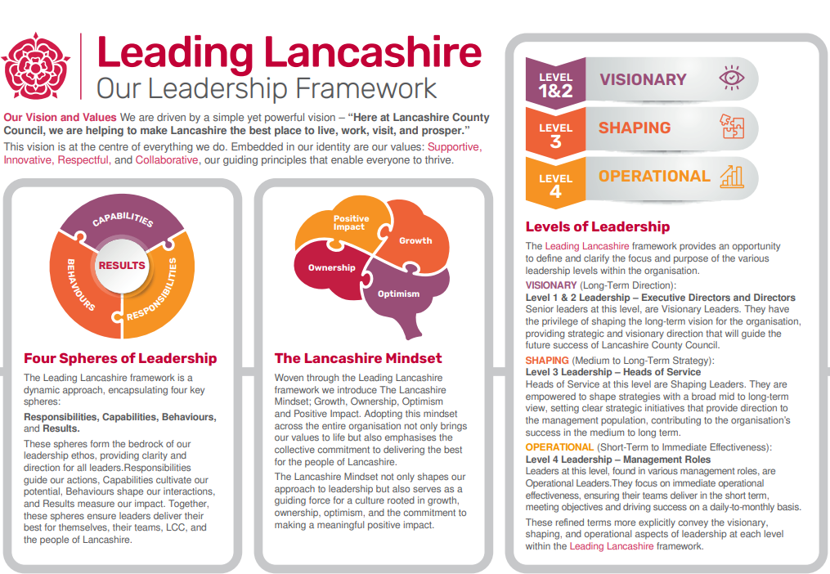

Accountabilities/Responsibilities
- Lead the Legal Services function, its people and financial resources ensuring that these
services deliver council priorities, statutory duties and value for money.

- Lead the promotion and delivery of legal, governance and high standards of conduct across the council with responsibility for conduct and ethical matters on behalf of the Director of Law and Governance. Promote and uphold and model the Nolan principles of public life (Selflessness, Integrity, Objectivity, Accountability, Openness, Honesty, Leadership).

- Provide strategic legal and governance advice to elected members, the Chief Executive, Executive Management Team, statutory officers, and senior leaders.

- Lead on the development and promotion of robust legal governance initiatives, projects and
activities across the authority, working collaboratively with elected members, statutory officers, the Executive Management Team and senior leaders on initiatives relating to law and governance to support the delivery of corporate objectives and to ensure compliance with all statutory and governance requirements, standing orders and financial regulations.

- Determine how best to achieve the objectives related to the areas of responsibility, including the development, implementation and communication of strategy, policy and operational business plans across the wider service area, scanning the horizon for relevant changes that may impact the service and the council as a whole.

- Lead on the design and delivery of the Legal Services business plan to deliver service
improvements, utilising strong knowledge and understanding of the issues and an ability to
analyse data and use innovative approaches.

- Lead work with the public, partners and stakeholders on projects and initiatives that deliver law and governance objectives to support the delivery of the wider corporate objectives, and to represent the council at forums involving the public, partners and stakeholders on issues related to the service.

- Manage a £12.4m budget and resources for the service, monitoring financial performance, seeking savings and efficiencies and identifying opportunities to draw funding where appropriate.

- Foster a positive and collaborative work environment that promotes a culture of professional development, knowledge sharing, and open, honest, and transparent communication.

- Champion customer excellence and learning from feedback to drive continuous improvement.

- Work with the Director of Law and Governance and the council's Returning Officer to appoint
Deputy Returning Officer(s) to administer elections and oversight of the council's responsibilities in respect of electoral registration.

- Act as the Deputy Monitoring Officer in relation to monitoring officer responsibilities relating to law and governance matters, including but not limited to all matters relating to the conduct of members, the council's constitution and advising its decision-making bodies and persons.

- Work collaboratively with the Director of Legal and Governance, the Head of Governance and the Head of Democratic Services to ensure a strong ethical culture.

- Implementing corporate initiatives spanning the organisation, cutting across services outside of direct responsibility and control to ensure delivery against strategic objectives.

- Lead medium to large scale change programmes through the evaluation of existing provision, recommendation of service improvement initiatives for decision by senior management and delivery of chosen models to meet improvement objectives.

Other
- Equal Opportunities
We are committed to achieving equal opportunities in the way we deliver services to the community and in our employment arrangements. We expect all employees to understand and promote this policy in their work.

- Health and safety
All employees have a responsibility for their own health and safety and that of others when carrying out their duties and must help us to apply our general statement of health and safety policy.

- Customer Focused
We put our customers' needs and expectations at the heart of all that we do. We expect our employees to have a full understanding of those needs and expectations so that we can provide high quality, appropriate services at all times.

- Safeguarding Commitment
We are committed to protecting and promoting the welfare of children, young people and vulnerable adults.

- Skills Pledge
We are committed to developing the skills of our workforce. All employees will be supported to work towards a level 2 qualification in literacy and numeracy if they do not have one already.

Our Values
We expect all our employees to demonstrate and promote our values:

- Supportive
We are supportive of our customers and colleagues, recognising their contributions and making the best of their strengths to enable our communities to flourish.

- Innovative
We deliver the best services we possibly can, always looking for creative ways to do things better, putting the customer at the heart of our thinking, and being ambitious and focused on how we can deliver the best services now and in the future.

- Respectful
We treat colleagues, customers and partners with respect, listening to their views, empathising and valuing their diverse needs and perspectives, to be fair, open and honest in all that we do.

- Collaborative
We listen to, engage with, learn from and work with colleagues, partners and customers to help achieve the best outcomes for everyone.

Person Specification

All the following requirements are essential unless otherwise indicated by *

Your ability to meet the job requirements will initially be assessed by the information provided on your application but further assessment will be undertaken at interview and, in some cases, by using other types of assessment(s).

Qualifications
- Honours degree level qualification or equivalent experience with Admitted Solicitor or Barrister (England and Wales) with a current practicing certificate.
- Management qualification or equivalent experience.
- Evidence of Continuous Professional Development (CPD) in local government law and /or governance, and strategic and operational management.
Experience
- Substantial senior management experience in a legal services role within a local authority or similar public sector environment.

- A demonstrative record of delivering high quality services against challenging objectives and resources.

- A track record of improving services, managing complex budgets involving a range of funding streams, and delivering value for money.

- Experience of working at a senior level with elected members to deliver outcomes.

- Significant experience of engaging, guiding and influencing senior managers and statutory officers on complex law and governance matters within a legal or governance environment.

- Significant experience of partnership working and managing external relationships.

- Experience of leading, inspiring and motivating teams, colleagues and partners to drive service forward, achieving high quality delivery within reducing resources.

- Experience of working collaboratively across services outside of the area of responsibility to ensure delivery of corporate objectives
Essential knowledge, skills & abilities
- Excellent knowledge of the statutory legal basis and requirements of local authority decision making and governance.

- Strong communication, negotiation and influencing skills.

- Excellent political awareness, understanding and knowledge, taking into account both local and national issues.

- Ability to advise the council, politicians, senior and statutory officers on complex legal and governance issues, to identify and deliver options and solutions.

- Ability to lead, develop, manage and motivate services/teams in a challenging and changing environment.

- Ability to quickly build credibility with senior managers, elected members and stakeholders.

- Ability to embed services which are compliant and fit with the wider organisational strategy.

- Ability to utilise significant judgement to lead the design and delivery of operational business plans, using creative and innovative thinking.

- Ability to make complex and sensitive decisions as the council’s Deputy Monitoring Officer
Other essential requirements
- Commitment to equality and diversity.
- Commitment to health and safety.
- Display the LCC values and behaviours at all times and actively promote them in others.
- This is an essential car user post
You will be required to provide a car for use in connection with the duties of this post and must be insured for business use. In certain circumstances consideration may be given to applicants who, as a consequence of a disability, are unable to drive

