Job Description

Service: | Law and Governance
Team: | Internal Audit
Location: | County Hall, Preston, with a requirement to visit and work from any county council  or external client location within Lancashire.
Salary range: | £55,613 – £60,147 | Grade: | 12
Reports to: | Head of Internal Audit | Staff responsible for: | 7

Job purpose and scope
The core professional objectives of Lancashire County Council's Internal Audit Service are to:
- Deliver comprehensive assurance over the county council's internal control environment, risk management, and governance framework.
- Support high standards of governance by evaluating and improving risk management, control, and governance processes.
- Act in accordance with Global Internal Audit Standards (GIAS) and promote best practices across the council.
- Identify areas for enhancement and provide actionable recommendations.
- Align audit activities with the council's strategic objectives.
- Provide clear, objective, and reliable audit reports and insights
Leading Lancashire – Our Leadership Framework

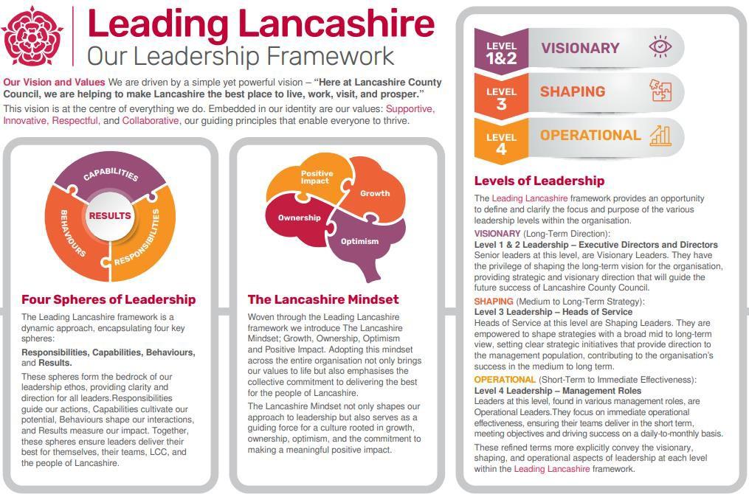
Accountabilities/Responsibilities
The Audit Manager will operate as part of the Audit Management Team, supporting the Head of Internal Audit generally, and specifically:
- Developing the Internal Audit Service by Enhancing the professional objectives and skills of the staff. This includes providing training and development opportunities and fostering a culture of excellence within the audit team.

- Managing Resources by allocate staff resources to meet audit programme priorities. This involves efficient planning and utilisation of resources. Provide leadership to the team, encouraging and motivating staff to ensure that audit projects are completed on time and within budget.
- Leading an audit team to foster effective team-working and set high standards of behaviour, performance, and integrity. This includes leading by example and promoting a positive work environment. Providing support, guidance, and supervision to team members to enable them to:
  - develop the scope of the assignment, seeking input from both the Head of Internal Audit and Auditees.
  - clearly understanding of the scope of our work and the sponsorship, information, and other inputs required from them.

- plan, manage, and ensure the assignment is completed by the deadline and within agreed resources.
- to persuade audit sponsors to accept our reports, working with auditees jointly to develop practical recommendations.
- Act as a sounding board for members of the team, providing clear leadership on technical or controversial issues. Regularly quality review the progress of the assignment, quality assessing likely findings and ensuring they are fully supported by appropriate evidence and redirecting the work to pursue new lines of enquiry where necessary.
- Promoting the Internal Audit Service by Acting as an advocate for the internal audit service and profession, highlighting its value and importance within the council and beyond. This involves engaging with stakeholders and promoting the benefits of internal auditing.
- Maintain effective, positive relations at the highest level within the client organisation; Act as the primary contact for external clients and county council services, ensuring effective communication and collaboration. This includes building and maintaining strong relationships with stakeholders, addressing their concerns, and providing expert advice.

- The Audit Manager will take responsibility for a portfolio of audit work within the county council and external clients and act as relationship manager for our external clients and for services within the county council.
  - demonstrate a breadth and depth of knowledge of the auditees' business and of audit techniques, advising the audit team and auditees;
  - take the lead and or support team members to lead in client meetings in providing advice and influencing discussions where non-routine or contentious issues arise;
  - oversee the development of annual risk-based audit plans providing the assurance required over clients' business risks;
  - ensure that our reports are clear, concise, logical and technically sound, and of a high presentational standard; and
  - Develop annual risk-based audit plans providing the assurance required over the clients' business risks; and produce good quality client correspondence.
Other

Equal Opportunities
We are committed to achieving equal opportunities in the way we deliver services to the community and in our employment arrangements. We expect all employees to understand and promote this policy in their work.

Health and safety
All employees have a responsibility for their own health and safety and that of others when carrying out their duties and must help us to apply our general statement of health and safety policy.

Customer Focused
We put our customers' needs and expectations at the heart of all that we do. We expect our employees to have a full understanding of those needs and expectations so that we can provide high quality, appropriate services at all times.
- Safeguarding Commitment

We are committed to protecting and promoting the welfare of children, young people and vulnerable adults.
- Skills Pledge
We are committed to developing the skills of our workforce. All employees will be supported to work towards a level 2 qualification in literacy and numeracy if they do not have one already.

Our Values
We expect all our employees to demonstrate and promote our values:
- Supportive
We are supportive of our customers and colleagues, recognising their contributions and making the best of their strengths to enable our communities to flourish.
- Innovative
We deliver the best services we possibly can, always looking for creative ways to do things better, putting the customer at the heart of our thinking, and being ambitious and focused on how we can deliver the best services now and in the future.
- Respectful
We treat colleagues, customers and partners with respect, listening to their views, empathising and valuing their diverse needs and perspectives, to be fair, open and honest in all that we do.

- Collaborative
We listen to, engage with, learn from and work with colleagues, partners and customers to help achieve the best outcomes for everyone.

Person Specification

All the following requirements are essential unless otherwise indicated by *

Your ability to meet the job requirements will initially be assessed by the information provided on your application but further assessment will be undertaken at interview and, in some cases, by using other types of assessment(s).

Qualifications
- Professional qualification and current membership of one of the Consultative Committee of Accountancy Bodies (CCAB) institutes or an equivalent professional qualification;
Or
- Qualification and full current membership of the Institute of Internal Auditors or equivalent.
Experience
- Experience of quality reviewing audit working to ensure that our reports are clear, concise, logical and technically sound, and of a high presentational standard.
- Experience provide leadership to the team, encouraging and motivating staff.
- Experience of working with public sector organisations either as an employee or external service provider. *
- Experience of providing internal audit services to a variety of clients (a range of different businesses within a large, complex organisation, or a number of different organisations), including:
  - Client relationship management;
  - Client service management including operating to contractual service standards;
  - Strategic audit planning and scoping;
  - Reporting (written and verbal, including presentations to audit committees).
- Experience of managing a team of audit staff including:
  - Reviewing work for technical quality;
  - Developing and coaching staff;
  - Performance review and management;
  - Resource management/ staff deployment
Essential knowledge, skills & abilities
- knowledge of the broad commercial/ service issues facing the service and external client and apply these within our work.
- Demonstrate and set high standards of behaviour, performance quality, credibility, and integrity.
- Able to think strategically about clients’ businesses and operations and to consider the widest organisational perspective.
- Able to build strong professional relationships with clients' directors and senior management teams, and with elected members.

- Imaginative and practical problem-solving and project management skills.
- Good technical understanding and demonstrable application of internal audit methodologies and current developments in theory and practice, including counter fraud governance requirements for Local Authorities.
- Interest in exploring ways to apply current best practice in audit methodology and techniques, including ICT, to the work of the team.
- Striving for professional quality and self-development.
- Self-motivated and able to use own initiative.
- Able to work effectively as part of a team.
- Effective analytical skills.
- Attention to detail at an appropriate level.
- Excellent written and verbal communication skills.
- Effective negotiation skills.
- Aware of, and able to manage, the potential risks to the county council in undertaking internal audit work.
- Effective ICT skills, in particular in Word and other Office products.
Other essential requirements
- Commitment to equality and diversity.
- Commitment to health and safety.
- Display the LCC values and behaviours at all times and actively promote them in others.
- This is an essential car user post*
You will be required to provide a car for use in connection with the duties of this post and must be insured for business use. In certain circumstances consideration may be given to applicants who, as a consequence of a disability, are unable to drive

