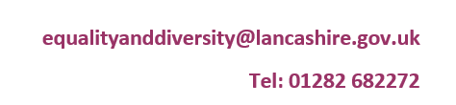

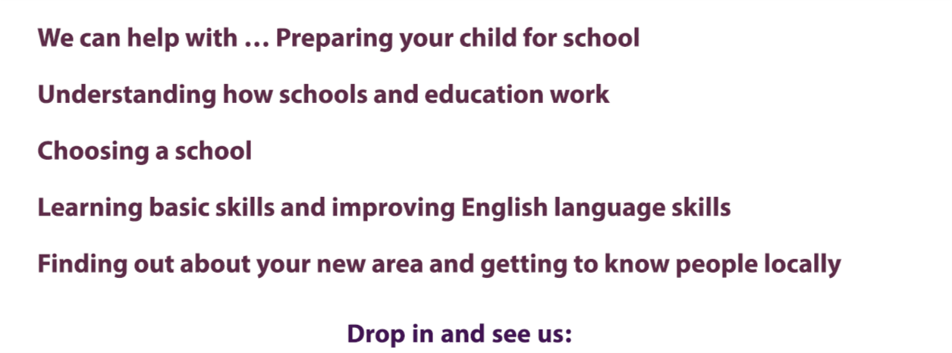

**Visit us:**

Every Wednesday 0930-1200

(Term Time only)

**ELLIE at New ERA Complex**

**Paradise Street**

**Accrington**

**BB5 1PB**

|  |  |  |
| --- | --- | --- |
| **21st July** | **-** | **29th August 2025** |
| **27th October** | **-** | **31st October 2025** |
| **22nd December** | **-** | **2nd January 2026** |
| **16th February** | **-** | **20th February 2026** |
| **30th March 2026** | **-** | **10th April 2026** |
| **25th May** | **-** | **29th May 2026** |
| **20th July** | **-** | **31st August 2026** |
|  |  |  |
|  |  |  |

**Closed during the following dates-**

**We are also closed on Bank Holidays.**

Please bring **any relevant ID documents** (Passport, UK Identity card, National Insurance Number, E-VISA **for each child and parent/Guardian**.