LANCASHIRE COUNTY COUNCIL
(CHURCH STREET, LANCASTER, LANCASTER CITY)
(TEMPORARY PROHIBITION OF THROUGH TRAFFIC) ORDER 2025

NOTICE IS HEREBY GIVEN that Lancashire County Council have made an Order under Section 14(1) (a) of the Road Traffic Regulation Act 1984, as amended, the effect of which will be to temporarily prohibit traffic on the roads set out in this notice.

- No person shall cause any motor vehicle to proceed over that length of Church Street, Lancaster from its junction with St Marys Gate to a point to the side of the Judges Lodging Museum.

- Nothing in this order shall apply to persons engaged in the carrying out of the works.

- The prohibition will be operative from 0800 hours on Wednesday 12th November 2025 until 1800 hours on Friday 14th November 2025 or until completion of the works within this period.

- Vehicular access for residents will be maintained whenever and wherever possible. Pedestrian access to properties will always be maintained.

- An alternative route for vehicular traffic affected by the closure is via:-
St Marys Parade – Castle Hill and vice versa.

The temporary prohibition is necessary to allow works to clear duct blockage be carried out.

Authority given for this Order to be made:

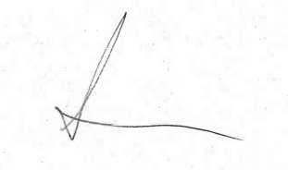

Amanda Meldrum,
Streetworks Team Leader
Highways and Transport
0300 123 6780

[Ref: HRiT/62958/EF]

