Job Description

Directorate: | Education and Children's Services
Service: | Children's Services
Location: | Lancashire
Salary range: | £66,336 - £72,151 | Grade: | 13
Reports to: | Head of Service | Staff responsible for: | Direct reports: 5  Team size: 35-40

Job purpose and scope
Working in a critical operational area the post will impact on the Council's corporate vision and reputation to maintain/increase Public confidence. The post holder is a lead professional with pivotal involvement, working with the Head of Service to develop, implement and provide direction at a senior level to inform the operational strategy of the service area.
Responsibility for managing a cluster of specialist teams, ensuring that children, young people, carers and families receive first class specialist assessments and timely support to meet their needs, manage risks to children and maximise children’s life chances.
Manage direct spend and staffing budgets maximising service provision but ensuring spend remains within allocated resources. Deliver inspection, contribute to serious case reviews and plan outcomes for the continuous professional development of staff and improvement of the quality of services for which responsible.
The Senior Manager will support the delivery of effective support and services to children, young people and families in line with the vision for Children and Families in Lancashire developed by the Children and Families Partnership Board which states;
Children, young people and their families are safe, healthy and achieve their full potential
To deliver this vision we have agreed some key outcomes:

Five Outcomes
- Vulnerable children and young people are safe from harm and build resilience.
- Children and young people achieve their full potential in education, learning and future employment.
- Children and young people enjoy heathy lifestyles and know how to help others.
- Children, young people and families have a voice in shaping the support they receive.
- Children and young people live in Lancashire where they can enjoy a good quality of life, be happy and want to stay.

Performance Indicators
- Quality of advice/service against legal, safety and best practice standards
- Achievement of relevant service targets
- Adherence to internal/external quality standards if applicable
- Adherence to policies and procedures
- Accuracy and timeliness of information recording and processing
- Customer and stakeholder feedback
- Leading Lancashire Framework

Leading Lancashire – Our Leadership Framework
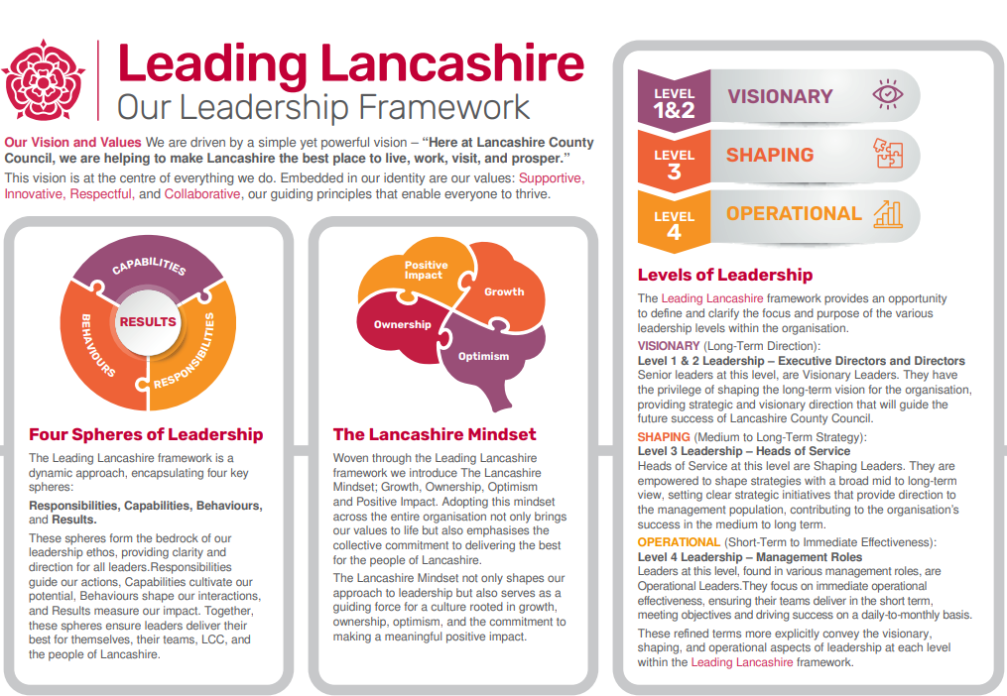

Accountabilities/Responsibilities
Vision, Strategy and Performance
Responsible for:-
- Ensuring delivery of Service Plan objectives for the specialist service area of responsibility and delivering results to meet the needs of the community or customer through effective leadership of people.
- Developing and embedding a performance culture that delivers results through rigorous challenge, disciplined delivery and continual improvement, ensuring that resources are targeted on business priorities and meeting customer needs.
- Maintaining effective systems for monitoring, reviewing and evaluating staff and own performance against the group’s objectives. Take appropriate corrective action as necessary.
- Supporting the Head of Service in the preparation of proposals for the strategic direction of the service function which supports the Council's overall future direction.
- Being fully conversant with alterations to national, regional and local influences, legislation, council procedures etc. and plan for consequent changes to services.
- Providing leadership and direction to staff; setting out the service goals; conveying how they support the fundamental purpose of the council and energise staff towards their achievement incorporating the Council’s values and behaviours.
- Ensuring that the Council performs its duties and functions in fulfilment of its statutory obligations.
- The managerial leadership of the group and its services and functions set within the Specialist Service.
- Promoting managerial responsibility for cross-organisational group working, and across boundaries with other agencies and partners, to improve services and solve problems in a coherent and integrated manner.
- Ensuring that relevant and best professional advice, guidance and information is available in an intelligible and timely fashion to appropriate senior officers as required.
- Sustaining and improving the overall reputation of the Council and acting in the best interests of Lancashire County Council through effective representations locally, regionally and/or nationally.

Effective Processes
Responsible for:-
- Supporting the development of the Council’s policies, processes, practices and systems in respect of the service function, contributing to and ensuring that they are current, of a high standard, conform to best practice, comply with legislation and/or meet the needs of the Council within that service area.
- Ensuring, within own group, that all Council policies, processes, practices and systems, including those covering service delivery, resource and relationship management, are operated/implemented in accordance with Council requirements.
- Reviewing, evaluating and recommending the necessary action to amend service processes, practices and systems that lead to improved service delivery.
- Reviewing as appropriate the effectiveness of other Council policies that impact on the delivery of services by the group and working with the corporate organisation for the overall improvement of services to the community.
- Establishing mechanisms for the collection of a range of information and/or data on the service function and its performance, including its analysis, interpretation, processing and presentation.
- Writing reports, and making presentations when required for a wide audience, such as Council Members, Project Boards, Cabinet and Council Committees, Community Groups etc.
- Ensuring that effective arrangements are in place to secure the well-being and the health & safety of all employees and people delivering services for the Council.

Organisation Learning, Growth and Sustainability
Responsible for:-
- Ensuring that all group members keep abreast of the Council’s changing legal obligations and mandates.
- Using internal/external relationships to get feedback on effectiveness of services delivered, continuously re-evaluate these services and make recommendations for, or take action to, make appropriate changes.
- Continuously reviewing and supporting the development of the strategies, policies, procedures and processes relating to own professional area and group remit, taking into account the views of all stakeholders both internally and externally.
- Provide positive leadership, acting with openness, honesty and integrity, and instilling a clear sense of direction, priority and pace.
- Leading people in an inclusive way to deliver strategic and operational objectives.
- Ensuring workforce capacity and capability and for development activities to maintain the professionally safe delivery and viability of services.

Service Delivery
Responsible for:-
- Ensuring delivery of Service Plan objectives for the team’s areas of responsibility and delivering results to meet the needs of the service users through effective organisation of the team and monitoring of workflow.
- Developing and embedding a performance culture within the team to ensure targets are met and poor performance is effectively managed.
- Maintaining effective systems for monitoring, reviewing and evaluating staff and own performance against the team’s objectives within the Service. Take appropriate corrective action as necessary.

- Visibly and actively supporting and promoting the corporate activities of the Council and the values and behaviours of the Council.
- Being aware of changes to policy and procedures and plan for consequent changes to services.
- Leading a process of continual improvement to contribute to improved life chances for children, young people and their families.
- Ensuring all staff are trained, supervised, developed and supported to provide the best possible outcomes for children, families and carers, seeking help from more senior managers and corporate colleagues as appropriate.
- Ensuring that the Council performs its duties and functions in fulfilment of its statutory obligation.

Management of staff
Responsible for:-
- To ensure the team has in place appropriate systems and procedures to prioritise and manage demands on the service by allocating staff and resources appropriately, in accordance with social care assessed need and Education and Children's Services policies.
- To monitor the team’s performance with reference to local and key performance indicators for Children’s social care services, producing performance and statistical reports as required.
- Supporting the development of the Council’s policies, processes, practices and systems in respect of service functions, contributing to and ensuring that they are current, of a high standard, conform to best practice, comply with legislation and/or meet the needs of the Service.
- Authorising assessments, reports and care plans and taking responsibility for ensuring plans for children and carers are implemented in accordance with statutory and Council requirements.
- Reviewing, evaluating and recommending the necessary action to amend service processes, practices and systems that lead to improved service delivery.
- Undertaking audits in line with the service’s quality monitoring requirements.

Partnership and Collaborative Working
Responsible for:-
- Engagement with children, young people and families to ensure that their requirements are at the heart of the design and delivery of services in accordance with the Council’s customer service strategy. Giving prompt attention to any complaints/concerns raised about the services/decision making of the team.
- Building and promoting successful partnership working across agencies and with children and young people and their families, to deliver more cost effective and valued services. Ensuring that the needs of all stakeholders in Lancashire are met by modelling behaviour, which fosters equality of opportunity in service provision and employment.
- Using internal/external relationships to get feedback on effectiveness of services delivered, continuously re-evaluate these services and make recommendations for, or take action to, make appropriate changes.
Key tasks and accountabilities are intended to be a guide to the range and level of work expected of the post-holder. This is not an exhaustive list of all tasks that may fall to the post-holder and employees will be expected to carry out such other reasonable duties which may be required from time to time.

Other
- Equal Opportunities
We are committed to achieving equal opportunities in the way we deliver services to the community and in our employment arrangements. We expect all employees to understand and promote this policy in their work.

- Health and safety
All employees have a responsibility for their own health and safety and that of others when carrying out their duties and must help us to apply our general statement of health and safety policy.

- Customer Focused
We put our customers' needs and expectations at the heart of all that we do. We expect our employees to have a full understanding of those needs and expectations so that we can provide high quality, appropriate services at all times.

- Safeguarding Commitment
We are committed to protecting and promoting the welfare of children, young people and vulnerable adults.

- Skills Pledge
We are committed to developing the skills of our workforce. All employees will be supported to work towards a level 2 qualification in literacy and numeracy if they do not have one already.

Our Values
We expect all our employees to demonstrate and promote our values:

- Supportive
We are supportive of our customers and colleagues, recognising their contributions and making the best of their strengths to enable our communities to flourish.

- Innovative
We deliver the best services we possibly can, always looking for creative ways to do things better, putting the customer at the heart of our thinking, and being ambitious and focused on how we can deliver the best services now and in the future.

- Respectful
We treat colleagues, customers and partners with respect, listening to their views, empathising and valuing their diverse needs and perspectives, to be fair, open and honest in all that we do.

- Collaborative
We listen to, engage with, learn from and work with colleagues, partners and customers to help achieve the best outcomes for everyone.

Person Specification

All the following requirements are essential unless otherwise indicated by *

Your ability to meet the job requirements will initially be assessed by the information provided on your application but further assessment will be undertaken at interview and, in some cases, by using other types of assessment(s).

Specifics to Family Safeguarding
- Ability and skills to manage a multi-disciplinary team of professionals from Children's Social Care, Health, Probation and Substance Misuse Services.
- Ability to ensure that all assessments are completed within timescales to a 'good' quality.
- To ensure that children, young people and families have access to a timely assessment.
- Experience and skills to facilitate regular multi-disciplinary (group) supervision using the 'workbook' as a support tool.
- Experience of managing case allocation to the social workers and also partner agencies.
- Experience and skills to manage complex cases, including child protection investigations, pre-proceedings, proceedings and assessments of strength/risk/need to achieve positive outcomes.

Requirements | Essential (E) or  Desirable (D) | Identified by  Application  Form (A) or  Interview (I)
Qualifications:
Professional and/or academic level qualification or equivalent or substantial vocational experience in a relevant  technical, scientific, specialised or operational field | E | A
Management Qualification or significant management training | E | A, I
CQSW, DipSW, BA in Social Work or equivalent | E | A
A professionally qualified, registered Social Worker adhering to the Social Work England professional standards and able meet the Knowledge and Skills statements for child and family social work. | E | A
Experience:
Significant lead professional, technical and/or specialist experience within a major operational area within the organisation | E | A, I
Minimum of 4 years of management or leadership experience in children's social care services. | E | A, I
A demonstrative record of delivering high quality services, advice and guidance | E | A, I
Service transformation within the relevant area of responsibility | E | A, I
Evidence of successful integrated working with colleagues across the service and agencies to promote the children and young people’s best interests. | E | A, I
Demonstrable commitment to diversity issues in both service provision and employment practices and evidenced achievement of positive outcomes | E | A, I
Experience of planning, commissioning and performance frameworks in a multidisciplinary and partnership environment. | E | A, I
Experience of working successfully at a supervisory/managerial level to develop a high performing social work team | E | A, I
Engaging, advising, guiding and directing managers and team members within the area of responsibility | E | A, I
Experience of inspiring and motivating teams to drive services forward, achieving high quality delivery and improved services | E | A, I
Ensuring delivering against agreed service plans and managing services in line with agreed budgets, targets and plans | E | A, I
Innovative and creative management of services within a diverse, changing and challenging financial environment | E | A, I
Significant risk management in complex cases/issues within a statutory child care setting. | D | A, I
Social work in statutory and safeguarding areas of service | D | A, I
Knowledge and Skills:
Children Acts 1989 and 2004, Adoption and Children Act 2002, Leaving Care Act 2000, Children and Young Person’s Act 2008 | E | A, I
Knowledge of all associated Guidance regulations such as Family Justice Review, Public Law Outline and Single Assessments, as well as Working Together 2018, Assessment Framework, ICS and Looked After Children/care planning procedures. | E | A, I
A clear understanding and awareness of the government agendas as applied to children and young people’s services and the ability to translate them into service requirements. | E | A, I
A good understanding of the relevant legal, political, operational, commercial and social aspects of a similar complex environment. | E | A, I
Ability to develop, motivate and challenge services/teams in a changing environment | E | A, I
Ability to quickly build credibility with managers, team members and stakeholders | E | A, I
Ability to contribute to the delivery of high quality services within challenging targets and budgets | E | A, I
Ability to develop strategy, new initiatives and new ways of working, in line with statutory/legislative/corporate changes | E | A, I
Ability to evaluate service delivery to inform and resolve service issues and/or improve services | E | A, I
Other (including special requirements)
1. Commitment to equality and diversity | E | I
2. Commitment to health and safety | E | I
3. Display the LCC values and behaviours at all times and actively promote them in others | E | I
4. This is an essential car user post. You will be required to  provide a car for use in connection with the duties of this  post and must be insured for business use.  In certain circumstances, consideration may be given  to applicants who as a consequence of a disability are  unable to drive. | E | I

Other essential requirements
- Commitment to equality and diversity.
- Commitment to health and safety.
- Display the LCC values and behaviours at all times and actively promote them in others.
- This is an essential car user post
You will be required to provide a car for use in connection with the duties of this post and must be insured for business use. In certain circumstances consideration may be given to applicants who, as a consequence of a disability, are unable to drive

