LANCASHIRE COUNTY COUNCIL
(FIRSWOOD ROAD, LATHOM, WEST LANCASHIRE BOROUGH)
(TEMPORARY PROHIBITION OF THROUGH TRAFFIC) ORDER 2025
(TEMPORARY AMENDMENT) ORDER 2025

The Lancashire County Council (“the County Council”) in exercise of its powers under Section 14(1) (a) of the Road Traffic Regulation Act 1984, as amended, (the Act), and of all other enabling powers, HEREBY makes the following Order:-

The Lancashire County Council (FIRSWOOD ROAD, LATHOM, WEST LANCASHIRE BOROUGH) (TEMPORARY PROHIBITION OF THROUGH TRAFFIC) ORDER 2025, is hereby temporarily Amended in that:

- To amend Article 3 as follows:

The prohibition will be operative from 0800 hours Wednesday 3rd September 2025 until 1700 hours on Tuesday 9th September 2025 or until completion of the works within this period. Access for emergency services will not be maintained due to the nature of the works.

This Temporary Amendment Order shall come into operation on 29th July 2025 and may be cited as “The Lancashire County Council (FIRSWOOD ROAD, LATHOM, WEST LANCASHIRE BOROUGH) (TEMPORARY PROHIBITION OF THROUGH TRAFFIC) ORDER 2025 (TEMPORARY AMENDMENT) ORDER 2025”

Authority given for this Order to be made:

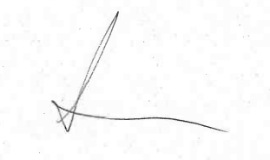

Amanda Meldrum
Streetworks Team Leader
Highways and Transport
Lancashire County Council
0300 123 6780

[Ref: HRiT/62172/HS]

