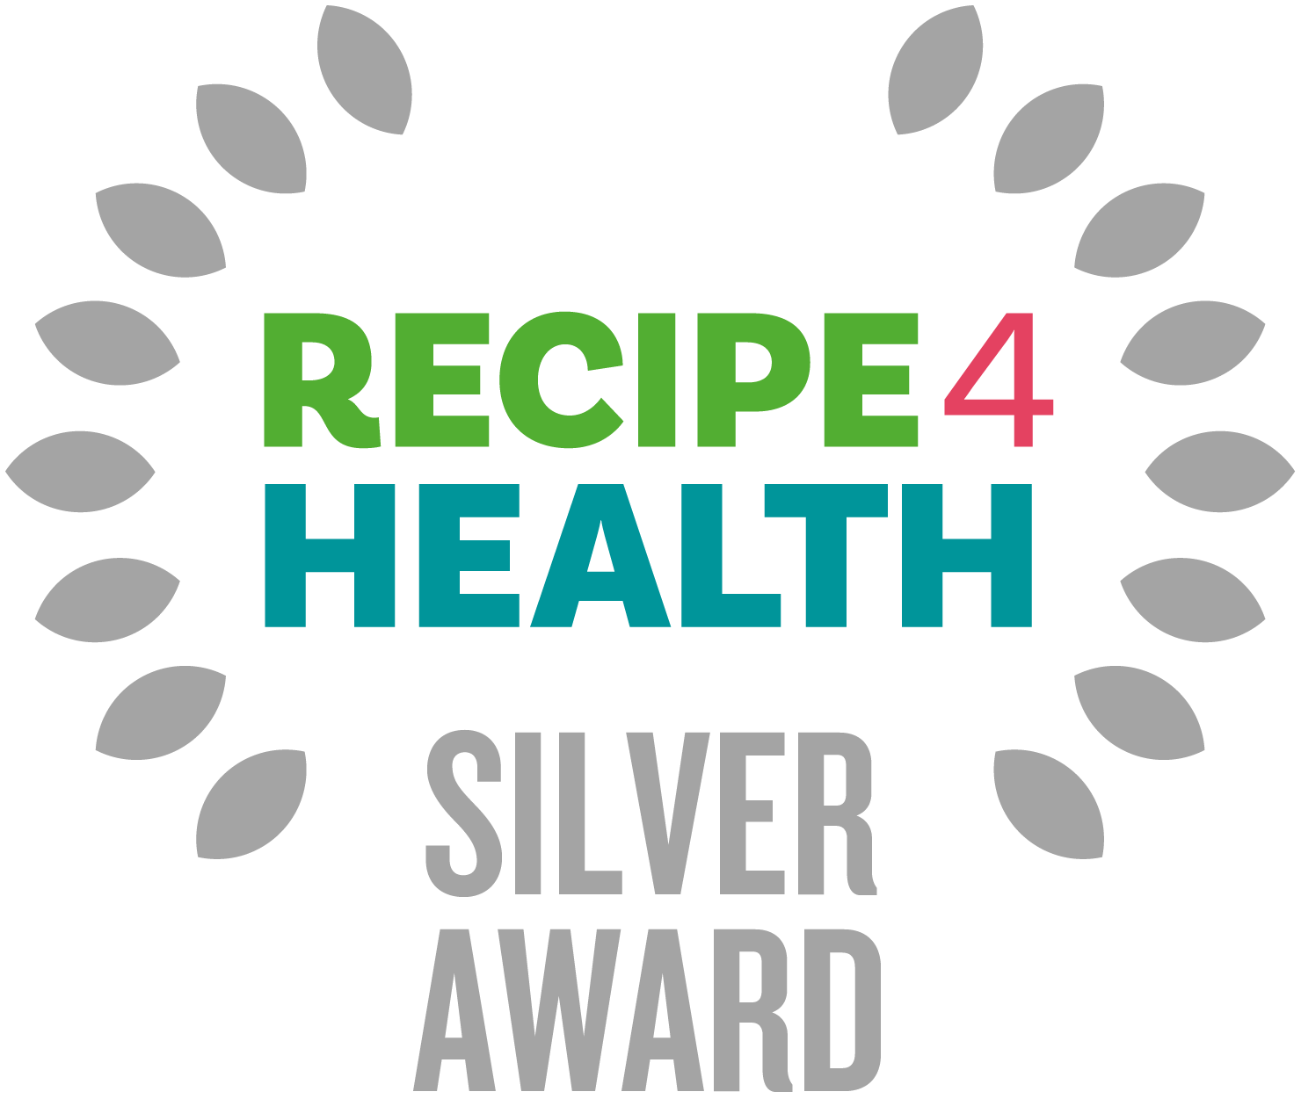

What is the R4H Award?
The R4H award promotes businesses that focus on healthier eating, environmental issues, and social responsibility. Sound like you? Read on. R4H is awarded by Lancashire County Council and is a Lancashire Trading Standards scheme for caterers.

Benefits for your business
- Businesses will be supported to make positive changes to their menus, policies, and practice to support the health of the local community and to the local environment.

- Businesses with the award will be promoted by Trading Standards, particularly on the Lancashire County Council website and social media platforms, and in council buildings.
- Businesses with the award will receive a promotion pack containing a certificate and other eye-catching materials to display in premises.

How to apply?

- There are three levels to R4H - Bronze, Silver and Gold.
- The award is free to apply for.
- You must have attained at least 4 stars for the Food Hygiene Rating Scheme at your most recent inspection.
- Please complete this self-assessment form. The form is then sent to Trading Standards. If you successfully qualify, you will receive your award during a short presentation. The whole process should take no longer than 1 month.
- You can apply to the award at any time of the year. If you have any questions, please contact: recipe4health@lancashire.gov.uk

Silver Award Criteria

Please complete this self-assessment form by carefully filling in the information requested. If you need more space, please include any extra information on additional paper and return it with your self-assessment form. If any questions are not applicable to your business, please write N/A.

Please provide a copy of your menu with your assessment sheet.

If you require any further advice or assistance in completing this form, please go to https://www.lancashire.gov.uk/business/trading-standards/recipe-4-health/ or contact the Recipe 4 Health team on 01772 532145 or email us on recipe4health@lancashire.gov.uk

Business details

Business Name
Business Address
Manager/Owner Details
Contact Telephone Number
Email Address
Website
Type of Establishment (e.g. Hot Food Takeaway)

SILVER AWARD CRITERIA

FHRS Rating
What is your current food hygiene rating?
(must be at least 4* for Silver award)

Promotions and Marketing
Is healthier eating promoted by staff?
e.g. Prompting customers to take side salad options, not asking if customers want salt or extras, nudging customers to try healthier options* etc.
Please provide details
*Healthier options can be considered as menu items which are lower in sugar, salt and saturated fat.
Do you keep food or drinks high in fat, sugar, or salt away from the point of purchase? i.e. at the serving counter / till point.

Healthy Eating*
Do you offer tap water and free water refills? (For more information, please look at the charity Refill and the benefits this has for your business)
If you offer fried fish, is this lightly battered?

Do you offer baked potatoes with low fat fillings? (e.g. cottage cheese, tuna with low fat mayo, beans)
Please provide examples
Do you provide thick cut chips or potato wedges as an alternative to French fries/ thin chips?
What bread options are available? e.g. 50/50, wholemeal, granary.
Is salad and/or rice offered with meals instead of chips? (If appropriate to your type of cuisine)
Please provide examples

*N.B. for premises providing food solely for under 5's such as nurseries and childcare settings there is no requirement to use low fat products, it is preferable to use full fat dairy products, however low sugar and low salt options are preferable.

Fruit and Vegetables
Has your business made efforts to incorporate more vegetables into recipes? e.g. sauces, soups.
Please provide details

Is the option of a portion of salad, vegetables or fruit available with all meals? (If appropriate for your cuisine)
Please provide details

If you offer desserts, are fruit and fruit-based desserts available? e.g. whole fresh fruit, fruit salads, malt loaf, fruit cake, fruit crumbles. Please provide details

Salt
Do you source low-salt stock cubes, gravy granules and sauces (where applicable)? Please provide product details

Sugar
Are reduced sugar/diet soft drinks and water displayed more prominently than non-diet drinks? e.g. at eye level in fridges, at the front of counters etc.
Please provide details

Has your business made any efforts to reduce the sugar content of any menu items?
e.g. by reducing the quantity of sugar or replacing sugar with fruit, spices or other healthier alternatives.
Please provide details

Fats and Frying
What type of oils do you use?
Unsaturated oils and fats are better e.g. olive oil, rapeseed, sunflower oil, non-blended vegetable oils, groundnut oil.

Do you use trimmed and unprocessed meat and poultry where possible?
Please provide details
Do you use reduced fat alternatives of cream and milk in cooking? Are these available as options for serving?
Please provide product details
Do you grill or steam any menu items in preference to frying?
Do you shallow fry menu items instead of deep frying?
Please provide details

Allergens
What is your procedure for dealing with orders from customers with an allergy / intolerance, and how are all staff made aware of the procedure?
Outline what procedures you have in place in relation to storage, preparation, cooking, hot holding, and cleaning to prevent cross contamination of allergenic ingredients?
Do you request a product specification from suppliers of foods that do not come with full labelling?
Do you request notification from suppliers about changes to recipes of prepared foods in relation to allergens?
How are tables, highchairs and other equipment used by allergenic customers cleaned before their use of it?

Environment
Do you separate waste for reuse and recycling? e.g. card, plastic, glass, metal
Please provide details
Do you use MSC-approved fish - which helps to maintain healthy fish populations?
Information:
What is the MSC | Marine Stewardship Council
Do you purchase cleaning products / washing detergents in bulk and in concentrated form, where possible?
Please provide details
Do you use refillable containers wherever possible? e.g. washing up bottles, soap dispensers, condiment pots.
Please provide details
Do you avoid using disposable products were possible i.e. single-use plastic straws, drink stirrers and cutlery AND do you avoid using expanded polystyrene food and drink containers.
Please provide details
Guidance –
https://www.businesscompanion.info/en/quick-guides/miscellaneous/single-use-plastics
and
https://www.gov.uk/guidance/single-use-plastics-bans-and-restrictions

General
Have all employees involved in handling food, completed the minimum of Level 2 Food Safety and Hygiene training?
Please provide copies of certificates.

Declaration
As an authorised person of the above-named business, I verify that all information supplied above is true and accurate at the time of completing this self-assessment form.

Print Name

Signature

Date

After completion please return to:
Recipe 4 Health,
Lancashire County Council Trading Standards Service
PO Box 100
County Hall
Preston
PR1 0LD

OR

By email to - recipe4health@lancashire.gov.uk

NB Don't forget to include a copy of your menu.

Further free guidance can be found here :

Business Companion - https://www.businesscompanion.info/en/in-depth-guides
Food Standards Agency - https://www.food.gov.uk/
Government website - https://www.gov.uk/

Data Protection:

In completing this form, you understand that Lancashire County Council has a requirement to process your personal data.

Lancashire County Council will only ever process your personal data where it has a clear lawful basis for doing so in full compliance with data protection legislation - UK GDPR and The Data Protection Act (2018).

We will ensure the security and confidentiality of your personal data at all times.

For full details of how Lancashire County Council handles your personal data please see our privacy notice here:
https://www.lancashire.gov.uk/council/transparency/access-to-information/service-and-project-specific-privacy-notices/trading-standards/

