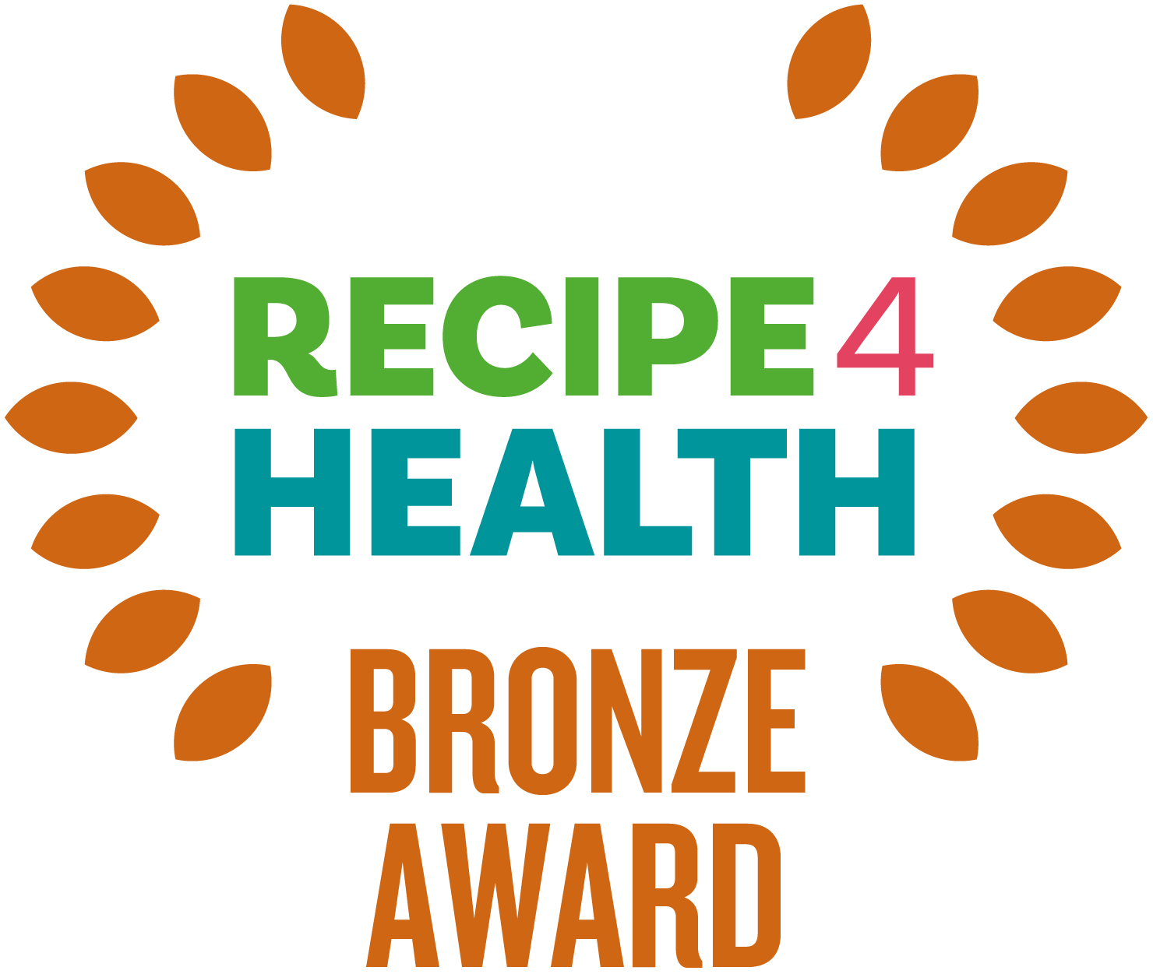

What is the R4H Award?

The R4H award promotes businesses that focus on healthier eating, environmental issues, and social responsibility. Sound like you? Read on. R4H is awarded by Lancashire County Council and is a Lancashire Trading Standards scheme for caterers.

Benefits for your business

- Businesses will be supported to make positive changes to their menus, policies, and practice to support the health of the local community and to the local environment.

- Businesses with the award will be promoted by Trading Standards, particularly on the Lancashire County Council website and social media platforms, and in council buildings.
- Businesses with the award will receive a promotion pack containing a certificate and other eye-catching materials to display in their premises.

How to apply?

- There are three levels to R4H - Bronze, Silver and Gold.
- The award is free to apply for.
- You must have attained at least 3 stars for the Food Hygiene Rating Scheme at your most recent inspection.
- Please complete this self-assessment form. The form is then sent to Trading Standards. If you successfully qualify, you will receive your award during a short presentation. The whole process should take no longer than 1 month.
- You can apply to the award at any time of the year. If you have any questions, please contact: recipe4health@lancashire.gov.uk

Bronze Award Criteria

Please complete this self-assessment form by carefully filling in the information requested. If you need more space, please include any extra information on additional paper and return it with your self-assessment form. If any questions are not applicable to your business, please write N/A.

Please provide a copy of your menu with your assessment sheet.

If you require any further advice or assistance in completing this form, please go to https://www.lancashire.gov.uk/business/trading-standards/recipe-4-health/ or contact the Recipe 4 Health team on 01772 532145 or email us on recipe4health@lancashire.gov.uk.

Business details

Business Name
Business Address
Manager/Owner Details
Contact Telephone Number
Email Address
Website
Type of Establishment (e.g. Hot Food Takeaway)

BRONZE AWARD CRITERIA

FHRS Rating
What is your current food hygiene rating?
(must be at least 3* for Bronze award)

Promotions and Marketing
Please detail how you promote or market any *healthier products/options.
*Healthier products/options can be considered as menu items which are lower in sugar, salt and saturated fat.
Promotions and marketing can include price promotions (e.g. buy one get one free); place promotions (products placed at key places where customers will view them e.g. on the counter); marketing materials (e.g. posters, leaflets, specials boards); social media.
Please provide a copy of your menu.
Where are *healthier options shown in the menu and how are they priced in comparison to standard options? Please provide details. *Healthier options can be considered as menu items which are lower in sugar, salt and saturated fat.

Healthy Eating*
What healthier options are available?
These options must be lower in fat, salt, and/or sugar than standard menu options. This can include lower fat, salt and/or sugar sauces, dressings and spreads, grilled dishes instead of fried, wholegrains, wholemeal breads, pasta and rice.
What healthier drinks are available?
e.g. water, pure fruit juice, semi and/or skimmed milk drinks.

*N.B. for premises providing food solely for under 5's such as nurseries and childcare settings there is no requirement to use low fat products, it is preferable to use full fat dairy products, however low sugar and low salt options are preferable.

Fruit and Vegetables
What fruits, salad and vegetables do you have available? (If appropriate for your cuisine)

Salt
Do you use reduced hole saltshakers?
i.e. with 3 holes or less, rather than 5 or more.
Do customers add any extra salt they want on prepared food themselves?
e.g. staff don’t add extra salt on behalf of the customer.
How is salt minimised in your food preparation?
e.g. not adding salt when cooking (i.e. when boiling potatoes, rice, or pasta), using black pepper or herbs and spices to flavour food instead, using homemade stock.
Please provide details

Sugar
Please list some of the soft drinks you offer that are reduced sugar or diet versions, including water’
Where hot drinks are served, including self-service, do you offer sweeteners as an alternative to sugar?

Fats and Frying
Which types of milk do you use or serve as standard for hot drinks?
i.e. not using whole milk as standard (exceptions for early years settings) or verbally offering semi or skimmed milk.
Do you follow healthier frying techniques? e.g. ‘bang, shake and drain’ method, oil at optimum temperature, oil regularly skimmed and filtered, and using healthier oils.
Please provide details
Guidance (fats and frying):
Recipe 4 Health award - Lancashire County Council

Allergens

How do you control allergens in your premises?
e.g. use of the SFBB allergen information sheet / FSA allergen matrix / allergen information sheet / cleaning regime?
Guidance:
Allergen guidance for food businesses | Food Standards Agency
Allergy information for food businesses - Lancashire County Council
Do you display signs encouraging customers to ask staff about allergenic ingredients? If yes, please give details of their location(s) and the wording on the signs.
How is allergen information made available to customers? e.g. on the menu, noticeboard, other signage, allergen matrix.

Are labels on prepacked products checked for the presence of allergens i.e. a 'may contains' type statement?
And are the labels retained on file for the lifetime of the food?
Have all employees involved in handling food, completed Food Allergen training?
Please provide details
Free training resources:
Online food safety training | Food Standards Agency
Allergy information for food businesses - Lancashire County Council

Environment
Please give details of any trade waste contract you may have, including, waste company name, frequency of collections, type of waste.
How do you dispose of your oil and animal by-products?
How do you minimise your impact on the environment? e.g. recycling, energy efficiency measures, minimising water waste.
Examples:
Taps not left running unnecessarily, switching off or turning down all energy using equipment when it is not being used, switching off lights when a room or area is unoccupied, dishwashers/washing machines only used when full, energy efficient bulbs used wherever possible, keeping the room thermostat temperature at the lowest comfortable level,
heating turned off before windows are opened.
Is the meat you use accredited to a voluntary assurance scheme e.g. Red Tractor approved meat, RSPCA assured, Organic Certified, Quality Standards Mark Certified or LEAF Marque Standard Certified?
If yes, please state all that apply?
Please outline how you actively discourage food waste? e.g. by offering smaller portions.

General
What steps are taken to ensure that accurate descriptions are given to all products?
e.g. Diet Cola rather than Diet Coke, homemade is made from scratch on the premises, meat products meet the minimum standards.
Any foods containing Genetically Modified Organisms (GMOs or GM food) are legally required to be labelled or made known to the customer. What steps are taken to ensure you comply with the law?
Examples of possible GM foods include flour, cooking oils and glucose syrups.
Guidance:
Genetically modified foods | Food Standards Agency
Are clear prices given for all items, with no hidden charges (service, delivery etc)?
Where do you display business ownership details? It is legally required unless exempt.
Guidance - https://www.businesscompanion.info/en/quick-guides/miscellaneous/company-and-business-names
All food handlers in your business must receive adequate supervision, instruction and/or training in food hygiene for the work that they do. Please provide details

Declaration
As an authorised person of the above-named business, I verify that all information supplied above is true and accurate at the time of completing this self-assessment form.

Print Name

Signature

Date

After completion please return to:

Recipe 4 Health,
Lancashire County Council Trading Standards Service
PO Box 100
County Hall
Preston
PR1 0LD

OR

By email to - recipe4health@lancashire.gov.uk

NB Don't forget to include a copy of your menu.

Further free guidance can be found here :

Business Companion - https://www.businesscompanion.info/en/in-depth-guides
Food Standards Agency - https://www.food.gov.uk/
Government website - https://www.gov.uk/

Data Protection:

In completing this form, you understand that Lancashire County Council has a requirement to process your personal data.

Lancashire County Council will only ever process your personal data where it has a clear lawful basis for doing so in full compliance with data protection legislation - UK GDPR and The Data Protection Act (2018).

We will ensure the security and confidentiality of your personal data at all times.

For full details of how Lancashire County Council handles your personal data please see our privacy notice here:
https://www.lancashire.gov.uk/council/transparency/access-to-information/service-and-project-specific-privacy-notices/trading-standards/

