Treasure Chest x 1

Whiteboard, whiteboard pen and rubber x 7

Finger lights x 6

Finger spies x 6

Wands x 6

Pointers various x 6

Whisper phones x 6

Mobile phones- x 6

Microphone x 1

Question hand x 6

Character outline x 6

Spotter cards x 6

Likes/Dislikes card x 6

I can see/Tell me more x 1

Word rap poster x 1

Word mat x 1

Stars with questions (twinkle) x 15 approx

EYFS Guided reading group grids (one per group)

EYFS CLL key skills document

How to transform your guided reading session! This resource isn’t very expensive and doesn’t take much time to create. Below is a list of resources which could be used to support a phonic guided read or a guided read with a comprehension focus.







[](http://1.bp.blogspot.com/-QoL4b2C7ujI/UL_A91wkJdI/AAAAAAAB9Sw/BiLwxzrNIt0/s1600/Microphone_Clipart2.gif)

[](http://1.bp.blogspot.com/-QoL4b2C7ujI/UL_A91wkJdI/AAAAAAAB9Sw/BiLwxzrNIt0/s1600/Microphone_Clipart2.gif)



Spotter Spotter

Spotter Spotter

Think say feel…

**I can see…..**

**Tell me more…**

Likes/Dislikes



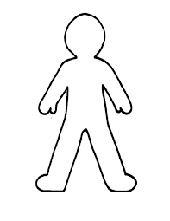Character outline…Roll on the wall type activity

