Right Start - Stage 3 – Look

Unit 1 - Be Safe Be Seen

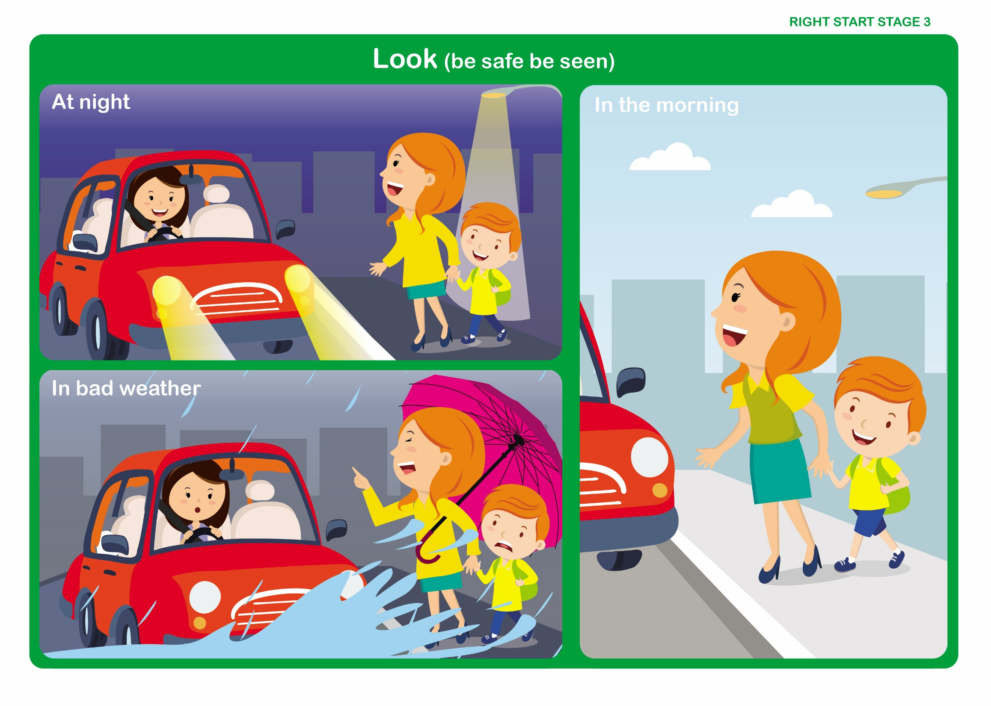

Let’s Talk

Discuss

Being Seen

• What materials are effective in daylight and darkness – (Fluorescent materials for daytime, Reflective materials for dusk/darkness) NB the jackets provided for the practical element of the programme will be useful to illustrate this point.
• Why we should always wear something light or bright especially in poor conditions - (Pedestrians need to be seen by drivers) What could we wear that is light and bright?
• Do you think that some vehicles are more easily seen because of their colour?
• How wearing a hood in bad weather may affect our ability to see clearly.
Right Start - Stage 3 – Look

Unit 1 - Vehicle Lights

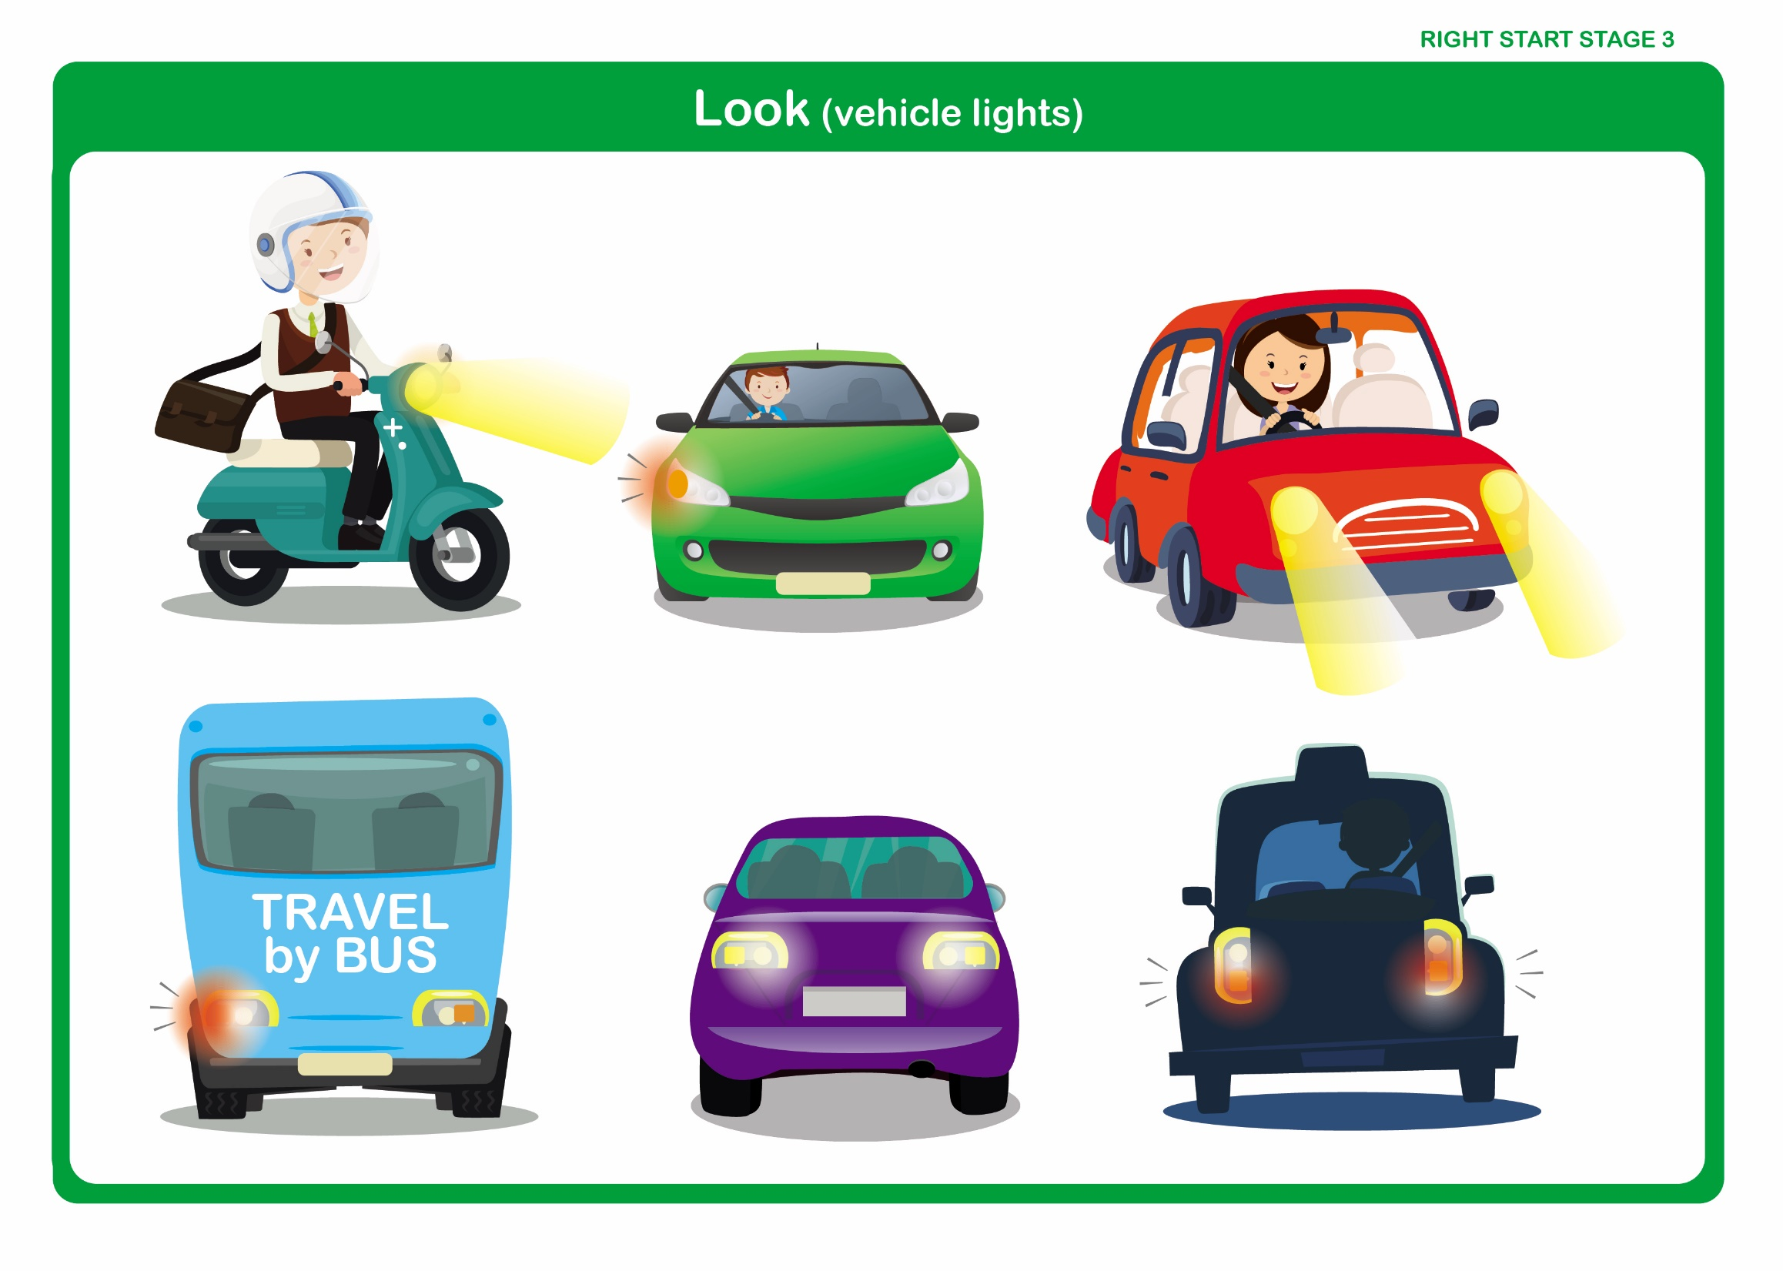

Let’s Talk

Discuss

- What lights we see on vehicles and what they tell us:-

• Orange indicators on each side telling us which way the vehicle is going to turn.

• White lights at the back when a vehicle is going to reverse.

• Red lights at the back when a vehicle is going to stop.
Right Start - Stage 3 – Listen

Unit 2 - Listen

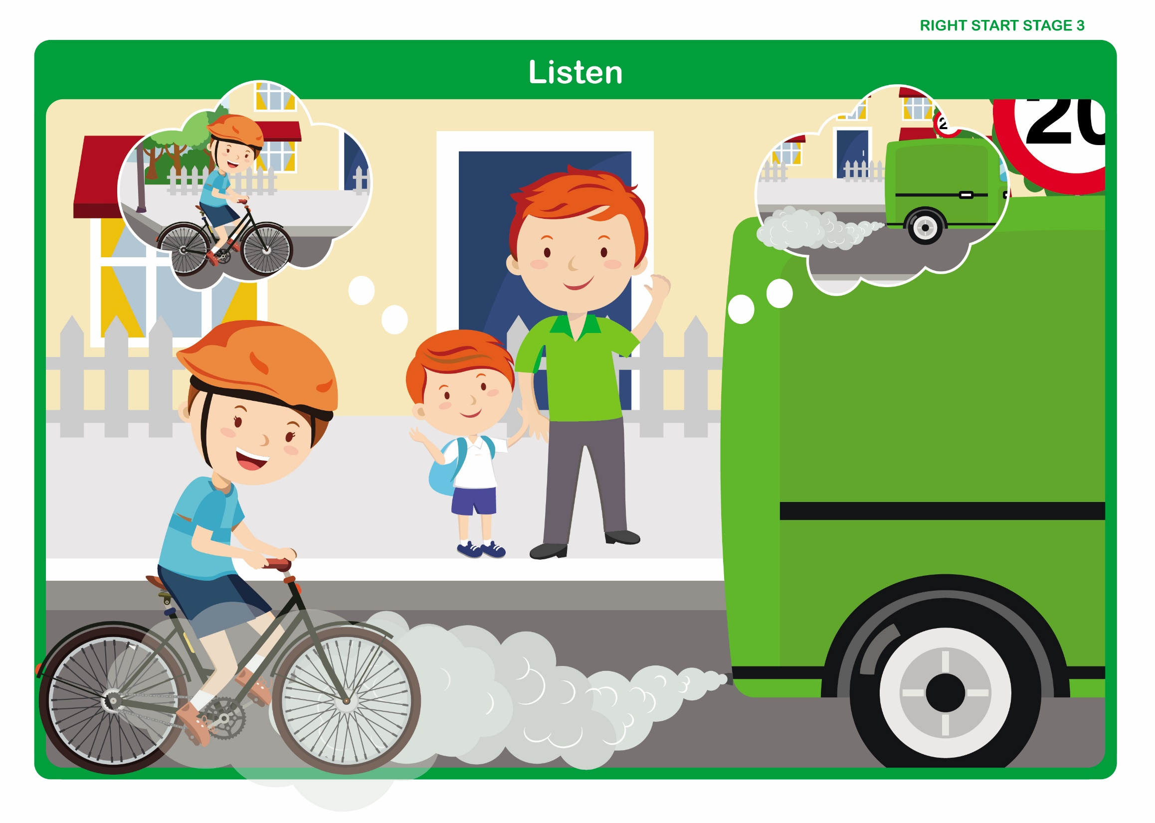

Let’s Talk

Discuss

• We listen with our ears, but our brain helps us to understand what we hear.

• Do we always understand what we hear?

• What effect could wearing a hood have on our ability to hear clearly?

NB In order to illustrate the necessary points the family in this pictorial aid are shown standing near a corner. This would not usually be recommended as a suitable place to cross the road. During the discussion this should be emphasised.
Right Start - Stage 3 – Safer Places

Unit 3 - Pelican Crossing

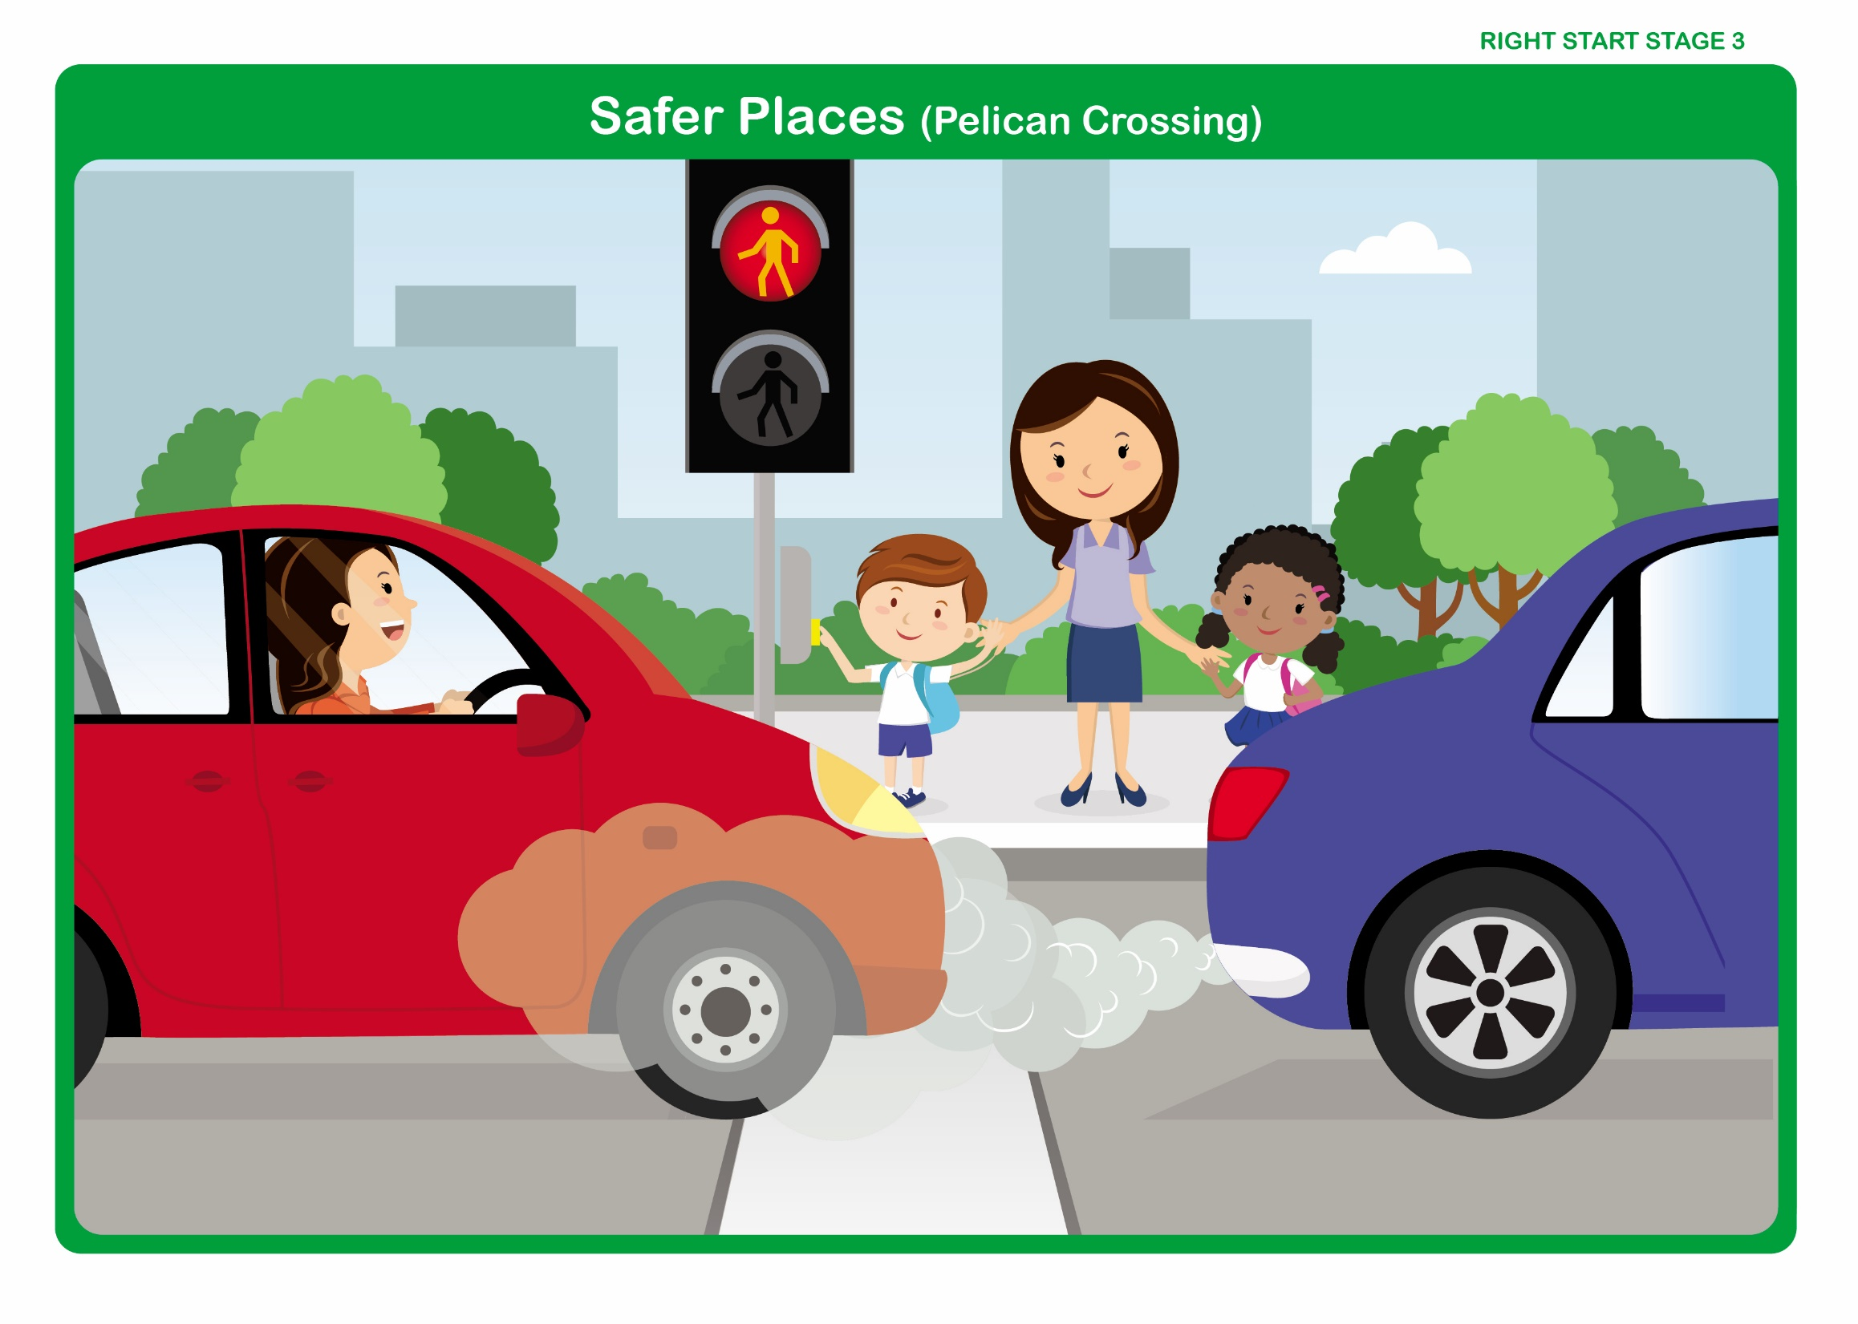

Let’s Talk

Discuss how to cross at a pelican crossing

• At a Pelican Crossing, the traffic is controlled by traffic lights.
• Press the button and wait on the pavement behind the kerb.
• When the red man signal is showing, stop and wait. DO NOT CROSS.
• When the green man signal appears, look and listen to make sure the traffic has stopped.
• Then walk across the road, DO NOT run.
• When the green man signal begins to flash, DO NOT start to cross.
• If you have started crossing, you will have time to finish crossing safely.
• Remember – do not cross on the zigzag lines.
• Remember – always hold the hand of the adult you are with.
Right Start - Stage 3 – Safer Places

Unit 3 - Zebra Crossing

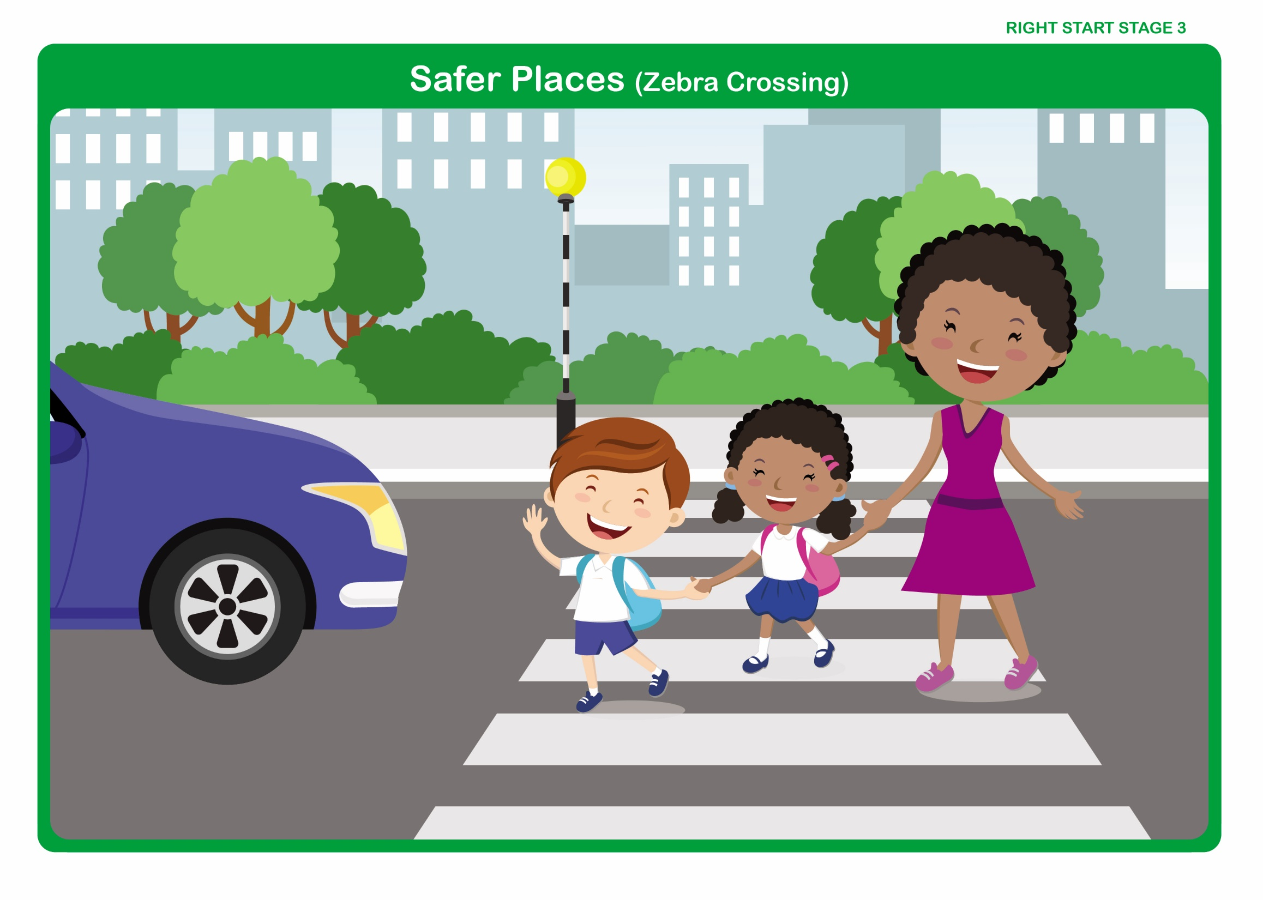

Let’s Talk - Discuss how to cross at a zebra crossing
• Do not cross on the zigzag lines, only cross on the black and white strips.
• Wait on the pavement behind the kerb until the traffic has stopped.
• Remember – drivers need lots of time to slow down and stop.
• Look and listen for traffic.
• After the traffic has stopped, walk straight across.
• Keep looking and listening – in case a driver has not seen you.
• Watch out for overtaking traffic.
• If there is an island in the middle of the crossing, when it is safe to do so, walk straight across the first half of the road and stop on the island.
• Keep looking and listening.
• After the traffic has stopped, walk straight across the second half of the road onto the pavement.
• Remember – always hold the hand of the adult you are with.
Right Start - Stage 3 – Safer Places

Unit 3 - Crossing at a Puffin Crossing

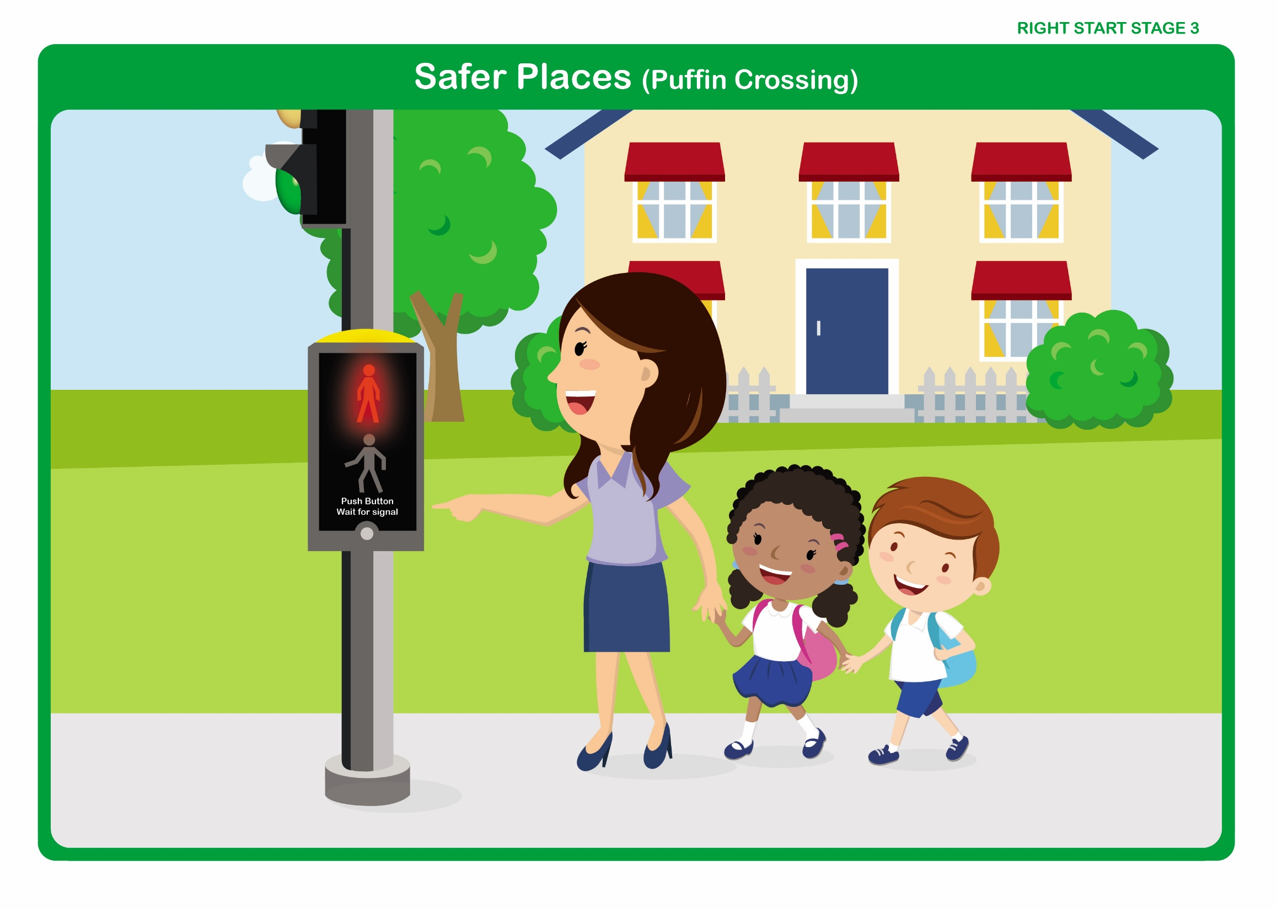

Let’s Talk

Discuss how to cross at a pelican crossing

- At a Puffin Crossing, the traffic is controlled by traffic lights.
- A Puffin Crossing has a tactile (bumpy) paving next to the control (push button) box
- It differs from a Pelican crossing in that the red and green men are now both above the push button on your side of the road.

There are sensors, which monitor people whilst waiting and crossing the road.

• Stand near to the post on the tactile paving.
• Press the button, (The sensors will know you are there).
• The word wait will appear.
• Watch the red man signal next to you.
• When it changes and the green man appears – check all the traffic has stopped.
• Cross, walking straight across the road, looking and listening as you go.
• The lights will only change when you have finished crossing the road.
Right Start - Stage 3 – Safer Places

Unit 3 - Footbridge

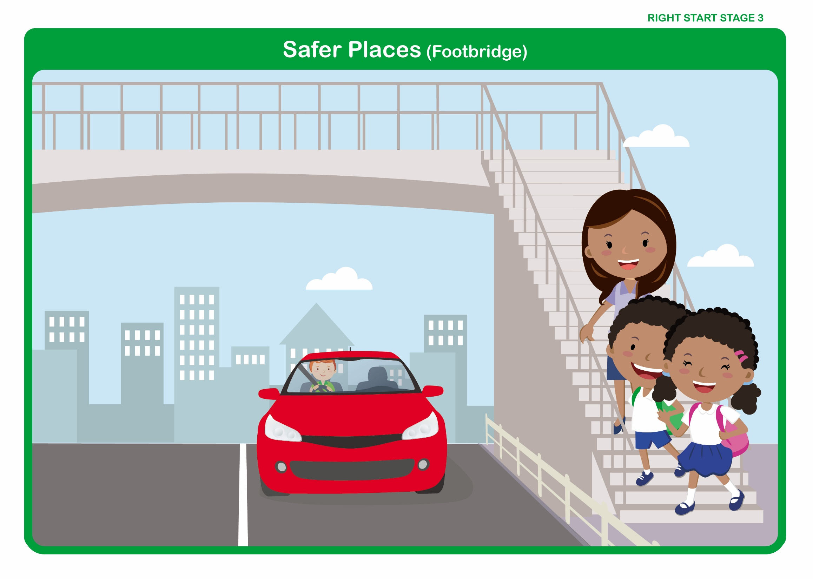

Let’s Talk

Discuss how to cross using a footbridge

• Footbridges take us over the road. This will take you over the traffic safely.
• Walk sensibly over the footbridge.
• Do not run.
• Remember – always hold the hand of the adult you are with.
• Remember – they are not safe places to play.
Right Start - Stage 3 – Safer Places

Unit 3 - Subway

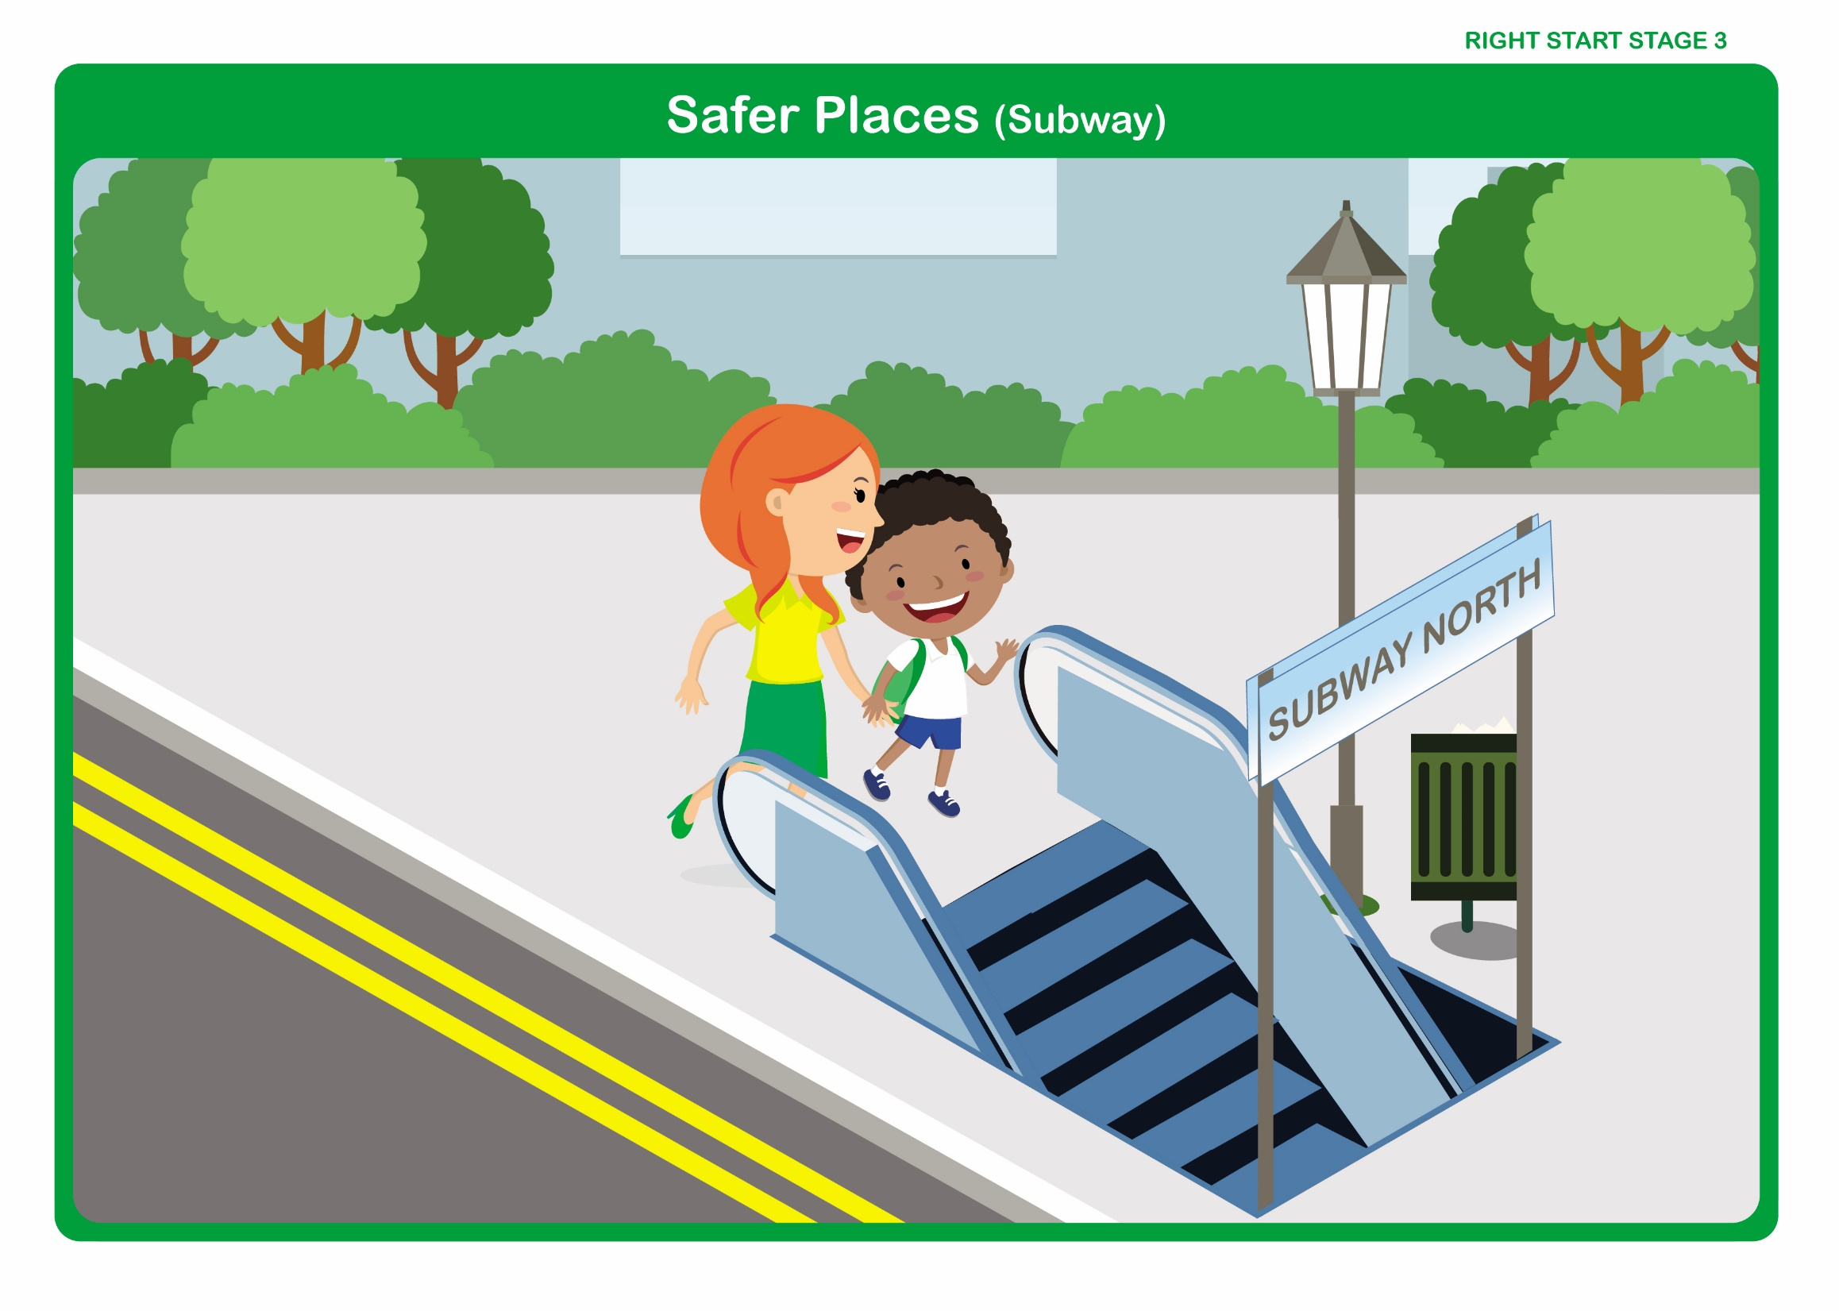

Let’s Talk

Discuss how to use a subway

• Subways take us underneath the road.

• It is safer to use a Subway with an adult that you know.

• Walk sensibly through the Subway.

• Do not run.

• Remember – always hold the hand of the adult you are with.

• Remember – Subways are not safe places to play.
Right Start - Stage 3 – Safer Places

Unit 3 - Traffic Island

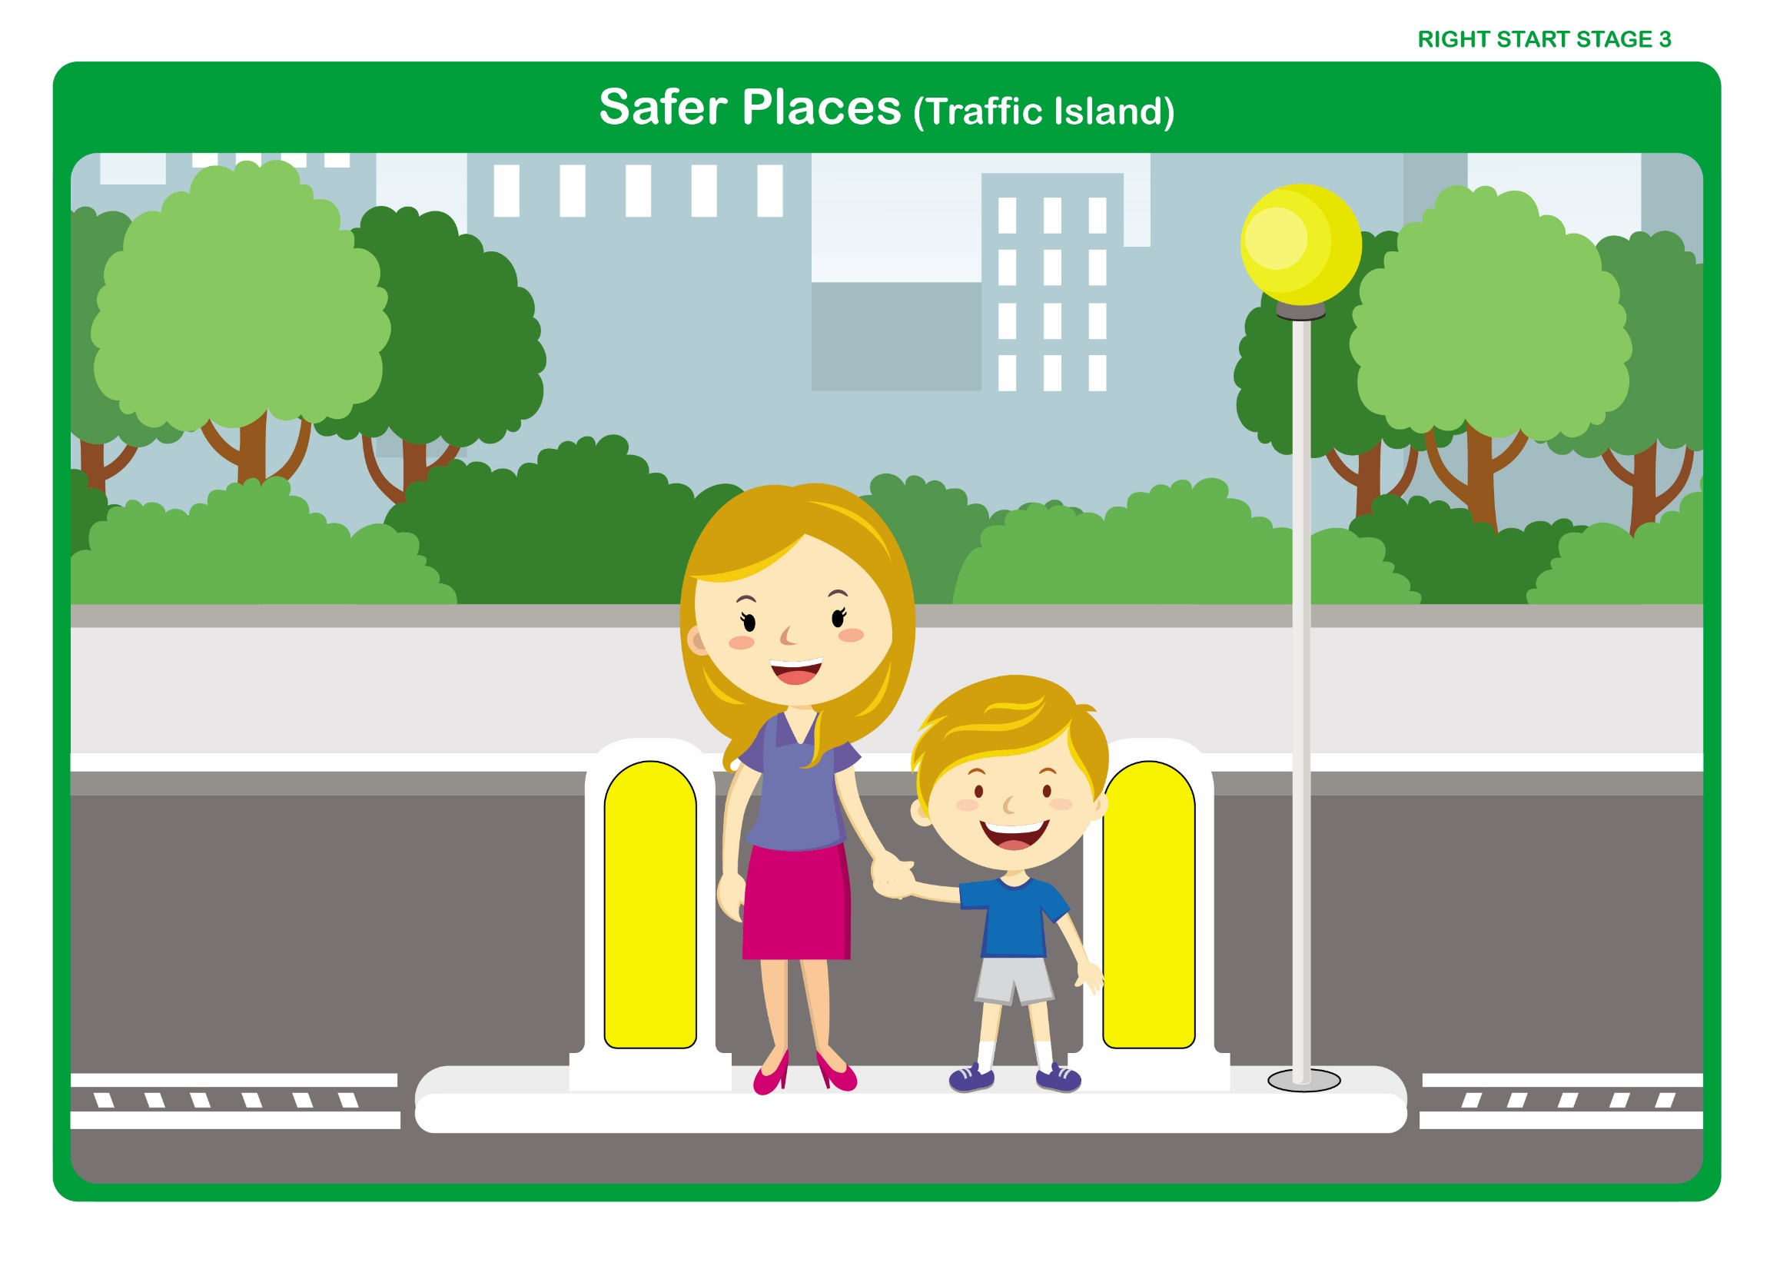

Let’s Talk

Discuss how to cross using a Traffic Island

• Traffic Islands are usually on very busy roads; you only have to cross one half at a time.

• Stop and wait on the pavement behind the kerb.

• Look and listen for traffic.

• When it is safe to do so, walk straight across the first half of the road to the central island.

• Stop on the island.

• Look and listen for traffic.

• When it is safe to do so, walk straight across the second half of the road on to the pavement.

• Remember – do not run.

• Remember – always hold the hand of the adult you are with.
Right Start - Stage 3 – Safer Places

Unit 3 - Parked Cars

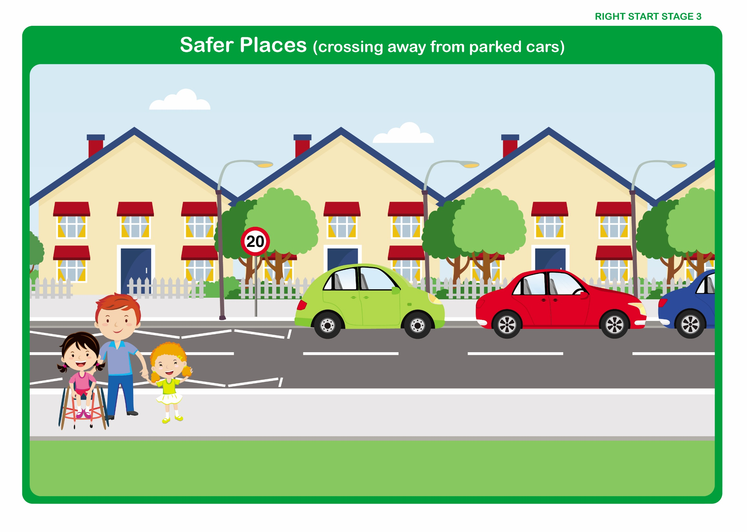

Let’s Talk

Discuss

• The importance of, whenever possible, crossing away from parked cars so that we can see clearly in both directions.

- Making it possible for car drivers to see us when we are waiting to cross the road.

