Right Start - Stage 2 – Stop

Unit 1 - Stop at the Kerb

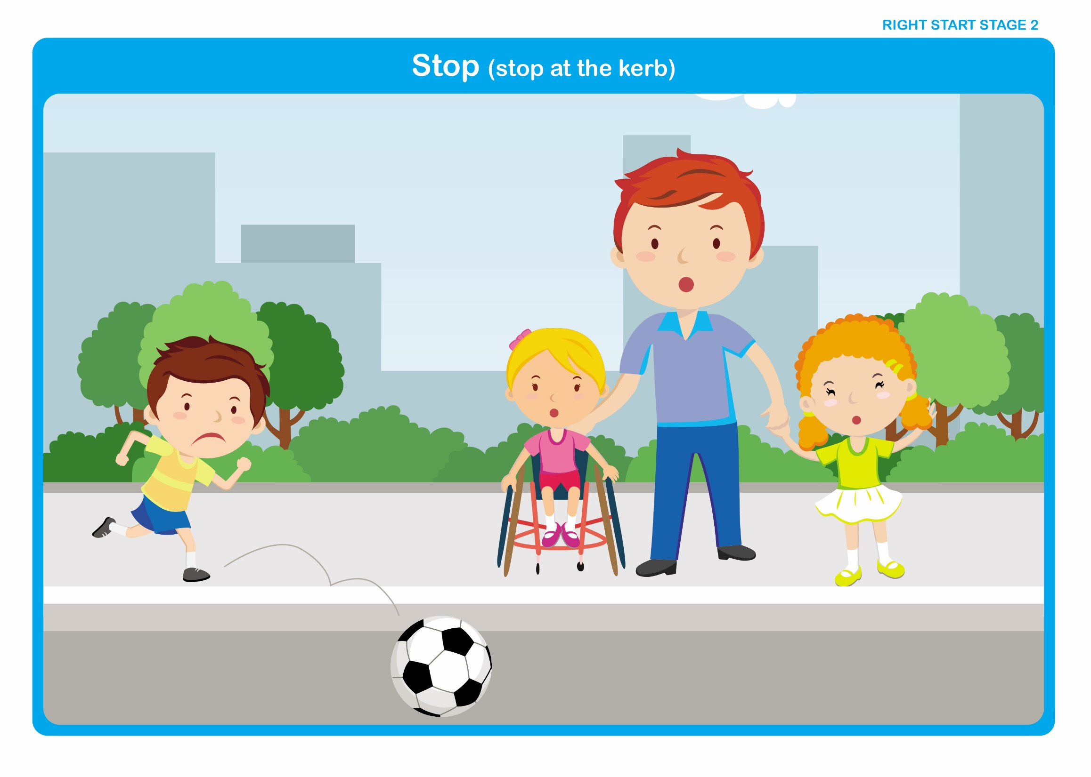

Let’s Talk

Discuss

Reinforce the following points previously covered in Stage 1
• What the word stop means.

• The importance of stopping before crossing the road.

• Where we stop and wait - (Feet should be behind the kerb).

• Why we stop and wait - (To give time to make sure it is safe to cross).

• How we wait - (Quietly and sensibly).

Introduce
• Times when it may be difficult to stop - (When playing or being chased, it may be more difficult or take longer to stop).

Right Start - Stage 2 – Stop

Unit 1 - Wet and Dry Roads

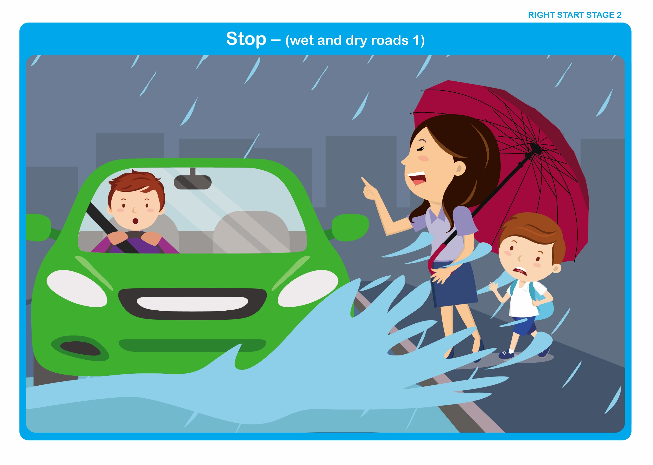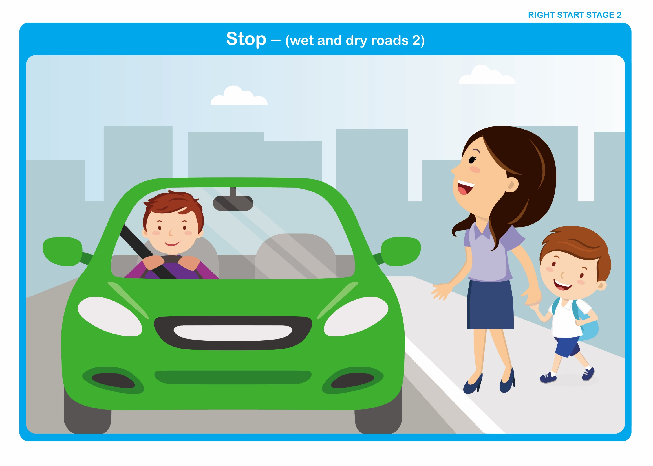

Let’s Talk

Discuss

• Are vehicles able to stop instantly?

• Do larger/heavier vehicles take longer than smaller/lighter vehicles?

• Do faster vehicles take longer than slower vehicles?

• How weather conditions may affect the time it takes to stop - (Slippery roads).

• What makes a road slippery? - (Rain, ice, leaves).
Right Start - Stage 2 - Crossing

Unit 2 - Walk Straight Across the Road

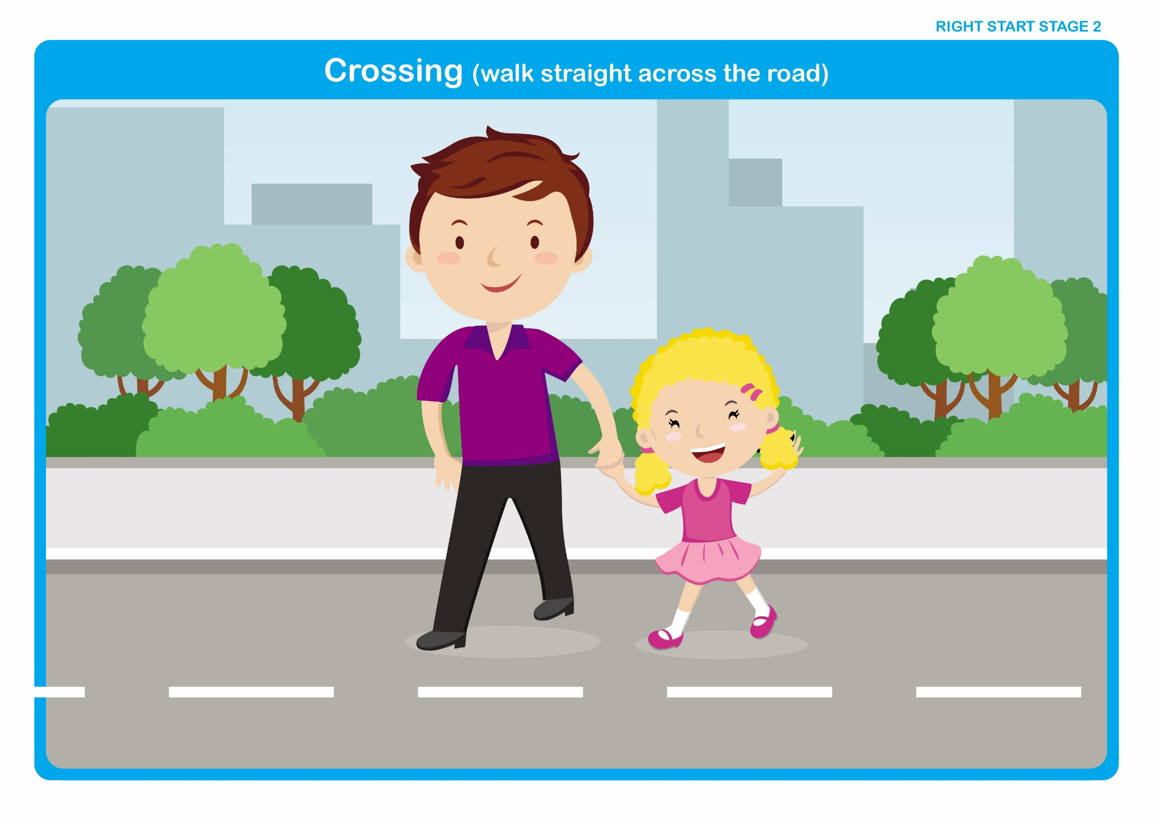

Let's Talk

Discuss

Reinforce the following points previously covered in Stage 1

• Why, even on quiet and familiar roads, we must still cross with a grown-up.

• Why we should not run across the road - (We might fall).

• Why we should keep hold of a grown-up’s hand - (To stay together and keep safe).

Introduce

• Why we should always walk straight across the road - (We reach the other side in the shortest possible time).

• Whilst crossing, if a vehicle approaches what should we do - (Keep hold of hands and listen carefully to the grown-ups we are with, they will tell us what to do).

Right Start - Stage 2 - Crossing

Unit 2 - Walking Straight Across the Road When Using a Zebra Crossing

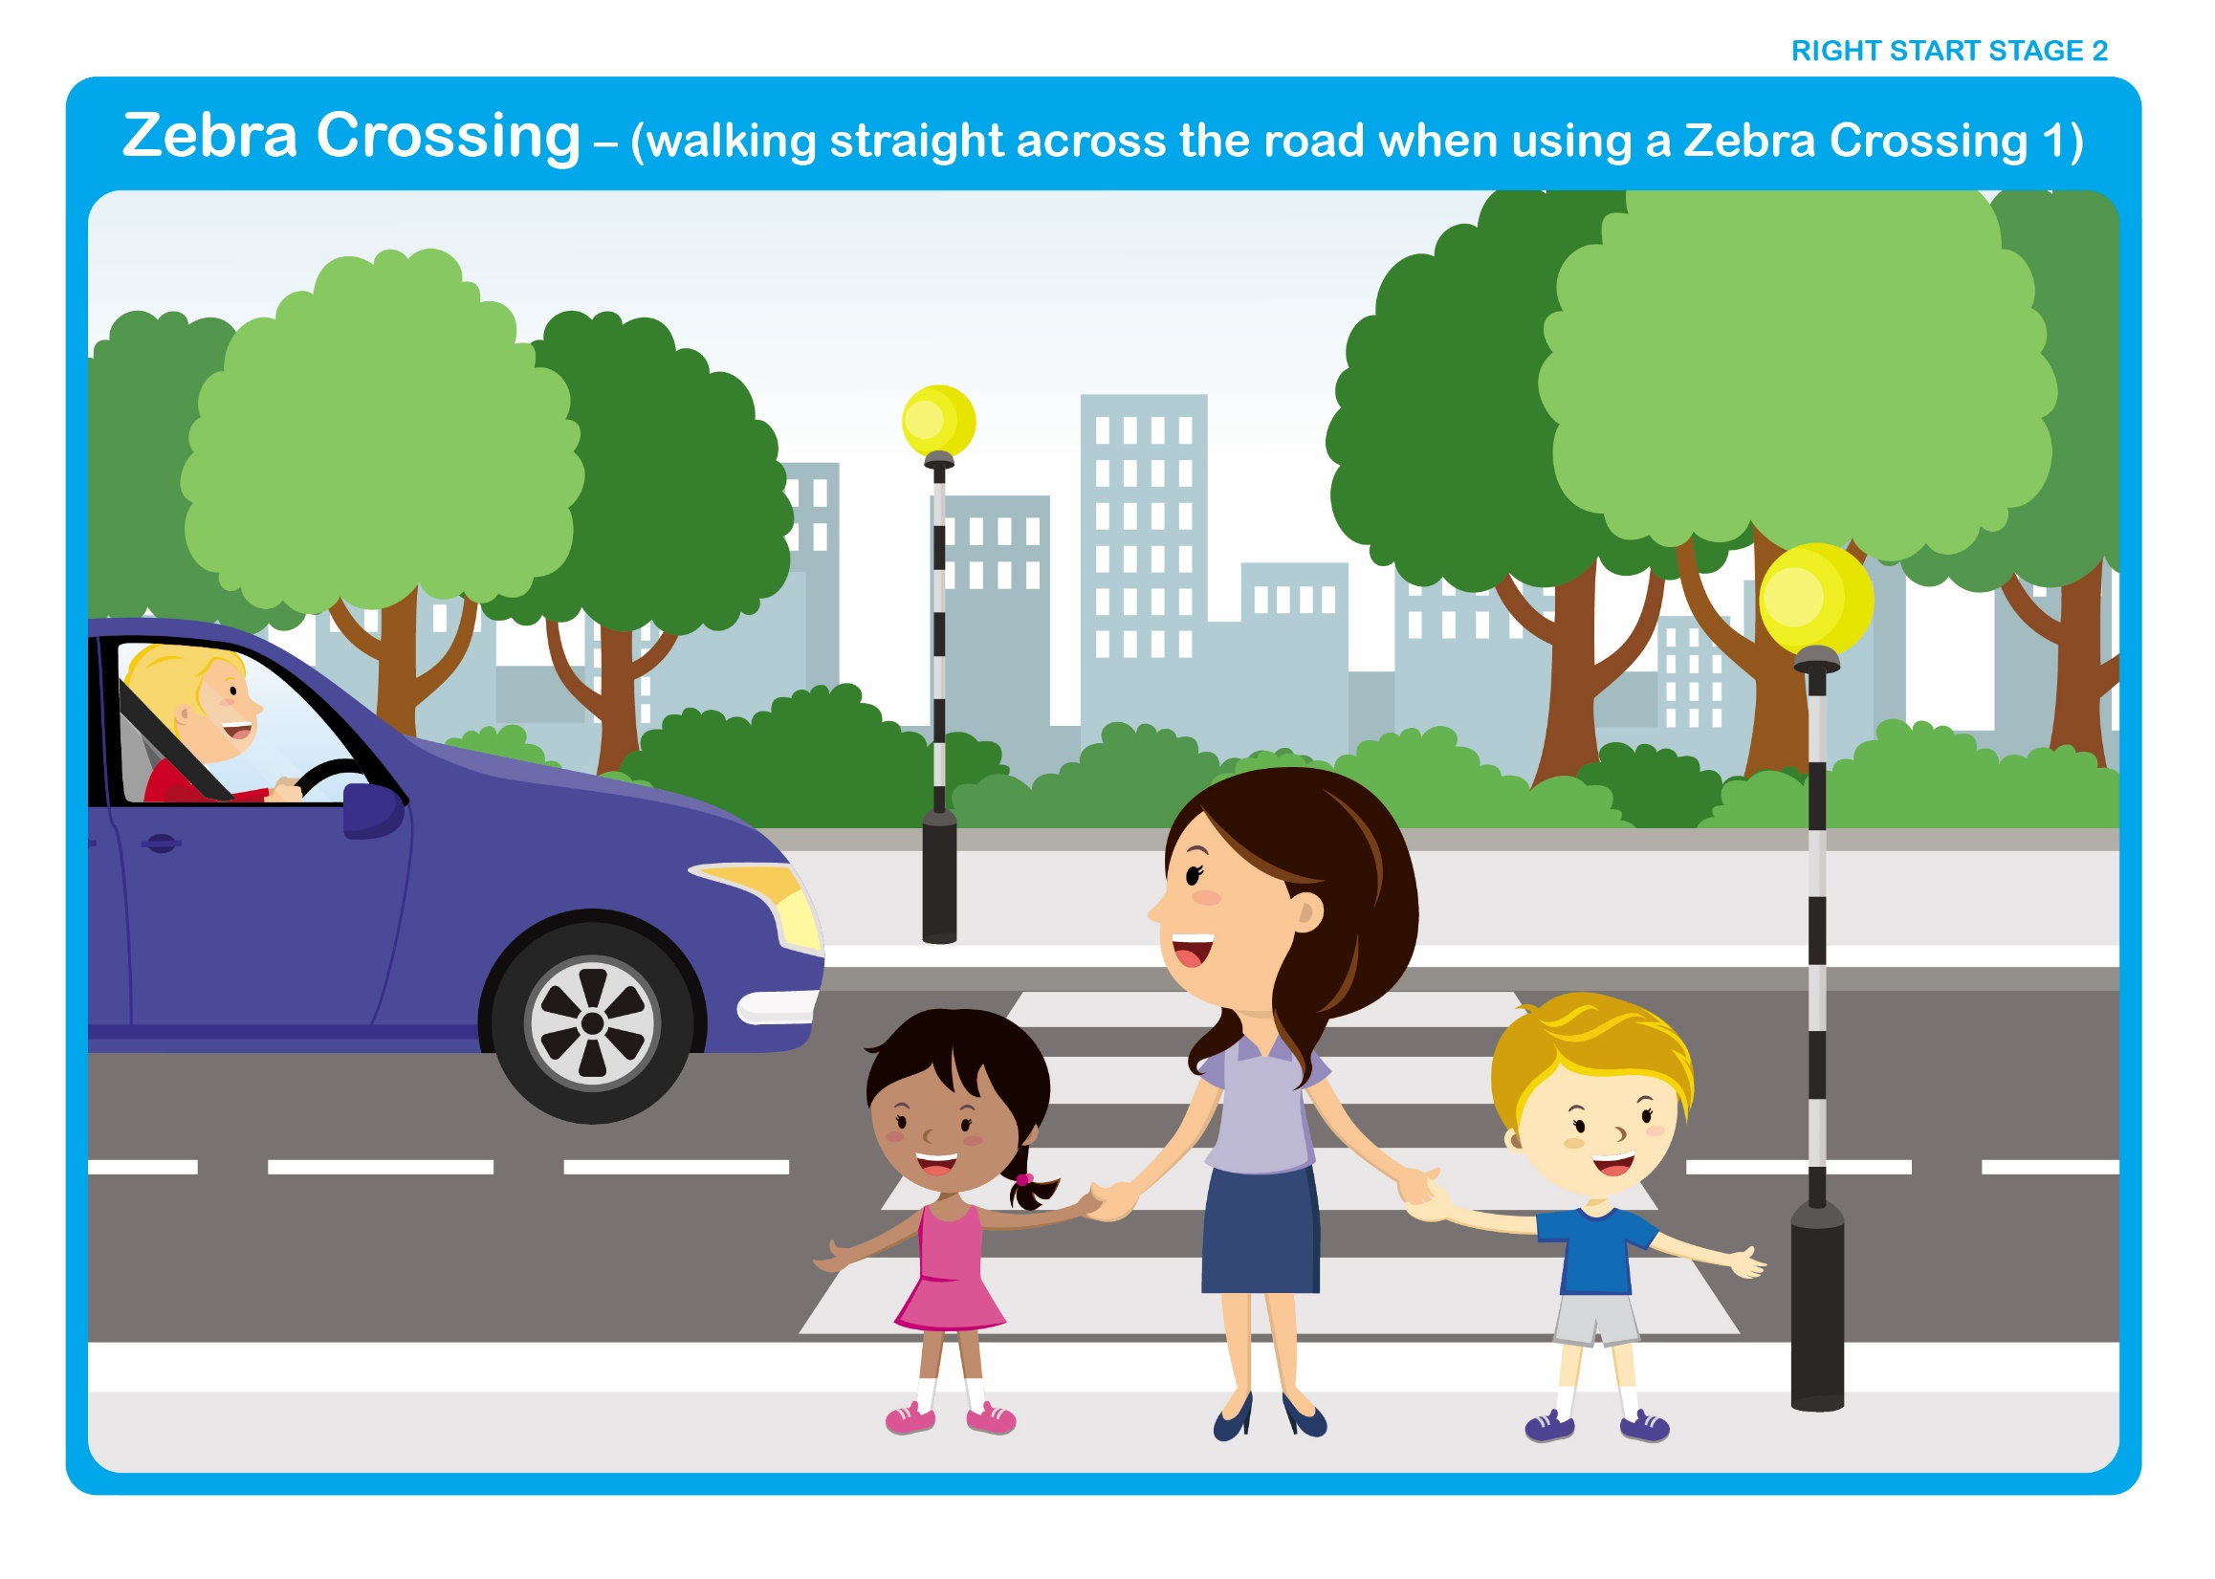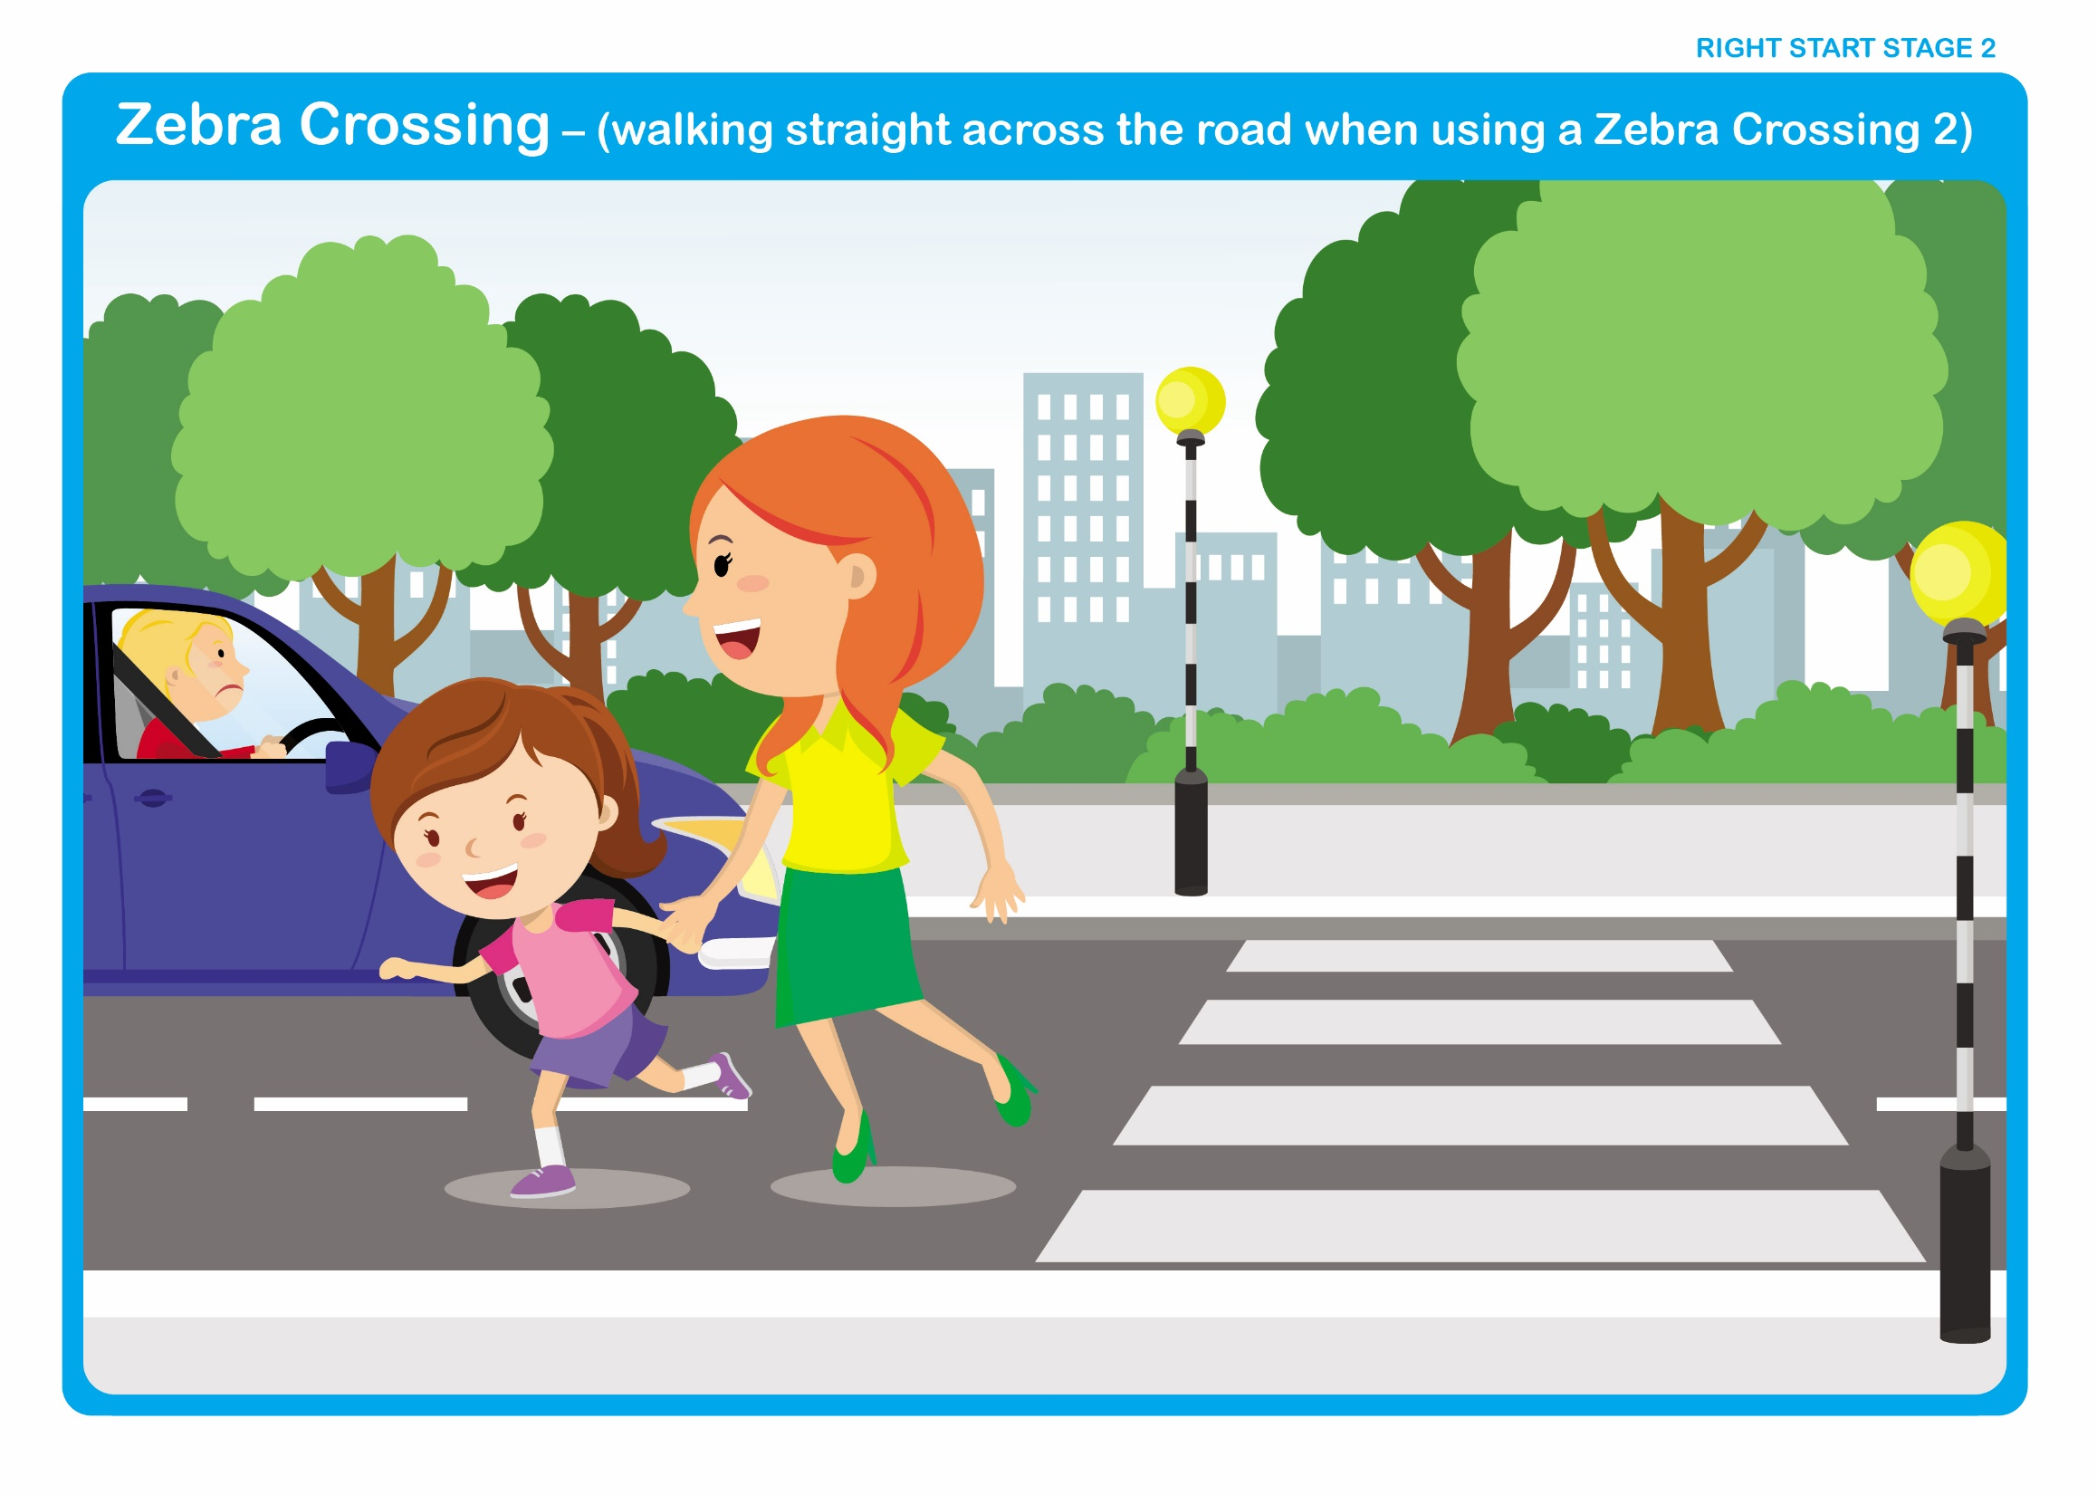

Let's Talk

Discuss

• Which is the correct way?

• Only cross on the black and white stripes.

• Do not cross on the zigzag lines.
Right Start - Stage 2 – Crossing

Unit 2 - Crossing between parked cars

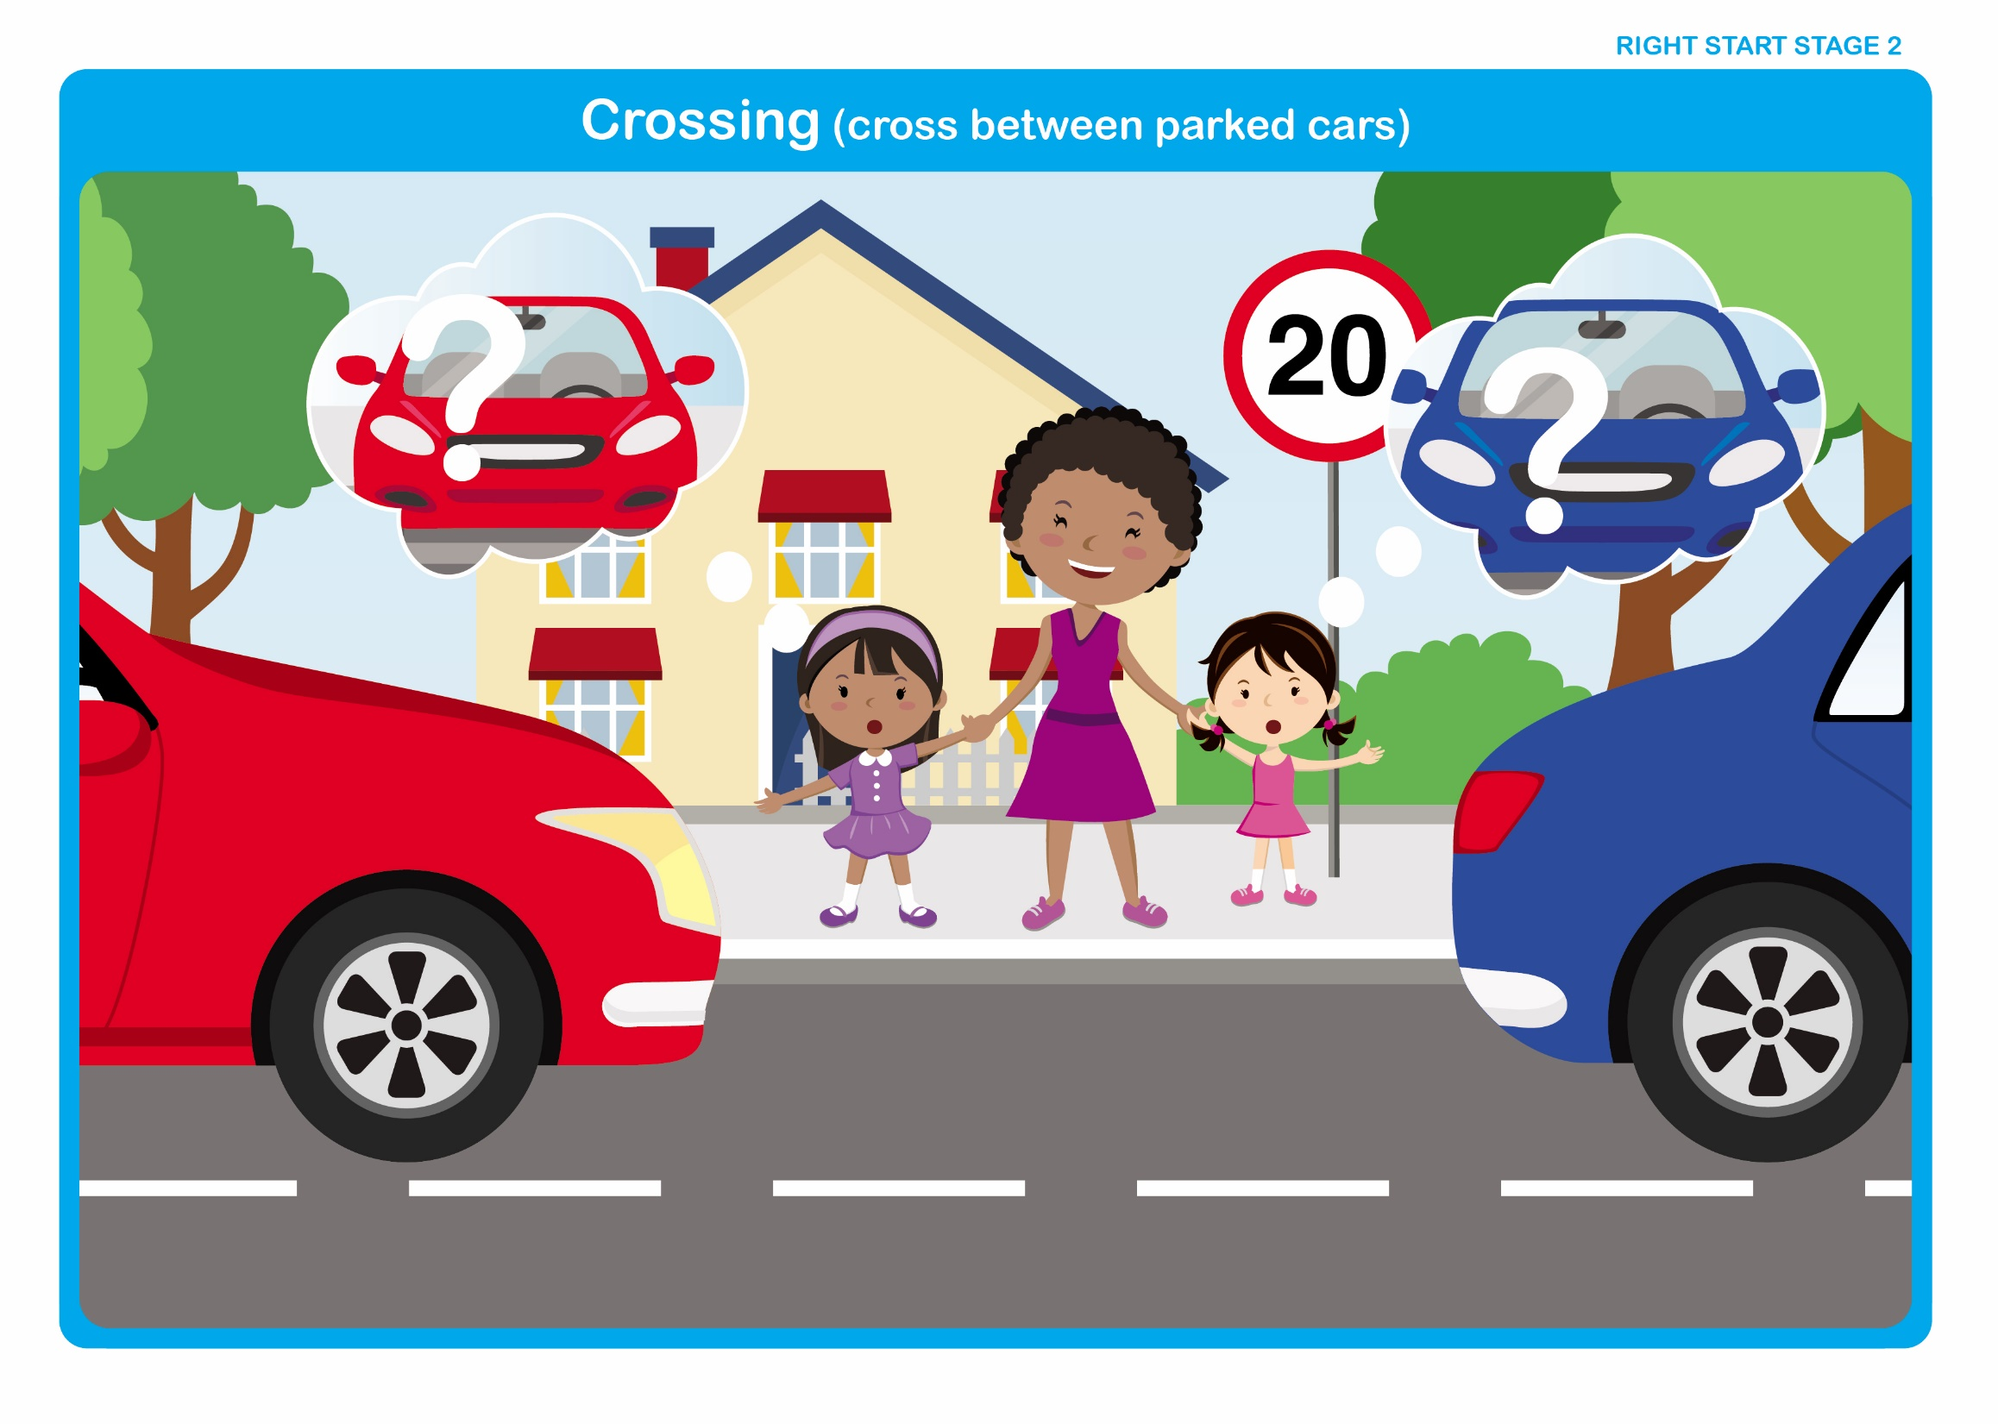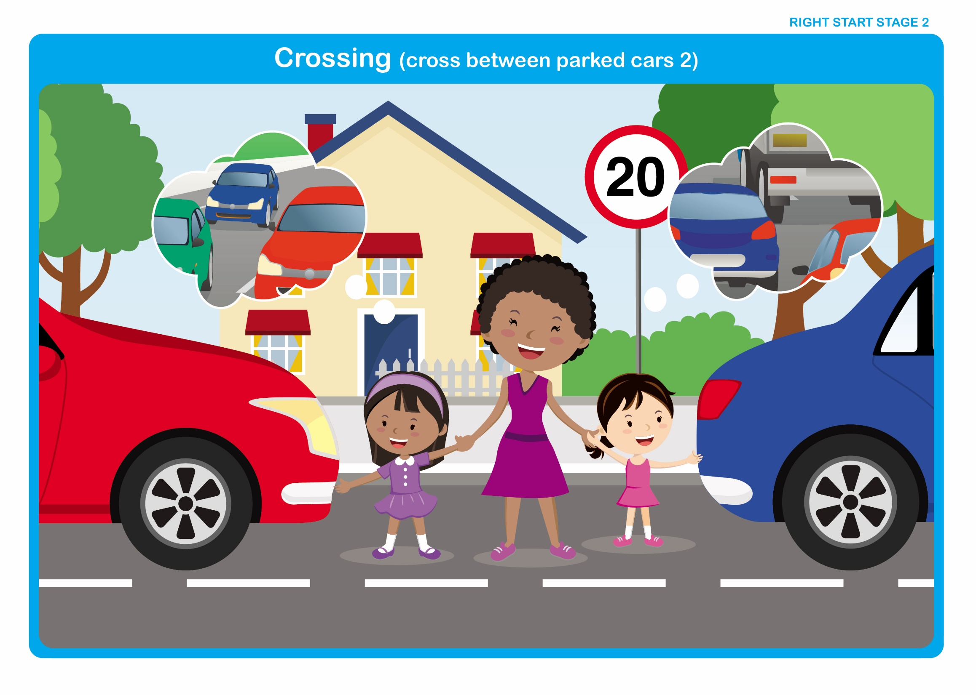

Let’s Talk - Discuss

• Would they be able to see clearly along the road? (Their view is obstructed by the vehicles and very often the vehicles are taller than the children).

• Although children can sometimes see through vehicle windows this does not give them sufficient view to decide whether it is safe to cross.

- Would drivers be able to see them? (Driver’s views are obstructed by the parked vehicles).

Whenever possible cross away from parked cars, yet there may be times when crossing between parked cars cannot be avoided and if so, this is what they should do.

- Choose a place where there is a space between two cars and make sure they can walk straight across to the other side of the road (no parked cars in the way on the other side).
- Make sure neither car is about to move by looking for drivers, checking for lights and listening for engine noise.
- Walk between the cars until they are level with the outside edge and stop. Here they can be seen by drivers and see clearly along the road.
- Look and listen for traffic.
- When it is safe, walk straight across the road. Do not run. Keep looking and listening for traffic as they cross.
Right Start - Stage 2 – Other People

Unit 3 - People Who Help Us

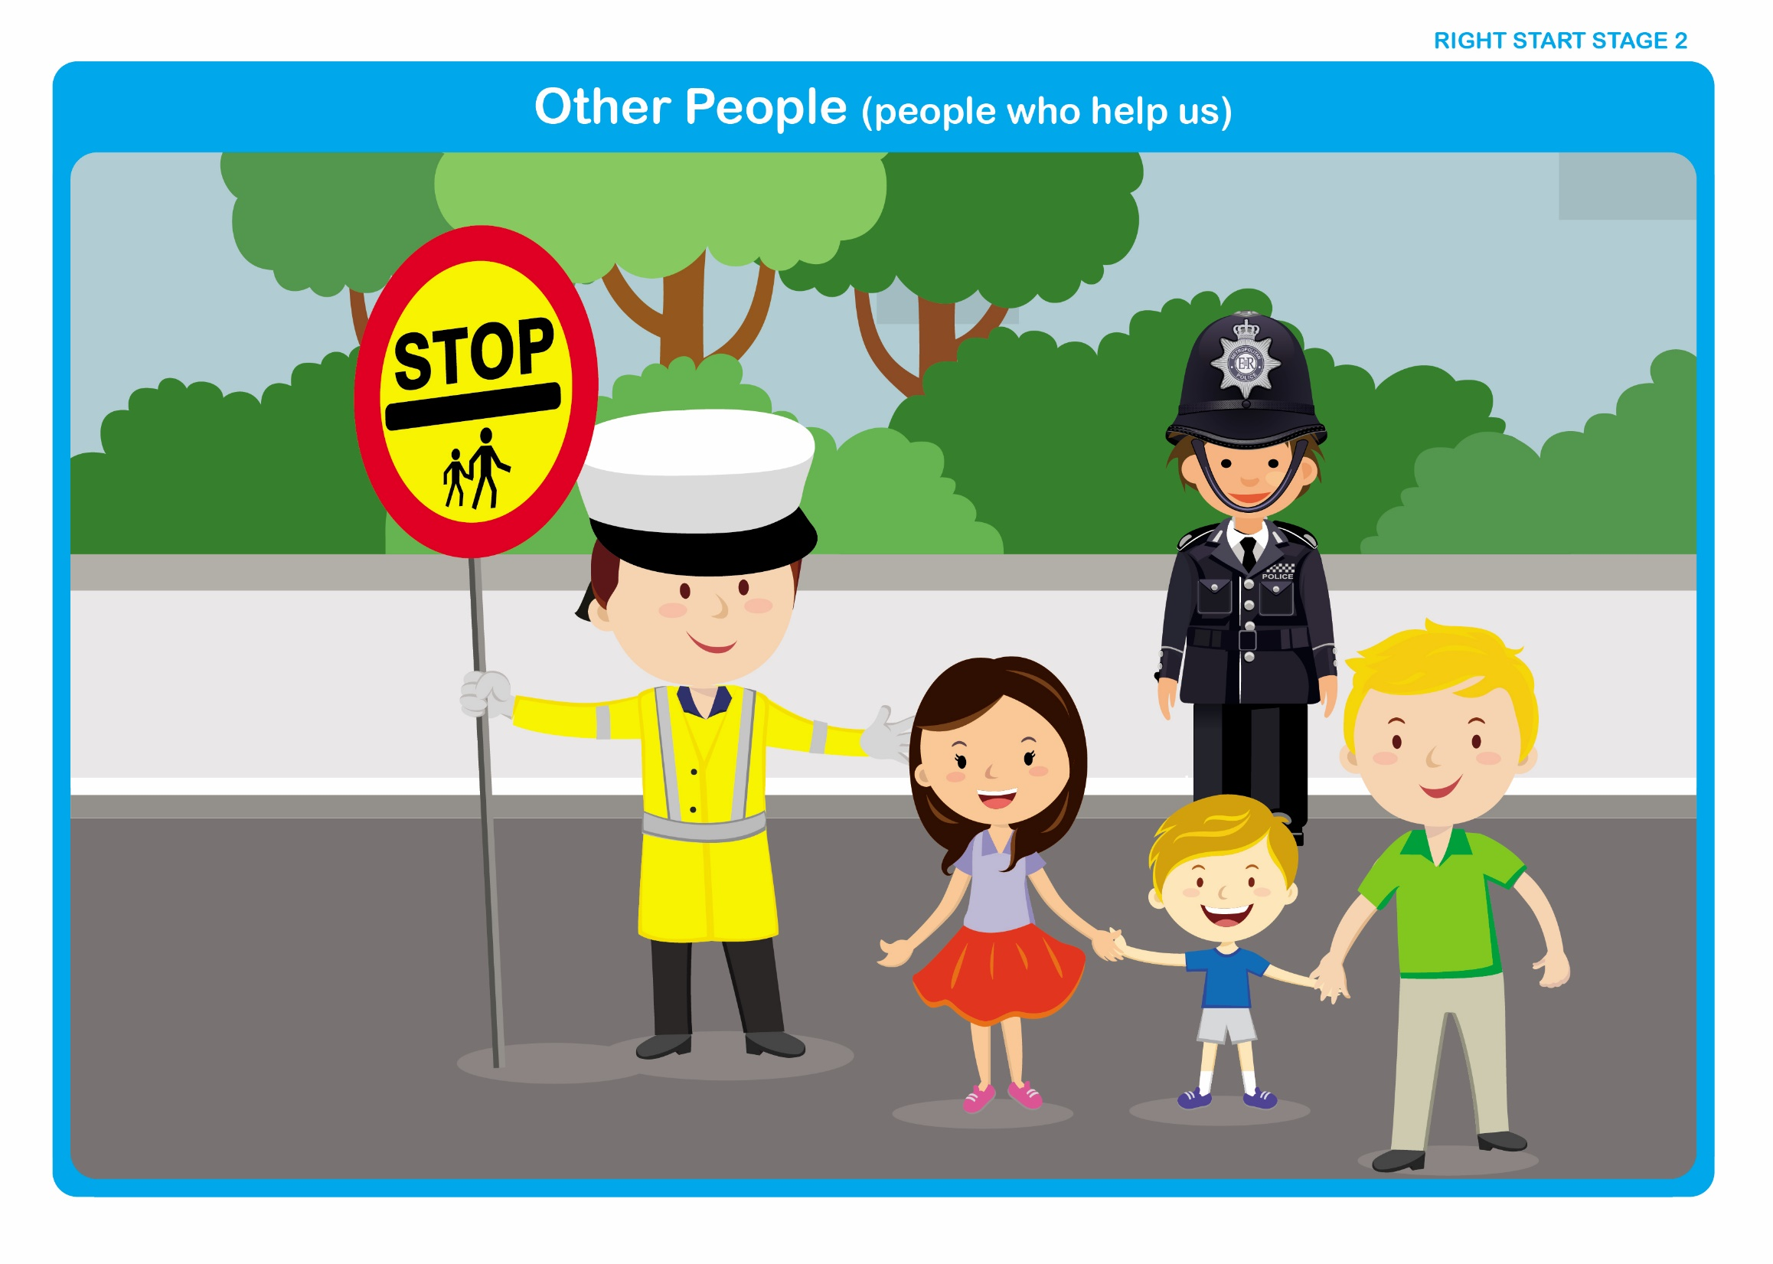

Let’s Talk

Discuss

• People who might help us to cross the road (Police, School Crossing Patrol and Grown-ups that we know well).

• When crossing with the help of a uniformed person, (Police, School Crossing Patrol), do not start to cross until they tell us to do so. Remember to cross in front of them.

• When other people are helping us to cross, should we still look and listen for ourselves? Why? (We may see something that the grown-up hasn’t seen).

