Right Start - Stage 1 - Other People

Unit 1 - Hold Hands

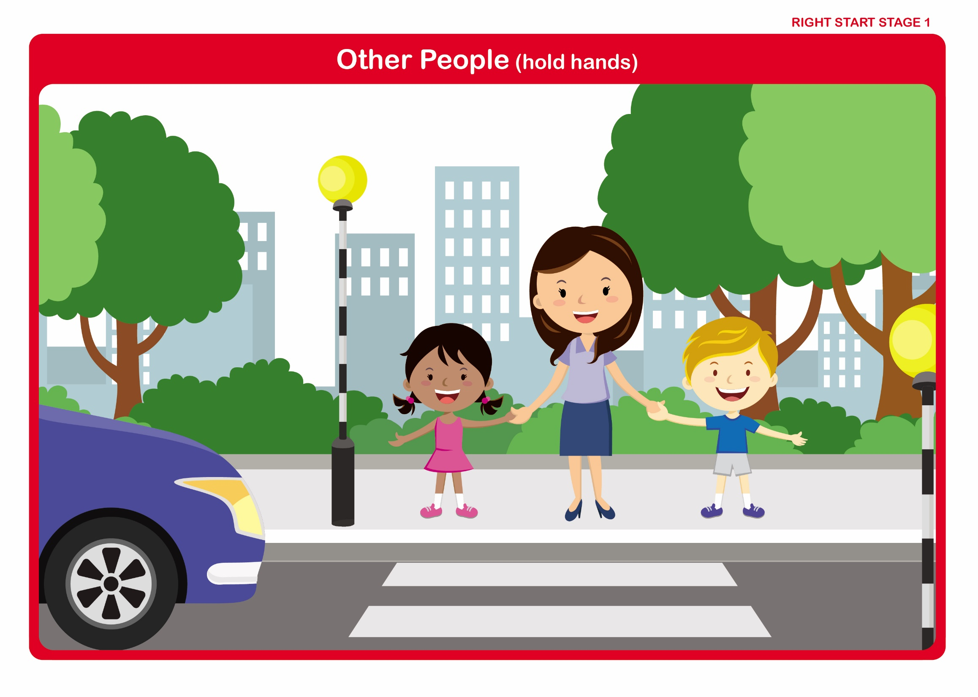

Let’s Talk

Discuss: -

• What and where is the footpath/pavement?

• What and where is the road?

• What and where is the kerb?

• Roads are for traffic, pavements are for people.

• Why children should only go out with a grown-up they know well - (Danger from traffic, stranger danger).

• Why they should hold a grown-up’s hand - (To stay together and be safe).
Right Start - Stage 1 - Other People

Unit 1 - Hold Tightly

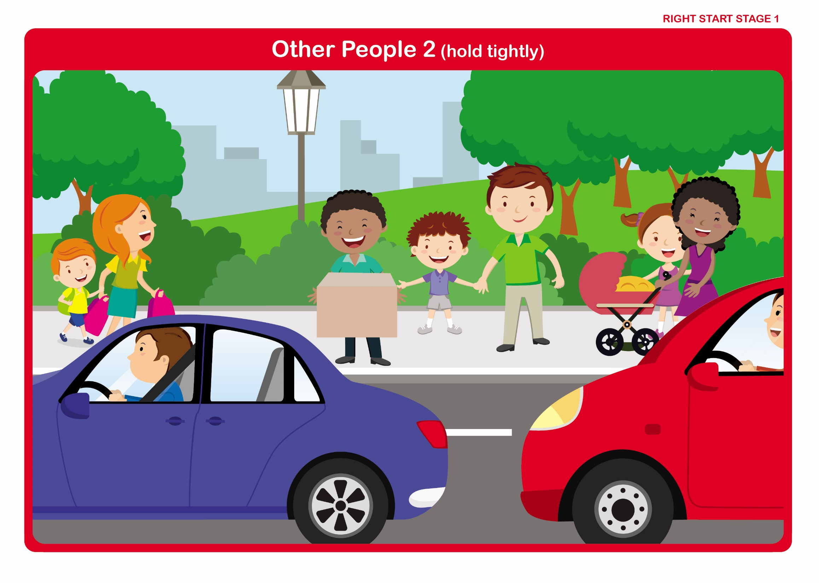

Let’s Talk

Discuss: -

• If they cannot hold a grown-up’s hand, what should they hold on to?
(i.e. pram handle, bag, arm).

• Why they should not run off - (danger from traffic).

• Where they should walk - (Away from the kerb, on the inside of the pavement).

Right Start - Stage 1- Safer Places

Unit 2 - Quiet and Busy Roads

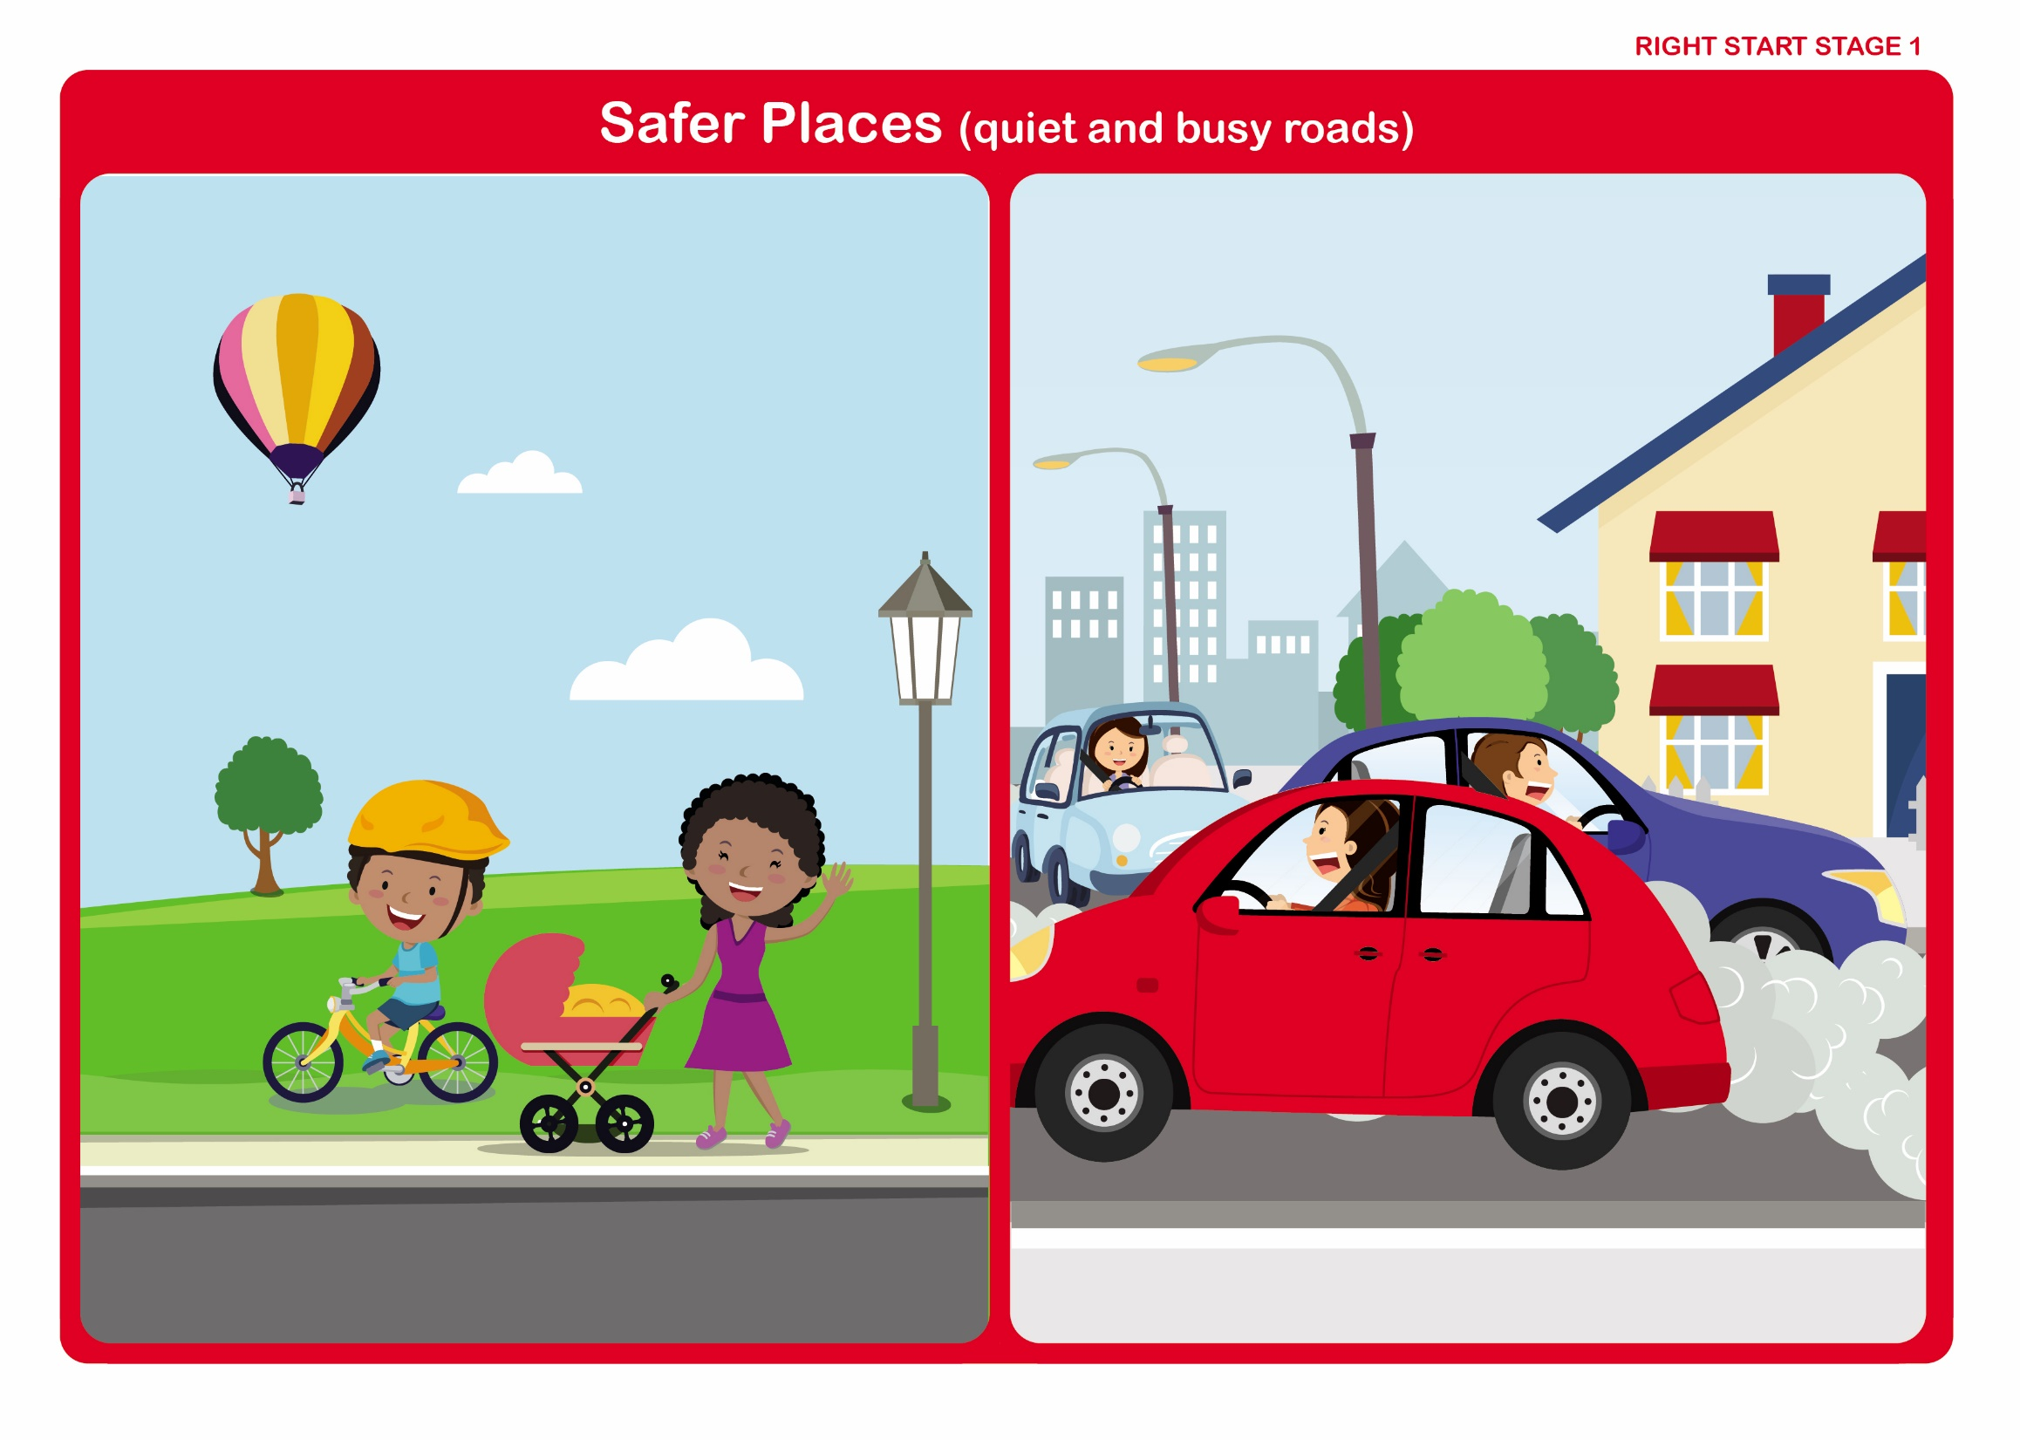

Let’s Talk

Discuss: -

• What we see moving along roads - (Cars, buses, etc.).

• The word to describe all of these - (Vehicles).

• The collective noun for vehicles - (Traffic).

• Which is a quiet road and why is it quiet?

• Which is a busy road and why is it busy?

• How any road can be quiet or busy?

Right Start - Stage 1- Safer Places

Unit 2 - In the Street

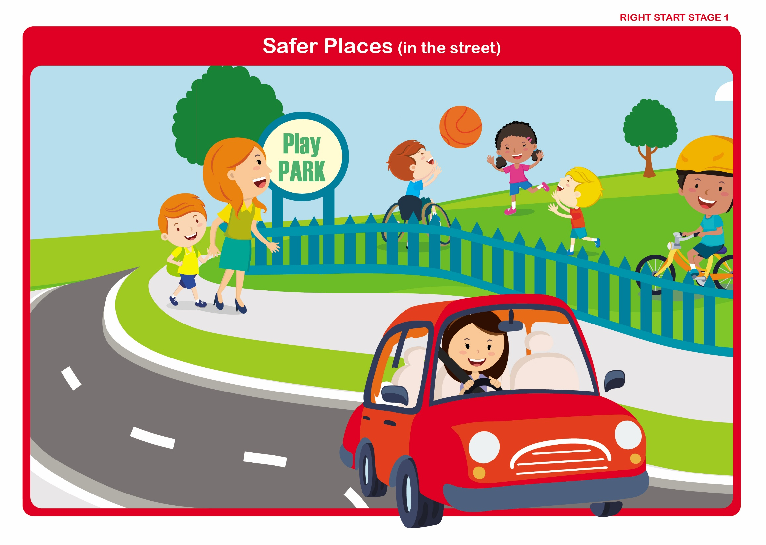

Let’s Talk

Discuss: -

• What and where is the footpath/pavement?

• What and where is the kerb?

• What is a grass verge? - (Children should not play on these).

• What is a driveway? - (Cars may emerge from or turn into driveways).

• Where to play away from traffic - (Park, garden).

• Where it is safe to walk - (Away from the kerb).

Right Start - Stage 1 – Stop

Unit 3 - Stop at the Kerb

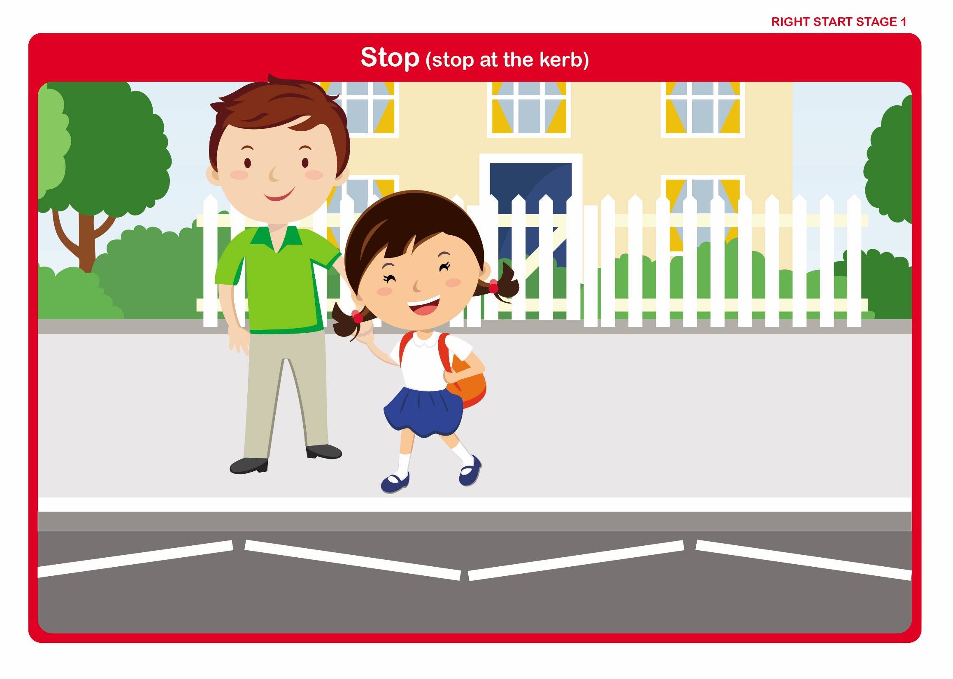

Let’s Talk

Discuss: -

• What the word stop means.

• The importance of stopping before crossing the road.

• Why they stop and wait - (To give time to make sure it is safe to cross).

• Where they stop and wait - (Feet should be behind the line of the kerb).

• How they wait - (Quietly and sensibly).
Right Start - Stage 1 – Look

Unit 4 - Look - Big or Small

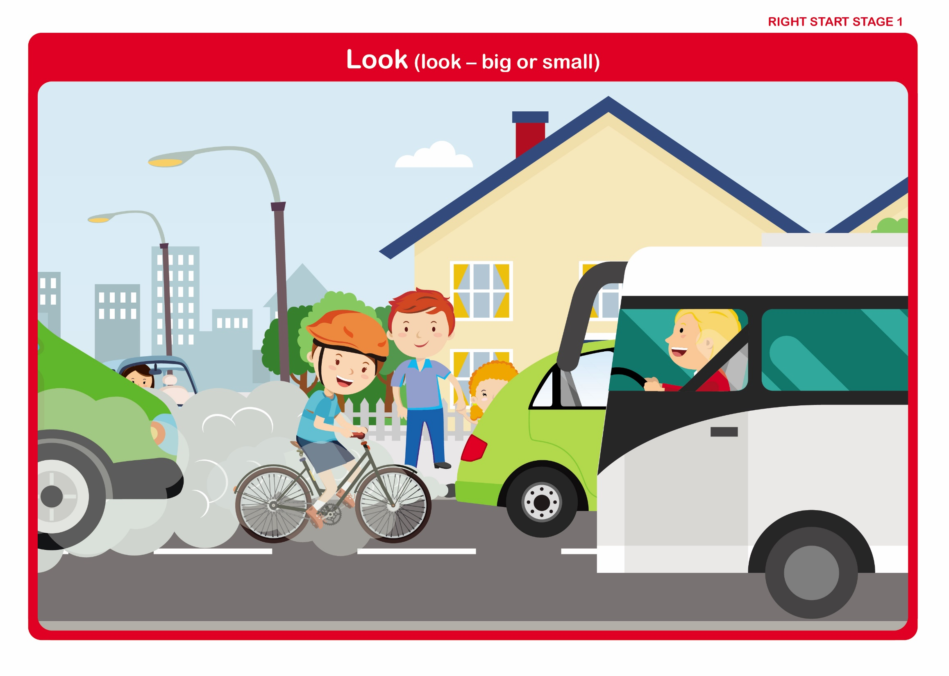

Let’s Talk

Discuss: -

• What we see moving along roads - (Cars, buses, etc.).

• The word to describe all of these - (Vehicles).

• The collective noun for vehicles - (Traffic).

• Which are big?

• Which are smaller?

• Which vehicles have stopped?

• Why they think the van has stopped - (To deliver goods).
Right Start - Stage 1 – Listen

Unit 5 - Listen Carefully for Traffic

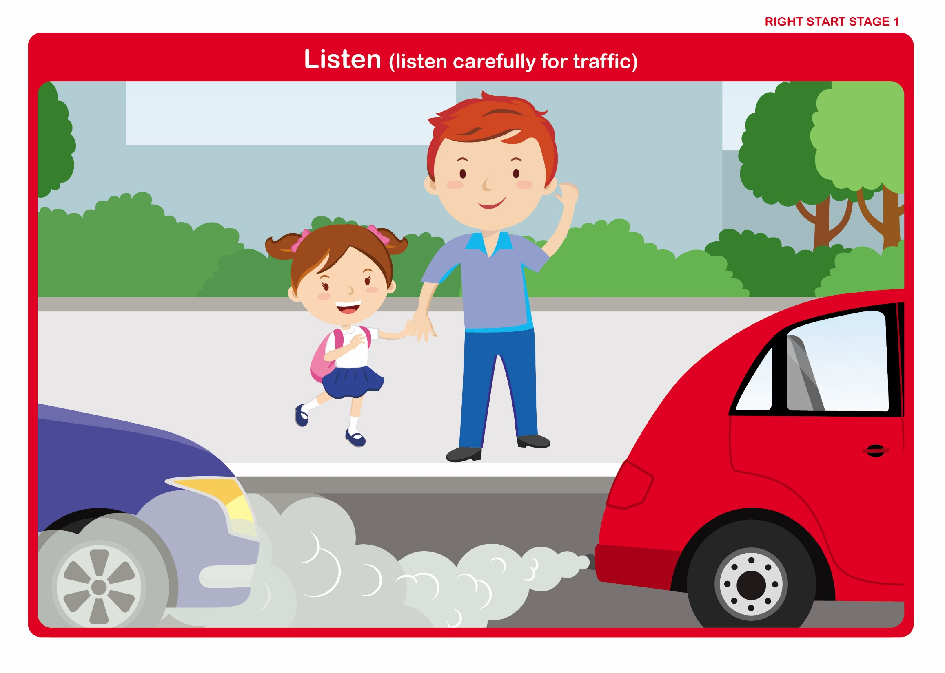

Let’s Talk

Discuss: -

• How we hear.

• The importance of listening before crossing the road.

• Noises that might be heard in the street.

• Why we listen - (Sometimes we hear traffic before we see it).
Right Start - Stage 1 – Crossing

Unit 6 - Always Cross With a Grown-Up

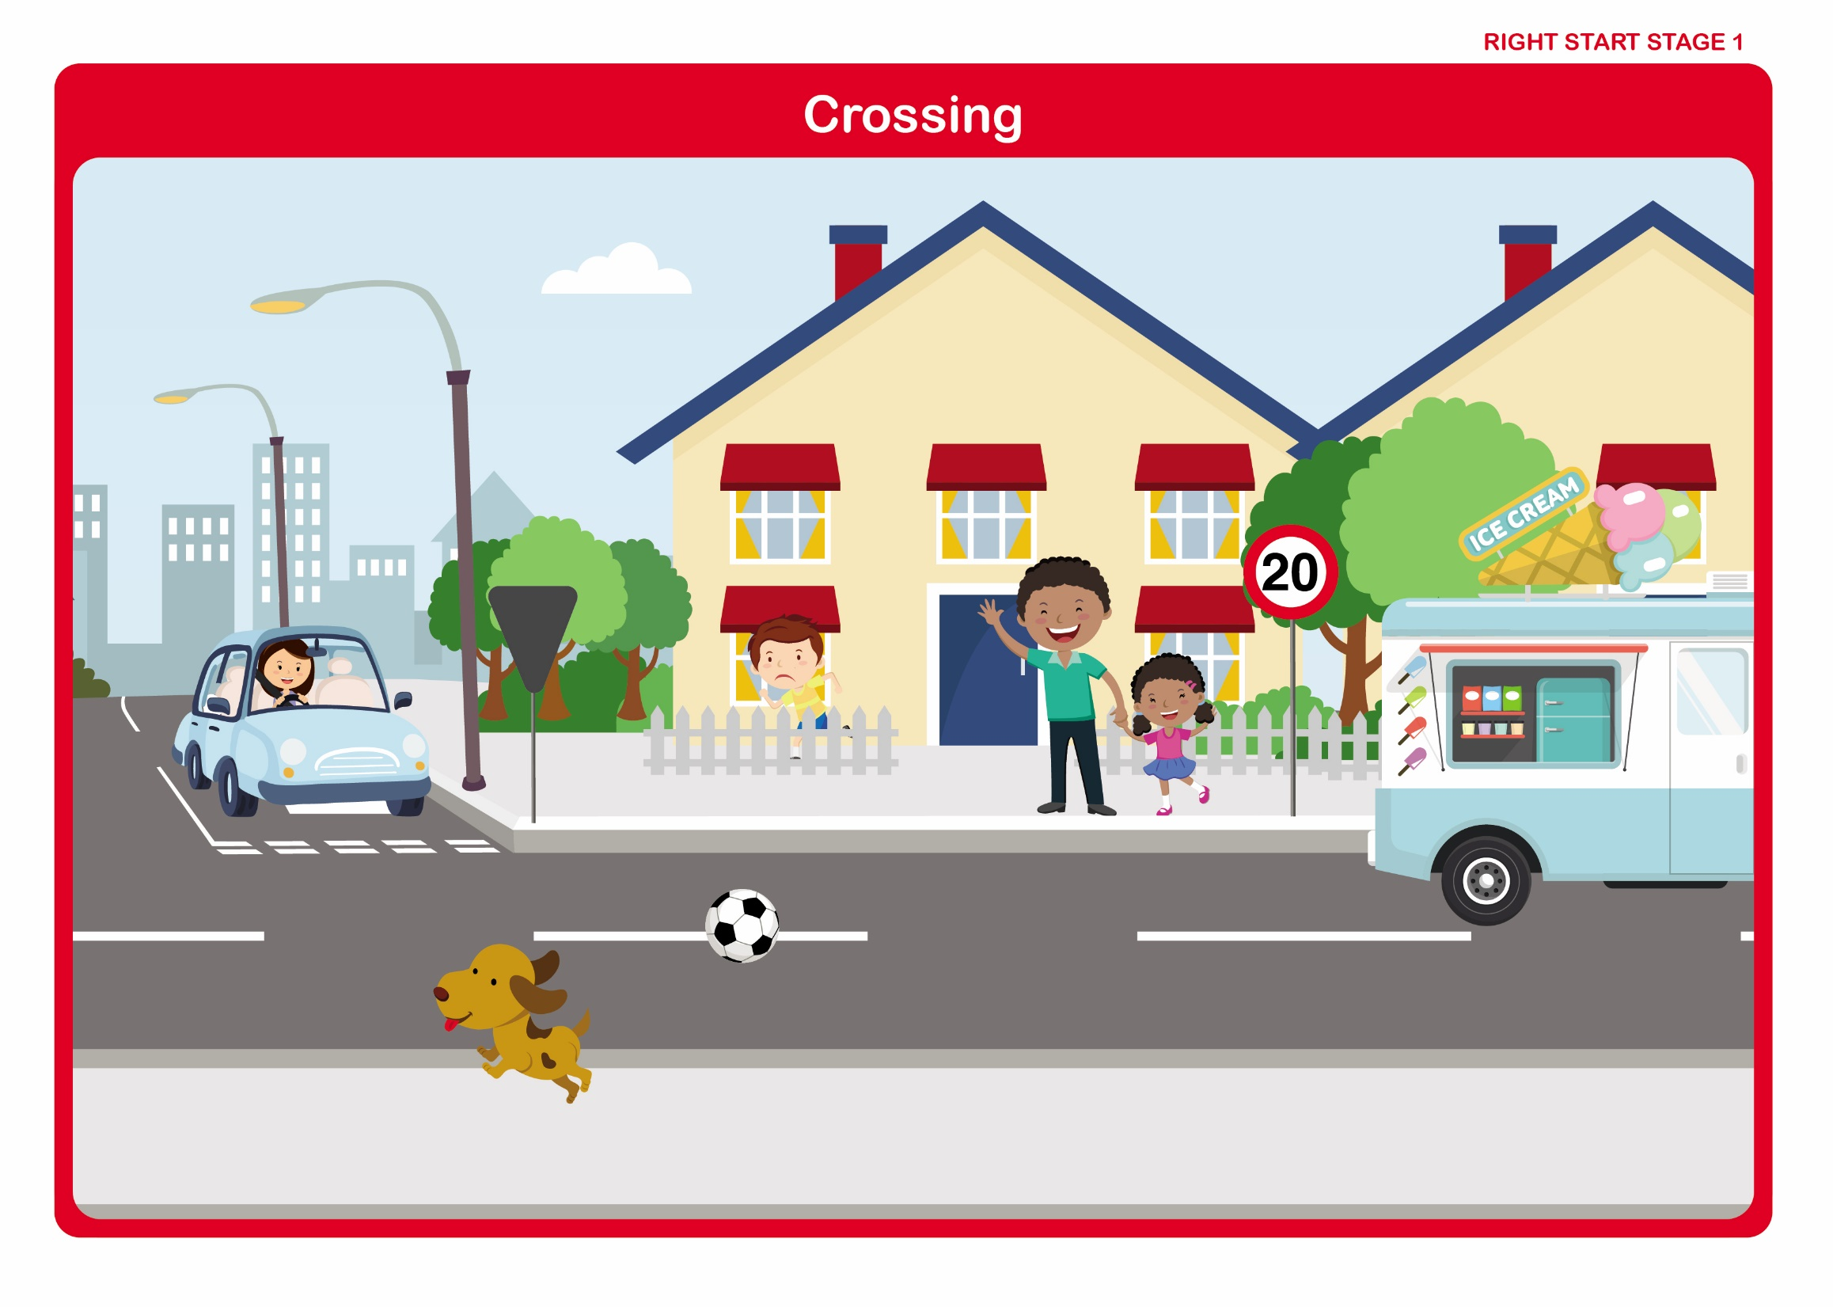

Let’s Talk

Discuss: -

• The reasons for not running across the road - (They might fall and cannot keep looking and listening as effectively).

• The need to keep hold of a grown-up’s hand while crossing the road - (To keep together and stay safe).

• Why, even on quiet and familiar roads, they must still cross with a grown-up - (Examples in picture: crossing to the ice cream van, boy should ask a grown-up to retrieve his ball).
Right Start - Stage 1

Country Roads

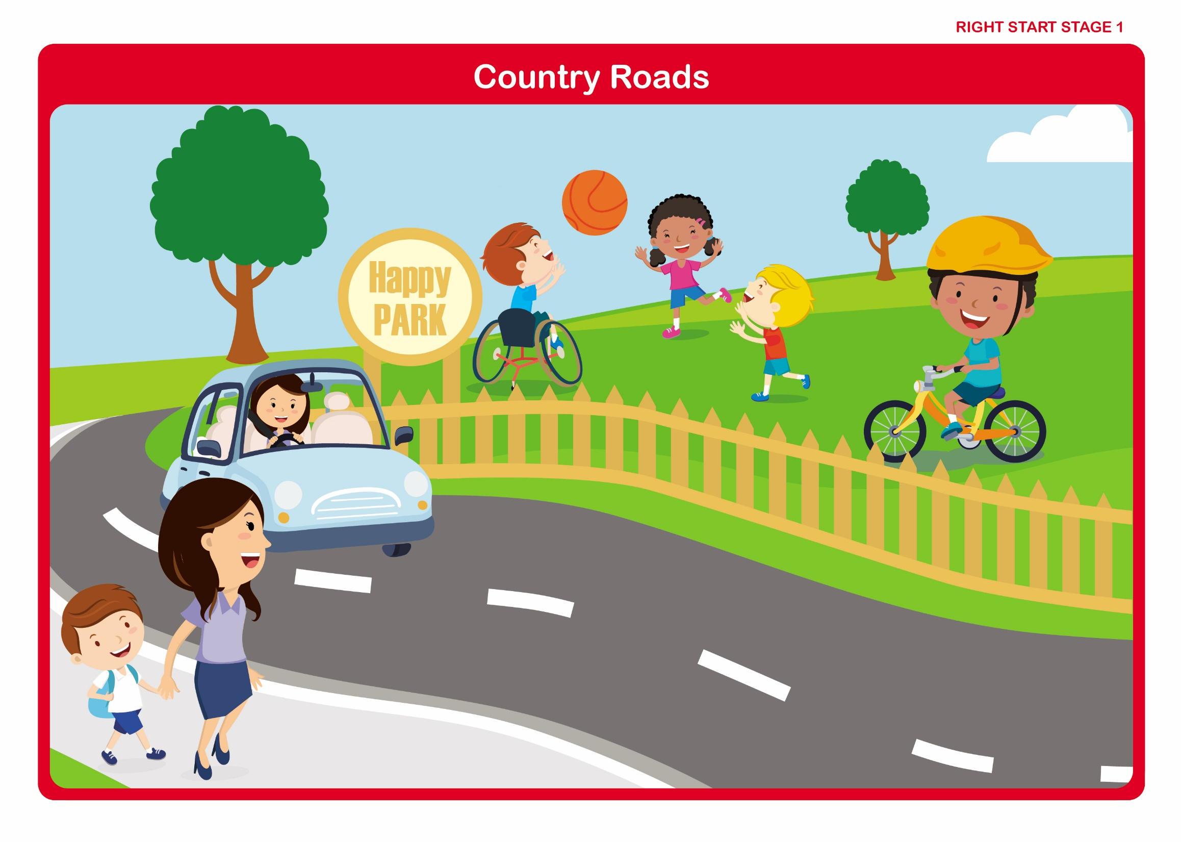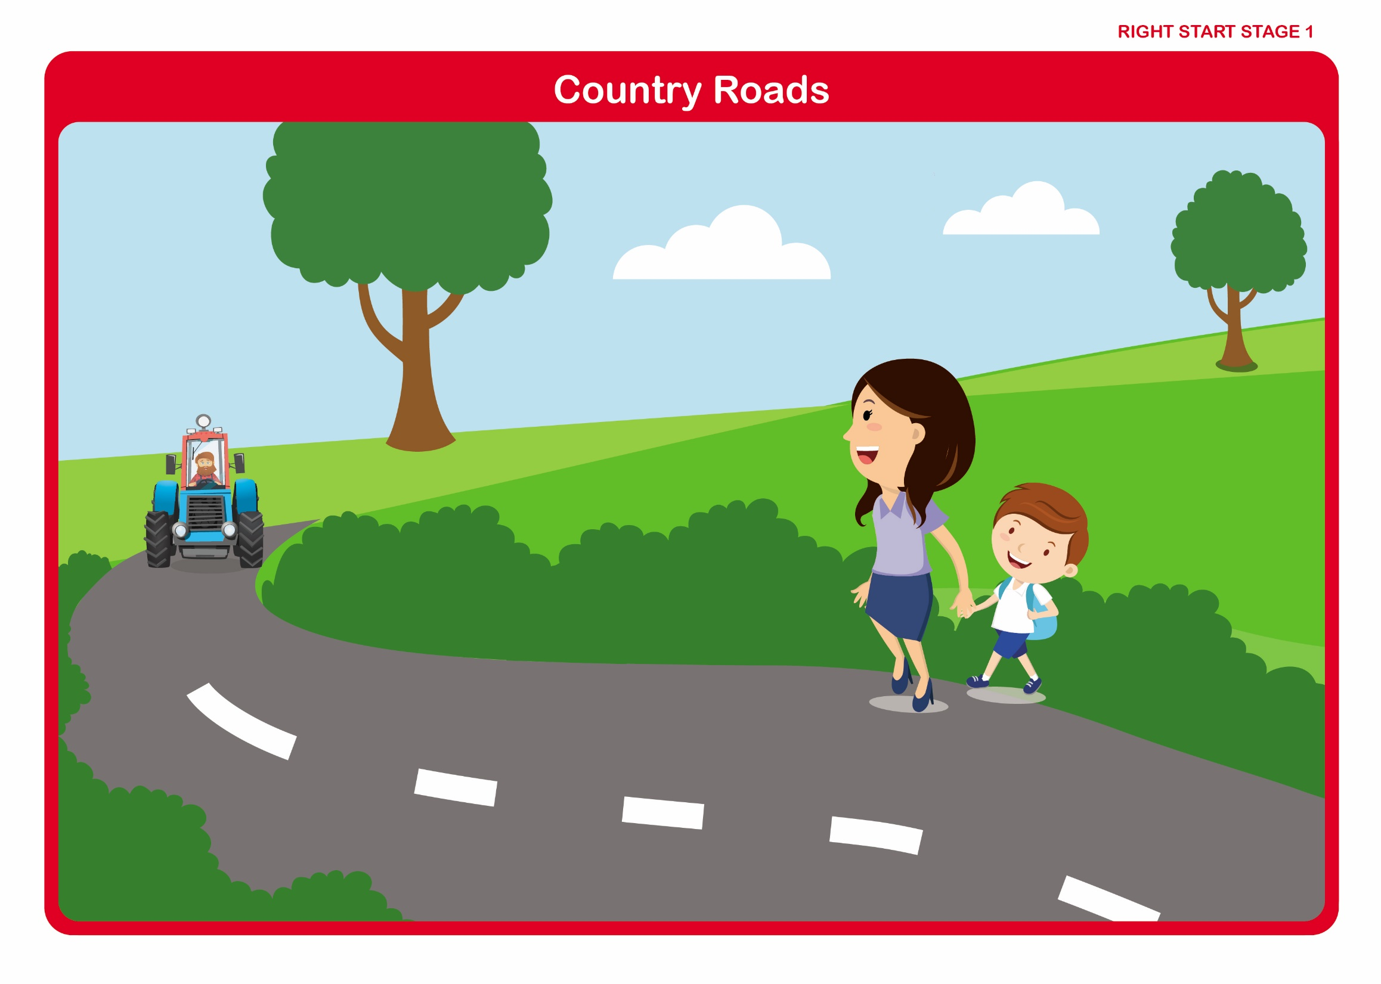

Let's Talk

Discuss

• Where there is a pavement always use it.

• Where to walk when there is no pavement -
(On the right hand side of the road facing oncoming traffic).

• The need to be extra careful when we can’t see the road very far ahead.

