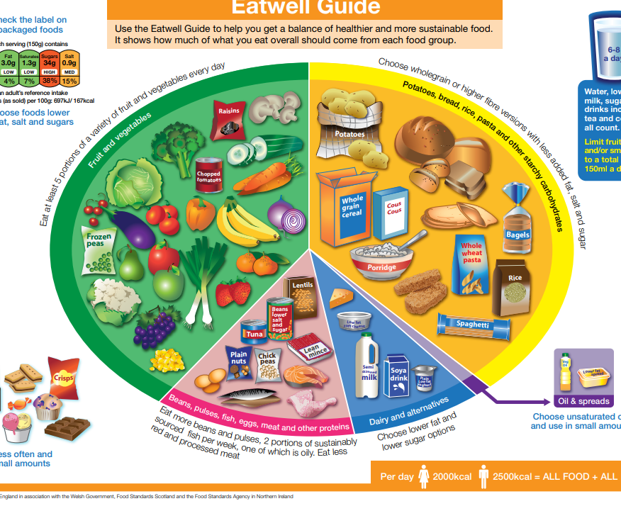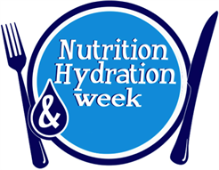

**Eating healthy will increase your energy levels**

**A well-balanced diet could improve your mood**

**Eating healthy can help prevent diabetes**

**True Or False**

1. **Potatoes are 80% water?**
2. **Strawberries aren’t actually berries.**
3. **The modern depiction of Santa Claus was created by Coca-Cola?**
4. **Apples belong to the rose family**
5. **Fruit juice and baked beans count as one portion of your fruit and vegetable intake.**

* **Eat at least 5 portions of a variety of fruit and vegetables every day**
* **Base meals on potatoes, bread, rice, pasta, or other starchy carbohydrates; choosing wholegrain versions where possible**
* **Have some dairy or dairy alternatives (such as soya drinks), choosing lower fat and lower sugar options**
* **Eat some beans, pulses, fish, eggs, meat, and other proteins (including 2 portions of fish every week, one of which should be oily)**
* **Choose unsaturated oils and spreads and eat in small amounts**
* **Drink 6-8 cups/glasses of fluid a day**

**Nutrition and hydration week**

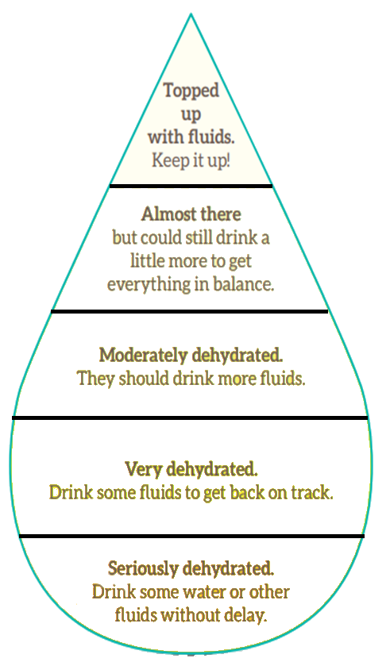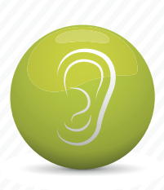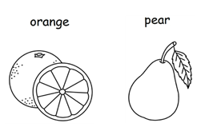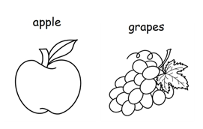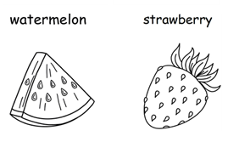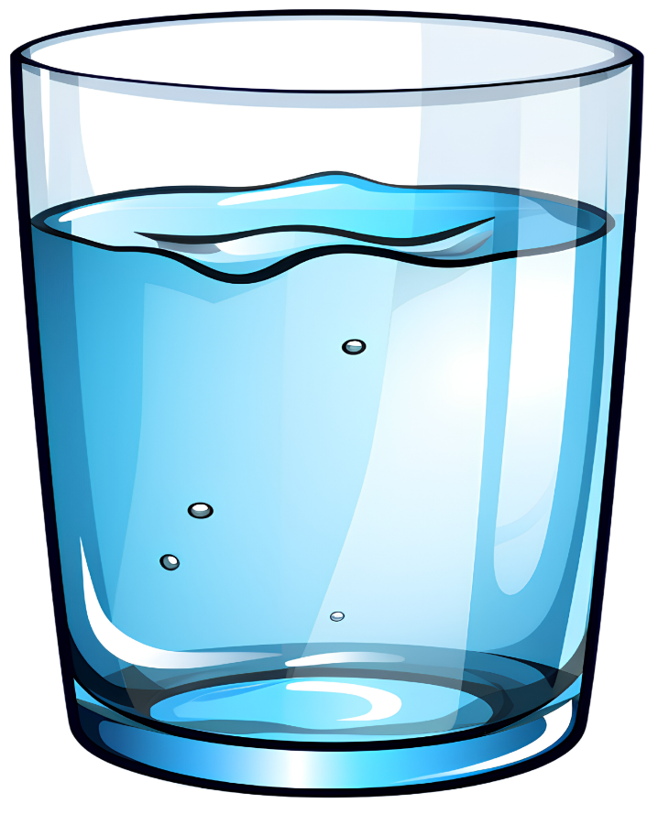

**Nutrition and hydration week**

**Can you colour the**

**hydration chart correctly?**

Taste

Sight

Hearing

Touch

Smell

**Top Tips to staying Hydrated**

* **Eat hydrating foods**
* **Set reminders**
* **Eat Healthy**
* **Try caffeine free tea/coffee**
* **Know the signs of dehydration**
* **Keep a drinks diary**

**Foods with high water content**

**Remember to drink 6-8 of me a day**

Wordsearch

* Fruit
* Health
* Tea
* Energy

|  |  |  |  |  |  |  |  |  |  |
| --- | --- | --- | --- | --- | --- | --- | --- | --- | --- |
| W | B | Y | A | U | T | I | U | R | F |
| L | A | R | P | H | H | O | M | G | H |
| S | E | T | Z | Y | I | R | S | W | E |
| T | S | I | E | D | R | U | C | A | A |
| I | F | R | A | R | S | I | X | T | L |
| D | J | E | T | A | T | U | H | K | T |
| F | H | D | D | T | Y | M | Z | Q | H |
| T | E | A | N | E | N | E | R | G | Y |

* Water
* Tired
* Thirsty
* Hydrate