Easy Baking recipes

Easy shortbread biscuits recipe
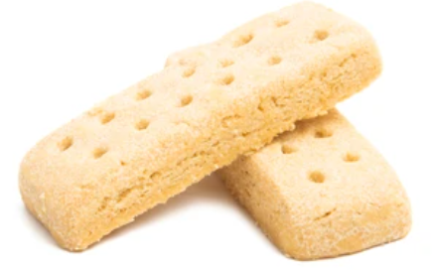
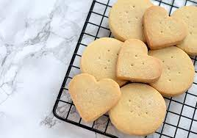
With only three ingredients, and ready in roughly 35 minutes, shortbread is an easy (and delicious!) choice for baking with older people – you can get them to mix the ingredients together with their hands, and to use cookie cutters to shape the biscuits.
This recipe makes roughly 10-20 biscuits, depending on how thick you roll the dough.

Ingredients
150g plain flour (plus a little extra for dusting your rolling surface)
100g butter, cubed
50g caster sugar (plus extra for sprinkling on your biscuits at the end!)

Method
1. Pre-heat the oven to 170C (150C fan/gas mark 3). Line a baking tray with greaseproof paper for later.
2. Mix together the butter, flour and sugar with your hands in a large mixing bowl until it resembles breadcrumbs, then squeeze it together to make a dough.
3. Lightly flour your worktop and use a rolling pin to roll the dough out to a thickness of roughly 1cm.
4. Either cut your dough into fingers or use cookie cutters for other shapes, and lay them on your lined baking tray. Re-roll any leftover dough and keep cutting until it is all used.
5. Use a fork to make the characteristic shortbread dimples, then pop the tray of biscuits in the fridge for about 20 minutes.
6. After chilling, bake in the oven for 15-20 minutes until golden. Remove and carefully transfer to a wire rack. Sprinkle with caster sugar, then let cool.
7. Enjoy with a lovely cup of tea!

Peach And Yogurt Surprise
This is one of the simplest, healthiest desserts for seniors and a firm favourite. The recipe below serves 3-4 people but can easily be adjusted to a single serving as the measurement don’t have to be exact. In fact, you can add or detract from any of the ingredients to personalize the dessert to your taste.

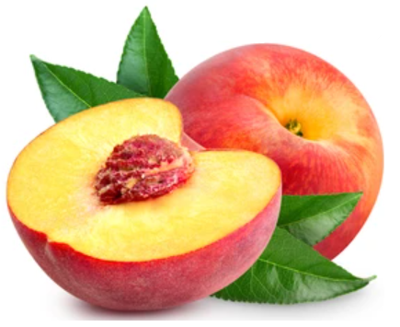
What You Need:
- 1 Can of peaches
- 2 Cups of plain Greek yogurt
- 2 Tablespoons of soft, brown sugar

How to Make it:
Strain the canned peaches to remove all the syrup. Then layer them at the bottom of a dish. Spoon the yogurt on top of the layer of peaches. Sprinkle the sugar over the yogurt. Allow the dessert to stand for 15-30 minutes to let the sugar melt over the yogurt. The brown sugar changes into a yummy, caramel syrup to sweeten the dessert.
You can substitute the canned peaches with other canned or fresh fruit or even create a fruit medley. However, it is recommended to avoid fruit that is too sweet. The sour flavour of the yogurt compliments the sweetness of the sugar which in turn should complement the tartness of the fruit.

Cereal Custard
Serves 4-6
Ingredients:
- 3 large eggs
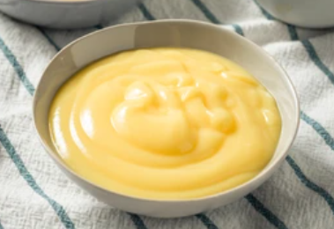
- 2 cups milk
- ½ cup Sweetener
- 2 tablespoons butter, melted
- 1 teaspoon vanilla extract
- 1 teaspoon ground cinnamon
- ½ teaspoon ground nutmeg
- ¾ cup cereal

Instructions:
- Beat eggs, then stir in milk, Sweetener, butter, vanilla, cinnamon, and nutmeg. Pour into a greased baking dish. Sprinkle Grape Nuts™ over top.
- Place baking dish in a water bath. Bake at 350º F for 45 minutes or until a toothpick inserted comes out clean. Serve warm.

Mini Berry Cream Pies
Nothing says summer quite like a traditional sweet. This diabetic dessert makes a cute and delicious treat. And the recipe is so simple!
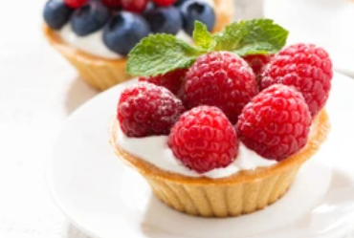
Ingredients:
- 1/4 cup whipping cream
- 2 tsp. sugar substitute
- 1/4 cup non-fat vanilla Greek yogurt
- 15 frozen mini filo cups
- 15 fresh blueberries
- 15 fresh raspberries
Directions:
Using a small bowl and an electric mixer, beat the whipping cream until peaks form. Then, add the sugar substitute until it reaches a stiff consistency. Carefully fold in the Greek yogurt until well combined.
Place yogurt cream evenly amongst the filo cups, then top with one blueberry and one raspberry. You can chill this dessert for up to four hours or enjoy it immediately!

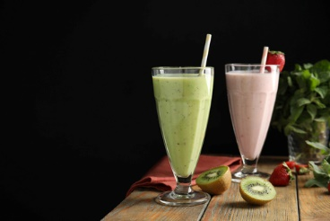
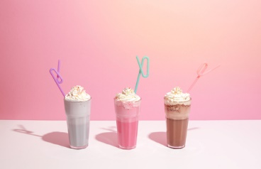
Milkshake Monday

Strawberry ice cream shake

Ingredients
- 225g strawberries hulled
- 300ml cold milk
- 3 large scoops vanilla ice cream
- extra strawberries to serve (optional)

Method
- STEP 1
Tip the hulled strawberries into a food processor with the milk and ice cream. Blend until smooth and creamy.
- STEP 2
Pour into tall glasses, top with sliced strawberries.

Peach Melba Smoothie Milkshake

Ingredients
- 410g can peach halves
- 100g frozen raspberries- plus a few for garnish
- 100ml orange juice
- 150ml fresh custard, plus a spoonful for garnish

Method
- STEP 1
Drain and rinse peaches and place in a blender with raspberries. Add orange juice and fresh custard and whizz together.
- STEP 2
Pour over ice, garnish with another spoonful of custard and a few raspberries. Best served chilled.

Mini Milkshakes
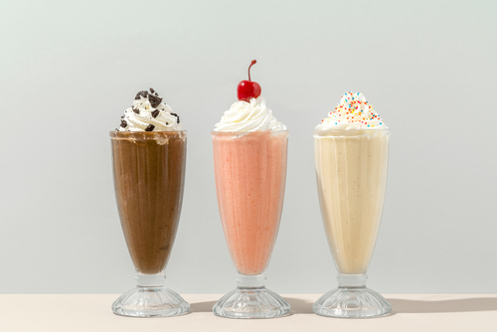

Ingredients
- 1 small ripe banana- chopped
- 400ml whole milk
- 100g natural yogurt
- 1 small punnet blueberries
- 6 strawberries hulled
- 1 small punnet raspberries
- 120g mango chunks (fresh or frozen)
- 200ml coconut milk for drinking (or coconut kefir)
- 1⁄2 lime cut into wedges

Method
- STEP 1
Put the banana, half the milk and half the yogurt in a blender, and blend until smooth. Pour into two or three milk bottles. Divide the blueberries between two skewers to make stirrers, then drop one into each bottle. Stir before serving.
- STEP 2
Put the strawberries and six raspberries in a blender with the rest of the milk and yogurt. Blend until smooth, then divide between two small milk bottles. Push the remaining raspberries onto two skewers to make stirrers as before.
- STEP 3
Blend the mango and coconut milk until smooth, then add a squeeze of lime. Divide between two milk bottles and serve with the lime wedges.

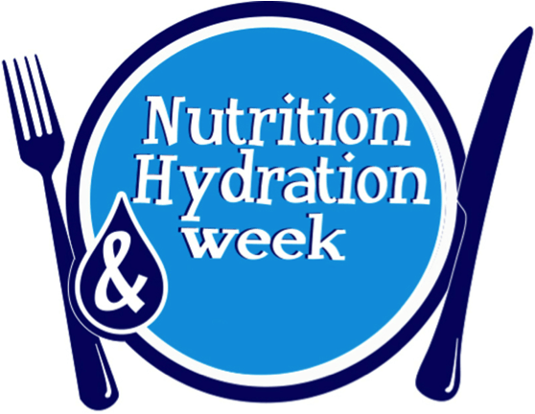

You can go as big or small as you want. Milkshake straws, powders, and syrups are available at most shops/supermarkets.

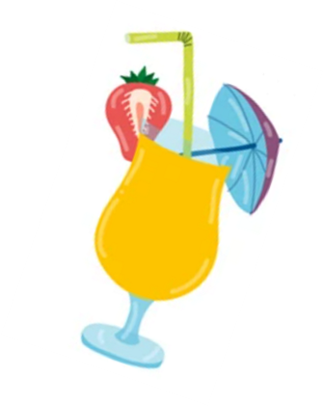
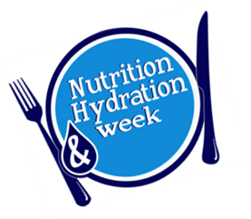
Cocktail hour

Summer cup Mocktail

Ingredients
- 1cm thick slice of cucumber
- 1 sprig mint
- few frozen red berries
- 120ml clear, sparkling lemonade
- ice

To garnish
- more frozen berries , chopped fruits, cucumber slice, mint, citrus – all optional

Method
- STEP 1
Chop the cucumber and mint sprig into small pieces. Bring 200ml water to the boil in a small pan and then add the mint and cucumber. Turn off the heat and leave for 2 mins. Add a small handful of frozen berries, let them defrost for a minute, then crush them lightly with the back of a spoon. Strain the mixture. This will keep in the fridge for up to 24 hours and will be enough to make four drinks.
- STEP 2
Pour 40ml of your strained mixture into a tall glass. Add a handful of ice and top up with 120ml lemonade. Garnish with whatever chopped fruit you like or some more frozen berries and mint leaves if you have them. Stir gently to combine.

Sunrise Mocktail

Ingredients

- Alcohol-free sparkling wine or alternatives (sugar free lemonade)
- Orange juice (no pulp)
- 2.5 mls Grenadine

Method
- Add equal amounts orange juice and non-alcoholic sparkling wine (sugar free lemonade) into a champagne flute style glass
- Gently pour in the grenadine.
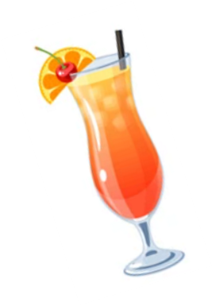
- Garnish with your choice of fruit and serve.

Fruit Punch

Ingredients
- 8-10 strawberries , halved or sliced
- ½ orange , sliced
- ½ lemon , sliced
- handful of mint leaves
- large handful of ice
- 500ml pineapple juice
- 300ml orange juice
- 300ml lemonade

Method
- STEP 1
Put the fruit, mint and ice in a large jug. Pour in the juice, stir and top up with sugar free lemonade.

You can go as big or small as you want with the size of your mocktails. A selection of straws, syrups, and fruit are available at most shops/supermarkets.

