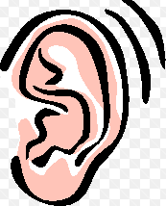

What sounds can you hear?

What does it rhyme with?

Can you hear any other words inside this word?

Have you heard of the word before?

Where have you heard it?

What do you think the word means?

Talk to a partner.

(Use a dictionary to check).

Put the word into a sentence of your own.

 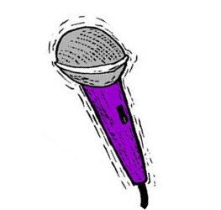

What other words mean the same?