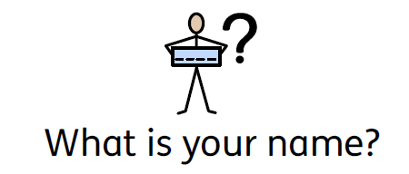
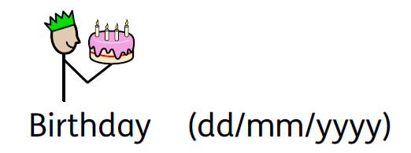
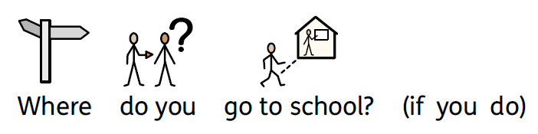
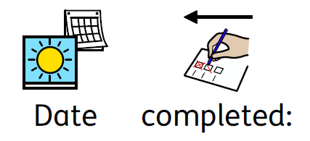

This is your opportunity to talk about your EHCP and about the help you receive inside and outside of school.

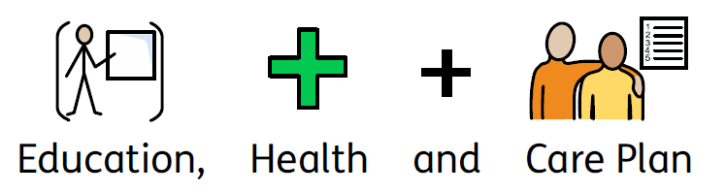

What is an EHCP?

EHCP means Education, Health and Care Plan.

It is all about what you are good at and what things you might need some help with. It also contains a section about your goals for the future and tells anyone supporting you what help you need to achieve your goals.

Why have we sent you this form?
We are either deciding if you need an EHCP or reviewing one you already have.
If you are unsure, you can speak to an adult you trust who will be able to explain more details to you.

Why do we need your views and ideas?
Because it is all about you!
We want to know what you can do well, what you enjoy, as well as your views about what support you need and how we can help you to become a more independent learner and person.

You can use this form to tell us what adults need to know about your life now.

You can draw pictures, write or type comments or send us photographs to share your views.
If you want to use extra pages or a different type of form, you can.

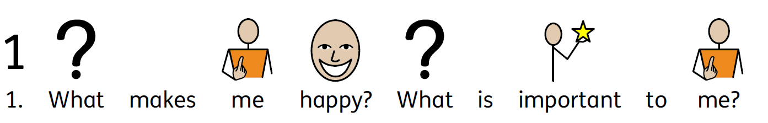
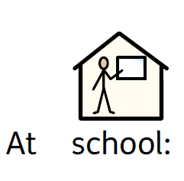
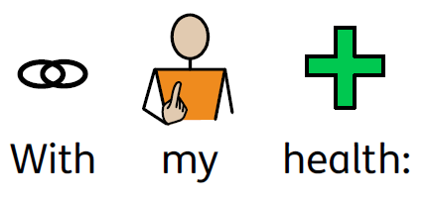
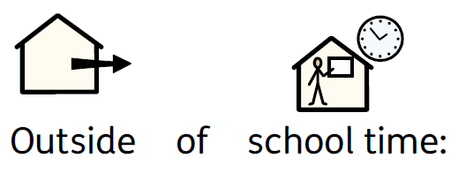

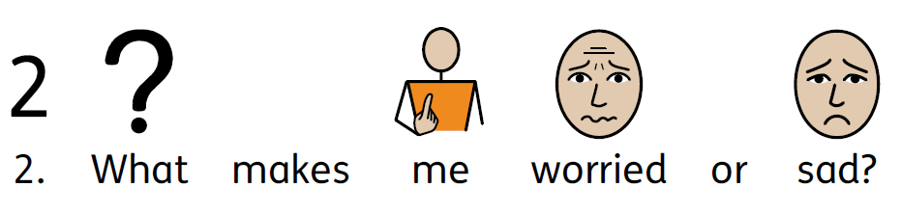

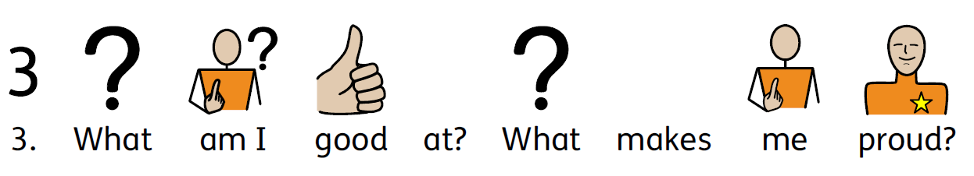

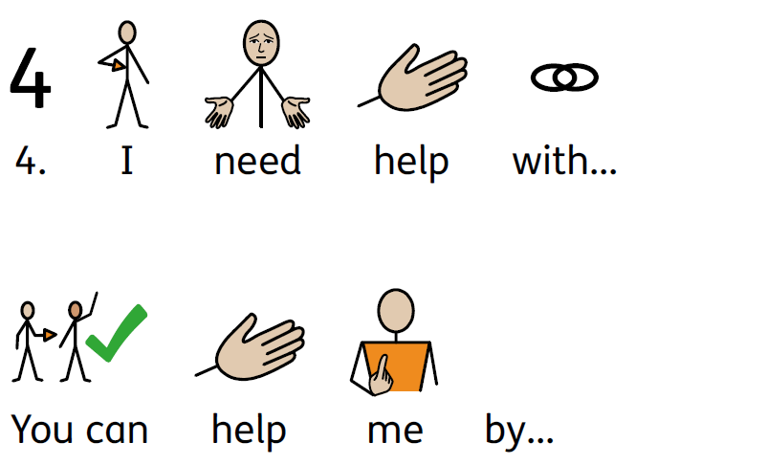

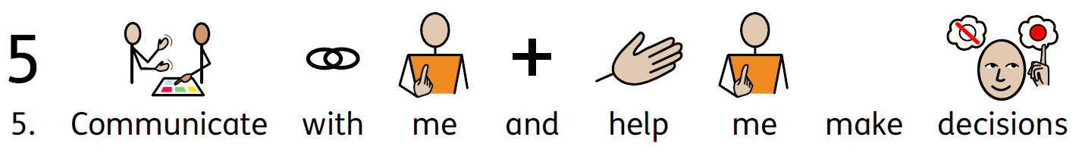

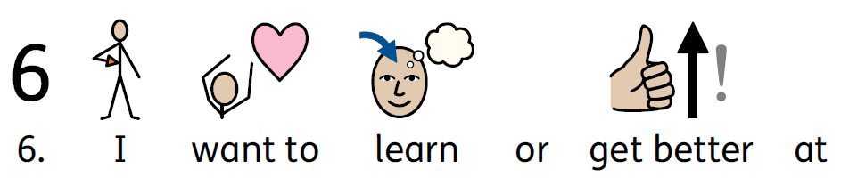
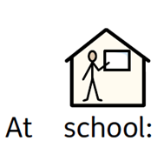
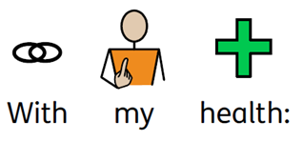
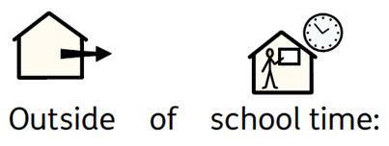

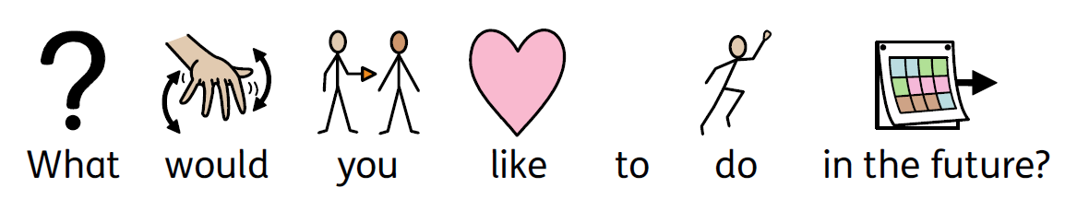
For those in Year 9 and above
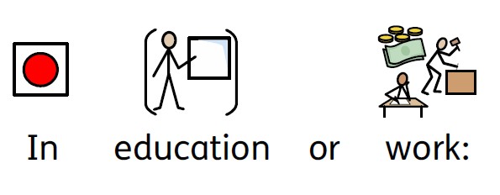
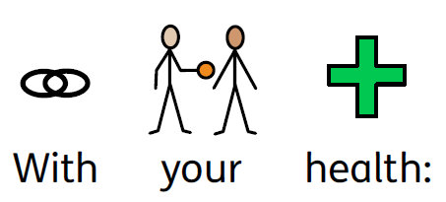
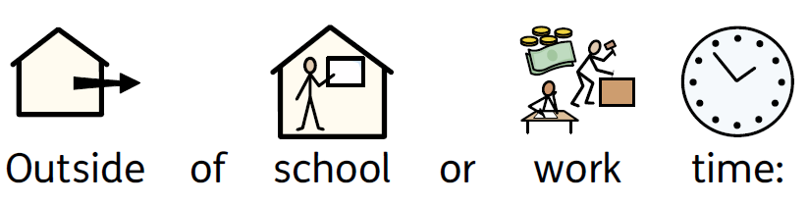
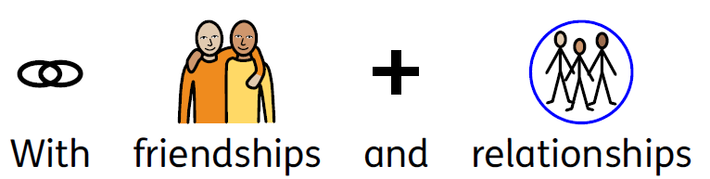
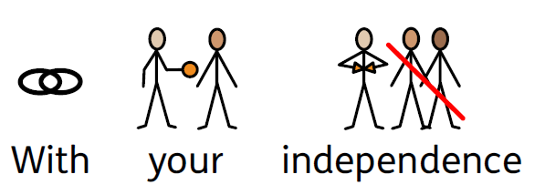

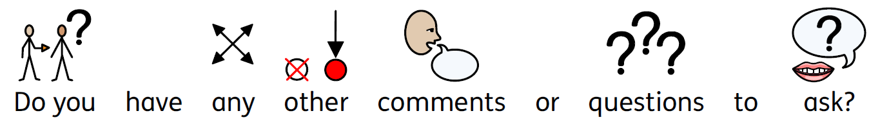
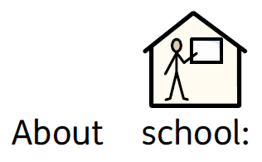
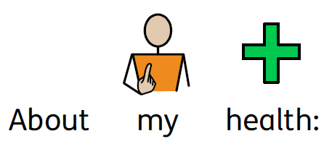
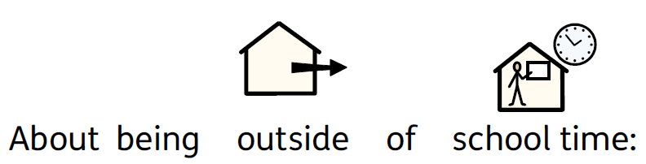

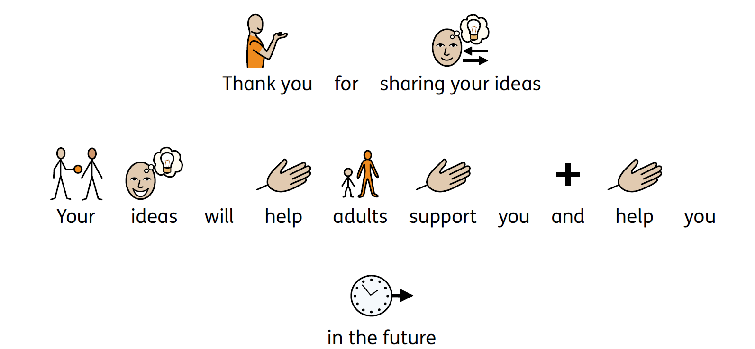

Did you have help to complete this form? (Please tick)

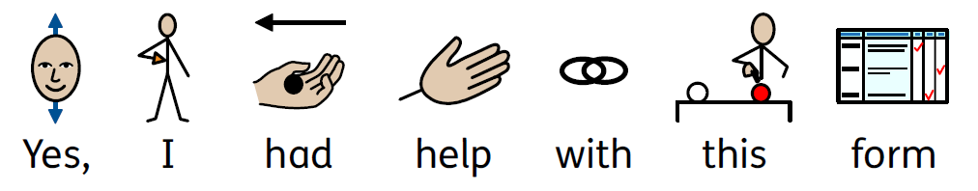
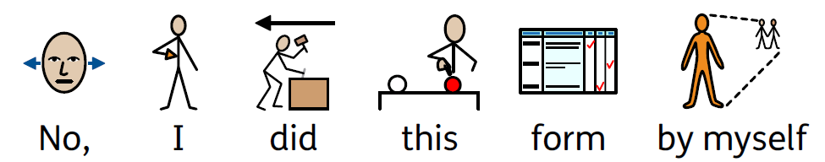

If you have supported a child or young person with this form, please indicate your name, role and briefly how information was gathered.

Thank you.

