Laundry Audit tool
The purpose of this tool is to ensure all staff are aware that used laundry e.g., linen, resident or service users' clothing's, staff uniform or workwear, can become soiled with blood, faeces, body fluids and micro-organisms. So safe practices need to be followed to prevent the spread of infection.
Key Points | - All used clothing and linen should be handled with care including disposal and transportation.  - All used laundry should be washed appropriately ensuring the correct temperature.  - Disposable apron and gloves should be worn when handling used, soiled, infected linen and clothing  - When handling used, soiled, or infected linen and clothes, after removing gloves, hands must be washed thoroughly with liquid soap and warm running water, and dried using paper towels.  - To prevent contamination of hands, the sink and surrounding environment, staff should not rinse soiled linen and clothing by hand. Soiled items should be washed on a pre cycle, and not hand sluiced in the sink/buckets.
- Staff have completed specific training in the handling of linen and laundry.

- Risk assessment carried out of area including access to PPE.

- Aware of the management of used linen and infectious linen.

- Staff should ensure cuts and grazes are covered with waterproof plaster.

- Uniforms and workwear worn by staff when carrying out their duties should be clean and fit for purpose.

Auditor: Unit/Location: Laundry Room/Linen Store room/Cupboard Date:
Observation |  |  | COMMENTS
No. 1 | There is a dedicated laundry room, e.g., the room is not used for any other function. | ☐ Yes ☐ No
No. 2 | Machines (including dispensers) are in good condition and clean, e.g., free from dirt, dust, mould and spilt or congealed washing power/liquid. | ☐ Yes ☐ No
No. 3 | Dedicated hand hygiene facilities, including wall mounted dispensers for liquid soap (with single use cartridge) and paper towels, are available, in good condition and clean | ☐ Yes ☐ No
No. 4 | A laminated ‘Hand hygiene technique for staff’ poster is displayed. | ☐ Yes ☐ No
No. 5 | Access to the handwash basin is clear | ☐ Yes ☐ No
No. 6 | The handwash basin is free from clutter, e.g. used items. | ☐ Yes ☐ No
No. 7 | There is a dirty to clean workflow process in place, e.g. washing machines are sited in the laundry room nearest to entering the room and the tumble driers sited after the washing machines. | ☐ Yes ☐ No
No. 8 | Only commercial washing machines and tumble driers are in use. | ☐ Yes ☐ No
No. 9 | There is documented evidence linen is washed at 65oC for not less than 10 minutes or 71oC for not less than 3 minutes. | ☐ Yes ☐ No
No. 10 | Laundry staff wear appropriate PPE, e.g. gloves and apron, when handling all used, soiled, fouled and infected linen. | ☐ Yes ☐ No
No. 11 | Laundry waiting to be laundered is correctly segregated in the appropriate colour bags. Used, soiled and fouled linen in a white bag. Infected linen in a soluble bag placed inside a red bag | ☐ Yes ☐ No
No. 12 | Used and clean linen are kept separate in the laundry room during the washing and drying process. | ☐ Yes ☐ No
No. 13 | Clean linen, e.g. residents clothing, is not stored in the laundry room. | ☐ Yes ☐ No
 | Linen Storeroom/Cupboard
No. 1 | A linen storeroom/cupboard is available (this should be separate from the laundry room; clean linen should not be stored in a laundry room). | ☐ Yes ☐ No
No. 2 | The room/cupboard is free from inappropriate items, e.g., fans, Christmas decorations, equipment | ☐ Yes ☐ No
No. 3 | Linen is stored on shelving and above floor level. | ☐ Yes ☐ No
No. 4 | Shelving is impervious and in a good state of repair. | ☐ Yes ☐ No

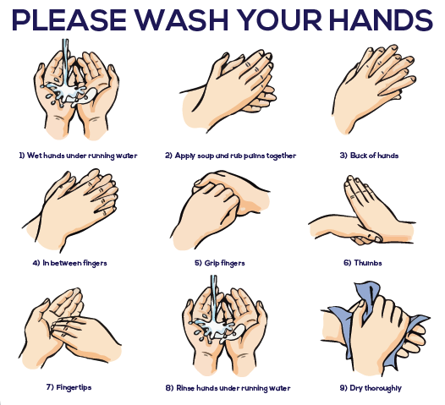

Five Principles of Cleaning

