

**Health Equity Screening Tool**

# Why should I consider health equity?

Health inequalities are avoidable, unfair, and systematic differences in health between different groups of people.

People living in our county's poorest areas spend more of their lives living with a long-term health condition or disability and die around 16 years earlier than those living in our wealthiest areas.

To create a county where everyone can thrive and where we can achieve our shared vision for Lancashire, we need to ensure that all the right building blocks are in place: stable jobs, good pay, quality housing, good education, and access to environments that promote health.

**These building blocks are also known as the wider determinants of health.**

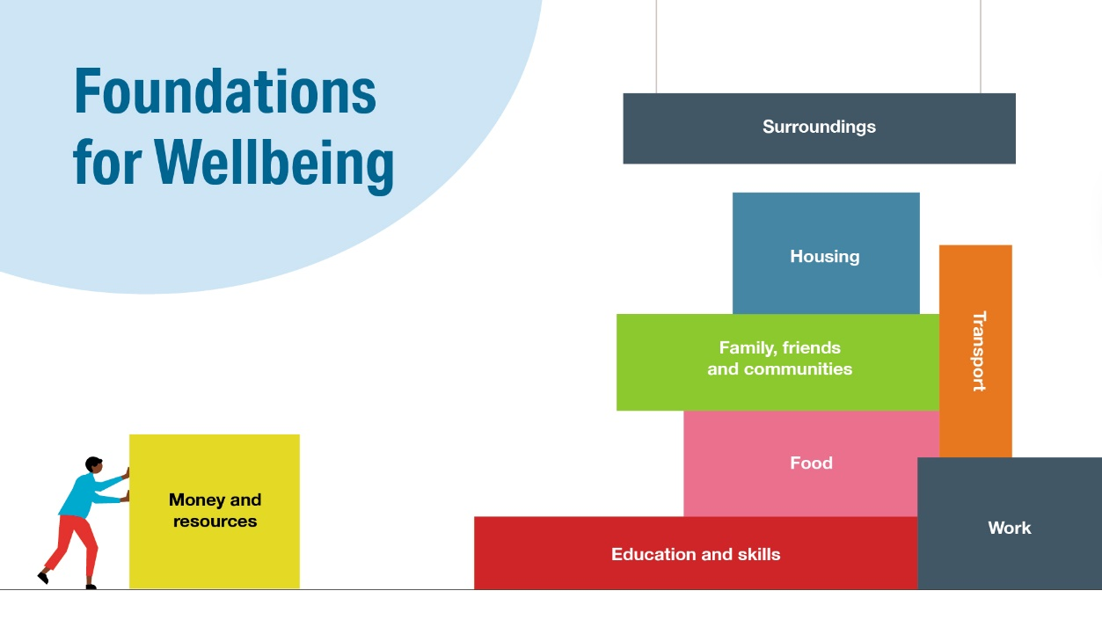

To put in place the building blocks for good health for all, we must pay close attention to health equity.

Health equity is achieved when **everyone** can attain their full potential for health and well-being. An equitable approach to addressing inequalities considers the impact of our services, facilities, or infrastructure on the whole population, but gives specific consideration to the impact on defined population groups where inequalities exist.

# Who is the tool for and why use it?

The Health Equity Screening Tool is available for everyone to use.

It has been designed to support you to think about how your service, facility, or infrastructure impacts on health inequalities, on a practical level. This allows you to take action to serve our communities equitably, and thus achieve our corporate priorities to deliver better services and care for the vulnerable.

The tool helps you to identify:

* Strengths of your service, facility, or infrastructure regarding its contribution to reducing health inequalities
* Opportunities to further strengthen your service, facility, or infrastructure to address health inequalities

The Tool should also help you to consider any unintended consequences of your service, facility, or infrastructure, such as increasing existing inequalities or introducing new ones.

# When should I use it?

The Health Equity Tool is a working document intended to **be used continuously** throughout the lifecycle of your service, facility, or infrastructure. It should be used to influence discussion and action at the development phase, and then reviewed regularly to ensure inequalities in health continue to be considered and addressed appropriately.

# How should I use it?

A strength of this Tool is that it promotes conversation. Using it in a group can help to broaden discussion, highlighting fresh perspectives on inequalities and impacted population groups that you may not have previously considered.

**Which groups should I consider?**

Prior to completing the Tool, you will need to define the general population that your service, facility, or infrastructure relates to, and also define what inequalities exist within the affected population.

This might include consideration of the following:

1. The protected characteristics outlined in the Equality Act 2010:

* age
* sex
* race
* religion or belief
* disability including deaf people
* sexual orientation
* gender reassignment
* pregnancy and maternity
* marriage and civil partnership

1. Socio-economic differences such as employment status, income, area deprivation.
2. Area variations by deprivation level (Index of Multiple Deprivation), service provision, urban/rural or in general.
3. Other groups for specific consideration for example people experiencing homelessness, people in prison, or young people leaving care.

# The 'Super 7' Components of Equity

The Health Equity Tool asks you to consider the 'Super 7' components of equity.

These are defined as follows:

|  |  |
| --- | --- |
| ***Availability*** | Availability is the opportunity for people to obtain a resource, for example, a service, facility, or infrastructure. |
| ***Accessibility*** | Accessibility refers to how people are able to access a resource.  How people can access depends on several factors, including:   * proximity/geographical location. * the provision of appropriate physical adaptations to enable access for everyone irrespective of degree of impairment or level of mobility. * the provision of social/cultural support, such as a translator for people who are not fluent in the official language of the country. * the provision of information/educational support to enable the best use of a resource for people with low levels of educational attainment, for instance, taking action to increase health literacy. |
| ***Quality*** | Quality is the degree to which a resource meets a set standard regardless of when, where, or how it is deployed. |
| ***Acceptability*** | Acceptability is when a resource is provided in a way that is appropriate for those who access it. An “acceptable” resource provides a good “fit” with people’s requirements in terms of age, sex, culture/ faith, state of health, educational attainment, level of literacy/health literacy and other factors. |
| ***Affordability*** | Affordability is the cost incurred by the individual accessing a resource.  Some costs can be hidden, for example a staff member needing to take unpaid leave to access a service; or a service using needing to pay to use public transport to access a service. |
| ***Safety*** | Safety is the unintended risk of harm to an individual, associated with their use of a resource.  An example could be the implementation of a policy that does not consider its potential impact on the pre-existing mental health of an individual. |
| ***Adaptability*** | Adaptability is the ability of the resource to respond to emerging and changing needs to ensure that no population groups are left behind.  There are several aspects to consider, including:   * pro-active engagement of users. * responding to changing population-level need. |

## The Health Equity Screening Tool

|  |  |  |  |  |
| --- | --- | --- | --- | --- |
| **Name and description of service, facility, or infrastructure being screened:** | | | | |
| **Completed by:** Click or tap here to enter text. | | | | |
| **Date Completed:** Click or tap here to enter text. | | | | |
| **Contact Person:** Click or tap here to enter text. | | | | |
| 1a) What is the general population affected by your service, facility, or infrastructure?  Click or tap here to enter text. | | | | |
| 1b) What inequalities exist within this population?  Click or tap here to enter text. | | | | |
| 1. Does your service, facility, or infrastructure have a **positive impact** on the following components of equity… | *…for each of the population groups where inequalities exist?* | *…for the general population?* | | |
| * Availability | Click or tap here to enter text. | Click or tap here to enter text. | | |
| * Accessibility | Click or tap here to enter text. | Click or tap here to enter text. | | |
| * Quality | Click or tap here to enter text. | Click or tap here to enter text. | | |
| * Acceptability | Click or tap here to enter text. | Click or tap here to enter text. | | |
| * Affordability | Click or tap here to enter text. | Click or tap here to enter text. | | |
| * Safety | Click or tap here to enter text. | Click or tap here to enter text. | | |
| * Adaptability | Click or tap here to enter text. | Click or tap here to enter text. | | |
| 1. **Look at the balance of your answers above…** | | | | |
| 1. Does your service, facility, or infrastructure have positive effects **mainly** for groups where inequalities exist? 2. If your answer is Yes, is your service, facility, or infrastructure likely to **reduce** inequalities? | | | Yes  Yes | No  No |
| 1. Does your service, facility, or infrastructure have positive effects **mainly** for the general population? 2. If your answer is 'Yes', is your service, facility, or infrastructure likely to **increase** inequalities? | | | Yes  Yes | No  No |
| 1. Does your service, facility, or infrastructure have positive effects for groups with existing inequalities **and** the general population? 2. If your answer is 'Yes', is itit I your service, facility, or infrastructure **unlikely** to **reduce** inequalities? i.e. both groups improve but the gap between them stays the same. | | | Yes  Yes | No  No |
| Please explain your answers:  Click or tap here to enter text. | | | | |
| 1. Could your service, facility, or infrastructure be changed to reduce inequalities? | | | Yes | No |
| 1. If “Yes”, how could this be achieved? Which inequalities would be reduced?   Click or tap here to enter text. | | | | |
| 1. If you decide your service, facility, or infrastructure needs to be changed who needs to be informed of this decision?   Click or tap here to enter text. | | | | |
| 1. What is your timescale for reviewing the changes you have implemented?   Click or tap here to enter text. | | | | |

**Acknowledgement**

This tool is based on the *Focusing on Equity and Health: An inequality screening tool for policy and other types of proposal* developed on behalf of Belfast Healthy Cities