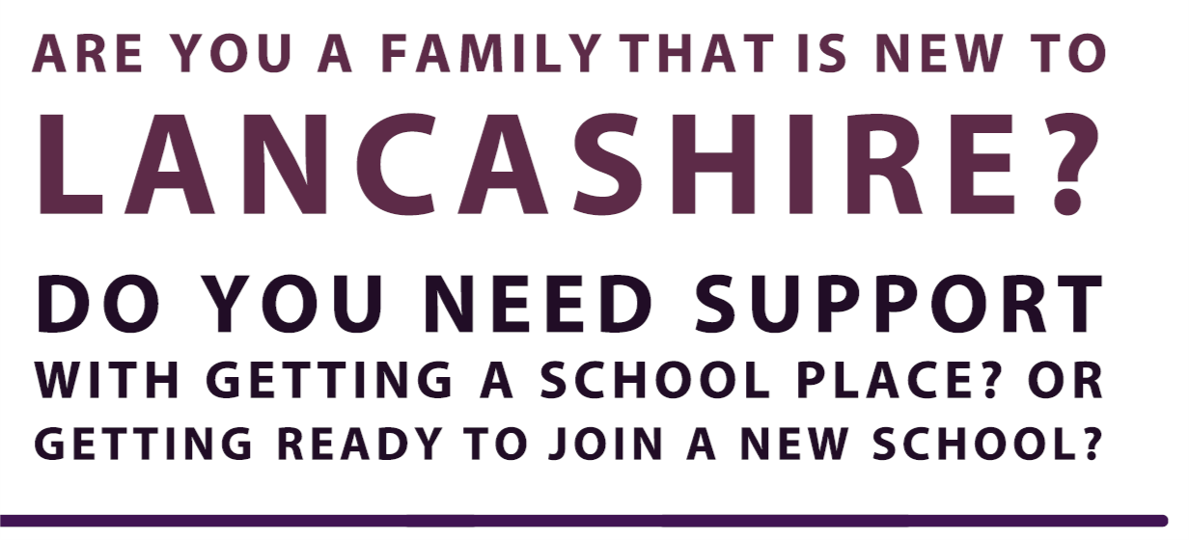
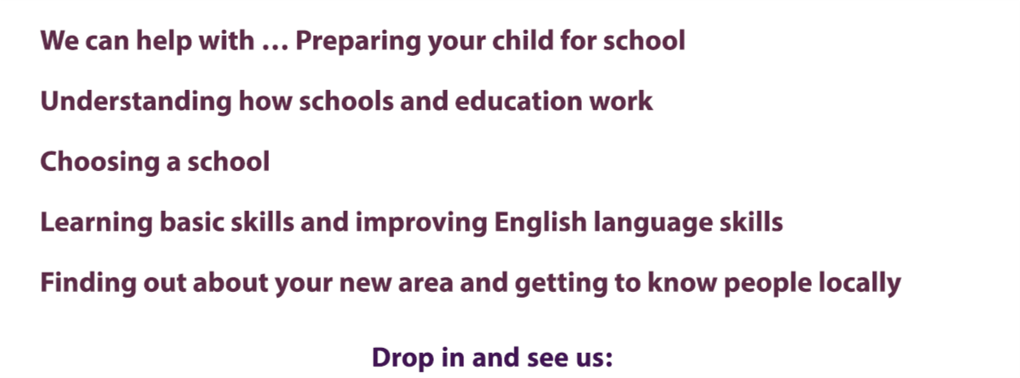
Telephone: 01282 682275
Visit us:
Monday to Friday, 9am- 1pm
(Term Time only)
ELLIE at the Faith Centre
Barden Lane
Burnley
BB10 1JD

Closed during the following dates-
29th May | - | 2nd June 2023
21st July | - | 1st September 2023
23rd October | - | 27th October 2023
22nd December | - | 8th January 2024
12th February | - | 16th February 2024
28th March | - | 15th April 2024
27th May | - | 31st May 2024
22nd July | - | 2nd September 2024
21st October | - | 25th October 2024
20th December | - | 6th January 2025
(Lancashire School holidays)

