Child’s Name:
Date of Birth:
Name of Setting:
Date of completion of Transition Document:
Completed by:
Parent’s Signature:
Attendance pattern:
Other professionals worked with:
Accessed a funded 2YO place Y/N | Accessed EYPP funding Y/N
Additional interventions / support provided:
How to support me in my new setting to ensure a smooth transition - needs and interests:

Further information/key person’s comments: who lives with the child, any siblings, language spoken at home, medical needs, allergies, child attends other settings/childminder etc.

The information in this document is produced from conversations with parents/carers, evidence from the child’s learning journey and also observations from practitioners within the setting. I give permission for this information to be passed to my child's next setting.
Early Years Foundation Stage
Pre-school Transition Document

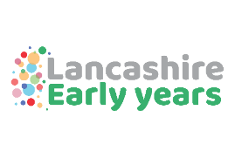
Lancashire Early Years Quality Improvement Team

Summative assessment judgements – Development Matters
- Indicate the age phase that best fits the child`s stage of development. | - Date Completed | Birth - 3 years old | 3 - 4 years old
Personal, Social
and Emotional Development
Physical Development
Communication and Language
- Literacy
- Mathematics
- Understanding the World
- Expressive Arts and Design
- Comment on how the child learns - the Characteristics of Effective Learning, schemas etc:

