Overview of Action Plan for Science
- SCIENCE AUDIT & ROBUST SELF EVALUATION: £10 Can be ordered for each subject from 'Examining Teaching and Learning in Science' at
https://lpds.lancashire.gov.uk/publications.asp?q=examining+teaching+and+learning
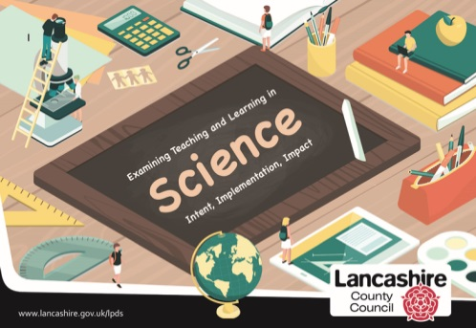
Complete this self-evaluation, alongside discussion with the SLT, to identify strengths and weaknesses of the science provision in your setting. What are the main priorities for the year ahead? These can be transferred as key aims in your action plan.

- LONG TERM PLAN: Curriculum map for science agreed prior to each September
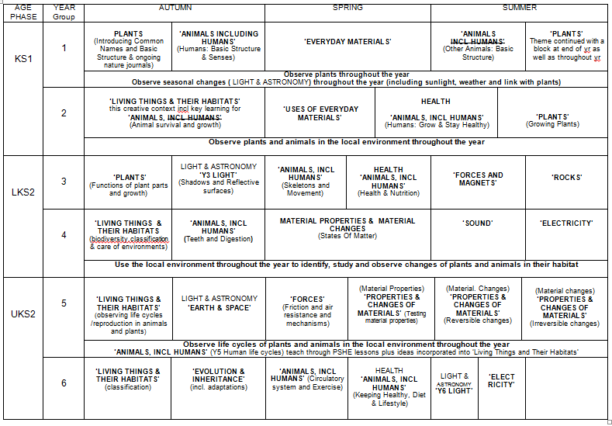
Schools are free to decide how to sequence units across a year and within an age phase taking into account that some aspects may need to be revisited throughout the year, for example: seasonal change, plants, habitats. In the suggested curriculum map, some NC units have been spread across a whole term to allow more time to embed key concepts or provide more time for practical experiences (e.g. Y4 States of Matter) or split into 2 units (e.g. Y3 'Animals Including Humans' split into Health & Nutrition and Skeletons & Movement). In the suggested curriculum map, the 'Plants' and 'Living Things and Their Habitats' units have been placed in the first half term – this is only to act as a reminder to schools to plan for these across the year. The main teaching of these is more likely to be planned for the summer term.

Guidance about how to sequence the units across a year group or how to sequence units within a 2-year rolling program for mixed age classes can be found at;
https://www.primary-science.co.uk/product-page/sequencing-science-topics
https://www.primary-science.co.uk/product-page/sequencing-science-topics-curriculum-map-example
https://www.primary-science.co.uk/product-page/sequencing-science-topics-curriculum-map-example-2-year-group-mixed-classes

- SHARED VISION FOR SCIENCE: To create a shared vision for science across a school, staff could come together to discuss the phrase 'Science is good when…' This task can help create a vision and set of principles for teaching science at your school. These key messages could be displayed and referred to in each classroom to embed the principles. What main features would you like to see for your setting? Where will the poster be displayed? How will it be monitored each half term to ensure it is being used/referred to regularly? Are children involved in the monitoring during lessons to help support impact? Is EVERYONE within the school community committed to the vision for science? Does everyone know about it?

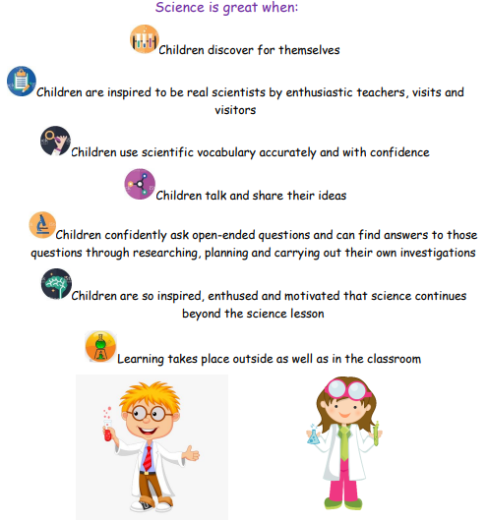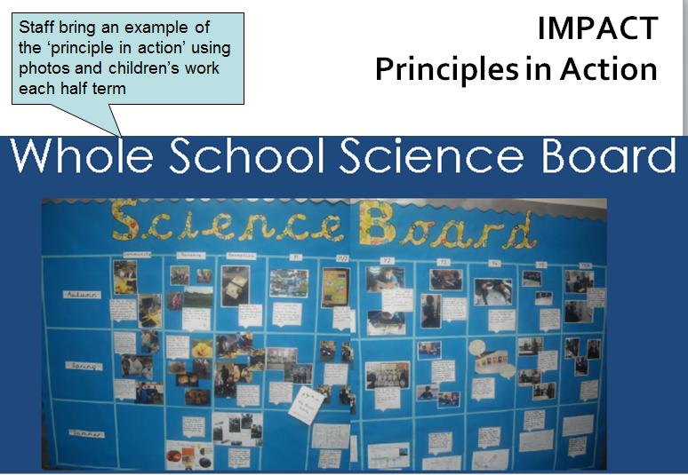

- SHARING AGE RELATED EXPECTATIONS AND EXEMPLIFICATION TO SUPPORT PLANNING AND EVIDENCE IN BOOKS:
www.planassessment.com ‘Examples of Work’ are free to download for every unit in each year group (Y1-Y6). They exemplify all the outcomes for one child working at ARE for a whole unit. These can be shared with staff to show what the work of a ‘secure/on track’ child might look like for a particular unit. They can also be used to support planning a sequence of learning and to see how another teacher has approached the unit. They provide ideas for how children can record so it is focused on capturing the 'learning' rather than the 'doing'. How is this helping staff? How do you know they are using it? Is teachers' planning in line with ARE? Are children's outcomes in line with ARE in each class?
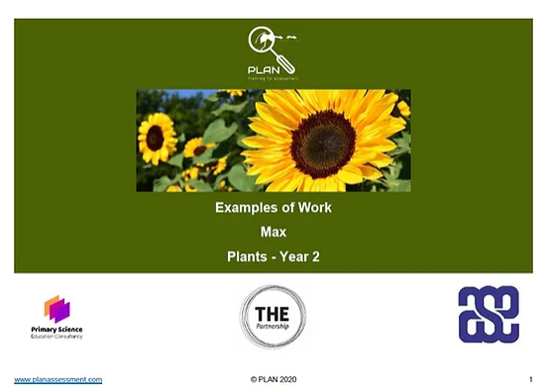

- SUPPORTING TEACHERS’ SHORT-TERM PLANNING:
www.planassessment.com 'Knowledge Matrices' (downloaded for free from the 'Resources' section of the website)
This resource is available to download for free for every year group and topic, from year one through to year six. (NB - EYFS Matrices are also available to support the development of an Early Years' curriculum in line with the 2021 Statutory Framework for EYFS). The Knowledge Matrices (for Y1-6) add more detail to the NC2014 requirements and support teachers by outlining:
- Prior and future learning associated with a year group unit. This helps teachers to link with the learning children had in a previous unit to the concepts being taught next. This, along with the child’s own experiences will help support assessment for learning at the beginning of a unit. The ‘future learning’ section also helps teachers to see what learning is coming next and where their topic fits within this progression of the big ideas in science.
- Key learning to identify the depth a concept needs to be developed within a unit. This section adds more detail to the NC2014 statements and helps to make it clear just what the children need to be able to know and understand for an age phase.
- Key vocabulary which we would expect a child working at age related expectation to use to discuss their understanding and learning. Can the children use this language and vocabulary to talk about the concept in sentences with some confidence and accuracy for their age phase?
- Common misconceptions for teachers to be aware of. This can be used to support formative assessment at the beginning and throughout a unit and can also help teachers to be prepared for adapting their teaching to address these.
- A range of enquiry opportunities to help teachers plan a sequence of learning to immerse the children in a concept. This will help to ensure the children experience concepts in a variety of ways and practise different types of enquiry which actively engage them and make links with everyday life. Providing lots of enquiry opportunities can help develop children's thinking, provide opportunities for discussion, and allow for the teaching, modelling and practising of relevant vocabulary which will help them to articulate their understanding of a concept(s) along with an opportunity to develop the skills of working like a scientist. By being immersed in a concept practically and in a variety of different ways, this helps make learning memorable, visual, hands-on and provides lots of opportunities to practise and develop the language linked to a concept. These all work to help learning stick.
- Possible evidence suggestions which can be used by the teacher to identify the most important aspects of a unit and to check back on which parts of the learning have ‘stuck’ and been embedded. The ‘possible evidence’ can be used to support AfL opportunities.
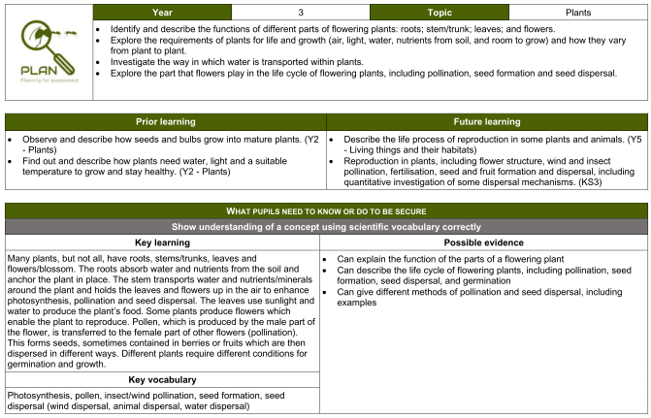
2). USE TO SUPPORT EMBEDDING KEY CONCEPTS – During a 'sharing good practice' meeting, staff can share this evidence of work from a child working at ARE for a unit they have just completed. Could the child do this independently? Do they agree they were working at ARE? Discuss with a colleague.
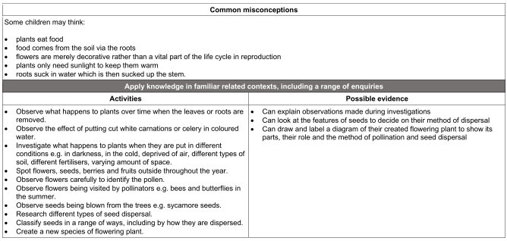
1). WS - During a 'sharing good practice' meeting, staff can share how many of these opportunities they provided within a unit of work.

Note: EYFS – Guidance for providing learning opportunities which support working scientifically in EYFS can be found in the following Lancashire publication 'EYFS- A Framework to Support Curriculum Planning' along with all other areas of learning for EYFS. A sample can be requested by emailing lpds@lancashire.gov.uk
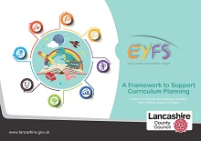
Or full document ordered from https://lpds.lancashire.gov.uk/publications.asp?q=eyfs
£75
- TRACKING PROGRESS AGAINST AGE RELATED EXPECTATIONS:
Staff could highlight a planning overview (e.g. their PLAN Assessment Knowledge Matrix for their unit) as they work through it to ensure coverage of the NC2014. Planning could be annotated to show next steps/support/challenge for particular children/groups. At the end of a unit, staff collate an overview table of children in their class – ‘on track’ or not for ARE? Which pupils are on the boundaries? How can these pupils be supported next? How often does the subject leader ask for these? Is the information transferred to an electronic tracker at the end of a year?
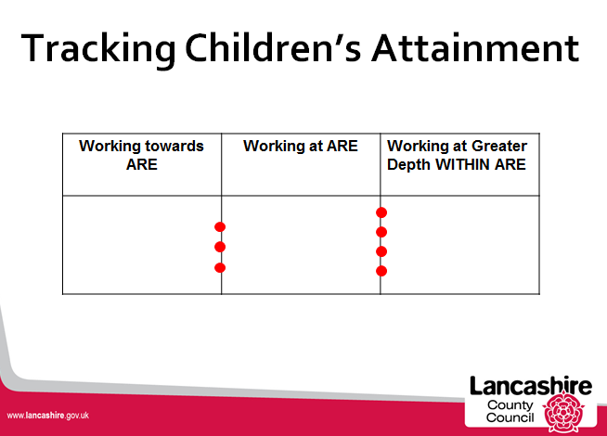

- SUPPORTING PLANNING OF SKILLS AT ‘ARE’: Out of the 3 options below possibly start with the 3rd option (planassessment.com ‘WS matrices’) but have included others as additional/alternative options.
Option a) Lancashire Primary Science Assessment materials – introduce skills progression A3 grid - statutory requirements (in orange title boxes), ARE and how to track progress. This is good for detailed discussions around skill progression but is quite wordy for a day to day document.
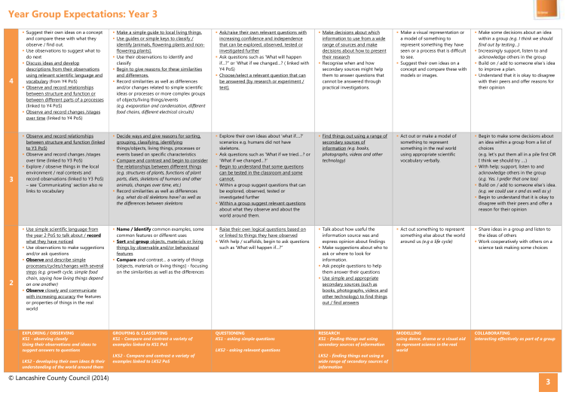
Option b) Or check out the resource at CIEC http://www.ciec.org.uk/resources/working-scientifically.html where you can download some progression documents and posters to use with children. By getting children to identify the skill they are focusing on each lesson, this also encourages teachers to become more familiar with the skills for their age phase. The child-friendly posters encourage the skills to be used within the lesson rather than just having a progression grid on the school website which might not be being used day to day to support learning. It also encourages children to embed what it means to 'Work Like a Scientist – Working Scientifically'
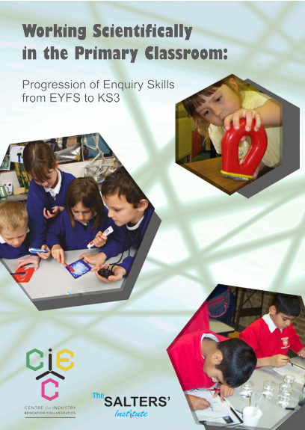
Option c) Or the Working Scientifically Matrices from www.planassessment.com which are simpler for staff to follow – less text so more likely to be used day to day. The Working Scientifically skills in the NC2014 are by age phase rather than year group. It is the same skills for each year group within an age phase – staff model and children practise skills in first year of an age phase and then children get more confident and independent (with the same skills) as they move to the next year within the age phase.
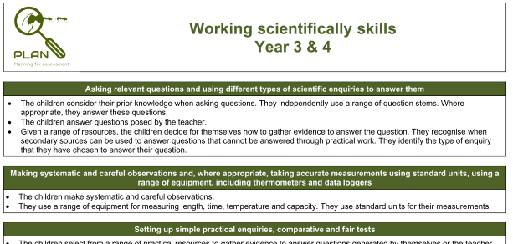

- CPD REQUIREMENTS – DEVELOPING UNDERSTANDING OF SCIENCE SKILLS & PROGRESSION: Identify if staff need CPD on Working Scientifically? Does the subject leader need to attend a course or book a staff twilight/INSET?

Full day course to support WS Skill Progression can be booked here https://lpds.lancashire.gov.uk/

Focus areas for twilight training could be:
- WS = Different types of enquiry and Science skills
- Skills progression across school
- The importance of vocabulary
- Focused recording of a skill which can they be assessed (see TAPS resource too in point 9 below)
- Investigations – children raising their own questions to test / planning a fair test / developing independence (Choice)
- Investigations – data handling
- Investigations – conclusions
A good book to support this especially in Y4-6 - ‘Scientific Enquiry Games’ Ann Goldsworthy www.milgatehouse.co.uk
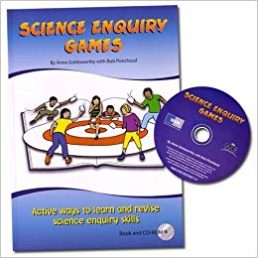
- RESOURCES TO SUPPORT STAFF WITH WORKING SCIENTIFICALLY SKILLS (USING TAPS): TAPS or Teacher Assessment in Primary Science provides teachers with a focused investigation for each unit and ensures progression of ARE based on statutory requirements in each age phase.
https://pstt.org.uk/resources/curriculum-materials/assessment ‘Focused Assessments’ section

The resource provides an overview grid of opportunities for a focused skill assessment and a set of planning documents to support the setting up of each focused assessment lesson. It encourages teachers to think about which aspect of an investigation is most important and focus on this for the pupils’ recording and then for assessment purposes. An essential ingredient for science provision in your setting could be that staff do a minimum of ONE TAPS Focused Assessment each half term. These are generally done two thirds or three quarters of the way through a unit once children have already been immersed in a concept in a variety of ways.

Outcomes from the tasks can then be used to support moderation and to help confirm teacher judgements. At a 'Sharing Good Practice' staff meeting, staff could share one child's TAPS outcome against the ARE for that skill. Do they agree it matches ARE for that skill?

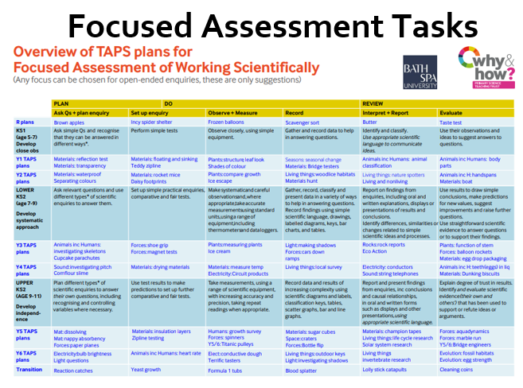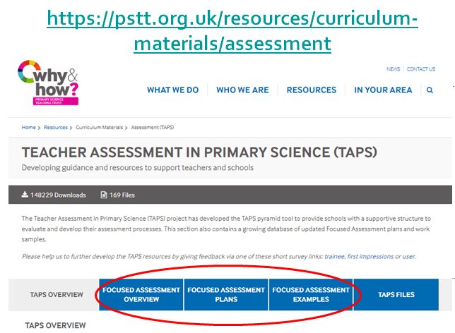

- CPD REQUIREMENTS – DEVELOPING SUBJECT KNOWLEDGE AND CONFIDENCE WITH KEY CONCEPTS IN SCIENCE: Introduce staff to FREE ReachOutCPD to support individual subject knowledge linked to topics and key concepts taught. https://www.reachoutcpd.com/

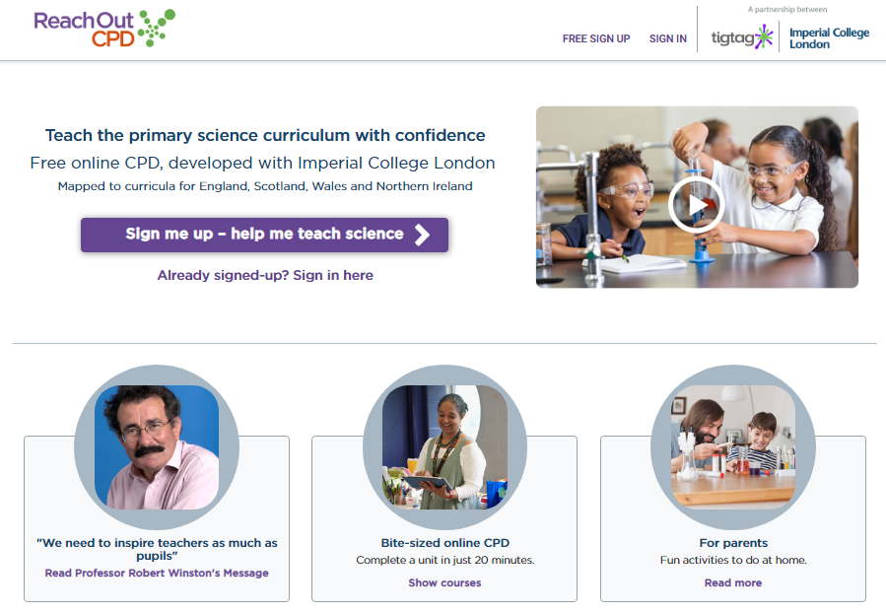
LPDS course on 'Sticky Learning in Primary Science' focusing on AfL and assessing genuine understanding of a concept (at ARE) and confident and accurate use of vocabulary relevant to the unit and age phase.
https://lpds.lancashire.gov.uk/ to book course

- CPD REQUIREMENTS – VOCABULARY: Do staff understand the importance of vocabulary in every science lesson – taught, modelled, discussed, practised verbally in sentences, used in writing. Do you have non-negotiables for science displays in your setting? These might include;
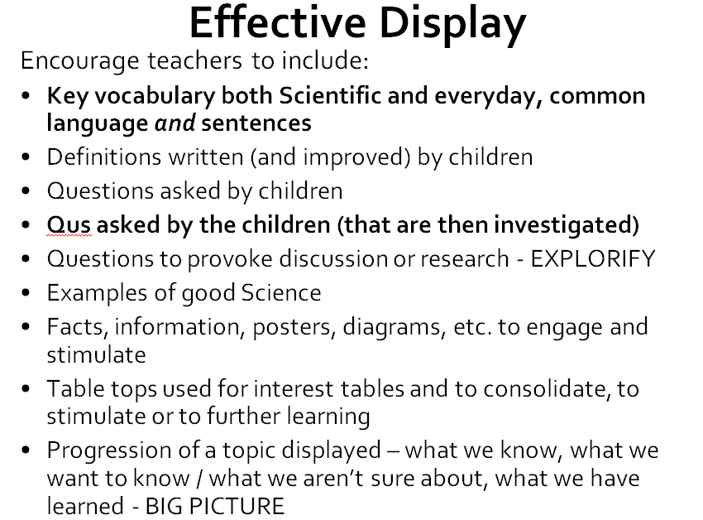

- RESOURCES TO SUPPORT LEARNING:
- Introduce staff to Explorify (FREE) https://explorify.uk/ to support AfL, challenge, higher order thinking skills and discussion
- Odd one out
- What if…? Scenarios / PMI
- Big Questions
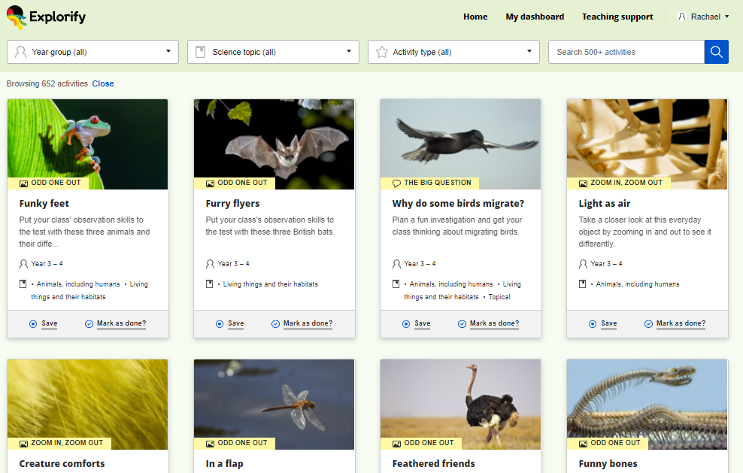
Introduce the above 3 activity types first then encourage use of others. Possibly make them 'Key Ingredients / Non – negotiables' for science in your setting. They promote lots of talking and discussion and so are an excellent way to develop the use of vocabulary verbally before writing. Odd One Out and What if..? Scenarios encourage children to apply their thinking to different scenarios and so can support assessment of understanding as well as use of vocabulary. Odd One Out works well throughout a unit and What if…? Scenarios answered with a PMI (plus/minus/interesting) are great assessments towards the end of a unit. Explorify allows you to search for topic and year group and provides ideas for every unit making it easy to embed across a school.
b)Explore, Engage, Extend book – great for hands-on, practical AfL at beginning of a unit in KS2 topics. This is a paid for resource. More information and samples for Y4 Sound and Y5 Forces can be found here: https://pstt.org.uk/resources/resources-available-through-tts/explore-engage-extend
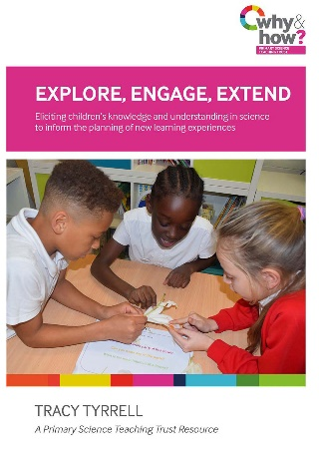
c)Concept Cartoons – to support thinking and AfL from https://www.millgatehouse.co.uk/ Children are presented with a cartoon which shares 3 or 4 different children's ideas about a concept or practical scenario. The cartoon speech bubbles often contain common misconceptions and provide a starting point for teachers to discuss these.

