EYFS ‘We Are Reading’ 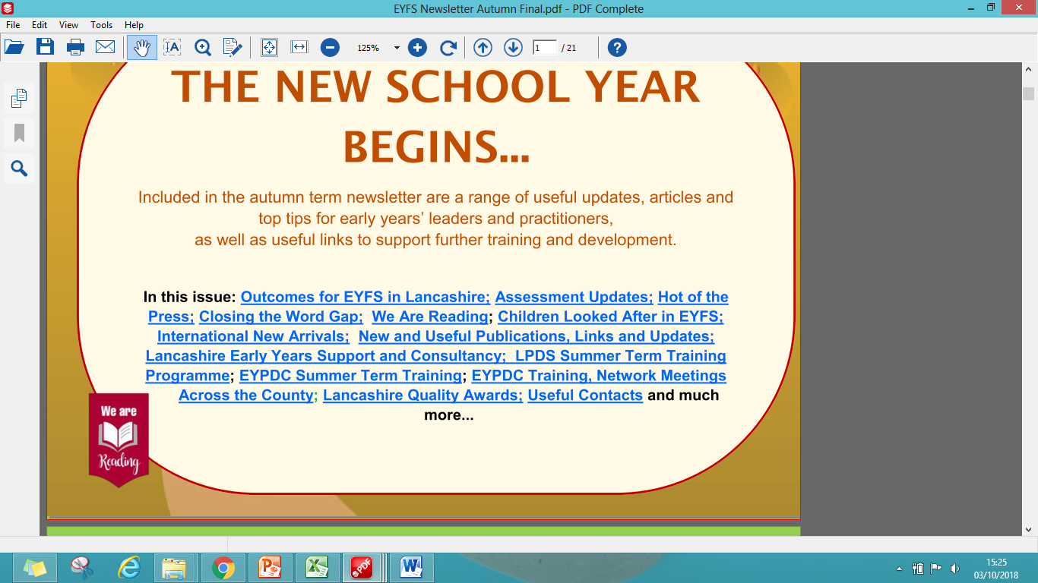

**Getting Everyone Reading**

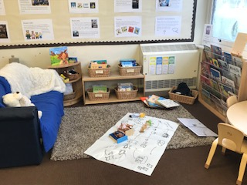EYFS consultants recognise the important role that early years has to play in setting the foundations for life long reading. We are raising the profile of reading, enabling practitioners to share their ideas and enthusiasm. The regular 'We Are Reading update' on our newsletter will provide information and links to support and challenge existing ideas and creativity, including links to outside agencies for parents. There will be a dedicated 'reading zone' at the Early Years Professional Development centre with the latest news, ideas and resources. Our summer term open evening will celebrate reading with ideas to encourage children to love books and share stories.

LPDS Early Years Teaching and Learning Consultants are committed to supporting the ‘We Are Reading’ initiative. We will be dedicating part of our website to the project which will be updated half termly with exciting ideas, activities, photographs, new texts to support schools in their commitment to getting our youngest children interested in books, stories, story-telling and much more. To get you started on this journey take time to reflect on your environment to identify where you currently provide opportunities for your children to engage with books. Look at how your books are organised and presented for easy access to the children, the range of books you offer and how adults themselves share their love of books with the children. If you have any photographs you want to share with others send them to us and we will add them to our website. Let’s get excited about reading! [www.lancsngfl.ac.uk/curriculum/earlyyears](http://www.lancsngfl.ac.uk/curriculum/earlyyears) @lancsearlyyears

**Becoming a reading school**

Our very youngest children may not be able to read independently but they certainly have lots of stories to tell. We can help by having knowledgeable adults who take the time to listen to children and create inviting reading areas that entice children with the promise of a cosy space and good quality books that support their developing reading skills and ignite their interest. Holding reading events, sharing top tips with families and linking up with local libraries will ensure that all aspects of early years provision support early reading skills in fun and interactive ways.

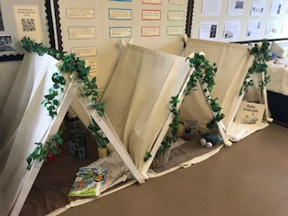

A library is a place through which we can open up a world of knowledge to a young child and to ignite their interest in books. Consider how you can introduce children to ‘a library’, for example setting up a library within your classroom, regular opportunities to use the school library, or if possible arranging a visit to your local library. Involve both children and parents in planning and activities, ask a local librarian to come into school to help set up your class library with the children, and talk to you and your children about how to use your library effectively.

**Summer Holiday Reads**

The summer holidays are almost here, bringing with it an exciting time for staff, parents and children to indulge in the pleasure of reading with quality time to explore new books, revisit old favourites, or find the latest story by a favourite author. Reading with and to young children opens the door to new vocabulary, interesting facts, stories with exciting characters who have amazing adventures. Reading is part of our daily life and this can be fun if we involve young children, for example sharing maps, spotting signs, following directions and finding out about new places. Make a list of fun reading opportunities for children to engage in with their parents over the holidays, and ask parents to make a record of their exciting reading opportunities so they can share them with their new class in September.

Share information about local reading events over the summer and give families web links to reading events that they can take part in with other families and children. The Lancashire Library Summer Reading for children is worth promoting with families with ideas for children from five years old. The love reading 4 kids website has great suggestions for summer reads from babies through to older children. Set holiday challenges to encourage younger children to find out more information about things they see or notice when they are out and about.

<http://www.lancashire.gov.uk/libraries-and-archives/libraries/reading-journey/>

<http://www.lovereading4kids.co.uk/genre/sr/Summer-Reading.html>

**Cross Curricular Reading**

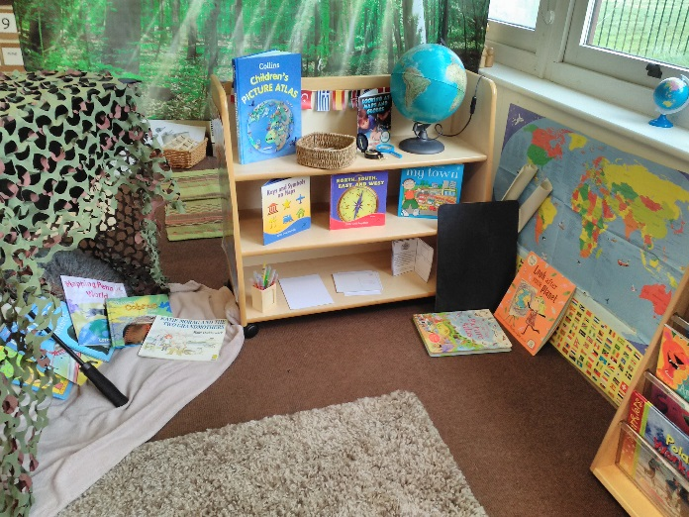Cross curricular reading is an integral part of early years practice as knowledgeable adults follow young children's interests and provoke their ideas through a range of exciting books and resources. Creating a focus on non-fiction or information books in a nursery or preschool book area can help children to make links between their thinking and also develop new vocabulary. Using books to find pictures to stimulate talk with young children will encourage them to explore lots of different ways of describing things. Adding stories that use the same vocabulary in a narrative way enhances children's confidence and their understanding of new vocabulary will be secured.

Purposefully displaying books in interesting places across the early years classroom can ignite children’s curiosity and provide opportunities to stimulate learning linked to the natural world, people, places within the local environment and the wider world. For example add books about the park, shops, houses and homes alongside small world resources. Add books about water including uses of water and water in the environment, (rivers, ocean, the pond, under the sea, etc.), alongside the water area together with exciting resources to further develop language and vocabulary and to build on children’s experiences of the world around them. Use the role play area as a place to support children in retelling familiar stories, taking on the role of story characters, for example Percy Park-keeper stories linked to the seasons. Books can open up a world of knowledge and experiences for our youngest children.

**Exploring the Great Outdoors**

Finding out about nature and the amazing world around them is important for each child’s learning and development. Exploring the great outdoors is the key to stimulating a child’s understanding of nature, but using books and stories can help us take a child on a journey beyond their immediate environment. Books allow us to enhance a child’s experiences, to ignite their interest and curiosity to show them the wonders of the natural world. Here are links to three websites to get you started.

[www.runwildmychild.com](http://www.runwildmychild.com) has selected 30 beautiful picture books about nature. The website provides a list of fantastic books as a starting point to exploring nature with your children.

[www.rspb.org.uk](http://www.rspb.org.uk) allows children to step into the lives of some amazing animals through audio books and stories.

[www.booktrust.org.uk](http://www.booktrust.org.uk) has 10 books about wildlife chosen by author Nicola Davies, including ‘Big Blue Whale’ and ‘Surprising Sharks’.