Dear Parents,
What a lovely week we have had! We finally got some good weather on Tuesday so we went on our walk to look at the houses and visit the piglets. It was great fun! You can read all about it in the school newsletter on Monday as the children have wrote all about it for Mrs Bamber. Lots of photos will be going onto our class page of the school website too so please remember to take a look.
BIG WRITE
Thank you for all you resources linked to ‘Room on the Broom’. We will be starting work on this book on Monday. The children will start by thinking about what a witch needs (i.e. hat, broomstick, black cape, long pointy nose, wand, caldron) and drawing and labelling their own witch. Over the weekend can you talk to your child about all the things the witch needs? They might even want to draw their own witch and label it.

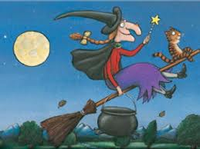

MASSIVE MATHS
I have attached a link to two games the children can play over the weekend both linked to work we have been doing on more and less than.
http://www.ictgames.com/mucky.html
http://www.ictgames.com/rabbit2.html

Next week in the creative area the children will be encouraged to make their own resources from the story so if we could have any old cereal boxes etc that would be fantastic. Hope you all enjoy the bank holiday weekend and the weather stays nice and sunny! See you all Tuesday!
Lisa x

Name: Date:

