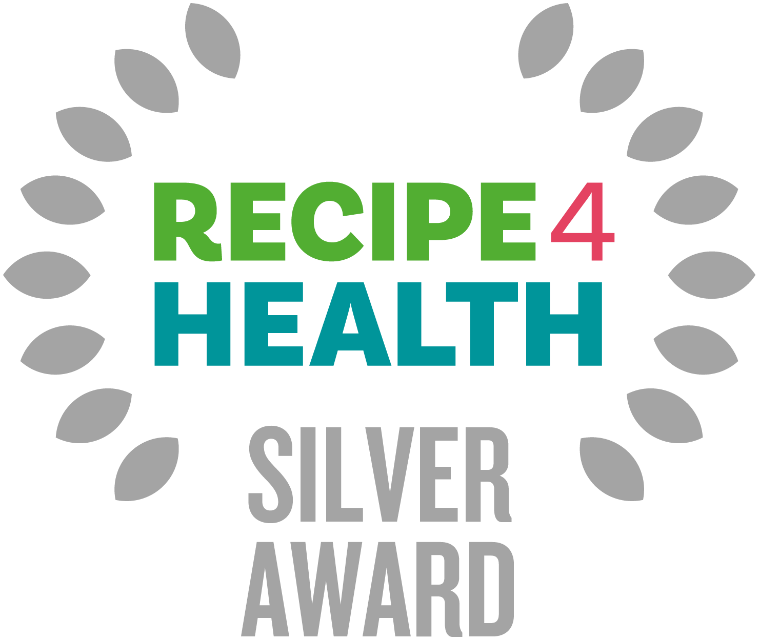

What is the R4H Award?
The R4H award promotes businesses that focus on healthy eating, environmental issues, and social responsibility. Sound like you? Read on. R4H is awarded by Lancashire County Council and is a Lancashire Trading Standards scheme for caterers.

Benefits for your business
- Businesses will be supported to make positive changes to their menus, policies, and practice to support the health of the local community and to the local environment.

- Businesses with the award will receive online promotion on the Lancashire County Council website, which is promoted across the country, and in council buildings.
- Businesses with the award will receive a promotion pack containing a certificate and other eye-catching materials to display in premises.

How to apply?

- There are three levels to R4H - Bronze, Silver and Gold.
- The award is free to apply for.
- You must have attained at least 4 stars for the Food Hygiene Rating Scheme at your most recent inspection.
- Please then fill in this self-assessment form. The form is then sent to Trading Standards. If you are successful, you will be notified by post. This should take no longer than 1 month.
- You can apply to the award at any time of the year. If you have any questions, please contact: recipe4health@lancashire.gov.uk

Silver Award Criteria

Please complete this self-assessment form by carefully filling in the information requested. The more information you give us, the less likely it is an officer will need to undertake an assessment visit. If you need more space, please include any extra information on additional paper and return it with your self-assessment form. If any questions are not applicable to your business, please write N/A.

Please provide a copy of your menu with your assessment sheet.

If you require any further advice or assistance in completing this form, please go to https://www.lancashire.gov.uk/business/trading-standards/recipe-4-health/ or contact the Recipe 4 Health team on 01772 532145 or email us on recipe4health@lancashire.gov.uk

Business details

Business Name
Business Address
Manager/Owner Details
Contact Telephone Number
Email Address
Website
Type of Establishment (e.g. Hot Food Takeaway)

SILVER AWARD CRITERIA

Clean
ESSENTIAL

Attained 4 stars for Food Hygiene Rating Scheme (OFFICE USE ONLY)

Promotions and Marketing
DESIRABLE

Do you keep food or drinks high in fat, sugar, or salt away from the point of purchase? i.e. at the serving counter / till point
Do you avoid prompting customers to take larger servings? e.g. ‘extra toppings’ or ‘go large’

Healthy Eating*

ESSENTIAL

Where are healthier options shown in the menu and how are they priced in comparison to standard options? Please provide details AND a copy of your menu.
Do you use trimmed meat and poultry where possible?
Do you use reduced fat alternatives of cream and milk in cooking? Are these available as options for serving? Please provide product details
Do you grill or steam any menu items in preference to frying? Please give details
Do you shallow fry menu items instead of deep frying? Please give details
If processed products such as soups, sauces and pies are bought in, what lower salt and/or sugar options do you provide? Please give examples.
Do you offer tap water and free water refills? (For more information, please look at the charity Refill and the benefits this has for your business)
DESIRABLE

Do you provide low fat sauces, or do you prepare your own sauces with low fat ingredients? Please give details
What type of oils do you use? Unsaturated oils and fats are better e.g. olive oil, rapeseed, sunflower oil, non-blended vegetable oils, groundnut oil
If you offer fried fish, is this lightly battered?
Do you offer baked potatoes with low fat fillings? (e.g., cottage cheese, tuna with low fat mayo, beans) Please give examples
Do you provide thick cut chips or potato wedges as an alternative to French fries/ thin chips?
What bread options are available? e.g. 50/50, wholemeal, granary
Do you provide low fat salad dressings? Please give details
What healthier drinks are available? e.g. water, pure fruit juice, semi and/or skimmed milk drinks

*N.B. for premises providing food solely for under 5's such as nurseries and childcare settings there is no requirement to use low fat products, it is preferable to use full fat dairy products, however low sugar and low salt options are preferable.

Fruit, Fibre and Vegetables
DESIRABLE

Do you serve one portion of vegetables in each meal? (Around 80g of vegetables)

Salt
ESSENTIAL

How is salt minimised in recipes? Please provide details
Do you source low-salt stock cubes, gravy granules and sauces (where applicable) Please provide product details

Sugar
DESIRABLE

Are all fruit juices pure and unsweetened and available in 150ml servings? Please provide product details

Fats and Frying
DESIRABLE
Do you look at oil maintenance and how this could be improved (e.g. oil in deep fryers is regularly strained/debris skimmed after each batch/throughout service, fully filtered at least weekly, oil is topped up after every session and oil is changed before it froths, foams or smokes) Please state what you do

Allergens
ESSENTIAL

Do you have a written procedure in place for dealing with allergens, and are all cooking staff aware of the procedure? Please give details
Are labels on prepacked products checked for any allergens present, and are the labels retained on file for the lifetime of the food?
Do you request a product specification from suppliers of foods that do not come with full labelling?
Do you request notification from suppliers about changes to recipes of prepared foods in relation to allergens?
Outline what procedures you have in place in relation to storage, preparation, cooking, hot holding, and cleaning to prevent cross contamination of allergenic ingredients?
Are tables, highchairs and other equipment used by allergenic customers cleaned thoroughly before their use of it?
Are reworked/reused/leftover foods controlled to ensure that no loss of identity occurs in relation to allergens? Please explain how

Alcohol Awareness (for licensed premises only)
ESSENTIAL

Do you have low alcohol and alcohol-free drinks available?
Under licensing legislation, it is mandatory for those supplying alcohol to have an age verification policy. Have you received details of the 'Check 25' policy from the Trading Standards Service and have all relevant staff viewed this resource?
Do you operate a 'Check 25' policy for the sale of alcohol and display proof of age signage on the premises stating that a 'Check 25' policy is in operation?
What forms of ID do you accept for age restricted products? e.g. PASS accredited ID, photo driving licence, passport
Are staff trained on: not to serve alcohol to under 18s, 'Check 25' policy, how to spot underage purchasers, how to politely refuse a sale to reduce conflict, the use of the refusals log, signs that a person has already consumed an excessive amount of alcohol? Please give details
Do you keep a refusals log of underage people attempting to purchase alcohol detailing: date, time, description of person, item attempted to purchase, comments from staff, staff details

Environment
ESSENTIAL

Do you ensure that taps are closed whenever they are not in use, and they are not left running unnecessarily?
Do you switch off or turn down all energy using equipment when it is not being used?
Do you switch off lights when a room or area is unoccupied or not being used?
Are dishwashers/washing machines only used when full?
Do you separate waste for reuse and recycling? e.g. card, plastic, glass, metal
Are energy efficient bulbs used wherever possible?
DESIRABLE

Do you use MSC-approved fish - which helps to maintain healthy fish [populations

Do you keep the room thermostat temperature at the lowest comfortable level? Is the heating turned off before windows are opened?
Do you avoid disposable products where possible, if hygienic to do so?
Do you purchase cleaning products / washing detergents in bulk and in concentrated form?
Do you use refillable containers wherever possible? e.g. washing up bottles, soap dispensers, condiment pots.

Declaration
As an authorised person of the above-named business, I verify that all information supplied above is true and accurate at the time of completing this self-assessment form.

Print Name

Signature

Date

After completion please return to:
Recipe 4 Health,
Lancashire County Council Trading Standards Service
PO Box 100
County Hall
Preston
PR1 0LD

OR

By email to - recipe4health@lancashire.gov.uk

NB Don't forget to include a copy of your menu.

Further free guidance can be found here :

Business Companion - https://www.businesscompanion.info/en/in-depth-guides
Food Standards Agency - https://www.food.gov.uk/
Government website - https://www.gov.uk/

Data Protection:

In completing this form, you understand that Lancashire County Council has a requirement to process your personal data.

Lancashire County Council will only ever process your personal data where it has a clear lawful basis for doing so in full compliance with data protection legislation - UK GDPR and The Data Protection Act (2018).

We will ensure the security and confidentiality of your personal data at all times.

For full details of how Lancashire County Council handles your personal data please see our privacy notice here:
https://www.lancashire.gov.uk/council/transparency/access-to-information/service-and-project-specific-privacy-notices/trading-standards/

