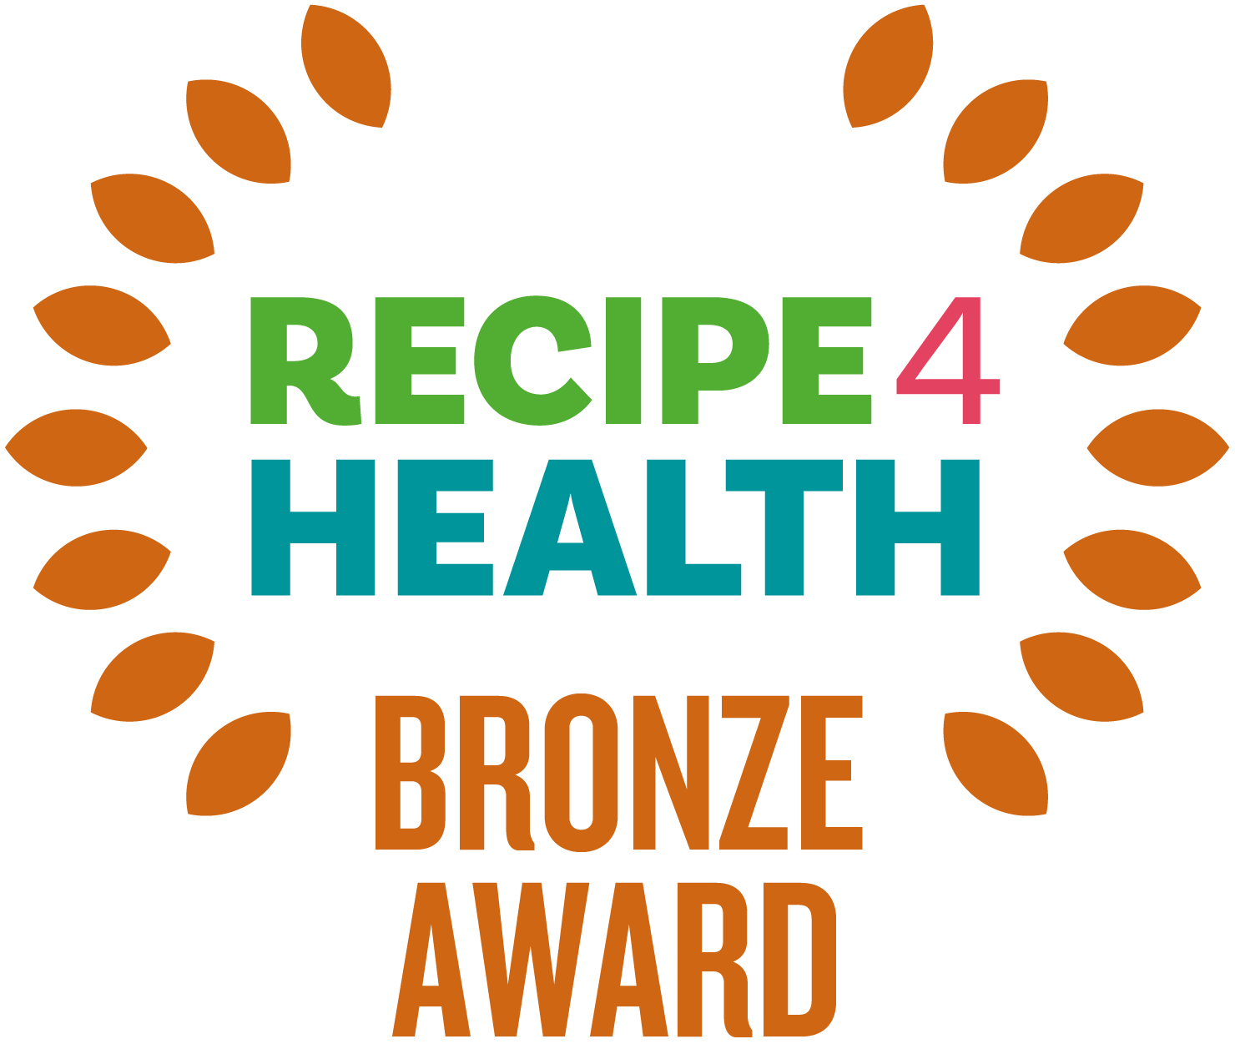

What is the R4H Award?

The R4H award promotes businesses that focus on healthy eating, environmental issues, and social responsibility. Sound like you? Read on. R4H is awarded by Lancashire County Council and is a Lancashire Trading Standards scheme for caterers.

Benefits for your business

- Businesses will be supported to make positive changes to their menus, policies, and practice to support the health of the local community and to the local environment.

- Businesses with the award will receive online promotion on the Lancashire County Council website, which is promoted across the country, and in council buildings.
- Businesses with the award will receive a promotion pack containing a certificate and other eye-catching materials to display in their premises.

How to apply?

- There are three levels to R4H - Bronze, Silver and Gold.
- The award is free to apply for.
- You must have attained at least 3 stars for the Food Hygiene Rating Scheme at your most recent inspection.
- Please then fill in this self-assessment form. The form is then sent to Trading Standards. If you are successful, you will be notified by post. This should take no longer than 1 month.
- You can apply to the award at any time of the year. If you have any questions, please contact: recipe4health@lancashire.gov.uk

Bronze Award Criteria

Please complete this self-assessment form by carefully filling in the information requested. The more information you give us, the less likely it is an officer will need to undertake an assessment visit. If you need more space, please include any extra information on additional paper and return it with your self-assessment form. If any questions are not applicable to your business, please write N/A.

Please provide a copy of your menu with your assessment sheet.

If you require any further advice or assistance in completing this form, please go to https://www.lancashire.gov.uk/business/trading-standards/recipe-4-health/ or contact the Recipe 4 Health team on 01772 532145 or email us on recipe4health@lancashire.gov.uk.

Business details

Business Name
Business Address
Manager/Owner Details
Contact Telephone Number
Email Address
Website
Type of Establishment (e.g. Hot Food Takeaway)

BRONZE AWARD CRITERIA

Clean
ESSENTIAL
Attained 3 stars for Food Hygiene Rating Scheme (OFFICE USE ONLY)

Promotions and Marketing
ESSENTIAL
Please detail any healthier products you promote or market.
Promotions and marketing can include price promotions (e.g., buy one get one free), place promotions (products placed at key places where customers will view them e.g. on the counter) and marketing materials (e.g. posters, leaflets).

Fair
ESSENTIAL
What steps are taken to ensure that accurate descriptions are given to all products?
e.g. Diet Cola rather than Diet Coke, homemade is made from scratch on the premises, meat products meet the minimum standards.
Any foods containing Genetically Modified Organisms (GMOs or GM food) are legally required to be labelled or made known to the customer. What steps are taken to ensure you comply with the law?
Guidance - https://www.businesscompanion.info/en/quick-guides/food-and-drink/genetically-modified-foods
Are clear prices given for all items, with no hidden charges (service, delivery etc)?
Are stamped glasses and equipment used to serve beer, wine, and spirits? (NB licensed premises only)
Are weights and measures notices displayed regarding the sale of wine and spirits? (NB licensed premises only)
Where do you display business ownership details? It is legally required unless exempt.
Guidance - https://www.businesscompanion.info/en/quick-guides/miscellaneous/company-and-business-names
DESIRABLE
Has your organisation signed up to be Baby Friendly? Visit the following link https://www.familiesandbabies.org.uk/locations/lancashire/

Healthy Eating*
ESSENTIAL
What healthier options are available? These options must be lower in fat, salt, and/or sugar than standard menu options.
DESIRABLE
If processed products such as soups, sauces and pies are bought in, what lower salt and/or sugar options do you provide? Please give examples
Do you offer tap water and free water refills? (For more information, please look at the charity Refill and the benefits this has for your business)

*N.B. for premises providing food solely for under 5's such as nurseries and childcare settings there is no requirement to use low fat products, it is preferable to use full fat dairy products, however low sugar and low salt options are preferable.

Fruit, Fibre and Vegetables
DESIRABLE
What fruits and vegetables do you have available as snacks? (If appropriate for your cuisine)

Salt
ESSENTIAL
Do you use reduced hole saltshakers? i.e. with 3 holes or less, rather than 5 or more
DESIRABLE
Do you avoid adding salt when boiling potatoes, rice, or pasta?

Sugar
DESIRABLE
Where hot drinks are served, including self-service, do you offer sweeteners as an alternative to sugar?

Fats and Frying
DESIRABLE
Which types of milk do you use or serve as standard for hot drinks?
i.e. not using whole milk as standard (exceptions for early years settings) or verbally offering semi or skimmed milk.
Do you operate the ‘bang, shake and drain’ method for frying to help reduce the amount of oil absorbed?

Allergens
ESSENTIAL
How do you control allergens in your premises? e.g. use of the SFBB allergen information sheet / FSA allergen matrix / allergen information sheet / cleaning regime?
Do you display signs encouraging customers to ask staff about allergenic ingredients? If yes, please give details of their location(s) and the wording on the signs
What instructions are given to waiting staff or serving staff when dealing with any customers who have a query about allergens? Are these instructions recorded?

Alcohol Awareness (for licensed premises only)
ESSENTIAL
Please give details of your age restricted sales policy? e.g. refusals records, regular training, signage

Environment
ESSENTIAL
Please give details of any trade waste contract you may have, including, waste company name, frequency of collections, type of waste.
How do you dispose of your oil and animal by-products?
What do you do to minimise your impact on the environment? e.g. recycling, energy efficiency measures, minimising water waste.
DESIRABLE
Is all the meat you use Red Tractor approved meat, Organic Certified, Quality Standards Mark Certified or LEAF Marque Standard Certified? If yes, please state all that apply?
Please outline how you actively discourage food waste? e.g. by offering smaller portions

General
ESSENTIAL
Briefly outline the Induction process for new staff, and what it includes.

Declaration
As an authorised person of the above-named business, I verify that all information supplied above is true and accurate at the time of completing this self-assessment form.

Print Name

Signature

Date

After completion please return to:

Recipe 4 Health,
Lancashire County Council Trading Standards Service
PO Box 100
County Hall
Preston
PR1 0LD

OR

By email to - recipe4health@lancashire.gov.uk

NB Don't forget to include a copy of your menu.

Further free guidance can be found here :

Business Companion - https://www.businesscompanion.info/en/in-depth-guides
Food Standards Agency - https://www.food.gov.uk/
Government website - https://www.gov.uk/

Data Protection:

In completing this form, you understand that Lancashire County Council has a requirement to process your personal data.

Lancashire County Council will only ever process your personal data where it has a clear lawful basis for doing so in full compliance with data protection legislation - UK GDPR and The Data Protection Act (2018).

We will ensure the security and confidentiality of your personal data at all times.

For full details of how Lancashire County Council handles your personal data please see our privacy notice here:
https://www.lancashire.gov.uk/council/transparency/access-to-information/service-and-project-specific-privacy-notices/trading-standards/

