In confidence

Digital Services

Remote Access to Corporate Desktop (RACD)

Getting Started Guide

# Contents Page

1. Remote Access to Corporate Desktop (RACD) 4

2. Using RACD for the first time on a Device. 5

Downloading, installing or checking the Citrix WorkSpace App 5

3. Logging in to the Remote Access service (RACD) 7

4. Navigating around the Remote Desktop on your iPad / Android or Windows tablet 13

5. Troubleshooting / Error Messages 15

Issues Launching RACD 15

Issues logging into RACD 18

6. Appendix 19

# Remote Access to Corporate Desktop (RACD)

Welcome to Remote Access to Corporate Desktop (RACD), a service provided by Digital Services to allow employees access to a standard corporate desktop session from a non-corporate device e.g. home computer or tablet, via the Internet.

These instructions have been produced to guide you through the steps required to setup and login to this service. To access this service you must have Symantec VIP token and have applied for and had your access set up to use RACD by ICT Services. (For guidance on how to apply for this service, please go to the ICT knowledgebase and search for KB0019535).

Whilst every effort has been made to ensure compatibility with as many different non-corporate device setups as possible, ICT Services are not able to guarantee this service on your personal device and are unable to offer support in the setup of this service. A compatibility list is available in the appendix.

If additional security / pop-up blockers are installed on the machine you are using, it may help to enter the web address below into the exceptions list. The online help guide within your web browser should be able to provide guidance on how to do this.

<https://remotedesktop.btlancashire.co.uk/>

# Using RACD for the first time on a Device.

If you are using RACD for the first time on any device, you are advised to check that you have the most up to date Citrix WorkSpace App installed on your machine. RACD relies on this for the best experience, but you must be certain that other applications on your personal computer will be unaffected if you decide to install this.

You only need to complete this task on your initial RACD setup, the next time you use RACD proceed straight to the steps in section 3 - Logging in to the Remote Access service. However, the Citrix WorkSpace software client will be updated periodically by the supplier, so you should check from time to time that you have the current version installed or this could prevent RACD from working.

## Downloading, installing or checking the Citrix WorkSpace App

To do this, click on the link below:

* <https://www.citrix.com/en-gb/downloads/workspace-app/>

The Citrix website will appear and display a list of WorkSpace App installations available for various devices (Fig 1.1).

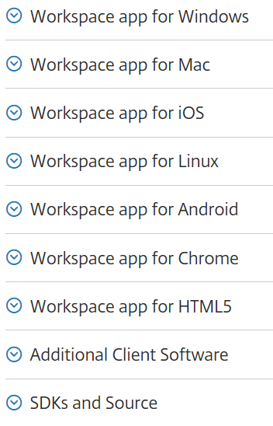

**Fig 1.1 – Example of WorkSpace App software for different devices**

Click to reveal the submenus (Fig 1.2).

**Fig 1.2 – Example of the submenus**

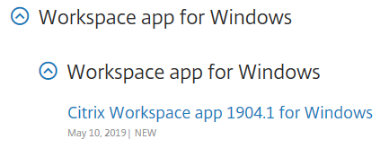

Click the hyperlink in Fig 1.2. Please follow the instructions on screen, these instructions will be different depending on the type of device you are using.

On Apple iOS devices (such as iPads), or Android devices, the instructions will automatically take you to your App Store or Google Play store to download and install the Citrix WorkSpace App (please note this app is free to download).

If prompted you will need to enter your ***personal*** app store account details and then download the app as you would for any other app you download onto your device.

If you are prompted to enter an email address and register, you can ignore / skip this, as you do not need to add an account. You can click on the finish button and proceed to the next section of this guide.

# Logging in to the Remote Access service (RACD)

To log in to the Remote Access service (RACD), navigate to the ICT Mobility page in your internet browser or click on the link below:

* <http://www.btlancashire.co.uk/mobility/>

Click on the blue boxes "Login to RACD" to logon to the Organisation you're a member of (shown highlighted red in Fig 3).

**Fig 3 – ICT Mobility page**

This will take you to the RACD login page (examples shown in Fig 4 and Fig 5)

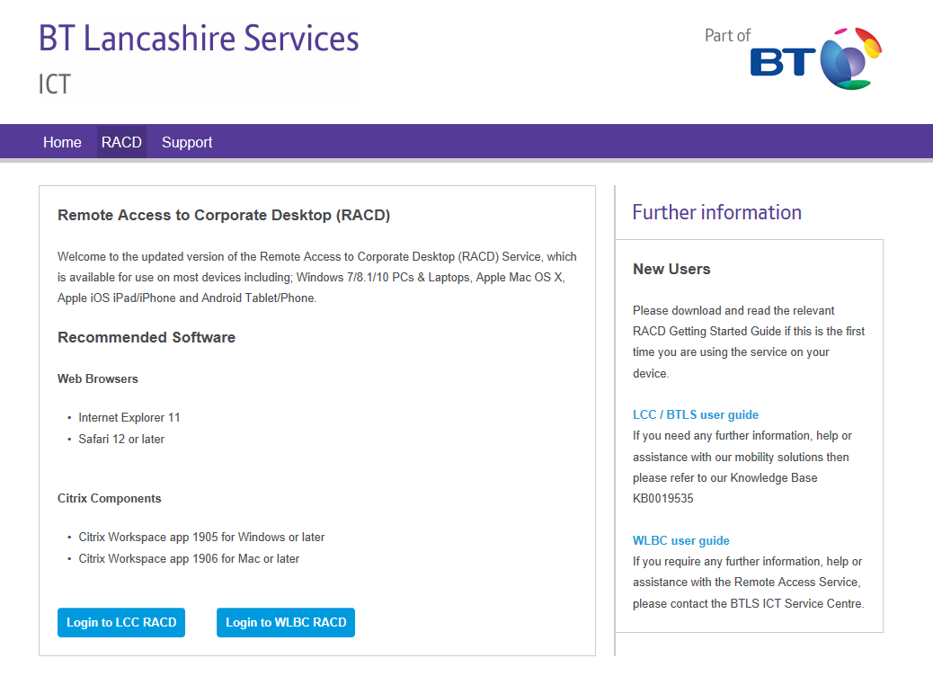

**Fig 4 – Example on a Windows Device**

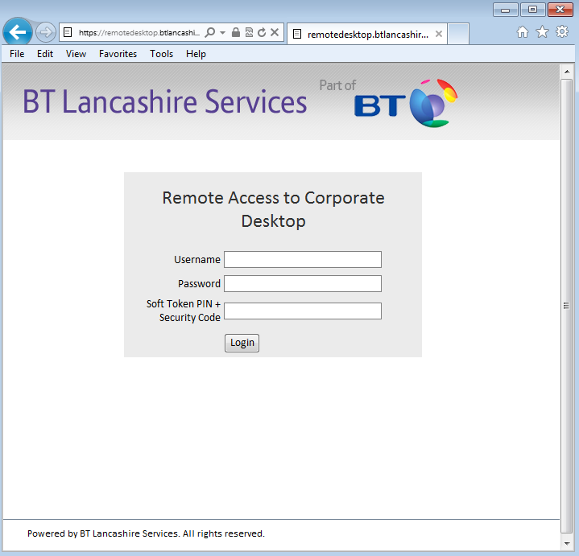

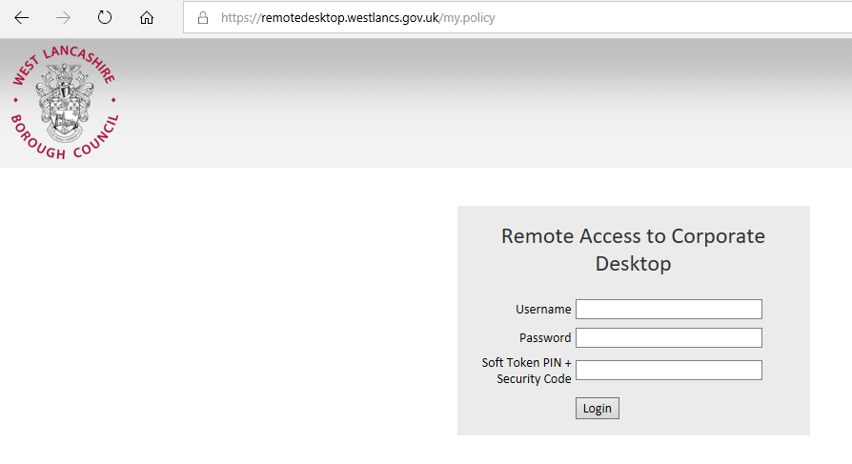

**Fig 5 – Example of an Android or Apple iOS Device**

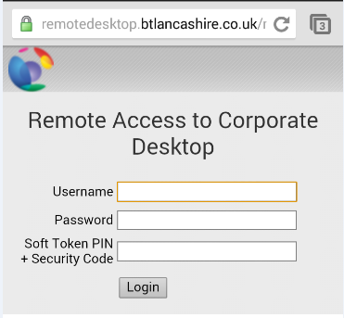

To login enter the following details then click Login.

|  |  |
| --- | --- |
| **Username** | This is your username used to login to an LCC\WLBC corporate machine (your AD login). |
| **Password** | The password used with this account. |
| **Soft Token PIN and Security Code** | This is made up from your 4-digit pin code and the current number displayed on your token screen. Enter them one straight after the other, no spaces.  Security Code      Legend  Pin Number  Security Code    8461016383 |

Once successfully authenticated you will be required to accept a short Acceptable Use Policy (Fig 6), please read and click "Click here to continue" if you are happy to do so.

**Fig 6 – Example of the short Acceptable Use Policy**

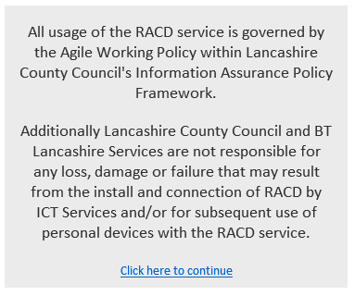

When presented with the following screen (Fig 7), click the icon to launch the desktop.

* 'RACD for Windows 10 users'
* 'WLBC RACD' - For WLBC users

**Fig 7 – Example of the Desktop launch screens**

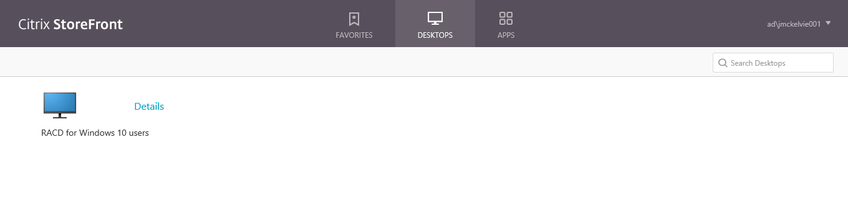

And WLBC users will see the following icon instead (those WLBC users who have been migrated over to Windows 10 will also see the 'RACD for Windows 10 Users'):

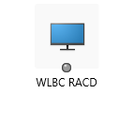

Your Remote Desktop session will now launch.

**Fig 8 – Example of the RACD desktop after launch**

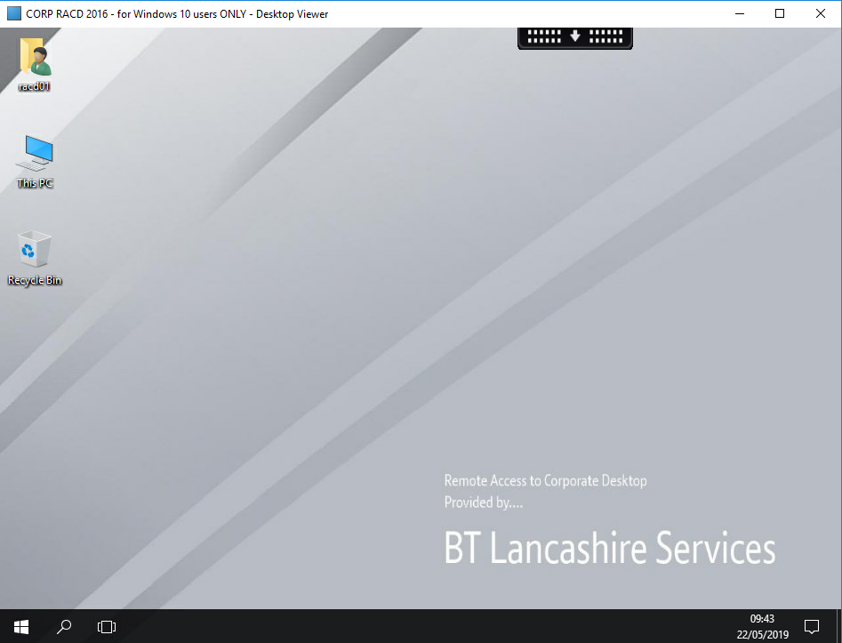

To end your Remote Access session, right-click the start button on the desktop, and then select 'Sign Out' from the start menu (shown highlighted red in Fig 9).

**Fig 9 – Example of how to Sign Out**

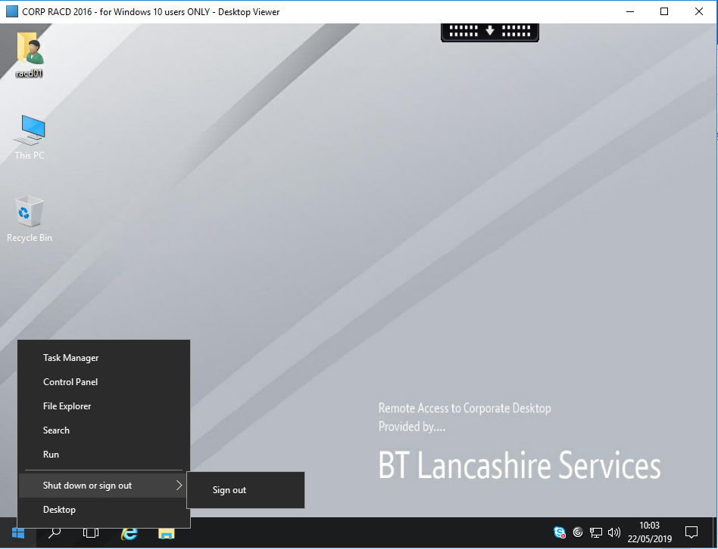

Then click on the 'Logout' button from the next screen (shown highlighted red in Fig 10).

**Fig 10 - Logout**

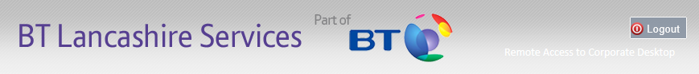

Your Remote Access (RACD) session will now be shut down and you will receive the following message. (Fig 11)

**Fig 11 – Session end**

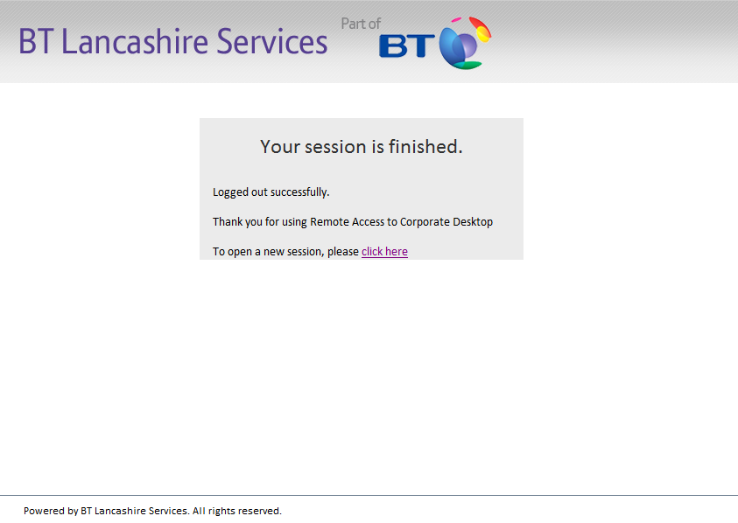

# Navigating around the Remote Desktop on your iPad / Android or Windows tablet

By tapping on  you will be able to find your usual applications.

For example; **Start | Excel 2016** will launch Excel 2016

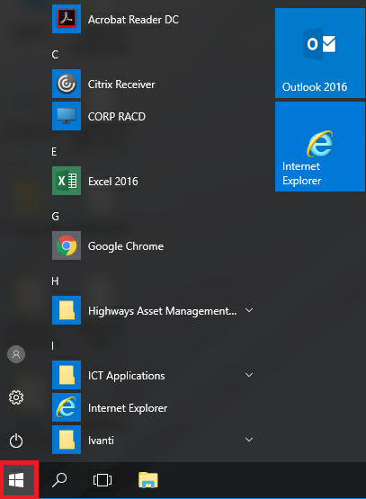

Fig 12

Tapping the arrow at the top of the screen will show the system menu options, such as the keyboard and the Home button; which when tapped will disconnect your RACD session.

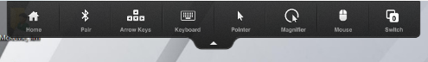

Fig 13

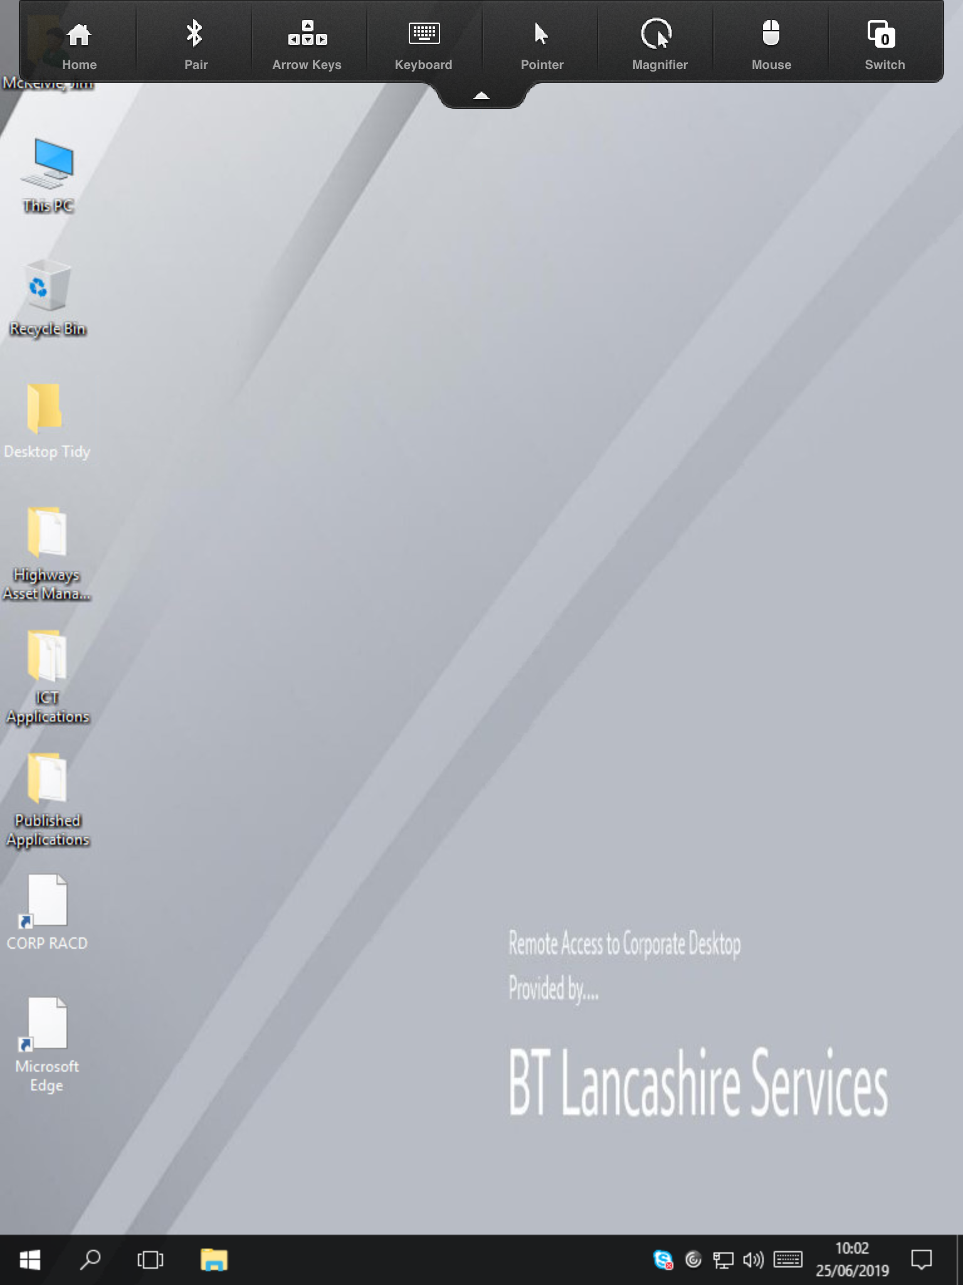

Fig 14

The RACD desktop as displayed on the device.

When you have finished you will need to Log off from both your windows session and your secure connection. From the toolbar click the Home button, close the Workspace App and logout of the Remote Desktop webpage.

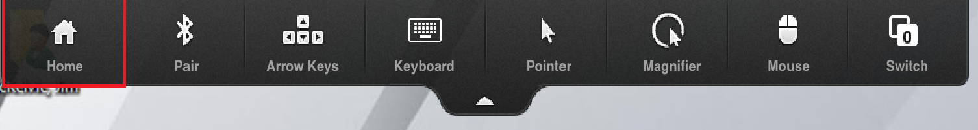

Fig 15

# Troubleshooting / Error Messages

## Issues Launching RACD

|  |  |  |
| --- | --- | --- |
|  | **Question / Query** | **Answer** |
| 1 | When I click the Remote Access (Remote Access to Corporate Desktop) icon to launch the session on a windows device I get the following message "do you want to open or save launch.ica from remotedesktop.lancashire.gov.uk?" | If you receive this message, click on "Open", as highlighted in red. |
| 2 | When I click the Remote Access (Remote Access to Corporate Desktop) icon to launch the session on an Apple iOS device I get the following message: | If you receive this message, Tap on '*Open in 'Workspace'* ' as highlighted in red. |
| 3 | When I click the Remote Access (Remote Access to Corporate Desktop) icon to launch the session on an **Android** device nothing happens. | Depending on the personal settings on your device, it may not auto run file downloads. You will have to navigate to your Downloads app  and tap on the ***launch.ica file*** to allow your Remote Desktop session to launch. |
| 4 | When I click the Remote Access (Remote Access to Corporate Desktop) icon to launch the session on an **Apple Mac** device nothing happens. | Depending on the personal setting on your device, Safari may prevent RACD from launching within Safari. To resolve this issue you will need to:   1. Launch **Safari** 2. Click on **'Preferences'**   cid:image001.png@01D004D3.B23961E0   1. Next, click on '**Security**'   cid:image002.jpg@01D004D3.B23961E0   1. Check that the Citrix Workspace plugin settings are set to '**Allow Always**' for remotedesktop.btlancashire.co.uk, as shown below |
|  | When I click the Remote Access (Remote Access to Corporate Desktop) icon to launch the session on a windows device I get the following message | This message can be due to a number of reasons:   * On some devices this message is shown the first time you login, please click skip and continue as normal. If the message is shown again please refer to the next point. * You may not have correctly followed section 2 and installed the Citrix WorkSpace App or the Citrix WorkSpace App version is out of date. Please click download (see icon in left hand column) this will take you to the Citrix website in section 2 and then follow the remaining instructions in section 2. After this if the message is shown again please refer to the next point. * Your virus/malware/browser/security software may be blocking the RACD website from checking if you have a Citrix Workspace App installed. Please follow the instructions for your specific software on how to add https://remotedesktop.btlancashire.co.uk into the allowed/safe sites list. * It is possible on some devices you will also get this message even after following the above instructions, please click skip and continue as normal to access RACD. Please log a call with ICT Services and we may be able to advise you further. |
|  | When I click the Remote Access (Remote Access to Corporate Desktop) icon to launch the session on a windows device I get the following message | If you receive this error message, click on the "Allow" Button (Highlighted Red) |

## Issues logging into RACD

**When I enter my login details and click on login, I receive one of the following messages:**

|  |  |
| --- | --- |
| **Error Message** | **Solution** |
|  | Click "Click here to continue" and try to login again.  Please make sure you are entering your username and password correctly. This is the username and password you use to login into an LCC Corporate Machine. |
|  | Click "Click here to continue" and try to login again.  Please make sure you are entering your PIN and token Security Code correctly. It is your 4 digit PIN followed by the current Security Code displayed on your token. Do not add any spaces between the two numbers. |
|  | Click "Click here to continue" and try to login again.  Please make sure that you have followed the process for requesting access to the RACD service and have received confirmation from ICT that you have been setup. |

If any of the above messages continue after trying the above solutions then please contact the ICT Service Centre.

# Appendix

**Compatibility**

Whilst every effort has been made to ensure compatibility with as many different computer configurations as possible, ICT Services are not able to guarantee this service as your personal device may have incompatible software installed or incompatible configurations.

Citrix WorkSpace App provides access to RACD. Citrix supports WorkSpace App on many devices.

Further information on device compatibility can be found here: <https://www.citrix.com/en-gb/downloads/workspace-app/>