Shavuot messaging 16 May

Twitter | Graphic
Happy #Shavuot to those celebrating!  We know it's been challenging to follow Covid-19 restrictions when marking religious festivals.  If we follow the guidance and continue to protect each other, next year could look very different. ❤️ | 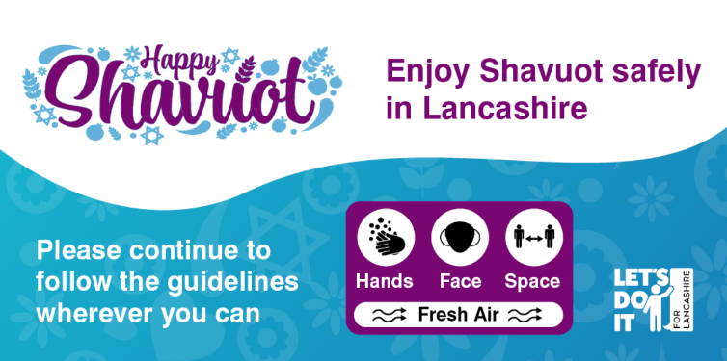
❗ Restrictions change tomorrow, which means those celebrating #Shavuot can meet up to 6 people or 2 households indoors.  To read the full list of changes starting from 17 May, click here: https://www.gov.uk/guidance/covid-19-coronavirus-restrictions-what-you-can-and-cannot-do | 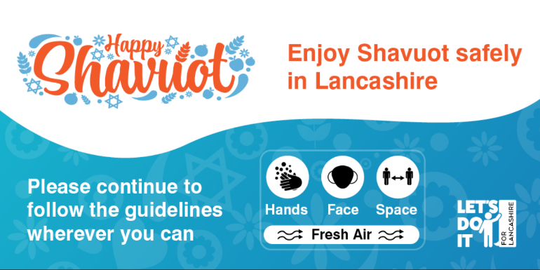
✨ Happy #Shavuot to everyone celebrating!  💡 Remember, #Covid19 restrictions are different from Monday.  We want to thank you for continuing to follow guidance and hope you have a wonderful and safe time celebrating! | 