Twitter | Graphics
🚫We know restrictions have been tough  Celebrations were changed or cancelled, making it difficult to mark religious festivals that are important to many of us.  Please continue to follow Covid-19 guidelines when marking Eid this year to keep you and your loved ones safe ❤️ | 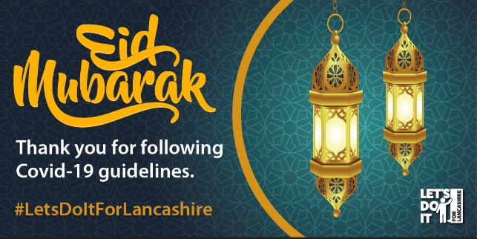
❤️ We want to thank you for persevering with challenging restrictions over the last year.  Please celebrate Eid safely this year, as you have been doing since the start of the pandemic.  Eid Mubarak ☪️ | 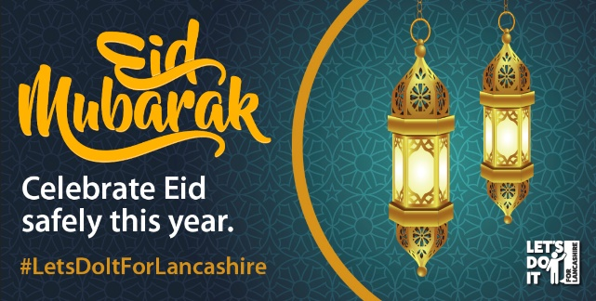
While many celebrations, including Eid, still look different, we hope you enjoy them as best you can.  🙏 It is thanks to those following the rules that we can now meet up with loved ones outdoors.  Please keep going and enjoy. #EidMurabak ☪️ | 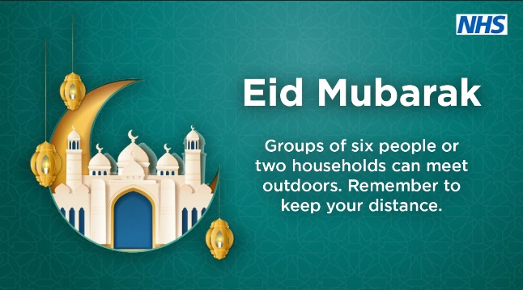

🙏 Thanks to everyone celebrating Eid safely this year.

If we keep following the guidelines, we hope things will look very different for all celebrations and festivals in the future.

Stay safe this #EidMurabak ☪️

