Facebook | Twitter | Images
💉 Today marks a year since the first national lockdown. Since then, Lancashire's vaccination teams, including many volunteers, have been working tirelessly to get the county vaccinated.  👏To date, we have vaccinated more than 750,000(to be updated) people!  ❤️Thank you to each and every person who has contributed to the vaccination programme, as well as to everyone who has accepted their invitation to be vaccinated to help us get back to normality. | 💉Since the first national lockdown, more than 750,000 people have been vaccinated in #Lancashire.  ❤️ Thank you to everyone who has helped to deliver the vaccination & everyone who has come forward to be vaccinated.  #CovidAnniversary | 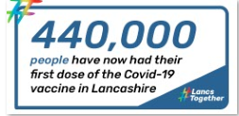  NB: This will be updated with accurate figures nearer the time
🔗Testing for Covid-19 is vital if we are to break the chains of transmission and save lives.  Across Lancashire, a total of 52 testing sites are in operation, offering testing for those with symptoms, those without symptoms who cannot work from home, children in schools, colleges and their support bubbles and workplace testing.  🙏We want to acknowledge the tremendous efforts of those carrying out Covid-19 testing across Lancashire for their commitment to identifying positive cases and keeping our communities safe. | 🔗Testing for Covid-19 is vital if we are to break the chains of transmission and save lives.  🙏Thank you to those carrying out testing at all of the 52 sites in #Lancashire to help identify positive cases and keep communities safe.  #CovidAnniversary | 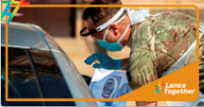
🧠 The pandemic has had a profound impact on mental health for many people.  ‼️Remember, help and support is available and you do not have to suffer in silence.  You can contact Every Mind Matters for support with everything from dealing with loneliness and grief to money worries and job uncertainty: https://www.nhs.uk/oneyou/every-mind-matters/ | 🧠 The pandemic has had a profound impact on mental health for many people.  ‼️Remember, help and support is available and you do not have to suffer in silence.  Visit #EveryMindMatters for support. https://www.nhs.uk/oneyou/every-mind-matters  #CovidAnniversary | 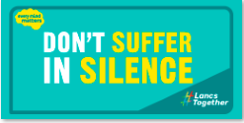
↔️ From keeping your 2m distance to washing your hands regularly, using hand sanitizer when shopping for essentials and wearing face coverings, everyone has been doing their bit for the last year to help stop the spread of Covid.  🤞 While we have a long way to go, this is working – and we should keep going so that we can stay on track for the lifting of all restrictions, so we can get back to some form of normality.  ❤️Thank you for all that you are doing. | ↔️ From keeping your 2m distance to wearing face coverings, we have all been doing our bit to help stop the spread of Covid-19.  ❤️ On the #CovidAnniversary, we want to say thank you for your continued efforts that will help us get back to normal. | 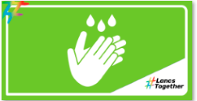
✏️Thousands of parents and carers across Lancashire have, up until recently, been juggling home schooling with their daily lives and responsibilities.  This is no mean feat, and has presented very real challenges, both for children and their parents and carers.  💻 Equally, teachers in the county have kept schools open for children of key workers and vulnerable children, whilst providing remote lessons for others. They've ensured their pupils are still learning despite not always being in a face-to-face setting.  ❤️ So whether you are a parent or carer, school pupil or a teacher, you have shown true resilience in the past 12 months and we want to say thank you. | ✏️ Parents & carers across #Lancashire have juggled home schooling with their daily lives.  💻 Teachers have provided remote lessons, ensuring children are still learning during such uncertain times.  ❤️ Thank you to parents, carers & teachers for your resilience #CovidAnniversary | 