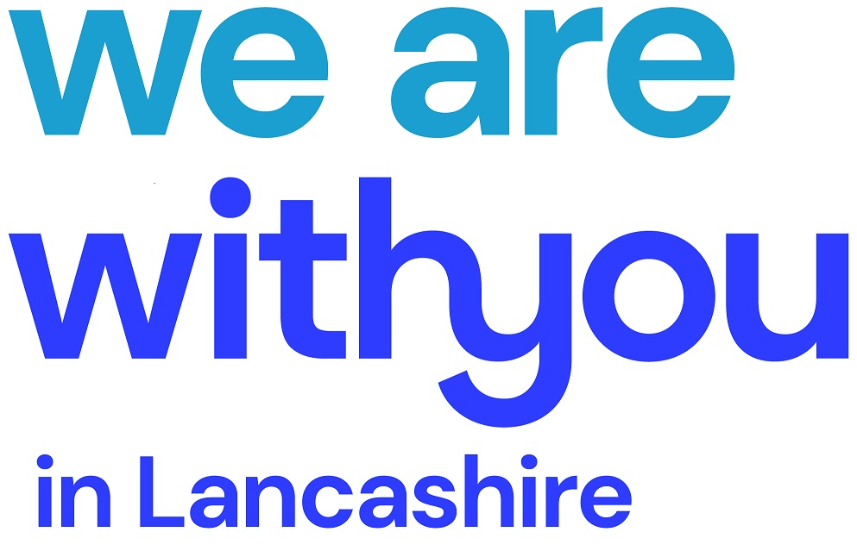
Service Information

We Are With You is one of the UK’s largest specialist drug and alcohol treatment charities. We work with over 95,000 people every year, helping them and their families deal with the effects of drug and alcohol misuse. As well as adult services, we also provide services specially tailored to the needs of young people and parents.
We Are With You was founded in 1967, when Mollie Craven wrote to the Guardian newspaper. Mollie’s son was addicted to heroin. In her letter, she called for the formation of a group, to provide support to people in a similar position to her own. Out of this was created ‘APA’ -standing for both ‘The Association of Parents of Addicts’ and ‘The Association for the Prevention of Addiction’. In 1997, APA re-branded as Addaction. Most recently, February 2020 we have rebranded to We Are With You - and since 1967, it has grown to a national organisation. Over the years we have built links with government, policy-makers and influencers.
We Are With You Lancashire
We Are With You deliver drug and alcohol services throughout Lancashire (excluding Blackpool and Blackburn). We aim to deliver an accessible, young person friendly service which focusses on a variety of needs. We are offering an integrated early intervention, prevention, treatment and community engagement service for young people up to 25 years. The new service is commissioned in partnership with the Public Health Department within Lancashire County Council.
As part of our service we:
- Work one to one and in groups with young people to address their own substance or alcohol misuse
- Deliver group work sessions with young people in schools, colleges and youth groups etc.
- Train professionals, parents, and foster carers on substance misuse and the wider risks associated
- Address a range of issues that impact on the young person and affect their resilience e.g. smoking, self-harm, emotional health and wellbeing (see additional model information)
- Support families and carers
- Link into wider support within the county including our own bespoke groups
- Operate regular detached outreach with the provision of diversionary activities across Lancashire

With bases in Preston, Lancaster and Burnley, we will be available for drop-in and appointments with the continued in-reach service delivered in schools, YOTs and wider community / partner venues. Our service will be responsive to the local needs of young people so will operate during evenings and weekends as required, with on-going input from our young people to drive new ideas and improvements forward.

We work with all drugs, alcohol and solvent use, including legal highs / NPS and steroids. We also have a prescribing service with our own Doctor should our young people require it.

Our Volunteer Programme

We have opportunities throughout Lancashire for anyone 18+ to be part of our volunteer programme. With our training and support you can make a difference whilst also; learning new skills, improving your confidence, giving something back and improving your health and well being. For more information please call your local office.

Please do not hesitate to contact us if you require any further information:
Ray Jones– Service Manager
Simon Rothwell – North Team Leader
Emily Brocklebank – Central Team Leader
Darren Mansfield – East Team Leader
Claire Helme-Fawcett – Community Engagement Coordinator

Email – spoc.yalancs@wearewithyou.org.uk
YP Freephone Number – 0808 164 0074

Central Office  Ringway House, Percy Street, Preston,  PR1 1HQ  01772 281495 | North Office  YMCA, Fleet Square, Lancaster LA1 1EZ  01524 239570 | East Office  CVS, 62-64 Yorkshire Street, Burnley, BB11 3BT  01282 505037

www.wearewithyou.org.uk lancashireinfo@wearewithyou.org.uk
www.facebook.com/wearewithyoulancs Twitter: @WAWYLancs

