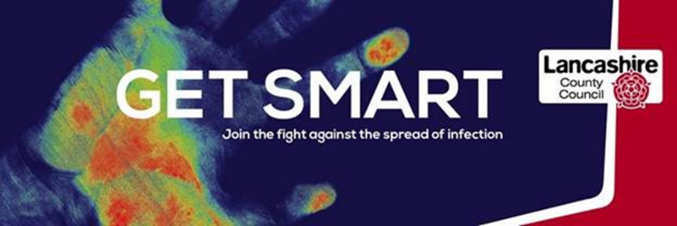
Terminal Clean Checklist
Care Home Name:

Care home staff member providing information about the terminal clean

Name:

Designation:

Date checklist (below) completed:

Terminal Cleaning
Terminal cleaning is a more enhanced programme of environmental cleaning, which compliments the routine daily cleaning in a care home. It includes the thorough cleaning of all surfaces, floors, soft furnishings and reusable equipment either within the whole environment or in a particular area, e.g. resident’s room.
The deep clean must only be performed by staff whom have been trained in the use of appropriate personal protective equipment (PPE), and in line with the current Public Health England (PHE) and national guidance.

Colour Coding
All care home facilities are recommended to adopt the national colour coding scheme for cleaning materials (see below). All cleaning items, e.g. cloths, mops, buckets, aprons, should be colour coded.
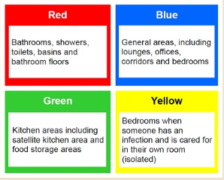
Equipment required for a deep clean
The golden rule for cleaning is to always work from the cleanest area toward the dirtiest area, and from top to bottom, covering all surfaces using a ‘S’ shaped pattern, taking care not to go over the same area twice. This will greatly reduce the risk of cross contamination. PPE should always be worn, e.g. disposable gloves, apron, mask and eye protection.
- New colour coded cloths and mop heads used for each room and disposed of after use.
- Cleaning and disinfectant products, either:
  - A dual purpose cleaning and disinfectant solution at a dilution of 1000 parts per million available chlorine OR
  - Warm water and detergent, this should be changed for each episode of cleaning and when moving from one room or environment to another, and when water is visibly dirty or contaminated, followed by a freshly made chlorine-based disinfectant solution.
Note: Chlorine-based disinfectants may damage soft furnishings, carpets and furniture. Therefore, detergent and warm water, steam cleaner or carpet shampoo machine, should be used as appropriate.
- Vacuum cleaner fitted with a high particulate filter (HEPA filter).
- Steam cleaner or carpet shampoo machine.
- PPE - disposable apron, gloves, fluid resistant face mask and visor/eye protection.
- Laundry hamper/bag/trolley placed as near to the point of use, but do not take into the isolation room.
Before entering the room
- Collect all cleaning equipment and appropriate waste bags. See ‘Handling waste during COVID-19’ below.
- Cleaning trollies should not enter the room.
- The person responsible for undertaking the cleaning with detergent and disinfectant should be trained in the process.
- Donning (putting on) PPE as per PHE guidance.
- Follow the ‘Procedure for a deep clean of a resident’s room’ (table below).

Upon completion of the deep clean
- Doffing (removing) PPE as per PHE guidance before leaving the room.
- Ensure all PPE is disposed of in double bagged, tied waste bags
- Dedicated or disposable equipment, e.g. mop heads, cloths, must be used for environmental decontamination.

Handling waste during COVID-19
- All waste must be double bagged, tied and discarded into the clinical waste stream. If there is no clinical waste stream, use domestic black bags, label with date and time, store securely in a designated waste disposal area for 72 hours and then discard as household waste.
Procedure for a deep clean of a resident’s room
 | Task | Instructions | Signature | Date
1. | Consumable items | Dispose of all consumables, e.g. flowers, chocolates, waste, PPE, tissues, paper towels, toilet rolls, into appropriate double bagged, tied bags.
2. | Windows | Open windows to facilitate drying and prevent build-up of fumes from chlorine-based disinfectant solution.
3. | Re-usable equipment,  e.g. glucometer, blood pressure monitor, digital thermometer, commode, wheelchair,  walking frame | Clean and disinfect before removing from the room.  Equipment should not be returned to the room until the deep clean has been completed.
4. | Window curtains, soft furnishings, e.g. scatter cushion covers | Launder wherever possible (see 5 below) or if not possible, steam clean.
5. | Linen, towels and other laundry | Remove and place in a red water soluble (alginate) bag, tie then place in a secondary clear bag and tie. When removed from the room, place directly into the nearby laundry hamper/bag/trolley and transfer as soon as possible to the laundry room.  Note: laundry must be stored in a designated safe lockable area whilst awaiting laundering or collection from contractor.
6. | Lamp shades | Remove shade and if wipeable, clean and disinfect, or steam clean. If not wipeable with disinfectant or unable to be steam cleaned, they should be disposed of with other waste (see ‘Consumables’ above).
7. | Curtain tracks | Clean and disinfect.
8. | Picture rails, ledges, dado rails | Clean and disinfect.
9. | Light switches, door knobs | Clean and disinfect.
10. | Windows | Clean and disinfect.
11. | Furniture | Clean and disinfect.
12. | Bed frame and mattress, bed rails and bumpers | Clean and disinfect. Both sides of the mattress should be cleaned, checking the cover for visible signs of tears and staining, unzip and check inside cover and foam mattress for stains. If evidence of staining, mattress and cover should be replaced.
13. | Radiators | Remove radiator cover. Clean and disinfect cover and radiator.
14. | Skirting boards | Clean and disinfect.
15. | Carpet | Vacuum followed by steam cleaning or carpet cleaning machine.
16. | Flooring - washable | Clean and disinfect.
17. | Ensuite | Clean and disinfect all surfaces, e.g. soap dispensers, paper towel holder, bathroom cabinet, shelving, shower, sink, taps, toilet handle, raised toilet seat, toilet, toilet roll holder, waste bin. Ensure you work from the cleanest area to the dirtiest area.
18. | Stock | Restock room with consumables, e.g. paper towels, PPE.
19. | Make bed | Make the bed with clean linen.
20. | Hang curtains | Hang clean curtains if they have been removed.
21. | Documentation | Complete, sign and date document.

Adapted using Harrogate and District NHS Foundation Trust, Infection Prevention and Control and Cumbria County Councils terminal clean documents.

