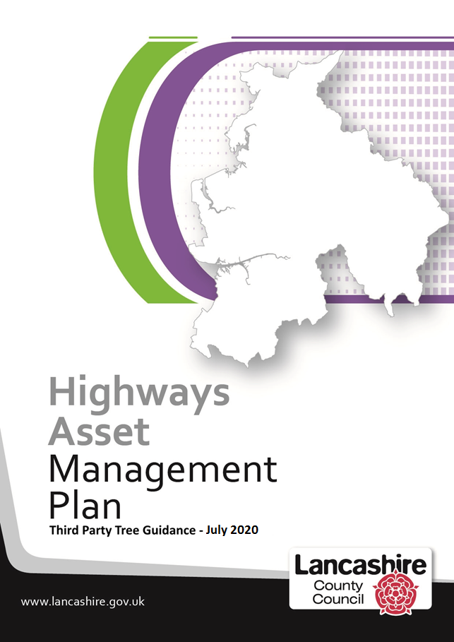
Third Party Tree Guidance
Chapter | Description | Page
1 | Introduction…...……………………………………………………………. | 3
2 | Planned Safety Inspections of Trees ………..………………………….. | 5
3 | Consent Trees……………………………………………………………... | 6
4 | Adjoining Trees…………………………………………………………….. | 9

1 - Introduction

In accordance with the Highways Act 1980, the county council is not only responsible for Highway trees, but also has some responsibility for Consent trees and Adjoining trees.

This guidance document has been drafted to:-

- help county council officers distinguish between the various types of tree growing within, or close to the vehicular highway boundary
- outline what the county council will and won't do with regards these types of tree

This is one of a number of related tree documents that gives help and advice in respect of various tree related issues which can be found on the Highway Asset Management webpage at:-

http://www.lancashire.gov.uk/council/strategies-policies-plans/roads-parking-and-travel/highway-asset-management-in-lancashire/codes-of-practice/tree-safety/

Any reference to a 'tree' in this document also includes tree roots, tree trunk and tree branches. Throughout this document, various categories of tree are referred to and for clarity these are explained below:-

- Highway Tree – these are trees that the county council owns or manages which grow within the extent of publically maintainable vehicular highways ,(except those in Byways Open to All Traffic or Restricted Byways) which are not Consent trees and may have been;

- planted by the county council under Section 96 or 64 of the Highways Act 1980
- planted as part of a highway scheme
- planted to replace a highway tree we have previously removed
- acquired on adoption or transfer of a highway to the county council
- acquired in highway extent through 'nature', by for example self-seeding
- acquired in existing highway extent through land purchase

- Consent Tree – these are trees, shrubs, hedges or other vegetation growing within the highway boundary that have been planted by third parties, but with our consent in accordance with various sections of the Highway Act 1980. The county council does not own these trees and will not normally carry out any maintenance on them, apart from on safety grounds.

- Adjoining Tree – these are trees, shrubs, hedges or other vegetation that are growing on private property on land adjoining the highway.

Trees by their nature are dynamic living systems. They have evolved to cope with losing limbs, breaking apart and being wounded and grow adaptively in response to the environment around them. Trees and woodlands can make a significant contribution to quality of life, the local economy and the environment. However, where trees and people co-exist, there is a need to ensure that a tree’s natural processes do not pose a risk to the people and property around them.

Owners of trees have a legal duty of care and are obliged to take all reasonable care to ensure that any foreseeable hazards can be identified and made safe. Doing all that is reasonably practicable does not mean that all trees have to be individually examined on a regular basis.

The county council is not expected to guarantee that all its trees are safe, but is required to take such care as could be expected of a reasonable and prudent tree owner. In addition to managing its own trees, the county council as Highway Authority is also responsible for ensuring that Consent and Adjoining trees do not pose a hazard to road users.

Although it is not possible to completely eliminate the risk of a tree or branch failing, there are often indications that a tree may be in decline, has structural faults or be suffering from decay or pests and diseases.

2 – Planned Safety Inspections of Trees

In order to mitigate the risk of a tree or branch falling and causing injury or damage to as low a level as practically possible the inspection of trees has been incorporated into the Highway Safety Inspection regime – see the 'Tree Safety Management Guidance – Risk Based Inspections' document for more information about the systems and procedures we have put in place to manage the risk posed by trees.

As we have previously given permission for Consent trees to be planted within the vehicular highway boundary, Highway Inspectors will by default, also include these types of tree within their inspection regime. In order to protect public safety Highways Safety Inspections will also be looking at those Adjoining trees that are growing on private land but within falling distance of a vehicular highway boundary.

Whilst the county council will be inspecting Consent and Adjoining trees as part of the Highway Safety Inspection, this does not absolve the owners of these trees of any responsibility with regards tree maintenance, public safety obligations or liability in the event that such a trees causes injury and/or damage.

When Highway Safety Inspectors identify a tree defect this will be will recorded in the Highway Safety Inspection Reporting System and will be passed automatically to appropriate Area Office for attention. Where the inspectors observe trees that are considered to pose an immediate risk to people or property the county councils Arboriculture l Officer and/or the Highways Team, depending upon the circumstances, should be contacted immediately for advice or action.

Where we have concerns about Consent or Adjoining trees we will follow the procedures as set out in the following sections.

3 – Consent Trees

Legal Background
Various sections of the Highways Act 1980 permit district councils, parish councils and private individuals to plant hedges, trees, shrubs and other vegetation within the highway boundary by licence or consent of the county council as Highway Authority.

- Section 96 - allows district and parish councils, with permission of the county council as Highway Authority to plant trees, shrubs or other vegetation within the highway and erect fences or other guard for protection.
- Section 142 – the county council as Highway Authority may grant a licence to the owner or occupier of any premises adjoining the highway to plant and maintain, or to retain and maintain various forms of vegetation such as trees, shrubs, plants or grass in such part of the highway as may be specified in the licence.

Consent Licences
When issuing such a licence the county council will insert such conditions as considered appropriate, this may include, but not limited to the following provisions:

- outlining procedures following a change in the ownership of the premises
- to protect the safety and convenience of passengers in the highway
- to prevent traffic within the highway being delayed
- to prevent any nuisance or annoyance being caused to the owners or occupiers of other premises adjoining the highway
- to protect the apparatus of statutory undertakers and that of other organisation's who are permitted to locate equipment within the highway limits
- to provide for emergency works
- to provide for a maintenance regime and replacement regime

Prior to the granting of a licence, the licensee shall indemnify the highway authority against any claim in respect of injury, damage or loss arising out of;

- the planting or presence in a highway of trees, shrubs, plants or grass to which the licence relates, or
- the execution by any person of any works authorised by the licence or by the highway authority,
- the execution by or on behalf of the highway authority of any works

When a licence is issued it is important that the details are fully documented and attached to the appropriate asset in the Highway Asset Management System so that the ownership details are known and the owner can be contacted should the need arise.

Due to problems associated with tree root damage, updating records when licensees move and moving trees when s.142 licences expire, particularly if a tree has been planted for some time, we are now unlikely to permit the planting of any trees as part of a s.142 licence. Where a licence is issued, it will usually not permit tree planting and may be for specific periods of time that either permit or prohibit the re-assignment of the licence when the owner or occupier of the premises changes.

Withdrawal, Surrender or Expiry of Licence
Should the licensee fail to act, or fail to keep the trees, shrubs, hedges or other vegetation in the condition set out in the licence, or the county council wishes to use the highway extent on which the trees, hedges, shrubs or other vegetation are growing, we may by notice served on the licensee withdraw a licence granted to them. The period of notice the county council needs to give the licensee differs according to why the licence is being revoked. Where a licence expires or is withdrawn or surrendered, the county council:

- may remove all or any of the trees, shrubs, plants or grass to which the licence relates and reinstate the highway and recover the expenses it has reasonably incurred from the last licensee; or
- if satisfied that the licensee can, within such reasonable time as they may specify, remove such trees, shrubs, plants or grass etc. and reinstate the highway to an acceptable standard, we may authorise them to do this at their expense.

Tree Owner Responsibilities
If in the course of the Highway Safety Inspections we become aware of problems with any Consent trees, shrubs or hedges, these will be recorded in the Highway Safety Inspection Reporting System and passed automatically to the relevant Area Office so the licensee can be contacted and asked to carry out appropriate remedial action. Where the licensee fails to act within a reasonable timescale, we will serve notice against them in accordance with the Highways Act 1980 and recover the cost of such works from them. Where the condition of a Consent tree, warrants immediate action we will carry out such works at our expense and inform the licensee retrospectively.

Where we find trees growing or being maintained in a manner that is otherwise than in pursuance of a licence we have granted these items will be deemed to have been placed within the highway without permission and the county council may serve notice in accordance with the Highways Act 1980, on the person planting these items to remove them, or request that they apply for a licence to be granted for the items they have planted.

If damage is caused by a Consent tree, shrub or vegetation or associated fence or guard, the person who has suffered injury or loss is entitled to recover compensation from the licensee, except where such damage was caused by their own negligence.

In respect of Consent trees it is the licensee's responsibility to comply with all relevant tree legislation prior to carrying out any works. Information relating to current guidance is contained in the General Tree Information document and it is the tree owner's responsibility to check that this information is still current.
4 – Adjoining Trees

This category of tree refers to those trees growing outside of the highway boundary, on adjoining land but growing within falling distance of the highway. Adjoining trees also include bushes, shrubs and hedges regardless of whether they are growing in domestic gardens, on agricultural land, on commercial premises or as part of a woodland area.

Legal Background
The Highways Act 1980 provides the county council as Highway Authority with various powers it can use against land owners/occupiers where Adjoining trees are causing, or are likely to cause damage to the highway and/or road safety issues as set out below:

- Section 79 – the county council may serve a notice on the owner/occupier of land where it is deemed necessary for the prevention of danger arising from obstruction to the view of persons using the highway on any land at or near any corner or bend in the highway or any junction of the highway. Under this section, the county council can direct the owner/occupier of land to alter any tree, shrub or other vegetation on their land, or stop them from or impose conditions on the planting of trees, shrubs or vegetation on their land.
- Section 136 - if a highway which consists of or comprises a carriageway is being damaged in consequence of the exclusion from it of the sun and wind by a hedge or tree (other than a tree planted for ornament or for shelter to a building, courtyard or hop ground), the county council may apply to the magistrates’ court to require the owner or occupier of the land on which the hedge or tree is growing, so to cut, prune or plash the hedge or prune or lop the tree as to remove the cause of damage
- Section 141 – no tree or shrub shall be planted in a made-up carriageway, or within 15 feet from the centre of a made-up carriageway. If a tree or shrub is planted in contravention of this section the county council as highway authority, may by notice given either to the owner or to the occupier of the land in which the tree or shrub is planted require him to remove it within 21 days from the date of service of the notice.
- Section 154 – where a hedge, tree, shrub or vegetation of any description. overhangs a highway or any other road or footpath to which the public has access so as to endanger or obstruct the passage of vehicles, pedestrians, horse-riders or obstructs or interferes with the view of drivers of vehicles or the light from a public lamp, the county council may issue a notice to the owner of the hedge, tree or shrub or to the occupier of the land on which it is growing, require him within 14 days from the date of service of the notice so to lop or cut it as to remove the cause of the danger, obstruction or interference.

In addition, where it appears to the county council that any hedge, tree or shrub is dead, diseased, damaged or insecurely rooted, and that by reason of its condition it, or part of it, is likely to cause danger by falling on the highway, road or footpath, we may, by notice request the owner of the hedge, tree or shrub or to the occupier of the land on which it is situated, to cut or fell it as to remove the likelihood of danger require him within 14 days from the date of serving the notice. If the person on whom a notice is served above fails to comply with it within the specified period the period the county council authority may carry out the work required by the notice and recover the expenses reasonably incurred by them in so doing from the person in default.

Contacting Adjoining Tree Owners
Whilst this category of tree is owned by parties other than the county council, we will, in order to protect public safety include these within the Highway Safety Inspection regime. Such inspections will involve a limited visual assessment typically focussing on identifying trees with an imminent and/or probable likelihood of failure by looking for obvious defects. Such inspections are intended to supplement rather than relieve the tree owner of their responsibility to ensure that such trees do not pose a danger to the public or property. The county council will assume no responsibility or liability arising from such inspections.

If in the course of the Highway Safety Inspections we become aware of problems with any Adjoining trees, shrubs or hedges, these will be recorded in the Highway Safety Inspection Reporting System and passed automatically to the relevant Area Office who will contact the landowner or occupier and ask that they arrange for their tree to be inspected by a competent person and carry out any remedial work as required. There is specific power to enter the adjoining land for surveying and executing works under S154 (see S294)

In the event of failure to carry out remedial work as directed, the county council may use statutory powers contained in the Highways Act 1980 to issue a notice or other procedures and implement essential works and charge the costs to the land owner or occupier.

Where the condition of an Adjoining tree, shrub or hedge warrants immediate action, (e.g. following a storm) we will carry out such works at our expense and inform the land owner/occupier retrospectively. Under S150 of the Highways Act 1980, the county council has a duty to remove obstructions from the highway and may recover from the tree owner all costs incurred in removing a tree where it causes an obstruction. Should the removed tree not be claimed by the tree owner within 7 days from the date of removal the county council may sell the wood in accordance with S150 (40)(b).

Where the county council has to hire expensive equipment to remove an obstruction, or where the tree owner hadn’t taken reasonable care as requested under a S154 notice or had not acted upon notices from the county council or other third parties regarding a tree that was known to be insecurely rooted, the county council may seek to recover our reasonable expenses in accordance with S150 (40).

In respect of Consent trees it is the licensee's responsibility to comply with all relevant tree legislation prior to carrying out any works. Information relating to current guidance is contained in the General Tree Information document and it is the tree owner's responsibility to check that this information is still current.

