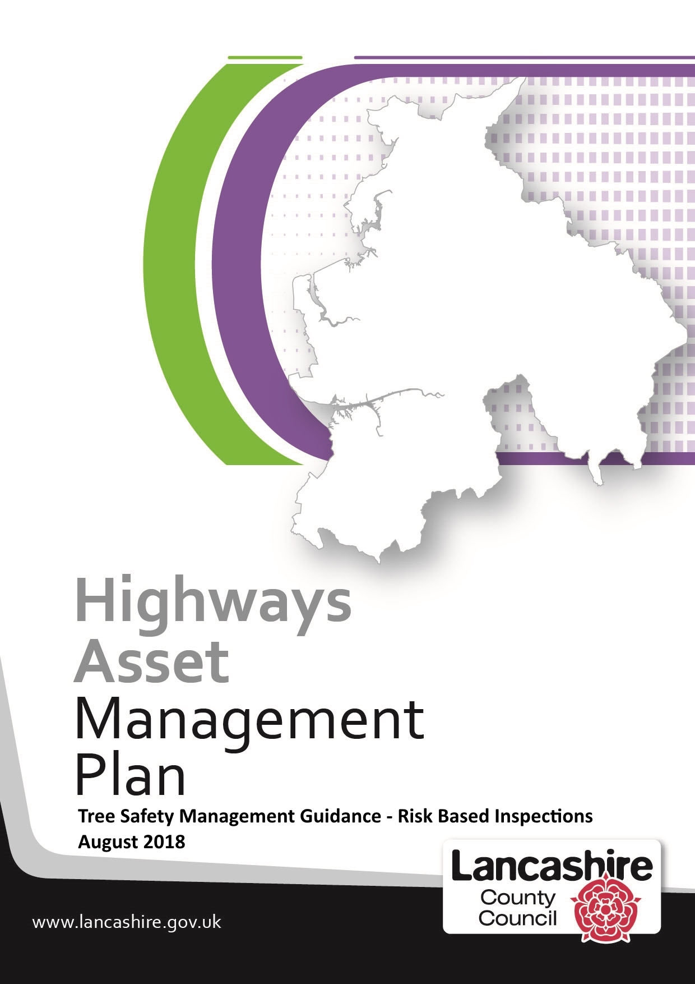
Tree Safety Management Guidance - Risk Based Inspections
Chapter | Description | Page
1 | Scope……….………………………………………………………………. | 3
2 | Introduction……………………………………………….………………... | 4
3 | Planned Safety Tree Inspections…………………………….………….. | 5
4 | Detailed Highway Tree Inspections……………………………………… | 7
 | Appendix A - Arboricultural Inspection Report…………………………. | 9

1 - Scope

This guidance document has been drafted to:-

- enable the county council to improve its procedures with regards the planned inspection of trees growing within or close to the vehicular highway boundary and in particular the identification of obvious tree safety defects
- formally establish a register of higher risk Highway trees that will be subject to detailed tree inspections by an Arboricultural Officer at frequencies that are proportionate to the risk posed to highway users/property

This document:

- covers planned and detailed Highway tree inspections
- will ensure that all Highway Safety Inspectors (HSI) and appropriate officers and operatives receive basic tree awareness training
- that those trees visible and within falling distance of footways/carriageways are included in the Highway Safety Inspection regime
- records of all tree defects identified by the Highway Safety Inspection regime will be retained within the Highway Safety Inspection Reporting system

The operation of this guidance will enable the county council mitigate tree risks to as low a level as is reasonably practicable by reducing the risk of :-

- personal injury through falling trees and falling branches
- personal injury through trips and falls on footways disturbed by tree roots

We have produced a number of supplementary guidance documents dealing with General Tree Information, Third Party Trees and Tree Nuisance which can be found on the Highway Asset Management webpage at :-

http://www.lancashire.gov.uk/council/strategies-policies-plans/roads-parking-and-travel/highway-asset-management-in-lancashire/codes-of-practice/tree-safety/

2 – Introduction

In drafting this document reference has been made to:-

- The National Tree Safety Group publication 'Common Sense Risk Management of Trees,
- The Highways Act 1980,
- Town and Country Planning act 1990,
- Health and Safety Executive Guidance on 'Management of the Risk from Falling Trees or Branches'

Trees by their nature are dynamic living systems. They have evolved to cope with losing limbs, breaking apart and being wounded and grow adaptively in response to the environment around them. Trees and woodlands can make a significant contribution to quality of life, the local economy and the environment. However, where trees and people co-exist, there is a need to ensure that a tree’s natural processes do not pose a risk to the people and property around them.

Owners of trees have a legal duty of care and are obliged to take all reasonable care to ensure that any foreseeable hazards can be identified and made safe. Doing all that is reasonably practicable does not mean that all trees have to be individually examined on a regular basis.

The county council is not expected to guarantee that all its trees are safe, but is required to take such care as could be expected of a reasonable and prudent tree owner. In addition to managing its own trees, the county council as Highway Authority is also responsible for ensuring that Consent trees (i.e. trees planted within the vehicular highway boundary with our consent by third parties) and Adjoining trees (i.e. trees growing on private land adjacent to the vehicular highway) do not pose a hazard to road users.

The county council supports the view that trees have a social and environmental value and where reasonably practical should be retained and allowed to complete their life cycle with minimal management interventions.

3 – Planned Tree Safety Inspections

In order to mitigate the risk of a tree or branch falling and causing injury or damage to as low a level as practically possible the inspection of all trees growing within, or are within falling distance of a vehicular highway, are to be incorporated into the Highway Safety Inspection regime. This will ensure that such trees are inspected at the frequencies set out in the Highway Safety Inspection Policy and that once tree safety defects are identified, they are recorded and actioned in accordance with prescribed procedures set out in our General Tree Information document.

Tree Inspection Course
The county council will initially train all Highway Safety Inspectors via an in-house 'Highway Tree Inspection Course' which in time may be extended to other appropriate officers and operatives. As part of the course, personnel will be trained to look for the most common and obvious defects so they are able to make a risk based judgement as to what follow up action is required.

Training will look at identifying the following common tree safety defects:-

- Fungal fruiting bodies (at the base or on the trunk and branches),
- Dieback of the crown – i.e. foliage not dense, foliage not the right colour or size,
- Dead branches (especially on species that are not oaks),
- Dead trees,
- Detached branches, hanging branches or branches lodged within the canopy,
- Compression forks,
- Cracks and splits,
- Major or numerous cavities,
- Dead bark,
- Significant bulges,
- Evidence of root damage or severance,
- Presence of ivy and its significance,
- 'Bleeding' areas and fluxes,
- Major cavities within the trunk or large branches

Tree Inspections
Trees located in urban areas will be subjected to an inspection usually carried out on foot whilst trees in rural locations will typically be inspected from a slow moving vehicle. Such inspections will involve a limited visual assessment focussing on identifying trees with an imminent and/or probable likelihood of failure by looking for obvious tree safety defects.

The Highway Safety Inspectors will record all tree defects in the Highway Safety Inspection Reporting System which automatically passes defect reports to the appropriate Area Office for attention.

Where the inspectors observe Highway, Consent or Adjoining trees that are considered to pose an immediate risk to people or property, the county councils Arboricultural Officer and/or the Highways Team, depending upon the circumstances, should be contacted immediately for advice or action.

Where trees are considered to be dangerous we will follow the guidance contained in the General Tree Information guidance document. Where we identify Consent / Adjoining trees with non-urgent/non-dangerous tree defects we will contact the licensee or landowner in line with the guidance contained in our Third Party Tree Guidance document. These and other tree related documents can be found at:-

http://www.lancashire.gov.uk/council/strategies-policies-plans/roads-parking-and-travel/highway-asset-management-in-lancashire/codes-of-practice/tree-safety/

4 - Detailed Highway Tree Inspections

The county council is responsible for a number of Highway trees at various locations across Lancashire which, for a variety of reasons, are considered to pose a higher risk to the public and therefore require a more detailed inspection than the inspection carried out as part of the Highway Safety Inspection regime.

Detailed Tree Inspection Survey - Risk Assessment
Whilst we have identified a small number of trees that require on-going detailed tree inspections, further work is required to fully understand the extent of such trees within our tree stock. In order to do this, we have devised a risk based methodology that uses the network hierarchy, as set out in the Highway Safety Inspection policy, to determine survey priorities.

Starting with the highest category of road, the Arboricultural Officer will undertake a desktop survey using available video survey information and the risk factors listed below to identify target site survey locations. Typical risk factors include:-

- Transport Nodes – bus stations, taxi ranks, train stations etc.
- Economy and Employment – shopping centres, supermarkets, restaurants, etc.
- Social Vulnerabilities – schools, colleges, universities, children's centres etc.
- Emergency Services – accesses to police, fire stations, hospitals etc.
- Traffic Volume and Footfall Indicators – concentrations of footfall e.g. zebra, school and pedestrian crossing points
- Tree Characteristics - species, age, physiological condition, structural condition etc.

Where a visit to a particular tree is considered necessary a risk based assessment will be carried out on site by a tree specialist, using the four main factors of location, size, condition etc. to determine risk. The results of the risk assessment will be recorded on the 'Arboricultural Inspection Report' at Appendix A to ensure a consistent approach across Lancashire.

Detailed Tree Inspection I
Having identified higher risk Highway trees, these will the subject of a regular detailed tree inspection which will be carried out by an Arboricultural Officer at frequencies that take into account the condition of the tree, its general characteristics, location, road category within the network hierarchy and the level of risk posed.

Where remedial work is required following a detailed tree inspection, the Arboricultural Officer will make an assessment as to whether the tree is a likely habitat for a European Protected Species as set out in our General Tree Information document and make arrangements with the appropriate Area Office for the necessary works to be carried out.

Recommended actions may include further detailed tests such as a PiCUS Sonic Tomograph, which uses ultrasound to map the amount of decay within a trunk or branch; or make a request to Natural England for a licence where works would otherwise risk breaching legislation relating to protected species using the tree. Work specified will be prioritised according to urgency.

Ordering of work following Detailed Highway Tree Inspection
If the county councils Arboricultural Officer recommends emergency action is carried out this will be arranged by the appropriate Area Office and may be undertaken by the county councils Highway Team or a contractor from the county council’s approved list of tree surgeons.

Such works need to be carried out in line with the information contained in our General Tree Information document which outlines legislation relating to bats, endangered species, nesting birds, Conservation Areas, Tree Preservation Orders and bour procedures for dealing with dangerous trees.

Updating records
The results of detailed tree inspections, together with plans, photographs and other relevant information should be uploaded onto the Highways Asset Management database.

Appendix A

Arboricultural Inspection Form

Enquiry by |  |  | PEM No. |  |  | N/A |  |  |  |  |  |  | Email
 |  |  | Phone |  |  |  |  |  |  |  |  |  | Other
Enquiry Date |  |  |  |  |  | Contact
Telephone No |  |  |  |  |  | Email
Location of trees |  |  |  |  |  |  |  |  |  |  |  |  |  |  |  | Post Code
 |  |  |  |  |  |  |  |  |  |  |  |  |  |  |  | OS Grid Ref
Tree Protection |  |  | Tree Preservation Order |  |  |  |  |  |  |  |  |  |  |  |  |  | Conservation Area
Nature of Enquiry
Problem Recognised on site
Tree Species
Height
DBH
Tree Score  (See Score Sheet) |  |  | Age Class |  |  |  |  |  |  | Physiological |  |  |  |  |  |  |  |  |  |  | Structural
Overall Condition
Foliage
Branch Structure
Trunk
Rooting Zone
Potential target
Risk of failure
Recommendations
Action Required
Urgency |  |  | Urgent |  |  |  |  | One Month |  |  |  |  |  |  | Three Months |  |  |  |  | Six Months |  |  |  | One Year
Additional Comment
Inspection date |  |  |  |  |  |  |  |  |  |  |  | Report Date
Steve Edwards - Arboricultural Officer - Landscape Team
Tel | 01772 534116 |  |  | Email |  |  |  |  | steve.edwards@lancashire.gov.uk

Tree Inspection Score Sheet

Age Class
NP | Newly Planted
Y | Young – fully established and up to 25% of expected life for the species
SM | Semi–mature – up to 50% of expected life for species
M | Mature – between 50% and 75% of expected life for species
OM | Over-mature – greater than 75% of expected life for species
V | Veteran – significantly older than expected life for species
Overall Condition
Physiological
A | Good | Good vitality and no significant defects
B | Fair | Fair – Normal or slightly impaired vigour and/or currently acceptable defects
C | Poor | Poor vitality and with unacceptable defects that must be addressed
D | Dangerous | Potentially imminently dangerous physiological defects
DD |  | Dead
Structural
1 | Good | Good structural integrity with no defects
2 | Fair | Normal or slightly impaired structural integrity and/or currently acceptable defects
3 | Poor | Significant structural defects that must be addressed
4 | Dangerous | Potentially imminently dangerous structural defects

