**Outbreak Control Plan**

**COVID-19**

**Version 1.0**

**Contents**

1 Introduction 6

1.1 Purpose 6

1.2 Key Themes 6

1.3 National NHS Test and Trace Programme 7

1.4 National contact tracing system 8

2 Background 9

2.1 Definition 9

2.2 Aim 9

2.3 Objectives 9

2.4 Function 10

3 Our approach 11

3.1 Identification of Outbreaks 15

3.2 Declaring/Notification of an outbreak 15

3.3 Single Point Of Contacts and Outbreak control teams 16

3.4 Infection Prevention advice to SPOCS 17

3.5 End of an Outbreak 17

3.6 Health Protection Board 18

3.7 Communicating concerning outbreaks 18

4 Measures to prevent spread of COVID-19 and protect people at increased risk of severe illness 19

5 Local Outbreak Management Plan 21

6 Theme 1 - Preventing and managing Outbreaks in Care Homes and schools 22

6.1 Care Homes 22

6.2 Schools 26

7 Theme 2 - Preventing and managing outbreaks in other high-risk places, locations and communities of interest 30

8 Theme 3 – Local Testing Capacity 34

9 Theme 4 - Contact Tracing in complex settings 37

10 Theme 5 – Data Integration and Surveillance 44

11 Theme 6 - Supporting local Vulnerable People 45

12 Theme 7 - Local Governance Structures 46

13 Deploying Appropriate Legislative and Regulatory Powers 48

14 Administration 49

Ownership and Title 49

15 Amendment History 50

16 Summary Roles of Each Agency 51

Appendix 1 - Care Home Outbreak Management Plan 52

Appendix 2 - Schools & Education Settings Outbreak Management Plan 57

Appendix 3 - Managing outbreaks in other high-risk places, locations and communities of interest 64

Appendix 4 – SOPs 74

Appendix 5 – Template Agenda for OCT meetings 75

Appendix 6 – LCC HPB Escalation and System Architecture 76

Appendix 7 – Health Protection Board Terms of Reference 78

Appendix 8 - Local Outbreak Engagement Board 81

Appendix 9 – Testing Pathways 82

|  |  |
| --- | --- |
| Suspected Case (COVID-19) | A person with a new continuous cough OR fever OR loss of/ change in smell or taste. |
| Confirmed Case (COVID-19) | A person with laboratory confirmation of virus causing COVID-19 infection, irrespective of clinical signs and symptoms. |
| Outbreak | Two or more cases which meet the clinical case definition above, arising within the same 14-day period in people who live or work together  The occurrence of two or more cases of suspected or confirmed COVID-19 arising within the same 14-day period in a shared setting. |
| Incident | Two or more cases within a setting that doesn’t meet the criteria for declaring an outbreak by PHE |
| Coincidence Alert | If two or more confirmed cases in same setting within 14 days, review to assess whether likely to indicate transmission within the environment **(CTT)** . This includes:   * dates of onset of illness and of last attendance at health care setting * dates of contact between cases in the setting and use of PPE/social distancing during contact episodes * links between cases outside the setting e.g., home address, social activities, friends, or other known links |
| Consequence Management | Identified impact on local public sector services or critical national infrastructure (eg power plants) due to high proportion of staff quarantining (eg school that informs tier 2 that will have to close as all staff quarantining). |
| Contact | A contact of a COVID-19 case is any person who has had contact with a COVID-19 case within a timeframe ranging from 48 hours before the onset of symptoms of the case to 14 days after the onset of symptoms.  If the case had no symptoms, a contact person is defined as someone who has had contact with the case within a timeframe ranging from 48 hours before the sample which led to confirmation was taken, to 14 days after the sample was taken. |
| High-risk contact | A contact of a COVID-19 case who came within 1 metre of the case for more than 1 minute, or within 2 metre for more than 15 minutes. |
| Direct close contacts | Direct face to face contact with a case for any length of time, including being coughed on or talked to. This will also include exposure within 1 metre for 1 minute or longer |
| Proximity contacts | Extended close contact (within 1-2m for more than 15 minutes) with a case |
| Closed setting | Pertains to residents in a residential setting usually a care home or patients in a health care setting |
| Open setting | All other settings where staff, students or service users move in and out of community settings |

# Introduction

Our COVID19 Outbreak Control Plan describes how we will contain outbreaks and respond to complex cases and incidents in Lancashire. This builds on the existing generic strategic multi-agency plan for the control of human infectious disease in the community. It addresses the requirement from the national NHS Test and Trace programme on all local authorities to contain COVID19 outbreaks.

Based on the public health duties of the county council, our 12 district councils, statutory role of Director of Public Health, NHS, and working with Public Health England’s local health protection teams, Lancashire County Council will put in place measures to identify and contain outbreaks and protect the public’s health. The Director of Public Health (DPH) is responsible for providing local leadership and producing the plan, through the Health Protection Board and an elected member led Local Outbreak Engagement Board. The DPH will be supported by and work in collaboration with the Lancashire Resilience Forum.

This plan adopts the 'Guiding Principles for Effective Management of COVID-19 at a Local Level' produced jointly by the Association of Directors of Public Health, Faculty of Public Health, Local Government Association, Public Health England, Society of Local Authority Chief Executives, UK Chief Environmental Health Officers group.

Given the evolving nature of the national policy in managing the COVID19 pandemic, this plan is a 'live' technical document. We will constantly improve this plan using the sector led improvement methodology and learning from the Local Government Association's Good Practice Network.

## Purpose

* The overall purpose of the outbreak management plan is to prevent avoidable mortality and reduce harm from Covid-19, in order to allow lockdown restrictions to be safely relaxed.
* The purpose of the plan is to enable a rapid, effective and coordinated approach to the identification, investigation and control of an outbreak of COVID-19.
* It describes the continuum of outbreak management, from prevention, initial detection to the formal declaration of the end of the outbreak and written review of lessons learned.
* The plan identifies the roles and responsibilities of key stakeholders, describes managerial and organisational aspects of the COVID-19 outbreak response, and outlines communication, investigation and control procedures

## Key Themes

Our COVID-19 outbreak management plan forms a core part of delivering the national NHS Test and Trace Service. It is not intended to replace existing plans to manage outbreaks in specific settings. It combines health protection expertise, such as epidemiology & surveillance, infection prevention and control techniques, contact tracing and evaluation, with wider multi-agency efforts, to minimise the impact of COVID-19 on local communities. Our plan covers the following themes:

1. Planning for managing local outbreaks in **care homes and schools**
2. Identifying and planning how to manage **other high-risk places, locations and communities** **of interest**
3. Identifying methods for local **testing** to ensure a swift response that is accessible to the entire population.
4. **Contact tracing and infection control capability in complex settings**
5. Integrating national and local **data and scenario planning,** through the Joint Biosecurity Centre
6. **Supporting vulnerable local people** to get help to self-isolate and ensuring services meet the needs of diverse communities.
7. **Establishing governance structures,** including Member-led Boards to communicate with the general public

## National NHS Test and Trace Programme

Government announced the new NHS Test and Trace service on the 28th May across England and this will form a central part of the government's coronavirus recovery strategy. Anyone with symptoms will be tested and their close contacts will be traced. New guidance means those who have been in close contact with someone who tests positive must isolate for 14 days, even if they have no symptoms, to avoid unknowingly spreading the virus. The governments testing strategy is framed around five pillars:

|  |  |
| --- | --- |
| **Pillar 1** | Scaling up NHS swab testing for those with a medical need and where possible, the most critical key workers |
| **Pillar 2** | Mass-swab testing for critical key workers in the NHS, social Care and other sectors (including symptomatic children of critical key workers) |
| **Pillar 3** | Mass-antibody testing to help determine if people have immunity to coronavirus |
| **Pillar 4** | Surveillance testing to learn more about the disease and help develop new tests and treatments |
| **Pillar 5** | Spearheading a Diagnostic National Effort to build a mass testing capacity at a completely new scale |

The primary objectives of the Test and Trace service will be to control the Covid-19 rate of reproduction (R), reduce the spread of infection and save lives, and in doing so help toreturn life to as normal as possible, for as many people as possible, in a way that is safe, protects our health and care systems and releases our economy.

Achieving these objectives will require a co-ordinated effort from local and national government, the NHS, GPs, businesses and employers, voluntary organisations and other community partners, and the general public. Local planning and response will be an essential part of the Test and Trace service, and local government has a central role to play in the identification and management of infection.

DHSC National Test and Trace Strategy

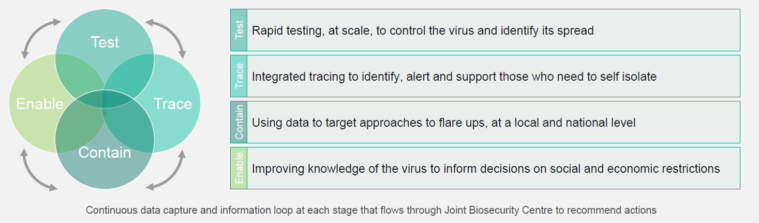

## National contact tracing system

The national contact tracing system is expected to operate at four broad levels

|  |  |
| --- | --- |
| Automatic | an app-based platform that automatically alerts people to possible contact with a positive case and directs them to testing |
| Level 1 | Local systems for managing the most complex outbreaks, or outbreaks with the most complex implications |
| Level 2 | Regional teams of health professionals (approximately 3,000) – currently being recruited |
| Level 3 | National teams of call handlers (approximately 15,000) – system outsourced to Serco |

# Background

## Definition

Outbreak definition: "Two or more confirmed cases of COVID-19 among individuals associated with a specific setting with onset dates within 14 days".

When two or more cases are reported in open setting within 14 days of each other, careful and rapid assessment should be made. This should include a review of:

* clinical features of the cases and microbiological data
* dates of onset of illness and of last attendance
* links between cases outside the setting e.g., home address, social activities, friends, before/after school childcare or other known links
* the type of setting (pre-school, primary school, secondary school or university)
* numbers of students/workers/service users (with consideration in the school and in each school year

## Aim

The primary aims of outbreak management plan is to:

* To provide an overarching framework for prevention, investigation and management of COVID-19 outbreaks.
* To ensure that outbreaks of COVID-19 are effectively and rapidly identified, verified, investigated, brought under control and, where necessary, procedures put in place to reduce the likelihood of similar outbreaks occurring in the future.
* To ensure that legislative controls are applied appropriately and correctly, in consultation with relevant partners in order to mitigate and further cases of COVID-19.

## Objectives

The objectives of outbreak investigation are to

* Determine/confirm that it is a COVID-19 outbreak,
* Identify the pathway(s) of transmission,
* Prevent generation of further cases,
* Plan and implement priority interventions/control measures to mitigate the effect of the outbreak
* Bring the outbreak to an end
* Produce an outbreak report at the end of cluster outbreak

## Functions

The key functions in managing outbreaks include the following:

* Identification and initial response;
* Investigation;
* Risk assessment;
* Surveillance, notification and reporting;
* Risk management;
* Risk communication;
* Audit, evaluation and documentation.

# Our approach

Our approach focusses on achieving the following effects:

**Prevention**

We will work with our district councils and key stakeholders in adopting a graduated response for preventing outbreaks in the first place. This will include education, engagement, engineering measures to prevent infections. We will use enforcement as a last resort and only when necessary.

**Identification and Initial response**

We will establish networks that will enable rapid case finding and referral through primary care, schools, care homes, and larger employers in the County. Ultimately these networks should expand to include a much wider range of community organisations that can provide valuable local intelligence. These networks will identify symptomatic people, advise them to self-isolate, and inform a central contact point to arrange contact tracing and advice provision.

As the national contact tracing service is established and grows in scale and scope, it will feed in to our local surveillance and case finding system and will alert us locally to outbreaks that would best be managed locally*.*

**Central contact and co-ordination**

We have established a seven day service with a central contact point for notification of cases and potential outbreaks from Public Health England. Notification will be through our dedicated email box [COVID19-healthprotection@lancashire.gov.uk](mailto:COVID19-healthprotection@lancashire.gov.uk)

This central contact and co-ordination point will be located within the County Council Public Health Team.

We expect the notification to mainly come from the national test and trace programme and PHE North West.

**Appropriate data system**

We will establish a central shared data system for managing the contact tracing and outbreak control process. In the very early stages of implementation, our Public Health Team will provide a local solution. This will in time be moved over to a bespoke case management system.

**Team of contact tracers**

In the immediate term we will utilise capacity for contact tracing from within our existing staff groups including District Councils, customer service staff and public health staff. In the short term this group will be supplemented further with additional capacity, with appropriate training provided. We will keep this under review as the national NHS Test and Trace service develops and make adjustments to our local capacity accordingly.

**Access to testing**

We are reliant on the national testing programme for delivering timely test results. We are aiming to utilise local NHS testing channels in order to secure timely testing undertaken. As an early adopter LRF area, we are also co-designing a more sustainable approach to community based testing with the NHS Test and Trace programme.

**Capacity to manage and respond to outbreaks**

This work will build on the experience of the existing Outbreak Control Team that is focused on outbreaks in care homes, and on the existing capacity and expertise within Environmental Health Teams, the Public Health Team, Infection Prevention and Control staff, CCGs and Public Health England. In the short term this can be managed within existing resources: however as with contact tracing, in the longer term this is unlikely to be possible as more staff return to their mainstream duties. We plan to recruit additional capacity using the national funds allocated to us to manage this programme during the next 24 months.

The Lancashire approach to outbreak management will be based around the following structure and as highlighted in Appendix 6

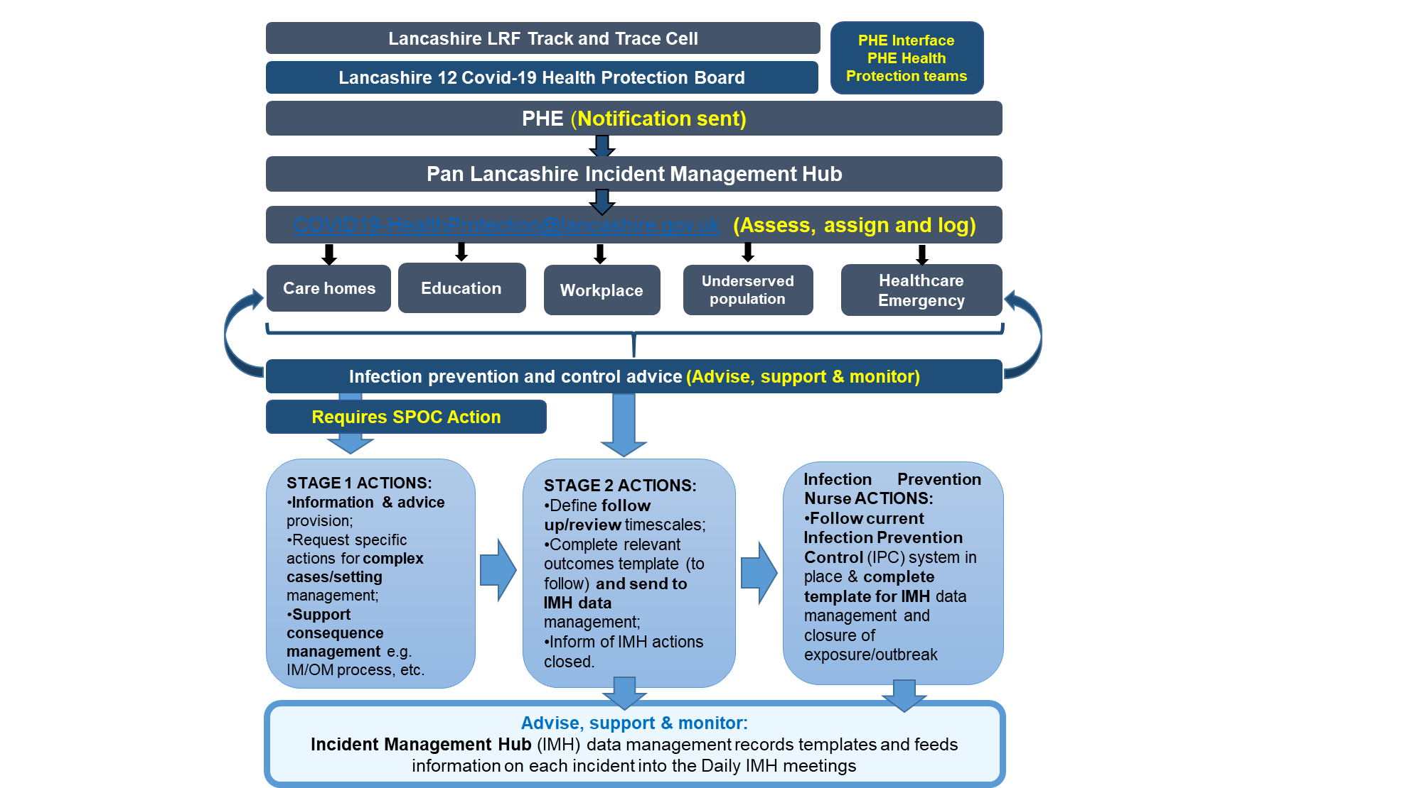

'In

Development'

Until then notifications come straight to Inbox/IMT.

**Risk Assessment**

Based on the findings from the investigation and an assessment of the effectiveness of control measures taken, the IMH / OCT should assess the ongoing risk to the public and to patients if the outbreak is in a hospital or similar community facility. The purpose of this assessment is two-fold, to assess: (i) whether exposure is ongoing, and (ii) the impact of exposure (numbers affected and severity).

Risk assessment essentially entails appraising the evidence collected in the incident investigation and determining whether it indicates that there is an ongoing significant threat to public health. The risk assessment should be dynamic and regularly reviewed by the IMH/SPOC and should include the following considerations:

**Severity:** Dynamically assessed degree of foreseeable harm that may be caused to individuals or to the population and possible issues with recovery in the aftermath of the outbreak.

**Confidence:** Knowledge, derived from all sources of information, that confirms the existence and nature of the threat and the routes by which it can affect the population.

**Spread:** The size of the actual and potentially affected population.

**Interventions:** The availability and feasibility of population interventions to alter the course and influence the outcome of the event.

**Context:** The broad environment, including media interest, public concern and attitudes, expectations, pressures, strength of professional knowledge and external factors including political decisions. (STEEP criteria – social, technological, economic, environmental, political).

Conclusions derived from the risk assessment are principally a matter of professional judgement. However, for reasons of public accountability and understanding, it is essential that this process is as transparent as possible. The OCT should discuss and record in writing the outcome of the risk assessments. Once the risk has been assessed, a decision should be made on how the risk is likely to be perceived by the public. This should inform the development of specific public communications about the risk and how it is being mitigated.

## Identification of Outbreaks

Outbreaks may be recognised by PHE, Local Authorities or NHS Microbiologists. Each organisation has its own procedures for surveillance, detection and control and as soon as it becomes apparent that an outbreak may exist, immediate contact between these parties is essential. Initial investigation to clarify the nature of the outbreak should begin within 24 hours of receiving the initial report. Immediate control measures should be implemented if necessary.

To establish key facts and inform the decision to declare an outbreak the following steps may be undertaken:

* confirm the validity of the initial information upon which the potential outbreak is based (including ascertainment bias; the possibility of laboratory false positives etc);
* conduct preliminary interviews with initial cases to gather basic information including any common factors;
* collect relevant clinical and/or environmental specimens;
* form preliminary hypothesis;
* consider the likelihood of a continuing public health risk; and
* carry out an initial risk assessment to guide the decision-making process

At a district level Environmental Health teams and other council departments have excellent working relationships with the local community, businesses and the voluntary sector. Many of these groups looks at the district council for advice, support and guidance for a range of regulatory matters including infection control, health and safety and how to run their business safely. Environmental Health are familiar with the local community and businesses and have significant amount of intelligence which allow a risk based local approach to tailor interactions and prevention work. The local district council officers are diverse in their approach and can be flexible to support the prevention of Covid in a range of settings and work closely with other agencies to ensure consistency and partnership working. The local prevention work will be driven by a range of proactive and reactive measures which are based on horizon scanning and our local knowledge and expertise.

## Declaring/Notification of an outbreak

Public Health England Cumbria & Lancashire Health Protection team will notify any potential outbreak situations directly to the dedicated mailbox at [*COVID19-Healthprotection@lancashire.gov.uk*](mailto:COVID19-Healthprotection@lancashire.gov.uk).

This mailbox will be monitored 8am to 8pm seven days a week staffed by Lancashire County Council Public Health.

The Outbreak Support team will hold responsibility for:

* The receipt of an initial assessment of all notifications into the dedicated mailbox:
* forwarding the notification to the relevant setting SPOCs (single point of contacts);
* logging full details of the incident within the defined Outbreak Management log (currently in Excel spreadsheet format);
* provision of consequence management support to the setting SPOCs, including contacting the setting to complete the relevant setting checklist;
* recording of actions, recommendations and follow up details plus case closures;
* holding, extracting and reporting key outbreak management information into the daily Health Protection Board meeting to provide assurance to the Director of Public Health (DPH).

## Single Point of Contacts and Outbreak control teams

We have established single points of contacts for various settings (e.g. care homes, schools etc.). Upon notification, the relevant settings SPOC will assess the situation, follow the standard operating protocol for the relevant setting and establish an outbreak control team (OCT) where necessary to:

* Confirm and assess any outbreak,
* Establish appropriate outbreak control measures to minimise viral transmission while mitigating social risks caused by control measures,
* Mobilise the people and resources required to maximise outbreak control
* Where necessary and appropriate, this will include identifying and allocating surge-capacity of additional contact tracers and resources to control outbreaks.

The purposes of the OCTs is to agree and coordinate the activities of the agencies involved in the investigation and control of the outbreak in order to assess the risk to the public’s health and ensure that the cause, vehicle and source of the outbreak are identified and control measures implemented as soon as possible and, if required, legal advice sought.

Specifically:

* the terms of reference should reflect the team’s purpose and should be agreed upon at the first meeting and recorded accordingly;
* the Chair of the OCT should be appointed at the first meeting;
* membership of the OCT should be confirmed and it is the responsibility of the Chair and members to ensure that all key individuals relevant to the outbreak are represented and invited;

The local Outbreak Control Teams will convene in response to potential outbreaks in settings such as care homes, schools and workplaces.

When two or more cases are reported in open setting within 14 days of each other, careful and rapid assessment should be made. This should include a review of:

* clinical features of the cases and microbiological data
* dates of onset of illness and of last attendance
* links between cases outside the setting e.g., home address, social activities, friends, before/after school childcare or other known links
* the type of setting (pre-school, primary school, secondary school or university)
* numbers of students/workers/service users (with consideration in the school and in each school year”

Other escalation criteria might include: Increase in background rate of absence due to suspected or confirmed cases of COVID-19 (does not include absence rate due to individuals shielding or self-isolating as contacts of cases)”. Requires consequence management

## Infection Prevention and Control

Providing timely infection prevention and control support is a central tenet in our outbreak control plan. Our nurse-led Infection Prevention and Control team will work across the county and provide advice and support to manage COVID-19 incidents and outbreaks when they occur. They will be notified of the incident by the single point of contact (SPOC) for the specific setting.

The team will lead on:

* Servicing the outbreak/incident control meetings
* Investigating the incidents
* Collaborating with stakeholders, subject matter experts
* Advice and specialist support
* Implementing guidance
* Distribution of resources
* Education
* Prevention of further outbreaks

## End of an Outbreak

Each OCT specific SPOC will decide when the outbreak is over. The Lancashire 12 COVID-19 Health Protection Board will make a statement to this effect via an outbreak summary email which will be based on an ongoing risk assessment and considered when:

* There is no longer a risk to public health that requires further investigation or management of control measures
* no further cases for 14 days since the onset of the last symptomatic person or positive test
* Confirmation that an end of outbreak deep clean has taken place of the premises

## Health Protection Board and Lancashire COVID19 Outbreak Engagement Board

A multi-agency Health Protection Board, chaired by the Director of Public Health, oversees the delivery of our outbreak plan. Terms of reference for the board can be found at Appendix 7.

In addition, an elected member led Lancashire COVID19 Outbreak Engagement Board is also being established under our Health and Wellbeing Board to provide political ownership and public facing engagement and communication.

## Communication following outbreaks

Standard communications protocols will be followed to ensure the appropriate dissemination of critical information within relevant organisations during the management of outbreaks.

A communications strategy for informing the public and key stakeholders will be discussed and agreed during the management of the incident or outbreak.

# Measures to prevent spread of COVID-19 and protect people at increased risk of severe illness

There is currently no vaccine to prevent COVID-19.

The following measures are recommended to help reduce the spread of COVID-19 and to protect people at increased risk of severe illness:

Hand hygiene is essential to reduce the transmission of infection. Everyone should regularly decontaminate their hands with thorough hand washing for 20 seconds.

Physical (social) distancing measures should be followed by everyone, including children, in line with the government advice to [stay at home.](https://www.gov.uk/coronavirus) The aim of physical (social) distancing measures is to reduce the transmission of COVID-19. Up to date information can be found on the gov.uk website. Note that shielding advice should be followed by individuals at risk of severe infection.

Shielding is a measure to protect people, including children, who are extremely vulnerable to severe illness from COVID-19 because of certain underlying health conditions. The aim of shielding is to minimise interaction between these individuals and others to protect them from coming into contact with the virus that causes COVID-19. People with these serious underlying health conditions are strongly advised to rigorously follow shielding measures in order to keep themselves safe. Further information, including the list of underlying health conditions that make people extremely vulnerable, is available on the gov.uk website.

Stay at home guidance for households with possible COVID-19 should be followed by people with symptoms and their household contacts to reduce the community spread of COVID-19. This means that anyone who has symptoms of COVID-19 and anyone else living in the same household should follow ‘stay at home’ advice on [gov.uk.](https://www.nhsinform.scot/illnesses-and-conditions/infections-and-poisoning/coronavirus-covid-19/coronavirus-covid-19-stay-at-home-advice)

Staff (such as health care workers) with underlying health conditions that put them at increased risk of severe illness from COVID-19, including those who are immunosuppressed, should not provide direct care to patients with possible or confirmed COVID-19. Staff who think they may be at increased risk should seek advice from their line manager or local Occupational Health service. Pregnant staff should also seek advice from their line manager or local Occupational Health service. Guidance on COVID-19 and pregnancy is available on gov.uk

District councils have a key role in supporting businesses and the community to remain safe during the pandemic. We continue to support businesses using a range of different proactive prevention tools including advice visits, forums, producing guidance and communication messages. We continue to visit businesses to review compliance with being Covid secure and are available to offer support and respond to outbreaks and complaints. We do also have and will use enforcement powers if businesses or settings do not comply with the spirit of the legislation and guidance to safeguard the public and its staff. This is paramount to ensure that staff and the public attending settings which are well managed and have implemented effective controls.

# Local Outbreak Management Plan

The DHSC response plan for Local Government requires Local Authorities and partners to be able to respond to 7 Key themes. At this stage are considering our response to themes 1,2 ,4,6 and 7 only as 3 and 5 are already being undertaken at LRF level.

The 7 themes that the Local Outbreak Management Plans will centre on are;

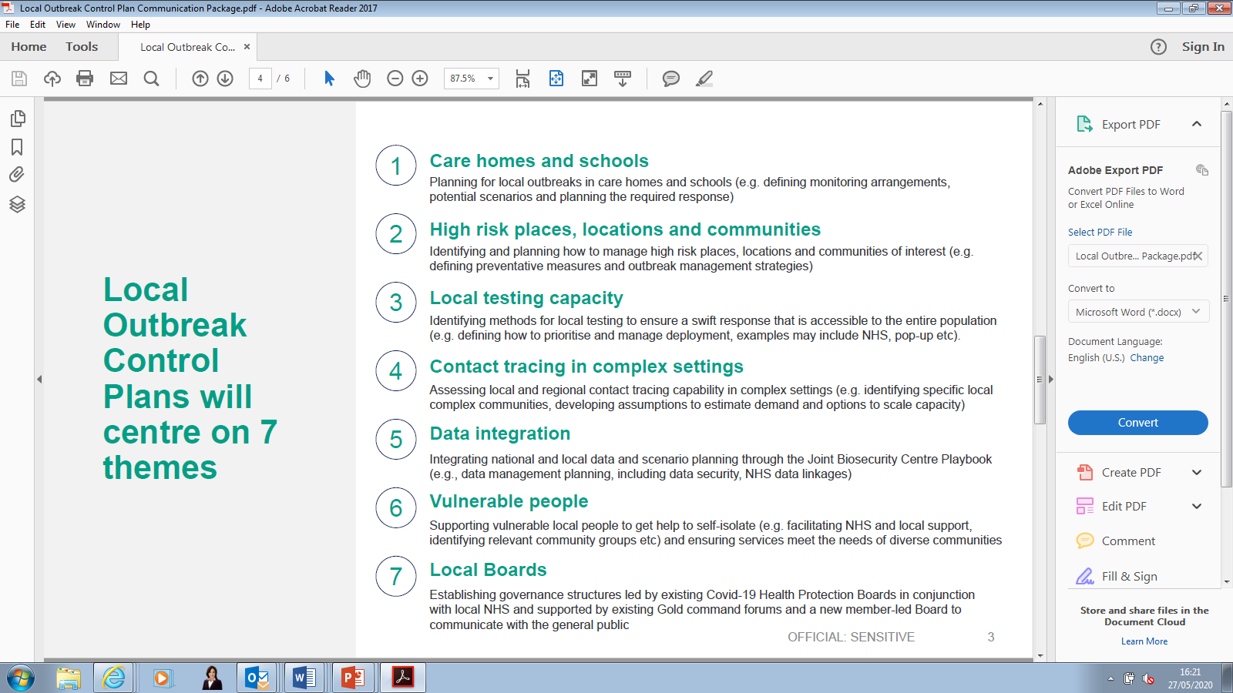

# Theme 1 - Preventing and managing Outbreaks in Care Homes and schools

From the beginning of the pandemic care homes and schools were identified as high risk settings for COVID-19 outbreaks. Significant multi agency work has already been developed across Lancashire County Council and the LRF footprint to prevent and manage the risk of outbreaks in these settings.

## Care Settings

**Background**

Care providers face particular and significant challenges in trying to prevent, protect and respond to the pandemic; however, care homes have been particularly susceptible to outbreaks of COVID-19.

Infection prevention and control has remained our core focus in prevention and managing outbreaks in care settings. Our activity to date has focused on supporting care homes to understand the frequently changing guidance, ensuring they had adequate personal, protective equipment and working with them to understand their immediate challenges and subsequently establishing pathways to try and resolve these. Key to our approach has been daily contact with each care home to gauge their operating confidence and to capture important information that would support the local authority and multi-agency partners to better understand and react to the pressures the wider market is facing as well as issues specific to each care home. Data from these calls is reviewed regularly by contract management and quality teams and appropriate action is taking including signposting to LCC IPC for advice and guidance, particularly where there have been suspected or confirmed cases in staff or residents that has not met the PHE outbreak definition.

**Managing cases and outbreaks**

***Communication***

Due to the rapid change in guidance and increasing amount of information that needed to be shared quickly, the local authority established weekly webinars, open to all care providers across Lancashire. The webinars provide an opportunity for the local authority and partners to share key messages and updates but it is also interactive, allowing providers to submit questions and request advice and guidance on areas they feel need to be expanded. For example an extended session on test and trace has been delivered as well as one on the infection control grant funding and a session where a local home was able to share their experiences and ideas on how they have responded to the pandemic. The webinars are recorded and documentation from each is uploaded to the local authority provider portal.

Providers are also sent a weekly newsletter summarising information from the webinar and any national, regional, local updates that are pertinent.

***Escalation***

A multi-disciplinary Team process has been developed to ensure a holistic and whole system response for care homes that meet the trigger levels;

1. Provider's Business Continuity Plan has already been activated and risks to mitigate safe service delivery as intended are failing
2. Representations from one or more Statutory health or Social Care Partners  have  information and intelligence concerns relating to a Provider's ability to deliver safe services
3. Providers who require additional advice and support to interpret and implement COVID PHE and Government Covid-19 advice because people cared for have complex care needs – e.g. MH, Dementia, LD etc.
4. There are multiple complex presenting issues that the provider is struggling to manage

Representation at the MDT is dependent on issues the care home is facing, but where this is concerning an outbreak (s) or related queries an IPN is part of the process or a referral is made for supporting guidance.

During the MDT stage regular contact is maintained with the care home including at the weekend through welfare call arrangements; this is in addition to the daily tracker calls referred to above[1]. Welfare calls are also offered to care homes that may not be in a MDT process but there is a recognition that they may benefit from extra support/contact, this includes care homes that exit the MDT process but have asked for continued contact.

***Identifying possible cases***

The local authority has routinely promoted the whole home testing programme with care homes across Lancashire and have established pathways and processes to assist care homes in undertaking this process safely. Support has included registering for testing kits on the care home's behalf and arranging volunteers to assist the care home with swabbing.

Public Health England (PHE) working with LCC Adult Social Care, Public Health and Infection Prevention and Control (IPC) teams will continue to support the care home sector within an overarching approach encompassing the three key themes of Prevent, Protect and Respond.

The detailed elements and existing current arrangements for each of these three themes are outlined in detail in Appendix One and work is currently ongoing to:

1. Expand local testing arrangements both in terms of capacity and also how we best align this available capacity to need with particular reference to the roll out of the whole care home testing programme
2. Strengthen the data flows around testing and how this interfaces with local Health Protection Teams, the Local Authority SPOC function and the emerging national NHS Test and Trace programme
3. LA SPOC seeking support and providing assurance to the Lancashire Health Protection Board

The detailed arrangements outlined in Appendix One are additionally being supported through the LCC COVID19 Adult Social Care Plan. This is monitored through the LCC Human Aspect Cell which currently meets twice weekly and reports directly to the LCC's Corporate Emergency Response Team.

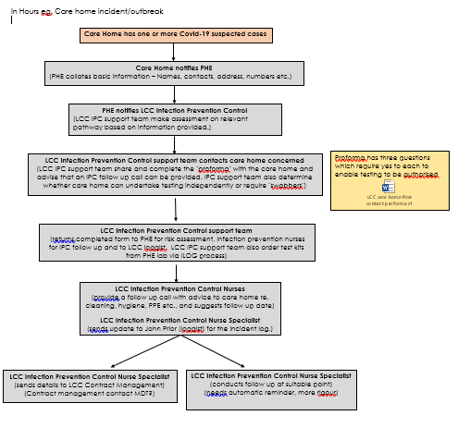

***Role of the care home in an outbreak***

When an outbreak is suspected in a care home, the care home will be asked to:

1. Name a lead member of staff to liaise regularly with the local infection control (ICN) team or the relevant PHE North West health protection team
2. Provide the relevant information when requested by ICNs
3. Keep a daily log of new cases
4. Ensure appropriate infection control measures are in place for the duration of the outbreak, detailed recommendations are outlined, key themes include:
   * Standard infection control precautions and respiratory hygiene/cough etiquette
   * Isolation of cases (including cohorting)
   * Adequate Personal Protective Equipment (PPE) for staff
   * Exclusion of symptomatic staff and visitors
   * Particular attention to cleaning
   * Special considerations for discharge from hospital to care home
   * Potential closure to new admissions
5. Support the outbreak control team with collection of respiratory swabs
6. The partners in the outbreak control team will:

* Provide infection control advice to the care home
* Arrange for respiratory swabs to be taken from affected residents (if not already done)
* Review the situation on a regular basis and decide on when the outbreak can be declared over
* Prepare a holding press statement and share this with the relevant Local Authority communications team

## Schools

**Background**

The extended opening of schools and educational settings to more children other than those in vulnerable groups and those of key workers means that there will be a greater need to plan, prepare and support schools to undertake timely risk assessments, implement effective infection prevention control measures, maintain a resilient workforce and respond to cases or outbreaks in their settings.

As part of national social distancing measures to limit the spread of COVID-19, the number of children and young people attending educational and childcare settings was limited to ensure that pupils and staff attending could do so safely. Education and childcare settings have been open to priority groups such as vulnerable children and children of critical workers since the epidemic started.

Given that we did not have local arrangements in place for test and trace for the 1 June, schools were advised not to re-open until it was safe to do so.

These Government plans have now been extended from 1 June to September 2020 but schools can start to take these children and young people if they feel it is safe to do so and we still continue to provide for vulnerable children and children of key workers.

Educational settings will include not only include the above settings but also Colleges and Universities. Similar arrangements have been established with leads from higher education and early years settings.

The **Schools Outbreak Management Plan** (Appendix 2) will cover the following key areas of outbreak management activity;

* Proactive advice and guidance
* Monitoring arrangements
* Infection Prevention and Control (IPC)
* Testing and tracing
* Data gathering and Intelligence

**When an outbreak is suspected in an education setting, the following process will be followed:**

* A lead member of staff will liaise with the infection control team or the relevant PHE North West Cumbria & Lancashire health protection team depending on who and how the outbreak is identified. At the moment we are seeing cases both from a bottom up approach direct from education settings such as schools to a top down approach direct from PHE.
* Relevant information will be provided to the health protection email address and this will be filtered accordingly
* A daily log of new cases will be kept
* A checklist will be completed to obtain any additional information
* Appropriate infection control measures will need to be in place for the duration of the outbreak, detailed recommendations are outlined, key themes include:
* Standard infection control precautions and respiratory hygiene/cough etiquette
* Isolation of cases
* Adequate Personal Protective Equipment (PPE) for staff
* Exclusion of symptomatic staff and children
* Particular attention to cleaning and hygiene
* Potential closure of setting
* Identify or escalate complex cases to the SPOC depending on what has been identified within the SPOC
* The SPOC will where necessary support as part of the outbreak control team
* The partners in the outbreak control team will:
* Provide infection control advice to the setting
* Review the situation on a regular basis
* Work with the Director of education and Public Health in order to prepare relevant communications to share this with the relevant services, schools and stakeholders.

**Consequence Management Scenarios**:

**PPE and supply**

The majority of staff in education, childcare and children’s settings will not require PPE beyond what they would normally need for their work. PPE is only needed in a very small number of cases.

Additional PPE has been provided to schools should this be required with clear messages in terms of how to use and also when and where this should be used as part of FAQs.

**Managing cases and outbreaks in educational settings**

The Director of Children’s Education and Public Health have worked closely with schools via weekly bulletins to educational settings, development of individual risk assessments, as well as meetings to provide advice, guidance and support.

The Director of Education will act as the SPOC for schools and the Consultant in Public Health is acting as the SPOC for children and young people with a focus on public health in educational settings. This arrangement will be integrated into the Lancashire Outbreak Management plans and managed through the Health Protection Board.

**Identifying possible cases and outbreaks**

If one or more children, young people or members of staff attending or working in an educational setting develop symptoms of COVID-19, Head Teachers or other leads within the setting (e.g. pre-school lead, childminder) will be asked to ensure that a member of staff contacts the Lancashire Incident Management Support team (IMST) within 24 hours of becoming aware of the suspected/confirmed case(s). *The IMST will be operational from 1 June and will be available 7 days a week 9am-8pm.*

*Alternatively, the IMST may be made aware of suspected or confirmed cases of COVID-19 in educational settings via Public Health England, local microbiology labs or the national Test and Trace service.*

*At initial contact, the IMST will capture a minimum data set of information. They will seek to clarify what testing has already taken place. They can also provide some basic advice regarding isolation if the caller is from an educational setting. They can also arrange testing if the caller requests it. The data collected by the IMST will be shared with the contact-tracing team and they will then contact the setting to provide further infection prevention and control (IPC) advice and identify if contact tracing is required. If it is, they will also carry out this work*.

Data will be shared between the IMST and outbreak management team/contact-tracing team via telephone, with contact-tracers using their existing systems to capture information. It is hoped the contact-tracing team will have direct access to the same digital database as the IMST.

The Public Health Team at Lancashire County Council are developing a standard operating procedure and suite of information sheets that will inform the work of call-centre staff. In addition, on an ongoing basis, the public health team will work with service team leaders/managers to quality assure the information and practice of the call-centre team and contact-tracing team.

**Testing**

Local testing arrangements are being finalised, but testing options available are set out in Section 8.

As confirmed via the regional STAC we are testing children under the age of 5 but this is likely to happen at home with a self-swabbing kit than at a mass testing centre. This will also depend on locally commissioned services. The government have pledged for increased capacity for testing and is working towards achieving this. There are a number of pathways that can be taken e.g. GPs, CCGs, through employers and via pillar 1 testing but this will be confirmed with the national team for a definitive answer tbc

# Theme 2 - Preventing and managing outbreaks in other high-risk places, locations and communities of interest

Working with our district councils, we have identified a number of local high risk places, locations and communities of interest and have developed our plans to mitigate these.

There is clear evidence that COVID-19 does not affect all population groups equally. Many analyses have shown that older age, ethnicity, male sex and geographical area, for example, are associated with the risk of getting the infection, experiencing more severe symptoms and higher rates of death.

**Ethnicity**

Data suggests that people of Black, Asian and other minority ethnic groups may be more exposed to COVID-19, and therefore are more likely to be diagnosed. This could be the result of factors associated with ethnicity such as occupation, population density, use of public transport, household composition and housing conditions, which the currently available data did not allow us to explore in this analysis.

Many of the pre-existing health conditions that increase the risk of having severe infection (such as having underlying conditions like diabetes and obesity) are more common in BAME groups and many of these conditions are socioeconomically patterned. For many BAME groups, especially in poor areas, there is a higher incidence of chronic diseases and multiple long-term conditions (MLTCs), with these conditions occurring at younger ages.

The LRF BAME inequalities group is a strategic senior officer and community organisational leads group working collaboratively to co-produce a Lancashire wide strategy across the key partners with experience in BME inequality and policy.

The group have developed a Rapid Action Programme to:

* Identify real time inequalities in COVID19 morbidity and mortality among BME communities in Lancashire
* Identify causes of increased risks of COVID19 inequalities in morbidity and mortality among BME communities in Lancashire
* Mobilise a rapid collective response to identifying, managing and mitigating inequalities in COVID19 morbidity and mortality and social and economic wellbeing among BME communities in Lancashire during the coronavirus pandemic.

**Deprivation and inequalities**

People facing the greatest deprivation are experiencing a higher risk of exposure to COVID-19 and existing poor health puts them at risk of more severe outcomes if they contract the virus.

The government and wider societal measures to control the spread of the virus and save lives now (including the lockdown, social distancing and cancellations to routine care) are exacting a heavier social and economic price on those already experiencing inequality.

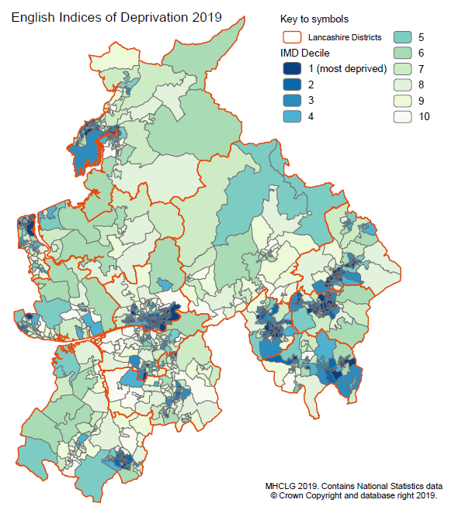

**Upper-tier local authority summary**

* Lancashire-12's index of multiple deprivation (IMD) ranking is 78/151 of upper-tier local authorities but 1/26 of 26 two-tier county council areas, where 1 is the most deprived.

**Lower-tier local authority summary**

* Burnley (11/317) and Hyndburn (18/317) are both in the most deprived 10% of the lower-tier local authorities within England on the IMD rank of average rank measure, Pendle and Preston are both in the most deprived 20%.

Many public health commissioned services have been disrupted by COVID, but a number of critical services have remained operational including alcohol and drug services, stop smoking, sexual health and school nursing and health visiting services. Services will begin to roll out a more complete offer as we enter the next phase of COVID19 response.

**Travellers**

Our Underserved settings SPOC will link in with the Local Authority Traveller Liaison Officer if an outbreak occurs within the traveller community.

**Homeless/HMOs**

The government’s advice on social distancing and self-isolation during the coronavirus (COVID-19) pandemic is challenging for people experiencing homelessness and rough sleeping.

HMOs were identified locally as a high risk setting early in the pandemic and a multi-agency working group has been established to support these settings.  Proactive advice and guidance has been provided and site specific infection control and contingency plans are already in place.  These will be reviewed and extended to support local Outbreak Management Hub arrangements.

The LRF has a Homeless Cell looking at housing and health related issues.

District Councils lead on homelessness and housing, though LCC does commission a number of complex needs units.

Underserved SPOC will liaise directly with identified district leads regarding outbreaks for this group.

**Drug & Alcohol services**

People who use or are dependent on drugs and alcohol may be more vulnerable to the impact of infection because of underlying conditions.

Community alcohol and drug services have remained open and operational during this period. Significant changes to operation have been introduced including digital/online and telephone support for most people and changes to prescribing regimes to alleviate pressure on pharmacies and risk to medication disruption, plus to reduce risk of COVID transmission.

Residential detoxification and rehabilitation services have largely remained open, though with new measures such as isolation, reduced capacity and restricted entry. Testing mechanisms for these environments is being implemented following changes to 'care home' guidance.

**Key transport locations**

We have identified our key locations. Train stations and Ports and any links with these will be through our known contacts within the LRF.

**High Risk Workplaces**

Local Authorities have a key role in promoting and enforcing covid-secure workplaces based on the five main steps to working safely. These are:

1. Before restarting work employers should ensure the safety of the workplace by **carrying out a COVID-19 risk assessment**
2. Increase the frequency of handwashing and surface cleaning by **developing cleaning, handwashing and hygiene procedures**
3. Take all reasonable steps to **help people to work from home**
4. Where possible, **maintain 2m social distancing**
5. Where it's not possible for people to be 2m apart, workplaces should do everything practical to **manage the transmission risk**

The Public Protection Teams across Lancashire are working proactively with businesses and community groups to promote COVID-19 secure practices, promoting infection control, monitoring compliance and taking action where necessary. This will include close working with businesses, the community, strategy partners, the Business Improvement Districts (BID) and other local business networks.

A programme of Covid-secure inspections are being undertaken, targeting high risk workplaces and responding to complaints and requests for advice.  Enforcement action will be escalated where informal approaches do not bring about the required level of compliance.

Work has commenced to identify and work proactively with high risk workplaces across the county.  This is based on local intelligence, workplaces where there is a high risk of close contact, increased complaints, shared facilities, likelihood of non-compliance or other risk factors such as high proportion BME workforce and any lessons learnt from outbreaks.

A range of prevention work is being undertaken at a local and county level and we continue to be involved in the prevention work as a key strand of the pandemic.

* Local web pages with links to advice and guidance on working in accordance with COVID security measures
* Dedicated communications circulated to high risk workplaces about how to follow COVID secure guidance and any implication of track and trace
* General communications and social media channels for all business on COVID secure guidance

In addition we will continue to offer advice and guidance to businesses and individuals who request it.

The Underserved Outbreak Management plan (Appendix 3) goes into more detail on how we will manage outbreaks in these settings

# Theme 3 – Local Testing Capacity

Timely and accessible testing and appropriate reporting are crucial to predict and intervene in local outbreaks.

Essential Workers in England, Scotland or Northern Ireland and can apply for priority testing through GOV.UK by following the guidance on [testing for essential workers](https://www.gov.uk/guidance/coronavirus-covid-19-getting-tested#self-referral). Individuals can also get tested through this route if they have symptoms of COVID-19 and live with an essential worker.

These tests for essential workers are prioritised over the tests available for the wider public through the NHS.

Testing for members of the public who are symptomatic (or contacts positive cases who themselves become symptomatic) is now accessed through NHS.uk/coronavirus or via 119, delivered by nationally commissioned, regionally delivered 'Pillar 2' testing.

If a child (currently 5 years or over, but the Government has committed to making testing available to children aged under 5 when early years and childcare settings reopen more widely), young person or any of their contacts or household members have, or develop, symptoms of COVID-19 they can [ask for a test through the NHS website.](https://www.nhs.uk/conditions/coronavirus-covid-19/testing-and-tracing/ask-for-a-test-to-check-if-you-have-coronavirus/)

**LRF Test and Trace cell**

The role of the Test and Trace subgroup is to consider, plan, coordinate and support the delivery of a wide range of testing and tracing programmes to minimise the impact of the COVID-19 pandemic, specifically within the Care Sector and other pathways across the LRF area.

Methods for local testing identified to ensure a swift response that is accessible to the entire population of Lancashire include:

* **Regional Testing Centre at Preston College**. We are also in the process of working with Deloittes to introduce another site in the East of the county.
* **Military Testing Units** – From 13 July 2020 there will be six sites for Lancashire. These will become permanent fixtures at Lancaster, Blackpool (North & South), Chorley, Skelmersdale, Nelson and Rossendale.

The Map below provides a footprint with RTSs in Purple, permanent MTUs in green and the alternating Blackpool sites in yellow

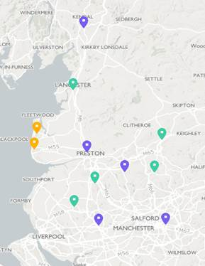

* **Community Swabbing Teams** (VirginCare/Team Rubicon)
* Home testing delivered by post/courier
* Care home whole home testing pathway
* Vulnerable people services
* Testing for homeless
* LCC testing hub – LCC testing front door – looking to field school enquiries through
* Domiciliary care/home care testing– *Karen Thompson email from Lisa Slack*

**Lancashire LRF Early Adopter**

As an early adopter LRF, we are working with the NHS Test and Trace programme to co-design a comprehensive local testing plan. Our intention is to outline a Pan-Lancashire testing plan that integrates the NHS testing plan. The Pan-Lancashire testing plan is designed to identify cases earlier, enable effective contact tracing, and prepare for the enduring testing programme. Furthermore, the plan also addresses inequalities in testing by removing barriers for high risk groups and settings.

It covers the future intention for Whole Home Testing within the Care Sector.

It also integrates with the UTLA Outbreak Management plans.

This plan is designed to be a framework for Co-Designing a national framework and obviously will be aligned to changes in National Policy.

*Our unifying effort remains to save lives and control the virus.*

The Pan-Lancashire testing plan is intended to have the following impacts:

* Find the virus by applying targeted response testing around cases.
* Find the virus by proactively testing in high risk settings and groups.
* Fix inequalities in the testing regime in which currently, the bulk of testing efforts focus on low risk groups.
* Reassure hard to reach and high-risk groups.
* Inform the public about suitable pathways to testing.
* Cooperate with stakeholders and transition to Local Authority control.
* Prepare the testing regime for handover to a commercial partner.
* Reassure business communities.

# Theme 4 - Contact Tracing in complex settings

We will work closely with PHE Health Protection Team and our Clinical Commissioning Groups (CCGs) to deliver effective contact tracing, control and management of COVID-19 incidents and outbreaks in complex settings, and manage potential consequences that may arise.

**Scope of Contact Tracing Activity in Complex Settings**

a. **Contact Tracing in complex cases or settings**:

* Potentially complex settings (For example: schools, Special Schools, Homeless Accommodation; domestic violence refuges; Police and Fire Stations; HMO’s; Day Centre Provision; NHS Settings; Social Care settings; Statutory Service HQ’s; residential children’s homes)
* Potentially complex cohorts (For example: rough sleepers; faith communities, asylum seekers)
* Potentially complex individuals and households (For example: Clinically shielded; Learning Disability and Autism; diagnosed Mental Illness; substance misusers Rough Sleepers; Victims of Domestic Abuse; complex social-economic circumstances)

b. Providing **direct support** to those identified through contact tracing for whom adherence to self-isolation measures may be challenging, including links into locality hub pathways for shielded and vulnerable cohorts.

c. **Consequence management** as a result of contact tracing or managing an outbreak in a complex setting or within a complex cohort.

**Key Roles and Responsibilities – National Test and Trace**

Level 3 (National Call Handlers) who are responsible for:

* Providing advice to contacts according to Standard Operation Procedures (SOPs) and scripts. This will include the Household and Community contexts of cases escalated to Level 1.
* Escalating difficult issues to the level 2 staff.

Level 2 (Professional Contact Tracers) who are responsible for:

* The interviewing of cases, and identifying their contacts using SOPs and scripts
* The handling of issues escalated from level 3 staff.
* Escalation of complex issues and situations to Level 1.

Level 1 (PHE NW and Lancashire County Council are jointly responsible for):

* Leading on ‘complex’ contact tracing.
* Consequence Management.
* Supporting vulnerable people and households.

We will receive Tier 1 notifications for local complex cases, contact tracing and consequence management through our dedicated email box [COVID19-healthprotection@lancashire.gov.uk](mailto:COVID19-healthprotection@lancashire.gov.uk)

**Criteria for Escalation from Tier 2/3 (National) to Tier 1**

**Cases where liaison with an educational / childcare setting or employer may be required:**

1. Cases who have attended educational/childcare setting while infectious (*Call handler and Central escalation*).
2. Cases who have attended work while infectious and who are unable to identify their contacts who will require follow up (*Call handler and Central escalation*).

**Complex and high-risk settings:**

1. Case living or working in care home/long term care facility or other care facility for those with complex needs (*Direct allocation and Automatic escalation*).
2. Cases in Healthcare workers (*Automatic escalation*).
3. Cases in Emergency Services workers (*Automatic escalation*).
4. Cases in Border Force and Immigration officers (*Automatic escalation*).
5. Cases who attended healthcare for non COVID reasons (*Automatic escalation*).
6. Cases in those living or working in Prison or other places of detention (*Automatic escalation*).
7. Cases in those attending or working in special schools (*Automatic escalation*).
8. Cases in those living in homeless hostels or shelters or refuges and similar residential settings (*Automatic escalation*).
9. Cases attending Day care centres for older/vulnerable people (*Call handler and Central escalation*).
10. Cases with concerns about deductive disclosure (*Call handler escalation*).
11. Cases where contacts can’t be identified without disclosure of name to employer or other third party (*Call handler escalation*).
12. Cases or employers unwilling to provide information (*Call handler escalation*).

**Consequence Management:**

1. Identified impact on local public-sector services or critical national infrastructure (eg. power plants) due to high proportion of staff quarantining (eg school that informs tier 2 that will have to close as all staff quarantining) (*Call handler escalation*).
2. Cases or contacts who are unable to comply with restrictions (homeless, complex social issues etc) (*Call handler escalation*).
3. Likely Media or political concerns/interest eg death in child (*Call handler escalation*).

**Increase in disease frequency or severity that may require further investigation locally:**

1. Second or subsequent cases in school class (small number of children taught together) (*Call handler and Central escalation*).
2. Reported high absenteeism rate in school or workplace (*Call handler and Central escalation*).
3. Reported high levels of hospitalisation or death.

**Criteria for Escalation to Single Points of Contact (SPOC)**

Cases linked to care home or other social care settings: UTLA SPOC (for IPCT response).

Cases linked to NHS Acute or Community Trust health care settings (SPOC identified for all Lancashire Acute or community trusts.

Cases in emergency service workers (SPOC).

Case in underserved population linked to complex setting requiring bespoke response (e.g. case linked to homeless hostel or CDAS setting).

Cases linked to prison or other custodial setting (Health protection team).

Community Health or Social Care worker – UTLA (SPOC) or NHS/CCG (SPOC) depending on employing/commissioning organisation.

Consideration will be given for escalation to UTLA SPOC or NHS/CCG SPOC if any of the following criteria are met in other settings following baseline risk assessment:

* Large number of contacts are likely to meet the proximity or direct contact definition.
* High numbers of vulnerable people are identified as potential contacts within the setting.
* Potential impact on service delivery if staff are excluded for 14 days from exposure.
* Significant consequence management concerns.
* Outbreak declared.
* Death or severe illness reported in the case or contacts.
* Significant likelihood of media or political interest in situation.

This consideration will be applied in all instances, whether escalation would be ‘for action’ or ‘for information’.

As three upper tier local authorities (Lancashire, Blackpool and Blackburn with Darwen), we are in the process of developing a Memorandum of Understanding with Public Health England North West Health Protection Team to develop a Pan Lancashire Hub to embed their specialist expertise within our Lancashire system.

**Local Planning Assumptions**

To estimate demand for test and trace we have utilised the Demand Model Assumptions for Contact Tracing produced by PHE NW:

PHE estimates suggests that each symptomatic person will have up to 14 contacts, of which 12 can be contact traced on average. Therefore, based on **symptomatic** cases only, in Lancashire a total of **5256** cases would require tracing (high end estimate).

This tracing will be conducted at national level in the first instance, and then by Tier 2, before being escalated to Tier 1b. PHE estimate that Lancashire will receive between 5% to 20% of total cases to manage, based on the escalation criteria for complex cases. Therefore, Tier 1b can expect to manage between **262** to **1051** cases daily.

**Our response to rising levels demand is as follows:**

Level 1 – IM Hub front door, 7 day 8-8, setting SPOC and aligned graduated PH named staff (low staffing levels) working with district council EHO SPOCs – threshold capacity to handle 262 cases daily.

Level 2 – IM Hub front door, 7 day 8-8, setting SPOC and aligned graduated PH named staff (medium-high staffing levels) working with district council EHO SPOCs - threshold capacity to handle 520 cases daily.

Level 3 – IM Hub front door interface with customer access service staff, 7 day 8-8, setting SPOC and aligned graduated PH named staff (high staffing levels) working with district council EHO SPOCs - threshold capacity to handle 770 cases daily.

Level 4 – IM Hub front door interface with customer access service staff, 7 day 8-8, PH named staff working with district council EHO SPOCs - threshold capacity to handle 1051 cases daily.

Initial surge capacity will be identified from existing call handling team, Public Health and Wellbeing team, Infection Prevention and Control team, and the capacity available from district council environmental health teams, with appropriate training provided.

In the longer term it is unlikely that this will be sustainable as more staff return to their usual duties alongside other COVID-19 generated tasks. Given the anticipated demand for tracing described above it is anticipated that this workforce will be supplemented further and additional capacity secured. There are ongoing discussions with district council colleagues as to how best identify and train further health protection capacity, whilst retaining knowledge of local communities and businesses.

# Theme 5 – Data Integration and Surveillance

In order to support the effective management of contact tracing and outbreak surveillance, a number of teams across different organisations will need to share confidential personal-identifiable data. We are in the process of securing our own case management system that will have the capability to interoperate with PHE and national systems.

As an LRF, we have already agreed to develop a local data hub with appropriate information governance in place. We have confirmed the requirements for information sharing with Public Health England to receive the line lists.

In order to identify issues and outbreaks early, we are also in the process of developing a local biosecurity and health surveillance programme with support from our academic partners. This will also provide the interface with the national joint biosecurity centre and any regional arrangements that will evolve across the North West.

# Theme 6 - Supporting local Vulnerable People

Supporting people who are most vulnerable to COVID19 and those who may become vulnerable by being asked to self-isolate through the NHS test and trace service is a key function to the test and trace program. It is important that we minimise the socio-economic impacts on these individuals and support them through their isolation period.

We have established local districts based community hubs to support vulnerable people throughout the pandemic. If welfare advice and support is needed to enable people to self-isolate, there are a number of levels of support:

Individuals asked to self-isolate will be questioned whether they need practical support with:

* Obtaining food
* Finances
* Mental Wellbeing , social isolation and loneliness
* Obtaining health care and medication
* Support for someone they care for
* Dog Walking

If the individual cannot provide this support for themselves they will be encouraged to get support from family, friends or trusted neighbours, this will reduce the strain on voluntary and council services.

If these options aren’t appropriate, individuals will be signposted to their local council community hubs for support where each local council can direct the individual to local community volunteers, The voluntary, community and faith sector (VCFS) and any other support functions that have been set up in their areas.

**Other routes of help for individuals**

Individuals could also be directed to the [NHS Responder volunteers](https://www.goodsamapp.org/NHS) via the Good Sam app. The GoodSAM Platform is powering the [NHS Volunteer responder](https://www.goodsamapp.org/NHS) scheme across the UK. 750,000 Volunteers are helping those self-isolating due to Covid-19.

The Age Concern Coronavirus Support Service is aimed at helping those within self-isolation and their carers to access a range of support services.

# Theme 7 - Local Governance Structures

**LRF level Governance**

In response to the Coronavirus (COVID-19) outbreak, the Lancashire Multi-Agency Strategic Co-ordination Group (SCG) has established a number of sub-groups which feed back into the LRF. There is a Test and Trace Cell that oversees the Pan Lancashire arrangements in Lancashire.

**Local Health Protection Board**

A multi-agency Health Protection Board, chaired by the Director of Public Health, oversees the delivery of our outbreak plan in Lancashire. Terms of reference for the board can be found at Appendix 7.

The board will provide regular updates to the LRF Test and Trace Cell, Local Outbreak Engagement Board and our Health and Wellbeing Board.

**Local Outbreak Engagement Board**

The function of the Local Outbreak Engagement Board is to provide political ownership and public-facing engagement and communication for outbreak response. The Terms of reference for the local outbreak engagement board is to be agreed by our Health and wellbeing Board on the 3rd July 2020. It can be found in Appendix 8.

**Communications Plan**

A programme of key messages and clear communications to support the TT programme will be developed by the LRF Warning and Informing Cell and Lancashire County Council Communications Team, working with a range of partners. This will include;

* Support for interpretation and dissemination of setting specific advice and guidance, adapted to meet the need of local communities.
* Provision of easy-to-follow, practical advice about how to comply with TT guidance, including reporting procedures, testing processes and how to effectively self-isolate and practice infection control within the household.

# Deploying Appropriate Legislative and Regulatory Powers

This is for guidance only and does not claim to address all powers available to all agencies. It is not a substitute for each agency taking its own legal advice in any given scenario.

The LRF Legal Cell have determined that the following pieces of legislation are relevant to enforcement in the pandemic, and the LRF Test & Trace Sub-Group have highlighted those having particular relevance to tracing in blue:

* 1. **Coronavirus Act 2020**

Section 10 and Schedule 8 – Mental health and capacity

Section 51 and Schedule 21 - Potentially infectious persons

Section 52 and Schedule 22- Powers relating to events, gatherings and premises

* 1. **Health Protection (Coronavirus, Restrictions) (England) Regulations 2020 as amended**

Regulation 4 - Requirement to close premises and businesses during the emergency

Regulation 5 - Further restrictions and closures during the emergency period

Regulation 6 - Restrictions on Movement

Regulation 7 - Restrictions on Gatherings

* 1. **Public Health (Control of Diseases) Act 1984**

**as amended by the Health and Social Care Act 2008**

* 1. **Health Protection (Part 2A Orders) Regulations 2010**
  2. **Health Protection (Notification) Regulations 2010**
  3. **Health Protection (Local Authority Powers) Regulations 2010**
  4. **Health and Safety at Work Act 1974**
  5. **Antisocial Behaviour, Crime and Policing Act 2014**

The exercising of any powers must be necessary and proportionate, and with due consideration of:

1. **European Convention on Human Rights**
2. **Human Rights Act 1998**
3. **Discrimination and Equality Act 2010**

# Administration

## Ownership and Title

This Outbreak Control Plan is prepared, maintained and published by the Lancashire Health Protection Board and will be signed off by Sakthi Karunanithi, Director of Public Health and CC Shaun Turner, Cabinet member for Health and Wellbeing.

**Only the owner as described above can authorise alterations.**

The Health Protection Board will ensure that:

a) Live plan is held on Resilience Direct.

b) It is updated and reviewed as the national guidance evolves and when necessary.

**Reviewing**

The plan will be reviewed and updated in 3 months. However, consideration should be given to reviewing the plan following activation or an exercise. The plan owner will ensure that the document is reviewed as stated. In addition, a full revision of the Outbreak Control Plan should be carried out every three years from the date of issue.

**Version 1.0 Published: 1st July 2020**

# Amendment History

|  |  |  |  |  |
| --- | --- | --- | --- | --- |
| **Version Number** | **Date** | **Section/page Number** | **Amendment Notes** | **Officer Initials** |
|  |  |  |  |  |
|  |  |  |  |  |
|  |  |  |  |  |
|  |  |  |  |  |
|  |  |  |  |  |
|  |  |  |  |  |
|  |  |  |  |  |
|  |  |  |  |  |
|  |  |  |  |  |
|  |  |  |  |  |
|  |  |  |  |  |
|  |  |  |  |  |
|  |  |  |  |  |
|  |  |  |  |  |
|  |  |  |  |  |
|  |  |  |  |  |
|  |  |  |  |  |
|  |  |  |  |  |
|  |  |  |  |  |

# Summary Roles of Each Agency

|  |  |  |  |
| --- | --- | --- | --- |
| **PHE** | **UTLA** | **District Council** | **NHS** |
| * Notifies UTLA of level 1 incidents * Provides specialist health protection advice * Provides timely testing using PHE labs * Administers OCTs | * Facilitates outbreak management virtual hub * Takes a lead role in managing outbreaks in care homes, education settings, complex cases * Coordinates local communication * Liaises with district councils * SPOC and provides DPH oversight and assurance | * Identifies hotspots via local intelligence * Leads on environmental health, housing related incidents and promoting COVID secure businesses and workplaces * Local community engagement * Participates in OCTs and deploys regulatory powers as required * Support for vulnerable people via hubs | * Provides clinical input as required * Facilitates timely testing using NHS labs |

# Appendix 1 - Care Home Outbreak Management Plan

|  |  |  |  |
| --- | --- | --- | --- |
|  | **Key Area** | **Action** | **Responsible Person(s)** |
| **PREVENT** | **Proactive Engagement, including advice and guidance** | 1. Conduct daily call with care home for situational data collection and relationship building to identify immediate need. May need to provide information and advice as required and log assistance given or required. 2. Regular proactive engagement with care homes through weekly webinar and follow up newsletter, providing timely advice and information from national, regional and local sources. 3. Reliable and robust sources of key information to be made available on the LCC website and to include national guidance on:   [National PPE Guidance](https://www.gov.uk/government/publications/wuhan-novel-coronavirus-infection-prevention-and-control/updates-to-the-infection-prevention-and-control-guidance-for-covid-19)  [National Care Home Guidance](https://assets.publishing.service.gov.uk/government/uploads/system/uploads/attachment_data/file/878099/Admission_and_Care_of_Residents_during_COVID-19_Incident_in_a_Care_Home.pdf)  [Social Care Guidance](https://www.gov.uk/government/collections/coronavirus-covid-19-social-care-guidance)  PHE North West Care Home Pack  Bespoke Care Provider Employee Wellbeing information available through Webinar information and LCC [Every Mind Matters](https://www.lancashire.gov.uk/health-and-social-care/your-health-and-wellbeing/mental-health/) | LCC Care Capacity Tracker Team  Adult Social Care Team |
| **Strategic Communications** | Ensure providers are kept informed through a variety of regular communications:   1. Communications from PHE HPT and PH care home supporting staff when outbreaks first occur. 2. Use of and building on existing relationships between the Quality Assurance team, care arrangers and domiciliary care contract lead and providers to ensure ongoing support 3. Communications from the Strategic Commissioning Team both routine information and notices responding to specific issues. 4. Communications from the PRCC – emails and Quality Forum 5. Communications from the CCGs Commissioning support Unit 6. Individual support/advice from IPC Training Staff and Quality Teams 7. Linking in across local authority boundaries such as LCC especially where shared providers are involved. | LRF  LCC  PHE  Partners |
| **Intelligence Driven** | 1. LCC Adult Social Care and LCC Business Intelligence Team to conduct regular intelligence gathering on care market 2. DHSC Spreadsheet monitoring for information on care homes registered for whole home testing 3. Auto-registration of care homes, as per agreed priorities 4. Collation of data regarding positive cases and CV19 related deaths in care home settings 5. CQC 6. PHE   An ICS tracker system has been adopted to collect information from providers via an established daily call system to care providers to determine individual provider risk. Calls to providers are managed by commissioning staff.  The information gathered is critical to inform responses to PPE and equipment shortages, the mobilisation of infection, prevention and control support and auxiliary staffing.   * This data and reporting provides essential information for the prevention and management of outbreaks and enhances the information contained within the NHS (NECS) tracker. * PH to share relevant care home information such as insight from first contact proformas, PHE surveillance data, DHSC reports with Social Care and regulated care cell   The outbreak management process is critically dependent on appropriate flow of data between different partners and IT systems; there is acknowledgement of the ongoing issues relating to the flow of information between our care home tracker and NECS tracker. | ASC  ASC  Related intelligence from PHE is also routinely collated through the daily reports into the LRF intelligence cell |
| **PROTECT** | **Personal Protective Equipment (PPE)** | The council's procurement team have been working alongside ICP partners and the LRF to secure sufficient quantities of compliant PPE to support both the council's in house care service staff and the wider market.  PPE pathway has been established which encourages care providers to secure their own PPE equipment via the national route, and to proactively contact the council in the event that other routes are not likely to be successful.  Supply of PPE has been linked to the financial support offer for providers and PPE advice and guidance is being provided by IPC and Contracts and Quality teams | LCC  Providers |
| **Vulnerable and isolated persons (shielded and isolating)** | 1. **Support providers to maintain safe and healthy care services for their residents. This includes:-**  * Providing advice on IPC protocols measures, as necessary * Publishing regular guidance and advice to all providers, including guidance documents and video training for the correct use of PPE, in an attempt to clarify and simplify the myriad of guidance documents and changes to advice. * Delivering IPC Training to all Care Homes using a ‘train the trainer’ model, offered virtually to reduce footfall into Care Homes, however, if Community Nursing staff are already visiting the Home they will offer the training face to face (making every contact count). * Seeking assurance, using a competency-based approach, that all Homes have cascaded the training to relevant staff members and that all staff are now competent in the three elements of the training:  PPE, IPC and swabbing. (These trainers are playing a key role in gathering intelligence on practice in relation to outbreaks in homes and supporting care providers in minimising and preventing the further spread of the disease.)  1. **Ensure effective and safe hospital discharge and movement of residents between settings:**  * **Care Homes Admission Policy Statement:** this sets out how to best maintain the status of those homes with no cases and reduces the spread of infection in those homes with cases. * **Before admissions to residential and nursing care:** * **At the commencement of a care package:** | Infection Prevention and Control Team (IPC)  LCC  CCG?  CCG? |
| **Testing and tracing of key workers**  **Reactive testing for staff presenting as symptomatic**  **Reactive testing for staff teams where there is a confirmed case, or multiple cases amongst their colleagues**  **Planned routine surveillance testing across care home staff including national approach to whole care home testing** | 1. **Pillar 2:** The LRF Adult Social Care cell has developed an ICS level approach for testing for residents and staff in our care homes, pillar 2 testing. This is a multi-agency approach to whole care home testing for residents and staff, asymptomatic and symptomatic. This includes preparing for managing contingencies.  * The LRF has written to all care homes setting out the testing policy and procedure for care homes to follow for all of their staff and residents. * The LRF Adult Social care cell has approved the Testing Policy for care homes, which is aligned to the Care Homes Admissions Policy. * An LRF Volunteer Swabbing Team is in place, trained by CCG led training in PPE and Infection Control and swabbing. A guidance document has been developed to assist those undertaking a swab test in any setting as well as guidance on the government website. * Care Providers to register on the government portal to be able to request its own test kits and to liaise with the volunteers swabbers if the home is not competent and confident to complete the tests themselves.   ***NOTES:***   1. *A sustainable solution to take the place of the LRF volunteer swabbers needs to be put in place within the next four weeks* 2. *Repeat testing* 3. *Advice for those refusing the be tested* 4. *Mental Health Capacity Act information* | LCC Testing Hub  Care Home providers through registration of the care home provider portal  CQC (registration/ID)  LRF Swab Team  CCG (Training role) |
| **RESPOND (incl consequence mgmt)** | **Outbreak Monitoring** | 1. **Pillar 1:** Existing testing pathway in place for suspected and confirmed outbreaks in care homes. 2. **Pillar 2:** Testing for staff and staff teams as a result of confirmed or multiple cases amongst colleagues (see above in PROTECT)   Planning is ongoing to ensure that existing outbreak monitoring plans interface with the wider Test, Trace & Isolate system as this is developed | PHE suspected outbreak / confirmed outbreak testing |
| **Auxiliary workforce** | The Adults Services and HR leadership team have created a task group to identify and develop an auxiliary workforce that can be mobilised as part of the response contained within the Provider Failure Plan |  |
| **Clinical Support** | Working with PCNs on a pathway in relation to nursing support and clinical/medical interventions that may be required to provide support in a care setting |  |
| **Financial assistance** | A flexible and prompt financial support package for providers has been agreed |  |
| **Provider Failure:**  **Modelling and alternative accommodation options** | A robust provider failure plan is in place  LCC's Market Position statement has identified an over provision of care homes offering residential care and our strategy of developing extra-care accommodation is proving successful in slowing the rate of admissions. There are currently over 60 care home vacancies within the borough across the spectrum of need. New extra care accommodation offering a further 74 units of accommodation will be available in Autumn 2020 with care contracts already set. The following measures are in place:-   * LCC will continue to work with the NHS to ensure hospital discharge is run smoothly during this pandemic. * The council has engaged with CCG commissioners in creating new pathways to newly commissioned local resource, which can be accessed if care homes are not in a position to admit due to staffing or an inability to isolate. |  |

# Appendix 2 - Schools & Education Settings Outbreak Management Plan

|  |  |  |  |
| --- | --- | --- | --- |
| **PREVENT** | **Key Area** | **Action** | **Responsible Person(s)** |
| **Proactive Engagement, including advice and guidance** | 1. Facilitate a proactive distribution of advice and guidance to schools and effective liaison between schools and specialist sources of advice such as Public Health, HR and Health and Safety. 2. Use a local risk assessment tool to support schools to prepare for opening, remaining open and for extended opening arrangements. 3. Provide regular proactive engagement with schools and education settings, providing timely advice and information from national, regional and local sources:    1. Social distancing for different groups:    2. Settings specific guidance    3. Testing and tracing information    4. Infection prevention and control    5. Coronavirus Resource Centre posters 4. Schools will be provided with a resource pack incorporating guidance on;    1. Key Area Contacts    2. COVID-19 Key Messages    3. Management of a suspected case    4. Management of a confirmed case    5. Management of an outbreak    6. Frequently Asked Questions i.e. cases and contacts, testing, high risk groups, staff, cleaning    7. National Guidance Documents 5. Standard template for absence monitoring | Executive Director of Education & Children's Services  Director of Children's Social Care, Education & Children's Services  Dir, CSCECS  Public Health  LCC Comms  DfE  DHSC  PHE  District Councils |
| **Strategic Communications** | Ensure schools are kept informed through a variety of regular communications:   1. Regular proactive engagement with through weekly webinar and follow up newsletter, providing timely advice and information from national, regional and local sources. 2. Reliable and robust sources of key information to be made available on the LCC website and to include national guidance on: |  |
| **Intelligence Driven** | 1. LCC Adult Social Care and LCC Business Intelligence Team to conduct regular intelligence gathering on care market 2. DHSC Spreadsheet monitoring for information on care homes registered for whole home testing |  |
| **PROTECT** | **Personal Protective Equipment (PPE)** | The council's procurement team have been working alongside ICP partners and the LRF to secure sufficient quantities of compliant PPE to support both the council's in house service staff and the wider care market. Further liaison is ongoing with education settings | LCC  Providers |
| **Vulnerable and isolated persons (shielded and isolating)** | 1. **Support schools to maintain safe and healthy school environments for staff, children and young people and volunteers:**  * Providing advice on IPC protocols measures, as necessary * Publishing regular guidance and advice to all providers, including guidance documents and video training for the correct use of PPE, in an attempt to clarify and simplify the myriad of guidance documents and changes to advice. * Delivering IPC Training to selected school settings using a ‘train the trainer’ model to enable correct PPE & swabbing. | Infection Prevention and Control Team (IPC) |
| **Testing and tracing of essential workers**  **Reactive testing for staff presenting as symptomatic** | 1. **Pillar 2:** Symptomatic testing is available for education and childcare workers including support and teaching staff and specialist education professionals and as essential workers they are prioritised for testing which is available as follows:   **LCC Testing Hub:** Schools can contact the LCC Testing Hub on [Covid19-testing@lancashire.gov.uk](mailto:Covid19-testing@lancashire.gov.uk) or phone 01772 532123  **Employer Portal:** The employer referral portal allows employers to refer essential workers who are self-isolating either because they or member(s) of their household have coronavirus symptoms, for testing.  The employer referral portal is a secure portal for employers to use to upload the full list of names and contact details of self-isolating essential workers.  If referred through this portal, essential workers will receive a text message with a unique invitation code to [book a test for themselves](https://test-for-coronavirus.service.gov.uk/appointment) (if symptomatic) or their symptomatic household member(s) at a regional testing site. In order to obtain a login, employers of essential workers should email [portalservicedesk@dhsc.gov.uk](mailto:portalservicedesk@dhsc.gov.uk) with:   * organisation name * nature of the organisation’s business * region * names (where possible) and email addresses of the 2 users who will load essential worker contact details   Once employer details have been verified, 2 login credentials will be issued for the employer referral portal  **Self-Referral:** The self-referral and employer referral test booking routes for essential workers are available for England. Staff will be able to to choose between a drive-through appointment and home test kit:   * [Apply for a coronavirus test if you’re an essential worker](https://www.gov.uk/apply-coronavirus-test) * [Book a drive-through test appointment if you have a verification code](https://test-for-coronavirus.service.gov.uk/appointment)   **Children under 5 years old** who have symptoms of coronavirus and live with an essential worker (this test must be performed by a parent or guardian) can also access test through the self-referral route above.  **Anyone over 5 years old who has symptoms of coronavirus and lives with an essential worker** can also access test through the self-referral route above. | LCC Testing Hub  School  Employee/Parent  Employee/Parent |
| **RESPOND (incl consequence mgmt)** | **Outbreak Monitoring** | 1. **Pillar 2:** Testing for staff and staff teams as a result of confirmed or multiple cases amongst colleagues (see above in PROTECT) | PHE suspected outbreak / confirmed outbreak testing |

**Schools & Education Settings Strategic Outbreak Control Plan**

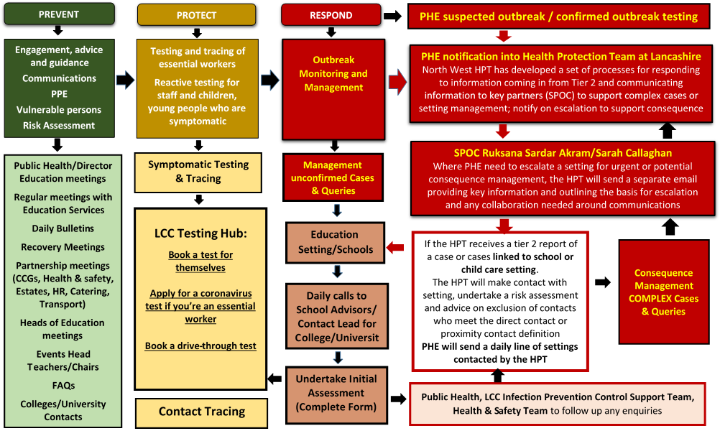

**Schools & Education Settings Strategic Outbreak Control Plan – Who is involved and Key Contacts**

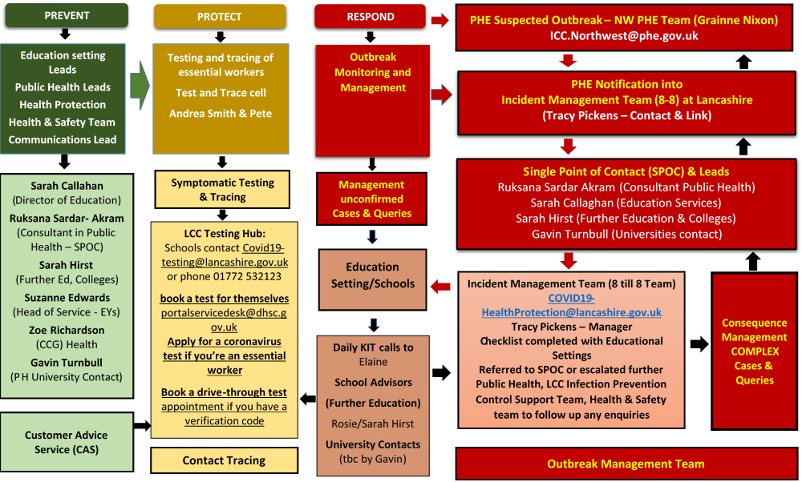

**A three step approach to managing Covid 19 in Education settings**

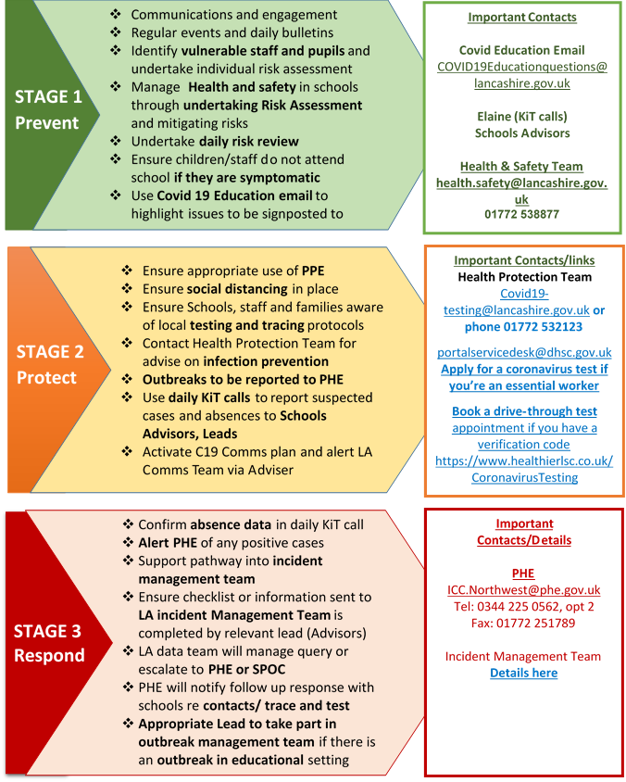

# Appendix 3 - Underserved groups and settings Outbreak Management Plan

|  |  |  |  |
| --- | --- | --- | --- |
|  | **Key Area** | **Action** | **Responsible Person(s)** |
| **PREVENT** | **Proactive Engagement, including advice and guidance** | 1. Conduct weekly call with commissioned services for situational data collection and relationship building to identify immediate need. May need to provide information and advice as required and log assistance given or required. 2. Providers invited to weekly webinar and follow up newsletter, providing timely advice and information from national, regional and local sources. 3. Reliable and robust sources of key information to be made available on the LCC website and to include national guidance on:   PHE North West Care Home Pack  [National PPE Guidance](https://www.gov.uk/government/publications/wuhan-novel-coronavirus-infection-prevention-and-control/updates-to-the-infection-prevention-and-control-guidance-for-covid-19)  [National Care Home Guidance](https://assets.publishing.service.gov.uk/government/uploads/system/uploads/attachment_data/file/878099/Admission_and_Care_of_Residents_during_COVID-19_Incident_in_a_Care_Home.pdf)  [Social Care Guidance](https://www.gov.uk/government/collections/coronavirus-covid-19-social-care-guidance)  Advise manager to refer to <https://www.gov.uk/government/publications/covid-19-stay-at-home-guidance> and <https://www.gov.uk/government/publications/covid-19-decontamination-in-non-healthcare-settings>  PHE Drug and alcohol guidance – new version on its way  Homelessness guidance - <https://www.gov.uk/government/publications/covid-19-guidance-on-services-for-people-experiencing-rough-sleeping>  Traveller site – TBC  Migrants / Asylum seekers  Underserved Population setting resources - have not yet been publically released. So referral to the general household information available for the principles of household isolation: [https://www.gov.uk/government/publications/covid-19-stay-at-home-guidance](https://www.gov.uk/government/publications/covid-19-stay-at-home-guidance%20%20%20)  Bespoke Care Provider Employee Wellbeing information available through Webinar information and LCC [Every Mind Matters](https://www.lancashire.gov.uk/health-and-social-care/your-health-and-wellbeing/mental-health/) | LCC PH leads |
| **Strategic Communications** | Ensure providers are kept informed through a variety of regular communications:   1. Communications from PHE HPT and PH care home supporting staff when outbreaks first occur. 2. Utilise existing relationships between PH commissioning leads and provider organisations, LCC leads re travellers and links with district housing teams. 3. Communications from the Strategic Commissioning Team both routine information and notices responding to specific issues. 4. Individual support/advice from IPC Training Staff and Quality Teams 5. Linking in across local authority boundaries such as LCC especially where shared providers are involved. | LRF?  LCC?  PHE  Partners?  Districts |
| **Intelligence Driven** | 1. Weekly SITREP reports from commissioned services 2. CQC 3. PHE 4. Testing data - TBC | Intelligence Cell |
| **PROTECT** | **Personal Protective Equipment (PPE)** | Settings to ensure appropriate use of PPE  Ensure social distancing in place and use of "bubbles".  Ensure that the settings are aware of national and local testing and tracing protocols  Contact the Health Protection Team for advice on infection prevention and cleaning protocols  Outbreaks to be reported to PHE / [Covid19-healthprotection@lancashire.gov.uk](mailto:Covid19-healthprotection@lancashire.gov.uk) | LCC / Settings |
| **Vulnerable and isolated persons (shielded and isolating)** | 1. **Support providers to maintain safe and healthy care services for their residents. This includes:-**  * Providing advice on IPC protocols measures, as necessary * Publishing regular guidance and advice to all providers, including guidance documents and video training for the correct use of PPE, in an attempt to clarify and simplify the myriad of guidance documents and changes to advice. * Delivering IPC Training to commissioned providers using a ‘train the trainer’ model, offered virtually. * Seeking assurance, using a competency-based approach, that all providers/units have cascaded the training to relevant staff members and that all staff are now competent in the three elements of the training:  PPE and IPC. * Detox and rehab providers advised on isolation of new entrants and safe travel between units (PHE and LCCPH input) * Delivery of digital/telephone services where possible to shielded/isolating persons. | Infection Prevention and Control Team (IPC) |
| **Testing and tracing of key workers** | * Symptomatic testing for essential workers can be accessed through pillar 2 testing protocols through the government regional testing sites and home-testing from the online portal. * Asymptomatic testing is not yet available and neither is whole settings testing. However, this is to be reviewed imminently. * Symptomatic testing is available for individuals through the government portals. Asymptomatic testing is not yet available but this is under local review. * The priority is to have preventative and reactive testing for staff teams, service users and individuals in complex settings / cohorts where there is a confirmed case, or multiple cases amongst the cohort. * A pathway for testing in complex settings to address people with higher vulnerabilities is being developed for non CQC settings * Homeless/rough sleeper communities can be tested via Pillar 1 testing capacity. | LCC Testing Hub  LSCFT (Central & BwD)  Blackpool CCG (Fylde & Wyre) |
| **RESPOND (incl consequence mgmt)** | **Cluster/Outbreak Monitoring** | Access to testing is through the LCC Testing Hub. The pathway, supported by Customer Access Service, escalates cases to the [covid-19-healthprotection@lancashire.gov.uk](mailto:covid-19-healthprotection@lancashire.gov.uk) rota team based on the PHE definition of a cluster:  LCC Incident Management Hub (rota team) will complete the Tier 1 checklist for supported living accommodation with the setting and inform the LCC Setting SPOC. A decision will then be made about whether to hold a multi-agency Incident Management Team (IMT) meeting and continue to identify consequence management actions.  Planning is ongoing to ensure that existing outbreak monitoring plans interface with the wider Test, Trace & Isolate system as this is developed | PHE suspected outbreak / confirmed outbreak testing |
| **Provider Failure:**  **Modelling and alternative accommodation options** | Robust provider failure plans to be developed |  |

|  |  |  |
| --- | --- | --- |
| COVID-19 Outbreak Management Tier 1 Checklist for Workplaces | | |
| **Actions for EH / HP Team** | | **Comments** |
| Date completed: | |  |
| Checklist completed by and which organisation: | |  |
| Local SPOC | |  |
| **Contact Details**  Name  Position  Number  Email  Address of the affected setting. | |  |
|  | |  |
| **Type of Workplace:**  Please tick:  Construction  Factories, plants and warehouse  Office and contact centres | Restaurants, pubs and cafe  Shops and retail  Others (please specify)………………………………………….  LA / HSE Enforced (please circle) | |
| **Use** <https://www.gov.uk/guidance/working-safely-during-coronavirus-covid-19> **for specific guidance for each type of workplace** | | |
| **Details of Staff**  Number of staff  Number of staff in the workplace at one time  Shift patterns / rota  Do you have agency staff and if so, obtain details of roles, frequency and numbers?  Are there regular visitors onsite?  Do staff working across different sites / branches – for example across two or three branches of a fast food chain  Is there a car sharing scheme in place for staff?  Is the building open to the public and if so, please add more info about numbers, frequency etc | |  |
| **Size and Layout of Workplace** (ask them to describe and see if plans are available)  (Including number of rooms, workspace areas (?2m apart), number floors, sharing with different businesses, details of toilet/bathroom facilities, communal areas, canteen, details of handwashing facilities, etc).  Ventilation arrangements – are air conditioning units in place? | |  |
| **Risk Assessment**  Is a Covid19 secure risk assessment available? Copy requested and ask to email immediately (see template) | |  |
| **Details of the Current Outbreak:**  **Do not disclose cases details unless case has agreed in T2 checklist.**   * Number of cases * Date of onset in first case * Date of onset in most recent case * Last day in the office/work setting for cases * Nature of symptoms and severity * Any tests already done - obtain case details to f/u results * Any cases required admission to hospital * Number of staff already confirmed * Number of staff currently in isolation/shielding | | Use table to record |
| **Past Outbreaks**   * Number of past outbreaks * Dates (start date) * Number of staff affected | |  |
| **Action taken to date?**  **Deep clean?**  **Communication with employees?**  **Still open / trading?** | |  |
| **Meetings and Workspace – Identifying potential contact risks** What social distancing measure are in place? Are they being followed?   * Do employees attend any ‘in person’ meetings? * Workstations/area -? hot desking, ?2m apart * Is PPE being worn (depending on type of work will depend if needed – see link below to specific workplace). * Are there communal areas? (kitchen, canteen etc)   <https://www.gov.uk/guidance/working-safely-during-coronavirus-covid-19>  Advise what a workplace contact is and follow up action (if not already completed) see below | |  |
| **If case has agreed to disclose details to employer –**   * identify possible contacts * Identify contacts they share a workspace * Identify contacts they attended meetings * Identify and other at risk employee | | Use table to record |
| **Definition of workplace contact**   * **Direct close contacts**: Direct face to face to face contact with a case for any length of time, including being coughed on or talked to.  This will also include exposure within 1 metre for 1 minute or longer * **Proximity contacts**: Extended close contact (within 1-2m for more than 15 minutes) with a case * **Travelled in a small vehicle with a case**   **Advice**  Workplace contacts are advised to self-isolate for 14 days. This group will not be offered testing unless symptomatic. If symptomatic staff may be advised to arrange test via the portal.  Contacts who are symptomatic to self-isolate and get tested. We will need contact case details for contact tracing.  Household contacts of contacts do not need to self-isolate. | | |
| **Cleaning** - after person with suspected COVID has left the workplace   * Clean area/room/desk space with usual detergent and disinfectant (Check disinfectant is effective against viruses) after someone with suspected COVID-19 has left the area to reduce the risk of transmission * Use appropriate PPE i.e. gloves and apron when cleaning * Use disposable cloth, clean hard surfaces with soap/detergent and water. Disinfect hard surfaces with normal cleaning products paying attention to door handles, tables, chairs, rails etc * If there are body fluid spillages, use full PPE protection for eyes, nose and mouth along with aprons and gloves   See guidance for COVID-19: cleaning in non-healthcare settings <https://www.gov.uk/government/publications/covid-19-decontamination-in-non-healthcare-settings>  **Advice about disinfection**  Disinfectants that comply with the standard known as BS EN 14476 are the ones that will be effective against viruses within the “coronavirus” family. If you are struggling to get hold of cleaning products that are compliant with BS EN 14476, thick bleach when used at a strength of 1000ppm can be used to kill traces of the virus lingering on surfaces. To work out how to dilute a bleach product to the required strength, you can use the dilution calculator at the following web link: <https://grimedoesntpay.com/bleach-dilution-calculator/>. Combine the required amount of water in a spray bottle with the required amount of bleach, mix well and use to disinfectant surfaces.  The World Health Organisation have reported that products based on hydrogen peroxide, peracetic acid or sodium hypochlorite (bleach) are all effective against the coronavirus “family” as are solutions containing greater than 70% alcohol when used at the right dilution and correctly. | | |
| **IPC Advice for Workplace** | | Comments |
| Link to specific workplace guidelines:  <https://www.gov.uk/guidance/working-safely-during-coronavirus-covid-19> | | |
| **Hand Hygiene**  Reinforce education [about hand and respiratory hygiene](https://www.gov.uk/government/news/public-information-campaign-focuses-on-handwashing) and display [posters](https://campaignresources.phe.gov.uk/resources/campaigns/34/resources/2665) widely. Ensure infection control policies are up to date, read and followed by all staff. | |  |
| **Facilities**  Ensure liquid soap and disposable paper towels are available at each wash hand basin and sink, and alcohol-based hand rub (at least 70%) is in every bathroom and communal and work areas, and stocks are adequately maintained.  Minimise need to touch hand contact points throughout workplace routes e.g. prop doors open wherever safe and possible. | |  |
| **Personal Protective Equipment (PPE)**  For most workplaces it is generally not advised however check specific advice for work categories (PPE section). If workplace wants to use PPE a RA must be done to decide if it is needed.  If the RA deems it necessary, it must be provided free to workers and fit properly.  <https://www.gov.uk/guidance/working-safely-during-coronavirus-covid-19>  If facemasks are being used discuss the need for proper hand hygiene, avoid touching face, change when they become damaged or wet and wearing them correctly (covering nose and mouth). Highlight social distancing and proper hand hygiene is still needed. | |  |
| **Social Distancing**  Give advice on social distancing, enhanced cleaning and exclusion (self-isolation)   * Where possible abide by social distancing advice – 2m apart * Clean workspace when you arrive for work and on leaving * Where possible have virtual meetings or organise meetings in rooms where social distancing measures can be followed * All symptomatic staff should be excluded from the workplace for at least 7 days and until they are asymptomatic. * Publicising clear respiratory hygiene measures within the workplace such as regular handwashing and “Catch It, Bin It, Kill It” and hand hygiene * Enhanced cleaning (increased regularity and focus on handles and surfaces   See guidance for COVID-19: infection control: <https://www.gov.uk/government/publications/wuhan-novel-coronavirus-infection-prevention-and-control> | |  |
| **Environmental cleaning**  Cleaning company aware of outbreak?  Heightened environmental cleaning of surfaces, desk spaces and high touch areas frequently. *(paying particular attention to frequently touched surfaces, e.g. door handles, lift buttons, taps, communal equipment – such as kettles, toilet handles, light switches, etc.).*  **See guidance for COVID-19: cleaning in non-healthcare settings** <https://www.gov.uk/government/publications/covid-19-decontamination-in-non-healthcare-settings> | |  |
| **Ventilation Systems – best practice**  **See:** <https://www.rehva.eu/fileadmin/user_upload/REHVA_COVID-19_guidance_document_ver2_20200403_1.pdf>  Recommendations of practical measurers to reduce risks to as low as is reasonably achievable would include:   1. Secure ventilation of spaces with outdoor air - also consider pest egress (you may need to pest screen the windows.) 2. Switch ventilation to nominal speed at least 2 hours before the building usage time and switch to lower speed 2 hours after the building usage time 3. At nights and weekends, do not switch ventilation off, but keep systems running at lower speed 4. Ensure regular airing with windows (even in mechanically ventilated buildings) 5. Keep toilet mechanical ventilation 24/7 in operation 6. Avoid open windows in toilets to assure the right direction of ventilation 7. Instruct building occupants to flush toilets with the toilet lid closed 8. Switch air handling units with recirculation to 100% outdoor air 9. Inspect heat recovery equipment to be sure that leakages are under control 10. Switch fan coils either off or operate so that fans are continuously on 11. Do not change heating, cooling and possible humidification setpoints 12. Do not plan duct cleaning for this period 13. Replace central outdoor air and extract air filters as usually, according to maintenance schedule 14. Regular filter replacement and maintenance works shall be performed with common protective measures including respiratory protection Increase natural ventilation | |  |

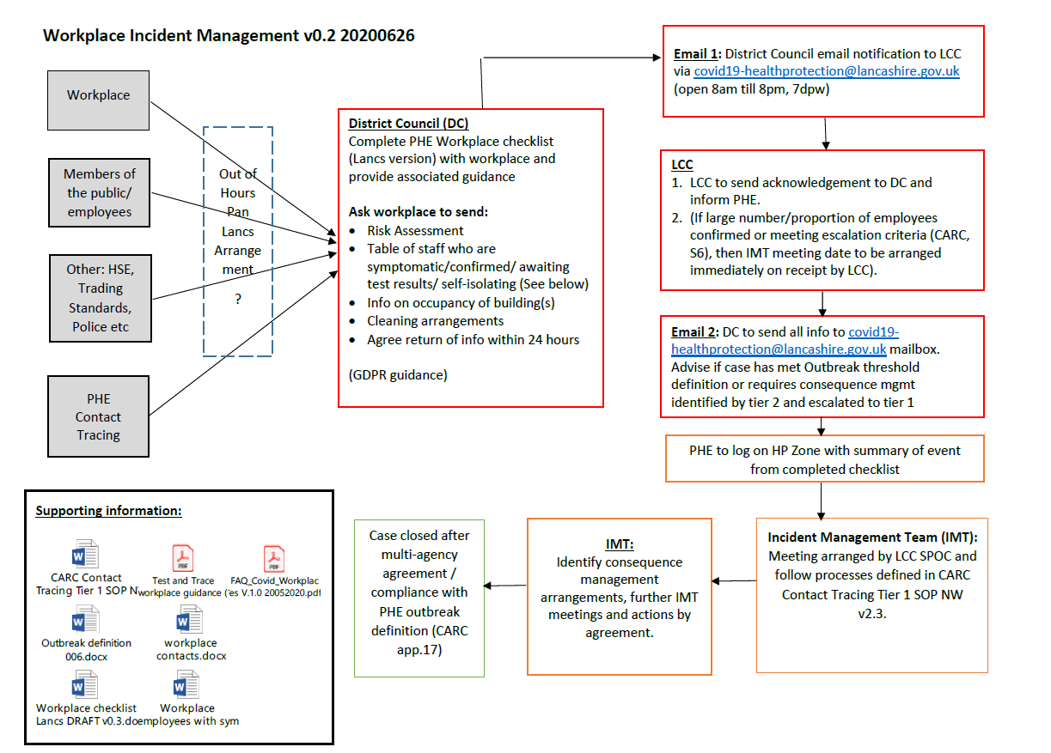

# Appendix 4 – SOPs



# Appendix 5 – Template Agenda for OCT meetings

[INSERT TITLE OF OUTBREAK] Outbreak Control Team Meeting to be held on [INSERT DATE (including year), TIME & VENUE] AGENDA

1. Introductions

2. Apologies

3. Minutes of previous meeting (for subsequent meetings)

4. Purpose of Meeting (FIRST MEETING)

* Agree Chair
* Agree Terms of Reference
* Agree Ownership of Outbreak Report

1. Review of Evidence

* Epidemiological
* Microbiological
* Environmental

1. Current Risk Assessment

* Escalation considerations

7. Control Measures

8. Further Investigations

* Epidemiological
* Microbiological
* Environmental

9. Communications

* Public
* Media
* Healthcare providers (e.g. GPs, A&E, etc.)
* Wider LRF
* Others

10. Agreed Actions

11. Any other business

12. Next Meeting

# Appendix 6 – LCC HPB Escalation and System Architecture

**The process flow from Tier 2 (PBCT) to Tier 1 (SPOC PHE).**

* Tier 2 Call Handler identifies issue that meets the criteria or otherwise requires further investigation or management.
* Tier 2 Call Handler liaises with Tier 2 Team Lead.
* Tier 2 Team Lead assesses and determines if escalation required.
* If escalation required, contact Tier 1 Team Lead for relevant area.

**The criteria for Tier 2 to declare a complex or high risk setting and pass to Tier 1:**

1. **Cases where liaison with an educational/childcare setting or employer may be required.**

* Cases who have attended educational/childcare setting while infectious
* Cases who have attended work while infectious and who are unable to identify their contacts who will require follow up

1. **Complex setting or settings potentially requiring consequence management.**

* Case living or working in care home/long-term care facility or other care facility for those with complex needs
* Cases in Healthcare workers
* Cases in Emergency Services workers
* Cases in Border Force and Immigration Officers
* Cases who attended healthcare for non COVID reasons
* Cases in those living or working in prison or other places of detention
* Cases in those attending or working in special schools
* Cases in those living in homeless hostels or shelters or refuges and similar residential settings
* Cases attending day-care centres for older/vulnerable people
* Cases with concerns about deductive disclosure
* Cases where contacts can’t be identified without disclosure of name to employer or other third party
* Cases or employers unwilling to provide information

1. **Consequence management scenarios.**

* Identified impact on local public sector services or critical national infrastructure (e.g. power plants) due to high proportion of staff quarantining (e.g. school that informs Tier 2 that will have to close as all staff quarantining)
* Cases or contacts who are unable to comply with restrictions (homeless, complex social issues etc.)
* Likely Media or political concerns/interest

1. **Increase in disease frequency or severity.**

* Second or subsequent cases in school class (small number of children taught together).
* Reported high absenteeism rate in school or workplace.
* Reported high levels of hospitalisations

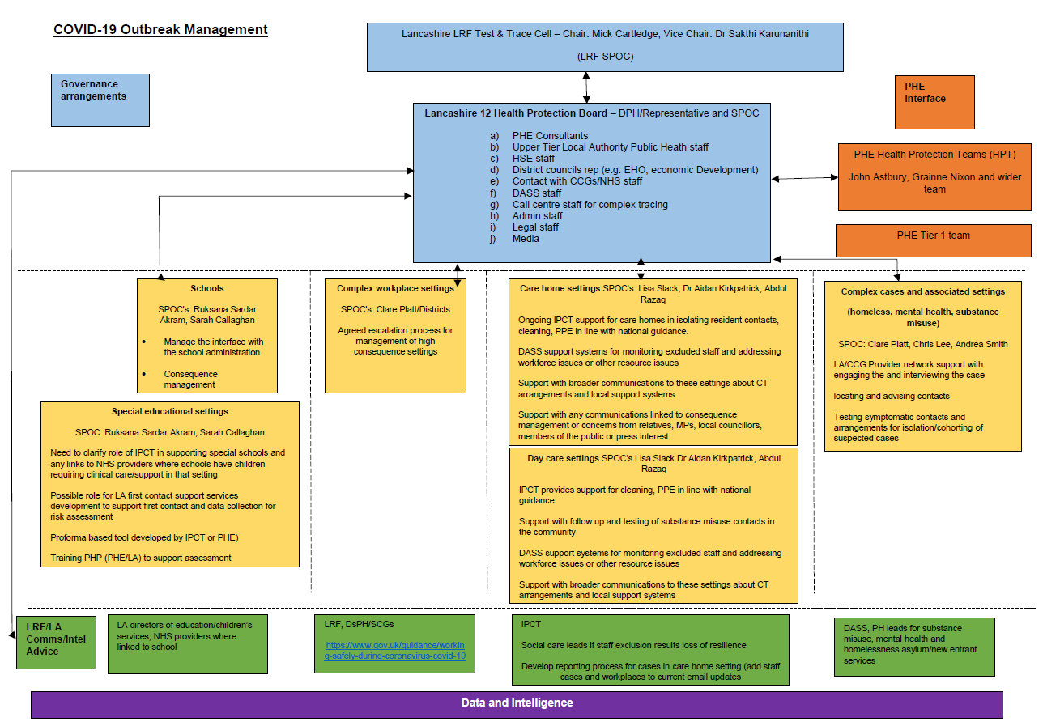

# Appendix 7 – Health Protection Board Terms of Reference

**Lancashire 12 COVID-19 Health Protection Board - Terms of Reference**

|  |
| --- |
| 1. **Purpose**   As Level 1 Response is clearly the responsibility of local systems, the primary focus must be under the control of the respective Directors of Public Health within the Upper Tier Local Authorities to coordinate the respective details of Outbreak Control Plans.  The Lancashire 12 COVID-19 Health Protection Board will be responsible for preventing and managing outbreaks in key settings, including conducting a timely initial risk assessment following an initial positive result and deploying teams to complex cases and outbreaks.   1. **Chairing Arrangements**   The Lancashire 12 COVID-19 Health Protection Board will be chaired by the DPH/Representative supported by a SPOC.   1. **Prevention**   Understanding distribution of cases and identifying hotspots from various sources of intelligence  Coordinating proactive infection prevention and control programme including advice and where necessary regulatory actions  Undertake any communication campaigns as necessary     1. **Outbreak and Complex Case Management**   The Lancashire 12 COVID-19 Health Protection Board will oversee three main areas of activity:   1. **Complex and high-risk settings** 2. Case living or working in care home/long term care facility or other care facility for those with complex needs. 3. Cases in Healthcare workers. 4. Cases in Emergency Services workers. 5. Cases in Border Force and Immigration officers. 6. Cases who attended healthcare for non COVID reasons. 7. Cases in those living or working in Prison or other places of detention. 8. Cases in those attending or working in special schools. 9. Cases in those living in homeless hostels or shelters or refuges and similar residential settings. 10. Cases attending day care centres for older/vulnerable people. 11. Cases with concerns about deductive disclosure. 12. Cases where contacts cannot be identified without disclosure of name to employer or other third party. 13. Cases or employers unwilling to provide information. 14. **Consequence management** 15. Identified impact on local public sector services or critical national infrastructure (eg power plants) due to high proportion of staff quarantining (eg school that informs tier 2 that will have to close as all staff quarantining). 16. Cases or contacts who are unable to comply with restrictions (homeless, complex social issues etc). 17. Likely Media or political concerns/interest eg death in child. 18. **Increase in disease frequency or severity** 19. Second or subsequent cases in school class (small number of children taught together). 20. Reported high absenteeism rate in school or workplace. 21. Reported high levels of hospitalisations. |
| 1. **Membership** 2. PHE Consultants 3. Upper Tier Local Authority Public Heath staff 4. HSE staff 5. District councils rep (e.g. EHO, economic Development) 6. Contact with CCGs/NHS staff 7. DASS staff 8. Call centre staff for complex tracing 9. Admin staff 10. Legal staff 11. Media |
| 1. **Meeting arrangements**   The Lancashire 12 COVID-19 Health Protection Board will meet initially on a daily basis. An action log with named leads will be produced and kept up to date at each meeting. |
| 1. **Governance review arrangements**   As a minimum, this board will report to the LRF wide test and trace cell, Local outbreak engagement board and health and wellbeing board. The governance arrangements for this The Lancashire 12 COVID-19 Health Protection Board will be reviewed on a monthly basis.  Interdependencies  This hub will depend on the all LRF structures and in particular testing and tracing cell, and the joint intelligence and planning cell. |

# Appendix 8 - Local Outbreak Engagement Board

**Terms of Reference**

The Board will be a Working group of the Lancashire Health and Wellbeing Board and has the following terms of reference

**Membership**

Membership shall consist of the County and District Council members of the Lancashire Health and Wellbeing Board, as follows:

* + The Cabinet Member for Health & Wellbeing, LCC (Chair)
  + 3 LCC members to be nominated by the Conservative Group
  + Three District Councillors (one from each of the sub areas of Lancashire, to be nominated by the Lancashire Leaders Group)
  + The Spokesperson for Adult Social Care from the main opposition group on the County Council

Administrative support for meetings will be provided by Lancashire County Council

**Frequency of Meetings**

Meetings will be held monthly, or as required.

**Functions**

* Undertake the roles and functions of a COVID19 Local Outbreak Engagement Board in line with regulations or guidance issued by government or relevant bodies
* Provide political ownership and public facing engagement and communication for an outbreak response
* Create appropriate arrangements for the full engagement of elected politicians (including MPs, county and district councillors) in local outbreaks, including the development of a communications protocol for the sharing of information with elected representatives at all levels and the public.
* To report activities to the Health and Wellbeing Board on an exception basis

**Quoracy, Decisions and Voting**

Quoracy – 3 members, including at least 1 county councillor and one district councillor

It is intended that decisions are reached by consensus. Where required, voting is by a show of hands. The Chair carries a second or casting vote.

# Appendix 9 – Testing Pathways

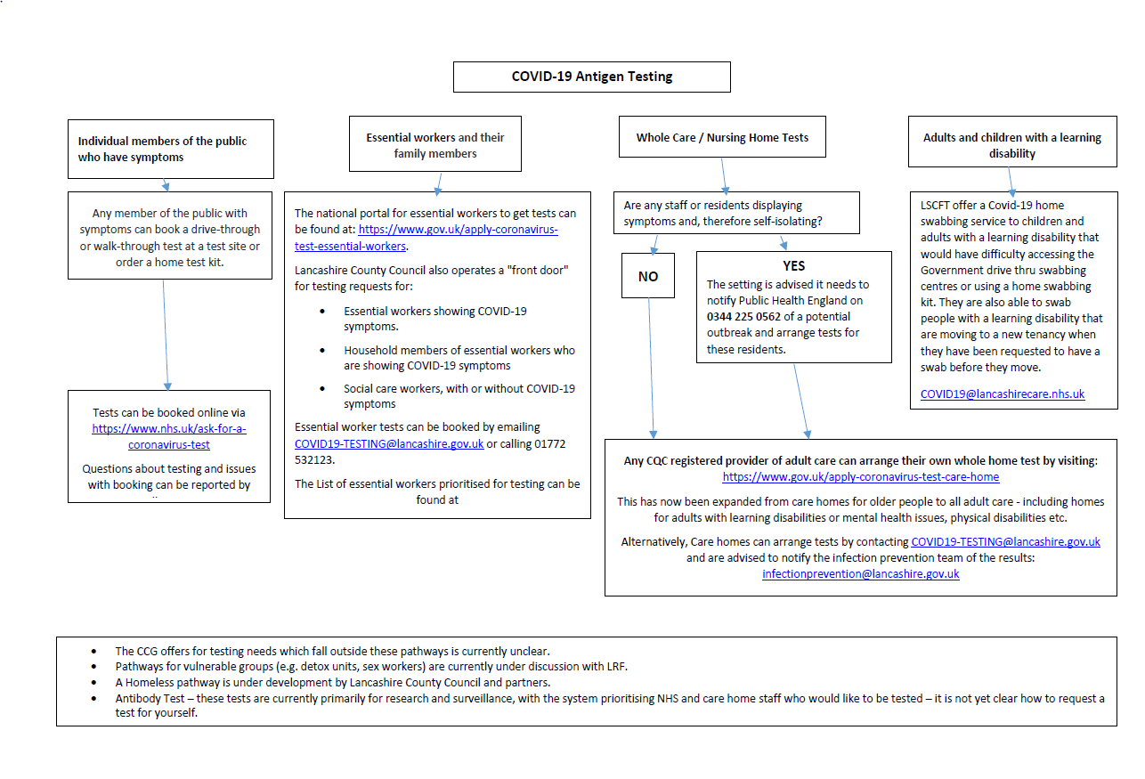



1. Subject to change as the service transitions to an on-call rota