London Eye Health Network

XXXXX London

Eye health and sight loss pathways and

ophthalmic referral guidance

Pathways

1 Emergency Eye Care (same day) 2
2 Urgent Ophthalmology Referrals 3
3 Suspect Wet AMD Pathway 4
4 Routine Ophthalmology Referrals 5
5 Minor Eye Conditions 5
6 School Vision Screening 7
7 SEL Diabetic Eye Screening 8
8 Cataract Pathway 9
9 Glaucoma Pathway 10
10 Low Vision, ECLO and Rehabilitation Pathway 11
11 Vision and Falls 13
12 Patient Information and Contacts Sheet 14

These pathway notes have been devised for general GUIDANCE only. They do not remove from practitioners their professional responsibility to each patient, who should all be dealt with on an individual basis.

PATIENTS WHO ARE MONOCULAR OR HAVE OTHER RISK FACTORS
MAY CONSTITUTE A HIGHER RISK

1 Emergency Eye Care (same day)

Resources

NICE: Age-related macular degeneration NG82 - 2018
https://www.nice.org.uk/guidance/ng82

Clinical Knowledge Summaries
https://cks.nice.org.uk/clinicalspeciality#?speciality=Eyes

CCEHC: Primary Eye Care Framework (2018): www.ccehc.org.uk (includes LOCSU pathways)

RCOphth: The Way Forward - Emergency Eye Care 2017

https://www.rcophth.ac.uk/wp-content/uploads/2015/10/RCOphth-The-Way-Forward-Emergency-Eye-Care-300117.pdf

https://www.rcophth.ac.uk/wp-content/uploads/2015/10/RCOphth-The-Way-Forward-Emergency-Eye-Care-Summary-300117.pdf

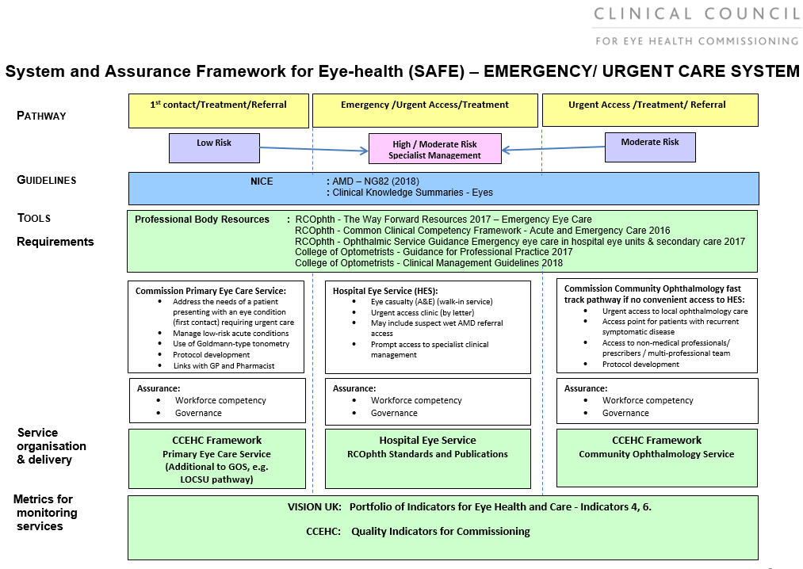

What is an eye emergency? Examples include:
- Chemical injury to eye or lids (acid or alkali)
- An injury involving severe trauma or penetrating injury to the eye ball, lids or socket. by severe traumatic injury or retrobulbar bleed
- Sudden onset of painful eye with severe reduction or loss of vision blind or painful eye which causes sickness and general malaise (e.g. acute glaucoma, severe uveitis, blebitis).
- After an eye operation, an unexpectedly painful, red, or swollen eye with reduced vision (e.g. endophthalmitis, severe post-operative uveitis).
- Patients with any eye symptoms following corneal graft surgery (graft rejection)
- Recent onset of shadows or ‘curtaining’ in the field of vision, typically associated with flashing lights or an increase in seeing floaters (retinal tear/ detachment).
- Sudden onset of red and painful eye, particularly if associated with wearing contact lenses (e.g. corneal ulcer with/without hypopyon).
- Sudden loss of vision with no other symptoms (e.g. retinal/ optic nerve vascular or inflammatory event).
- A swollen, painful, red eye with blurred or double vision and malaise, especially in a child (orbital cellulitis).
- Ptosis, headache and diplopia – (third nerve palsy posterior communicating artery aneurysm).
- Headache +/- loss of vision – (e.g. giant cell arteritis).

In XXXXXXX London, Emergency Eye Care can be accessed at:

- XXXXXXXXX Eye Rapid Access Service

Opening times:

Contact details:

- XXXXXX Eye Referral Service

Opening times:

Contact details:

- XXXXXX Eye Referral Service

Opening times:

Contact details:

2 Urgent Ophthalmology Referrals

What constitutes an urgent referral varies considerably between practitioners as well as the time expected for patients to be seen. This could vary from 2-6 weeks depending on the condition (decisions are based on the assessment of the referral letter content). Where there is a level of urgency, referral letters must include a detailed history and full clinical findings to support the case to be seen more urgently.

Suspect Wet AMD: use the NICE 2-week referral pathway (section 3).

What is an urgent referral and waiting time?

- Persistent floaters or photopsia with no visible break
- Vitreous haemorrhage in a non-diabetic patient;
- Elevated IOP in eye with narrow van Herick but normal pupil and clear cornea
- Severe or chronic conjunctivitis
- Child with consistent white pupil reflex (retinoblastoma) – ‘urgent <1/52’ rather than ‘emergency.
- Another example
- Another example

GPs and MECS Optoms should refer to SPA via e-RS and classify the referral as urgent and fully state the reasons why it is urgent.

Non MECS practices with NHS.mail, should use the email for each site.

Non MECS Optoms and not on NHS.mail can only refer via eye emergency referral clinic or via the GP. State reasons for urgency, but anything less than 4 weeks may not be achievable via the GP.

- XXXXXXXXXXXX

By NHS Secure email

- XXXXXXXXXXXX

By NHS Secure email

- XXXXXXXXXXXX

By NHS secure email:

3 Suspect Wet AMD Pathway

Resources

NICE: Age-related macular degeneration NG82 - 2018
https://www.nice.org.uk/guidance/ng82

Depression in adults with a chronic physical health problem: recognition and management - CG91- 2009.
https://www.nice.org.uk/guidance/cg91

CCEHC: NICE Guideline Implementation Template - 2018 www.ccehc.org.uk

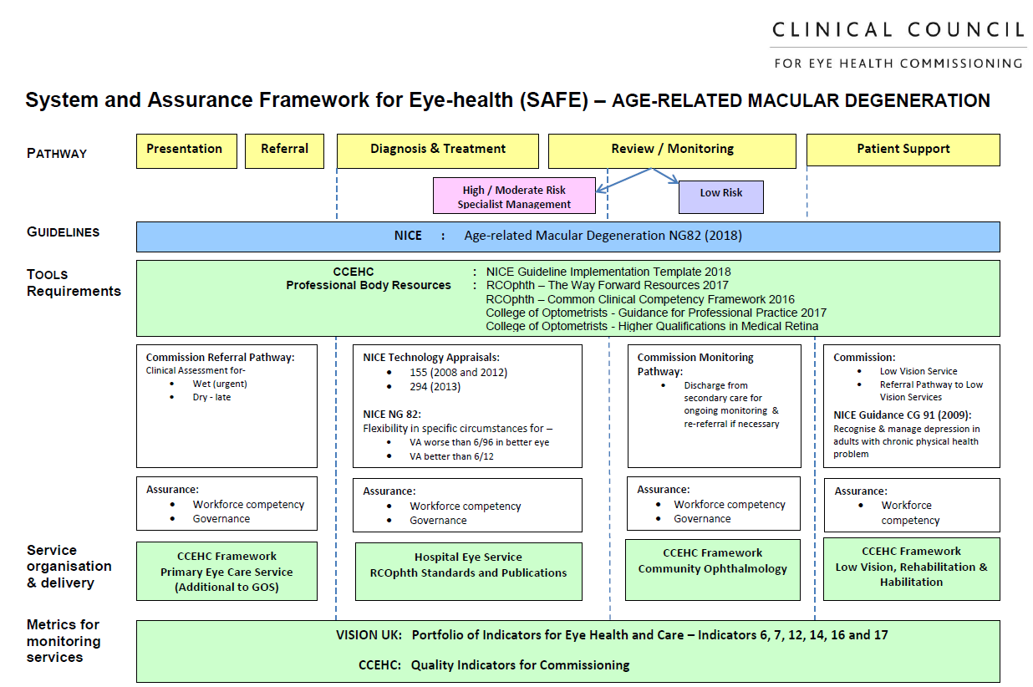

NICE AMD guidance 1.4.3. Do not refer people with asymptomatic early AMD to hospital eye services for further diagnostic tests.

Referral options:

- XXXXXXXXXXXX

Refer on e-Referrals marked as urgent or b) use protocols for sending urgent

Fax:
Queries: Tel 020 XXXX XXXX.
By NHS Secure Email:

- XXXXXXXXXXXX

Fax:
Queries: Tel 020 XXXX XXXX.
By NHS Secure Email:
- Routine Ophthalmology Referrals

- XXXXXXXXXX Trust

- XXXXXXXXXX Trust

- XXXXXXXXXX Trust

- Other ophthalmology sites offered by choice
- GPs should refer routinely via e-RS.

- MECS Optometrists should refer routinely via e-RS

- Non-MECS optometrists on NHS net should email to the referral triage hub SPA

- Non-MECS optometrists not on NHS net should send to GP to put on e-RS for triage (SPA)

5 Minor Eye Conditions

CCEHC: Primary Eye Care Framework (CCEHC 2018): www.ccehc.org.uk (includes LOCSU pathways)

Eye conditions that can be seen under MECS

- Sudden or recent reduction or distortion of vision in one or both eyes
- Recent onset or sudden increase in floaters and /or flashes in one or both eyes
- Red eye(s) or red lids
- Pain and /or discomfort in the eyes, around the eye area or temples
- Swelling, itching or irritation of lids or conjunctiva
- Mild trauma e.g. scratched cornea
- Suspected foreign body in the eye or in turning eye lashes
- Significant recent discharge from or watering of the eye
- Recent onset double vision

Website:

CCG | Pre-referral options | e-Referral single point of access | MECS Practices
CCG | MECS  Glaucoma filtering  Cataract refinement. | Yes
CCG | MECS  Glaucoma filtering  Cataract refinement | Yes
CCG | MECS  Glaucoma filtering  Cataract refinement | Yes
CCG | MECS  Glaucoma filtering  Cataract refinement | Yes
CCG | MECS  Glaucoma filtering  Cataract refinement | No
CCG | MECS  Glaucoma filtering  Cataract refinement | Yes

6 School Vision Screening

Indicators: Eye Indicator 1: % of school entry children (4-5yrs) having vision screened.

School vision screening (for 4-5-year old’s) is commissioned by Local Authorities. Resultant referral pathways usually involve assessment provided by multi-professional team of orthoptists, optometrists and ophthalmologists.

Local  Authority | School vision screening model | Referral criteria | Referral pathway
 | Public health HCA vision screeners  Thompson software | <0.200 either eye
 |  | <0.450
 | Nursery nurse vision screeners.  Keeler crowded logMAR | < 0.200
 | School nurses  Thompson software | <0.200
 | Orthoptists | VA less than 0.2 EE or unable to test secondary screening
 | No school vision screening
 | Orthoptic technician (trained by orthoptist) | <0.2 in either eye or unable to test

7 SEL Diabetic Eye Screening

Eye Indicator 2i: Proportion of those offered diabetic eye screening who attend a digital screening event (all ages). DES-PS-7
Eye Indicator 2ii: % children and young people aged 12-24 years diagnosed with diabetes that are screened.
Eye Indicator 9: % of R3A M0 and R3A M1 Diabetic Eye Disease seen within 6 weeks of screening event. DES-PS-12

The XXXXXX London Diabetic Eye Screening Programme is provided by XXXXXXXXXX NHS Trust in XX clinic sites across XXXXXXX London. Administration is managed centrally at XXXX, clinics are as follows and include Saturday opening:

Borough | Screening locations

Contact details: Administration Team for all queries: Email: or Tel:
Programme Manager:

All patients who are diagnosed with diabetes and registered with a GP in XXXXX London will be automatically referred to the programme, direct from the GP electronic systems.

Patients with diabetes should attend for annual screening unless they are already under the care of an ophthalmologist for diabetic eye disease. If referable diabetic retinopathy is detected at screening, the programme will refer on to the nearest hospital eye service and follow up the patient to ensure they are seen and remain in care or return to screening.

If patients state they have not attended screening, they should be encouraged to attend and the contact details for the programme given if needed. All patients are automatically sent 3 invites (2 fixed appointments and an invitation letter) each year if they do not attend but can contact the programme any time if they are overdue for screening to arrange another appointment. If there is a reason why the patient has not attended, or they have not received any invitations it is extremely helpful to pass this information onto the programme office so adjustments or investigations can be made.

If any referable sight threatening diabetic eye disease is detected at a sight test, please contact the programme to first check if the patient has recently had screening and if they are already under care of an ophthalmology service; the programme will reply to you promptly and arrange for screening and onward referral if grading finds this necessary.

By notifying the programme to make the referral if necessary, this ensures that the patient is followed up to ensure they attend and reduces unnecessary referrals.

The diabetic eye screening test is only for diabetic eye disease and patient are reminded to attend their opticians/optometrist for 2 yearly sight tests, unless advised differently by their optometrist.

Equally, optometrists should ensure patients are aware that attending for a sight test does not replace the need for attending the diabetic eye screening appointment and vice versa.

8 Cataract Pathway

Resources

NICE Cataract – NG 77.- 2017.
https://www.nice.org.uk/guidance/ng77/evidence/full-guideline-pdf-4655997901
https://www.nice.org.uk/guidance/ng77/resources

RCOphth Cataract Commissioning Guidance 2018 – NICE accredited
https://www.rcophth.ac.uk/wp-content/uploads/2018/02/Cataract-Commissioning-Guide-January-2018.pdf

CCEHC: NICE Guideline Implementation Template - 2018 www.ccehc.org.uk

Primary Eye Care Framework (CCEHC 2018): www.ccehc.org.uk (includes LOCSU pathways)

Eye Indicator 5: Cataract Referral Pathway commissioned.
Eye Indicator 8: Visual Acuity outcomes of Cataract Surgery: (i) Visual acuity at time of surgery (pre-operative); (ii) Visual acuity at 4-6 weeks post-operative assessment
Eye Indicator 15: Post-op Cataract Pathway commissioned and provided within the Hospital Eye Service, Community or both.

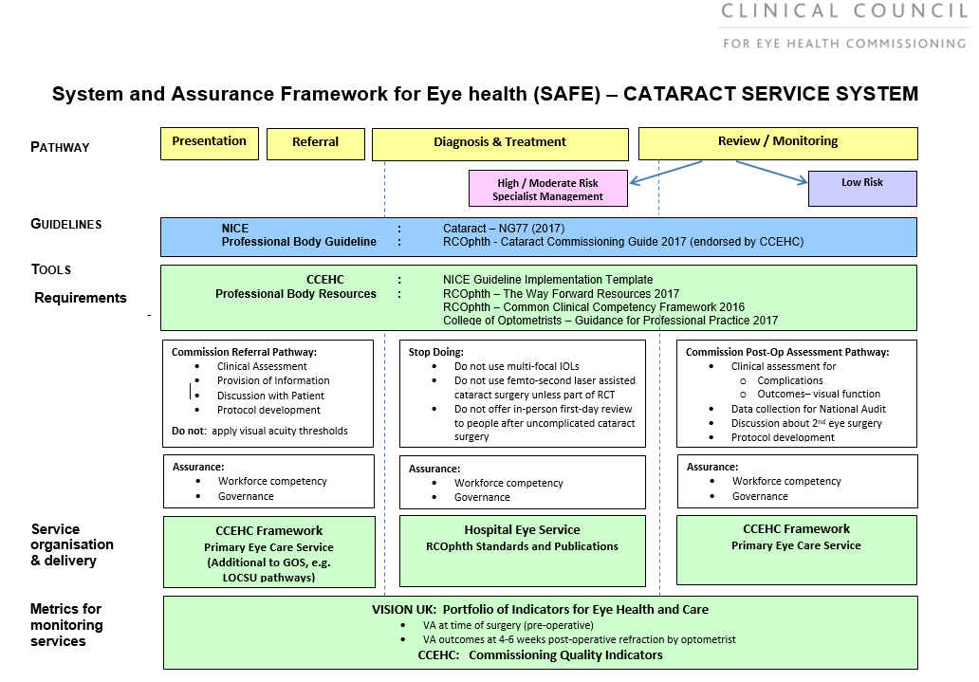

Patients with Cataract should not be referred unless they are having significant visual symptoms, and want surgery.

If a patient is found to have other significant ocular or systemic pathology, this should be highlighted on the referral form. The assessment enables discussion of cataract surgery with the patient and explanation of the risks involved. This can then be weighed up by the patient and they can decide whether or not they wish to be referred for surgery depending on their degree of visual difficulty and their attitude to the surgery.

Patients with some cataract present, but symptoms not being caused by the cataract should be examined (and referred for other co-morbidity if necessary) in the normal way. Patients should only receive an assessment if a decision to refer is being considered and then should only be referred following assessment if they are:

• symptomatic of cataract
AND
• have some impairment of lifestyle (typically involving a reduction in visual acuity) AND
• willing to have surgery (following counseling and discussion with the optometrist).

Draft London Choosing Wisely Cataract Referral Guidance (2018).

- Patient has a best corrected VA of 6/9 or worse in the first or second eye AND
- Patient has impairment in lifestyle such as substantial effect on activities of daily living, leisure activities, and risk of falls.

All patients should be given the opportunity to engage with shared decision making at each point in the pathway to cataract surgery to ensure they are well informed about the treatment options available and personal values, preferences and circumstances are taken into consideration.

Surgery is also indicated for management of cataract with co-existing ocular comorbidities:
- Conditions where cataract may hinder disease management or monitoring, including diabetic and other retinopathies including retinal vein occlusion, and age-related macular degeneration; neuro-ophthalmological conditions (e.g. visual field changes); or getting an adequate view of fundus during diabetic retinopathy screening
- Oculoplastics disorders where fellow eye requires closure as part of eyelid reconstruction
- Corneal disease where early cataract removal would reduce the chance of losing corneal complications (e.g. Fuch's corneal dystrophy or after keratoplasty)
- Corneal or conjunctival disease where delays might increase the risk of complications (e.g. cicatrising conjunctivitis)
- Severe anisometropia in patients who wear glasses
- Posterior subcapsular cataracts

Develop cataract post op assessment linked to capture of refraction and VA data for national ophthalmology cataract database audit.

9 Glaucoma Pathway

NICE: Glaucoma guidance - NG 81 - 2017.
https://www.nice.org.uk/guidance/ng81/evidence/full-guideline-pdf-4660991389
https://www.nice.org.uk/guidance/ng81/resources

Depression in adults with a chronic physical health problem: recognition and management - CG91 - 2009.
https://www.nice.org.uk/guidance/cg91

RCOphth: Glaucoma Commissioning Guidance – 2016 – NICE accredited.
https://www.rcophth.ac.uk/wp-content/uploads/2016/06/Glaucoma-Commissioning-Guide-Long-June-2016-Final.pdf

CCEHC: NICE Guideline Implementation Template - 2018 www.ccehc.org.uk

Primary Eye Care Framework (CCEHC 2018): www.ccehc.org.uk (includes LOCSU pathways)

Indicators:

Eye Indicator 4i: Number (and %) of CCGs in England (or by defined commissioning body in devolved nations) procuring a Glaucoma Referral Filtering Pathway for (a) repeat measurement service or (b) enhanced case finding service.
Eye Indicator 4ii: Number (and %) of participating practices in Glaucoma Referral Filtering Pathways for (a) repeat measurement and / or (b) enhanced case finding; by CCG (in England); or by defined commissioning body in devolved nations.

Eye Indicator 13: Monitoring Pathway commissioned for low risk or stable OHT and suspect COAG.

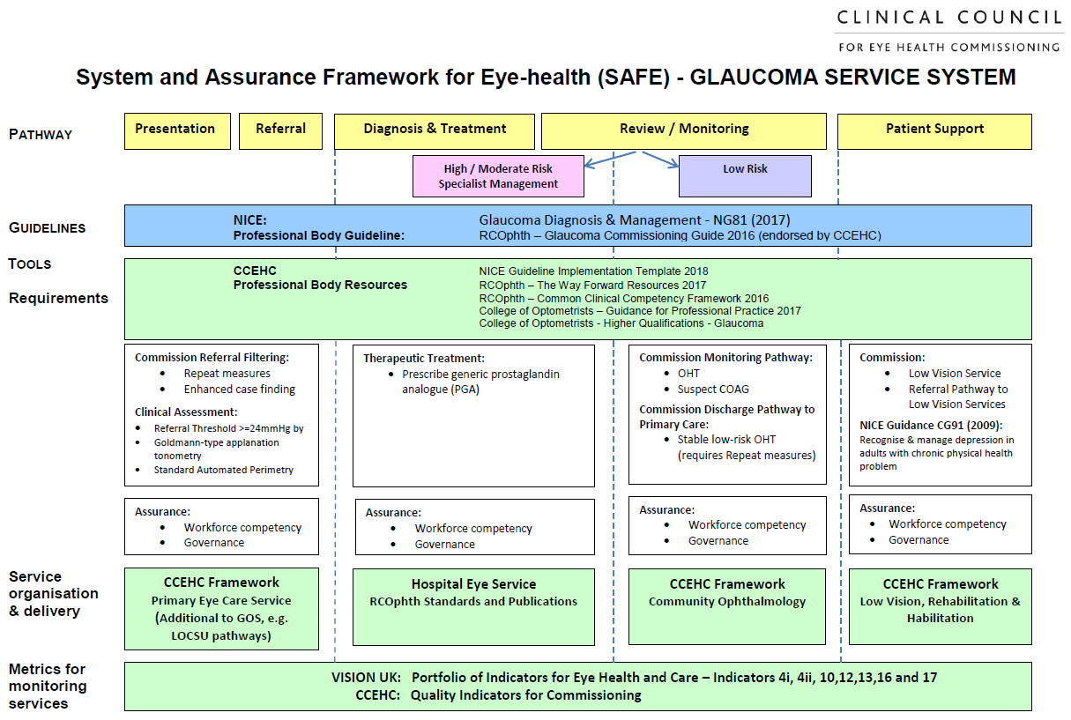

Acute glaucoma should be referred same day direct to eye emergency referral clinic.

Add local guidance and pathway: Glaucoma repeat measures are part of the MECS contract.

The following NICE recommendations on case-finding are for primary eye care professionals before referral for diagnosis of chronic open angle glaucoma (COAG) and related conditions, and are separate from a sight test.

1.1.1 Before referral for further investigation and diagnosis of COAG and related conditions, offer all of the following tests:
- central visual field assessment using standard automated perimetry (full threshold or supra-threshold)
- optic nerve assessment and fundus examination using stereoscopic slit lamp biomicroscopy (with pupil dilatation if necessary), and optic nerve head optical coherence tomography (OCT) or imaging if available
- intraocular pressure (IOP) measurement using Goldmann-type applanation tonometry
- peripheral anterior chamber configuration and depth assessments using gonioscopy or, if not available or the patient prefers, the van Herick test or anterior chamber OCT. [2017]

1.1.2 Do not base a decision to refer solely on IOP measurement using non-contact tonometry. [2017]

1.1.3 Do not refer people who have previously been discharged from hospital eye services after assessment for COAG and related conditions unless clinical circumstances have changed, and a new referral is needed. [2017]

1.1.4 Before deciding to refer, consider repeating visual field assessment and IOP measurement on another occasion to confirm a visual field defect or IOP of 24 mmHg or more, unless clinical circumstances indicate urgent or emergency referral is needed. [2017]

1.1.5 Refer for further investigation and diagnosis of COAG and related conditions, after considering repeat measures as in recommendation 1.1.4, if:
- there is optic nerve head damage on stereoscopic slit lamp biomicroscopy or
- there is a visual field defect consistent with glaucoma or
- IOP is 24 mmHg or more using Goldmann-type applanation tonometry. [2017]

1.1.6 Provide results of all examinations and tests with the referral. [2017]

1.1.7 Advise people with IOP below 24 mmHg to continue regular visits to their primary eye care professional. [2017]

HES Discharge back to primary care

1.4.14 Discharge people back to primary eye care services if:
- they were referred for OHT but do not need treatment
- they were referred for suspected COAG, but this is no longer suspected.
- Advise people that they should continue with regular visits to their primary eye care professional, at clinically appropriate intervals. [2017]

1.4.15 Give a discharge summary with guidelines (target IOP by Goldmann-type tonometry) for re-referral where applicable (and visual field and/or disc imaging reports if relevant) to people who have been assessed and discharged to primary care. Send a discharge summary to their GP and, with patient consent, copy the relevant information to the primary eye care professional nominated by the patient. Advise people to take their discharge summary with them when attending future sight tests. [2017]

10 Low Vision, ECLO and Rehabilitation Pathway

CCEHC: Low Vision Habilitation Rehabilitation Services Framework (2018): www.ccehc.org.uk

Indicators:
Eye Indicator 12: Audit of certification of visual impairment (CVI): (i) where the primary cause of vision impairment in Adults is due to Age Related Macular Degeneration (AMD), Glaucoma and Diabetic Eye Disease (ii) in Children by primary cause
Eye Indicator 16: Eye Care Liaison (ECLO) Service commissioned and provided within the Hospital Eye Service, Community or both.
Eye Indicator 17: Low Vision, Habilitation, and Rehabilitation Services (LVHRS) commissioned and provided within the Hospital Eye Service, Community or both.
Eye Indicator 18: Registered blind and partially sighted persons: number registered and number of new registrations at time of reporting

Low vision is a substantive non-correctable loss of vision. The term low vision may be used interchangeably with terminology such as sight loss, visual impairment, partial sight of blindness. Low vision aids may refer to optical aids prescribed and loaned by hospital services or digital aids provided by the statutory service, third sector or purchased by the patient.

Rehabilitation workers provide statutory support to people living with sight loss in the community and the emphasis of their work is to promote and support independent living. The home assessment covers daily tasks including indoor and outdoor mobility, reading and the use of low vision aids, lighting, cooking, managing personal care, and social activities. Early referral to the rehabilitation service at the local authority is essential Early referral to rehabilitation service is essential. The certification process is not linear, and patients can move between the services Treatments do not need to be exhausted before referral or certification as sight impaired (SI) or severely sight impaired (SSI) completed. Eye Clinic Liaison Officers (ECLOs) should be the bridge between community and hospital-based services.

Low vision clinics assess and provide people with sight loss optical aids to assist with reading, writing, daily living and getting around outdoors. Clinics can be based within hospital or community centres. Low vision services are accessed through the usual referral pathway, with clear indication of reasoning. It is not necessary to be registered as sight impaired (SI) or severely sight impaired (SSI).

Optometrists considering making a referral to a low vision clinic can make a start by trying high adds in appropriate circumstances. They can also make patients aware of agencies locally, including the social services to help a patient even while they are being referred to hospital. Looking at www.southlondonvision.org may help with this.

Any patient referred to a low vision clinic should have:
- Acuity of 6/12 or worse in BOTH eyes and/or significant visual field loss.
- A recent ophthalmological review confirming diagnosis and excluding treatable causes of visual loss.
- People undergoing treatment should still be seen concurrently in a low vision clinic especially if the acuity is likely to deteriorate. Sometimes this is overlooked in the hospital clinic and a good reason for optometric direct referral to the appropriate hospital low vision service.

The low vision clinic should be able to make the best of the remaining vision. This would normally include: Refraction and trial of magnifiers and low vision aids which are then ’loaned’ to the patient free of charge.

The low vision clinic should also make an assessment of the patient’s general and social needs. This includes awareness of depression and communication with the GP. This is usually achieved by an ECLO ideally at the same appointment.

ECLOs provide advice and support to patients. They are adept at alerting medical staff to social issues, signposting agencies to help newly visually impaired people and providing some degree of support. They liaise directly with the borough charities and rehabilitation officers (ROVIs) and can act quickly in urgent cases. They also provide practical advice and emotional support in coming to terms with sight loss and maintaining independence. This can include applying for benefits and getting practical aids for the home

 | Low vision clinics | ECLO support | Rehabilitation services contact information
CCG
CCG
CCG
CCG
CCG

Other support information

XXXXXXXXXXXX provides advice support and assistive technology training to people with sight loss. XXXXX also has a network of social groups providing peer support, alongside a calendar of sporting and cultural events.

11 Vision and Falls

Falls are the most common cause of hospital admission for people aged over 65. One in three people aged over 65 will fall each year, and one in two people over the age of 80 will fall each year. NICE Clinical Guideline 161 (updated 2017), “Falls in older people: assessing risk and prevention” recommends a multifactorial risk factor assessment, including a recommendation to check for visual impairment. However, a 2014 College of Optometrists ‘Focus on Falls’ report found that only half of falls services checked vision as a core part of the service.

See South London Innovation network website: https://healthinnovationnetwork.com/visible/

Add links to local falls teams

12 Patient Information and Contacts Sheet (complete for local access and patient need)

Blindaid provides support to socially isolated people within their homes – contact xxxxxx

Blind Veterans UK
020 7723 5021 enquiries@blindveterans.org.uk
Provides physical and emotional support for ex-service men and women to enable them to live as independently as possible.

Deaf Blind UK
Tel/Textphone: 01733 358 100 info@deafblind.org.uk
Specialises in supporting those experiencing dual sensory loss, in particular in enabling deaf blind individuals to communicate and express themselves to the wider world.

Guide Dogs (inc. Blind Children UK)
0118 983 5555 guidedogs@guidedogs.org.uk
Organises and trains dogs for the visual impaired, as a charity their primary interest lies in enabling the mobility of the visually impaired.

International Glaucoma Association (IGA)
01233 648 170 info@iga.org.uk
The IGA is the charity for people with glaucoma. It provides information, literature, advice and funds essential research to prevent unnecessary loss of sight through early detection, diagnosis and treatment.

Macular Society
01264 350 551 info@macularsociety.org
Offers support and information on macular disease and central vision loss, and has branches throughout UK

Partially Sighted Society
0844 477 4966 info@partsight.org.uk
Provides equipment (such as magnifiers) and information (on matters such as lighting) for individuals to make the most of their remaining sight

RSBC (Royal Society for Blind Children)
020 3198 0225 enquiries@rsbc.org.uk
Focuses particularly on supporting the education and skill development of blind and partially sighted young people in London.

RNIB (Royal National Institute of Blind People)
0303 123 9999 helpline@rnib.org.uk
Offers a telephone counselling service for those having difficulties coming to come to terms with their sight loss, as well as a wealth of practical information for parents, carers and the visually impaired people

Sense
0300 330 9256 or 020 7520 0972 info@sense.org.uk
Textphone: 0300 330 9256 or 020 7520 0972
A national charity supporting and campaigning for deafblind people

Seeability
01372 755 000 enquiries@seeability.org
Provides support for people who are visually impaired but also have other disabilities, such as mental health problems, mobility impairment or learning disabilities.

Thomas Pocklington Trust
020 8995 0880 info@pocklington-trust.org.uk
Housing and support for people with sight loss, including Research, Tele, Email & Link-Up Befriending schemes.

.

