**On site high ropes/ climbing**

NEW 2015 - Bouldering wall

NEW 2015 - Climbing wall

NEW 2015 - Tree climbs

NEW 2015 -Tower of Borwick

NEW 2015 – Low ropes course

Sky pole

Crate stack

Tyrolean traverse

**On site water sports**

Canoeing

Bell boats

Improvised raft building

**On site team challenges**

Acid swamp, keypad, assault wall, matchsticks, see saw challenges, blindfold trail, bull horn, blindfold square, team juggle, team skip, pipeline, maze, captains pole, UXB, A-frame, interlocker, ever decreasing circles, ski planks, Bull horn etc..

**Other on site activities**

Orienteering

Geocaching

Archery

Bushcraft

New 2015 – 2 x LED lit artificial cave systems

**Off site activities**

Rocky rambles

Local walks

Sea kayaking

River kayaking

Canoeing

Caving

Off site climbing

Abseiling

Adventure days to the Lake District and the Yorkshire dales

Ghyll Scrambling

Mountain days

Scrambling

**Themed teambuilding programmes**

These programmes will be put together specifically for your team, after a conversation about your team and your requirements we will use our experience to put together a programme containing the most suitable activities for your team. These days can be designed to work on teambuilding as a whole or any specific requirements that you may have.

For more information on Borwick Hall please visit:

www.lancashire.gov.uk/education/outdoor/**borwick**

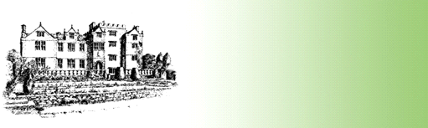

Borwick Hall

Group Activity List

2015

Borwick Hall