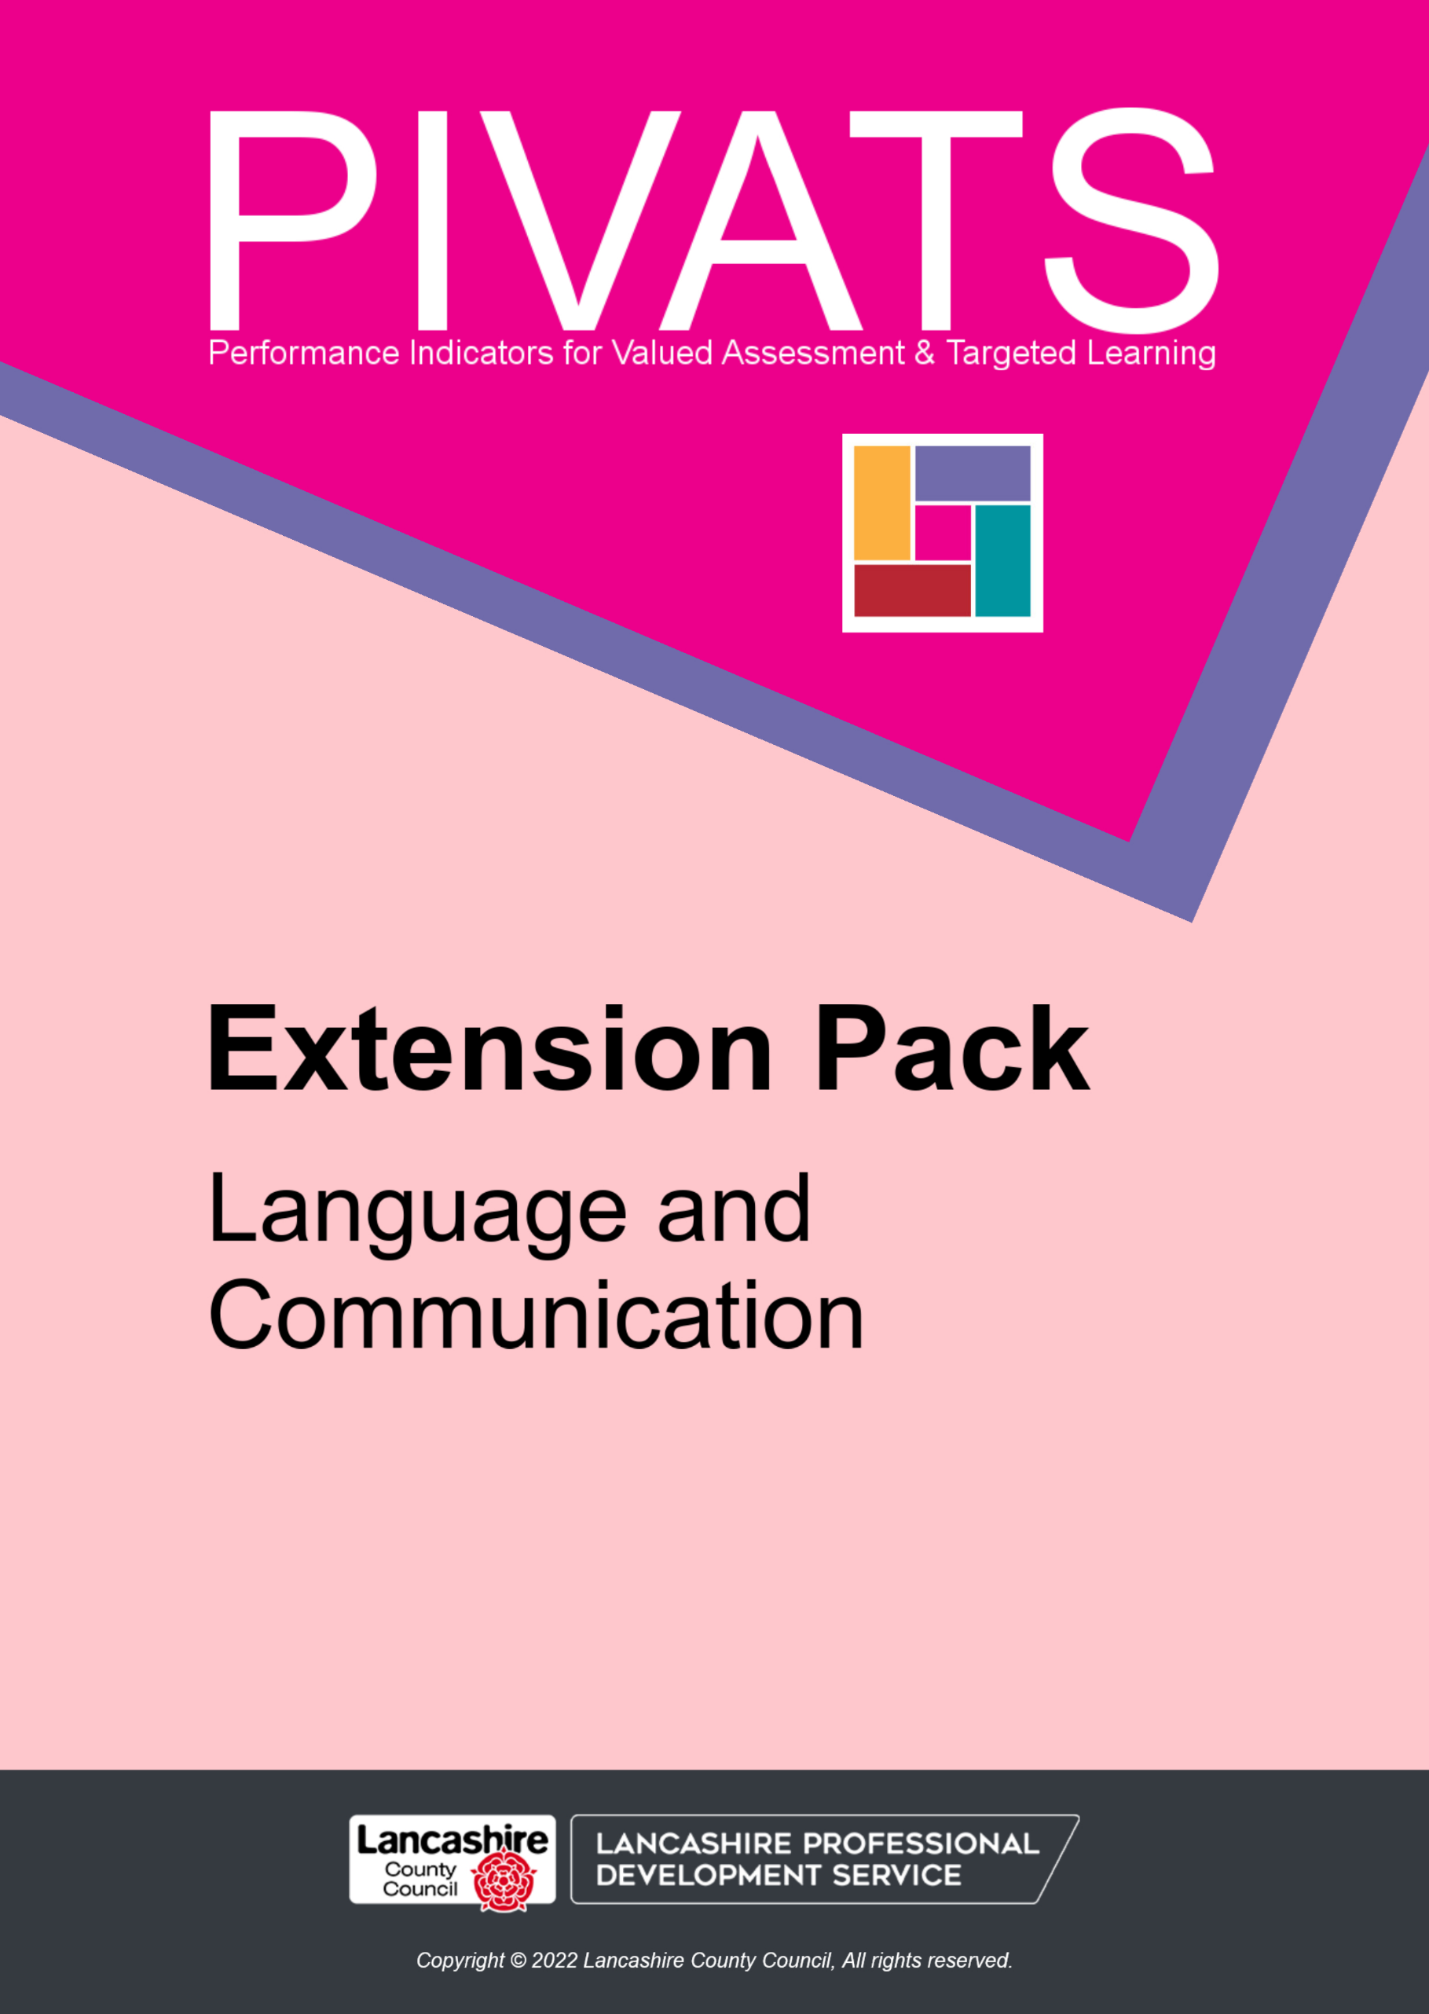

PIVATS Language and Communication Extension Pack

Language acquisition is becoming an increasing challenge for schools, as a growing number of pupils enter school with delayed language development. This then impacts on their social, emotional, and academic progress.

The PIVATS Language and Communication Extension Pack has been designed to give practitioners guidance on how to promote the development of listening and understanding of spoken language, and talking and communication skills, within a mainstream school setting – especially for pupils functioning within the earlier PIVATS milestones.

It is worth noting that 15-20% of pupils will have persistent SLCN (Speech, language, and communication needs) and these pupils would benefit from specialist support and intervention in addition to the strategies promoted in the PIVATS toolkit.

The PIVATS Language and Communication Extension Pack has been written to support provision for pupils being assessed using the PIVATS 5 Language and Communication Milestones. Where a criterion is highlighted, there is an example of a practical strategy which could be included in provision to develop that aspect of language and communication.

PIVATS 5 Language and Communication

For many years, there has been a focus on raising attainment in writing and, more recently, early reading. The fundamental skills of communication, and development of spoken language, have often been over-looked and yet these underpin pupils' ability to read and write. As Jean Gross illustrates in the following table from her book Time to Talk: Implementing Outstanding Practice In Speech, Language & Communication, the amount of teaching time focusing on reading and writing is often disproportionate to the time spent developing the essential skills underpinning these i.e. listening and speaking. (Gross, 2018, p.16).

 | Listening | Speaking | Reading | Writing
Learned | First | Second | Third | Third
Used | Most | Next to Most | Next to Least | Least
Taught | Least | Next to Least | Next to Most | Most

The Listening and Understanding strand of PIVATS 5 is organised into the following indicators from P Scale Milestone 4 upwards:

- Attention and Listening Skills
- Understanding Words
- Understanding Sentences
- Understanding Meaning (semantics)
- Listening to Stories and Rhymes

See Appendix 1 for typical age-related attention development

The Talking and Communication strand of PIVATS 5 is organised into the following indicators from P Scale Milestone 4 upwards:

- Vocabulary
- Sentence Structure and Grammar
- Narrative
- Communication Skills
- Social Interaction

Language development is a very complex and inter-linked process where each stage is dependent on another, therefore, there will inevitably be overlaps in some of these areas.

Please note the following colour-coding:

- Words in purple can be found in the glossary.

What do we mean by speech, language, and communication?

Speech – the sounds, and sound combinations, put together to make up words. This links closely with phonics and phonological awareness. Pupils develop speech sounds at different ages and there are typical speech sound substitutions made by pupils during the development of their speech-sound system. See Appendix 2 for an overview of developmental markers regarding speech/sound development.

Language – language can be split into two key areas:

- Understanding of spoken language – also referred to as receptive language or comprehension. This refers to understanding of words, sentences, and overall meaning. It also includes understanding of subtle and abstract language such as inference, idioms, and figurative speech.
- Expressive language – also referred to as talking. This refers to vocabulary, sentence structure, grammar, and oral narrative.
There is much research linking vocabulary acquisition to outcomes and life chances. In his book Closing the Vocabulary Gap, Alex Quigley states:

"Closing the vocabulary gap between our word-poor and word-rich students, could prove the vital difference between school failure and success." (Quigley, 2018).

Communication – this also includes social interaction skills.

This is the bi-directional, interactive means of sharing and receiving information. A way of sharing needs, wants and emotions with others. This includes the complex understanding of social context, adapting of register and development of emotional literacy. When using the suggested activities around social interactions, it is important to be aware of neurodiverse pupils and to develop neurodiversity affirming practice which recognises differences are to be understood rather than targeted through social interventions.

Delay and Disorder

Language and/or speech sound development may be delayed. This is when development follows the typical developmental pattern, but with progress being below age-related expectations.

Language and/or speech-sound development may be disordered. This is when an a-typical pattern is observed, or a-typical speech sound substitutions are a feature of the pupil's speech.

Analytical Language Development and Gestalt Language Development

Analytical Language Development is what has previously been considered ‘typical’ language development. This is the pattern we observe in young children who acquire language by learning to understand words of gradually increasing complexity. When learning to express themselves they will begin with single words, then combine words together, gradually building up to using longer phrases and sentences. An analytical language processor’s basic unit of language is a word.

Gestalt Language Processing is a natural way to develop language, however it is different to what has previously been considered ‘typical’. Gestalt Language Processing is a common pattern of language development observed in autistic individuals. Not all Gestalt Language Processors are autistic. Gestalt Language Processors focus on intonation, not individual words, before they have words they may copy to melody/intonation of language. When learning to express themselves they often begin with echolalia, or delayed echolalia. They tend to process language as a whole unit – not hearing/separating individual words, but using whole phrases, with the same intonation each time to express themselves. There are 6 stages of Gestalt Language Processing and eventually these children may get to original, flexible language, just like analytical language processors.

PIVATS-5 Listening and Understanding, Talking and Communication and the Language and Communication packs are focused on analytical language development.

References from www.meaningfulspeech.com (Alexandria Zachos, Speech & Language Pathologist) & Meaningful Speech Course Handbook, Kathryn Arnold, Speech & Language Pathologist, 2022.

Developmental Language Disorder – DLD

DLD was previously known as Specific Language Impairment (SLI). This is characterised by difficulties understanding and/or using spoken language which has a significant impact on progress at school and in everyday life. It is a life-long condition which is unlikely to show any improvement without specialist specific targeted intervention and is in the absence of any other known bio-medical condition, e.g. Downs Syndrome, Cerebral Palsy, Chromosomal Disorder etc.

When to Refer

If a pupil is on PIVATS Language and Communication, it is likely they have already been, or are waiting for, a referral. This should always be considered if pupils have delayed or disordered language and/or communication skills.

It is important to know the referral criteria for your local NHS SaLT (Speech and Language Therapy) department.

Pupils should be referred at any age if there are concerns regarding:

- Stammering/stuttering/dysfluency
- Selective mutism
- Swallowing/eating and drinking difficulties.
- Recently acquired disorder e.g. traumatic brain injury

- DLD
- Speech-sound difficulties in school-aged pupils

Neuro-affirming Practice

It is important to consider how to best support the development of social interactions for neuro-diverse learners in a neuro-affirming way, by recognising and valuing an individual's unique perspectives and communication styles.
It is essential to create inclusive environments that respect neurodiversity, offering tailored support that aligns with each learner’s strengths and preferences.
This may include:
- Providing clear and consistent communication: Use visual aids, written instructions, and structured routines to help neuro-diverse learners understand social expectations.
- Empowering learners to express their needs and preferences, so they develop a sense of autonomy and confidence.
- Creating opportunities for positive social experiences through group activities and collaborative projects, this could be based on learners' own interests as well as activities and topics that motivate them.
- Promoting awareness and understanding of neurodiversity for children and staff in the school and wider community.

By embracing these strategies, we can support neuro-diverse learners to build meaningful social connections in a way that honours their neurodiversity.

Ordinarily Available Provision

In addition to the hyperlinked practical ideas suggested for individual PIVATS criteria, there are generic strategies which are recommended as ongoing effective practice.

For example:

Strategy | Explanation/Ideas
Adult Interaction Strategies
Gaining the pupil's attention | - Say their name.  - Appropriate touch to talk.  - Be at the same level as the pupil.  - Use appropriate, stimulating resources.  - Acknowledge any distractions (e.g., it's snowing) and then redirect attention.
Consistent modelling of any language we want the pupil to use | Modelling is a very powerful teaching strategy. Giving pupils clear, correct models of how to say words, phrases and sentences is an essential aspect of language development.

Making learning and interactions fun | When pupils experience any challenge with learning, the risk is this can affect their self-esteem and they become disengaged. Try and make any learning and interventions something the pupil will enjoy and look forward to.
Wait time | Allow pupils time to process language. This may involve being comfortable with silences whilst they do this. Employing the 'silent' count to ten strategy is a helpful way to do this.
Say less… | Many educators like to talk. However, it is important to remember that pupils experiencing language and communication difficulties will need longer to process what is being said. Less is more – keep what you are saying clear and focused; avoid too much abstract information or too many anecdotes and regularly check for understanding.
Repeat, repeat, repeat! | This strategy connects to the modelling and the 'saying less'. Repetition of key words, phrases etc will help the pupil to encode these into long term memory.
Echo | Echoing what the pupil has said, correcting any errors/mispronunciations etc is an effective way of modelling without constantly drawing attention to mistakes, e.g.  Pupil: We goed park  Adult: Ah, so you went to the park?
Add a word or concept | For example:  Pupil: Look, car.  Adult: Yes, a red car  Pupil: I went to the park.  Adult: You went to the park with grandma.
Offer choices | This is a useful strategy for empowering pupils and engaging them, as they have some control in the learning/activity. It can also help to focus a pupil who may tend to always agree or choose an easy option. It creates a communication opportunity, e.g. Which of these stories shall we read?

Comment, rather than question (use the hand rule)  Please see Appendix 21 and the video accessible via https://youtube.com/shorts/PySWUMZFEbY | Evidence shows that pupils use more language when adults comment rather than question. It ensures that interactions are more conversational (rather than a question-and-answer session), e.g.  Question: "Why did Little Red Riding Hood leave the path?"  Comment: "Uh Oh!!! I think Little Red Riding Hood is going to leave the path”  Combine this with the ‘say less’ strategy – a long pause allows time for the child to process your language, generate their own thoughts/ideas and then be able to share these.
Use interesting and engaging non-verbal communication. | Facial expressions, gestures and tone of voice are all important elements of communication and understanding. It is important to be aware of this and use interesting and engaging non-verbal communication to show we are interested in what the pupil is communicating and to provide good models of this aspect of communication.

Nursery Rhymes and Rhyming Songs

Nursery rhymes and rhyming songs can benefit pupils' development in many ways:

- Development of early phonological awareness (onset and rime)
- Auditory memory
- Attention and listening
- From the repetitive formats, pupils learn about voice rhythm, speech sounds, rhyme, and words.
- Physical development (doing the actions)
- Vocabulary acquisition
- Development of linguistic concepts such as prepositions; temporal concepts such as before and after; sequencing such as first, next etc
- Number sequencing
- Social interaction
- Fun with language!
Strategy | Explanation/Ideas
Nursery Rhymes (For nursery rhymes, also include rhyming poems and songs as appropriate to the interest level/age of the pupils)
Daily Rhyme Times | - Singing rhymes together  - Reading rhymes  - Acting out rhymes (role play/actions)  - Sequencing key events in rhymes, e.g. sequencing pictures/lines/chunks etc  - Watching rhymes

Engage parents/carers | - Weekly 'Rhyme Time/Rhyme and Sign'  - Learn a rhyme a week off by heart.  - Invite parents to pick pupils up early on a set day, e.g. Friday.  - Perform the rhyme.  - Teach the actions/signs.  - Send a copy home/link to a website.  - Enhance with tea and biscuits!  - Stay and play sessions (focusing on rhymes and traditional stories).  - Extreme rhymes  - Take a photo/video of pupils reading/performing a rhyme at the top of a slide/in a tree etc – only when it is safe to do so! NB the emphasis should be on knowing the rhyme.  - Nursery rhyme story bags/packs/busy bags  - Lyrics, puppets and props, pictures to sequence etc.  - Take home character e.g. Humpty Dumpty  - Take pictures, e.g. on a 'real' wall  - Joining in with family life  - A 'diary' recording other songs/rhymes/stories which have been shared with Humpty etc.
Using Rhymes in Provision | - Creative  - Make pictures of the nursery rhymes through collage/painting/sculpture/playdough etc  - Construction, e.g.  - Build a wall for Humpty Dumpty.  - Build a shed/shelter for Baa, Baa Black Sheep.  - Build a tuffet for Little Miss Muffet etc.  - Make a pond for the five little ducks or a log for the five little speckled frogs etc.

Using Rhymes in Provision (continued) | - Outdoor  - All the above.  - Deconstructed role play  - Have available a variety of resources e.g. boxes, crates, tyres, logs etc and encourage the pupils to build the wall for Humpty Dumpty etc.  - Play a version of 'corners'. Have some props spread out in the area e.g. a star, a wall, a bag of wool etc. The adult starts to sing a rhyme and the pupils must run to the correct prop and join in.  - Reading  - Sequencing activities – pictures and/or lines of the rhyme.  - Different versions of the rhymes.  - Opportunities to record themselves reading/reciting/performing the rhyme.  - Writing  - Using the rhymes to innovate to make their own. Remember, oral practice and rehearsal MUST come before writing.  The above are examples. Consider how different areas of provision can be used to promote learning and recitation of rhymes.
Picture/Object and Word Match | - Identify common synonyms for nursery rhyme words, e.g. tuffet (Little Miss Muffet) - footstool; pail (Jack and Jill)– bucket; waterspout (Incy Wincy Spider) – drainpipe; fair (London Bridge)– pretty; master and dame (Baa, Baa Black Sheep) – man and woman, lane – road etc.  - Call out a word – who is first to find it?  - 'Kim's Game' – have a range of pictures/objects from nursery rhymes on a tray. Have a look; cover with a cloth; remove one; can the pupils identify which has gone and then say the rhyme together. If the pupils cannot remember, a clue can be given e.g. Jack and Jill used this…  - Play 'May I cross your golden river…' Allocate an object to a pupil and they can only cross the river if they have it then sing the rhyme.  - Pairs – match the picture to the people in the rhymes.  - Match the prop to the rhyme.  - Have a range of props in a bag. The pupils pick one out and identify the rhyme it is from and then perform the rhyme.
Rhyme Environment | - Pictures of characters with rhymes  - 'Rhyme Tree' displaying the rhymes learnt/vocabulary learnt through the rhymes/matching rhyming words etc.  - Picture books of rhymes

Traditional Tales

Knowing, and learning, traditional tales have many of the benefits outlined above re Nursery Rhymes etc and many of the ideas above could easily be adapted for traditional tales. You will probably already have many fabulous ideas of your own, but here are a few.

Strategy | Explanation/Ideas
Traditional Tales
Traditional Tales Collection  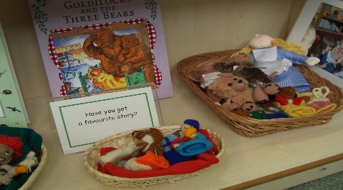  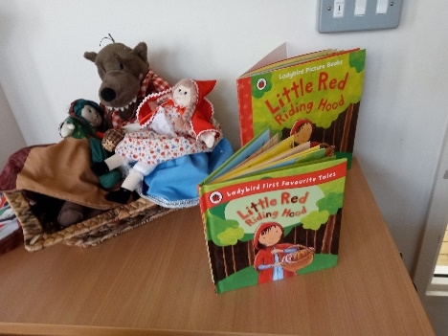 | - Encourage pupils to bring in favourite books/traditional tales and to share with the class, explaining why it is a favourite.  - Collect books which are retells/based on the same traditional tale. This might include parodies/quirky retellings if age appropriate.  - Compare and contrast different versions of the same tale – what are the similarities/differences; which is the favourite and why?  - Make 'character banks' for the different traditional tales – collect words and phrases to describe the character, including characteristics. Be ambitious with the word collections to extend pupils' vocabulary.  - Collect banks of typical characters and their characteristics, e.g. the main characters; villains; magical beings etc.  - Make collections of typical language, sentences, rhymes, and patterned language from traditional tales.  - Model having fun and playing with well-known rhymes and phrases E.g.  Just before lunchtime break – Fee, Fi, Fo, Fum, I smell lunch – now here we come!
Making Connections Collections | In addition to collecting versions of the same tales, consider adding tales/information texts that naturally link, e.g.  Little Red Riding Hood  The Three Little Pigs  Information texts about wolves.

Learn Stories by Heart | Learning stories by heart helps to internalise language and sentence structure and strengthens memory. Using actions for conjunctions, time adverbials and key vocabulary is an effective memory aid.  (For more information on how talk can be used to improve outcomes in English (and across the curriculum) see the Lancashire English Team's Talk Programmes https://www.lancashire.gov.uk/lpds/

Development of Early Sequencing

- What next? – e.g. after everyday actions such as taking coat off ask, "What happens next?"
- Sequencing of rhyme/poetry/song lines.
- Sequencing of events in traditional tales etc.
See Appendix 3 on "Sequencing"

For further examples of ideas for early language development see your setting's phonics scheme and/or Lancashire English Team's Phase 1 Phonics resource. Publications – Lancashire Professional Development Service.

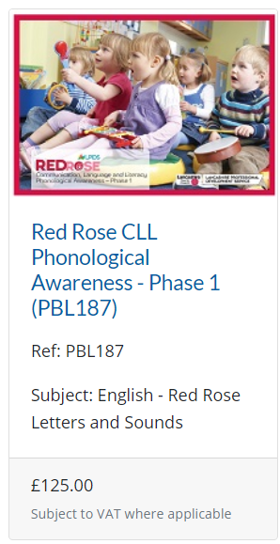

Learning Environment

Ensure the learning environment is language rich and promotes playing with language, but without being overstimulating.

Examples:

Access to high quality picture books to promote enjoyment of language and words. | - Ensure pupils have access to quality picture books at their interest level. This allows opportunity for talk and language development. An adult can share the book with the pupil and encourage them to talk about it and retell the story.  - Access to recorded stories e.g. online, where the pupil can see the pictures and words whilst listening to the story.  - Collect favourite words and phrases.  - Use these words/phrases in conversation with the pupil and encourage the pupil to use them independently.
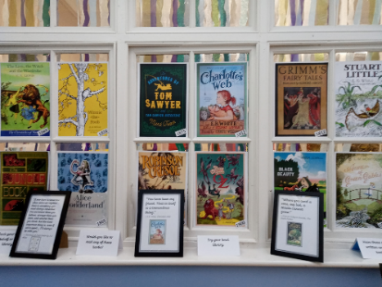
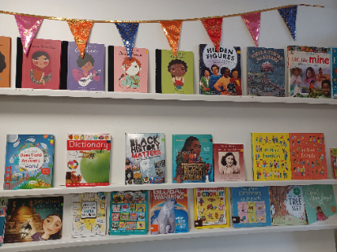
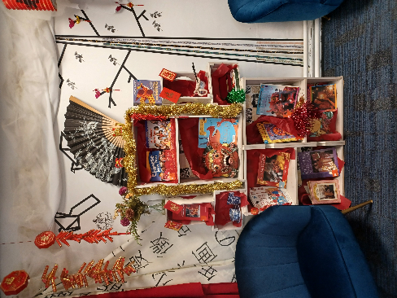
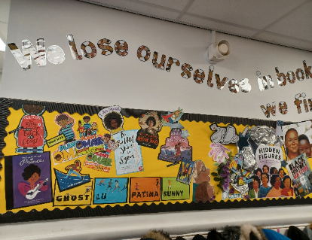
Face on

Inviting

Word of the Day | Many classrooms have adopted the idea of 'word of the week' however, word of the day would be more beneficial.  - Make sure the word is linked to the current learning so it can be used regularly in context.  - Say the word, act the word, see how many times a day the word can be used appropriately etc.
Idiom of the Week | The English language is littered with metaphors and idioms. (See what I did there?) Some pupils interpret language very literally and will need help understanding these. Assume nothing.  In addition to Word of the Day, consider Idiom of the Week. Start with commonly used ones first and then move onto less common ones. The pupils will have fun testing out peers and adults to see whether they know the meaning of them.

Homonyms | Homonyms are words that have the same sound and pronunciation but different meanings.  When learning words which are homonyms, explore the different meanings and discuss the contexts in which they might be used – as appropriate to the age and interest level of the pupil.  Make this fun and exploratory.  See the table below for examples.
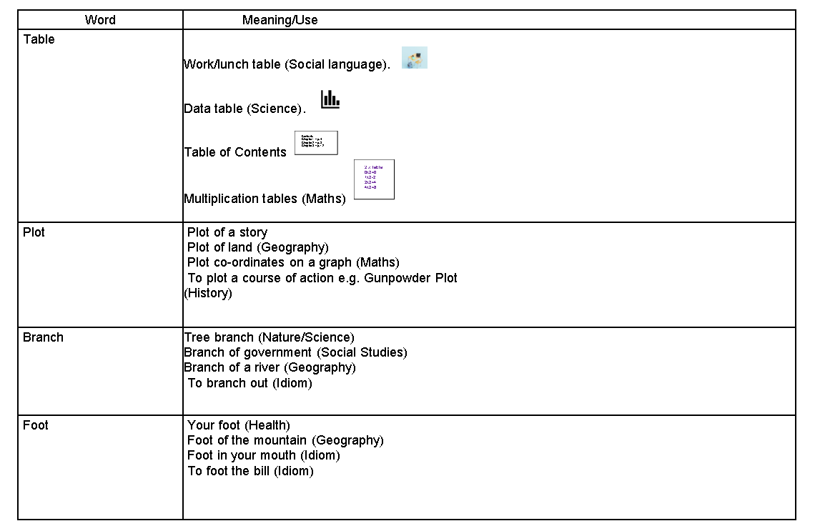

Talk Frames | It is common in classrooms to use writing frames to support writing, but how often are talk frames used to support language and communication?  When learning about a new topic, collect the subject specific words in one column and generally used formal academic words in the other. Encourage pupils to use these when answering questions or talking about their learning.
  Technical  /Subject Specific Words | Useful Academic  Words
  - Ecosystem  - Microorganism  - Habitat  - Aquatic | - Consist  - Affect  - Inhabited  - Part  - Changed
NCETM Mastery | NCETM have produced a short video (2 minutes long) on the benefits of encouraging pupils to answer questions in maths (any subject?) in full sentences (if they are able).  Take a look at the video "Mastery Moments – video shorts: 1. Answers in complete sentences" via the link below:  https://vimeo.com/193342125
Classroom Displays | Where possible, and appropriate, have images displayed alongside key vocabulary to support understanding. Use 'talk tins' so pupils can hear the word and practise saying it.
Speaking Prompts | As with the Talk Frame, speaking prompts/sentence starters can be a helpful scaffold for ALL pupils.  Progression in Language Structures from Tower Hamlets EMA team give useful sentence starters from YR level to Y6 for different genres of talk. e.g. Talk to recount, talk to discuss, talk to persuade etc.  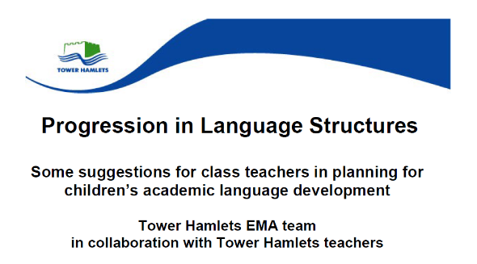

Further examples of ordinary available provision can be seen in the Lancashire SEND Specialist Teaching Service Publication – Lancashire Toolkit for SEND. These are taken from the Communication and Interaction Section and can be seen in the following appendices:

- Listening and Understanding
  - Attention and Concentration (Appendix 22)
  - Receptive Language (Appendix 25)
- Talking and Communication
  - Expressive Language (Appendix 24)
  - Selective Mutism (Appendix 26)
  - Social Communication (Appendix 27)
  - Social Interaction (Appendix 29)
- Appendices
  - Autism Spectrum Condition (Appendix 23)
  - Social Imagination (Appendix 28)
  - Transition (Appendix 30)

N.B. Links to third party websites are the sole responsibility of the person from which such content originated, and it is the end sole user responsibility to check the license for use of any of its content. The Lancashire County Council School Improvement Service provides it as a reference point only and do not guarantee, or accept responsibility for, the accuracy, integrity or quality of any of its material.

Additionally, Lancashire County Council cannot accept responsibility for any of the external links provided within this document that change or become obsolete following publication.

Acknowledgements:

Lancashire PIVATS Teaching and Learning Consultants
Louise Laycock – Bridge Speech Therapy
Lancashire SEND Specialist Teaching Service
Lancashire English Team
Lancashire MIT SENDcon – Helen Mansfield
Lancashire LPDS Publications and Marketing Team
With special thanks to Phil Gittins – PIVATS Technical and Systems Officer

© Lancashire County Council 2024

Contents
1. Modelling 'No' - 1 -
2. Indicating Activity Using an Object of Reference - 2 -
3. Develop Interactions - 3 -
4. Developing Interactions with Objects - 4 -
5. Offering Simple Choices with Objects - 5 -
6. Making Choices with Objects of Reference - 7 -
7. Now & Next - 8 -
8. Communication Boards - 9 -
9. Object to Object - 10 -
10. Prompt Cards - 12 -
11. 1-2 Word Level Comprehension - 14 -
12. Picture to Picture - 17 -
13. Visual Timetable - 19 -
14. Picture to Object - 20 -
15. Another Object in Category - 22 -
16. Object by Function - 23 -
17. Whole Body Listening - 24 -
18. Developing Linguistic Concepts - 26 -
19. Odd One Out - 28 -
20. 3-4 Word Level Comprehension - 29 -
21. Sort 2 Categories - 32 -
22. Sort 2 Sub-Categories - 34 -
23. Barrier Games - 36 -
24. Lego Based Activities - 37 -
25. Carpet Time/ Whole Class Teaching Cards - 38 -
26. Today Is – Tomorrow Is - 40 -
27. Turn Taking Cards - 41 -
28. Circle Time Rules - 42 -
29. Mind Maps - 43 -
30. A Game Explaining Idioms - 45 -
31. Green/Red Help Cards - 47 -
32. Social Story - 48 -
33. Active or Effective Listening - 50 -
34. Group Role Cards and Rules - 52 -
35. Category Sorting - 53 -
36. Socially Speaking Games - 55 -
37. Board Games - 56 -
38. Define and Rhyme - 57 -
39. Vocabulary Development Alongside Phonological Awareness - 58 -
40. Sorting in Sub-Categories - 59 -
41. I Feel …… Cards - 60 -
42. Talk Tokens - 62 -
43. Vocabulary Development - 63 -
44. Measures to Reduce Anxiety - 64 -
45. What's In Your Heart? - 66 -
46. Restorative Approaches - 68 -
PIVATS Language and Communication Extension Pack: Glossary
Appendix 1
Appendix 2
Appendix 3
Appendix 4
Appendix 4 (continued)
Appendix 5
Appendix 6
Appendix 7
Appendix 8
Appendix 9
Appendix 10
Appendix 11
Appendix 11 (continued)
Appendix 12
Appendix 13
Appendix 14
Appendix 15
Appendix 16
Appendix 17
Appendix 18
Appendix 19
Appendix 20
Appendix 21
Appendix 22
Appendix 23
Appendix 24
Appendix 25
Appendix 26
Appendix 27
Appendix 28
Appendix 29
Appendix 30

PIVATS Listening & Understanding - Milestones P(i) & P2(i)

Modelling 'No'

When to Use:

When a pupil demonstrates resistance to/during an activity or experience

Description of activity:

If the activity/experience is one that the pupil can stop or withdraw from:

- Consistently model simple language 1-3 words appropriate to what the pupil is communicating non-verbally e.g. “I don’t like it”.
- Consistently model appropriate key word signs e.g. ‘no’ or ‘finished’ to match what the pupil is communicating non-verbally.
- Use appropriate visual supports e.g. red traffic light card, when the activity/experience has finished.

If the activity/experience is not one that the pupil can stop or withdraw from:

- Use a calming voice to reassure the pupil that you are supporting them. “It’s OK. I am here."
- As soon as appropriate, reassure the pupil that the activity/experience will finish shortly, “One more minute,” then a countdown from 10.
- Use appropriate visual supports to let the pupil know the activity/experience has finished, e.g. red traffic light card, say and sign “Finished”.
- Praise the pupil, regardless of what their reaction has been, for completing the activity, e.g. “Finished,” “Well done,” “Water has finished”.

Have a highly motivating/rewarding activity ready straight afterwards and be prepared with the appropriate object of reference to communicate this.

Progression/Next steps:

- Consistently present the pupil with a range of sensory experiences.
- If they have previously shown resistance, make sure they are sensitively, and regularly, presented with the activity/experience again.

If possible, explore the same sensory experience, but in different ways. This may be more motivating, e.g. touching a wet/slimy texture. Put motivating items, such as familiar characters or fidget toys, in the slime for the pupil to retrieve.

Resources:

- Activity 2 – Using an object of reference.
- Appendix 5 - Traffic light cards

PIVATS Listening & Understanding Milestones P1(ii) and P2(ii)
PIVATS Talking & Communication Milestones P4

Indicating Activity Using an Object of Reference

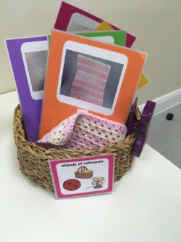
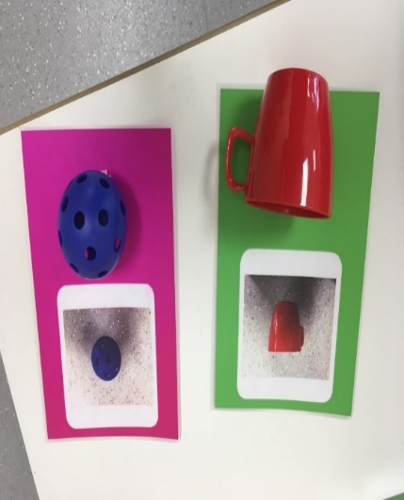

When to use:

During transitions or as part of a timetable. Use them consistently to let the pupil know what is happening next.

Description of activity:

- Begin with no more than five objects of reference.
- Select an object that links with familiar, regular activities throughout the day e.g. mealtime = spoon, drink = cup; outside play = high vis band/jacket; water tray = apron etc.
- Consistently present the pupil with the object, naming the appropriate activity, e.g. “Snack time,” each time the pupil is about the engage in that activity.
- Ideally make 'objects of reference' transition cards. This could be a card with the object (larger objects might need to be cut up so a part of the item is on the card e.g. a bit of high vis jacket), or a photo of the object and the text stating the name of the activity.
- The text supports all staff to be consistent with the language they use when presenting the pupil with the card.

Progression/Next steps:

- Continue to expand the range of objects of reference which the pupil understands/uses.
- As a pupil’s understanding develops, the aim is for them to be able to move on to understanding photos of the objects which represent activities and routines.

Resources:

Objects of reference appropriate to the pupil’s day which have been prepared appropriately to the pupil's needs.

PIVATS Listening & Understanding Milestones P1(ii) & P2(i), Four Stage 2
PIVATS Talking & Communication Milestones P2(ii), P4

Develop Interactions

When to use:

Throughout the school day.

Description of activity:

- These interactions are usually 1:1 with a pupil and with no objects involved initially.
- Some pupils may need to begin developing interactions around objects before they focus more on the interactions with another person.
- The focus is to develop 1:1 interaction between the pupil and a responsive adult.
- The target is to spend time together, following the pupil's lead.
- The adult is responsive to the pupil, copying their actions, vocalisations and joining with them (alongside rather than face-to-face) in the actions/activities they enjoy. A responsive adult may model simple language to comment on actions/emotions/mental state as appropriate during the interaction.
- The pupil is the leader in the interaction and the adult is responsive to them.
- The interactions can be brief – two to three minutes - and take place several times throughout the day.

Pupils may begin to initiate further interactions by approaching responsive adults, leading an adult, taking an adult's hand, or using resources in a way similar to a previous interaction/play routine.

Progression/Next steps:

Developing interactions with objects; developing interactions with a peer; structured turn-taking activities with a familiar adult and possibly a peer.

Resources:

Further information regarding interaction interventions can be found in The Intensive Interaction Handbook by Dave Hewitt, or through The Curiosity Programme by Gina Davies.

Please note, in order for Intensive Interaction to have maximum impact, and to understand the principles, practice and implications of this approach, please access further information and training from the Intensive Interaction Institute here

PIVATS Listening & Understanding Milestones P1(ii), P2(ii), P3(i), P3(ii), P4, P5
PIVATS Talking & Communication Milestone P3(i)

Developing Interactions with Objects

When to use:

Throughout the school day.

Description of activity:

- This may build on from developing interactions 1:1 with a pupil.
- Some pupils may need to begin developing interactions around objects before they focus more on the interactions with another person.
- The focus is to develop 1:1 interaction between the pupil and a responsive adult.
- The target is about spending time together following the pupil's lead.
- The adult is responsive to the pupil, copying their actions, vocalisations and joining with them (alongside rather than face-to-face) in the actions/activities they enjoy. A responsive adult may model simple language to comment on actions/emotions/mental state as appropriate during the interaction.
- The pupil is the leader in the interaction and the adult is responsive to them.
- The interactions can be brief – two to three minutes - and take place several times throughout the day.
- Play routines sometimes develop as part of these initiations. e.g. playing stop/go games with pouring water, or exploring other sensory activities, e.g. putting more dried pasta in a cup. The adult develops the routine saying, "Ready steady…", before waiting for eye contact, looking at the objects or possibly a vocalisation. The adult then models, “Go!” and pours the pasta out onto their hands.
- Ensure lots of repetitions of enjoyable play routines and adapting of these to follow the pupil’s interest.

Pupils may begin to initiate further interactions by approaching responsive adults, leading an adult, taking an adult's hand, or using resources in a way similar to a previous interaction/play routine.

Progression/Next steps:

Developing interactions with peers, structured turn-taking activities with an adult, and possibly a peer

Resources:

Motivating resources within the school environment.

Further information regarding interaction interventions can be found in The Intensive Interaction Handbook by Dave Hewitt, or through The Curiosity Programme by Gina Davies.

Please note, in order for Intensive Interaction to have maximum impact, and to understand the principles, practice and implications of this approach, please access further information and training from the Intensive Interaction Institute here

PIVATS Listening & Understanding Milestone P2(ii)

Offering Simple Choices with Objects

When to use:

Offer to the pupil the choice of two items from resources within activities, e.g. squish ball or feathers during sensory activity, or food items at snack/lunch.

Description of activity:

- Have two items/objects ready.
- When first introducing choice making, it is a good idea to use a preferred item and a non-preferred item.
- You may need to make adaptations to where you hold the items if the pupil has a visual impairment.
- Hold one item up in the centre of the pupil’s visual field and name it.
- Move it to the side or put it down if you need to.
- Hold the second item up in the centre of the pupil’s visual field and name it.
- Move it to the other side.
- Pick up the first item if you put it down so you have one item in each hand.
- Say, “Do you want X or Y?” highlighting the items by moving them as you name them.
- Give the pupil plenty of time to process the information.
- If the pupil reaches for one item – name it and pass it to them.
- If the pupil eye points to one item – name it and pass it to them.
- If the pupil reaches/eye points for both items – pull them back slightly out of reach, say, “X or Y?” highlighting the item with movement again as you name it. You may want to move the items further apart from each other.
- If the pupil reaches/eye points for an item which, when you give it to them, they reject, whilst reaching for the other item, hold both items up again and name them “X or Y?” then model “Y?” and offer the preferred item to the pupil whilst naming it.

IT IS IMPORTANT THAT YOU DO NOT ALWAYS HAVE THE PREFERRED ITEM ON THE SAME SIDE. MAKE SURE YOU SWAP THE SIDE OF THE PREFERRED ITEM WHEN YOU ARE OFFERING CHOICES THROUGHOUT THE DAY.
DO NOT SWAP THE ITEMS TO A DIFFERENT SIDE DURING A SINGLE CHOICE MAKING PRESENTATION

Progression/Next steps:

- Once the pupil is consistently choosing an item and accepting it (a preferred item, not necessarily THE preferred item you thought they might choose), you can begin to offer choices between two preferred items.
- Correspondence check – when offering two preferred items, you may want to check the pupil is making an active choice and isn’t just happy to receive either item, by saying, “Get it” and encouraging the pupil to take the item themselves rather than handing it to them.

As a pupil’s understanding develops the aim is for them to be able to move on to understanding photos of the objects they are choosing.

Resources:

A video to demonstrate https://youtube.com/shorts/va0UMXHbUdc

PIVATS Listening & Understanding Milestones P3(i) and P3(ii)

Making Choices with Objects of Reference

When to use:

To offer choices between activities/resources

Description of activity:

- Offer the pupil a choice of two known objects of reference (Activity 2)
- Present one object, naming it clearly, at one side of the pupil’s visual field.
- Present the second item, clearly naming it, at the other side of the pupil’s visual field.
- Say, “Would you like X or Y?” moving the object to emphasise it as you name it.
- Pause for at least three seconds. This might need to be longer depending on the individual pupil. Enable to pupil to scan the objects.
- The pupil may immediately eye-point/reach for an item.
- If not, repeat the naming of each item while moving the item slightly, to emphasise which item is being named.
- Once the pupil has indicated a choice, begin that activity/task immediately to support the link between the object of reference and the activity/task.
- If the pupil shows resistance, and it appears the opposite choice has been indicated to what they would like, return to presenting the objects in the same way, emphasising the object linked to the preferred choice.
- Make sure to move the objects of reference to different sides and, if there is a preferred activity/task, then make sure it is presented on different sides at different times. This avoids the pupils always eye-pointing/reaching to the same side.

Progression/Next steps:

Continue offering an increasing range of preferred, and non-preferred, choices.

Resources:

Objects of reference, appropriate to the pupil’s day and prepared appropriately as to the pupil's needs.

A video to demonstrate can be accessed via https://youtube.com/shorts/Or47HFWWLnE

PIVATS Listening & Understanding Milestone P4

Now & Next

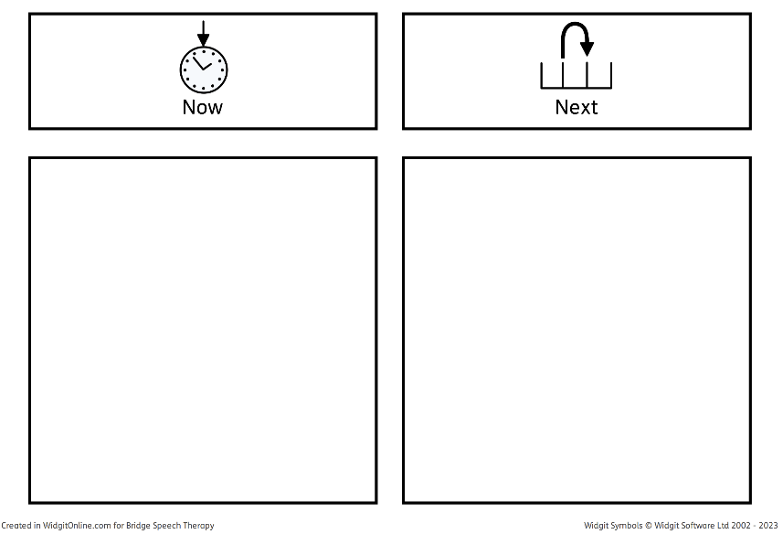
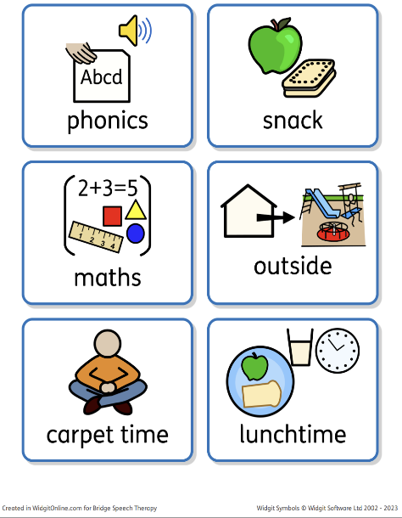
Widgit Symbols © Widgit Software Ltd 2002-2023 www.widgit.com

Description of activity:

- The now and next board progresses from single objects of reference/symbols/photos to let the pupil know what is happening throughout the day.
- The now and next board can be used with object of reference cards, photos, or symbols.
- The adult verbally reinforces the now and next with simple language, “Now it is phonics, next it is snack time, now it is phonics,” and guides the pupil towards the activity.
- If necessary, when first introducing the now/next board, the adult can give the object of reference/photo/symbol to the pupil whilst they move to the activity to reinforce association.
- Work towards the objects of reference/photo/symbol staying on the now and next board.
- At the end of the first activity return attention to the now and next board.
- Following the 'now' activity, the adult verbally reinforces, “Phonics is finished,” and removes the object of reference/photo/symbol from the board. Encourage the pupil to do this. Then point to the next activity, “It is time for snack,” and guide the pupil to the next activity.
- To encourage the pupil to complete less motivating activities, ensure a highly motivating activity is in the 'next' position.

Resources:

A now and next board and a range of object of reference cards/photos/symbols for the activities a pupil will be engaged in throughout the day. Whether you use photos/symbols will depend on the pupil’s visual representation/interpretation skills.

Appendix 7

PIVATS Talking & Communication Milestone P5

Communication Boards

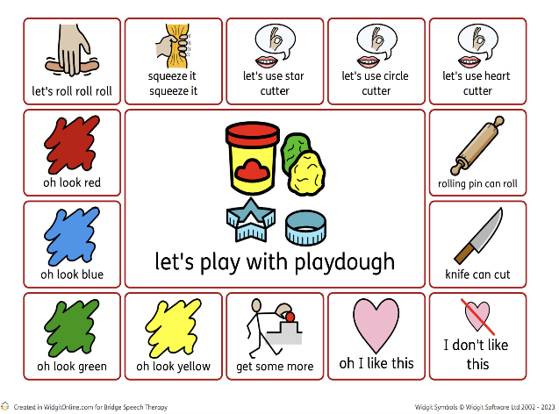
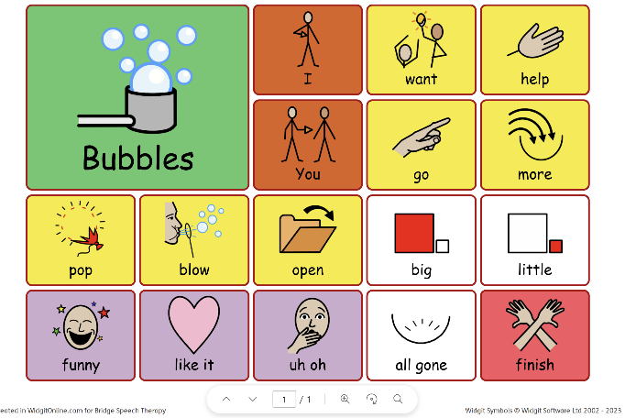

Description of activity:

- Use communication boards to support adults modelling expressive language.
- Communication boards offer a visual support for expressive language, which is more permanent than the oral language alone.
- A wide variety of communication boards can be produced to support different areas/topics/activities.
- Communication boards are effective visuals to have in your environment and will support pupils with a wide range of challenges expressing themselves.
- Adults also need to be aware of the language they are modelling, particularly when guiding pupils to the next step. If a pupil is currently non-speaking, or has a limited number of words and often points or indicates what they want with gesture/body language, adults need to model the language that they want to pupil to use.

Resources:

The language on the communication board is to support adults in modelling language and being consistent, between different adults and with the same adult at different times.

Appendix 8 - Modelling
Appendix 9 - How to Model Using a Communication/Core Words Board

PIVATS Listening & Understanding Milestone P4

Object to Object

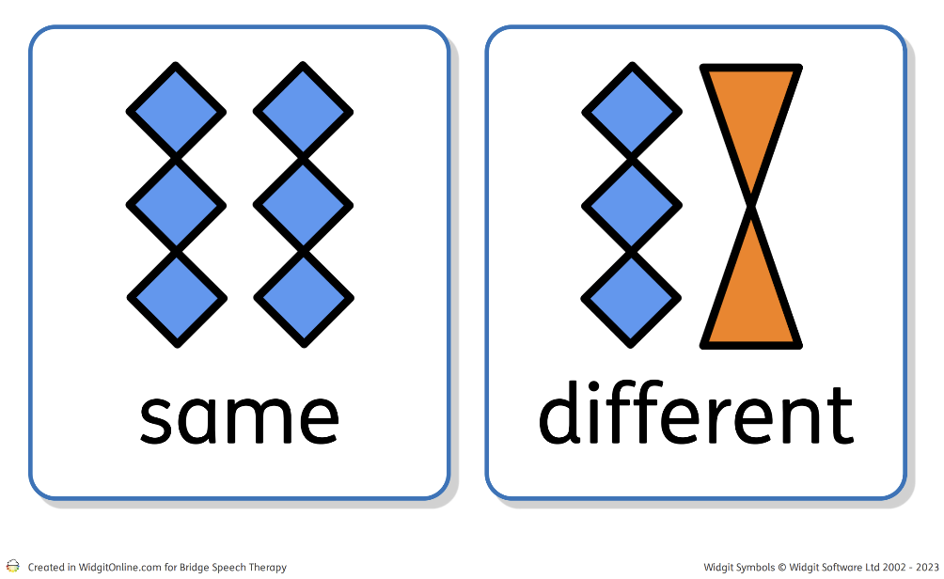
Widgit Symbols © Widgit Software Ltd 2002-2023 www.widgit.com

Description of activity:

- Play within a structured activity that is 1:1.
- Initially use the same set of objects, until the pupil becomes familiar with the activity.
- Use objects within set categories. It is usually best to start with everyday objects e.g. cup, brush, toothbrush, plate, spoon.
- Other categories to explore later might include clothing, classroom items, animals, food, transport. If the pupil has a particular area of interest, this can be useful for motivation, although sometimes pupils find it challenging to be flexible with their play around favoured items/topics.
- Using a feely bag, covered shoebox or another container helps to create interest and curiosity.
- Initially have two items out on the table/floor, pick these up or point to them as the adult labels them.
- Offer the bag/container to the pupil to “find something.” Encourage them to pick one item without peeking.
- Once the pupil has pulled an item out the bag/container say, “Find the same”, Signing “same” and/or using a symbol for same can support understanding.
- If the pupil picks up the matching item, label both items as you move/point/touch them, e.g. “Cup, cup. They are the same.” Support the verbal with signing ‘same’ and/or showing a symbol to reinforce understanding.
- If the pupil picks up the different item, label both items as you move/point/touch them, e.g. “Cup, brush. They are different, not the same.” Support the verbal with signing ‘different’ and/or showing a symbol to reinforce understanding.
- Offer the bag/container back to the pupil, with only the matching item in, and repeat to enable them to pick the matching item.
- Gradually increase the number of items for matching.
- This can bridge into continuous provision/other areas of the setting, such as at unstructured times. Using the same language, “Find the same,” and encouraging pupils to find similar items from a choice of two or more, such as finding a leaf, from a leaf and stick in forest school, or a matching spade or bowl in the sand/water.

Resources:

A range of objects, visual symbols for same and different such as the Widget symbols shown above.

Progression/Next steps:

Move on to picture/object matching (Activity 14)

PIVATS Listening & Understanding Milestone P4

Prompt Cards


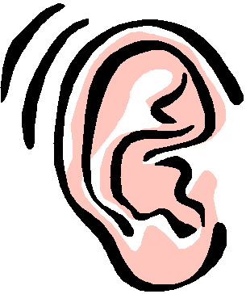
Good looking
Good listening

When to use:

Visual symbols can be used for pupils who need basic instructions when the use of lots of words may be confusing for them. Commonly PECS (Picture Exchange Communication System) pictures can be utilised for pupils who have a diagnosis of an Autistic Spectrum Condition or other Social and Communication Difficulty (SCD). Looking at a symbol will give them time to process what is being asked of them and therefore enable them to be more likely to process and follow simple instructions.

Why you may choose to use:

- To provide pupils with a visual cue in collaboration with an auditory cue.
- To assist pupils to focus for short periods and help them to learn how to focus.
- To refocus pupils when needed.
- To introduce concepts such as turn-taking.

How to use:

Introduce one prompt at a time, e.g. “Good looking”. Spend time teaching the meaning of the prompt, modelling what it looks like in practice, pointing out good examples in others and encouraging the pupil to practise it. Some prompts such as “good turn taking” will need clear modelling and specific opportunities to practise, e.g. physically at first – passing the prompt card to indicate ‘your turn’, ‘my turn’ before progressing.

Draw attention and praise every time the pupil displays the correct behaviour so that they are aware what you are looking for and how it feels. These cards should be used consistently by all adults involved with the pupil, ensuring that language is consistent and that the concept is reinforced regularly over time. The symbols can be specific to a pupil or used generically by all staff. Sharing symbols and language with home will also promote consistency. New instructions can be added when ready.

It is important that the cards are used with the same consistent language as this reinforces the message.

The cards can be specific to a pupil, or, ideally, general for all staff to use to support inclusion.

Progression/Next steps:

If used on a one-to-one basis, once the pupil fully understands each prompt, it can be used in whole class situations without interrupting the class, the teacher or teaching assistant can point to it or tap the prompt card to refocus attention.

You can also use a hand signal to support and then the hand signal can continue after the card is understood and then ultimately just the language.

The cards can be added to or swapped according to a pupil’s needs and clip art, illustrations or photographs of the pupil demonstrating the skill can be used.

You can retain the cards for future use – it can help to reinforce it regularly.

*Please note that consent for the use of references to PECS within this card has been received from the National Autistic Society.

PIVATS Listening & Understanding Milestones P4, P5, P6, P7, P8 & Bridge

1-2 Word Level Comprehension

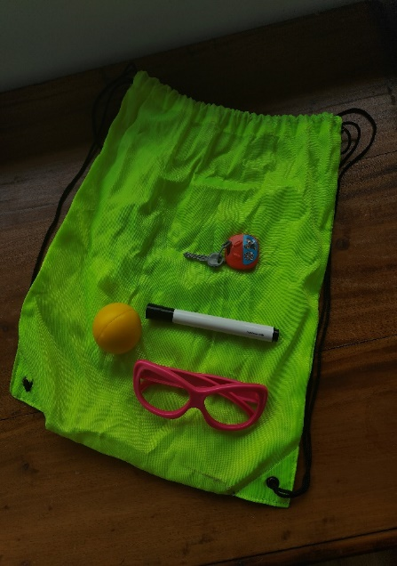
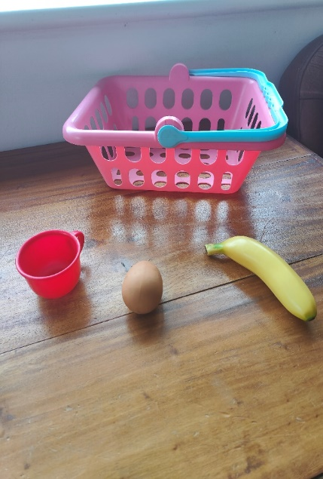
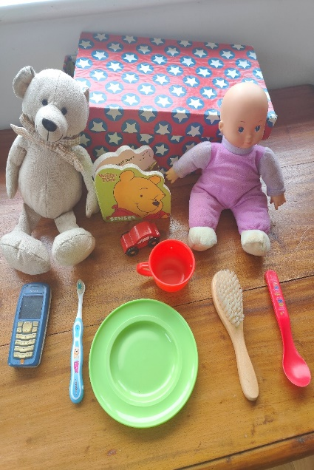

Description of activity:

- The key word level of a particular instruction or request is the minimum number of words in a sentence that the pupil needs to understand to carry it out, without extra clues such as facial expressions, natural gesture, routine of the day, familiarity of the instruction etc.

- The concept of Key Word Levels was devised by Knowles and Massidlover (1978) and underpins the Derbyshire Language Scheme.

- Each key word carries MEANING. Many words in a sentence are redundant – particularly in very familiar, highly predictable instructions that a pupil hears every day.

- For example, if the pupil is about to go outside and his mother is there holding a coat and says, ‘Put your coat on’, the pupil does not need to understand any of these words because he can see what is needed to do from the context. So, given this situation and particular instruction, ‘Put your coat on’ = 0 key words (the pupil is following routine and context).

- When providing instructions or directions, it is helpful to know how many key words the pupil is currently understanding. Then, gradually aim to extend their understanding of instructions within fun, play-based games.

- When increasing instructions within the following games, (e.g. moving from 1 key word to 2 key words), initially the pupil will need extra help and clues; pausing, gesture and overemphasizing of key words. If the pupil is successful in completing the instruction with extra clues, gradually reduce and fade out the clues.

Below are activities to develop 1 and 2 word level requests/instructions:

1 Key Word:

Feely Bag – Common Objects

Bag containing 8 -10 objects, either a mixture of objects or a specific category (e.g. animals, food, clothes).
Take out 2 - 4 of the objects, put them in front of the pupil and ask the pupil to, e.g. 'Find the ball.' etc.

Post Box – Common Objects

Collection of objects or photo/picture cards.

Comprehension: Place 2 -4 objects or pictures in front of pupil. Give the pupil the instruction, e.g. 'Find the dog,' etc. and then the pupil can post the picture in the box.

Shopping Activity - Food
Use same equipment as in the feely bag. Set up a 'shop' with 3 -4 items out at a time. Give the pupil a basket/bag and ask them to go and 'buy' an item, e.g. ‘Get me a banana’.

Beanbag Game – Body Parts
Comprehension: Give the pupil a beanbag. To practise learning body parts, ask the pupil to place the bean bag for example, 'On your head', 'On your foot' etc.

Spotty Dots/Stickers – Body Parts/Clothes
Comprehension: Using a doll/teddy and stickers, ask the pupil to put the stickers on different body parts for example, 'On dolly's tummy' etc.

Simple Actions
Comprehension: Using a teddy/doll, ask the pupil to get the teddy to do different things, for example, 'Make teddy jump', 'Make teddy sleep' etc. The adult can also encourage the pupil to do different actions to make it more fun and active.

Animals – Farm/Zoo Set
While playing with the farm/zoo set, build on comprehension by asking simple questions or giving simple instructions, e.g. ‘Where’s the cow?’ or ‘Put the pig here’.

2 KEY WORDS:

Animal toy/puppets

Choose 2 different toy animals or puppets, e.g. horse and dog. Ask the pupil 2-part commands containing a body part e.g. ‘Touch the horse’s head’, ‘Touch dog’s foot’.

Choose 2 or 3 different characters (monkey, teddy, and doll), plus some objects to put the characters in (e.g. box, toy chair, cushion). Give the pupil an instruction containing a place name, e.g. ‘Put the monkey on the cushion,’ or ‘Put the dolly on the sofa’.

Vehicles/Figures

Give the pupil instructions, for example, ‘Put the lady on the bus’, ‘Put Postman Pat on the train’. Again, encourage the pupil to tell you what to do to develop expressive language.

Use a box and chair, and small vehicles. Use instructions such as, ‘Put the fire engine in the box,’ ‘Put the car under the chair’.

Use the vehicles and give to different people, e.g. ‘Push the car to mummy,’ ‘Push the bus to Ryan’.

Food and Dolls

Feeding game – Have a selection of plastic food (at least 2 to 3 different food items) and 2 different dolls/puppets. Ask the pupil to, ‘Give the dolly an apple,’ ‘Give the teddy a banana’. Again, encourage the pupil to tell you they are doing/giving the puppets to encourage expressive language.

Action and Characters

Using teddies/dolls, T.V characters, plus sponge, hairbrush, cup, spoon. Ask the pupil to carry out 1 or 2 actions on the toys, e.g. ‘Wash teddy,’ ‘Brush dolly and give dolly a drink’.

Using the teddies/dolls, ask the pupil to do different actions with the toys, e.g. ‘Make teddy sleep,’ ‘Make dolly jump’.

Resources:

Photos showing some resources put together to support handout activities (see above).
Appendix 10 "The Concept of Key Words" handout.

PIVATS Listening & Understanding Milestone P5

Picture to Picture

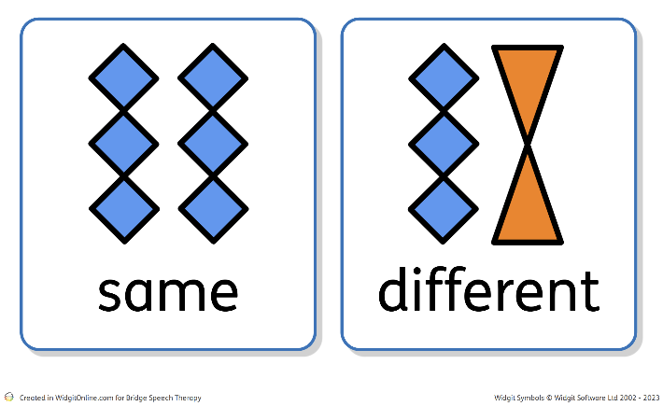
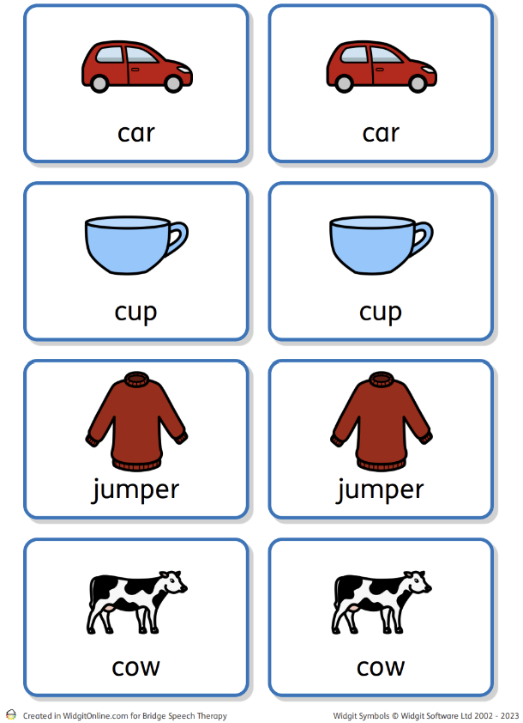

Widgit Symbols © Widgit Software Ltd 2002-2023 www.widgit.com

Description of activity:

- Play within a structured activity that is 1:1.
- You will need two identical pictures of each object/item/character you are using.
- Initially use the same set of pictures, until the pupil becomes familiar with the activity.
- Initially, use pictures within set, familiar categories. It is usually good to start with every-day objects, e.g. cup, brush, toothbrush, plate, spoon, or use highly motivating items/objects/characters focusing on the pupil’s interests.
- Other categories to explore later might include clothing, classroom items, animals, food, transport. If the pupil has a particular area of interest, this can be useful for motivation, although sometimes pupils find it challenging to be flexible with their play around favoured items/topics.
- Using a feely bag, covered shoebox or another container helps to create interest and curiosity.
- Initially have two pictures out on the table/floor, pick these up or point to them as the pupil labels them.
- Offer the bag/container to the pupil to “find something” encourage them to pick one item without peeking.
- Once the pupil has pulled a picture out the bag/container say, “Find the same.” Signing “same” and/or using a symbol for same can support understanding.
- If the pupil picks up the matching picture, or puts the picture next to the matching picture, label both items as you move/point/touch them, e.g. “Car, car. They are the same.” Support the verbal with signing ‘same’ and/or showing a symbol to reinforce understanding.
- If the pupil picks up the different picture or puts the picture next to the different one, label both items as you move/point/touch them, e.g. “Car, jumper. They are different, not the same.” Support the verbal with signing ‘different’ and/or showing a symbol to reinforce understanding.
- Offer the bag/container back to the pupil with only the matching item in and repeat to enable them to pick the matching picture.
- Gradually increase the number of pictures for matching.
- This can bridge into other games such as picture pairs.

Resources:

A range of objects and corresponding pictures, visual symbols for same and different such as the Widgit symbols shown.

PIVATS Listening & Understanding Milestone P5
PIVATS Talking & Communication Milestone P5

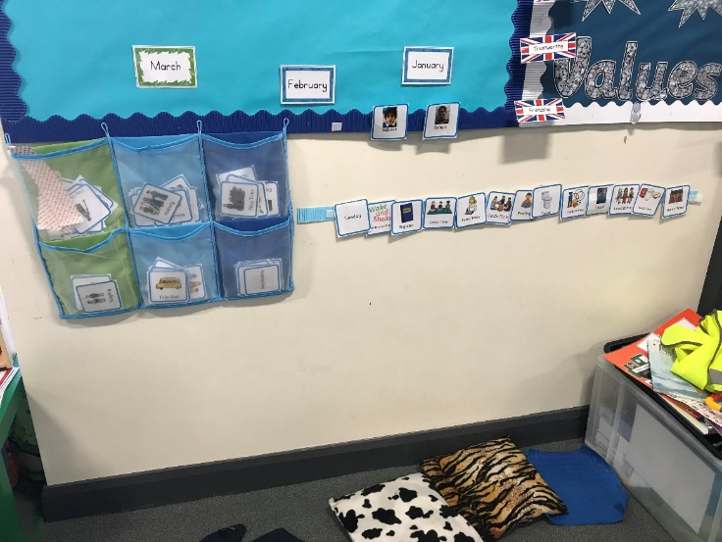
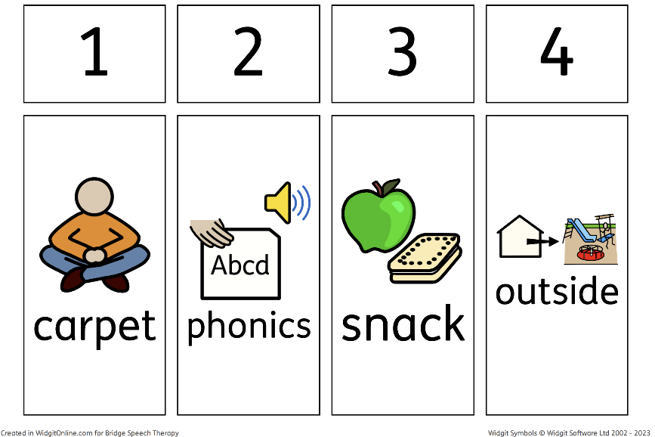
Visual Timetable
Widgit Symbols © Widgit Software Ltd 2002-2023 www.widgit.com

Thanks to Reedley Primary School for the permission granted.

Description of activity:

- The visual timetable should move on from the use of a now and next board (Activity 7) to let the pupil know what is happening throughout the day.
- The now and next board (Activity 7) can be used with object of reference cards, photos, or symbols.
- The timetable has a set place within the environment that the pupil returns to between each activity to remove completed activities and check what is happening next.
- The adult verbally reinforces the visual timetable with simple language, “Now it is phonics,” and guides the pupil towards the activity.
- At the end of the first activity guide the pupil back to the visual timetable.
- Prompt the pupil to remove the object reference card/photo/symbol for the completed activity and verbally reinforce, “Phonics is finished.” Put the discarded card/photo/symbol in an envelope or box.
- The adult points to and verbally reinforces, “It is time for snack,” and guides the pupil to the next activity.
- To encourage the pupil to complete less-motivating activities, ensure a highly motivating activity is in the ‘next’ position.
- It is important to be consistent in using this for it to have the intended impact.

Resources:

- A timetable and a range of object of reference cards/photos/symbols for the activities with which a pupil will be engaged in throughout the day.
- Whether you use photos/symbols will depend on the pupil’s visual representation/interpretation skills.
- Appendix 7 – Visual Supports in the Classroom

PIVATS Listening & Understanding Milestones P5 & One Stage 1

Picture to Object

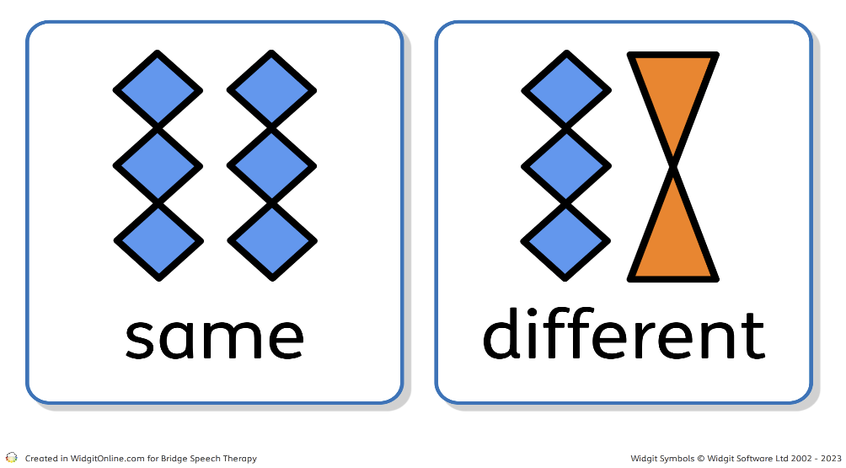
Widgit Symbols © Widgit Software Ltd 2002-2023 www.widgit.com

Description of activity:

- Play within a structured activity that is 1:1.
- Initially use the same set of objects and pictures, until the pupil becomes familiar with the activity.
- Initially, use objects and pictures within set, familiar categories. It is usually best to start with every-day objects, e.g. cup, brush, toothbrush, plate, spoon.
- Other categories to explore later might include clothing, classroom items, animals, food, transport. If the pupil has a particular area of interest, this can be useful for motivation, although sometimes pupils find it challenging to be flexible with their play around favoured items/topics.
- Using a feely bag, covered shoebox or another container helps to create interest and curiosity.
- Pictures might need to be photos for some pupils, or when initially introducing this target. Moving to symbols or more generic pictures of objects supports flexibility of thought, that the items do not need to be identical to be able to represent each other.
- Initially have two pictures out on the table/floor, pick these up or point to them as the pupil labels them.
- Offer the bag/container to the pupil to, “Find something.” Encourage them to pick one item without peeking.
- Once the pupil has pulled an item out the bag/container, say, “Find the same.” Signing “same” and/or using a symbol for same can support understanding.
- If the pupil picks up the matching picture, or puts the object next to the matching picture, label both items as you move/point/touch them, e.g. “Cup, cup. They are the same.” Support the verbal with signing ‘same’ and/or showing a symbol to reinforce understanding.
- If the pupil picks up the different picture or puts the object next to the different picture, label both items as you move/point/touch them, e.g. “Cup, brush. They are different, not the same.” Support the verbal with signing ‘different’ and/or showing a symbol to reinforce understanding.
- Offer the bag/container back to the pupil with only the matching item in and repeat to enable them to pick the matching picture.
- Gradually increase the number of objects and pictures for matching.

- This can bridge into continuous provision/other areas of the setting, such as at unstructured times. It is important to have pictures/photos or symbols of objects in the area. Using the same language, “find the same”, encourage pupils to find similar items from a choice of two or more, such as finding a leaf from a leaf and stick in forest school, or a matching spade or bowl in the sand/water.
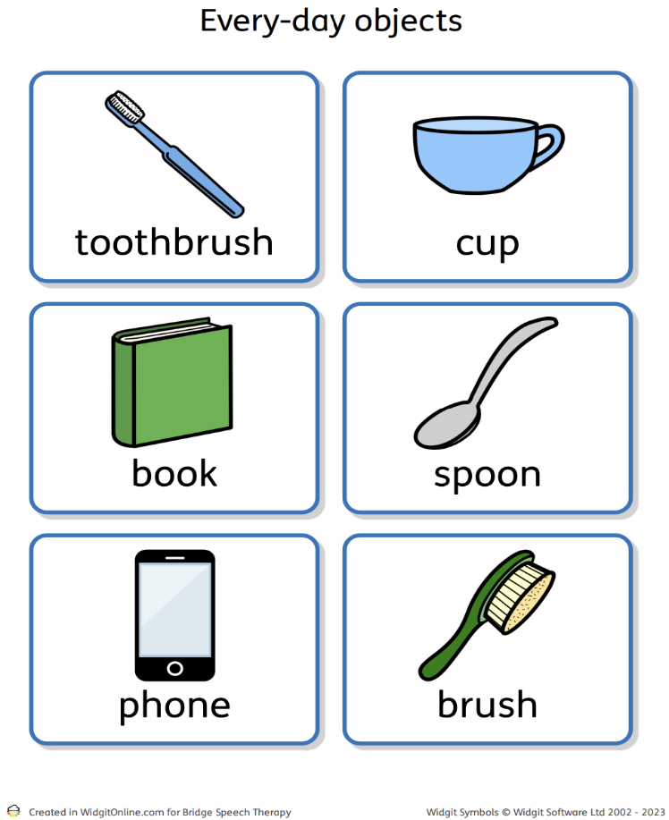
Widgit Symbols © Widgit Software Ltd 2002-2023 www.widgit.com

Resources:

A range of objects and corresponding pictures, visual symbols for same and different such as the Widgit symbols shown (above).

Progression/Next steps:

Move onto picture – picture matching (Activity 12)

This can support pupils using communication boards to understand the link between a visual representation of an object and the actual object.

PIVATS Listening & Understanding Milestone P6

Another Object in Category
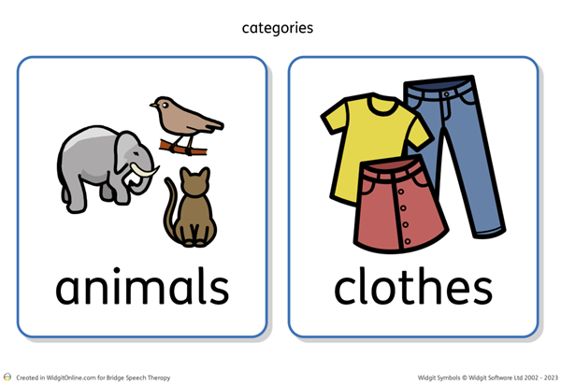
Widgit Symbols © Widgit Software Ltd 2002-2023 www.widgit.com

Description of activity:

- Play within a structured activity.
- This might be 1:1 or in a small group.
- Have one category picture out on the table and label this and link to a function word if appropriate, “We’re thinking about clothes, things we wear, clothes”.
- Tip out a selection of objects or pictures, between three and five.
- Adult models finding things for the given category, “A t-shirt, that is clothes, something that we wear, a t-shirt,” and moves it close to the category picture.
- The adult may need to model two items.
- Ask the pupil, “Find more clothes.”
- If the pupil indicates an item/picture that matches the category, by reaching or eye-pointing, label it, e.g. “A hat, that is clothes, something that we wear, a hat”.
- If the pupil indicates an item/picture that does not match the category, by reaching or eye-pointing, label it, e.g. “An apple, that is food, something that we eat, an apple”. Either the adult models, or prompts the pupil, to place the item to one side and asks again, “Find more clothes”.
- Gradually increase the number of items and the range of categories

Resources:

A range of objects. Visual symbols to represent the categories, e.g. selected Widgit symbols shown above.

Progression/Next steps:

Pupil identifies the odd one out from a selection of objects/pictures (Activity 19)

Pupil sorts objects into 2 broad categories (P7) (Activity 21)

PIVATS Listening & Understanding Milestone P6

Object by Function

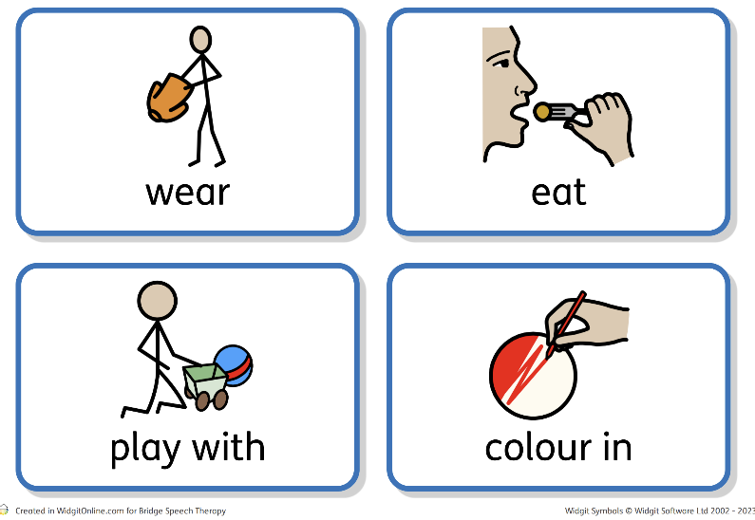
Widgit Symbols © Widgit Software Ltd 2002-2023 www.widgit.com

Description of activity:

- Play within a structured activity.
- This might be 1:1 or in a small group.
- Initially identify three or four familiar functions to introduce, e.g. eat, wear, play with, colour with.
- Collect a range of objects and pictures to match the functions you have chosen.
- Have two or three items out on the table/floor all with different functions, e.g. t-shirt, apple and a felt tip.
- Initially, have a visual symbol to show the function, label it for the pupil and ask them to find an item to match the function, e.g. “Things that we wear, clothes we put on. Find something that we wear.”
- If the pupil selects an item, by reaching or eye-pointing, that matches the requested function, label the item and the function, “A t-shirt, we wear it, a t-shirt”.
- If the pupil selects an item, by reaching or eye-pointing, that does not match the requested function, label the item and its function, e.g. “An apple, we eat it, an apple,” then repeat the request, “Find something that we wear.” Reinforce understanding by pointing to or picking up the visual symbol for wear.
- Signing or natural gesture can support understanding. This can be gradually reduced, if appropriate, as the pupil becomes more confident with the activities.
- Gradually increase the number of items and the range of functions.

Resources:

A range of objects. Visual symbols to represent the functions selected Widgit symbols shown above.

Progression/Next steps:

Pupil labels items linked with a given function.

PIVATS Listening & Understanding Milestones P6, P7 & Bridge

Whole Body Listening

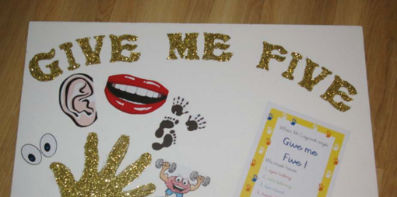
Thanks to Ben Laycock, Bridge Speech Therapy

Description of activity:

Pupils benefit from explicit teaching of what good listening is. The concept of whole-body listening is teaching pupils that we don’t just use our ears to listen. There are 5 key behaviours/areas that are focused on:

- Ears are listening.
- Eyes are looking (where appropriate as neurodiverse children may find this too challenging).
- Hands and feet are still – this may be unrealistic/unhelpful for some pupils who may listen better if they are fiddling. This is very much about knowing your cohort but you may wish to change the terminology to ‘listening hands and feet’.
- Lips are closed.
- Brain ready/ready to learn/brain box on (whichever terminology reinforces schools focus)

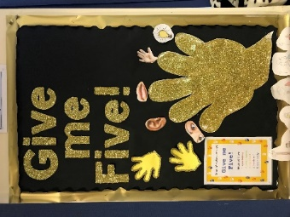

It is recommended that you have visuals ready to support these prior to teaching whole body listening. You may have these agreed as a whole school or have your own.

- Demonstrate bad listening – ask a pupil to come and have a conversation with you. They may be allowed to ask you anything they want! Once the pupil begins talking start showing some poor listening skills; move around, fiddle with your clothes/bag, don’t look at them, maybe hum to yourself.
- Ask the pupil how it felt.
- Talk about what good listening skills are vs bad listening skills.

- The children can then practise good listening skills with you and/or a partner.
- Introduce the prompt of ‘Give me 5!’ Explain that when you call “Give me 5!” and hold up your hand (it might be your actual hand or a foam hand/picture), you are asking pupils to listen to you with their whole bodies, remembering eyes, ears, lips, hands/feet and their brain.

Additional activities used in some schools include; hand prints and sticking a visual on each finger to make a listening display; sharing information and listening activity ideas with parents; running poster competitions etc.

PIVATS Listening & Understanding Milestones P6, P7, P8, Bridge, One Stages 1 & 2

Developing Linguistic Concepts

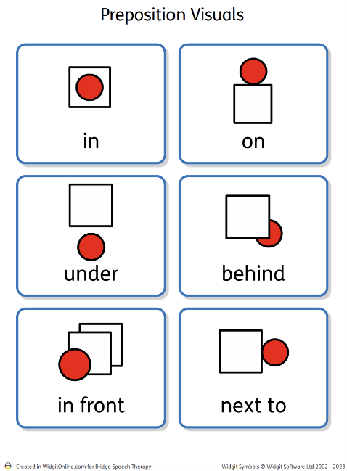
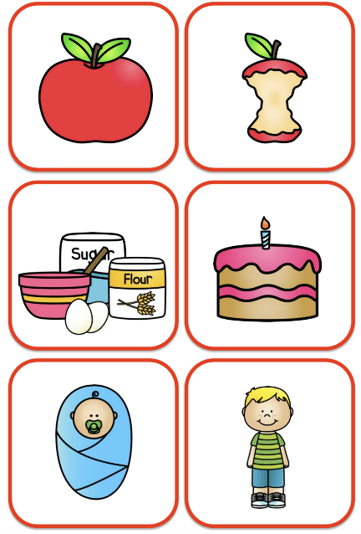
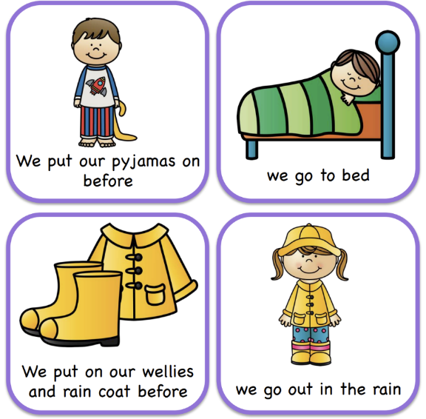

Permissions from Widgit and Carrie Hughes SLT
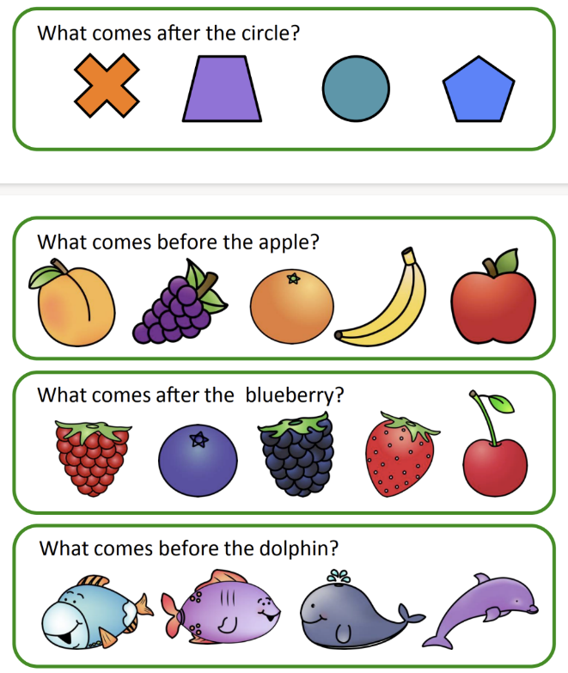
Description of activity:

- There are a wide range of linguistic concepts that we need to teach pupils. There may be resources available in your setting to support each concept. It is often possible to use everyday resources to develop understanding, e.g. a bag or a box with a lid are useful for prepositions as you can put items in, on or under.
- Where possible, support the pupil’s understanding with visual supports
- Play within a structured activity.
- This might be 1:1 or in a small group.
- Initially adult and pupil take turns to demonstrate understanding of the linguistic concept, this ensures that natural models are built into the activity.
- As the pupil’s understanding develops the adult should make purposeful errors, when it is their turn, to encourage the pupil to attend to others’ turns, to reinforce understanding and to encourage them to tell the adult.
- Staff need to leave a pause, e.g. count to 10, to give pupils time to express themselves, before offering the suggested models.
- Depending on your pupils' individual needs it is best to begin with real objects that the pupils can interact with before moving onto using pictures, e.g. putting items in/on/under/in front/behind a box before looking at pictures of items in different places.

- It is important to teach the concept in a structured way on its own, before putting it in longer sentences and then using it within the classroom, e.g. teach before/after in a structured activity – which one is before? Which one comes after? Looking at 3 sequence cards of a familiar everyday activity.
- Once the pupil is confident with this, use the concept in longer instructions, still within a structured activity, e.g. before you touch your toes, clap your hands. Then begin to apply this knowledge into the classroom.
- Remember to initially support understanding with visuals.

Resources:

Appendix 10 – Following Instructions and extending understanding – the concept of key words.
Appendix 12 – Linguistic Concepts

PIVATS Listening & Understanding Milestone P7

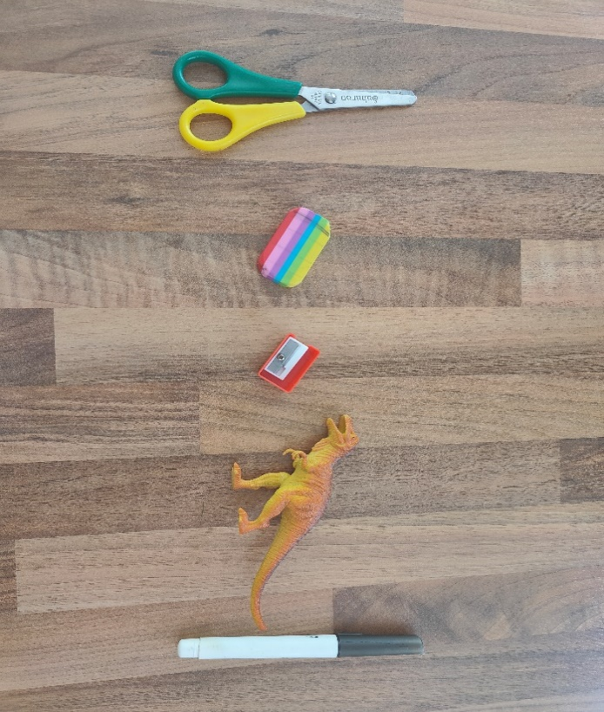
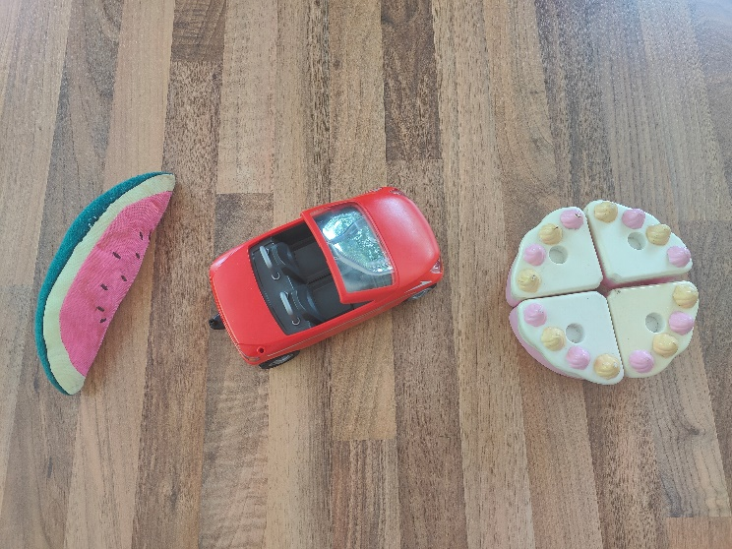
Odd One Out
Description of activity:

- Play within a structured activity.
- This might be 1:1 or in a small group.
- Have 3 items/pictures. 2 from one category and 1 from a different category e.g. car, bus, apple. Name each item/picture as you touch/lift/place it down.
- Explain ‘the odd one out’ is because it is in a different category/group.
- Adult to model the first turn, e.g. “A car, that is transport. A bus, that is transport. An apple, that is food, not transport. The apple is the odd one out”.
- A pupil can indicate the odd one out by pointing, picking up, touching or eye-pointing.
- Initially adult and pupil take turns to find the odd one out to offer natural models within the activity.
- As the pupil’s understanding develops the adult should make purposeful errors when it is their turn to encourage the pupil to attend to others’ turns, to reinforce understanding and to encourage them to tell the adult.
- Staff need to leave a pause, e.g. count to 10, to give pupils time to express themselves, before offering the suggested models.
- Gradually increase the number of items and the range of categories.
- You can model identifying objects from a different category when tidying up resources – purposefully put items in the wrong place/basket/box.

Resources:

A range of objects.

Progression/Next steps:

Pupil can sort objects and pictures into given sub-categories (Activity 21) e.g. sorting transport pictures into land, sea, and sky (P8)

PIVATS Listening & Understanding Milestones P7 & P8

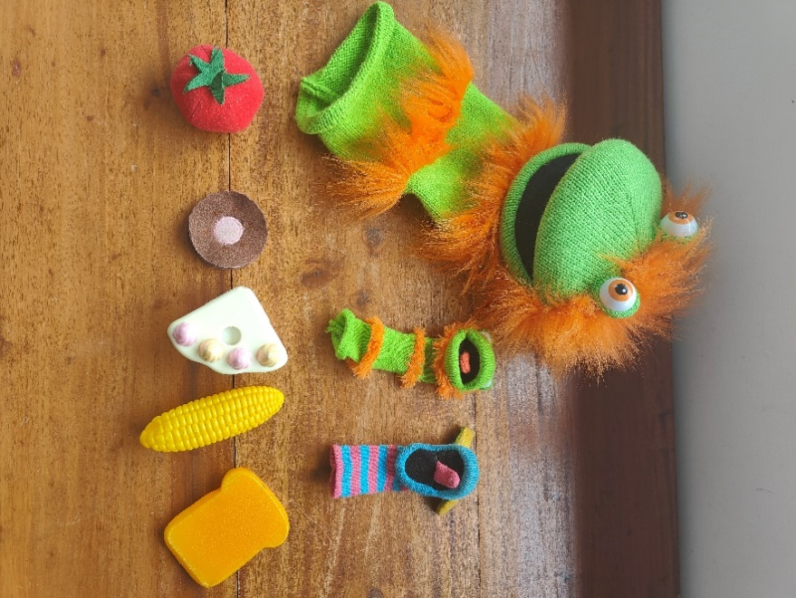
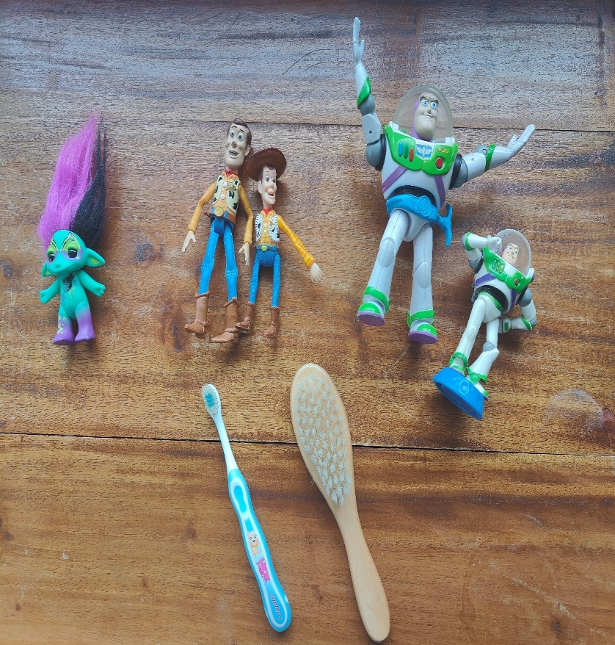
3-4 Word Level Comprehension

Description of activity:

- A useful way of describing and developing a pupil’s ability to understand instructions and process language is through Key Word Levels (or ‘Information Carrier Words’).

- The key word level of a particular instruction or request is the minimum number of words in a sentence that the pupil needs to understand in order to carry it out without extra clues, such as facial expressions, natural gesture, routine of the day, familiarity of the instruction etc.

- The concept of Key Word Levels was devised by Knowles and Massidlover (1978) and underpins the Derbyshire Language Scheme.

- Each key word carries MEANING. Many words in a sentence are redundant. Particularly very familiar, highly predictable instructions that a pupil hears every day.

- For example, if the pupil is about to go outside and his mother is there holding a coat and says, ‘Put your coat on’, the pupil does not need to understand any of these words because he can see what is needed to do from the context. Given this situation and particular instruction, ‘Put your coat on,’ = 0 key words (the pupil is following routine and context).

- When providing instructions or directions, it is helpful to know how many key words the pupil can currently understand. Then, gradually aim to extend their understanding of instructions within fun, play-based games.

- When increasing instructions within the following games, (e.g. moving from 2 key word to 3 key words), initially the pupil will need extra help and clues; pausing, gesture and overemphasizing key words. If the pupil is successful in completing the instruction with extra clues, gradually reduce and fade out the clues.

Below are activities to develop 3 and 4 word level requests/instructions:

The activities below are comprehension activities for when the pupil is listening to an adult giving the instructions. To develop the pupil’s expressive language skills, using the concepts and including all the information, let them have a turn to give instructions, with appropriate modelling and prompts as necessary.

To check the instructions have 3-4 pieces of information that the pupil truly understands, make sure there are plausible alternatives for all the words underlined (i.e. the key words). This will ensure the pupil has listened and understood the instruction correctly, e.g. "Give Spiderman the square biscuit.” there needs to be Spiderman, plus another character, e.g. Wonder Woman. There will also need to be a square biscuit and a circular biscuit, plus a square cake and a circular cake.

Barrier games

Have 2 full sets of matching pictures, e.g. the parts to build a snowman. Take it in turns to give each other instructions and then check that each person has listened/given clear instructions by seeing if your sets match, e.g. “Put the big snowball on top of the little snowball,” or “Put the black hat with the red stripe on the snowman’s arm”.
Other barrier games you could use include using a map and moving different coloured/sized vehicles around to different locations.

Putting coloured/shaped beads or counters in a particular order offers the opportunity to listen to and use sequential language and specific concepts, e.g. "Put the red square before the yellow triangle".

Food and Characters

Have a selection of food pictures; including different colours of the same foods, e.g. red apple and green apple, different coloured peppers etc. Also include different sizes/shapes of the same food e.g. big cake and little cake or square biscuit and circle biscuit. Have a couple of characters, either real objects, e.g. Spiderman and Wonder Woman, or pictures. You could also have a range of different coloured/sized plates.

Take it in turns to give each other instructions, e.g. “Give Spiderman the big pear,” or “Give Wonder Woman the green pepper”.

Action and Characters

Using motivating characters, plus a sponge, hairbrush, cup and spoon. Ask the pupil to carry out different actions, e.g. ‘Wash SpongeBob’s feet’, ‘Brush Woody’s boots".

Using the motivating characters, ask the pupil to do different actions with the toys, e.g. ‘Make Batman sleep on the bed’, ‘Make Barbie jump on the chair’.

Resources:

Photos showing some resources put together to support handout activities (see above). Appendix 14 "The Concept of Key Words" handout.

PIVATS Listening & Understanding Milestones P7 & Bridge
PIVATS Talking & Communication Milestones P8 & Bridge

Sort 2 Categories
Widgit Symbols © Widgit Software Ltd 2002-2023 www.widgit.com

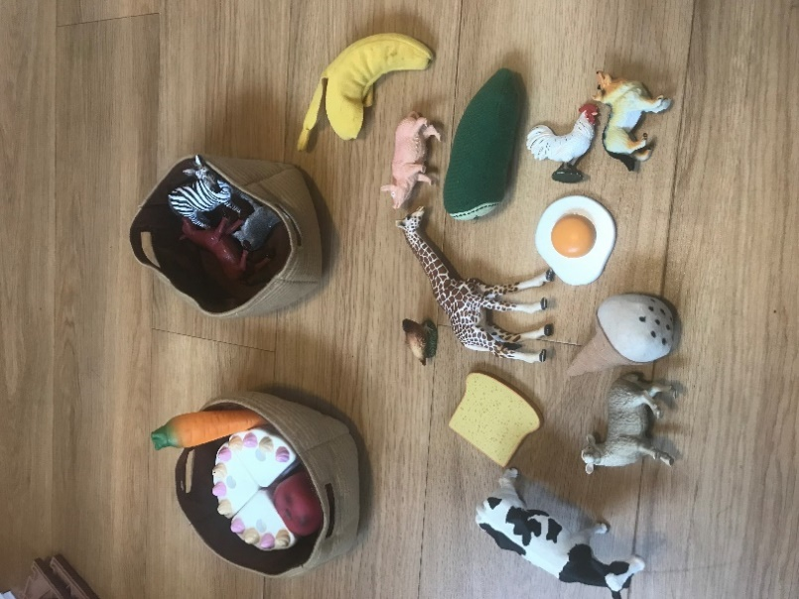
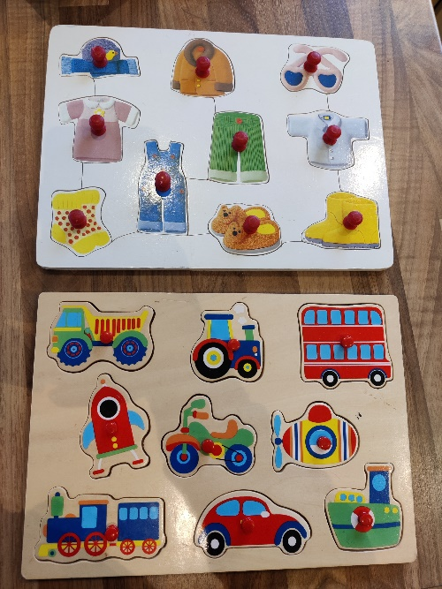

Description of activity:

- Play within a structured activity.
- This might be 1:1 or in a small group.
- Have two category pictures out on the table. Talk about each of these first, e.g. label the category and link to a function word if appropriate, “We’re thinking about clothes, things we wear, clothes”.

- Place the cards, with an obvious distance between them. You may want to put them inside a hoop on the floor, or on separate pieces of paper on the table, to highlight that they are separate groups/categories.
- Tip out a selection of objects or pictures, between 6-10.
- Adult models picking up an object/picture and moving it to one of the category cards, e.g. “A cow, that is an animal, we might see it on the farm, it says moo, a cow is an animal.”
- The adult may need to model 2 items.
- The pupil takes a turn.
- If the pupil places an item/picture in the correct category, by moving the picture/object or eye-pointing but does not name the item or the category then model, e.g. “Trousers, that is clothes, something that we wear, trousers.”
- If the pupil places an item/picture that does not match the category, by moving the pictures/object or eye-pointing, label it, e.g. “A cat, that is an animal, it can be a pet, it says meow, a cat”. Either the adult, or prompt the pupil, to place the item with the correct category card.
- Staff need to leave a pause, e.g. count to 10, to give pupils time to express themselves, before offering the suggested models.
- Encourage the pupil to label the categories.
- Gradually increase the number of items and the range of categories.
- You can sort items/pictures into other containers, e.g. shoe boxes, baskets etc.
- You can model sorting of categories when tidying up resources.
- You can use two (or more) different form-board jigsaws with different categories. Place all the pieces in a feely bag and, taking turns to take a piece out, label the item and the category and then place it in the correct board.

Resources:

A range of objects. Visual symbols to represent the categories selected Widgit symbols shown above.

Progression/Next steps:

Pupil can sort objects and pictures into given sub-categories e.g. sorting transport pictures into land, sea, and sky (P8). (Activity 22).

PIVATS Listening & Understanding Milestone P8
PIVATS Talking & Communication Milestone One Stages 1 & 2

Sort 2 Sub-Categories
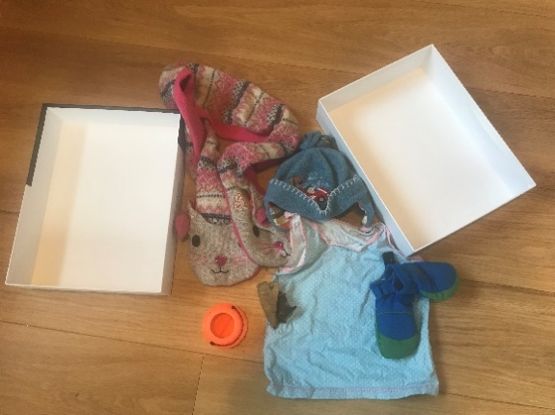
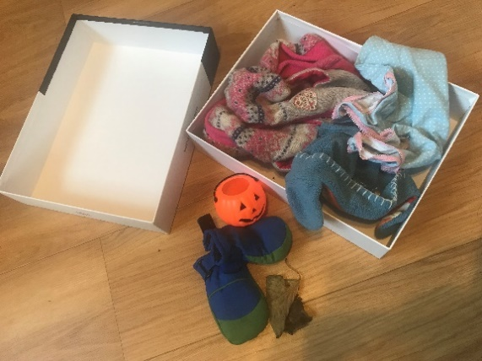
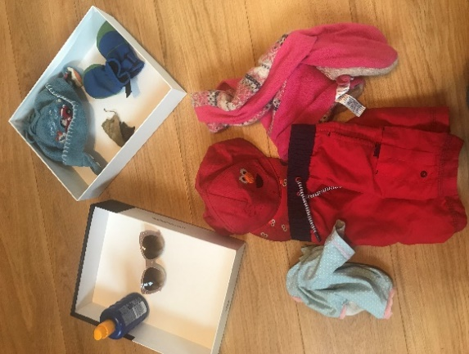
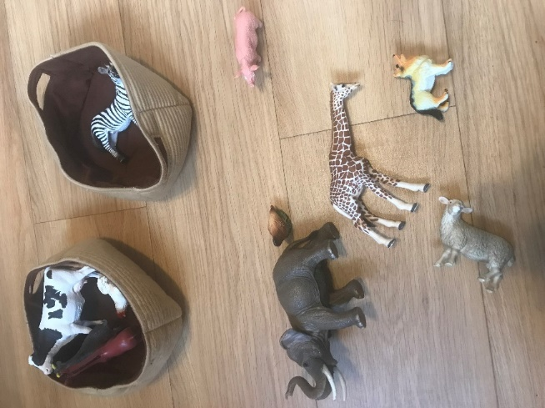
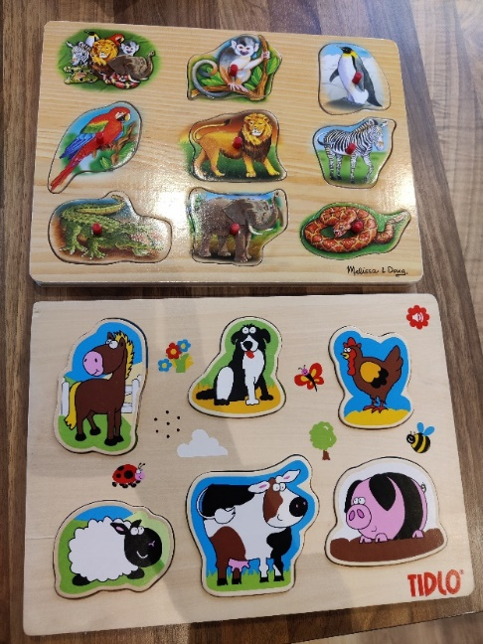

Description of activity:

- Play within a structured activity.
- This might be 1:1 or in a small group.
- Have two sub-category pictures out on the table e.g. zoo animals and farm animals. Talk about each of these first e.g. label the sub-category and link to a broad category and briefly differentiate between the sub-categories e.g. “Zoo animals, they are animals that we see in the zoo, they might not normally live in the UK. Farm animals, they are animals on the farm, we might see them in the fields, or they might be in a barn.”
- Place the cards with an obvious distance between them. You may want to put them inside a hoop on the floor or on separate pieces of paper on the table to highlight that they are separate groups/categories.
- Tip out a selection of objects or pictures, between 6-10.
- Adult models picking up an object/picture and moving it to one of the sub-category cards, e.g. “A zebra, that is a zoo animal, it lives in the zoo, it is from Africa.”

- The adult may need to model two items.
- The pupil takes a turn.
- If the pupil places an item/picture in the correct sub-category, by moving the picture/object or eye-pointing but does not name the item or the category then model, e.g. “Chicken, a farm animal, it lays egg. A chicken is a farm animal.”
- If the pupil places an item/picture that does not match the sub-category, by moving the pictures/object or eye-pointing, label it, e.g. “An elephant is a zoo animal, we don’t see it at the farm or in the fields, an elephant is a zoo animal.” Either the adult, or prompt the pupil, to place the item with the correct sub-category card.
- Staff need to leave a pause, count to 10, to give pupils time to express themselves, before offering the suggested models.
- Gradually increase the number of items and the range of sub-categories being sorted at one time e.g. school clothes, winter clothes, summer clothes.
- You can sort items/pictures into other containers e.g. shoe boxes, baskets etc.
- You can model sorting of sub-categories when tidying up resources.
- You can use two (or more) different form-board jigsaws with different sub-categories. Place all the pieces in a feely bag and taking turn to take a piece out, label the item and the category and then place it in the correct board.

Resources:

- Use objects (as above), photos if appropriate or early year board jigsaws are great with the pieces all put in a feely bag.
- Pupils can practise turn-taking to take a piece out the bag, name it and find the right category, putting in a bag/hoop, back into the jigsaw or if using pictures on a themed background.
- Lots of repetition of the category names as well as the specific vocabulary for each item from supporting adults.

A range of objects, Visual symbols to represent the categories selected Widgit symbols shown below:
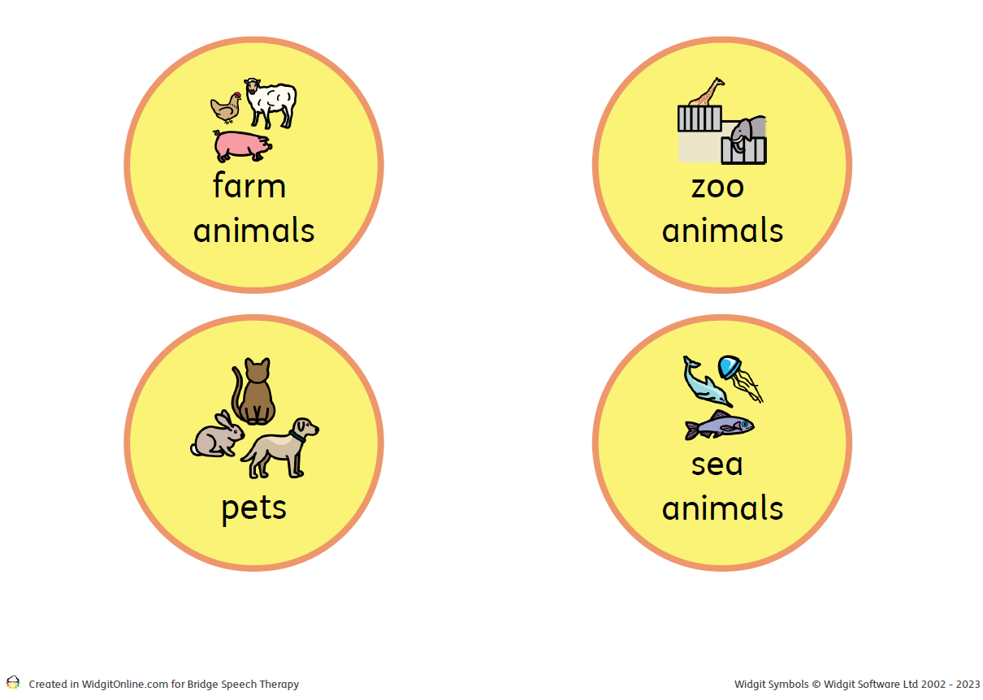

Widgit Symbols © Widgit Software Ltd 2002-2023 www.widgit.com

PIVATS Listening & Understanding Milestones P8, Bridge & One Stage 2

Barrier Games

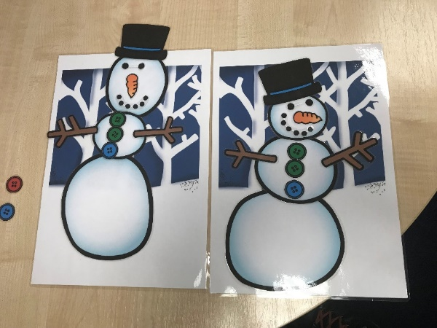
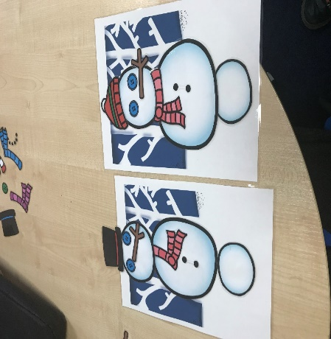

Description of activity:

Barrier Game Activities:

Two or more players have identical sets of resources and take turns to listen to/give instructions on how/where to place them without the other player being able to see (hence the barrier). Check at the end if the resources look the same.

Resources:

The resources in these photographs, above, were kindly provided by https://carriehughes-slt.co.uk/.

Appendix 15 – Barrier Games

A video to demonstrate can be accessed via https://youtu.be/TKybWuzxnac

PIVATS Listening & Understanding Milestone Bridge

Lego Based Activities

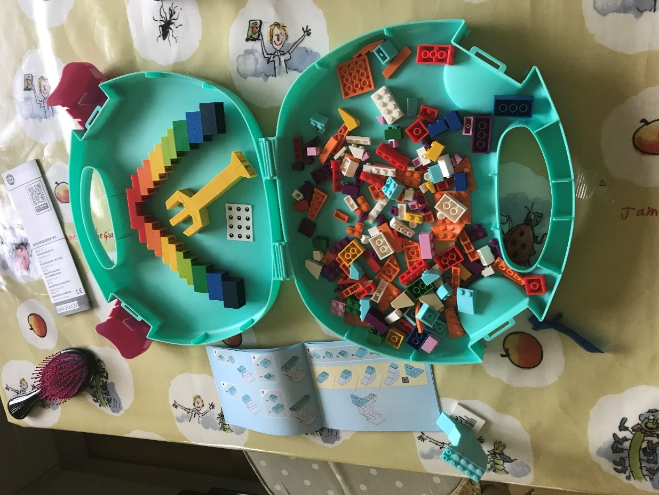

These are not Lego bricks, set from Lidl; Playtive.

Description of activity:

- Lego based activities – could be part of structured Lego based therapy, or just using Lego to support language development.
- Within structured Lego based therapy, pupils take on roles, e.g. the role of the builder who listens to instructions from the architect/engineer (another role).
- Otherwise, the adult (familiar or less familiar) gives instructions verbally, e.g. “Put the two light green blocks under the two yellow blocks.”

PIVATS Listening & Understanding Milestone One Stage 2

Carpet Time/ Whole Class Teaching Cards

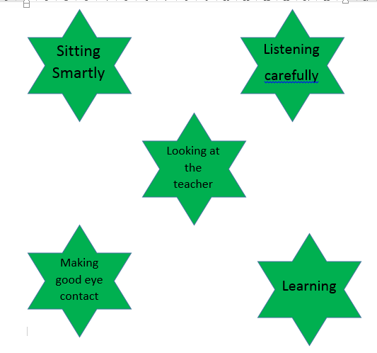

When to use:

‘Teacher Input/Carpet Time Cards’ are appropriate to use are pupils are expected to focus on the teacher or join in with group/whole class discussions. They are often used with pupils who have an Autistic Spectrum Condition (ASC), Attention Deficit Hyperactivity Disorder (ADHD), Attention Deficit Disorder (ADD) or Social, Emotional and/or Mental Health (SEMH) difficulty. They serve as a non-verbal prompt to remind the pupil what is expected of them in this situation.

- ‘Carpet Time Cards’ are particularly useful to encourage pupils to comply with simple requests in a visual way.
- They are a method of enabling pupils to make simple choices in relation to their behaviour.
- ‘Carpet Time Cards’ show the pupil what behaviour is expected of them in this specific situation.

Description of Activity:

- 'Carpet Time Cards/Whole Class Teaching’ can be used to support pupils to achieve success with their behaviour in a situation that presents challenge without these positive visual reminders.

- ‘Carpet places’ can also help a pupil, especially when the prompts or poster are in close proximity.

- To support inclusive practice, introduce to the whole class, using regular reminders and praising pupils when they uphold the expectations. If individual pupils need reminding, say the pupil’s name in front of instructions, pointing at cards, e.g. “Thomas, show me good listening,” and then withdrawing oral reminders and just using positive indication.

Progression/Next steps:

Begin with one picture e.g. ‘good sitting’, then extend this list to include other prompts such as ‘good listening’, remembering to ‘take turns to speak’, etc. Remove prompts as the pupil no longer requires them – allowing the pupil to physically remove the picture and putting it in a bin (or an ‘I have completed box’) which reinforces the positive progress they have made. N.B Reasonable adaptations may need to be made according to children’s needs.

Progress into ‘Talk Partner/Learning Partner’ rules/expectations.

Links…

- ‘Board Maker’ and 'Widgit' are resources that can be useful when creating the cards.
- Websites such as: ‘Twinkl’ or ‘Clip Art’

PIVATS Listening & Understanding Milestone One Stage 1

Today Is – Tomorrow Is

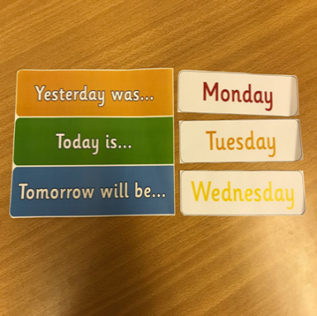

When to use:

This resource is similar in use to a visual timetable in that it helps pupils orientate themselves to the sequence of the days of the week. It is useful when pupils find the vocabulary of sequencing difficult or when they need to be aware of a change in routine.

Why you may choose to use:

To offer a visual structure to support learning of sequencing language and to identify who may need practice on learning the days of the week. It can also reinforce the pupil’s understanding of time and sequences.

Description of Activity:

- Regular use of questions. ‘What day is it today?’ ‘What day was it yesterday?’

- The pupil may be a participant in the chart at first but later may become the instigator of changing the day.

- The cards may change to become a written chart depending on the knowledge of the pupil.

- The pupil may be able to say the day, so no chart is required at all.

Progression/Next steps:

Could be extended to predict the following days of the week. Could be sequenced by the pupil themselves and moved each day so they can see that tomorrow becomes today on the sequence.

Links:

- ‘Twinkl’, SEN teacher; TES often have free printable days of the week.

PIVATS Listening & Understanding Milestone One Stage 1
PIVATS Talking & Communication Milestones P7, P8, Bridge, One Stage 3, Two Stage 1, Three Stage 2, Four Stage 1

Turn Taking Cards

Me
You
Taking Turns

When to use:

Turn taking cards can be used to teach socially acceptable responses used in a range of situations. They are often used with pupils who display Autistic Spectrum Condition (ASC) or Social, Emotional and/or Mental Health (SEMH) traits or behaviours. They serve as a way of reinforcing that the pupil is not always ’first’ and that taking turns is a social skill to be taught and can be practised in ‘real life’ in a none threatening positive way.

Why you may choose to use:

- This resource, along with similar versions, is particularly useful to teach pupils how to respond in a range of unfamiliar situations.
- It is a method of enabling pupils to make simple appropriate choices in relation to their behaviour.
- It reminds the pupil what behaviour is expected of them in this given situation.
Description of Activity:

Turn taking cards can be used to allow pupils to achieve success with their behaviour in a situation that they may feel is difficult to manage without the opportunity to practise their reactions and skills. The cards can be given out when ‘good turn taking’ is observed or as a prompt to remind pupils about the need for turn taking.

Progression/Next steps:

At first pupils may only be able to follow 1 to 3 steps in the turn taking process, such as listening to the other person, letting someone else go first.

The cards are easier to model through games with a trusted small group of peers and including pupils who are good role models of turn taking where possible.

The progression comes from the reduction in the reminders to use and could include rewards for modelling this behaviour. It may reduce cards to verbal prompts and then non-verbal cues.

PIVATS Listening & Understanding Milestone One Stage 1
PIVATS Talking & Communication Milestones P8, One Stage 3, Two Stage 2, Three Stage 2

Circle Time Rules

When to use:

Circle Time Rules are introduced to a small group of pupils prior to beginning a circle time session. Each rule is explained carefully and clearly to the pupils. Refer to the pictures linked to each rule to reinforce the rules.

Why you may choose to use:

- Circle time rules are helpful to use before a circle time session to provide clear structure to the session and appropriate behaviour during it.

Description of Activity:

- Agree and discuss the rules as a class and reinforce at each session.
- Clearly display the rules for all the pupils to see.
- Point to each rule and picture representation as you read out the rules and explain it.
- Continue to refer to rules/pictures throughout the session.
.
Progression/Next steps:

Circle time does not really lend itself to progression except for a reduction in prompts and ease in which a pupil is able to take turns and share their experiences and emotions.

Time engaged in the circle time activity may need to be short initially, depending on the concentration of the pupil but can increase in length over time as the pupil becomes more settled in the routines and more able to contribute.

A pupil should not be forced to contribute but encouraged to share their ideas. Most pupils enjoy using a toy or item to hold to signify when it is their time to talk.

Progression will be pupils accessing the same opportunities without prompts and adult support.

Links:

- Circle time resource online by Jenny Mosely at https://www.circle-time.co.uk/resources/
- TES Circle Time Cards
- Lancashire PHSE scheme of work
- SEAL resources

PIVATS Listening & Understanding Milestone One Stage 2

Mind Maps

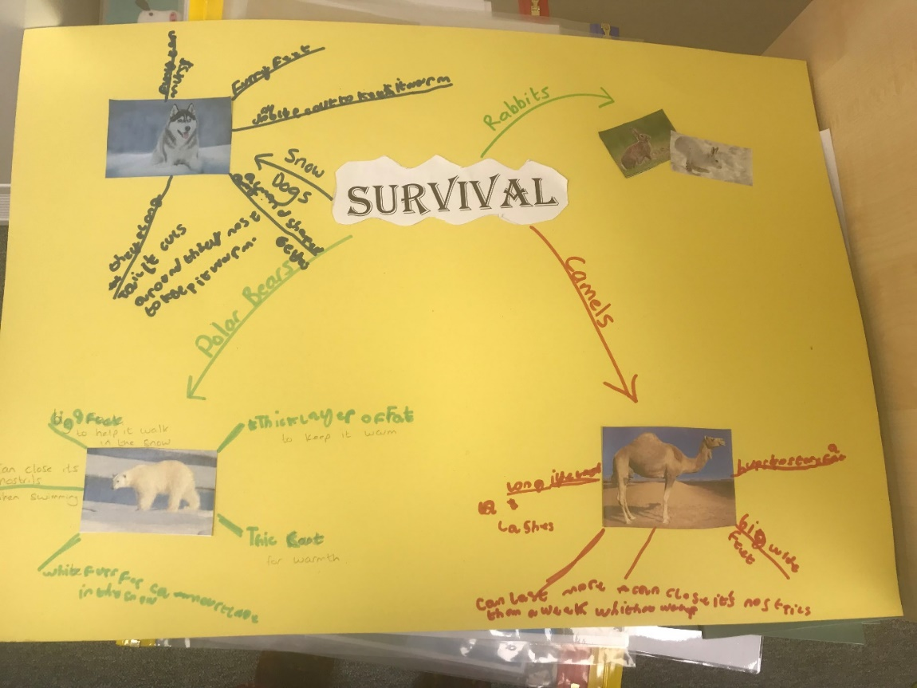

With thanks to Padiham Green C of E Primary School for their permission to use the photo above.

When to use:

A mind map can be used at any time as a visual support/representation of the learning taking place. It can be used before new topics/texts to assess prior knowledge; during the learning as a support for the learning taking place and after the learning as an assessment of this.

Why you may choose to use:

- Mind maps are visual tools to support, develop and organise learning.
- They are structured to help categorise learning to support memory.
- They help us understand concepts by breaking them down into component parts.
- They engage learners and can be used to support collaborative learning.
- They are flexible.

Description of Activity:

- Start with the central concept/idea in the middle.
- Identify its components/categories.
- Add these to branches leading from the main idea.
- Break each component/category using key words, images and colour.

Progression/Next steps:

- Initially components/categories may be given, however progression may include pupils identifying categories/sub-headings for themselves.
- Start with an initial thought shower of associated words and ideas and then identify categories from these. You may limit the number and have a category for 'other' where the miscellaneous information can be organised.
- Each category could develop into sub-categories.

Example Activity Above:

With a focus on the class topic ‘survival,’ the pupil gradually builds knowledge reinforcing topic vocabulary. In this instance, during each supported session, the pupil focused on one animal, using colour coding and visuals to support. This began with the focused vocabulary and information from whole class learning and then began expanding based on the pupil's interest.

Resources:

- Appendix 17 – "Mind Maps"

PIVATS Listening & Understanding Milestone Four Stage 2
PIVATS Talking & Communication Milestones Three Stage 1 & Four Stage 2

A Game Explaining Idioms

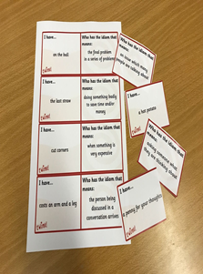

When to use:

When a pupil is struggling to understand idiosyncratic language such as ‘pull your socks up’ or 'it’s the last straw.'

Why you may choose to use:

- It allows pupils to become familiar with the phrases that have become part of everyday English language.
- It is particularly useful as a teaching aid for pupils who have a literal understanding of language – such as pupils with ASC.
Description of Activity:

- Use 1-1 or as part of a small group of pupils. It will allow for familiarity and discussion.

- The idiom game is a way of repeatedly supporting a pupil’s understanding of idioms. It will usually come after specific teaching of some common examples for the pupil to learn and understand.

- You will start with a couple of common idioms, perhaps ones that the pupil has come across or chosen to explore, or the teacher has identified, and then once these have been understood, extra examples can be added.

- The cards and the games allow for conversations. The next step would be pupils recognising idioms in conversations and language in books and researching their meanings before feeling confident enough to use them appropriately with others.

Resources:

Printed idiom games can be used, or the pupil could create their own picture based on their developing understanding. It is good to repeat regularly and to be able to role play, if necessary, some of the ideas.

Pupils could collect them as they come across them.

Links:

- http://www.instantdisplay.co.uk (click on writing and idiom game is listed to download)

PIVATS Talking & Communication Milestones P6, P8, Three Stage 1 & Four Stage 1

Green/Red Help Cards

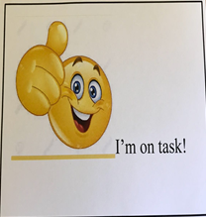

I need help please
I’m doing great thanks

When to use:

Green and red help cards card are useful in helping any pupil self-evaluate when they are able to work independently and when they need some extra adult input. They can be used as a tool to allow the pupil to access extra support without disrupting the learning of others. They can be used in whole class teaching scenarios where the pupil does not have access to immediate support.

Why you may choose to use:

- Help cards are particularly useful to encourage pupils to become independent learners but with the assurance that, if they need to, they can access extra adult support when faced with more challenging activities.
- Help cards are a method of enabling a pupil to make simple choices in relation to their behaviour.
Description of Activity:

- Make the cards (they could be red on one side and green on the other).
- Explain to the whole class how they are used.
- Either give one to each pupil or have a few on tables for pupils to access should they want to (this supports inclusive practice).
- Make sure adults in the classroom and regularly checking the status of the cards and quickly offering support when the red card is showing.

Progression/Next steps:

- Working well with partner and only using the red and green if they need more help than the 'buddy' can offer.
- Putting hand up and/or asking for help without the cue cards as they feel more confident.

PIVATS Talking & Communication Milestones P7, P8, One Stages 1 & 3

Social Story

*Please note that the original concept of social stories came from Carol Gray. Further information can be obtained through her resources available via (https://carolgraysocialstories.com/). An overview of the purpose of their use is detailed below.
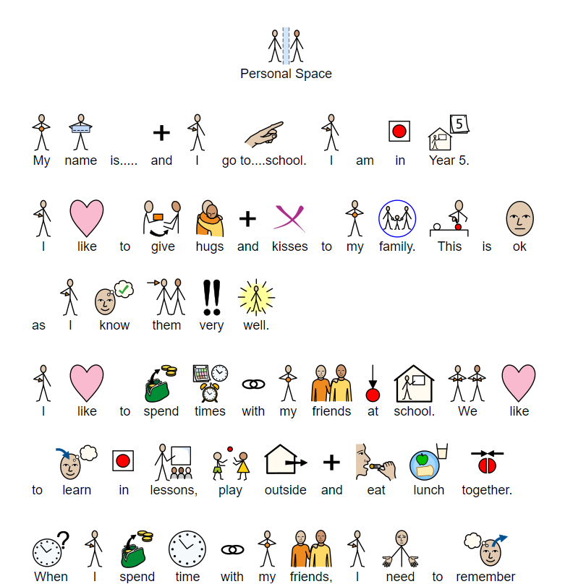
How to Play a Game

Sometimes I play games.

In games there are rules.

It might help if I learn the rules.

It makes people happy if I follow the rules.

I will try to follow the rules.

When to use:

This is useful for pupils with a diagnosis of Autistic Spectrum Condition (ASC); pupils with SLCN/DLD; pupils with SEMH; pupils with EAL; pupils who are struggling with specific social situations or routines, in fact all children who would benefit from being prepared for something different, e.g. going to the swimming pool; why school is different in December; World Book Day. Pupils should read and be familiar with their ‘Social Story’ leading up to the routine and just before e.g. In this case, regularly through the day (before unstructured times) and then as needed.

They can be used with a group of friends and also shared with individuals, groups or whole classes so they have a greater understanding of expectations of behaviour.

They can be used to address any aspect of behaviour which is being focused on.

Why you may choose to use:

Social Stories should be used when pupils continuously fail to follow the rules or routines in certain situations. Common examples are taking turns, going to a new place, lunch, PE and hygiene routines.

They can be used to highlight a particular issue to a pupil in an area they may be finding difficult. It allows you to broach it without the pupil feeling anxiety or that it is directed at them as an individual rather their behaviour.

Social stories are short and simple descriptions that are created with the intention of helping the pupil to understand a particular activity or situation, along with the how to behave in that situation. Social stories also alleviate anxiety by giving precise information on what the pupil could observe or experience.

They are often illustrated with photos to support understanding.

Description of Activity:

- They should be written in a language that is appropriate to the learner’s age and comprehension.
- They should be written consistently in the first or second person based on the pupil’s characteristics - typically first person.
- They should be an appropriate length, selecting a number of sentences per page, as meet the needs of the pupil.
- Construct sentences to be used to support understanding of the pupil. Many pupils are able to help construct their own social narrative and should be encouraged to do so.
- Use photos, pictures or illustrations to visually reinforce the learning. Illustrations need to match the pupil’s preference. Many pupils enjoy being the subject in their own story or illustrating it themselves.
- It needs to be a regular part of the pupil’s daily routine.

Progression/Next steps:

Reduced use of social stories and greater independence.

Links:

- Stories that explain: Social Stories for Children with Autism in Primary School – Lynn McCann
- https://www.autism.org.uk/about/strategies/social-stories-comic-strips.aspx
- https://www.wikihow.com/Use-Social-Stories
- http://www.autismtoolbox.co.uk/templates-and-resources

PIVATS Talking & Communication Milestones Bridge, One Stage 3, Four Stages 1 & 2

Active or Effective Listening

When to use:

Active listening is a way of focusing pupils on the ability to listen appropriately. It supports pupils with speech, language and communication needs. It could be that a pupil’s inability to effectively listen could be misunderstood as laziness or disinterest. Use this resource when you feel that there is a barrier to the pupil’s ability to follow instructions or respond to requests and when the pupil finds it difficult to ask for help.

Why you may choose to use:

- To support pupils to be able to tune into conversations or instructions.
- To improve access to the curriculum and to engage the pupil in learning.
- When the pupil becomes increasingly frustrated.
- To promote listening with understanding.
- If a pupil is ‘switched off’ to learning.
Description of Activity :

- Teach what 'good' listening is.
- Identify success criteria, e.g. look at the person talking (whenever possible, and appropriate, but take into account the needs of neurodivergent pupils who may show they are listening in different ways, think about what is being said, nod if you understand, ask questions if anything needs clarifying etc.
- Have pictures/symbols/images to represent the success criteria.
- Give the pupil something to listen for or have key words/images they touch/hold when the person talking mentions them.
- Review what has been said afterwards, this might involve using the above picture and/or introducing new ones or even having the pupil draw one to illustrate what has been said.
- Facilitate opportunities for the pupil to face the speaker in 1-1, small group and whole class situations.
- Support the pupil in developing questioning with scaffolds/prompts when appropriate, e.g. a question hand or question matrix.
- Provide support on the understanding of questions, commands, statements and the tone of voice which may be used with these.
- Regularly check understanding with the pupil and give opportunities for asking questions.
- Regularly review the strategies for effective listening and how they are helping with learning, interacting etc.
- Develop the pupil's understanding of how body language, volume and tone of voice are important in communication, as well as the content of what is being said/listened to.

Progression/Next steps:

- To gradually move from familiar to unfamiliar language.

- To reflect on contradictory statements/ fast speaking/different voices and accents and longer instructions.
- Increasing gaps or breaks between recall and application can develop the questioning aspect of communication.
- Encourage closer active listening through the following:
  - Dictation. Statements where you give either too much or too little information to check for active listening.
  - Identify missing words/phrases from the retelling of well-known stories.

Links:

- Talk for writing
- Grammar curriculum
- I went to the shop and I bought….
- Talking grids
- Top 5 words associated with a word.
- (Activity 17)

PIVATS Talking & Communication Milestones Bridge, One Stage 1,

Group Role Cards and Rules
When to use:

Group roles badges or role cards can be used to support pupils in understanding how to work effectively in a group. They help pupils understanding the purpose of different roles and that each member of the group has a responsibility. This supports turn-taking and collaborative talk/learning.

Why you may choose to use:

- To prepare pupils for effective collaborative learning.
- To help pupils value the function of each role.
- To teach pupils how to take turns and be patient.
- To develop listening and turn taking when speaking.
- To broaden pupils' experience of roles which may not be their preference.
- To allow pupils to have a variety of roles, which is especially beneficial for pupils who find written communication difficult. This allows them to excel in other aspects and demonstrate their learning.
Description of Activity :

- Pupils will need to be explicitly taught the different roles. Gradually introduce the different roles focusing on each role's purpose.
- Once taught, pupils will need guiding on what the functions of that role are and will need good role models. Encourage pupils to take a different role within the lesson at first as they may not be able to wait until the next session to fulfil that role (Lego therapy groups utilise this model).
- Ensure that, initially, the groups are led by an adult – some pupils may even need 1 to 1 modelling in order to practise before joining with other pupils.
- Badges/lanyards are effective for helping pupils to remember their role and their responsibility within it. They may also benefit from a prompt card with a list of jobs for that role until the full understanding and application is achieved.
- It is important to ensure that each pupil gets the opportunity to practise different roles otherwise pupils will find it difficult to be allocated a role in the future.

Progression/Next steps:

- Once modelled, pupils may need adult support to access all roles as some may be their preferred ones.
- The complexity and number of roles within the group can increase as the pupils gain confidence.

Links:

- TES free printable
- Twinkl have general role cards and those with Lego club
- https://www.boardmakeronline.com/Activities/Search
- Twinkl - https://www.twinkl.co.uk/resource/us2-e-66-discussion-role-cards
- Taking Roles in Groups - VLOG. Jen Little, September 2024

PIVATS Listening & Understanding Milestones P7 & Bridge
PIVATS Talking & Communication Milestones P8, Bridge & One Stage 1

Category Sorting

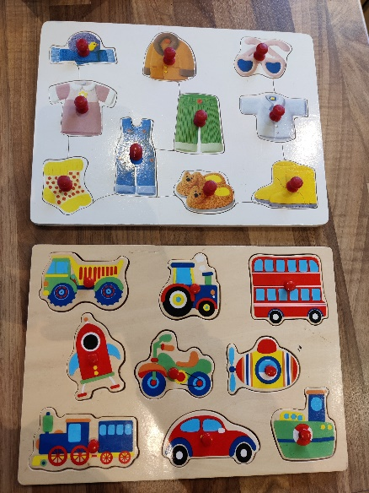
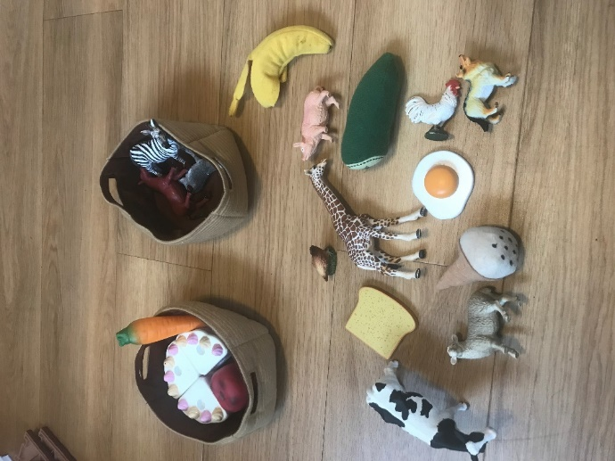

Why use:

- Categorisation skills are a critical component of language development.
- They are foundational to learning, relating, storing and recalling vocabulary.
- Developing understanding of categories not only builds and expands vocabulary, but supports recall and organisation of thoughts.
- When teaching words in groups, pupils are supported in developing a schema to help with understanding of those words.

Description of Activity:

- Pupils sort objects into identified categories.
- If needed, use visual supports to name/identify the categories working towards the pupil sorting objects independently.

Resources:

- Use objects (as above), photos if appropriate or early year board jigsaws are great with the pieces all put in a feely bag.
- Pupils can practise turn-taking to take a piece out the bag, name it and find the right category, putting in a bag/hoop, back into the jigsaw or if using pictures on a themed background.
- Lots of repetition of the category names as well as the specific vocabulary for each item from supporting adults.

Progression/Next steps:

- Ask the pupil to label the category from the given objects.

- Put all the items out and request something using a category name, e.g. "Find me an animal, give me some food, pass me some clothes, find me a vehicle/transport etc."
- Sort a group of objects or pictures into two similar sets.
- Sort a group of things by one feature.
- Sort into 2 and 3 categories.
- What doesn’t belong and why?
- What goes together and why?
- Name multiple items from a given category.
- Identify similarities and differences.

PIVATS Talking & Communication Milestones One Stage 1 & Four Stage 1

Socially Speaking Games

When to use:

This page serves to highlight a number of board games that can be purchased, or created by the school, in order to improve and facilitate pupils’ understanding of social situations and enable them to model and rehearse their words in an array of social situations which they may encounter.

Socially Speaking is one of a range of commercially available resources that can be used to teach socially acceptable responses to be used in a range of different situations. They are often used with pupils who display Autistic Spectrum Condition (ASC) or Social, Emotional and/or Mental Health (SEMH) traits or behaviours. They serve as a way of facing situations they would find challenging in ‘real life’ in a non-threatening way.

Why you may choose to use:

- The resource, along with others of a similar ilk, are particularly useful to teach pupils how to respond in a range of unfamiliar situations.
- They are a method of enabling pupils to make simple appropriate choices in relation to their behaviour. It teaches the pupil what behaviour is expected of them in a given situation.
How to use:

- Commercial games such as 'Socially Speaking' can be used to allow pupils to achieve success with their behaviour in a situation that they may feel is difficult to manage without the opportunity to practise their reactions.
- They allow conversations and modelling within a safe group for a variety of identified situations.
- They allow the adult to probe experiences and model answers in a safe place.
- When playing, it can be helpful to include pupils from the wider class who can be good role models. Choosing a group of pupils who all struggle socially will result in the adult leading modelling rather than the pupils.
- Choose a mix of pupils. Changing each time can be beneficial, especially if attempting to build friendships and trust between pupils.
- Frequency is dependent on needs, but at least weekly is beneficial to be able to reflect on events in between sessions. They can also be used at lunch and playtimes – especially if this is a focus for improvement.
- They will typically require an adult to be present to be able to model and amend any misconception or wrong answers. The adult is facilitating rather than leading.
- Games can be written with the pupil using a simple board game creator. Alternatively, adults working with the pupil may offer items to be included that are relevant to the pupil’s development and learning need.

Progression/Next steps:

- Reduction in need to use.
- Ability to transfer the skills in the game to real life situations

PIVATS Talking & Communication Milestone One Stage 1

Board Games
When to use:
These, and many other commercially available games, are often used with pupils who display Autistic Spectrum Condition (ASC) or Social, Emotional and/or Mental Health (SEMH) traits or behaviours. They serve as a prompt to practise and discuss what is expected of them in different situations.

Why you may choose to use:

Resources such as these are particularly useful to encourage pupils to develop different, more appropriate, responses in situations that they find challenging. They are a method of enabling pupils to make simple choices in relation to their behaviour. It shows the pupil what behaviour is expected of them in this given situation.

Description of Activity:

- Games such as these can be used to allow pupils to achieve success with their behaviour in a situation that they may feel is difficult to manage without these visual positive reminders. They can be used 1-1, small group or as part of whole class PSHE/circle time sessions.
- The board games are a non-threatening way of introducing emotions and feelings concepts to pupils in a 1 to 1 or group situation. Their ability to complete the tasks in the game may indicate their knowledge and ability to understand how to act/react in the classroom or at unstructured times.
- The conversations whilst playing the game can highlight to adults any further areas of concern or learning required.
- The games can be shared at home if this would benefit family relations.

Links:

- TTS Group: Personal & Emotional Skills Board Game
- Board game: Feeling up or down
- Board game: Escape from Anger Island

PIVATS Talking & Communication Milestone 1 Stage 2

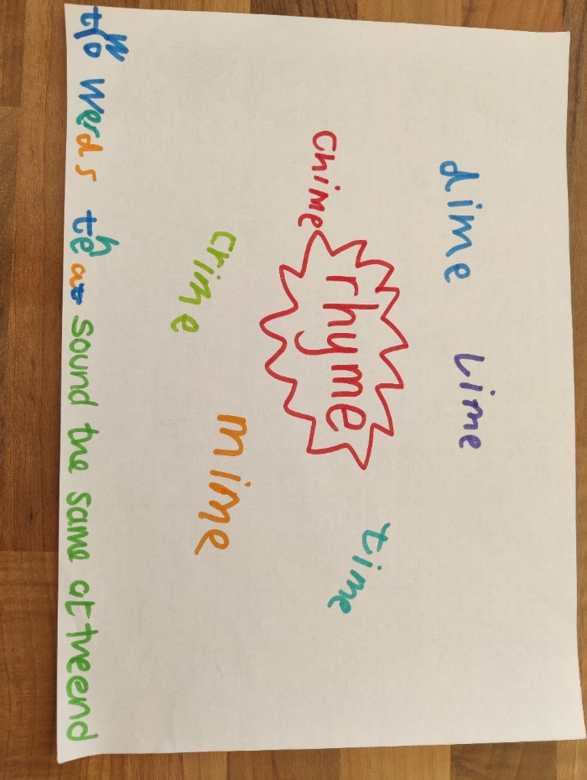
Define and Rhyme

Description of activity:

- Focused vocabulary activity.
- Identify a word, ideally one which the pupil can relate to and which rhymes with other words.
- Pupils generate a definition.
- Pupils also generate rhymes, with support if necessary, to develop phonological awareness.
- Symbols could be used alongside the written form of the word.

Links:

- Appendix 18 – Phonological Awareness

PIVATS Talking & Communication Milestone One Stage 2

Vocabulary Development Alongside Phonological Awareness
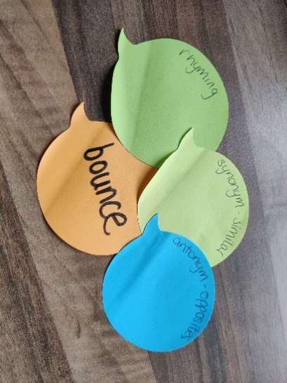
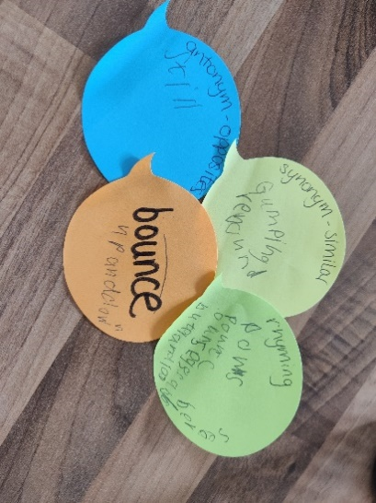
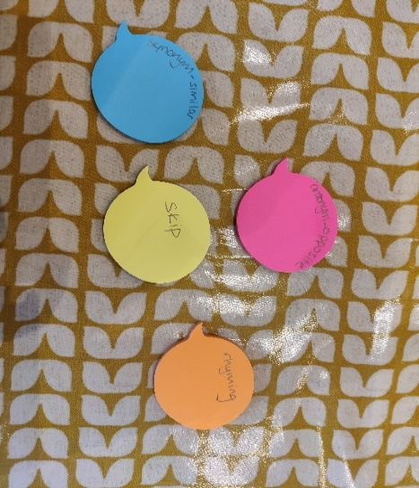
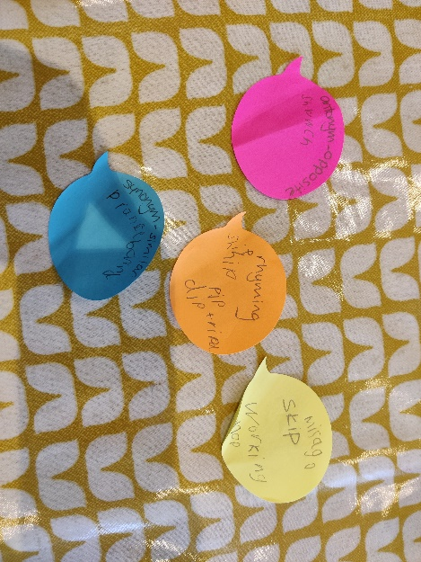

Description of activity:

Focused vocabulary activity. Pupils generate a definition, engage in conversation about synonyms and antonyms to develop semantic knowledge. Pupils also generate rhymes, with support, if necessary, to develop phonological awareness. Symbols could be used alongside the written version of the word.

Resources:

Appendix 18 – Phonological Awareness
Appendix 11 – Vocabulary
Appendix 11(continued) – Vocabulary

PIVATS Listening & Understanding Milestones P7 & Bridge
PIVATS Talking & Communication Milestones P8 & Bridge

Sorting in Sub-Categories
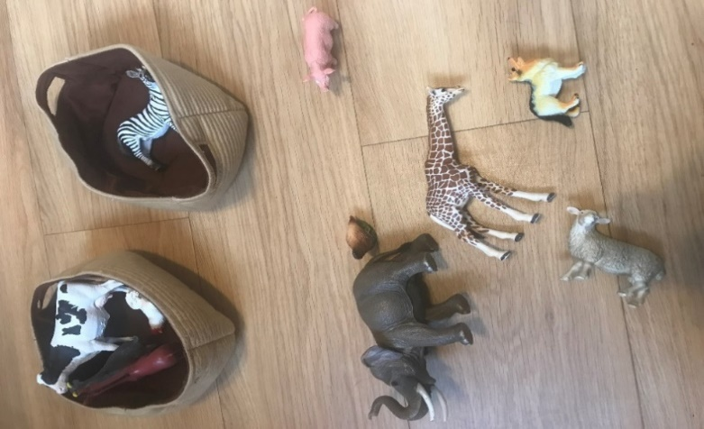
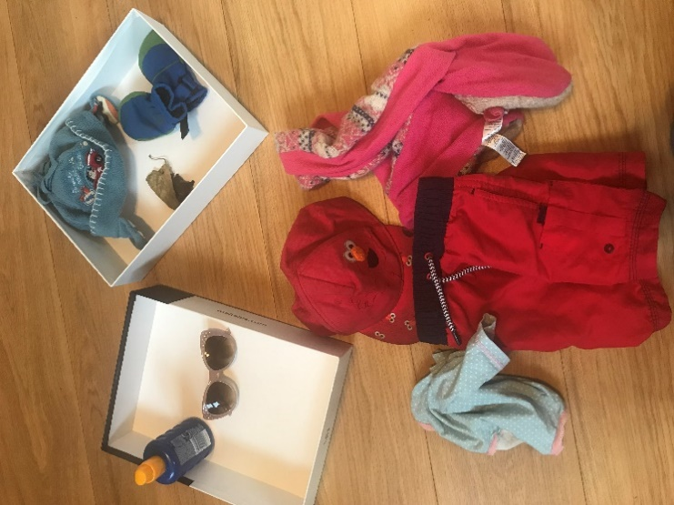
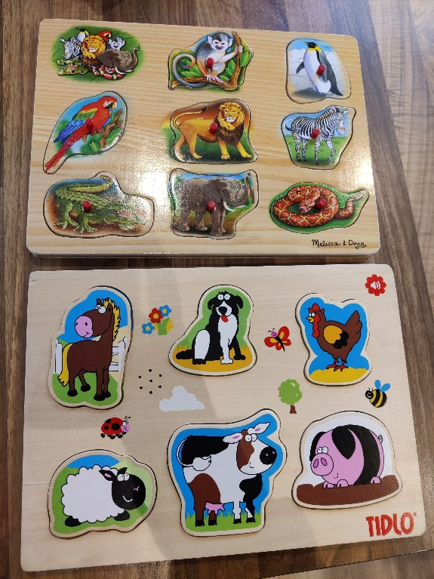

Description of activity:

Focused vocabulary activity:

- Pupils sort objects into identified sub-categories.
- If needed, use visual supports to name/identify the categories working towards the pupil sorting objects independently.

Resources:

Use objects (as above), photos or pictures. The board jigsaws are also great and pupils can practise turn-taking skills – take a piece out the bag, name it and then find the appropriate sub-category.

Thanks to Bridge Speech Therapy

PIVATS Talking & Communication Milestone Two Stage 2, Three Stage 1

I Feel …… Cards

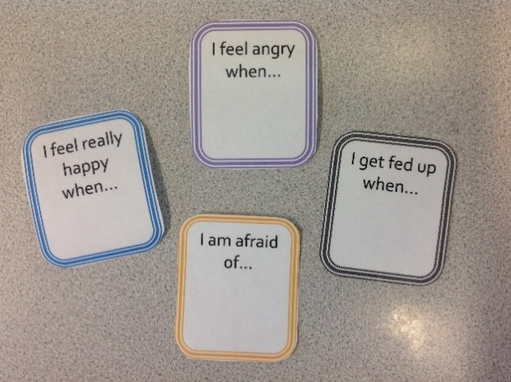

When to use:

These cards help to facilitate a pupil’s emotional development. They can be used to help a pupil recognise their feelings and the particular situations and events which cause them to feel different emotions. They may also be useful when upcoming events may cause the pupil to feel emotions they are not familiar with, for example anxious or excited.

The cards can help pupils to become more aware of their 'triggers' and as an introduction to self-regulation, identifying strategies that help them to be calm and feel happy. These can be used in isolation for 1:1 interventions for pupils with Emotional Social and Mental Health (ESMH) difficulties, or for a pupil to help with them to express how they feel throughout the day, or as part of a PSHE or Circle Time session for whole class or whole group teaching.

Emotion symbols could also be used on the cards to support dual coding.

Why you may choose to use:

These cards are useful in a wide range of lessons and activities, or as and when required on an individual basis, for pupils who may require support, e.g. after an incident where the pupil has become angry or upset.

To provide extra support or reassurance in various situations:

- To help pupils understand causes of different emotions.
- To prepare pupils for changing events and reduce anxiety about forthcoming events, e.g. residential, educational visit etc.

Description of Activity:

- These cards can be used on a 1:1 basis or in a small group, or even as a whole class. Model how to use the cards, e.g. ‘I am afraid of the dark.’ After modelling to the pupil, invite them to give their own examples. Some pupils will find it difficult to generalise and may only be able to identify triggers for their feelings after events and situations that arise. It is useful to then fill out the card together and use it as a starting point for discussion.
- With the pupil, identify what they could do to help with their feelings in different situations, e.g. bring their teddy on a residential, sleep in a room with friends and in a room next to familiar adult.
- The cards can be used in a lesson as a prompt to help pupils to think about how they feel in different situations, e.g. a pupil takes a card and says, “I feel … when…”. Adults should model using the cards by giving examples of how they feel too.
- Cards can be used with individual pupils who have difficulties in expressing their feelings and emotions. They could be used as a resource and strategy to de-escalate when a pupil is becoming upset or angry or after an occasion where they have become upset or angry. Adults should ask the pupil to use the card as a prompt to say how they feel and why, e.g. “I feel angry because…”
Progression/Next steps:

- To discuss with pupils how to handle and cope with differing emotions. Adults should encourage pupils to think about, “What could you do next time you feel…?”
- Events that help the pupil to feel calm or happy can be used as a starting point for generating strategies to self-regulate in stressful situations (see Resource 67 – the trigger scale).
Links:

- https://www.boardmakeronline.com/Activity/655710

PIVATS Talking & Communication Milestones One Stage 3, Two Stage 3

Talk Tokens


When to use:

When a pupil has struggles to take turns or tends to shout out in group and class situations, or is over dominant in group discussions.

Why you may choose to use:

- Talk tokens are particularly useful to encourage pupils to comply with simple requests in a visual way. They are a method of enabling pupils to make simple choices in relation to their behaviour.
- It reminds the pupil what behaviour is expected of them in this given situation.

Description of Activity:

- Talk tokens are used as a way of allowing the pupil to talk whilst restricting the frequency with which they shout out to the number of talk tokens they have been given.
- Identify success criteria/ground rules for participating in discussions. Align these with picture prompts.
- Pupils will need explicit teaching in how to participate appropriately in discussions and have this modelled to them. In the interests of inclusivity, this could be a whole class strategy taught to all the pupils.
- If pupils forget to comply, adults should positively and consistently remind them of the expectations.

Progression/Next steps:

Begin with 1 picture e.g. good sitting, then extend this list to include other prompts such as good listening, remembering to not shout out etc. Remove prompts as the pupil/s no longer require them. Allowing the pupil/s to physically remove the picture and put it in a bin reinforces the positive progress they have made.

Pupils may learn to write their ideas on a whiteboard or a jotter whilst moving away from shouting out or verbalising their thoughts.

Reduction in need for the talk tokens could be sign of progress in this area.

Links:

- www.teachertoolkit.co.uk/2017/07/12/one-minute-cpd-4/
- https://www.boardmakeronline.com/Activity/655710 (Time to Talk)

PIVATS Talking & Communication Milestone 2 Stage 3

Vocabulary Development

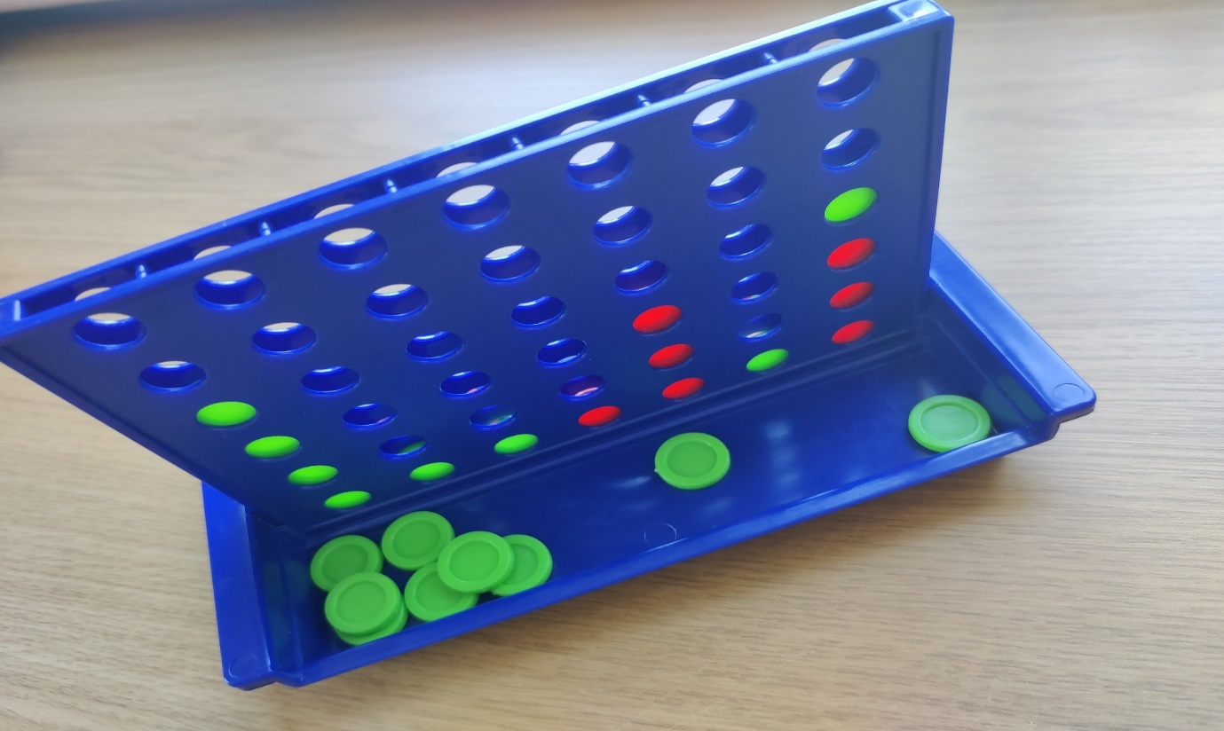

Description of activity:

Focused vocabulary activity to reinforce categorisation of vocabulary:

- Use a simple, motivating turn-taking game, such as 4 in a row.
- Before taking a turn, the player is given a category by the other player – adult or peer.
- The player has to label 4 words in the given category (the number can be altered, 4 is good for 4 in a row.)
- Take turns to complete the game.
- Think of different categories/sub-categories for each turn.

Resources:

See picture above.

Progression/Next steps:

Reverse the game – can the pupil label the category when their partner names 4 items from within the category e.g. peas, carrots, potatoes, and onions are all kinds of…
For additional activities please see Appendix 11 & Appendix 11(continued) – Vocabulary

PIVATS Talking & Communication Milestones One Stage 3, Two Stage 2, Three Stage 3

Measures to Reduce Anxiety


When to use:

Pupils who find it difficult to cope with their feelings of anxiety may need a range of strategies to help reduce their anxiety levels.

Why you may choose to use:

- To help pupils recognise and communicate their feelings.
- To provide pupils with self-help strategies to reduce levels of anxiety.
Description of Activity:

- One helpful strategy is to use a glitter jar. Talk to the pupil about how the jar represents their mind. Fill the jar with water and the pupil adds colours of glitter, one to represent feelings, one to represent thoughts and one reactions/behaviour. Discuss how it feels when the feelings are settled and talk about what makes the glitter whirl in the jar, linking this to the pupil’s triggers or upsetting events over the course of a day, drawing attention to times when the jar (their mind) is settled and times when feelings are whirling. Discuss how it feels when their feelings are whirling round and use this as a discussion point about how they can be calmer and how moments of stillness can help them to calm down. The pupil should have access to the glitter jar throughout the day and may choose to go to it when they are feeling heightened levels of anxiety, to shake it and watch the glitter settle as a way of calming themselves.
- An alternative strategy could be a jar of water with paper clips in and through the use of a magnet to move the objects around in the water, the pupil can break a cycle of negative feeling and be able to talk about their next steps.
- The use of a feather on their hand with the pupil blowing the feather gently to the hand of another friend or staff member. The pupil will have to blow gently to ensure they do not lose the feather and to ensure it blows carefully onto the flat hand of another. This helps control breathing, increases focus and promotes calming down. A cotton wool ball could be used as an alternative.
- Hide object in small beads (e.g. hama beads) or collect and sort beads.
- Another strategy which does not involve equipment is finger breathing. The pupil used the forefinger of one hand to slowly trace the outline of their other hand starting at the base of the thumb or the little finger. The object of this it to move the forefinger very slowly whilst breathing deeply. This helps the pupil is break connection with their strong emotion by concentrating on the task and breathing deeply.

Progression/Next steps:

- Initially, the pupil may need regular sessions to discuss when they may need to self-calming activities, also thinking about where they can go to use them independently, e.g. a regulation station. All adults should be aware of where the pupil is, if they independently go to this place.
- When teaching the pupil these strategies, the adult should model their use with a positive and calming self-narrative to encourage the pupil to do the same, e.g." Finger breathing helps me to regulate and be calm."
- Pupils may need to be offered a number of strategies before they find one that is the most effective for them, or they may prefer a suite of items that they can keep in a tray, or emotion box, which they can access and use when needed.
- Progression will be evident as the pupil becomes more independent in deciding what, when and how to use the different strategies.

Links:

- Behaviour Bitesize - Lancashire Professional Development Service
- Relax kids resources
- Pintrest have a high number of ideas for sensory and anxiety reducing art and craft ideas
- Sensory needs – Appendix 4

PIVATS Talking & Communication Milestones Two Stage 2, Three Stage 3

What's In Your Heart?



When to use:

This is useful for pupils who find it difficult to communicate in words how they are feeling, providing an opportunity for them to express their emotions and, from this, develop vocabulary to promote the healthy expression of emotion. It can also be useful as a stimulus for discussion to use with pupils who are confused about how they are feeling or who are struggling to process strong or conflicting emotions.

Why you may choose to use:

- To help pupils to identify their feelings.
- To encourage pupils to communicate their feelings.
- To help pupils understand that they may have more than one feeling in reaction to an event and that some of these feelings may be conflicting and that is usual.

Description of Activity:

There are two different ways to approach this activity.

- The first is to ask the pupil to draw what is in their heart (in terms of how they are feeling). It is best to try to avoid giving any suggestions as this may affect what they draw, however, the adult could model their own 'heart' first and then put it to one side. Pupils may choose to draw pictures or patterns or just a mixture of colours. Once they have finished, staff may ask the pupil to explain their drawing and how it feels/why they have chosen certain colours, what they remind them of etc.

- Sometimes it may be beneficial to list all the emotions the pupil knows before they begin and to assign a colour to each emotion. Then the pupil can fill in the heart with the amount of each emotion that they are feeling. When discussing the completed picture, discussions can explore what triggers certain emotions and whether they would like to be able to change any of those feelings. The discussion can then focus on what needs to happen to be able to change those feelings.

Progression/Next steps:

Broaden the range of emotion words used by the pupil to enable them to be able to communicate their feelings more confidently and precisely by having a greater vocabulary to draw from.

The heart sheets can be kept and used to reflect on the pupil’s feeling to ascertain improvements in mood or to identify triggers for certain emotions or behaviours.

PIVATS Talking & Communication Milestone Three Stage 3

Restorative Approaches

When to use:

Restorative approaches are built on values which separate the person from the behaviour. They promote accountability for hurt and distress caused to others and seek to repair any harm caused in a situation.

Please note, it is important to ensure a pupil has a minimum of Blank Level 3 understanding, usually Blank Level 4, to be able to engage in these restorative approach conversations or the language used may be beyond the pupil's understanding and lead to further dysregulation. (See below for link to Blank Level questioning).

Why you may choose to use:

When pupils are dysregulated, or recently dysregulated, distancing the person from the behaviour can support their ability to take responsibility for the hurt and distress their behaviour has caused.
Description of Activity :

A restorative approach may include having a ‘restorative conversation’. These may typically happen during the school day and practitioners will use restorative language and questions to allow pupils and young people to understand the impact of their behaviours.

Questions that may be asked are:
- What happened?
- What were your thoughts at the time?
- What have been your thoughts since?
- Who has been affected by what happened?
- How have they been affected?
- What do you think needs to happen now?

Adults can receive training in this area. However, staff working with pupils with restorative approaches, will need to develop listening skills, empathy, use of language (including body language) and understanding of situations from another person’s point of view.

Progression/Next steps:

Peer mediation is a process where pupils and young people are offered the opportunity to act as peer mediators. The peer mediator takes responsibility for supporting younger pupils in the school to find a solution to their issue. Pupils or young people who volunteer to become a peer mediator will receive appropriate training and support. They will learn invaluable skills and contribute to more positive relationships between pupils.

Links:
- Restorative justice council
- Restorativejustice4school
- Appendix 19
- Appendix 20

PIVATS Language and Communication Extension Pack: Glossary

Word/Phrase | Definition | Examples/Extra Information when Applicable
Abstract Language | Language that relates to ideas/concepts that are not directly experienced by the pupil. The language is more subtle and may be considered vague, or require the pupil to draw on previous experiences or knowledge. | Abstract language includes concepts such as time e.g. yesterday, next week. It also includes inferential and figurative language.
Academic Vocabulary | Words commonly found in texts which are more formally written and which are not, typically, part of everyday/colloquial conversation. | Text, compare, contrast, describe, evaluate, demonstrate etc.
Alliteration | The occurrence of the same phoneme at the beginning of adjacent or closely connected words in a phrase e.g. Lovely Louise likes to laugh loudly. | The sound of sweet birds singing.  Delicious desserts.
Co-active | Actively engaged in an interaction with another person.
Communication Breakdown | When a breakdown occurs due to expressive language and/or speech being incomprehensible to one of more members of the conversation. This might be caused by information being omitted, language being muddled and difficult to follow or words/sounds being unclear and the listener in unable to decipher the meaning of the utterance.
Concrete Language | Language that relates directly to the current situation that the pupil is engaged in or directly to resources (pictures/objects) that they have. It is language that describes physical objects/events that the pupil is experiencing.
Conjunctions | Words used to connect phrases/sentences. There are a range of different conjunctions;  - co-ordinating, e.g. and, but, or  - subordinating, e.g. because, although  - adverbial, e.g. instead, unless
Co-ordinating Conjunctions | A joining word that links together two or more words, clauses, phrases or sentences of equal importance. | And, but, or, so
Delayed Language Development | When a pupil does not meet the language developmental milestones for their age.
Homonyms | Words which have the same sound, or spelling, but which differ in meaning.  This term includes both homographs and homophones. | Bat (sports equipment) and bat (animal);  By (preposition), buy (to purchase) and bye (when leaving).
Idioms | A word or phrase which is symbolic, rather than literal, in meaning.  I.e. The meaning does not directly link to the meaning of the words in the phrase e.g. to hit the roof. | Pull your socks up.  It's raining cats and dogs.  Barking up the wrong tree.
Inference | Implied meaning that is not explicitly stated but eluded to in the language used. Inferential language requires to listener to pick out clues to understand the overall meaning.
Integrated Attention | The ability to focus on multiple stimuli at one time. | Pupil can play a game and listen to someone talking without needing to look up.
Intentional | Intentional communication is when the child is deliberately able to foster an interaction to display/express their wants, needs and feelings. This is not necessarily verbal and may be in a pre-linguistic stage (before words) or they may be verbal. Children may use sounds/vocalisations, actions, facial expressions or behaviour. | Facial expressions such as a smile indicates happiness/pleasure at seeing someone etc.
Jargon | Strings of speech sounds which are not intelligible words e.g. dub-a-dub-a-diba-doba-doo. Pupil may produce these in play to self or within interaction/conversation with another person/s when they want to interact and understand that strings of sounds are used, but do not have to expressive vocabulary to do so.
Joint Attention | Joint attention is when two people (or more) focus on an object/event, for the purpose of interacting with each other. It involves sharing a common focus on something, with someone else. It is not just looking/watching the same thing, but requires an interaction around that object/activity being watched. For example a child and an adult may both look towards a toy/moving object and then return their attention to each other to comment or gesture e.g. pointing or saying, “Look at that”. It requires the ability to gain, maintain and shift attention, this might be done with eye-contact, gesture, vocalisations or spoken words.
Key Words | The key word level of a particular instruction or request is the minimum number of words in a sentence that the child needs to understand in order to carry it out without extra clues, such as facial expressions, natural gesture, routine of the day, familiarity of the instruction.  The concept of Key Word Levels was devised by Knowles and Massidlover (1978) and underpins the Derbyshire Language Scheme. Each key word carries MEANING. Many words in a sentence are redundant – particularly very familiar, highly predictable instructions that a child hears every day. For example, if the child is about to go outside and his mother is there holding a coat and says, ‘Put your coat on,’ the child does not need to understand any of these words because they can see what is needed to do from the context. So, given this situation and particular instruction, ‘Put your coat on,’ = 0 key words (the child is following routine and context). When providing instructions or directions, it is helpful to know how many key words the child is currently understanding. Then, gradually aim to extend their understanding of instructions within fun, play-based games. | Child: 'juice'  Adult: 'more juice?'  Adult: "Do you want the big ball or the small ball?"
Linguistic Concepts | Relational words that describe features of the world including attributes such as - size, colour, texture, shape (e.g. hard/soft, rough/smooth), time (before/after), positions (under, above), number/ quantity.
Literal Questions | Questions that ask for specific, concrete answers which can be found directly. | What is your favourite food?  What colour cloak did Little Red Riding Hood wear?
Modelling | A strategy to support the language development/ or speech sound development of pupils. | - Repeating  - Emphasising  - Expanding
Neuro-diverse | Neurodiversity is a relatively new term, coined by sociologist Judy Singer. It refers to a range of specific learning differences including; Autistic Spectrum Disorder, ADHD, Developmental Language Disorder, Developmental Co-ordination Disorder/Dyspraxia, Epilepsy, Tourettes Syndrome/Tic disorders, Dyslexia and Dyscalculia.  The term has been embraced by communities wanting to move away from the medical model and to dispel the concept that differences are something to be treated and/or cured.  It encourages society to view neurodevelopmental differences as natural variations of the human genome and is a term of empowerment positively promoting the qualities that individuals display.
Non-verbal Communication | The process of communicating without using words. | - Facial expressions  - Eye-contact  - Body language  - Tone of voice  - Posture etc.
Parallel Play | When pupils play independently next to each other, but do not interact directly. I.e. they are not playing together.
Pivot Words | A set of words used at an early stage of a child's acquisition of language as central items to expand the number of words pupils combine when expressing themselves. Words which can pivot include; more, all gone, again. | Pivot phrase – all gone  All gone sweets  All gone bread  All gone juice  Pivot word – off  Light off  Shoe off  Coat off
Phonological Awareness | A conscious awareness of the knowledge that sounds are the building blocks or words, and includes the ability to reflect on word structure e.g. what sound does 'is' start with, how many syllables does it have?  Phonological awareness involves: rhyme – being able to identify and generate rhyme; understanding and awareness of syllables, and phoneme awareness – being able to hear individual sounds within words and then being able to segment and blend the phonemes.
Pre-intentional | Pre-intentional communication is the natural and involuntary behaviours that children display that show how they are generally feeling, and often link to basic wants and needs, such as hunger, thirst, comfort and the need to interact.  At this stage children are not intentionally communicating. The behaviours are observed and interpreted by parents/school staff/caregivers to determine what the child needs. | - Body movements  - Bouncing when excited  - Yawning when sleepy  - Facial expressions  - Sounds etc.
Redundant Information | Unnecessary or additional information that is not deemed relevant or useful to a conversation. | If you hold out your hand and say, "Give me the ball," 'Give' is a redundant word as the gesture of holding out your hand already suggests this.
Register | In linguistics register is defined as the way a speaker uses language differently in a variety of situations. Selecting different vocabulary and sentence structure to create different levels of formality in the language. It also includes non-verbal aspects of language including tone of voice, volume, facial expression and body language. | The words, tone of voice and body language used when chatting to a friend will be different to a formal presentation or interview.
Repeat | A pupil experiencing a developmental language delay can enhance their learning by hearing words repeated during daily activities. Repetition by adults aids in understanding the word's meaning, categorisation, accurate sound production, and communication.
Responsive Adult | An adult who is actively engaged with the pupil and responds directly to the actions/words/behaviours of the pupil, over the pre-determined plans of the activity/task/session.
Sarcasm | Sarcasm is a form of verbal irony that involves saying something but meaning the opposite.  It often relies on context, tone of voice, and non-verbal cues to convey its true meaning. For individuals who struggle with social communication, identifying sarcasm can be difficult. | One of the key techniques used in speech therapy is the use of contextual cues and non-verbal communication. By teaching individuals to pay attention to the surrounding context and the speaker’s body language, speech therapists can help them better understand the underlying meaning of sarcastic statements.
Semantic Awareness | Semantic awareness is the ability to understand the meaning of words and their relationships to each other. It is a key part of language learning and proficiency, and involves a range of skills, including: vocabulary knowledge, contextual understanding, and the ability to infer meaning  It involves understanding how words are linked to each other and how we categorise and organise words. This supports understanding of words, expressive language skills and the ability to learn and store new words for use at a later time.
Semantic Language | Semantic language refers to the ability to understand and use meaning in words, phrases, sentences, and longer units. It also includes understanding how words are put together to create meaning, and the relationships between words and sentences.
Subject-Specific Vocabulary | Subject-specific vocabulary is a set of words or phrases that are used in a particular subject area. These words are also known as technical or domain-specific words. | E.g. for Vikings:  Raid, invasion, settlement, longboat, berserker, longhouse, Dane Law.
Subordinating Conjunctions | Subordinating conjunctions are words or phrases that connect a dependent clause to an independent clause in a sentence. They show the relationship between the two clauses and indicate which clause is more important. | - Because  - Although  - When  - After  - Since  - Unless etc
Temporal Concepts | Temporal concepts are concepts related to time, such as before, after, first, next, last, during, and while. They are important for developing communication skills and for understanding the flow of time and events.
Word-approximation | Word approximations are when pupils express words by utilizing parts of a word to describe it, such as “ba” for bottle or “muh” for more.

Appendix 1

Attention Development

Reference: Cooper, Moodley and Reynell, 1978, Helping Language Development

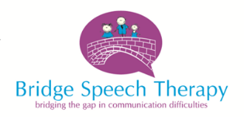

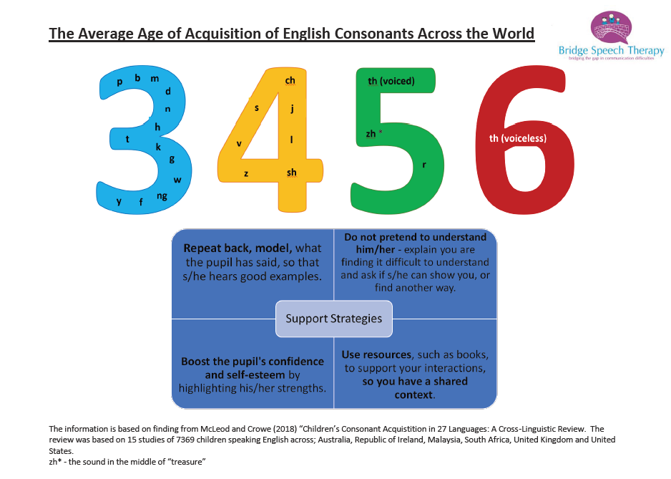

Appendix 2

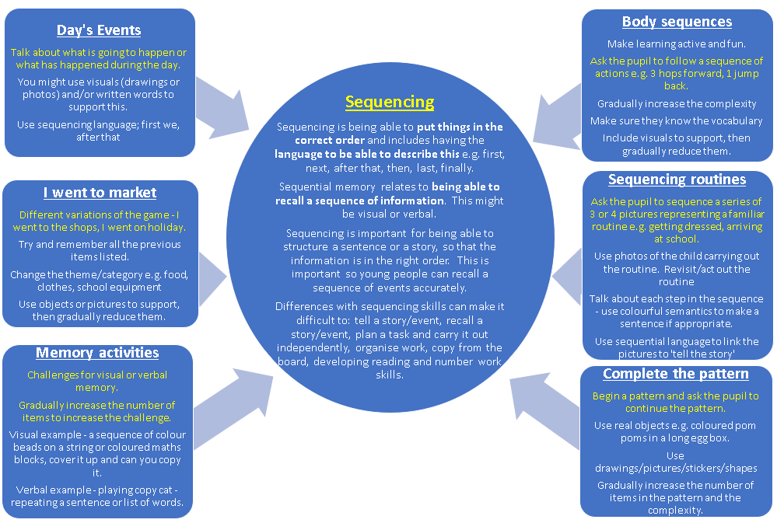

Appendix 3

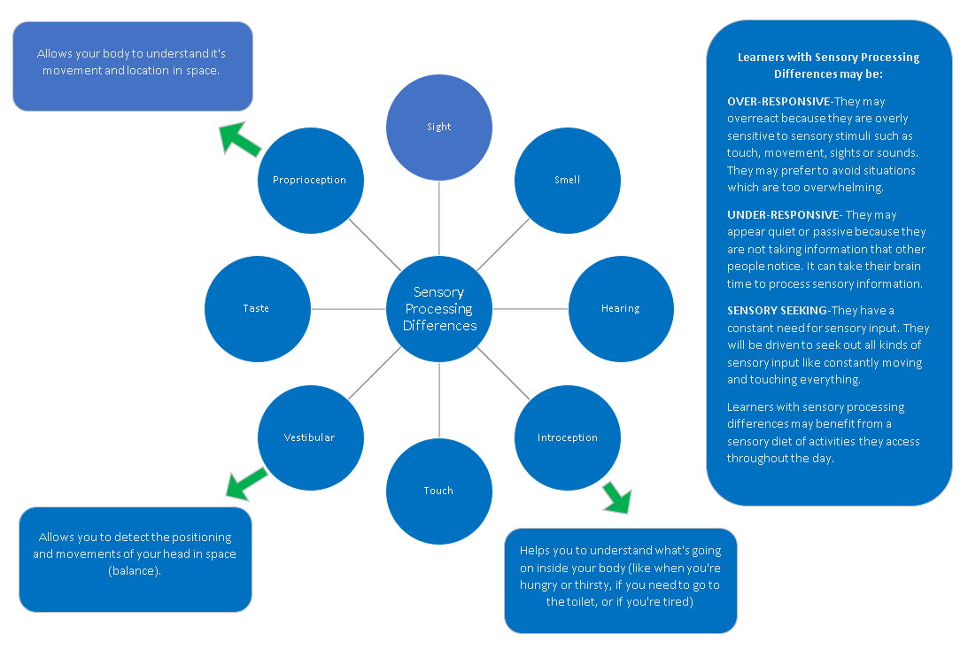
PIVATS Listening & Understanding Milestones P1(i), P1(ii), P2(i), P2(ii), P3(i)

Appendix 4
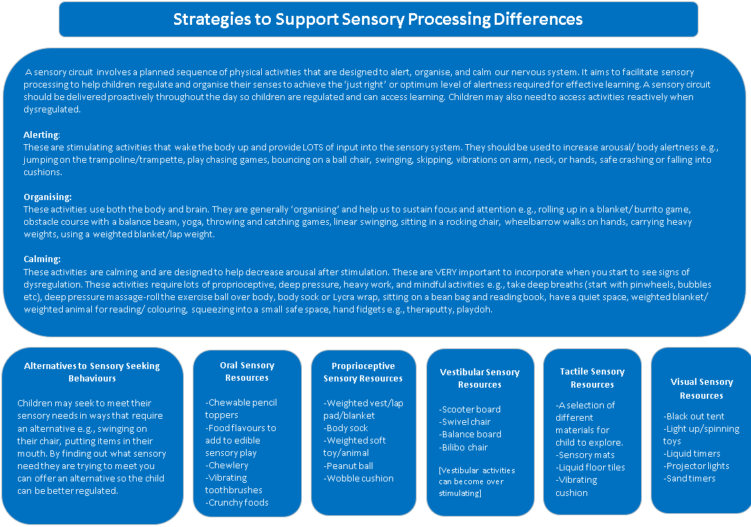
PIVATS Listening & Understanding Milestones P1(i), P1(ii), P2(i), P2(ii), P3(i)

Appendix 4 (continued)

Appendix 5
Traffic Light/Belt Clips Visual Support

Visual supports are beneficial for pupils with a wide range of language difficulties. Visuals can increase understanding for a pupil, they offer consistency and support adults working with pupils to be consistent with their language.

Verbal language can be challenging for some pupils to understand, particularly at times of stress or anxiety. Verbal language is also transient, it is gone in a millisecond, whereas visual supports are concrete, they can stay for as long as a pupil needs them.

The traffic light/belt clip system is an effective way of supporting pupils to understand when activities are going to begin or finish, they can support pupils in waiting for an activity/item and also support pupils to understand the activity/item is not currently available or is finishing. In addition to this they can be used to support pupils understanding of appropriate behaviours at different times throughout the day.

Red disc – show this when it is time to stop/finish an activity or when you want to an individual to stop what they are doing e.g., hitting is finished. Avoid the word ‘no’ this could be a trigger word for some pupils. Negative linguistic concepts e.g., no don’t, are harder to understand for some pupils. Use “finished” and tell the pupil what you want them to do, using the green disc “time to sit on the chair”.

Yellow/Orange disc- use this to warn that an activity is about to stop ‘one more minute’ or to encourage an individual/group to wait. If a pupil has to wait, this should be a very short time initially, so they trust the concept of ‘wait’ and the wait disc. The pupil MUST receive the item/activity if the wait disc is used.

Green disc – use to signal the start of an activity or to reinforce positive/appropriate behaviour e.g., ‘excellent sitting’ or ‘time for snack’.

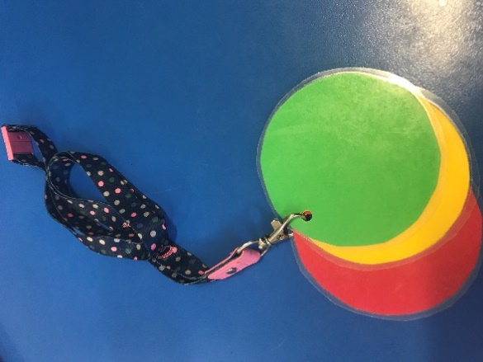

Discs are best used when they are portable – laminate them and put a hole in the corner. Keep them on a keyring/chain or on lanyard.

PIVATS Listening & Understanding Milestones P5, P6, P8, One Stage 1 and Stage 3, Two Stage 1

Appendix 6
Question Words

Supporting pupils to understand questions words is important to enable them to fully engage in social conversations and access the curriculum. Some pupils need explicit teaching of what question words mean.

Remember to make it visual. Use images to support understanding and use them consistently. Initially with each individual questions word and then to combine them to support narrative development. Model how to respond to the question. Take turns to be the teacher.

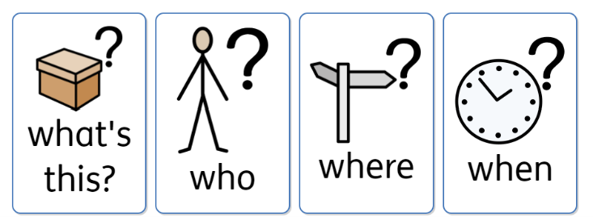

Widgit Symbols © Widgit Software Ltd 2002-2023 www.widgit.com

What is this? This is the first level of question at Blank Level 1 and links with a pupil’s understanding of spoken language at 1 key information carrying word level, developing their vocabulary knowledge. Fun, interactive games using feely bags, boxes and enjoying books together are great for developing understanding of ‘what is this’ and being able to respond.

What is… doing/What’s happening? – This is a Blank Level 2 question. This is in the present tense and relates to the here and now. Pupils develop understanding that what is… doing/happening relates to an action. A great way to develop understanding and responses to this question is to get active together with the pupils. Short videos of pupils carrying out a range of actions is also very motivating.

Who? This is a Blank Level 2 question. Pupils develop understanding that ‘who’ relates to a person or character. Photos, videos, and favourite books are fun and motivating ways to develop understanding of this question and how to respond accurately.

Where? This is a Blank Level 2 question. Pupils develop understanding that ‘where’ relates to a place. Moving around to different places helps pupils understand that the location is changing when they are thinking about ‘where’. It is possible to explore lots of different places after this with books, resources, and the internet – maps and StreetView can bring familiar places into school.

When? This is a Blank Level 3. Pupils develop understanding that ‘when’ relates to a time frame. This can be explored in lots of different ways and supports understanding of time scale. 'When' relates to telling the time, part of the day (day, night, afternoon), days of the week, months of the year and seasons of the year. Being able to understand and respond to 'when' is important for developing sequencing skills.

Why? This is a Blank Level 4 question, needing more abstract levels of understanding. Pupils need to develop understanding of cause and effect. Try and keep it interactive, using cause and effect resources. Introduce the vocabulary ‘because’ to support ‘why’ and the relationship between actions and outcomes. Remember to have a visual for ‘because’ to support this.

How? This is a Blank Level 4 question, needing more abstract levels of understanding. Understanding sequencing is important to be able to respond to how, e.g. how do you make a sandwich? Pupils need to develop inferencing skills to be able to answer somehow questions, e.g. how do we know that…? Being a co-explorer and supporting pupils to look for clues in the language or pictures will support pupils to be able to answer ‘how’ questions.

PLEASE REMEMBER

- It is important to remember which questions pupils understand when discussing social skills or challenging situations. We often ask pupils, “Why did you do that?” but they might not understand questions at that level.

- If a pupil is angry, upset, excited or tired this will affect their ability to process language and understand questions. Adults need to reduce their language and keep it simple.

- Developing understanding of questions is an important skill, but make sure to avoid asking too many questions.

- When interacting and talking with pupils, balance questions with

- Extra commenting
- Repeating back what the pupil has said.
- Addition/expansions of what the pupil has said by adding a new word or concept.

PIVATS Listening & Understanding Milestone P4

Appendix 7
Visual Supports in the Classroom

Visual supports can help pupils understand the instructions we say to them. Spoken language is very fleeting and it can be difficult for pupils to remember all the information we have given them.

Visual reminders are concrete, and pupils can keep checking they have completed all the tasks.

Visual supports can also help pupils to become more independent in completing routines, such as getting ready in the morning.

For regular routines it might be worth having a visual support made up that can be reused every time the pupil does the task/routine.

For less regular routines/activities a simple now/next or visual timetable can be drawn on a piece of paper.

Don’t worry about the quality of the art skills.

If possible, make up the visual and discuss it with the pupil, they can even do the drawings.

Always write a label for the picture too – this helps with reading and helps us adults be consistent in the language that we use.

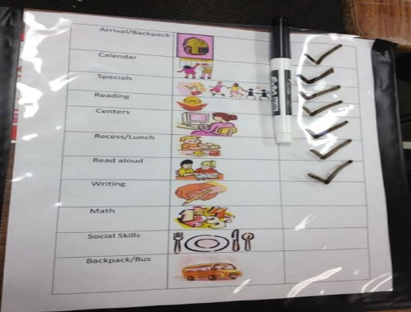
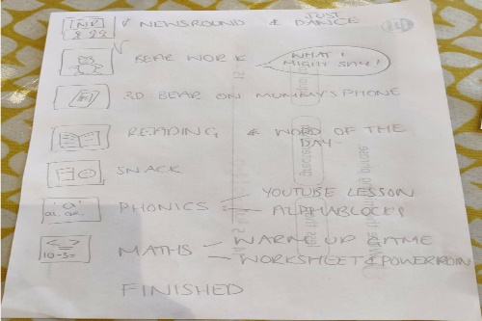
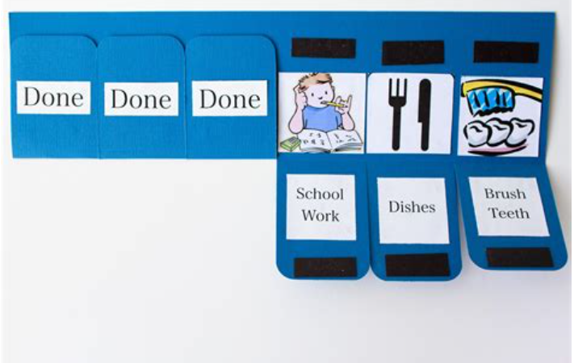
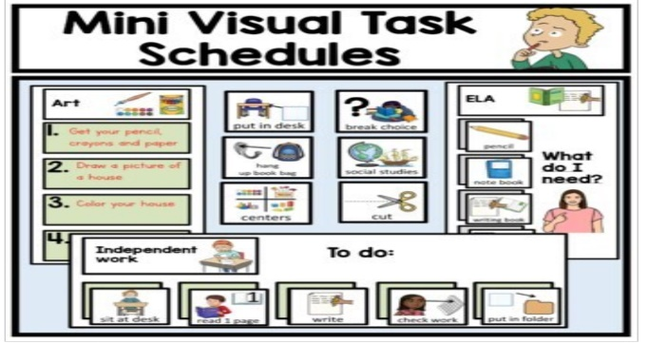

PIVATS Listening & Understanding Milestone One Stages 1 and 2

Appendix 8

Appendix 9
PIVATS Talking & Communication Milestone P5
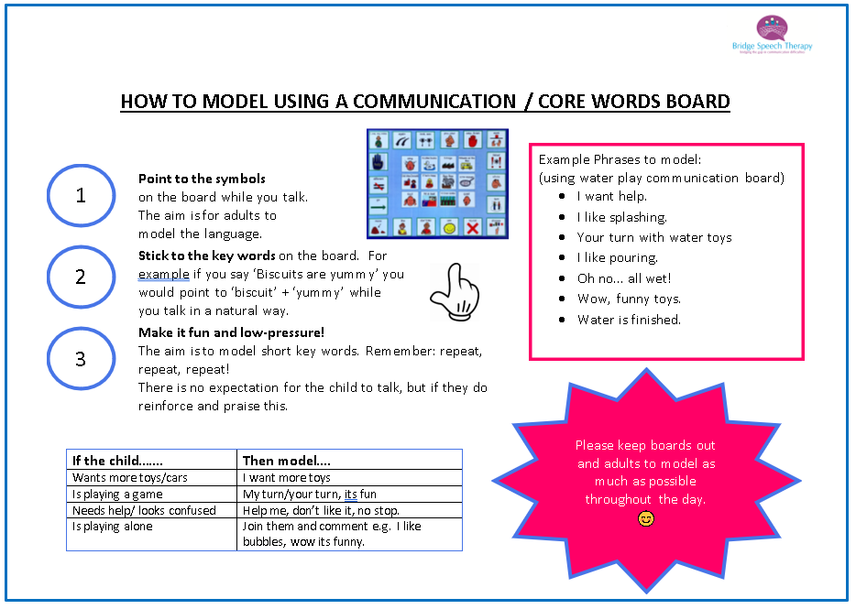

Appendix 10
Following Instructions and Extending Understanding
The Concept of Key Words

A useful way of describing and developing a pupils' ability to understand instructions and process language is through Key Word Levels (or ‘Information Carrier Words’).

The key word level of a particular instruction or request is the minimum number of words in a sentence that the pupil needs to understand to carry it out, without extra clues such as facial expressions, natural gesture, routine of the day, familiarity of the instruction etc.

The concept of Key Word Levels was devised by Knowles and Massidlover (1978) and underpins the Derbyshire Language Scheme.

Each key word carries MEANING. Many words in a sentence are redundant – particularly in very familiar, highly predictable instructions that a pupil hears every day.

For example, if the pupil is about to go outside and his mother is there holding a coat and says, ‘Put your coat on’, the pupil does not need to understand any of these words because he can see what is needed to do from the context. So, given this situation and particular instruction, ‘Put your coat on’ = 0 key words (the pupil is following routine and context).

When providing instructions or directions, it is helpful to know how many key words the pupil is currently understanding. Then, gradually aim to extend their understanding of instructions within fun, play-based games.

When increasing instructions within the following games, (e.g. moving from 1 key word to 2 key words), initially the pupil will need extra help and clues; pausing, gesture and overemphasizing of key words. If the pupil is successful in completing the instruction with extra clues, gradually reduce and fade out the clues.

Below are activities to develop 1 and 2 word level requests/instructions:

1 Key Word:

Feely Bag – Common Objects

Bag containing 8 -10 objects, either a mixture of objects or a specific category (e.g. animals, food, clothes).
Take out 2 - 4 of the objects, put them in front of the pupil and ask the pupil to, e.g. 'Find the ball.' etc.

Post Box – Common Objects

Collection of objects or photo/picture cards.

Comprehension: Place 2 -4 objects or pictures in front of pupil. Give the pupil the instruction, e.g. 'Find the dog,' etc. and then the pupil can post the picture in the box.

Shopping Activity - Food
Use same equipment as in the feely bag. Set up a 'shop' with 3 -4 items out at a time. Give the pupil a basket/bag and ask them to go and 'buy' an item, e.g. ‘Get me a banana’.

Beanbag Game – Body Parts
Comprehension: Give the pupil a beanbag. To practise learning body parts, ask the pupil to place the bean bag for example, 'On your head', 'On your foot' etc.

Spotty Dots/Stickers – Body Parts/Clothes
Comprehension: Using a doll/teddy and stickers, ask the pupil to put the stickers on different body parts for example, 'On dolly's tummy' etc.

Simple Actions
Comprehension: Using a teddy/doll, ask the pupil to get the teddy to do different things, for example, 'Make teddy jump', 'Make teddy sleep' etc. The adult can also encourage the pupil to do different actions to make it more fun and active.

Animals – Farm/Zoo Set
While playing with the farm/zoo set, build on comprehension by asking simple questions or giving simple instructions, e.g. ‘Where’s the cow?’ or ‘Put the pig here’.

2 KEY WORDS:

Animal toy/puppets

Choose 2 different toy animals or puppets, e.g. horse and dog. Ask the pupil 2-part commands containing a body part e.g. ‘Touch the horse’s head’, ‘Touch dog’s foot’.

Choose 2 or 3 different characters (monkey, teddy, and doll), plus some objects to put the characters in (e.g. box, toy chair, cushion). Give the pupil an instruction containing a place name, e.g. ‘Put the monkey on the cushion,’ or ‘Put the dolly on the sofa’.

Vehicles/Figures

Give the pupil instructions, for example, ‘Put the lady on the bus’, ‘Put Postman Pat on the train’. Again, encourage the pupil to tell you what to do to develop expressive language.

Use a box and chair, and small vehicles. Use instructions such as, ‘Put the fire engine in the box,’ ‘Put the car under the chair’.

Use the vehicles and give to different people, e.g. ‘Push the car to mummy,’ ‘Push the bus to Ryan’.

Food and Dolls

Feeding game – Have a selection of plastic food (at least 2 to 3 different food items) and 2 different dolls/puppets. Ask the pupil to, ‘Give the dolly an apple,’ ‘Give the teddy a banana’. Again, encourage the pupil to tell you they are doing/giving the puppets to encourage expressive language.

Action and Characters

Using teddies/dolls, T.V characters, plus sponge, hairbrush, cup, spoon. Ask the pupil to carry out 1 or 2 actions on the toys, e.g. ‘Wash teddy,’ ‘Brush dolly and give dolly a drink’.

Using the teddies/dolls, ask the pupil to do different actions with the toys, e.g. ‘Make teddy sleep,’ ‘Make dolly jump’.

Appendix 11
PIVATS Listening & Understanding Milestone P5, Milestone One Stage 2 and 3, Milestone 2 Stages 1, 2 and 3, Milestone 3 Stages 1, 2 and 3, Milestone 4 Stage 1, 2 and 3

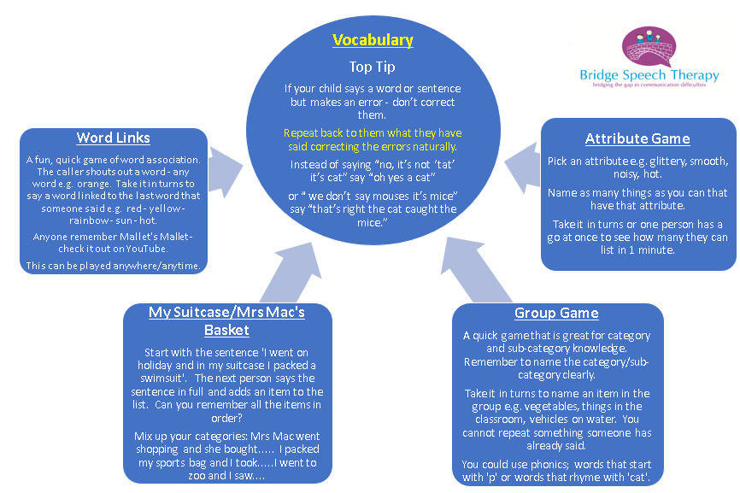

Appendix 11 (continued)
PIVATS Listening & Understanding Milestone P5, Milestone One Stage 2 and 3, Milestone 2 Stage 1, 2 and 3, Milestone 3 Stage 1, 2 and 3, Milestone 4 Stage 1, 2 and 3

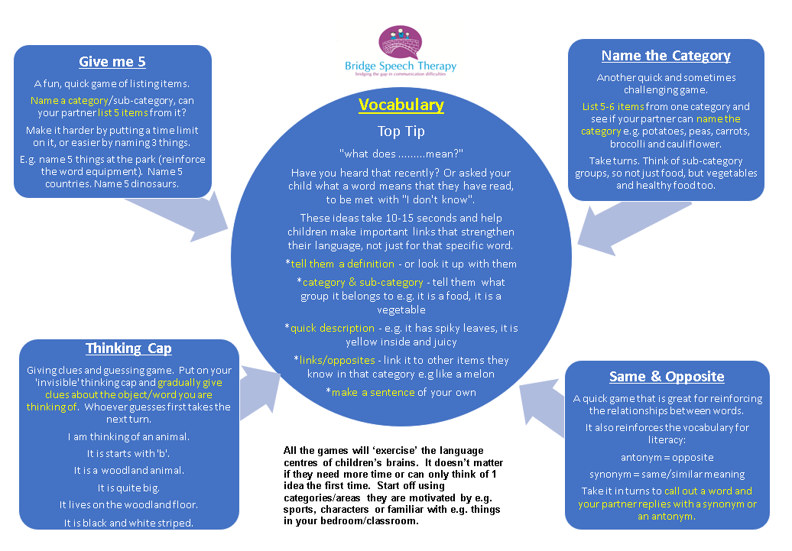

Appendix 12
PIVATS Listening & Understanding Milestones P6, P7, P8, Bridge, One Stage 1 and Stage 2

Linguistic Concepts

There are many linguistic concepts which pupils need to develop their understanding of.
These include:

- Positional/location: in, on, under, in the middle, between, next to, together, closest

- Size: small, big, large, tiny, gigantic, little – these are relational concepts and change depending on the situation or what the objects are being compared to.

- Quantity; all, some, many, few

- Comparison: same, different, similar

- Inclusion/exclusion: and, not, all, all but one, with, without

- Sequence: first, last, beginning, after, then

- Temporal: until, at the same time

- Conditional: if, unless, if…. if not

- A pupil needs to be able to consistently understand a concept before using it in their expressive language.

- Use visuals, objects, and actions, as much as possible, to support pupils to develop their understanding and to maintain interest and motivation.

- Remember to focus on understanding of the concept on its own first, before putting it into 2 or 3 word level instructions and longer phrases. This ensures that pupils develop understanding of the concept and that the amount of information does not add to the linguistic challenge.

- Remember to model to the pupil and take-turns to allow the pupil to be the teacher. This might be in the format of a barrier game, but it could be simple role swapping.

Appendix 13
PIVATS Talking & Communication Milestones Bridge, One Stages 1 and 2, Two Stages 1,and 3, Three Stage 2, Four Stage 1
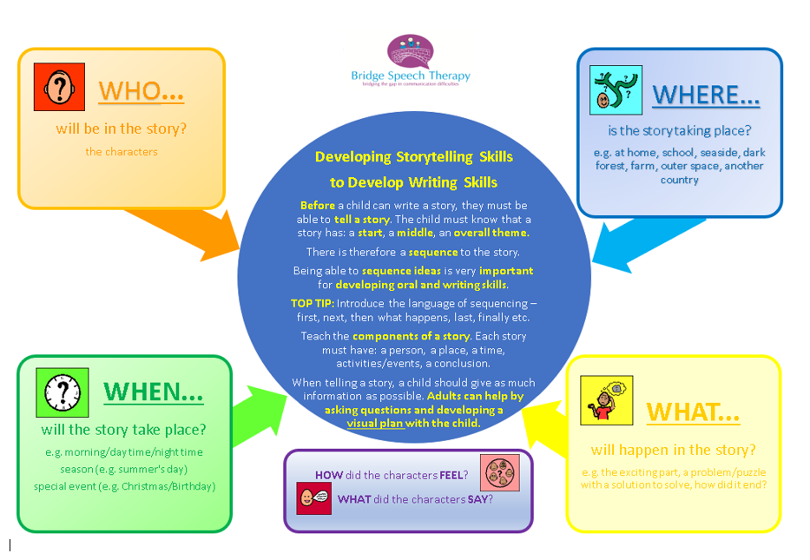

Appendix 14
Following Instructions and Extending Understanding
The Concept of Key Words

A useful way of describing and developing a pupil’s ability to understand instructions and process language is through Key Word Levels (or ‘Information Carrier Words’).

The key word level of a particular instruction or request is the minimum number of words in a sentence that the pupil needs to understand in order to carry it out without extra clues, such as facial expressions, natural gesture, routine of the day, familiarity of the instruction etc.

The concept of Key Word Levels was devised by Knowles and Massidlover (1978) and underpins the Derbyshire Language Scheme.

Each key word carries MEANING. Many words in a sentence are redundant. Particularly very familiar, highly predictable instructions that a pupil hears every day.

For example, if the pupil is about to go outside and his mother is there holding a coat and says, ‘Put your coat on’, the pupil does not need to understand any of these words because he can see what is needed to do from the context. Given this situation and particular instruction, ‘Put your coat on,’ = 0 key words (the pupil is following routine and context).

When providing instructions or directions, it is helpful to know how many key words the pupil can currently understand. Then, gradually aim to extend their understanding of instructions within fun, play-based games.

When increasing instructions within the following games, (e.g. moving from 2 key word to 3 key words), initially the pupil will need extra help and clues; pausing, gesture and overemphasizing key words. If the pupil is successful in completing the instruction with extra clues, gradually reduce and fade out the clues.

Below are activities to develop 3 and 4 word level requests/instructions:

The activities below are comprehension activities for when the pupil is listening to an adult giving the instructions. To develop the pupil’s expressive language skills, using the concepts and including all the information, let them have a turn to give instructions, with appropriate modelling and prompts as necessary.

To check the instructions have 3-4 pieces of information that the pupil truly understands, make sure there are plausible alternatives for all the words underlined (i.e. the key words). This will ensure the pupil has listened and understood the instruction correctly, e.g. "Give Spiderman the square biscuit.” there needs to be Spiderman, plus another character, e.g. Wonder Woman. There will also need to be a square biscuit and a circular biscuit, plus a square cake and a circular cake.

Barrier games

Have 2 full sets of matching pictures, e.g. the parts to build a snowman. Take it in turns to give each other instructions and then check that each person has listened/given clear instructions by seeing if your sets match, e.g. “Put the big snowball on top of the little snowball,” or “Put the black hat with the red stripe on the snowman’s arm”.
Other barrier games you could use include using a map and moving different coloured/sized vehicles around to different locations.

Putting coloured/shaped beads or counters in a particular order offers the opportunity to listen to and use sequential language and specific concepts, e.g. "Put the red square before the yellow triangle".

Food and Characters

Have a selection of food pictures; including different colours of the same foods, e.g. red apple and green apple, different coloured peppers etc. Also include different sizes/shapes of the same food e.g. big cake and little cake or square biscuit and circle biscuit. Have a couple of characters, either real objects, e.g. Spiderman and Wonder Woman, or pictures. You could also have a range of different coloured/sized plates.

Take it in turns to give each other instructions, e.g. “Give Spiderman the big pear,” or “Give Wonder Woman the green pepper”.

Action and Characters

Using motivating characters, plus a sponge, hairbrush, cup and spoon. Ask the pupil to carry out different actions, e.g. ‘Wash SpongeBob’s feet’, ‘Brush Woody’s boots".

Using the motivating characters, ask the pupil to do different actions with the toys, e.g. ‘Make Batman sleep on the bed’, ‘Make Barbie jump on the chair’.

Appendix 15
PIVATS Listening & Understanding Milestones P8, Bridge & One Stage 2

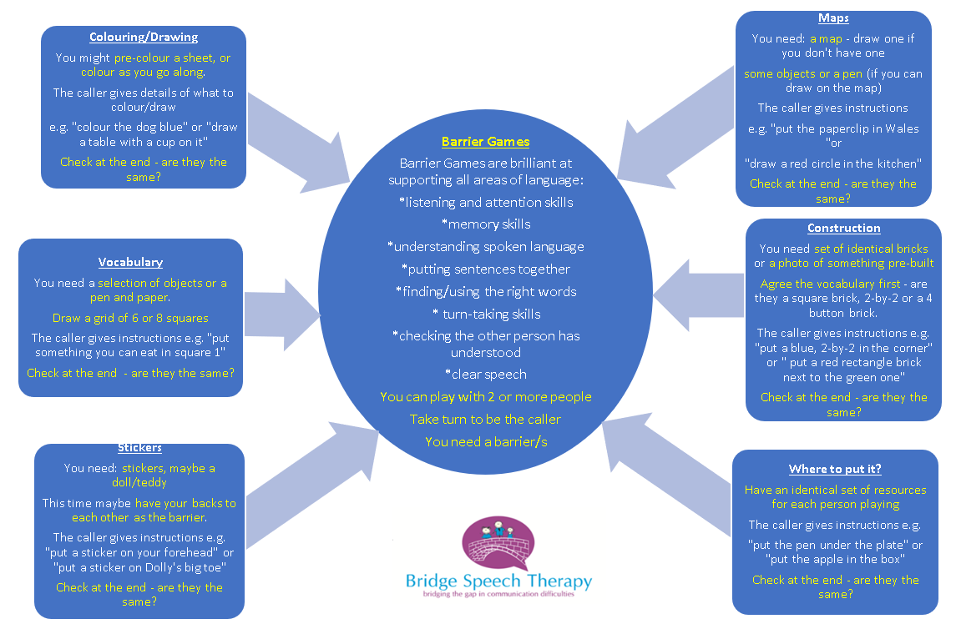

Appendix 16
PIVATS Talking & Communication Milestones Bridge, One Stages 1 and 2, Two Stages 1,and 3, Three Stage 2, Four Stage 1

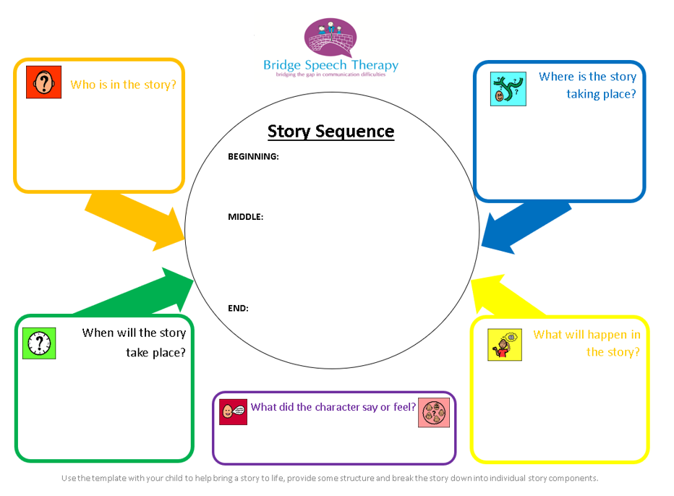

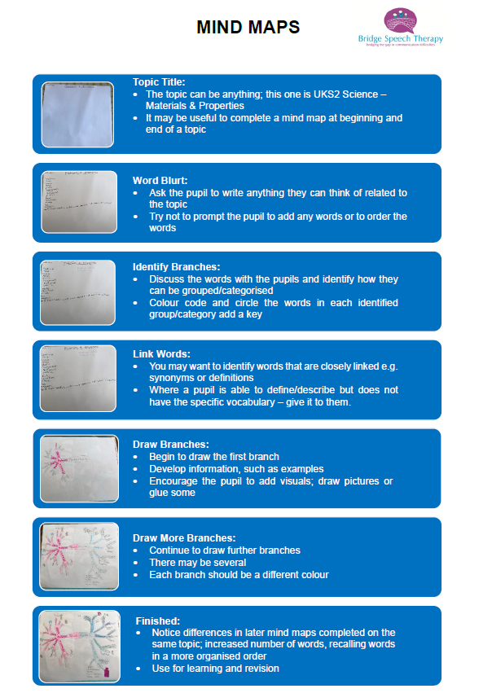

Appendix 17

PIVATS Listening & Understanding Milestones P4, P8 & Bridge

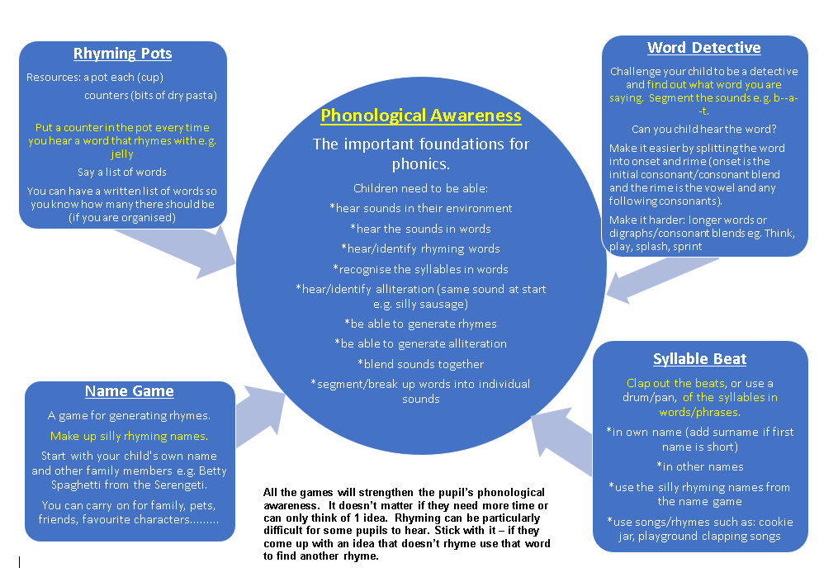

Appendix 18



Appendix 19

Blank Language Levels & Use of Questions

The Blank Language Learning Model was originally developed by Blank, Rose and Berlin (1979), and focused on the language that teachers used in class; ranging from basic questions with concrete information, to complex questions focusing on more abstract, verbal reasoning skills. Further work on this model was also carried out by Parson & Branagan (2005).

The Blank Language Scheme helps teachers and parents/carers to support children’s understanding of questions and develop their verbal reasoning skills.

It helps to teach more abstract language skills: why and how questions, making inferences, sequencing, problem solving & predicting.

The Blank Levels are particularly useful when working with children with ASD & SLCN as it helps to develop comprehension of the more abstract language that these children may find very difficult.

It contains 4 different levels ranging from those questions children first understand (e.g. who, what, where) to more complex questions (e.g. when, why, how).

Level 1 – NAMING
At this level the child is looking at the whole object and answering simple questions. The child is being asked to name something or show you something you name.
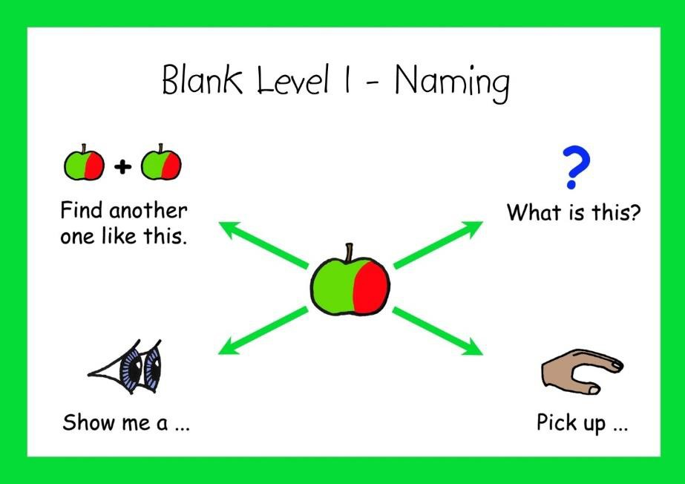
Examples:

What is that?

What are you doing?

Point to the ……

Show me the …..

Give me the ……

Find the …..

Pick up the

Level 2 – Describing

Many of the questions at this level involve describing something. It includes who, what doing, where questions. The child has to look at things in more detail.
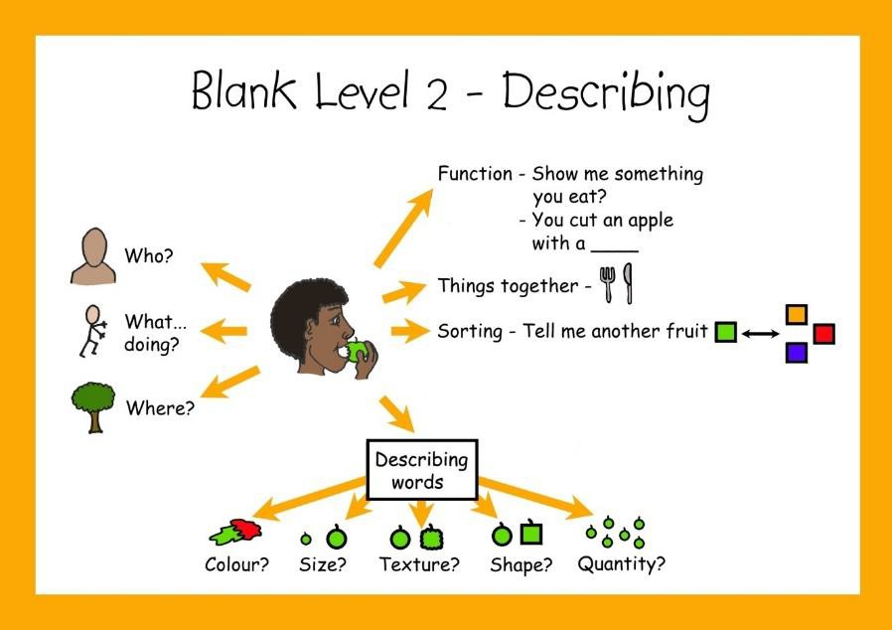
What’s happening?

Where’s the ……….?

What do you do with……?

Which one do we draw with?

Which ones go together? (fork and knife)

What is the boy/girl/dog doing?

Tell me another kind of (food/clothes)

What is different about 2 things

Listen to 2 pieces of information e.g. “find the big red ball?”

Level 3 – Story Telling & Re-Telling

At this level the child is able to re-tell an event or tell a story. They begin to understand feelings and emotions, and state what a character/person says or thinks, and how they are feeling. They can also predict what might happen next (sequencing), and follow a set of instructions.

One exception to the key theme of ‘re-telling’. Being able to give another example within a category but be able to listen to an extra condition (e.g. who did not eat their apple?).
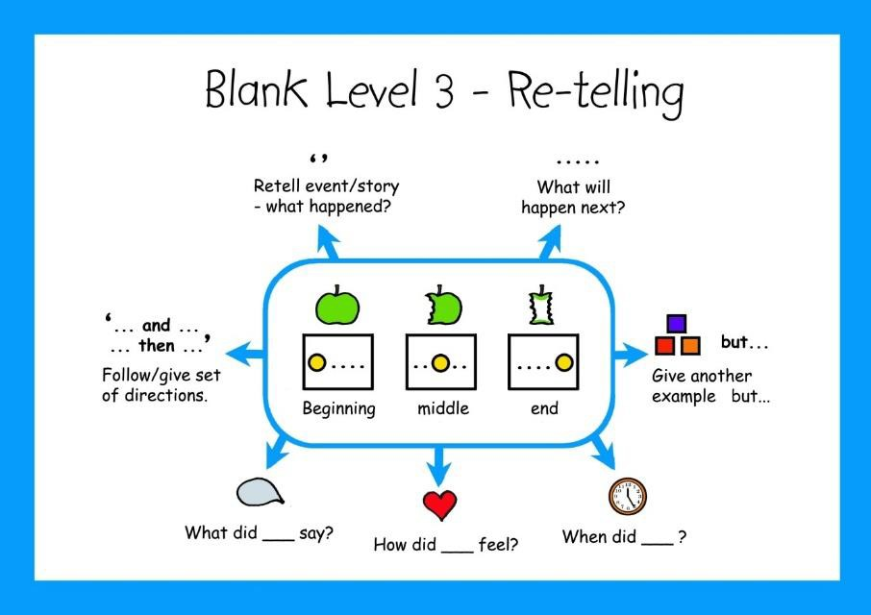
What will happen next?

What could he/she say?

What is the same about 2 things?

Find something that is not…heavy/sharp.

Categorise with more detail e.g. “tell me Something you can wear that’s made of wool?”

Simple word definitions e.g. “what does .mean?”

Arrange pictures in a sequence
Summarise the sequence in a short sentence.

Follow a set of directions; “get your shoes, and line up”

Plan and give a set of directions; “tell me how to get to……..”
Level 4 – Justifying/Why?

Objects or things are not present in the child’s view. Children must use reasoning & problem solving. This level requires the child to solve and justify abstract verbal problems. All ‘why’ questions are Level 4 because they ask the child to justify a decision. Many ‘how’ questions are also level 4.

Language load is increased using more complex vocabulary: evidence, conclusion, justify, predict & consequences.
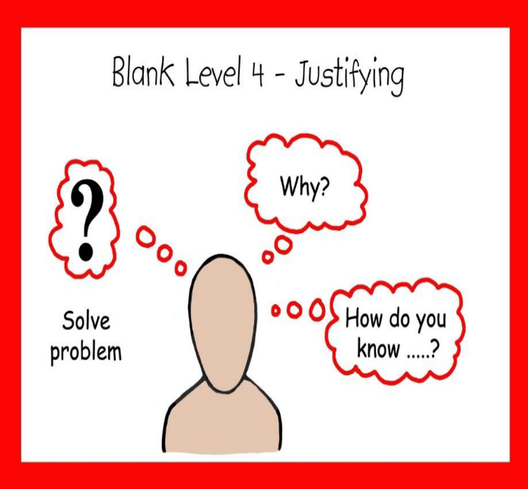
What will happen if……….?

What could you do when…….?

Inference: How can we tell that…….?

What could we use to………..?

Why can’t we….?

Why is ….. made out of ……..?

Justify a predication; “why will that happen?”

Justify a decision; “why did you…..?”

Identify the cause; What made that happen?

Although no age norms are provided 60% of 3 year olds should understand Level 1 & 2 questions, and 65% of 4-5 year olds should understand Level 3 & 4 questions. All levels are usually achieved by 6 years of age.

PLEASE REMEMBER:

- If a child is angry, upset, excited or tired this will affect the ability to understand questions & instructions. Adults should reduce their language and keep it very simple.

- Asking questions can help encourage the use of language skills BUT avoid asking too many questions, and ask questions that the child understands and at the right level.

- When interacting and talking with your child balance questions with:
- lots more comments (using short, simple commentary)
- repeat back what the child says
- add/expand on what the child says by adding a new word or one new idea

Advice written by Sophie Crilly, Speech & Language Therapist, Bridge Speech Therapy

Reference: Information & graphics for this handout are from Elklan, Let’s Talk with Young People with SLD & Supporting Verbal Pupils with ASD



Blank’s Levels of Questioning

Appendix 20

The Blank Language Learning model was originally developed by Blank, Rose & Berlin (1979) and focused on the language that teachers used in class. There are 4 levels of questions used within the Blank Language scheme, and these 4 levels of questioning move from simple questions focusing on concrete information to more complex questions focusing on abstract questions and verbal reasoning skills. All levels are usually achieved by 6 years of age.

Blanks Level 1 Questions
The objects are present/in front of them. The child is being asked to name something & can also include non-speech (e.g. pointing).

- Naming an object seen. ‘What is that?’
- Naming an object by touch. ‘What did you touch?’
- Naming an object heard. ‘what did you hear?’
- Looking for a matching object. ‘Find one like this?’
- What are you doing?
- Point to the………
- Show me the………
- Give me the………..
- Find the……………
- Pick up the………….
- Copying a simple sentences; say this……

Blanks Level 2 Questions
The objects/things are present. The pupil has to look at them in more detail/describe them.

- Describing a picture – ‘what’s happening?’
- Remembering simple information: who? what? where?
- What do you do with…………?
- Looking for an object by function (what it does); ‘find the one that can….?’
- Which ones go together? (fork & knife)
- What is the boy/girl/dog doing?
- Tell me another kind of…(food/clothes)
- Knowing differences; ‘what is different about 2 things?’
- Listen to 2 pieces of information e.g. “find the big red ball.”

Blanks Level 4 Questions
The objects/things are not present – children use their past experience and information beyond what they can see/hear. Children must use reasoning and problem solving.

- What will happen if……….?
- What could you do when……….?
- How can we tell that…………….?
- What could we use to………..?
- Why can’t we……………….?
- Why is ….. made out of ……..?
- Justify a predication; “why will that happen?”
- Justify a decision; “why did you…..?” “why would you…?”
- Identify the cause; What made that happen?
- Explain the logic to compound words e.g. “why is this computer called a laptop?”

Blanks Level 3 Questions
The objects/things may or may not be present. Children are learning to tell & retell stories. They must think and know the facts before giving an answer.
- What will happen next?
- What could he/she say?
- What is the same about 2 things?
- Find something that is not…..heavy/sharp.
- Categorise with more detail/subcategories e.g. “tell me something you can wear made of wool/on your top half.”
- Simple word definitions e.g. “what does …..mean?”
- Arrange pictures in sequence
- Tell a simple story from a set of pictures. ‘Can you tell me the story?’
- Follow a set of directions; “do this and then do that”
- Plan and give a set of directions; “tell me

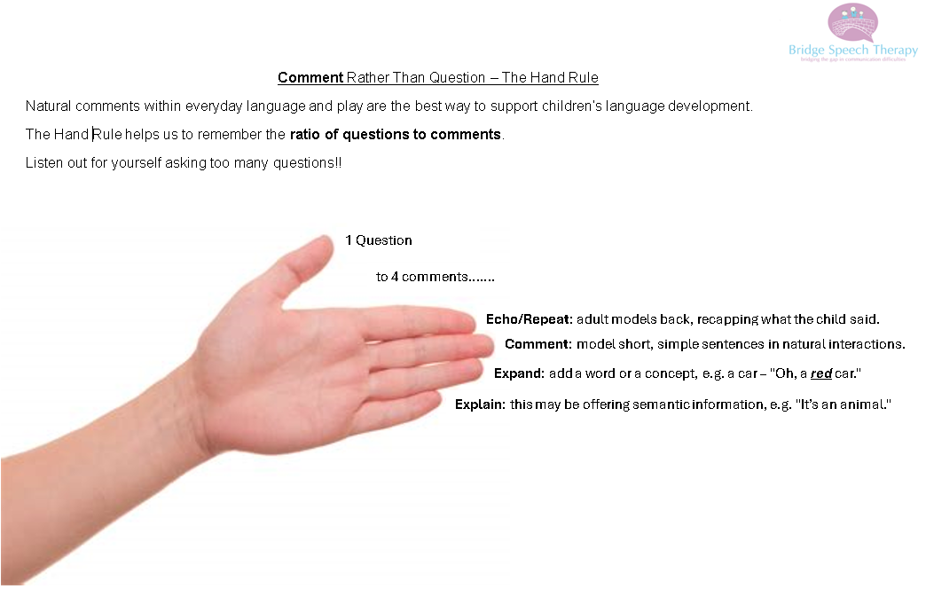

Appendix 21

To view the associated video, recorded by Bridge Speech Therapy, please visit the link below:
https://youtube.com/shorts/PySWUMZFEbY

PIVATS Listening & Understanding Milestones P5, P6, P7, P8, Bridge, Milestone One Stages 2 and 3, Milestone Two Stage 2

Appendix 22
Attention and Concentration

Pupils who appear to find it challenging to attend to the adult during focussed activities may struggle to apply their attention and concentration skills. A description of how pupils may present when they experience these challenges is detailed below.

Pupils with limited attention and concentration may be delayed within their learning.

Early Years:

Impact on Learning. What are their difficulties? | Actions and strategies:
The pupil may be unable to attend to activities for extended periods of time.  The pupil may move quickly from area to area and from activity to activity with limited engagement and learning taking place.  The pupil might move from one activity to the next without completing any given activity.  The pupil might avoid group activities and may be unable to engage in group activities.  The pupil may present as slightly disruptive to others during focussed learning activities.  The pupil may present with delays in reaching milestones.  There may be evidence that the pupil has difficulties in retaining concepts over time.  The pupil may begin to lose skills over time.  Due to significant difficulties with attention, the pupil may require a high level of support to maintain focus and promote learning through play.  The pupil may present as having limited play interests. | - Provide the pupil with consistent adult prompting and a high level of reinforcement to extend their attention during adult led activities e.g. "good listening / looking / sitting" etc.  - New learning needs to be broken down into small steps, and repetition and over learning is required for progress to occur and outcomes to be met. In addition, so that praise for attending can be given at very regular intervals.  - The pupil would benefit from frequent contact with a key adult, with the aim of encouraging them to remain ‘on task’. Frequent attempts should be made to approach the pupil while he or she is 'on task' so that adult attention is used to reward desired behaviour, rather than becoming available when the pupil is ‘off task’.  - Consider the environment.  - Help the pupil to focus by keeping distractions to a minimum, e.g. support play in a quiet area within the setting.  - During carpet time, position the pupil so that their back is towards a good proportion of the group to limit distractions. It may be useful to allocate the pupil their own space/chair and seat them close to the teacher to minimise distractions.  - Staff awareness of typical developmental patterns for pupils, to establish realistic expectations, set goals and identify difficulties.  - Training to develop an understanding of play development and the importance of play for developing cognitive and learning skills.  - Targeted small group support and interventions to develop skills for learning, such as sustained, focused and joint attention.  - Ensure there are plenty of opportunities to repeat activities.  - Encourage pupils to use a range of stimulating open ended resources that encourage pupils to use all their senses.  - Continue to create interesting experiences that develops a pupil’s curiosity and motivation to explore.  - Develop ‘joint attention’ by following the pupil’s interests, joining them in their play, and modelling language appropriate to the pupil’s level of development.  - Provide a language friendly environment offering regular, focused support and prompts from an adult, including cues to support all pupils’ understanding and participation in play and activities. These cues should be multi-sensory. For example: visual (e.g. signs, objects and symbols), audio (e.g. songs), and smell (e.g. spraying different scents on different days of the week).  - Provide structure to the day through the use of a visual schedules e.g. now and next boards (using photographs or pictures to show the routine of the day), gestures or sign along, to ensure all pupils’ understanding. Adults should use consistent language for equipment and routines, for example, all staff use the same term at mealtimes (e.g. dinner or lunch) rather than different terms being used. Activities that require more focus should be followed by activities that are less demanding.  - Adults simplify and repeat instructions to ensure they are understood. Adults promote joint attention, for example stating the pupil’s name before giving information or asking a question and place themselves where the pupil can see their face clearly.  - Provide a Total Communication Environment that uses a range of teaching and learning styles with emphasis on use of gestures, signing, Objects of Reference, key visuals and concrete examples to support spoken language.  - Adults prepare pupils for any changes in routines, for example, signal a change in activity using songs or a musical instrument to gain the pupils’ attention first; talk to pupils in advance if there is going to be a change in the daily routine or staffing; include photos of adults on notice boards or linked to activities on the daily timetable.  - Adults slow down the pace of delivery to allow for extra time to process information.  - Encourage pupils to repeat out loud the information back to themselves (verbal rehearsal) to help them remember key instructions.  - Adults model good interaction skills and physically get down to the pupil’s level when communicating with them.  - Use of Circle Time to help pupils develop their social, attention and listening skills. Additional adult support should be used to support group work (e.g. one adult leading, with another adult supporting the pupils’ engagement).  - Find out what gains the pupils' interests and attention and use this information to plan next steps for learning. Consolidate learning by ensuring that the activities that the pupil enjoys remaining available and are easily accessible. Extend and adapt activities as pupils’ interests and thinking develop and change.  - Provide developmentally appropriate activities and ensure that the pupil is able to access them at his/her own pace, thereby enabling the pupil to achieve.

School Age:

Impact on Learning. What are their difficulties? | Actions and strategies:
The pupil appears distracted from structured activity.  The pupil appears not listen or appears to not have understood a task.  The pupil may present as 'on the go' and fidgeting throughout structured times of day.  The pupil may be disruptive towards other peers by talking during lessons etc.  The pupil may present with what appears to be a behavioural issue.  The pupil may appear to have low self-esteem/low mood.  The pupil may display challenging, disturbing or disruptive behaviour during lesson time. | See 'Early Years' strategies as for some pupils in school these may still be appropriate.  - Provide appropriate small group interventions and resources specific to need with measurable SMART targets.  - Provide regular, specific focused teaching which is increasingly individualised from teacher or teaching assistant.  - Provide the pupil with opportunities to engage in short bursts of focused attention (a realistic amount of time should be agreed dependent on the pupil's needs).  - Ensure differentiation of learning tasks (e.g. break down tasks into small steps) so that they are more accessible to the pupil and will support them with extending their attention.  - Provide the pupil with opportunities to access learning breaks that include heavy muscle activity rather than breaks sitting at their desk / table, e.g. walks / runs in the school yard or movement activity in sports hall.  - Consider gaining access to additional resources to support concentration and distraction e.g. fidget toys / TheraBands / wobble cushions etc.  - Consider using technology to support a pupil's learning skills in lessons that they appear most distracted within, e.g. use apps for mental maths and GPS/ laptops for writing tasks etc.  - Ensure pupils are given appropriate time to process and respond to information. Not all pupils will process information at the same speed and pupils with lower concentration levels will take even longer than most.  - Adapt the environment to ensure that distractions withing the classroom are kept to a minimum, e.g. remove any unnecessary and distracting notices / notice boards. Consider where in the room the pupil is seated e.g. sitting by a window or next to the door can be very distracting for pupils with limited concentration. Consider sitting a pupil close to the teacher however ensure that they have a good view of everything that is within the room e.g. having sight of the door and not sitting with their back towards the rest of the class.  - Pupils may need a key person to speak to / a 'safe space' to go to as their limited attention and concentration skills may affect their mood and overall well-being if they are keen to learn and feel like they are struggling.  - The use of visual schedules (e.g. a now and next board) will support pupils with understanding the structure to their day. This will support their 'on task' behaviours if they know what activity they are to complete and what will be coming up next. Activities that require more focus should be followed by activities that are less demanding.  - Ensure that the pupil's interests are incorporated in their learning activities; this will support their motivation for learning tasks.  - Playing memory/concentration games can help students to learn to focus better and for longer.  - Include visual, auditory and kinaesthetic activities within lessons to ensure that pupils are able to learn using a multi-sensory approach. Some pupils with limited concentration may respond better and learn more effectively with visual as well as verbal information.

Appendix 23
Autism Spectrum Condition (ASC)
Autism Education Trust offer a wide range of resources and training.

Autism Spectrum Disorder (ASD) or Condition (ASC) is a term used to describe an individual who shows differences in their social communication and how they interact with others. Individuals with autism also show restrictive and repetitive behaviours from their early childhood, which can include sensory preferences. The DSM-5 Manual defines autism spectrum disorder as “persistent difficulties with social communication and social interaction” and “restricted and repetitive patterns of behaviours, activities or interests” (this includes sensory behaviour), present since early childhood, to the extent that these “limit and impair everyday functioning”. The 11th edition of the International Classification of Diseases and Related Health Problems (ICD-11, 2018) notes that: "autism spectrum disorder" is characterized by persistent deficits in the ability to initiate and to sustain reciprocal social interaction and social communication, and by a range of restricted, repetitive, and inflexible patterns of behaviour and interests. “

Autism is known as being a spectrum because whilst there are identifiable traits, there is wide variation in how these manifests themselves, and the impact on each individual and how they experience these will be different. Some individuals may refer to ASC as 'Autism Spectrum Condition' or 'Autism' as this supports the notion that autism is a different way of being, not a disorder. 6.29 The SEND Code of Practice describes how pupils and young people with ASC experience difficulties with social interaction, language, communication, and imagination. This can impact how pupils relate to others. It is further acknowledged within the SEND Code of Practice (2015) that pupils with ASC may experience differences and needs across all areas of their development.

It was previously thought that autism was more likely to occur in boys. Our understanding of autism has since developed and there is more awareness around the identification of girls with autism. It is thought that girls with autism often 'mask' their social differences through imitating others and rote learning conversational phrases. Girls with ASC are thought to be more able to adjust their behaviour, engage in reciprocal conversations, and be more likely to initiate friendships but have difficulty in the maintenance of friendships (Lai et al., 2015).

ASC can often co-occur with other conditions, for example, attention deficit hyperactivity disorder (ADHD). Approximately 55% of individuals with ASC also have a learning disability (Charman et al., 2011). In the Department for Education's most recent analysis of data on pupils and young people with SEND, ASC was the most common primary type of need for pupils with EHC plans at 30.1% (Department for Education, 2021).

Early Years

Impact on Learning. What are their difficulties? | Actions and strategies:
In the Early Years, practitioners may notice that a pupil prefers solitary play. As pupils develop, they will have a range of strengths and areas that they find more difficult. Often pupils with autism may show strengths in their physical development but may experience difficulties or show differences in their language development, their social and emotional development, and their play. | Provide visual prompts, including key vocabulary, visual timetables, now and next, and gestures. Labelling the environment, especially motivating objects with words and pictures, and using these frequently can help pupils to make the association between words and meaning. This will help support a pupil's understanding of language and routines. Visual choice boards can be used to also develop vocabulary and promote the pupil expressing their wants and needs.  Attention Autism is a group intervention model which aims to develop natural and spontaneous communication through the use of visually based and highly motivating activities.  Intensive Interaction is an approach designed to help develop pre-communication skills such as joint attention through sensory and shared joy activities. The adult take's the pupil's lead, responding to the things they do.  By responding instead of leading we don't make demands they cannot cope with.  https://www.intensiveinteraction.org/  Observation Profile (within Autism in the Early Years) provides tracking and monitoring tools specifically measuring the development of social communication and interaction skills development to develop SMART targets and monitor progress.  https://www.amazon.co.uk/Autism-Early-Resource-Materials-Teachers/dp/0415483735  School staff understand age-appropriate skills using a checklist such as the free Universally Speaking Age 4-11 checklist, available from The Communication Trust.  https://ican.org.uk/i-cans-talking-point/professionals/tct-resources/more-resources/primary-school-milestoneposter/  Black Sheep Press provides a wide range of resources to teach concepts in pictures and language in pictures. These can support a variety of age groups to learn aspects of language including grammar, vocabulary, and sentence construction.  Black Sheep Press https://www.blacksheeppress.co.uk/ has also developed an autism-friendly resource, using basic language and stories to support the development of friendships.  https://www.blacksheeppress.co.uk/product/friendship-terrace-friendship-skills/  Provide more time to respond to questions (e.g. 10-second rule) and to complete multi-step tasks.  Support pupil’s understanding of multi-step activities using task lists/ planners.  Time to Talk is a 40-session programme for pupils aged 4-8 that teaches and develops oral language and social interaction skills with Ginger the Bear.  https://www.ldalearning.com/product/communication-and-interaction/speech-and-language/teachingresources/time-to-talk/agmt00498  Autism Education Trust offer a wide range of resources and training.

School Age

Impact on Learning. What are their difficulties? | Actions and strategies:
Some pupils with autism may use words and phrases that they have heard others say without understanding the meaning or context of these. Other pupils may be able to talk about a particular topic at length and in detail but have difficulty in having a reciprocal conversation.  Some pupils with autism may not use words but may vocalise to show their feelings. If a pupil does not yet have the tools to communicate their needs and feelings, this can be highly frustrating, and they may show this frustration through their behaviour. | See early years strategies as for some pupils these may still be appropriate.  - Daily routines need to be clear and predictable. It is important to ensure there is a range of ways for a pupil to communicate both verbally and non-verbally. Visuals can help support a pupil's understanding of language and routines.  - Visual Timetables and classroom rules should be clearly displayed. Ensure visuals related to past events are removed from the pupil’s sight (e.g. take down pictures of activities as they are completed or use a clear marker to indicate where you are in the daily routine). The National Autistic Society's guide to visual supports details helpful information and resources  - Use the environment to support the understanding of expectations. The TEACCH approach is a way to provide high levels of visual structure and clarity to support pupils’ understanding of the environment, expectations, and activities (e.g. start and finish trays, use of a workstation). It is not a single method and can be used alongside other approaches.  - Try to avoid the use of non-literal language (e.g. idioms and sarcasm) and explain any abstract concepts in as concrete a way as possible (e.g. with pictures or objects). The book 'IS THAT CLEAR? Effective communication in a neurodiverse world' by Zanne Gaynor and Kathryn Alevizos may be helpful for adults to read to consider how they use language adjustments that can be made to support more effective two-way communication.  - Ensure access to a range of communication opportunities, so pupils can contribute in different ways or across contexts and in relation to different topics, (e.g. including those they are more confident/ interested in).  - Social stories (or social comic strips) to discuss hidden social rules and problem solve. Personalise social stories to the difficulty the pupil is having. Use ABC chart to identify social situation in which a social story may be needed. Wherever possible, include the pupil in the writing of social situations. For older students, consider supporting students to developing social stories using computer animation packages. Staff/parent training will support the effective use of social stories and social comic strips. Also consider the use of scripts. What Is a Social Story? - Carol Gray - Social Stories (carolgraysocialstories.com)  - Autism Education Trust offer a wide range of resources and training.

Appendix 24
Expressive Language

6.28 The SEND Code of Practice outlines that pupils and young people with speech, language, and communication needs (SLCN) have difficulty in communicating with others. This may be because they have difficulty saying what they want to, understanding what is being said to them or they do not understand or use social rules of communication. The profile for every pupil with SLCN is different and their needs may change over time. They may have difficulty with one, some or all of the different aspects of speech, language, or social communication at different times of their lives.

Expressive language is any important aspects of early development. A study by Manning et al (2019) looked at relations between toddler expressive language and temper tantrums in a community sample. More than 2,000 parents who had a toddler between the ages of 12 and 38 months were surveyed, with questions about their pupils’ number of spoken words and their tantrum behaviours. It found that late talkers have nearly double the rate of tantrums compared to their peers. The study identified a relationship between emergent language and mental health risk, with implications for early intervention.

Expressive Language difficulties can fall into two areas: Difficulties producing language and difficulties with speech sounds.

Difficulties with Producing Language

Planning, organising, and saying what we want to say involves many different skills. A pupil may have difficulty in one or more of the following areas. This will affect how well they express themselves.

Difficulties with vocabulary (semantics)

We need to put the right words in the right order to express ourselves clearly. We also need to have enough words and the 'right' ones to say what we want. Some pupils find it hard to learn or recall words. Some have difficulty choosing the right word to use. This is sometimes called 'word-finding' or 'word-retrieval difficulties'.

Difficulties with forming sentences (grammar or syntax)

We need to know how to put words together, so they make sense. Some pupils find it difficult to put words together in the right order. Some can miss words out of a sentence e.g. saying, 'playing ball' instead of 'Doggy is playing with the ball’. We need to know how the endings of words change when talking about the past or talking about more than one thing. Some pupils can have difficulty adding the right endings to words to show a different meaning e.g. saying 'I runned' instead of 'I ran'.

Difficulties with organising sentences and ideas

We need to link our sentences together in a logical order to make sense to other people. Some pupils find it difficult to organise their ideas. Their speech may not follow a logical order. They may talk about lots of different topics in the same group of sentences. Some may find it difficult to plan what they want to say. They may need more time to organise their thoughts and language.

Difficulties with Speech Sounds

This can include muscles used to create different sounds. This can be due to muscle weakness and may be linked to conditions such as cerebral palsy. Sending messages from the brain to make different speech sounds. This may sometimes be described as 'dyspraxia'. Learning and using different sounds to make words. This can be called ‘phonological difficulties'.

ICan is a pupils' communication charity and provides information about all areas of communication https://ican.org.uk/ see ICAN’s Talking Point page https://ican.org.uk/i-cans-talking-point/. They also provide progress checkers. They will provide short questions you can answer to see how your baby or pupil is getting on with their speech, language, and communication development.
https://ican.org.uk/i-cans-talking-point/progress-checker-home/

Also see Lancashire and South Cumbria NHS Foundation Trust | Children's Speech and Language Therapy Service (lscft.nhs.uk)

Early Years:

Impact on Learning. What are their difficulties? | Actions and strategies:
Expressive language is about being able to communicate with others and talk.  You should be concerned by 2 years if they are:  - Slow to follow simple instructions.  - Not saying 25 recognisable words.  .  By 3 and a half years old a pupil should be understood by people outside the family. You should be concerned if:  - They are struggling to turn ideas into sentences.  - The language they use is jumbled and difficult to understand. | Actions and strategies:  The actions and strategies below can be adapted to support a young child with their development of expressive language  Age 0- 3  - Adults give babies and children their attention when interacting with them, getting down to their level.  - When interacting with babies, adults copy the sounds the babies make back to them, to develop a two-way flow as if in conversation.  - Adults attach meaning to babies and pupils’ vocalisations, through watching their actions and saying out loud what they might be thinking ‘Oh you’re sad, I wonder if you’re hungry?’  - Adults copy the facial expressions babies make during interactions. Adults exaggerate their own facial expressions and change the pitch and tone of their voice to capture the baby’s interest.  - Adults keep their spoken language simple and comment on their own, as well as, the pupils’ play (running commentary), reducing the number of questions.  - Adults give the babies and pupils time to process language and then respond.  - Adults encourage use of gesture (e.g. pointing) and, if/when appropriate, encourage use of  accompanying language by modelling using objects, e.g. ‘Which one, ball or box?’ and saying back the correct language.  - Adults model language and extend pupils’ phrases by one word at a time. When using language extensions, instead of adding colour/size try to model use of verbs too (e.g. “push the car” …” the car’s stopped”).  - If a pupil mispronounces a word, adults model a correct form of the word rather than directly  correcting, (e.g. If the pupil says ‘tar’ say, ‘Yes, that is a star.’)  - Adults support the development of sharing and turn-taking in small groups and on an individual  basis as needed. are supported to contribute during group activities (e.g. give clear routines for  showing who’s turn it is during group work such as a using a ‘talking object’; pupils are prepared in advance by practising or being introduced to key vocabulary before being expected to use it in a group situation).  Age 3-4  - Have a special time to talk about the day. Talking about what has happened that day will help their memory skills. It will also help them to talk about things they cannot see and things that.  happened in the past which is an important skill for learning in school.  - Wherever possible, use pictures, objects, puppets, acting, gestures, and facial expressions. This will keep a pupil’s interest.  - Talk about or play games involving opposites like 'on and off' or 'big and little'.  - Join a pupil in pretend play. Let them take the lead. This will help their language and creativity. Talk about what they are saying and doing rather than asking lots of questions. Your commentary helps their language skills and shows you are listening and interested.  - Reversing roles can be great fun for a pupil. Let them be the 'mummy' or the 'teacher'. This helps them to talk about new situations.  - Play with and talk about sequences of coloured bricks or shapes, numbers, and days of the week.  Activity ideas and resources:  Small Talk is a guide to find out what helps pupils learn to talk, including developmental milestones and strategies for parents and carers.  Wellcomm (Early Years) – allows practitioners to screen a pupil’s speech and language skills from 6 months to 6 years. Associated ‘Big Book of Ideas’ gives lots of targeted activities to use once levels assessed.  BBC’s Tiny Happy People site offers loads of simple, fun, and free activities that parents/professionals can try with babies, toddlers, and young pupils https://www.bbc.co.uk/tiny-happy-people.  Hungry Little Minds has great ideas for pupils aged 0-5yrs  https://hungrylittleminds.campaign.gov.uk/.  Toddler Talk is an activity pack to promote communication development of toddlers from 18 months  to 3 years old. Chatting with Pupils promotes communication development of pupils from 3 to 5 years old. Both are available from ICAN.  Adults teach specific, functional vocabulary (e.g. more, hello, please, toilet) using appropriate Early Years strategies e.g. pairing words with a visual, using Signalong.  Adults offer pupils choices (e.g. for food, songs, stories, activities) making sure that a choice is supported visually with objects, pictures, or symbols.  Adults model and support skills to promote communication and language with peers (e.g. support to join group games, use of musical instruments/ actions to allow inclusion in circle time, structured physical games during outdoor play such as races and chase games which don’t depend on spoken language skills).  Provide alternative ways to record learning (e.g. photos or video recording) so pupils can share their ideas and progress can be captured.  Adults provide regular access to small group interventions to develop skills, for example: Talk Boost is a targeted intervention that narrows the gap between 4–7-year-olds with language delay and their peers.

School Age:

Impact on Learning. What are their difficulties? | Actions and strategies:
- Just by having good conversations with pupils, you are supporting their language. So, talk to them. Ask them how their day at school was and how their friends are. Hopefully they don't need too much encouragement to talk. Try to encourage conversations rather than just you doing the talking.

- Provide a range of planned communication opportunities in a range of settings, with enough time given for processing (e.g. 10-second rule), thinking and responding to verbal information and new vocabulary (e.g. see ELKLAN Language Builders book for activity ideas).

- Use of a range of whole-class or whole-school intervention programmes, for example providing consistent visual support to structure or record ideas (scaffolds or templates). Use word webs and vocabulary maps as a whole class when learning new vocabulary and story planners when retelling or story or giving a personal narrative.

- Provide opportunities for communication throughout the school day in a range of lessons. Including opportunities for discussion around books and narratives.

- During group work, allow the pupil to answer after other pupils and adults have modelled the answer a few times.

- Talk for Writing is a teaching framework that enables pupils to imitate the language they need for a particular topic orally, before reading and analysing it and then writing their own version.

- Provide an environment in which pupils are surrounded by spoken and written words and inspired to learn them using multi-modal approaches (e.g. key words highlighted on the board and in worksheets to remind the pupils to check their vocab sheet).

- Ensure access to a range of communication opportunities, so pupils can contribute in different ways or across contexts and in relation to different topics (e.g. including those they are more confident/interested in).

- Pre-teach key vocabulary and support generalisation to the classroom (e.g. have worksheets with key vocabulary on their desks, which they can refer to, use of word webs to promote experiential language learning).

- Teach specific vocabulary, such as ‘word of the day/ week’ in smaller groups and support vocabulary use and understanding within the classroom.

- Consider the three tiers of vocabulary:
i) Every day, basic words.
ii) More complex words (e.g. using ‘combine’ for mix) or words with more than one meaning.
iii) Subject specific e.g. Galapagos.

- Focus on developing the pupils’ understanding and use of words in Tier 2. These words have the highest utility in helping to close the language gap for those pupils with limited vocabulary.

- Use of vocabulary checklists/word maps. Create personalised dictionaries, vocab cards or knowledge organisers.

- Use the STAR approach in content-rich subjects: Select the really useful vocabulary that is from the topic or class text. Teach the selected vocabulary in a structured manner. Activate the meaning by using the words in context and linking the word to the pupil’s existing knowledge. Review the taught words to ensure they are retained.

- Use of intervention programmes within a small group, such as:

- Listening and Speaking and Oral to Written narrative packs from Blacksheep press. To support pupils’ structure of oral stories and the transition to a written narrative.
- Colourful Stories (ELKLAN) a visual support strategy which helps pupils to learn about the structure of stories and to become more confident about telling and writing stories.
- Colourful Stories encourages oral-narrative skills and introduces written words only when the pupil is confident about how to structure and tell a story orally.
- Talk Boost KS2 a targeted intervention for 7- to 10-year-olds with a language delay, which aims to narrow the gap between them and their peers.
- Colourful semantics an approach aimed at helping pupils to develop their grammar by linking the word to the pupil’s existing knowledge. Review the taught words to ensure they are retained.

- Nuffield Early Language Intervention (NELI) – programme for 4-5yr olds in reception which has been found to improve language and early literacy skills. https://www.teachneli.org/

- Wellcomm (Primary) – for ages 6 years to 11 years. As above.

- The National Literacy Trust have put together Words for Life. This site has some great ideas for very young pupils but also older teenagers https://wordsforlife.org.uk/.

- Stoke Speaks Out has step by step resources and approaches Resources & downloads | Stoke Speaks Out

Appendix 25
Receptive Language

Receptive language is the understanding of information that is provided in a variety of ways such as sounds, words, movement, gestures, signs, and symbols. Receptive language can also be demonstrated in a person’s body language and tone of voice. The environment and the situation also add to a person's understanding of what is being communicated.

Pupils and young people with limited receptive language skills may find it challenging to understand and respond appropriately to social situations. The difficulties experienced can impact on the development and maintenance of friendships or relationships. Pupils and young people with limited receptive language skills may be delayed within their learning.

See Lancashire and South Cumbria NHS Foundation Trust | Children's Speech and Language Therapy Service (lscft.nhs.uk)

Early Years

Impact on Learning. What are their difficulties? | Actions and strategies:
The pupil may find it difficult to identify objects.  The pupil may find it challenging to follow instructions.  The pupil may find it difficult to follow directions.  It may appear as though the pupil finds it challenging to understand a conversation.  The pupil may find it difficult to answer questions accurately and appropriately.  The pupil may find it a challenge to understand a story.  The pupil might use incorrect verb tenses, pronouns, plurals, etc, when communicating with others.  The pupil may find it difficult to organise thoughts for speech.  The pupil may find it difficult to organise thoughts for writing.  The pupil may respond to a conversation, off topic. | There should be a focus on developing early communication skills, e.g. shared attention, listening, turn-taking and comprehension.  There should be a focus on encouraging all vocalisation and non-verbal communication.  Activities should be aimed at developing listening and attention skills.  Activities should aim to develop some shared attention with a familiar adult, whereby an adult and the pupil focus on the same thing, even for very short periods of time. This can then gradually and sensitively be extended.  Use simple, precise, very short language, e.g. up to three words, to support the pupil's understanding.  Use alternative methods of communication e.g. Makaton, ICT, communication books and boards. You may also wish to consider use of a symbol communication system such as Picture Exchange Communication System (PECS) - please seek advice from your SENCO if needed.  Support verbal communication with the use of objects of reference.  Support verbal communication with the use of gestures.  Support verbal communication with the use of visual cues/picture prompts.  Give the pupil 'thinking time' to allow them to process the information given to them.  Consistent use of the same objects of reference to communicate with the pupil.  Consistent use of the same picture prompts to communicate with the pupil.  Introduce a variety of language through rhymes, songs.  Use the Blank Level of questioning to encourage development of general language and vocabulary as well as skills in comprehension, reasoning, inferencing, predicting, and problem solving (Blank, 2000).  Consider how many information carrying words a CYP can manage when giving instructions – adapt use of language and method, e.g. simple choices, reduce complexity and sentence length.  Be aware of your own body language: 70% of what we communicate is non-verbal.  Have an awareness of what would be an appropriate tone of voice (calm, not too loud), what would be an appropriate environment (noise, temperature, lighting, layout), use of language (some pupils  may need a language rich environment; others may need it to be kept simple).  Model language - reflect back correct speech rather than correcting.  Other resources include:  - Wellcomm (Early Years) – allows practitioners to screen a pupil’s speech and language skills from 6 months to 6 years. Associated ‘Big Book of Ideas’ gives lots of targeted activities to use once levels assessed.  - Resources & downloads | Stoke Speaks Out  - BBC’s Tiny Happy People site offers loads of simple, fun, and free activities that parents / professionals can try with babies, toddlers, and young pupils https://www.bbc.co.uk/tiny-happy-people  - Hungry Little Minds has great ideas for pupils aged 0-5yrs.  https://hungrylittleminds.campaign.gov.uk/.  - EYBIC is a great resource for developing understanding and use of information carrying words with preschool pupils (available from ELKLAN).  - ICAN’s Talking Point page https://ican.org.uk/i-cans-talking-point/

School Age

Impact on Learning. What are their difficulties? | Actions and strategies:
See 'Early Years' section for 'impacts of learning' as for some pupils in school these may still be appropriate.  The pupil may find it difficult to carry out a reading comprehension task.  The pupil appears not to listen.  The pupil appears not to have understood a task.  The pupil appears not to have understood an instruction or a direction.  The pupil appears not to have understood the story.  The pupil may appear to have low self-esteem.  The pupil may appear to have a low mood.  It may appear as though the pupil finds it challenging to understand a conversation.  The pupil may find it difficult to answer questions accurately and appropriately.  The pupil might use incorrect verb tenses, pronouns, plurals, etc, when communicating with others.  The pupil may find it difficult to organise thoughts for speech.  The pupil may find it difficult to organise thoughts for writing.  The pupil may find it difficult to play games that require instructions.  The pupil may look towards peers to support their understanding of what to do.  The pupil may wait to see what other peers do before acting.  The pupil may only complete half or part of a task.  The pupil might ask for someone to repeat themselves, such as repeat an instruction.  The pupil may have a limited vocabulary, in comparison to their peers. | See 'Early Years' strategies as for some pupils in school these may still be appropriate.  Provide appropriate small group interventions and resources specific to need with measurable SMART targets.  Provide regular, specific focused teaching which is increasingly individualised from teacher or teaching assistant.  Ensure differentiation of learning tasks (e.g. break down tasks into small steps) so that they are more accessible to the pupil and will support them with extending their attention.  Consider using technology to support a pupil's understanding skills in lessons, such as using apps for mental maths.  Ensure pupils are given appropriate time to process and respond to information. Not all pupils will process information at the same speed.  Playing memory / concentration games that can help students to learn to focus better and for longer,  which will support the development of receptive language skills.  Include visual, auditory, and kinaesthetic activities within lessons to ensure that pupils are able to learn using a multi-sensory approach. Some pupils with limited receptive skills may respond better learn more effectively with visual information as well as verbal information.  Adapt the environment to ensure that the pupil has access to all forms of information being provided.  For instance, ensure that they have a good view of everything that is within the room e.g. not sitting  with their back towards the rest of the class. The pupil may rely on cues from other pupils to support their understanding.  Pupils may need a key person to speak to / a 'safe space' to go to as their limited receptive language skills may affect their mood and overall well-being if they are keen to learn and feel like they are struggling.  The use of visual schedules (e.g. a now and next board) will support pupils with understanding the structure to their day. This will support their 'on task' behaviours if they know what activity they are to complete and what will be coming up next. Activities that require more focus should be followed by activities that are less demanding.  Ensure that the pupil's interests are incorporated in their learning activities; this will support their motivation for learning tasks.  Support the student in understanding words at different levels. Determine what words the pupil understands and the amount of information carrying words the pupil can understand in one instruction. Use the information to work on increasing the pupil’s ability to attach meaning to words and understand instructions with increasing amounts of information.  Consider how many information carrying words a pupil can manage when giving instructions – adapt  use of language and method, e.g. simple choices, reduce complexity and sentence length.  Build on the pupil's development of information carrying words (ICW) so that the pupil can then move on to understanding words and information in different sentence structures, paragraphs, and long narratives.  Play following direction games, in order to encourage listening skills through play.  Pre-teach topic vocabulary and provide opportunities to re-visit understanding and use of words.  The following are online resources that may support speech, language, communication, and interaction skills in pupils:  https://www.speechandlanguagekids.com/receptive-language-delay/  https://www.twinkl.co.uk/search?q=receptive+language  https://www.gl-assessment.co.uk/assessments/products/wellcomm/  Resources & downloads | Stoke Speaks Out  Nuffield Early Language Intervention (NELI) – programme for 4-5yr olds in reception which has been found to improve language and early literacy skills. https://www.teachneli.org/  Wellcomm (Primary) – for ages 6 years to 11 years. As above.  The National Literacy Trust have put together Words for Life. This site has some great ideas for very young pupils but also older teenagers https://wordsforlife.org.uk/.

Appendix 26
Selective Mutism

'Selective Mutism, sometimes called Situational Mutism, is an anxiety-based mental health disorder which usually begins in early childhood. Pupils and Young People presenting with selective mutism speak fluently in some situations but remain consistently silent in others. They may have a blank expression or appear ‘frozen’ when expected to speak. With early intervention the prognosis for recovery is good, but in some cases, it may persist and last right through a pupil’s school life and sometimes even into adulthood. It is important to understand that those with SM want to speak but find themselves physically unable to do so due to their anxiety' Selective Mutism Information & Research Association (SMIRA)

The essential feature of selective mutism is the persistent failure to speak in specific social situations (e.g. at school, with peers and/or the teacher), despite being able to speak in other, more familiar situations. DSM V definition of selective mutism (pg. 195) states there is a consistent failure to speak in certain social situations where speaking is expected, despite speaking in other situations.

- Has persisted for at least one month, not including first month in a new social situation.
- Not due to unfamiliarity or discomfort with the spoken language required.
- Cannot be accounted for by a communication disorder (e.g. stuttering, ASD)

Pupils with this disorder:

- Sometimes use non-spoken or non-verbal means to communicate and may be willing or eager to perform/engage in social encounters when speech is not required.

For unknown reasons, Selective Mutism appears to be more prevalent amongst girls and more cases are reported from migrant and multi-lingual families. Pupils with EAL (English as an additional Language) are at higher risk of also developing selective mutism.

Early Years

Impact on Learning. What are their difficulties? | Actions and strategies:
Observed difficulties with the following:  Difficulties speaking in specific locations and with specific people.  Difficulties reading aloud to certain adults and in certain situations. (The pupil may be happy to read at home but not in school).  Difficulties interacting with peers verbally which can impact on the development of social skills and development of reciprocal friendships.  Always remember that the non-speaking may hide other educational or physical problems. | The-Selectively-Mute-Child-in-School-v2.pdf (selectivemutism.org.uk)  Provide a communication safe environment:  - Identify key adult for the pupil to build rapport and confidence with.  - Focus on discovering their interests and strengths and having fun together.  - Be patient. Provide opportunities to speak without putting pressure on the pupil to speak and do not ‘over’ react if the pupil does speak.  - Make comments rather than ask questions.  - Provide non-verbal ways to respond and join in during group activities (e.g. using music instruments or actions alongside words).  - Encourage participation through ‘show’ rather than ‘tell’.  - Use of question starters such as ‘I wonder….’  - Encourage joint activities with a quiet pupil.  - Provide traffic lights or ‘ask for help’ cards to allow support to be requested non-verbally.  - Use informal ways to support the pupil’s confidence to speak.  - For further ideas and strategies please see nursery and play group staff guidelines.  Multiagency working  - Seek multi-agency support from outside services and work with the pupil’s family to devise an individualised support plan.  - Refer to speech and language therapy service for assessment of core speech and language skills if concerned/unsure of skills.  - Liaise closely with parents and carers to develop an understanding of the pupil's strengths and needs. Use assessment tools such as the talking map (selective mutism resource manual) which can highlight where the pupil is happy to speak and whom with. Over time the aim is to increase the places the pupil feels confident to speak and increase the number of people the pupil is happy to speak in front of.  - Use of the ‘Sliding in Technique’ detailed in The Selective Mutism Resource and included on the SMiRA website:  http://www.selectivemutism.org.uk/info-the-sliding-in-technique-and-progress-charts/  - This involves an adult (parent or staff member) as the pupil’s talk partner. Activities from the elective mutism manual focused on the correct level (for the pupil) are completed on a regular basis within the pupil’s talk partner in a safe and quiet area of the setting.  - The activity should be simple and involve something that the pupil enjoys and is familiar with (e.g. a favourite game or book from home). As the pupil becomes confident, their tolerance to another person gradually coming closer and joining the activity (‘sliding in’) is increased.  PARENT-Game-ideas-for-sliding-in.pdf (selectivemutism.org.uk)  - Seek advice from the small steps program when problems occur – for instance if the pupil become stuck at the whisper phase.  - Carefully support the pupil’s transition to school, please see Preparing to change School, Class or Teacher or start at school or nursery Care Pathway for Selective Mutism

School Age

Impact on Learning. What are their difficulties? | Actions and strategies:
- Use of questions such as ‘I wonder…’

- Encouraging joint activities with a quiet peer.

- Identifying a key adult for the pupil to build rapport and confidence with.

- Providing traffic lights or ‘ask for help’ cards to allow them to access support non-verbally.

Seek multi-agency support from outside services and work with the pupil’s family to devise an
individualised support plan.

- Liaise closely with parents and carers to develop an understanding of the pupil's strengths and needs. Use assessment tools such as the talking map (selective mutism resource manual) which can highlight where the pupil is happy to speak and whom with. Over time the aim is to increase the places the pupil feels confident to speak and increase the number of people the pupil is happy to speak in front of.

- Use of the ‘Sliding in Technique’ detailed in The Selective Mutism Resource and included on the SMiRA website

This involves an adult (parent or staff member) as the pupil’s talk partner. Activities from the selective mutism manual focused on the correct level (for the pupil) are completed on a regular basis within the pupil’s talk partner in a safe and quiet area of the setting.

The activity should be simple and involve something that the pupil enjoys and is familiar with (e.g. a favourite game or book from home). As the pupil becomes confident, their tolerance to another person gradually coming closer and joining the activity (‘sliding in’) is increased. PARENT-Game-ideas-for-sliding-in.pdf (selectivemutism.org.uk)

Seek advice from the small steps programme when problems occur – for instance if the pupil become stuck at the whisper phase. Small Steps Programme

Carefully support the pupil’s transition to school. Preparing to change School, Class or Teacher or start at school or nursery.

Appendix 27
Social Communication

Social communication refers to the way in which language is used in social situations. Social communication is a broad term which encompasses social interaction (e.g. social reasoning, cooperative play / learning), social cognition (e.g. joint attention, inference, the ability to connect emotional states to oneself and others), pragmatics (e.g. understanding/use of body language, gaze, positioning) and language processing. Based on research, the ASHA (American Speech-Language-Hearing Association provide a summary of the different skills involved in social communication.

Components of Social Communication (asha.org)

Pupils and young people with social communication will have difficulties using language socially both expressively and receptively. They may also have difficulties understanding the implicit rules within a social situation. Due to the wide range of skills encompassed by social communication, the difficulties experienced will vary. The difficulties experienced can impact on the development and maintenance of friendships or relationships. Below are examples of difficulties or differences that a practitioner may recognise if a pupil or young person has social communication needs:

- Initiating, maintaining, repairing, and closing conversations.
- Understanding the needs of the listener e.g. not providing context or sufficient information for the listener to understand.
- Recognising non-verbal communication cues (e.g. body language, facial expression) and using non-verbal communication (e.g. eye contact, intonation of voice).
- Understanding the social behaviour or feelings of others.
- Sharing joint attention.
- Working or playing co-operatively in a group.
- Understanding and following routines.
- Understanding inference (both in written work/reading and in conversations).

Social communication is a high incidence SEND. Social communication needs may become particularly apparent during transitions to new settings or during adolescence / secondary school were social rules and norms can become more complex.

Social communication difficulties area a characteristic of a range of conditions including attention deficit hyperactivity disorder, development coordination disorder and autism spectrum disorder. As a central difficulty experienced by pupils and young people with ASD, many of the strategies used to support pupils with ASD will also support pupils with social communication difficulties. However, not all pupils with social communication difficulties have ASD, for example they might not have ritualistic or repetitive behaviours. Pupils with social communication difficulties also often experience differences in sensory processing.

Early Years

Impact on Learning. What are their difficulties? | Actions and strategies:
In the Early Years practitioners may notice that the pupil frequently engages in solitary play. Solitary play maybe the pupil's preference, or the pupil may attempt to have interactions with their peers but know the right way to initiate these. The pupil may find it difficult to share or take turns with others. The pupil may find changes to their routine upsetting. | To support the development of interaction and play skills:  With adults: Allow specific time for interaction with adults during each session. Examples of specific techniques used to support the development of early interaction skills:  Intensive Interaction: An approach which was developed to help people who are at an early stage of communication skill development enjoy being other people and interact with them. The approach supports pupils to know, understand and practice communication routines.  Intensive Interaction - Fundamentals of Communication  Identity play: An approach that is used to help establish shared focus in play and supports the development of skills.  With other pupils: Structured, small group activities which target the teaching of teachings of specific skills e.g. turn taking. Teach structured playground games such as 'tig' and 'hide and seek'. TreasureTrove provides examples of activities to support the development of targeted social communication, attention and listening skills.  To make the implicit explicit  Use visuals (depending on the pupil's understanding these could be objects of reference, real-life photographs, or symbols) to clearly communicate rules and expectations. Use visual timetables to support pupils to understand their daily routine. Provide warning of upcoming changes to routine. Model routines and rules (e.g. going to the library) using puppets.  Social stories can help pupils to understand social situations. Specific information can be included about how the pupil could respond (e.g. if another pupil takes their toy). Make social stories personalised.  ICAN pupils trust provide a range of resources to support the development of communication skills including communication skill trackers (to identify SMART targets for focussed intervention). Training and intervention ideas are also available through I CAN.  What works database (ican.org.uk) provides a summary of evidence-based interventions for pupils  with speech, language and communication needs in the Early Years.

School Age

Impact on Learning. What are their difficulties? | Actions and strategies:
At school age practitioners may notice that the pupil:  - Experience difficulties understanding unwritten social cues / rules such as others body language/facial expressions.  - Difficulty moderating the volume of intonation of their voice.  - Find group work challenging.  - Avoidance of social situations or have high level of social conflict.  - Appears more unsettled following breaks and lunchtimes. | For some pupils, early years strategies may continue to be supportive.  I CAN provides information and intervention strategies across Key Stage 1 and 2.  To support the development of social communication skills:  - Use of structured interventions to support social communication skills. Incorporate these into students' individual education plan. For example, R Time is a structured programme that builds and enhances pupils relationships. This is aimed to pupils from Early Years until the end of primary school. I CAN database provides a summary of evidence-based interventions for School Age pupils with speech, language, and communication needs. What works database (ican.org.uk)  - Remain mindful that pupils may need support to generalise the skills that they are learning in targeted interventions.  - Talks About Activities: Developing Social Communication Skills 225 practical activities to develop social communication skills.  Talkabout Activities: Developing Social Communication Skills: Kelly, Alex: Amazon.co.uk: Books  - Lego therapy (LeGoff et al 2014) is an evidence-based approach that aims to develop social communication skills in young people who have ASD.  - Provide clear roles during group work (e.g. Kagan Co-operative Learning groups. This is a teaching style in which one student supports another student with their learning. This provides a clear social rule).  - Provide alternative methods of communicating e.g. a private hand signal, 'I need a break cards', placing a pencil on the desk to communicate that a break is needed. Work together with the young person to develop these alternative ways of communicating.  To make the implicit explicit:  - Use of visuals e.g. visual timetables which may communicate lesson timings. Involve the pupil in deciding the visuals. Visuals could be whole class or personalised for the individual. As pupils get older consider the use of schedules. Provide staff training on the use of visuals to support communication. Provide prior warning of upcoming changes to routine and represent his on personalised visual timetable/schedule.  - Set clear expectations around behaviours and work. Discuss boundaries for upcoming activities. Social stories can support with the clear communication of expectations.  - Use the environment to reinforce clear rules and expectations, e.g. written rules, clearly labelling the environment. The TEACCH approach can support with this.  Home | TEACCH® Autism Program  - Social stories (or social comic strips) to discuss hidden social rules and problem solve. Personalise social stories to the difficulty the pupil is having. Use ABC chart to identify social situation in which a social story may be needed. Wherever possible, include the pupil in the writing of social situations. For older students, consider supporting students to developing social stories using computer animation packages. Staff/parent training will support the effective use of social stories and social comic strips. Also consider the use of scripts.  What Is a Social Story? - Carol Gray - Social Stories (carolgraysocialstories.com)  Peer mentoring and interventions to support social inclusion e.g. circle of friends. This is an approach in which a young person's peers provide support and engage in problem solving with the young person to solve difficulties.  Circle of Friends | Inclusive Education (inclusive-solutions.com)  Monitor at break times / lunchtimes and intervene where necessary e.g. teaching and modelling of structured playground games that will support peer interactions.  Consider providing access to adult support and / or a quiet space during unstructured times of the day such as break times and lunchtimes. Consider setting up clubs e.g. chess clubs that are centred around the pupil/young person's interest to provide opportunities to develop social communication skills.  Check in's following lunch and break times to give pupils and young people an opportunity to talk through social situations that may have occurred.  Ensure all staff who work with the pupil have an understanding of strengths and needs (e.g. One-page profile can support to communicate this, staff briefings).  SCERTs provides a model for providing targeted social skills intervention and monitoring progress.  The SCERTS® Model

Appendix 28
Social Imagination

Social imagination, sometimes referred to as Theory of Mind, can be defined as the ability to imagine what another person may be thinking or feeling where this is not explicitly stated. Social imagination can be observed through pupils and young people's (CYP's) interactions with others and through their pretend play. Some CYP can present with difficulties with social imagination and this might present as them struggling to understand:

- what others may be thinking or feeling based on non-verbal cues, e.g. facial expressions,
- how others may respond in different situations,
- predicting what might happen next in a scenario based upon non-verbal and social cues,
- difficulties in deducing the meaning from idioms.

Difficulties in this area may be particularly apparent in CYP with neurodevelopmental differences, e.g. Autism Spectrum Disorder (DSM-V, 2013). It is important to stress that although a CYP may have difficulties in deducing others' thoughts and feelings from non-verbal cues, it does not mean that they do not wish to have fulfilling and mutually beneficial social interactions.

CYP might have differences in:

- making and maintaining friendships with other CYP,
- understanding unspoken verbal communications, e.g. facial expressions, different tones of voice,
- expressing themselves during interactions in a culturally accepted manner,
- predicting what might happen next in a scenario.
- engaging in pretend play.

Identify CYP's existing skills in social imagination through completion of 'communication and interaction', social understanding and relationships' and 'emotional understanding and self-awareness' on the Autism Education Trust (AET) Progression Framework (2019) or similar document.

Form a targeted learning plan (TLP) or similar alongside the CYP's parents/carers and/or the CYP (dependent on their age) to plan small steps and intervention based on their goals. Review this every half term with their parents/carers and/or CYP. The targets on this plan should be specific, measurable, attainable, relevant and time-limited (SMART).

Promote close communication with the CYP's parents/carers to support positive outcomes (Parental engagement | Education Endowment Foundation | EEF).

As all people are different, we all have different levels of desire for social interactions. For example, some CYP may wish to be with their peers every break time, whereas others may wish to play with a peer once a week, or not at all. It is important to consider the CYP's views with respect to their desired level of social interaction when planning intervention.

Early Years

Impact on Learning. What are their difficulties? | Actions and strategies:
In the Early Years | - An adult to join and extend their play, incorporating new imaginative play actions.  - Use of Social Stories where developmentally appropriate  - Modelling play actions for pupils to watch and copy.  - Think about using play resources which pupils have a particular interest in to encourage imaginative play.  - Observe, comment on and wonder aloud about other pupils' play.

School Age

Impact on Learning. What are their difficulties? | Actions and strategies:
- Use of Social Stories and Comic Strip Conversations social stories and comic strip conversations
(autism.org.uk)
- The Incredible 5-point Scale (Kari Dunn Buron & Mitzi Curtis, 2012)
- Use of role play for teaching of initiating interactions and responding in social situations.
- An adult to join and extend play, incorporating some imaginative play.
- Lego therapy for teaching of scripts and social interaction skills
- Teach scripts for different social situations in real-life scenarios.
- There are computer games available which claim to increase CYP's social imagination skills.

Appendix 29
Social Interaction

A social interaction is an exchange between two or more individuals. It is the process by which we act and react to situations involving others around us. Persistent social interaction between two or more individuals leads to the formulation of social relationships.

Some pupils find forms of social interaction difficult which may impact their ability to form healthy and long-term relationships with others and can also impact their attainment.

Social interaction difficulties are a characteristic of a range of different needs including autism spectrum disorder (ASD), attention deficit hyperactivity disorder (ADHD), language difficulties / delay, low self-esteem and Social, Emotional and Mental Health (SEMH) needs.

Early Years

Impact on Learning. What are their difficulties? | Actions and strategies:
Observed emerging, fluctuating, or persistent difficulties with the following:  Difficulties with interpersonal communication or relationships, regularly reluctant to share materials or attention and/or participate in social groups.  Often engages in solitary play.  Playing alongside other pupils without initiating interaction  Lack of communication with adults and peers  Difficulties building and maintaining relationships with others in the setting.  Lack of social empathy  Difficulties building and maintaining relationships with others in the setting.  Lack of social empathy | - Ensure the pupil experiences regular, positive interactions with an adult, including pupils who appear to prefer solitary play.  - Determine the pupil's level of language development. The language ability will have an impact on their ability to socially interact with others (if necessary, follow strategies to support expressive/receptive language development).  - Reduce language used / questions asked. Follow the pupil’s lead and join in with their play.  - Establish the pupil's joint / shared attention skills. To support joint attention, provide Intensive Interaction strategies:  - Play alongside the pupil and imitate their actions. Do not interfere in, or try to guide their play; instead, copy what they are doing. Follow the pupil's lead rather than directing them and join in where there are two sets of the chosen activity/object to allow modelling and copying to take place. This will make them more likely to pay attention to you and focus on the same thing as you.  - Continue to encourage joint attention through engaging in simple social games that encourage anticipation such as 'ready, steady, go' games; ball games; and nursery rhymes. WAIT and pause to see if he communicates 'go' or 'more'. Accept any intentional communication as a request for more (e.g. vocalisation, word or looking).  - Use adult led 'fun' activities to improve the quality of interaction between the pupil and adults. Motivating activities should be used as specific intervention.  - See An-Introduction-to-Intensive-Interaction-2019.pdf (leedsandyorkpft.nhs.uk)  Intensive-interaction-Handout.pdf (hallsville.newham.sch.uk)  - Allow a balance of pupil-led and free play, as well as adult-directed tasks, this may be implemented through a 'first work, then play' strategy.  - Adults model positive relationships and social skills. Use turn-taking games and circle time on a regular basis.  - Provide opportunities to develop interactive play skills via:  - Commentary – Describe aloud what the pupil is doing (at their language level) by giving a running commentary. This supports pupils’ language development and play skills.  - Imitation – where you tune into the pupil and copy their actions and vocalisations as an introduction to bringing your actions and vocalisations to their attention.  - Play routines – e.g. simple anticipation games which build to a conclusion using songs, rhyme, and social surprise games.  - Early turn-taking games – e.g. rolling a ball; peek-a-boo.  - Play simple turn-taking activities that encourage anticipation e.g. 'Ready, steady, go' games; ball games; and games with bubbles, etc. Use a stimulus-response approach to model turn-taking interaction for short periods of time.  - Social interactions (e.g. sharing and turn-taking skills) to be taught explicitly, through a small  steps approach and consistent adult modelling of skills. Where possible provide small group input, gradually increasing the number of peers involved over time as skills progress. Focus on one specific skill (e.g. sharing) and provide opportunities for overlearning.  - Provide opportunities for the pupil to engage in parallel play / paired activities – sharing equipment, and resources (e.g. during water play /construction), playing board games and playing with toys of interest.  - Plan opportunities to learn and practise social and emotional skills during structured activities  (e.g. role playing).  - Use stories that generate problem solving around different social situations during circle time. Model and support pupils to practise the use of these skills (e.g. home corner, shop role play area).  - Use role play/verbal rehearsal before activities to reinforce behavioural expectations and reduce anxiety (e.g. how to ask for a turn on the bikes).  - Use of whole group/class interventions to support social and emotional development (e.g. carpet time).  - Ensure the pupil is offered positive feedback (e.g. praise and reward) stating exactly what they have done well, praise should be given frequently throughout the day.  - Use structured and predictable rule-based action games to encourage and practice turn-taking and sharing skills.  - Environmental considerations to the organisation of the space, seating, and group dynamics.  - Access to a range of social opportunities and extra-curricular activities.

School Age

Impact on Learning. What are their difficulties? | Actions and strategies:
Observed emerging, fluctuating, or persistent difficulties with the following:  Difficulties with interpersonal communication or relationships, regularly reluctant to share materials or attention and/or participate in social groups.  Appears withdrawn and isolated. Regularly appears on the fringe of activities.  Removal of self from social environments.  Often engages in solitary play.  Difficulties initiating social interaction with peers.  Inability to interpret social cues correctly.  May not respond appropriately to initiations by peers.  Lack of appropriate social conversational skills.  Lack of social empathy.  Lack of or unawareness of others’ personal space  Difficulties maintaining appropriate eye contact.  Inappropriate use of facial expression | - Ensure the pupil experiences regular, positive interactions with an adult, including pupils who appear to prefer solitary play.  - Determine the pupil's level of language development. The language ability will have an impact on their ability to socially interact with others (if necessary, follow strategies to support expressive/receptive language development).  - Adopt a planned PSHE curriculum to support social and emotional development that involves whole class discussion and activities that explore different relationships.  - Adults to model positive relationships and appropriate social skills throughout the pupil's day, during structured and unstructured times.  - Follow the pupil’s lead and use the pupil's preferred activities / interests to create opportunities to join in with their play.  - Set up structured and co-operative learning activities (e.g. the use of turn-taking games) during subject lessons.  - Social interactions (e.g. sharing and turn-taking skills) to be taught explicitly, through a small steps approach and consistent adult modelling of skills. Where possible provide small group input, gradually increasing the number of peers involved over time as skills progress. Focus on one specific skill (e.g. sharing) and provide opportunities for overlearning.  - Provide planned opportunities within activities for pupils to interact with one another at the level appropriate for that pupil to learn and practise social and emotional skills during structured activities, e.g. role playing.  - Use stories and other stimuli that generate problem solving around different social situations, modelling, and practising the use of skills.  - Use social stories to support pupils to understand the nuances of interpersonal communication and support them to make progress with their social interaction skills.  Home - Carol Gray - Social Stories (carolgraysocialstories.com)  - Promote interaction with a pupil’s peer group through small group interventions:  - Socially Speaking  - Lego Therapy lego-therapy-pack.pdf (cornwall.gov.uk)  - Provide reinforcement and ensure the pupil is offered positive feedback (e.g. praise and reward) stating exactly what they have done well, praise should be given frequently throughout the day.  - Ensure the pupil has opportunities to practise and overlearn skills over an extended period of time.

Appendix 30
Transition

We as adults can often find change difficult and it is therefore unsurprising that many pupils can struggle with transitions at different points in their lives. The term transition is used to describe moves, shifts, or changes within educational contexts. The transition between phases of education (such as primary to secondary education) are significant milestones for all pupils and all would benefit from some support. However, there are some cohorts of pupils who may require further support and intervention to manage the transition, such as pupils with Communication and Interaction or SEMH needs. In education, the term 'transition' may also refer to changes or shifts which occur within the school day such as those which occur between activities, lessons, or classrooms. Some pupils may struggle with these transitions which happen as part of their daily routine.

Transition can be stressful and lead to pupils feeling unsettled or anxious as they are faced with uncertainty and unfamiliarity. Stress arising from transition can impact upon pupils social and emotional wellbeing and their academic achievement. It is important that pupils and young people receive appropriate support during transition so that they feel safe, confident and have the best possible experience as they move through school.

The SEND Code of Practice (2015) states that:

5.47 SEN support should include planning and preparing for transition, before a pupil moves into another setting or school. This can also include a review of the SEN support being provided or the EHC plan. To support the transition, information should be shared by the current setting with the receiving setting or school. The current setting should agree with parents the information to be shared as part of this planning process.

Early Years

Impact on Learning. What are their difficulties? | Actions and strategies:
In the Early Years | Transitions within the setting:  - Create a plan for all staff to follow to support the pupil who finds transitions unsettling.  - Give warnings and use environmental cues to prepare pupil in advance such as songs, music or  visual cues.  - Use of 'Now and next board'.  - Use of sand-timer or traffic light system to prepare for the activity to end.  - Monitor which transitions the pupil finds challenging. This could be done through completing an ABC Chart over a period of time.  - Prepare for any changes well in advance.  - Provide key adult support at specific times which have been identified as challenging.  - Use of transition objects between environments (for example, when the pupil struggles with the transition from home to the setting).  Transition to new Early Years setting or Primary School:  - Preparation should start several weeks in advance.  - Transition meeting with all parties including staff, parents/carers, and the receiving setting.  - Carefully structured transition plan agreed with all parties working together. This should  include actions: What? Who? By when?  - Additional visits to new setting, and vice versa. Familiarity is important to reduce uncertainty.  - Share what works well with the receiving setting through a Transition Handover and/or Pupil Passport.  - Personalised transition books with photographs of the new environment and the key adults  there.  - Watch videos of the school, talking about possible sounds, smells and sights.  - Facilitate positive relationships between the pupil and the key staff who will be supporting them.  - Identify a key worker will help to provide a 'secure base' as they navigate their new  environment.  - Complete a Story Board with the pupil which provides key information to reduce uncertainty such as 'At lunch time X will help me with my lunch' and 'At the end of the day X will take me home?'.  - The transition may be worrying for parents/carers and they themselves may need support and reassurance during this time, encouraging positive discourse around the pupil's transition.  Example of Transition Handover: SENCO in Nursery Pre-School to Reception Handover Transition Sheet (twinkl.co.uk)  The following link includes a Checklist for Transition and other ideas to support transition to school:  Section-10-Transitions.pdf (foundationyears.org.uk)

School Age

Impact on Learning. What are their difficulties? | Actions and strategies:
Transitions within the school day:

- Consider transitions between rooms and how to plan and prepare for these e.g. opportunities to walk with an adult and practicing this several times before moving gradually towards independence.
- Transitioning between unstructured and structured times may be challenging. Follow transitions with a calming or mindful activity such as colouring or breathing exercises.
- A visual timetable or 'Now and Next' board to prepare the pupil for the day ahead, providing predictability. Involve the pupil in removing each activity once complete.
- Prepare for any changes well in advance.
- Provide key adult support at specific times which have been identified as challenging.
- Having a secure attachment with a key worker is important to support transitions.
- Pupils should be consulted in what helps them.

Transition to Secondary School:

- For many pupils, the suggestions made for Transition to new Early Years setting or Primary School (above) tailored to their developmental level, will remain appropriate.
- Identify the pupils who may struggle more with transition so that appropriate targeted intervention can be put in place. This resource could be used to guide you.
https://www.ucl.ac.uk/pals/sites/pals/files/start_questionnaire.pdf
- Provide a safe space for the pupil to ask questions and share their feelings, this could be done as a whole class or in a small group intervention. Using scenario cards such as these may help
- structure conversation (Year 6 Transition Scenario Cards and Action Plan Activity Pack (twinkl.co.uk))
- Social stories. Stories may include talking about and normalising their feelings about the transition or exploring other situations the pupil may encounter.
- In Secondary School, pupils will be required to make more choices and organise themselves independently such as reading a timetable, choosing where to sit, and choosing lunch from a menu. They may need some intervention to prepare them for this.
- Transition is regarded as a journey rather than an event and pupils should be supported throughout this as needed (rather than just before or just after). For example, pupils may require intervention in Year 6 and also into Year 7 following the move.

Information for teachers: https://www.ucl.ac.uk/pals/sites/pals/files/teacher_booklet.pdf
Booklet for pupils: https://www.ucl.ac.uk/pals/sites/pals/files/feedback_to_pupils.pdf

The following link includes a Checklist for Transition and other ideas to support transition to school.
Section-10-Transitions.pdf (foundationyears.org.uk)

Education Endowment Foundation Schools Transition Tool
Transition_tool.pdf (educationendowmentfoundation.org.uk)

Questionnaire for pupils about transition: Thomasson, R., Field, L., O'Donnell, C., & Woods, S.
(2006). School Concerns Questionnaire. Buckinghamshire: Buckinghamshire County Council.
https://www.ucl.ac.uk/pals/sites/pals/files/stars_report.pdf

