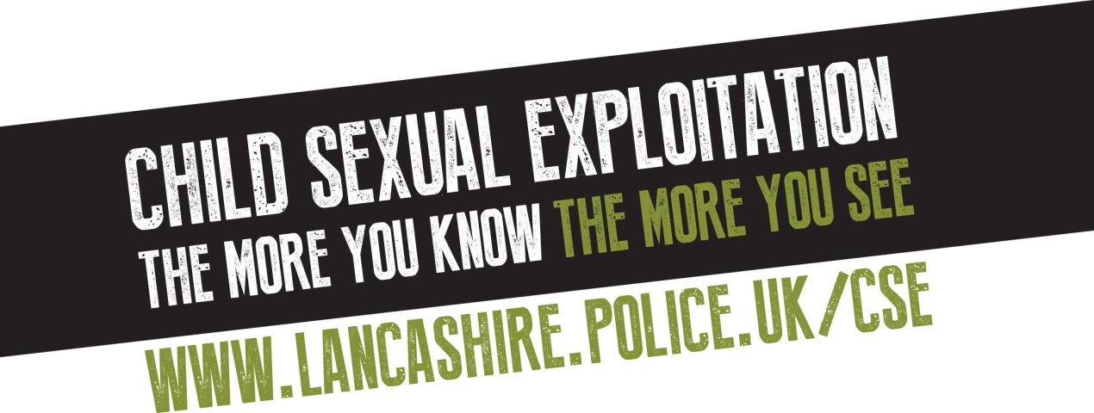

Key messages for CSE

- Child Sexual Exploitation is a crime that can affect any child, anytime, anywhere – regardless of their social or ethnic background.

- It involves offenders grooming youngsters and using their power to sexually abuse them. It can take many forms, whether it occurs through a seemingly 'consensual' relationship with an older boyfriend, or a young person having sex in return for attention, gifts, alcohol or cigarettes.

- Sexual exploitation is child abuse and, although they may not realise it, it puts the young victim at huge risk of damage to their physical, emotional and psychological health.

- Many young people who are being abused do not realise they are at risk and will not call for help. They may see themselves as willing participants when in fact their behaviour is anything but consenting.

- And, while there is no stereotypical victim of exploitation, there are warning signs in children's behaviour that may indicate something is wrong – and if you know what you're looking for, you can take steps to help them.

What are the signs you need to know?

- Has the young person received unexplained gifts or money?
- Do they use their mobile phone secretively?
- Do they have significantly older friends?
- Have they been picked up from home or school by someone you don't know?
- Are they associating with other young people who are already known to be vulnerable or involved in exploitation?
- Have they started playing truant from school or regularly going missing from home?
- Have they suffered from a sexually-transmitted infection?
- Are they self-harming?
- Has their appearance changed?

And what makes a child more at risk?

- If they come from a chaotic or dysfunctional household
- A lack of friends in the same age group
- Confused about their sexuality
- History of domestic abuse or neglect
- Learning disabilities
- Have come into contact with other exploited youngsters, e.g at school
- Have suffered a recent bereavement or loss
- Are homeless or living in residential care, a hostel or bed and breakfast
- Have low self-esteem or confidence
- Young carer
- Live in a gang neighbourhood

Key messages about offenders

- Offenders come from many different social and ethnic backgrounds but they all have one thing in common. They are abusing young people and are using their status or position to exploit vulnerable victims.

- We recognise that in some areas the number of Asian offenders is disproportionate to the population and far from ignoring this, have been tackling the issue head on by working with the local communities, giving presentations to community forums and visiting mosques to raise awareness.

- We will continue to target, warn and prosecute offenders to hit home the message that this type of behaviour is not just unacceptable, it is criminal, and we will pursue those people involved and bring them to justice, irrespective of their backgrounds.

- If you are concerned about a young person you know, call Lancashire Police on 101 or (insert local details). In an emergency, always dial 999. You can also visit www.lancashire.police.uk/cse for lots more information.

- A new website for young people will also be launched in September so please encourage as many as possible to visit www.trusted2know.co.uk where they can get help and advice on a range of subjects, including this one.

