SESSION 11: Worksheet One:
Facilitators information
Beth and Harry

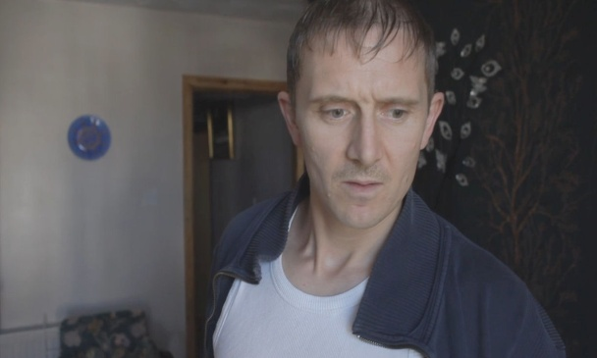

- Grooming

Beth (15 years old) meets Harry (aged 27 years). He impresses her with his reputation, money, lifestyle and he makes her feel important by paying her lots of attention. He buys her presents such as a mobile phone and gives her alcohol and drugs to relax her. They begin to have a sexual relationship. He is her first proper relationship; it makes her feel good that she is going out with an older boyfriend. Beth thinks she is in love. Harry meets her outside the school gates most nights and picks her up in his car. Beth thinks Harry is really cares about her.
- Creating Dependency
Harry begins to make Beth dependent on him – he is very possessive and is jealous of her relationship with Elisha and Nick. He constantly tells her to stop hanging around with such losers. Beth spends lots of time with Harry, and begins to let her friends down when she has arranged to meet them as she knows this won't please Harry. Beth thinks his jealousy is a sign of that he really loves her. She feels flattered and protected by him. Beth has to hide this relationship from her parents, her own relationship with her parents has deteriorated, she used to have such a good relationship with her Mum and Dad.

- Taking Control

Harry begins to control all aspects of her life: where she goes, who she sees, what she wears, what she eats and when she sleeps. He is starting to act violent around her. Harry gives her soft drugs and alcohol which is part of the process of undermining her resistance and is more effective as control than constant abuse. Beth is now worried but makes excuses for his behaviour, how can she tell her friends the truth? She has hidden the real relationship from her mates. She believes it is her fault that she gets him angry and she feels guilty. Beth persuades herself that if she keeps doing everything he asks then he will change back to being the guy he was in the beginning and above all, she still loves him.

- Total Dominance

Harry has become the all-important person in her life and he has created what can be referred to as a ‘willing’ victim. Beth often has sex with Harry even though she doesn't want to. Harry has started asking if Beth's friend Elisha will come out to house parties with a group of his older friends. Beth is beginning to feel totally out of control and has no self confidence left.

'Good Relationship Guide' checklist :
- What are you looking for in your ideal partner
- What would you like your ideal partner to be looking for in you?
- Think about a good relationship you know. What makes it good? How do they treat each other? What do they appreciate about each other?

In a good relationship;
- Do partners ever row? And if so, how do they deal with conflict?
- If they don't row, how do they resolve any differences?
- How equal is the partnership, in terms of respect, who has the power and control and who does the most of the work?
- What makes a relationship equal?

